Real-Time Hand Gesture Tracking and Interactive Drawing System

  - Introduction:

    - Purpose of the System:

The purpose of this document is to define the Software Requirements Specification (SRS) for a web application that allows users to draw on a canvas using their index and middle fingers. The application includes features like selecting drawing colors, shapes, brush sizes, and other functionalities similar to a standard paint application. The system integrates a custom-trained machine learning model to track finger movements without relying on external libraries or frameworks like YOLO, OpenCV, or MediaPipe

    - Scope of the System:

The application provides a drawing interface powered by a custom-trained machine learning model for finger tracking. It is designed to:
- Enable real-time finger tracking using a proprietary algorithm and model.
- Allow users to draw freehand, create shapes, and select brush sizes and colors.
- Be accessible via a web browser, with the backend built using Python for machine learning and Node.js with Express.js for server-side functionality.

  - General Description of the System:

    - Overall Description:
The application provides a drawing interface powered by a custom-trained machine learning model for finger tracking. It is designed to:
- Enable real-time finger tracking using a proprietary algorithm and model.
- Allow users to draw freehand, create shapes, and select brush sizes and colors.
- Be accessible via a web browser, with the backend built using Python for machine learning and Node.js with Express.js for server-side functionality.

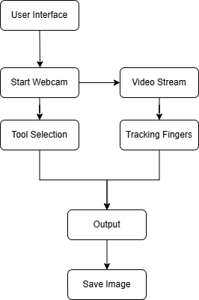
    - Feasibility Study:

- Technical Feasibility:
- Uses modern technologies like Python and Node.js.
- Runs on devices with camera support and modern web browsers.
- Custom ML models ensure flexibility and independence from external libraries.

- Economic Feasibility:
- Utilizes open-source tools and technologies to minimize costs.
- Major expenses include development time and server hosting.

- Operational Feasibility:
- User-friendly system designed for easy accessibility.
- Targets a wide audience, including artists, educators, and casual users.

  - Functional Requirements:

    - Module Description:

Video Capture Module
- Captures live video feed from the webcam.
- Adjusts resolution and frame rate for optimal performance.
- Passes frames to processing modules.

Hand Detection and Tracking Module
- Detects and tracks hand movements in real time.
- Identifies key points like fingertips and palm position.
- Provides coordinates for further processing.

Gesture Recognition Module
- Recognizes gestures such as index finger up, fist, or open palm.
- Maps gestures to actions like drawing, erasing, or shape selection.
- Uses custom ML models or heuristic-based classification.

Drawing Module
- Allows users to draw freehand and create shapes.
- Supports brush size, color selection, and stroke thickness.
- Provides undo/redo functionality.

User Interface (UI) Module
- Displays video feed with gesture-based controls.
- Provides buttons for tools like brush, eraser, and shape selector.
- Offers a settings menu for user preferences.

Event Handling Module
- Detects keyboard shortcuts and system events.
- Manages transitions like drawing mode, erasing mode, and clearing canvas.
Custom Algorithm Module
- Implements hand segmentation, contour analysis, and feature extraction.
- Uses in-house algorithms for gesture classification.

Data Management and Analytics Module
- Logs hand positions and gestures for debugging.
- Provides performance metrics and analytics for accuracy improvement.

Save and Export Module
- Saves drawings in PNG, JPEG, or SVG formats.
- Supports exporting drawings with transparent backgrounds.

Undo/Redo Module
- Allows users to undo or redo recent actions.
- Maintains drawing history for better flexibility.

System Optimization and Performance Module
- Ensures real-time gesture recognition with minimal lag.
- Reduces computational overhead for smoother performance.

    - Functions of Various Users of the System:

End Users
- Interact with the system to draw on the canvas using hand gestures.
- Customize drawings using brush sizes, colors, and shape selection.
- Save or export completed drawings for future use.

Developers
- Enhance gesture recognition accuracy by improving the ML model.
- Add new features and optimize application performance.
- Ensure compatibility across different devices and browsers.

System Administrators
- Maintain backend servers and system performance.
- Manage updates to the machine learning model and other components.
- Address user-reported issues and system failures.

  - Non-Functional Requirements:

Performance:
- The system should provide real-time hand tracking with minimal latency.
- Gesture recognition should have a response time of less than 100ms.
- The application should render drawings smoothly without noticeable lag.

Scalability:
- The backend should support multiple concurrent users without performance degradation.
- The system should allow for future expansion, such as adding multi-hand tracking or new gestures.
- Should be able to integrate with AR/VR environments in the future.

Usability:
- The user interface should be intuitive and easy to use without requiring extensive training.
- Users should receive real-time visual feedback for gestures and interactions.
- The system should provide help documentation or tooltips for first-time users.

Security:
- The system should not store user gesture data or drawings without explicit consent.
- All user interactions should be processed locally or securely on the server.
- The application should follow standard web security protocols to prevent unauthorized access.

Compatibility:
- The application should work on modern web browsers like Chrome, Firefox, and Edge.
- The system should support devices with different screen sizes, including PCs, tablets, and smartphones.
- The software should be operating system-independent and work on Windows, macOS, and Linux.

Reliability:
- The system should have 99.5% uptime, ensuring availability for users.
- In case of failure, it should recover quickly without data loss.
- The hand tracking and gesture recognition should work in varying lighting conditions with at least 90% accuracy.

Maintainability:
- The codebase should be modular and well-documented to allow for easy updates.
- Developers should be able to replace or upgrade individual modules without affecting the entire system.
- System logs should be maintained for troubleshooting and performance monitoring.

Portability:
- The application should be deployable on multiple platforms, including local machines and cloud environments.
- The system should allow easy migration between different hardware and software setups.

  - Interface Requirements:

    - GUI

- The application provides a responsive and intuitive user interface.
- The canvas is the main interaction area, occupying the majority of the screen.
- Tools such as the brush, eraser, shape selector, and color palette are available as buttons or dropdowns around the canvas.
- A real-time preview of selected brush size and color is displayed.
- Gesture-based controls are visually indicated on the interface.
- A settings menu is available for configuring preferences such as brush sensitivity or gesture calibration.

    - Hardware Interface

- A camera-enabled device (e.g., laptop, smartphone, or tablet) is required for finger tracking.
- Devices must support HD video input for optimal tracking performance.
- Minimum hardware specifications:
  - Processor: Dual-core CPU, 2.0 GHz or higher
  - RAM: 4 GB or higher
  - Camera resolution: 720p or higher

    - Software Interface

- The application is compatible with modern web browsers supporting HTML5, JavaScript, and APIs for accessing camera feeds.
- The backend interacts with:
  - Custom ML Model: Implemented in Python, deployed on the server, and integrated via APIs.
  - Node.js Server: Handles client requests, communicates with the ML model, and manages real-time tracking data.
- The frontend is built with HTML, CSS, and JavaScript frameworks.
- Third-party libraries or APIs (if any) must comply with standard web security protocols.

1.6 Data Dictionary:

1. Table Name : Login_Table

Description: Stores login credentials for Users.

Field Name | Data Type | Description | Constraints
user_id | Integer | Unique identifier for each user | Primary Key, Auto Inc
password | String | Password of the account | 6-12 characters
username | String | Username of the user | Unique, Max 50 characters
email | String | Email address of the user | Unique, Valid Email Format
role | String | Role of the user (End User, Admin, Developer) | Predefined Values
created_at | Timestamp | Account creation date and time | Auto-generated

2. Table Name : FingerTracking_Table

Description: Stores the details of fingers positioning

Field Name | Data Type | Description | Constraints
tracking_id | Integer | Unique identifier for each tracking event | Primary Key, Auto Increment
user_id | Integer | Identifier of the user being tracked | Foreign Key (User Table)
x_position | Float | X-coordinate of the finger position | Range: 0 - Canvas Width
y_position | Float | Y-coordinate of the finger position | Range: 0 - Canvas Height
.
3. Table Name : Training_Data

Description: Stores the details of different Samples.

Field Name | Data Type | Description | Constraints
sample_id | Integer | Unique identifier for each training sample | Primary Key, Auto Increment
frame_data | JSON | Stores the raw image/frame data used for training | Base64 or Image File Path
label | String | Label indicating the position or gesture of the fingers | Predefined Values (e.g., Index Up, Middle Up, Both Up)
timestamp | Timestamp | Time when the sample was collected | Auto-generated

3. Table Name : Training_Data

Description: Stores the metadata of the models.

Field Name | Data Type | Description | Constraints
model_id | Integer | Unique identifier for each trained model | Primary Key, Auto Increment
model_name | String | Name assigned to the trained model | Max 100 characters
version | String | Version number of the model | Semantic Versioning (e.g., 1.0.0)
accuracy | Float | Accuracy score of the trained model | Range: 0.0 - 1.0
training_date | Timestamp | Date when the model was trained | Auto-generated

Use Case Diagram of the System:

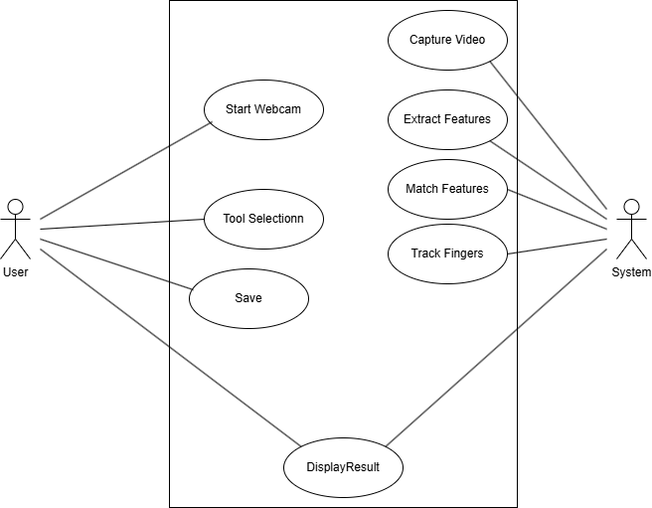

Class Diagram of the System:

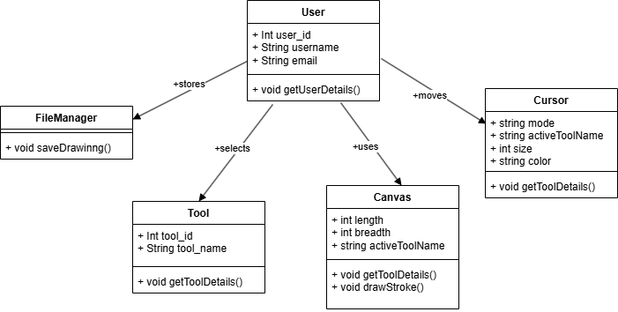

ER Diagram of the System:

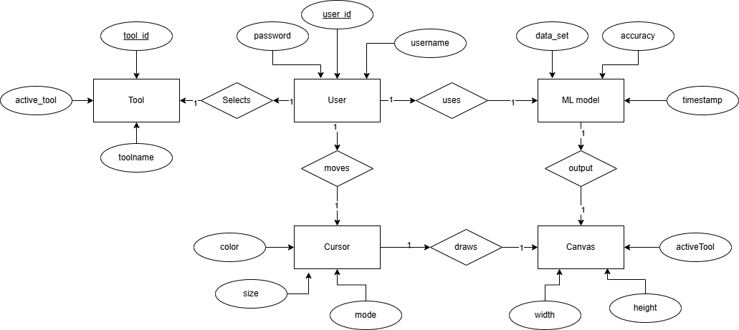

Sequence Diagram of the System:

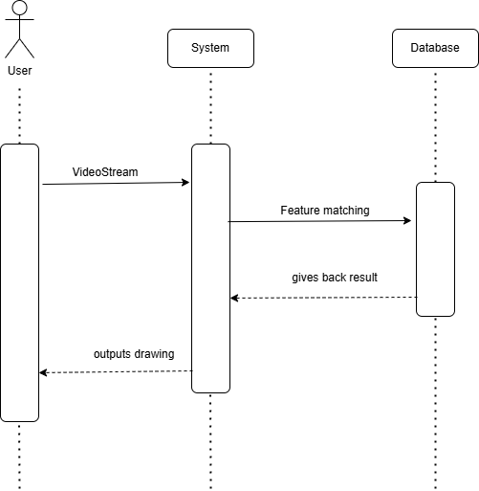

State Diagram of the System:

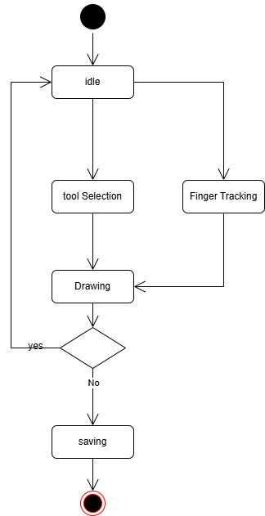

Activity Diagram of the System:
