**SHLOK ANAND**

**23070521142**

**Practical 3:**

**Part 5:**

Conversion Function in SQL

In SQL **data type conversion** is important for effective **database management** and accurate query results. Data type conversion ensures that data from different sources or columns can be correctly interpreted and manipulated, especially when dealing with different formats like **numbers**, text, **dates**, and other data types.

**Types of Data Type Conversion in SQL**

There are two main types of data type conversion in SQL.

* **Implicit Data Type Conversion:** This is done automatically by the database management system (**DBMS**) when SQL operations involve columns of different data types. For instance, a **string** value might automatically be converted into a **numeric type** if required by a mathematical operation.
* **Explicit Data Type Conversion:** This is done by the user, who specifies the conversion. This is necessary when SQL cannot automatically convert between data types, or when more control over the conversion is needed.

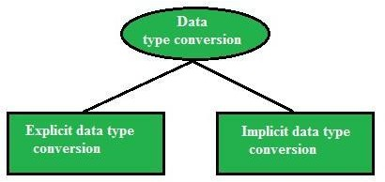

# Overview of Conversion Functions

|  |  |  |  |
| --- | --- | --- | --- |
| **Function** | **Oracle (SQL*Plus)** | **MySQL** | **Description** |
| TO_CHAR() | Yes | ❌ No | Converts a date/number to a string |
| TO_DATE() | Yes | ❌ No | Converts a string to a date |
| TO_NUMBER() | Yes | ❌ No | Converts a string to a number |
| CAST() | Yes | Yes | Converts from one data type to another |
| CONVERT() | ❌ No | Yes | Converts string from one character set to another |
| FORMAT() | ❌ No | Yes | Formats numbers with decimal places |
| STR_TO_DATE () | ❌ No | Yes | Converts a string to a date |
| DATE_FORMAT () | ❌ No | Yes | Formats a date as a string |
| TIME_FORMAT () | ❌ No | Yes | Formats time values |

|  |  |  |  |
| --- | --- | --- | --- |
| UNIX_TIMEST AMP() | ❌ No | Yes | Converts a date to Unix timestamp |
| FROM_UNIXTI ME() | ❌ No | Yes | Converts Unix timestamp to a date |

1. **Conversion Functions in SQL*Plus (Oracle) /skip if you want to use mysql platform**

Oracle provides TO_CHAR(), TO_DATE(), TO_NUMBER(), and CAST() for conversion.

* 1. **TO_CHAR() – Convert Date/Number to String**

**Use Case:** Format **date & time** into a human-readable string.

### SELECT TO_CHAR(SYSDATE, 'YYYY-MM-DD HH24:MI:SS') AS

formatted_date FROM dual;

## Output Example:

formatted_date

2025-01-29 14:35:50

## Format Number as Currency:

SELECT TO_CHAR(12345.67, 'L99,999.99') AS formatted_currency FROM dual;

## Output Example:

formatted_currency

$12,345.67

* 1. **TO_DATE() – Convert String to Date**

**Use Case:** Convert a **string** into a **date format**.

SELECT TO_DATE('2025-01-29', 'YYYY-MM-DD') AS converted_date

FROM dual;

## Output Example:

converted_date

29-JAN-25

## Using Different Date Formats:

SELECT TO_DATE('29-01-2025', 'DD-MM-YYYY') FROM dual;

Sample output

* 1. **TO_NUMBER() – Convert String to Number**

**Use Case:** Convert a **string** containing numbers into a **numeric type**.

SELECT TO_NUMBER('12345.67') AS number_value FROM dual;

## Output Example:

number_value

12345.67

* 1. **CAST() – Convert Data Types**

**Use Case:** Convert a number to a string or vice versa.

SELECT CAST(123.45 AS VARCHAR2(10)) AS string_value FROM

dual;

## Output Example:

string_value

123.45

## Convert String to Date:

## SELECT CAST(TO_DATE('2025-01-29', 'YYYY-MM-DD') AS DATE)

FROM dual;

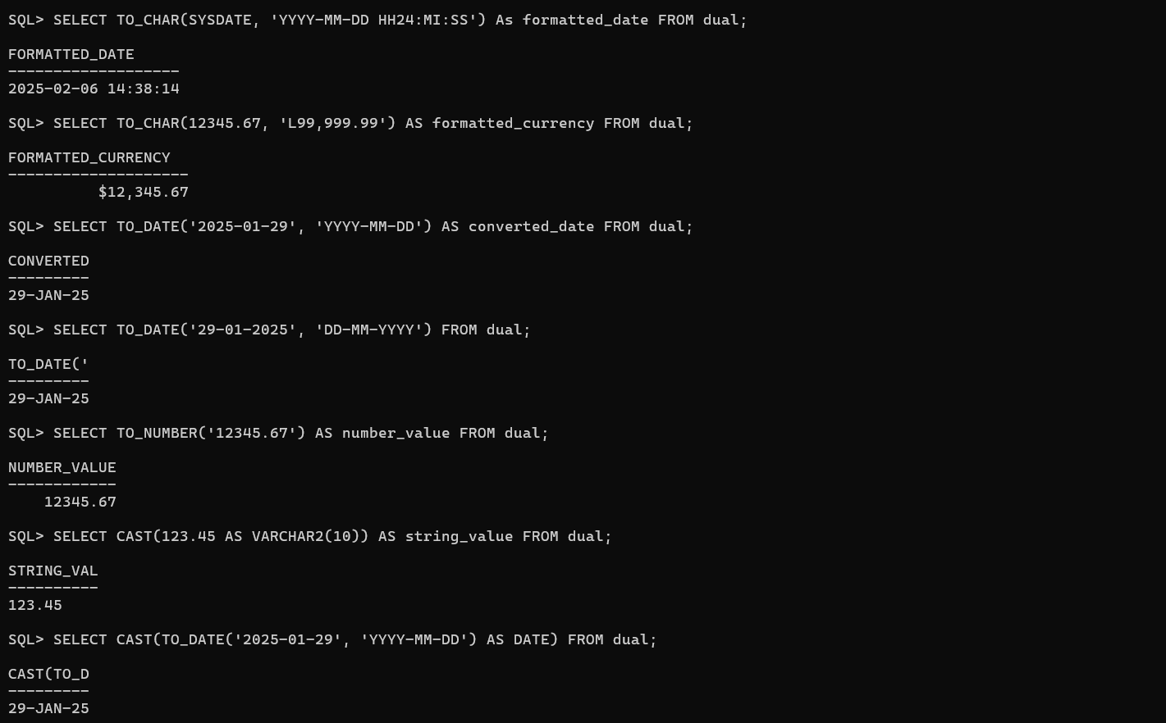

# 

# Real-World Use Cases of Conversion Functions

**Financial Data Reporting**

Convert salary figures into **formatted currency**.

SELECT emp_id, TO_CHAR(salary, 'L99,999.99') AS formatted_salary FROM employees;

**Log Analysis (MySQL)**

Convert timestamps into **human-readable format**.

SELECT FROM_UNIXTIME(UNIX_TIMESTAMP()) AS current_time;

**Data Migration**

When migrating from **CSV files**, convert **strings to dates**.

SELECT STR_TO_DATE('29-01-2025', '%d-%m-%Y') AS

converted_date;

# Summary Table

## Function Oracle (SQL*Plus)

## MySQ L

## Purpose

TO_CHAR() Yes ❌ No Convert date/number to string

TO_DATE() Yes ❌ No Convert string to date

|  |  |  |  |
| --- | --- | --- | --- |
| TO_NUMBER(  ) | Yes | ❌ No | Convert string to number |
| CAST() | Yes | Yes | Convert between data types |
| CONVERT() | ❌ No | Yes | Convert between character sets |
| FORMAT() | ❌ No | Yes | Format number with commas |
| STR_TO_DAT | ❌ No | Yes | Convert string to date |
| E() |  |  |  |
| DATE_FORMA | ❌ No | Yes | Format a date as a string |
| T() |  |  |  |
| TIME_FORMA | ❌ No | Yes | Format time values |
| T() |  |  |  |
| UNIX_TIMES | ❌ No | Yes | Convert date to Unix |

### TAMP()

FROM_UNIXT IME()

timestamp

❌ No Yes Convert Unix timestamp to date

# Advanced Real-World Use Cases of Conversion Functions in MySQL & SQL*Plus (Oracle)

**E-Commerce: Converting Prices for Different Currencies**



**1**

**Scenario:** An e-commerce site needs to convert prices from USD to INR and format them properly.

## Oracle (SQL*Plus):

### SELECT

product_id, product_name,

TO_CHAR(price_usd * 83.50, 'L99,999.99') AS price_inr FROM products;

## MySQL:

### SELECT

product_id, product_name,

FORMAT(price_usd * 83.50, 2) AS price_inr FROM products;

## Why?

* Uses TO_CHAR() in Oracle and FORMAT() in MySQL to **add currency formatting**.
* 1 USD = **83.50 INR** (exchange rate example).

**Example Output:**

|  |  |  |
| --- | --- | --- |
| **product_id** | **product_name** | **price_inr** |
| 101 | iPhone 15 | ₹99,999.99 |
| 202 | MacBook Pro | ₹2,19,999.99 |

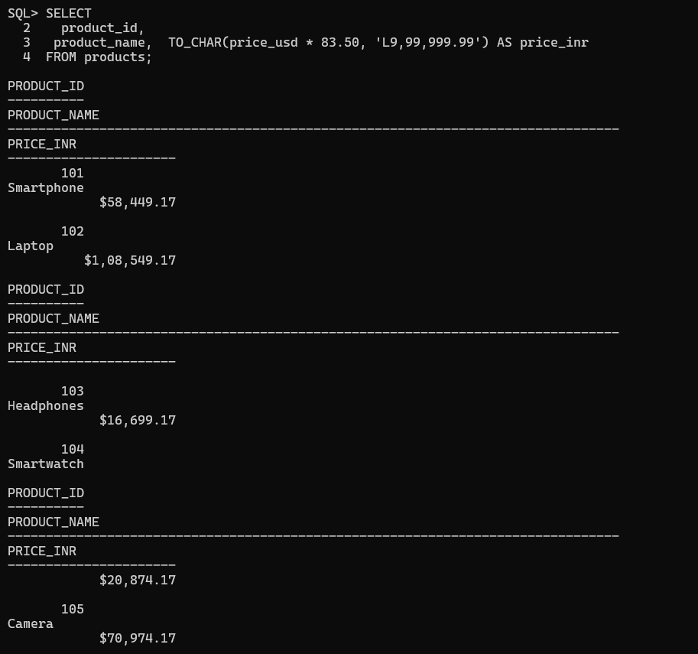

# Banking: Detecting Fraudulent Transactions Using Date Conversions



**2**

**Scenario:** A bank flags **suspicious transactions** that happened at **odd hours (midnight to 4 AM)**.

## Oracle (SQL*Plus):

SELECT transaction_id, account_id, amount, TO_CHAR(transaction_time, 'HH24:MI') AS transaction_hour FROM transactions

WHERE EXTRACT(HOUR FROM transaction_time) BETWEEN 0 AND 4;

## MySQL:

SELECT transaction_id, account_id, amount, TIME_FORMAT(transaction_time, '%H:%i') AS transaction_hour FROM transactions

WHERE HOUR(transaction_time) BETWEEN 0 AND 4;

## Why?

* Uses TO_CHAR() (Oracle) and TIME_FORMAT() (MySQL) to **extract and format time**.
* Filters transactions **between 00:00 and 04:00**.

**Example Output:**

|  |  |  |  |
| --- | --- | --- | --- |
| **transaction_id** | **account_id** | **amount** | **transaction_hour** |
| 89234 | 123456 | 5000 | 02:30 |
| 97345 | 789012 | 25000 | 03:15 |

# IoT & Smart Devices: Storing and Retrieving Unix Timestamps



**3**

**Scenario:** A smart home system stores **sensor readings** as Unix timestamps and needs human-readable timestamps.

## Oracle (SQL*Plus) - Convert Unix Timestamp to Readable Date:

SELECT sensor_id, FROM_TZ(TO_TIMESTAMP(1706505600), 'UTC')

AS reading_time FROM sensor_logs;

## MySQL:

SELECT sensor_id, FROM_UNIXTIME(1706505600) AS reading_time FROM sensor_logs;

## Why?

* Converts 1706505600 (Unix timestamp) into a **readable date-time format**.

**Example Output:**

**reading_time**

**sensor_id**

2025-01-29 12:00:00

101

# Marketing Analytics: Extracting Month and Year from Dates



**4**

**Scenario:** A company wants to analyze customer purchases by **month and year**.

## Oracle (SQL*Plus):

### SELECT

customer_id, purchase_date,

TO_CHAR(purchase_date, 'Month') AS purchase_month, TO_CHAR(purchase_date, 'YYYY') AS purchase_year

FROM purchases;

## MySQL:

### SELECT

customer_id, purchase_date,

DATE_FORMAT(purchase_date, '%M') AS purchase_month, DATE_FORMAT(purchase_date, '%Y') AS purchase_year

FROM purchases;

## Why?

* Uses TO_CHAR() (Oracle) and DATE_FORMAT() (MySQL) to extract

**month and year** from a **purchase date**.

## Example Output:

**customer_id purchase_date purchase_month purchase_year**

501 2025-01-29 January 2025

# Data Migration: Converting String Dates into Proper Date Format



**5**

**Scenario:** A company migrating old **CSV data** where dates are stored as strings (DD/MM/YYYY).

## Oracle (SQL*Plus):

SELECT TO_DATE('29/01/2025', 'DD/MM/YYYY') AS formatted_date FROM dual;

## MySQL:

SELECT STR_TO_DATE('29/01/2025', '%d/%m/%Y') AS

formatted_date;

## Why?

* Converts 29/01/2025 (string) into a **date type** in Oracle (TO_DATE()) and MySQL (STR_TO_DATE()).

**Example Output:**

2025-01-29

**formatted_date**

# Logistics & Delivery: Calculating Expected Delivery Time Based on Distance



**6**

**Scenario:** Estimate delivery **ETA** based on **distance traveled** and **average speed**.

## Oracle (SQL*Plus):

### SELECT

order_id, distance_km,

ROUND(distance_km / 60, 2) AS estimated_hours FROM deliveries;

## MySQL:

### SELECT

order_id, distance_km,

FORMAT(distance_km / 60, 2) AS estimated_hours FROM deliveries;

## Why?

* Divides distance_km by 60 km/h (average speed).

**Example Output:**

|  |  |  |
| --- | --- | --- |
| **order_id** | **distance_km** | **estimated_hours** |
| 1001 | 120 | 2.00 |

# Social Media Analytics: Converting Post Dates into Readable Formats



**7**

**Scenario:** A social media platform needs to display post timestamps **beautifully**. **Oracle (SQL*Plus):**

SELECT post_id, TO_CHAR(post_date, 'Month DD, YYYY HH24:MI') AS formatted_date FROM posts;

## MySQL:

SELECT post_id, DATE_FORMAT(post_date, '%M %d, %Y %H:%i') AS formatted_date FROM posts;

**Why?**

* Converts **date into a social-media friendly format**.

**Example Output:**

|  |  |
| --- | --- |
| **post_id** | **formatted_date** |
| 555 | January 29, 2025 14:35 |

**Summary Table**

|  |  |  |
| --- | --- | --- |
| **Scenario** | **Oracle (SQL*Plus)** | **MySQL** |
| Convert prices to INR | TO_CHAR(price, 'L99,999.99') | FORMAT(price, 2) |
| Detect fraud based on time | EXTRACT(HOUR FROM  transaction_time) | HOUR(transaction_tim e) |
| Convert Unix timestamp | FROM_TZ(TO_TIMESTAMP(  ...), 'UTC') | FROM_UNIXTIME(...) |
| Extract month & year | TO_CHAR(date, 'Month YYYY') | DATE_FORMAT(date, '%M %Y') |
| Convert string to date | TO_DATE('29/01/2025', 'DD/MM/YYYY') | STR_TO_DATE('29/01/2 025', '%d/%m/%Y') |
| Estimate delivery ETA | ROUND(distance_km / 60, 2) | FORMAT(distance_km / 60, 2) |
| Format social media timestamps | TO_CHAR(post_date, 'Month DD, YYYY HH24:MI') | DATE_FORMAT(post_dat e, '%M %d, %Y  %H:%i') |