SHLOK ANAND

23070521142

String Functions in SQL*Plus (Oracle) & MySQL

String functions allow you to **manipulate and process text data** in SQL. Below is a detailed comparison of **SQL*Plus (Oracle)** and **MySQL** string functions, including examples.

# String Functions in SQL*Plus (Oracle)

## CONCAT – String Concatenation

SELECT CONCAT('Hello', ' World') FROM dual; -- Result: Hello World SELECT 'Hello' || ' World' FROM dual; -- Alternative method using ||

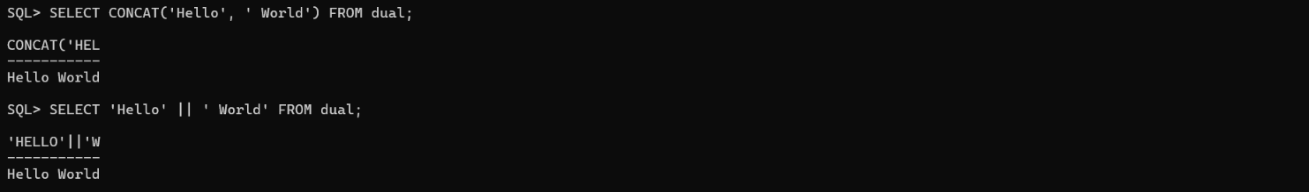

## LENGTH – String Length

SELECT LENGTH('Oracle Database') FROM dual; -- Result: 16

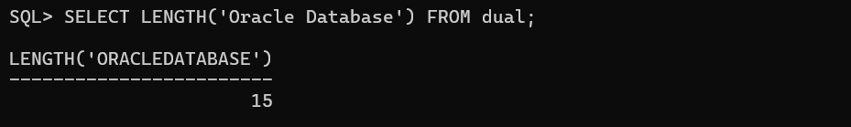

## SUBSTR – Extract Substring

SELECT SUBSTR('Oracle Database', 8, 3) FROM dual; -- Extracts 'Dat' (Start from 8, length 3)

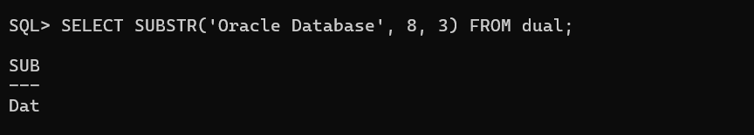

## INSTR – Find Position of a Substring

SELECT INSTR('Oracle Database', 'D') FROM dual; -- Finds position of 'D' (Result: 8)

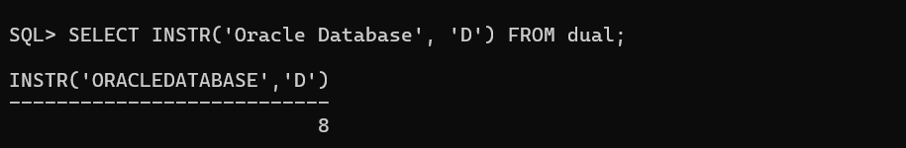

## REPLACE – Replace a Substring

SELECT REPLACE('Oracle Database', 'Database', 'SQL') FROM dual; -- Result: Oracle SQL

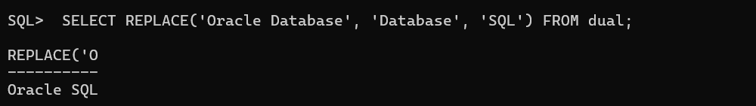

## TRANSLATE – Replace Multiple Characters

SELECT TRANSLATE('123-456-7890', '123', 'XYZ') FROM dual; -- Result: XYZ-456-7890

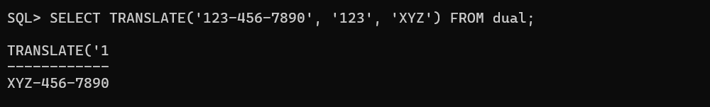

## 

## TRIM – Remove Spaces or Characters

SELECT TRIM(' Oracle ') FROM dual; -- Removes leading and trailing spaces

SELECT TRIM('O' FROM 'Oracle') FROM dual; -- Removes 'O' from both ends

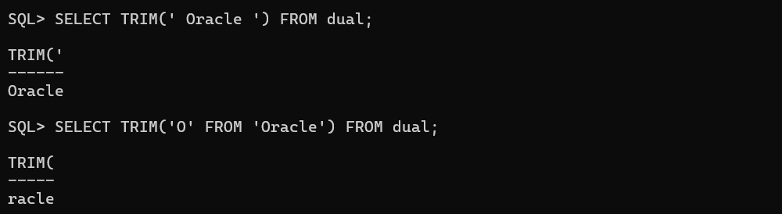

## LPAD & RPAD – Padding Strings

SELECT LPAD('Oracle', 10, '*') FROM dual; -- Result: ****Oracle SELECT RPAD('Oracle', 10, '*') FROM dual; -- Result: Oracle****

## LOWER, UPPER, INITCAP – Case Conversion

SELECT LOWER('Oracle Database') FROM dual; -- Result: oracle database SELECT UPPER('Oracle Database') FROM dual; -- Result: ORACLE DATABASE SELECT INITCAP('oracle database') FROM dual; -- Result: Oracle Database

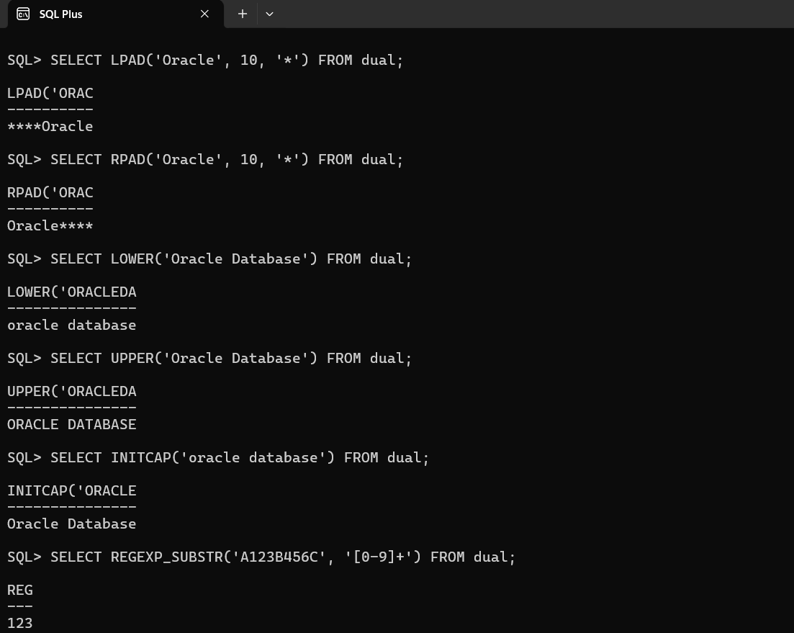

## REGEXP Functions – Regular Expressions

## SELECT REGEXP_SUBSTR('A123B456C', '[0-9]+') FROM dual; -- Extracts

first number (Result: 123)

SELECT REGEXP_REPLACE('abc123xyz', '[0-9]', '*') FROM dual; --

Replaces digits with '*' (Result: abc***xyz)

