**SHLOK ANAND**

**23070521142**

**Easy Level:**

**1. Function Declaration:**

Write a function that takes a name and prints “Hello, <name>!”.

Call it with different names.

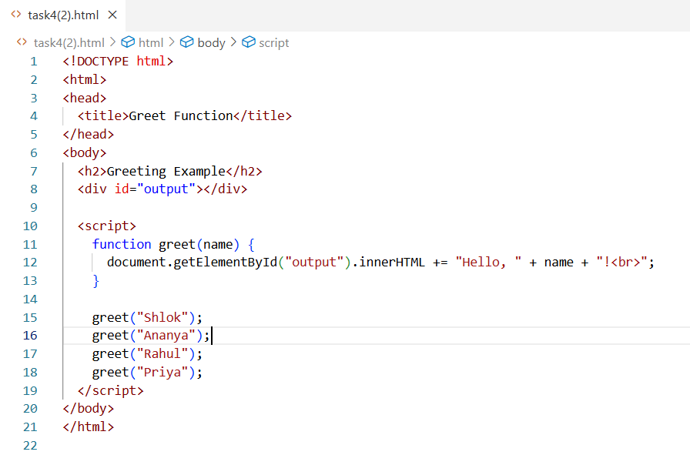

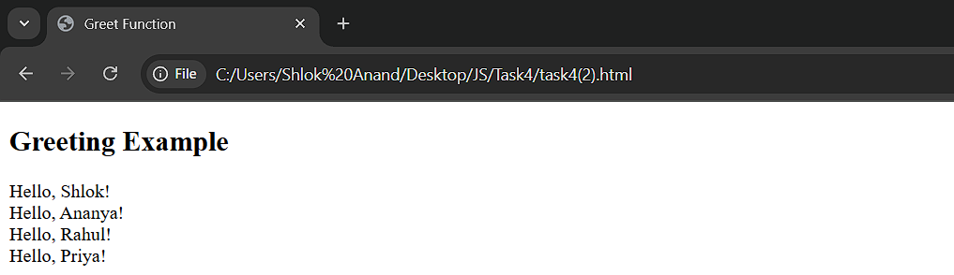

**2. Function Expression:**

Create a function expression that takes two numbers and returns their sum.

Test it with at least 3 sets of numbers.

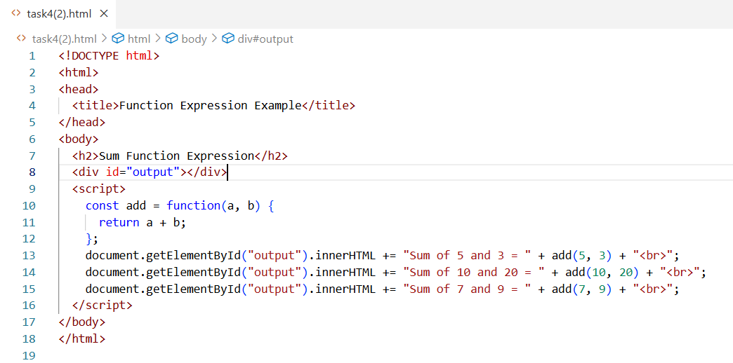

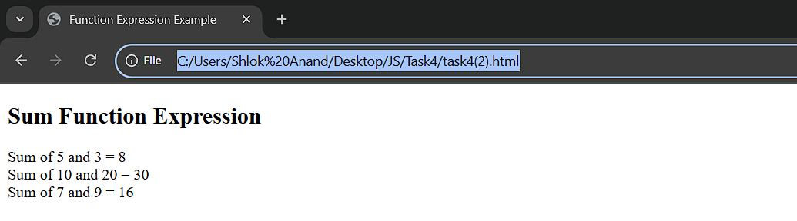

**3. Arrow Function:**

Write an arrow function that returns the square of a number.

Test it with numbers 2, 5, and 10.

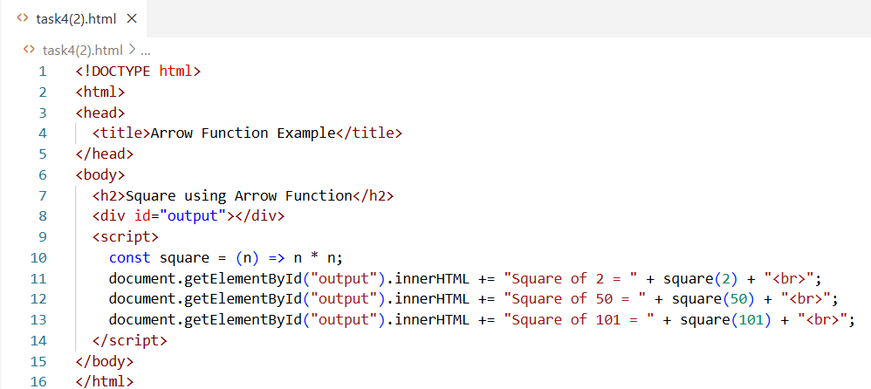

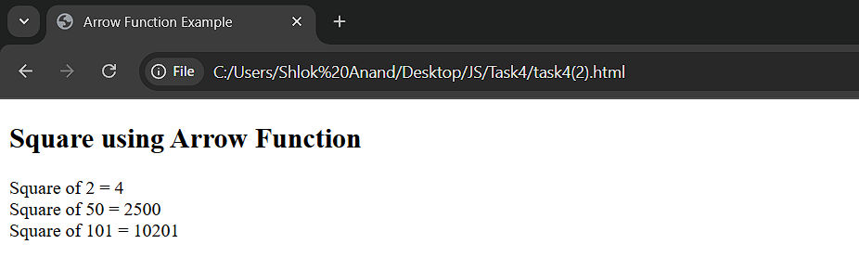

**4. Function Declaration with Default Parameter:**

Write a function that takes a name and a language (default &quot;English&quot;) and

prints “Hello” in that language.

Example(“Alice”,”Spanish”) → “Hola,Alice!”.

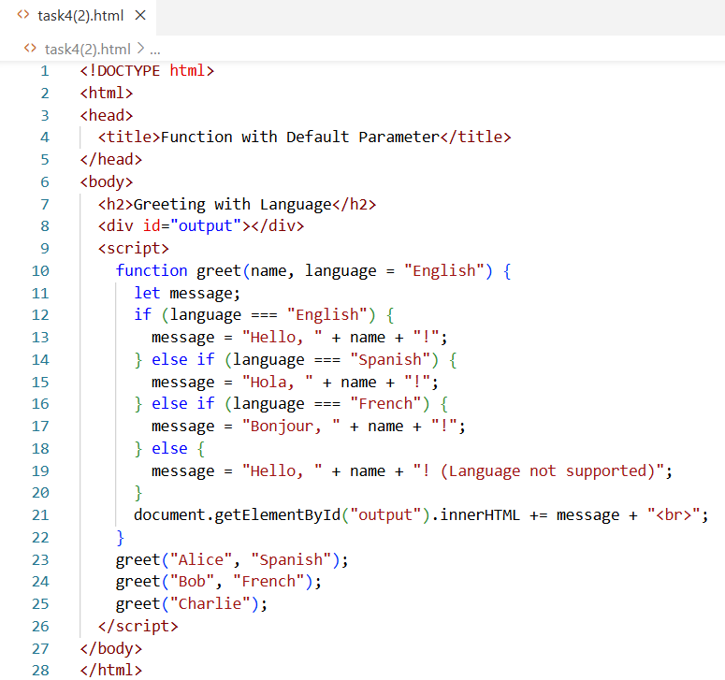

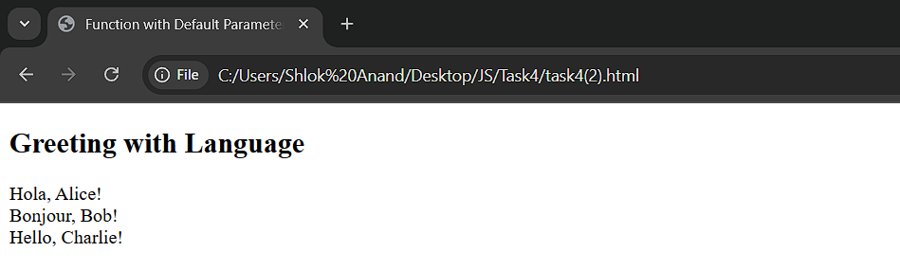

**5. Function Expression – Simple Math:**

Create a function expression that converts Celsius to Fahrenheit.

Formula: (C × 9/5) + 32.

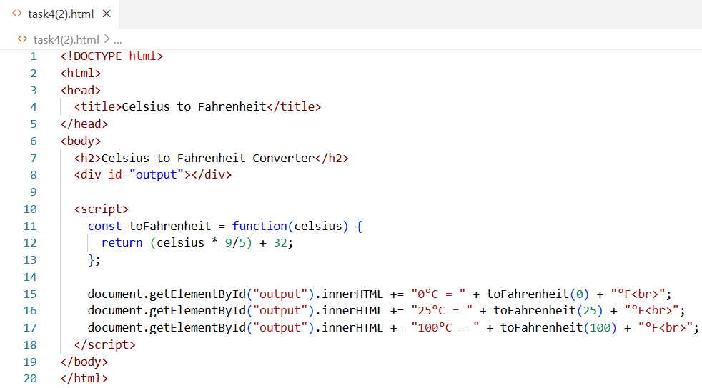

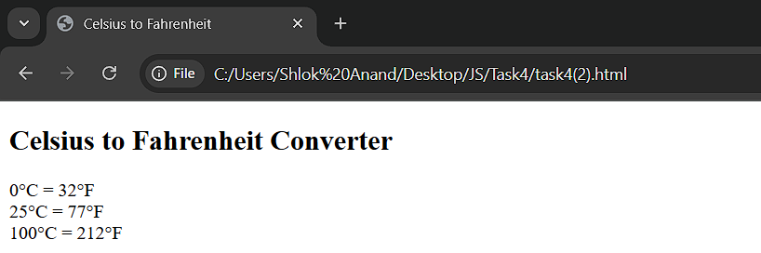

**6. Arrow Function – Word Count:**

Make an arrow function that takes a string and returns the number of words

in it.

Example: “I love JavaScript” → 3.

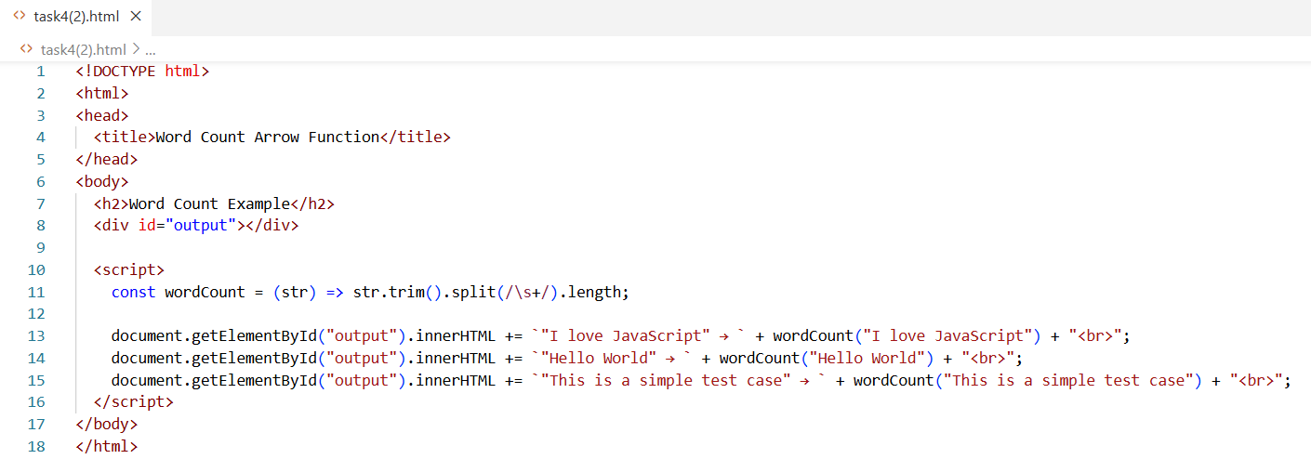

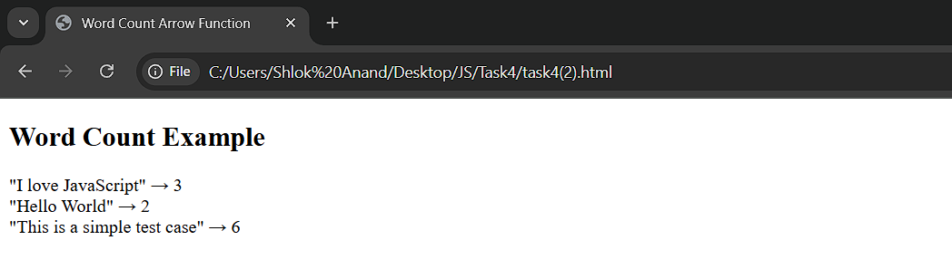

**7. Simple Closure – Personal Note:**

Write a closure that stores a note and returns a function to read it later.

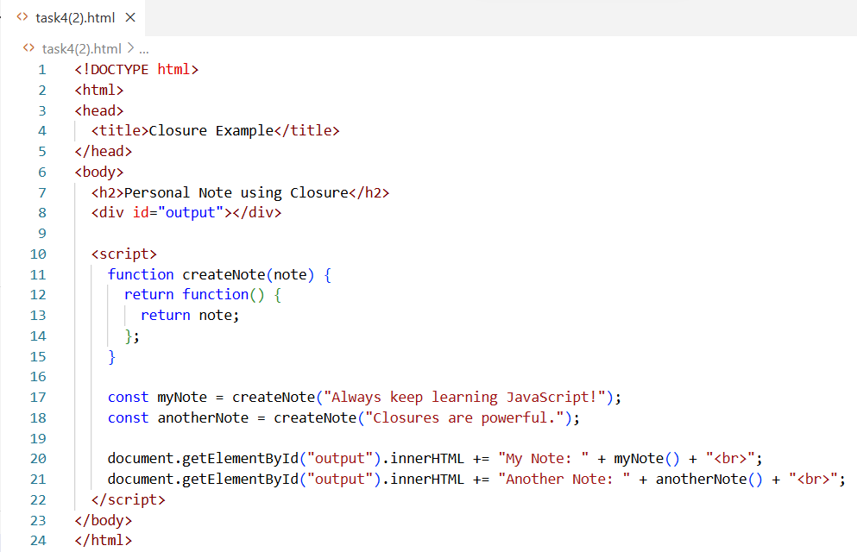

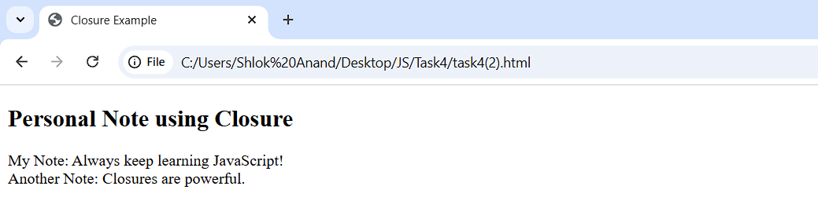

**Moderate Level:**

**1. Scope Practice:**

Create a global variable and a block-scoped variable.

Demonstrate which ones are accessible inside and outside a function and a block{ }.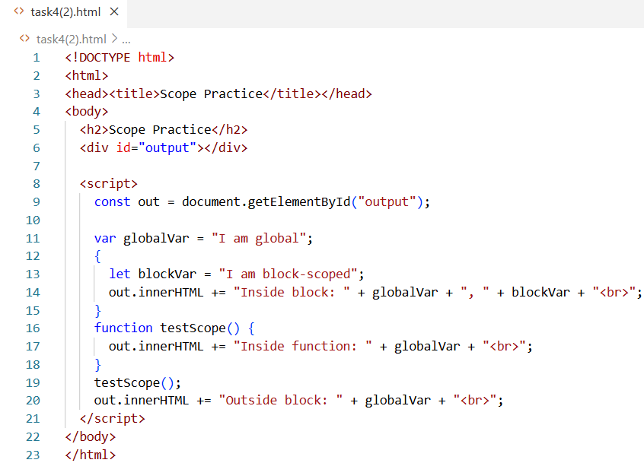

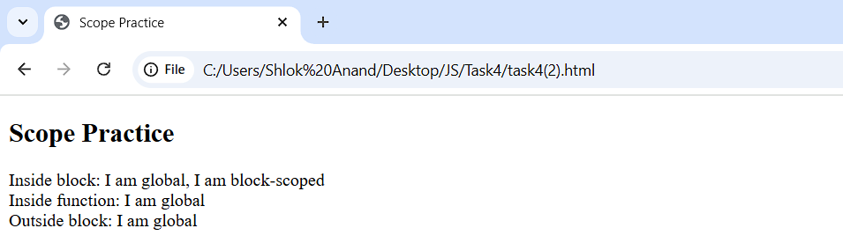

**2. Function Expression + Recursion:**

Write a named function expression that finds the nth Fibonacci number.

Test with n = 6 and n = 10.

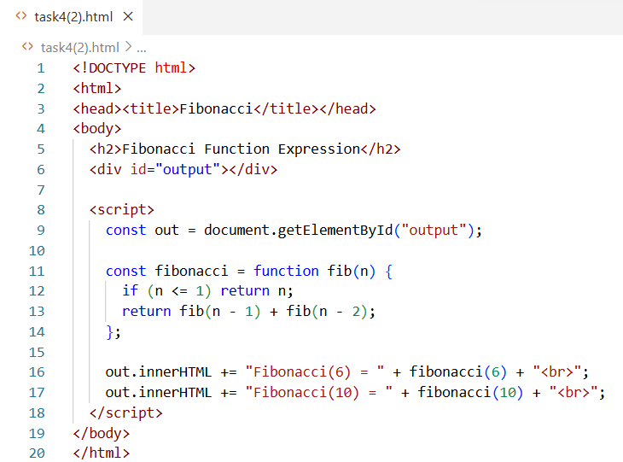

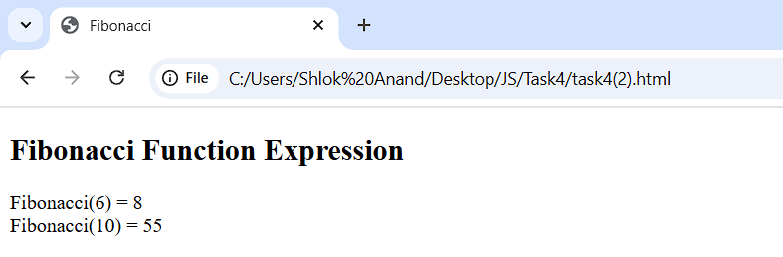

**3. Arrow Function String Check:**

Create an arrow function that checks if a sentence ends with “!”. Test it with both true and false cases.

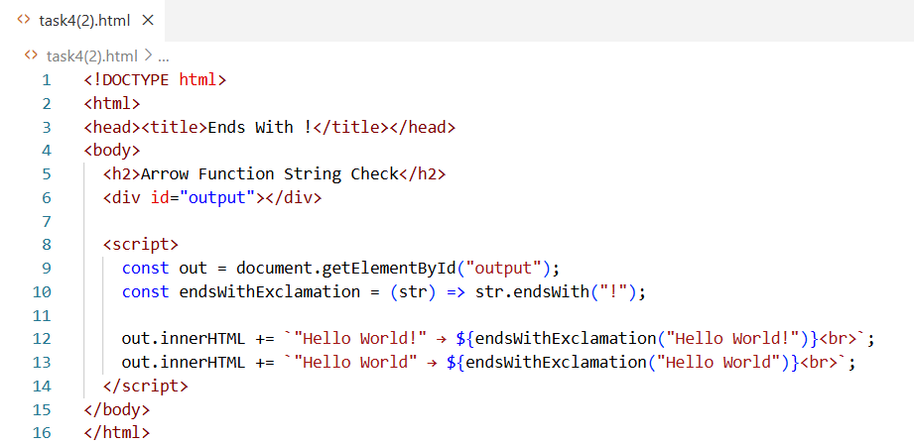

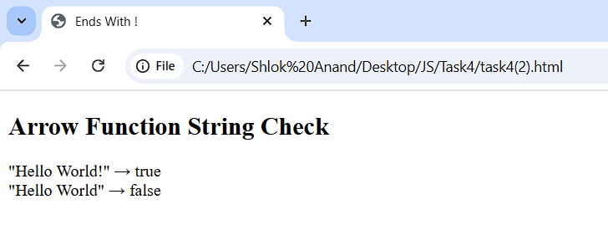**4. Simple Closure:**

Write a function createGreeter that stores a greeting message and returns a

function that prints it when called.

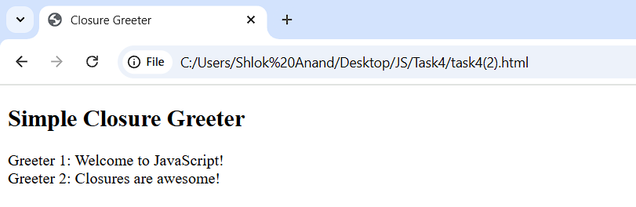

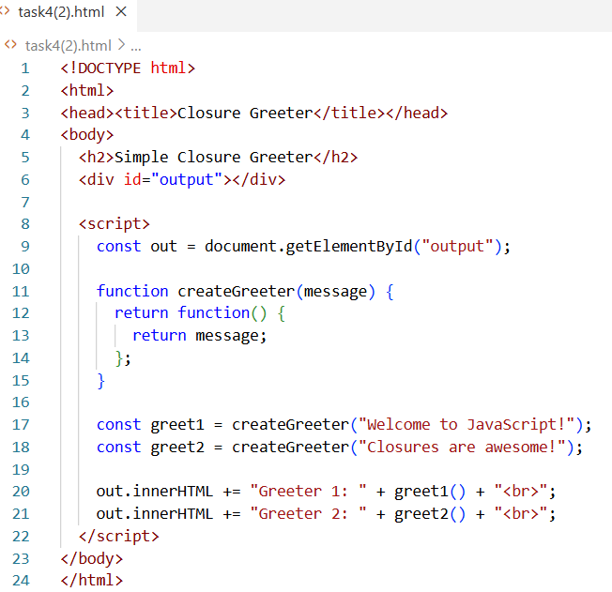

**5. Scope Example – Variable Shadowing:**

Create a function where a local variable has the same name as a global variable.

Show how JavaScript chooses which one to use.

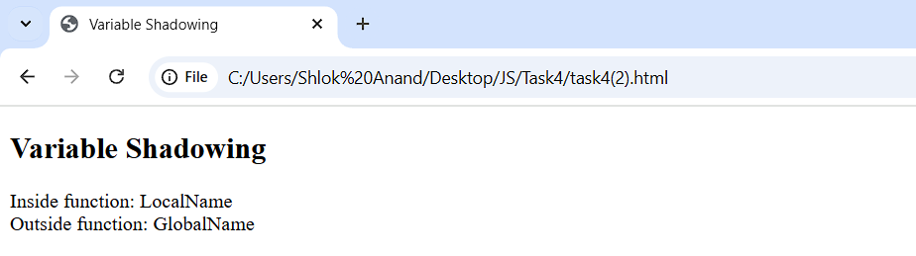

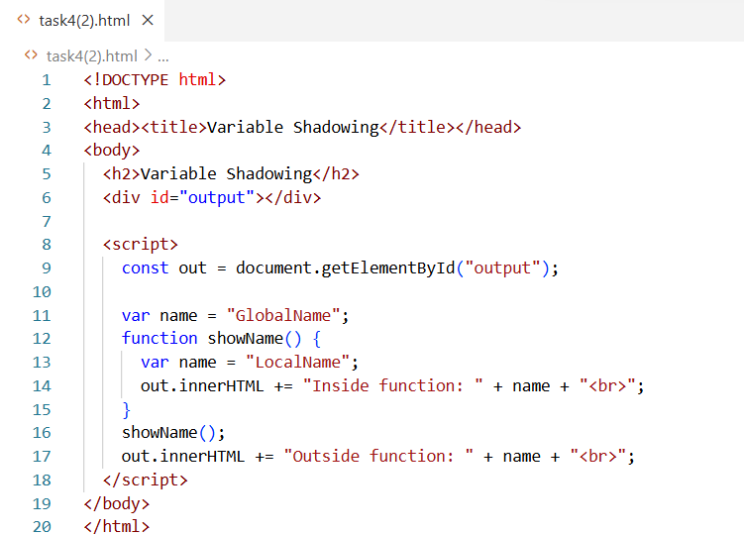

**6. Function Expression – Reverse String:**

Make a function expression that reverses a string without using built-in .reverse().

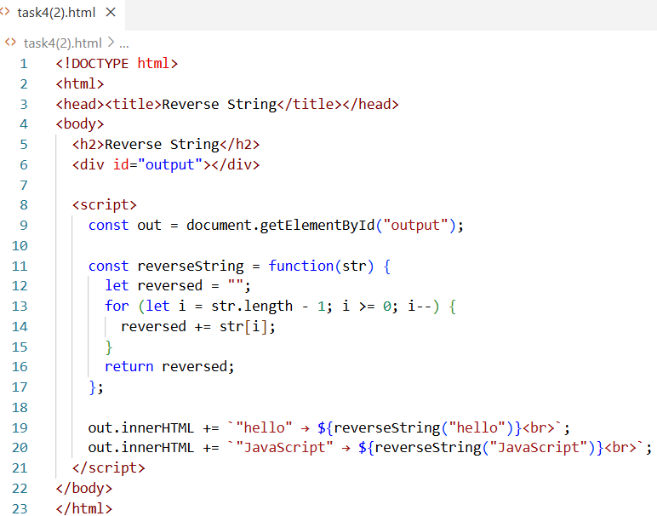

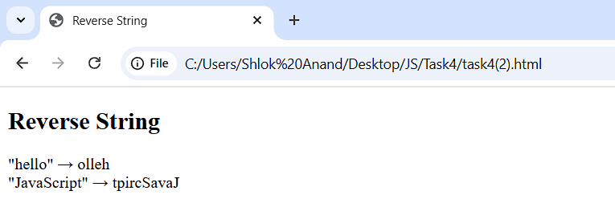

**7. Arrow Function – Multiple Checks:**

Write an arrow function that checks if a number is: a. Even b. Positive

Return true only if both conditions are met.

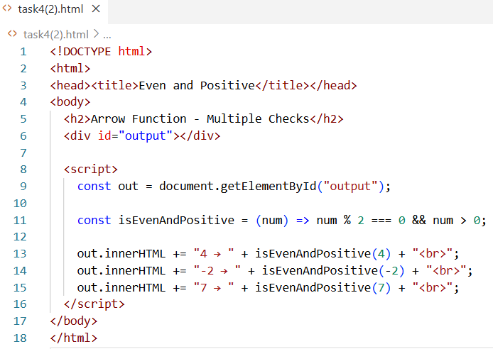

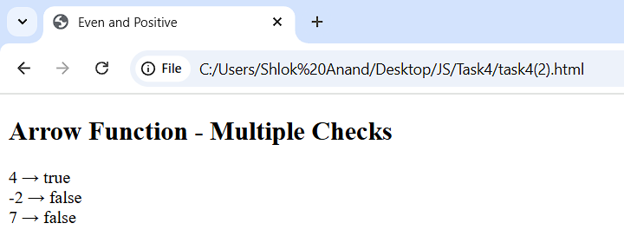

**8. Closure – Personalized Counter:**

Create a closure that counts how many times a specific person’s name is entered.

Example: If &quot;Alice&quot; is entered three times, it should return 3.

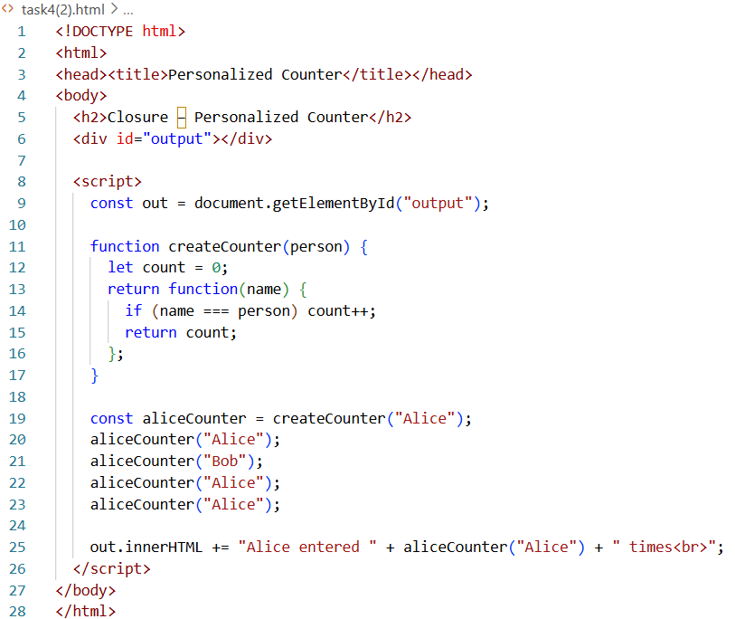

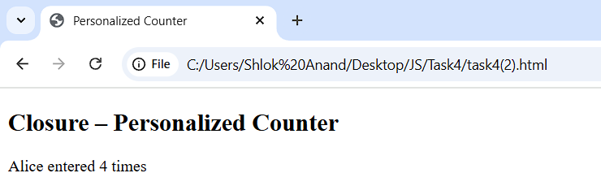

**Advanced Level**

**1. Closure for Counter:**

Create a closure-based counter that allows incrementing, decrementing, and resetting the count.

Each operation should be a separate function.

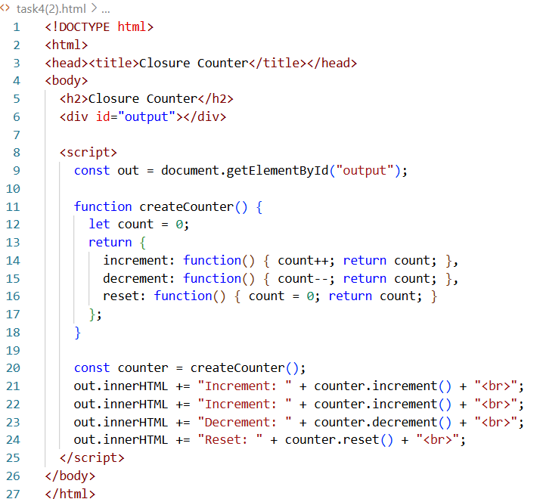

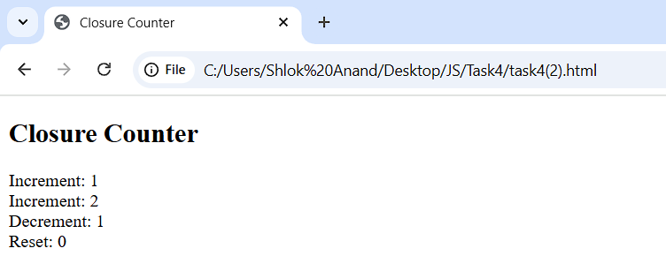

**2. Private Data with Closure:**

Make a createBankAccount function that stores a balance. Provide deposit, withdraw, and checkBalance methods. Ensure balance can’t be accessed directly from outside.

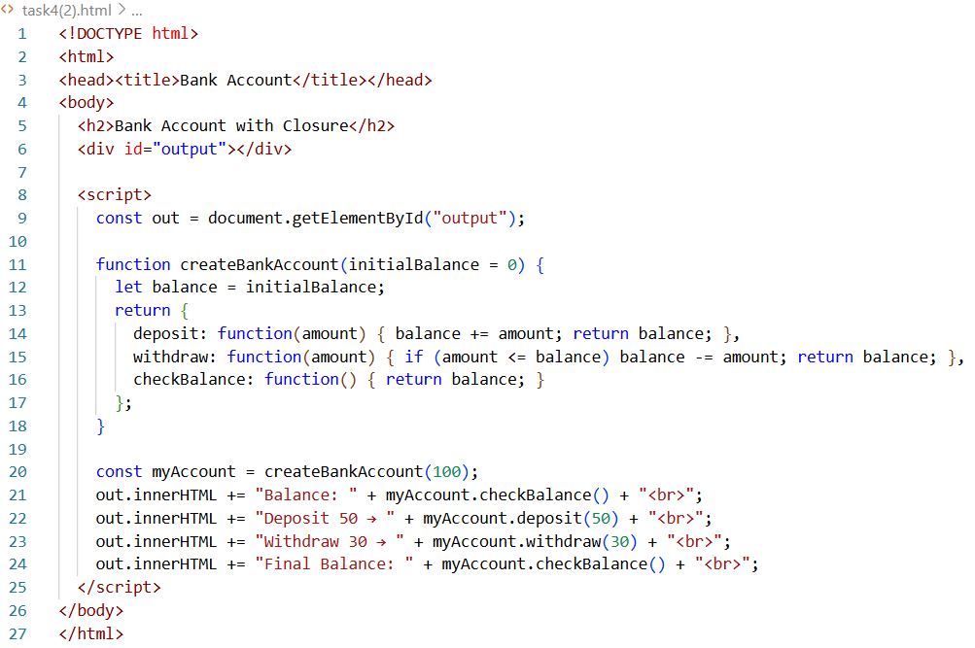

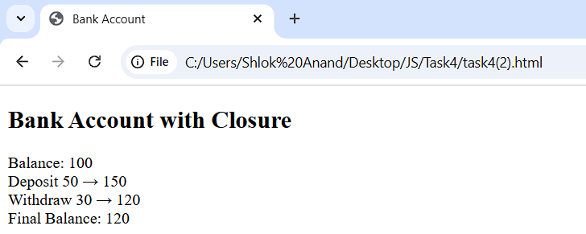

**3. Mixed Function Types:**

Function Declaration: Generates a random number. Function Expression: Checks if the number is prime. Arrow Function: Prints &quot;Prime&quot; or &quot;Not Prime&quot; based on the result.

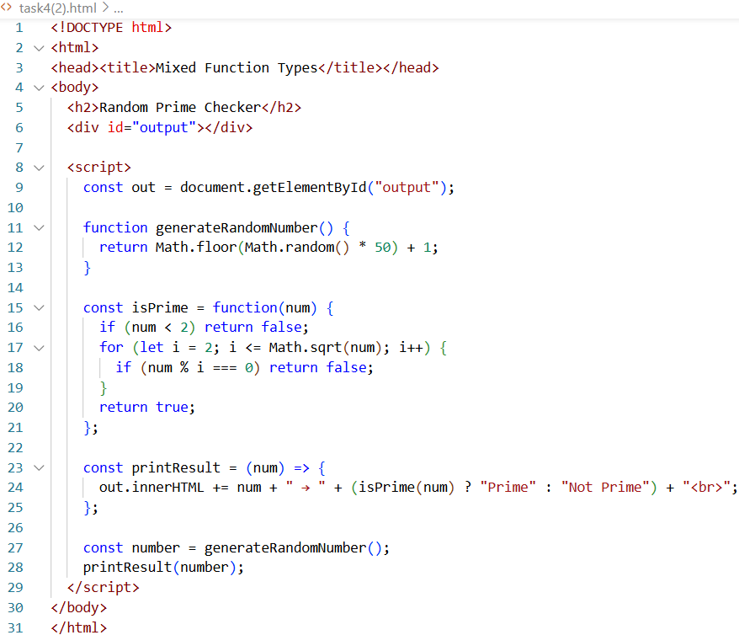

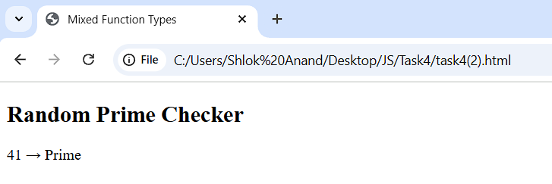

**4. Scope Chain Debugging:**

Write code with three nested functions (outer, middle, inner) each having variables

with the same name.

Log which one gets accessed in the innermost function and explain why.

