**SHLOK ANAND**

**23070521142**

**JS PRACTICAL 3 (TASK 1)**

1. **Write a program to check if a number is positive, negative, or zero using if...else.**

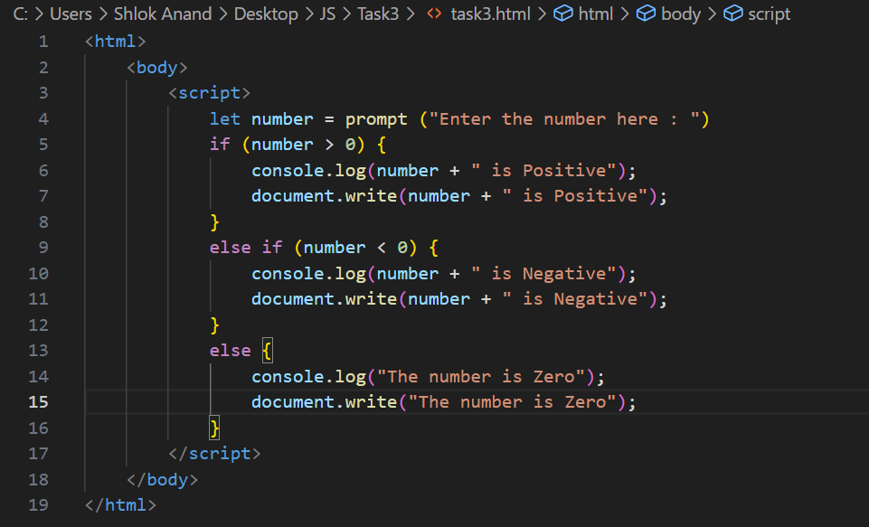

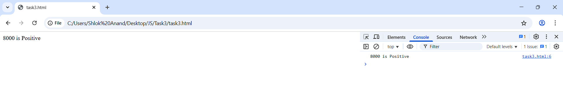

1. **Accept user input (via prompt()) for the day of the week and display a message using switch.**
2. <!DOCTYPE html>
3. <html>
4. <head>
5. <title>Day of the Week Message</title>
6. </head>
7. <body>
8. <script>
9. let day = prompt("Enter a day of the week (e.g., Monday):");
10. let message = "";
11. switch (day.toLowerCase()) {
12. case "monday":
13. message = "Start of the work week!";
14. break;
15. case "tuesday":
16. message = "Keep going! It's Tuesday.";
17. break;
18. case "wednesday":
19. message = "Midweek already!";
20. break;
21. case "thursday":
22. message = "Almost there!";
23. break;
24. case "friday":
25. message = "Last working day for many!";
26. break;
27. case "saturday":
28. message = "Weekend time! Enjoy.";
29. break;
30. case "sunday":
31. message = "Rest well, it's Sunday.";
32. break;
33. default:
34. message = "That's not a valid day of the week.";
35. }
36. alert(message);
37. console.log(message);
38. document.write("<h2>" + message + "</h2>");
39. </script>
40. </body>
41. </html>

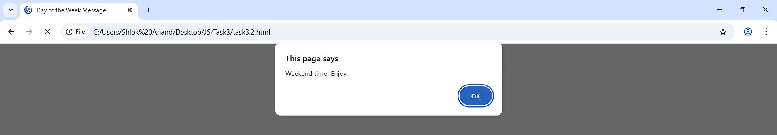

1. **Create a traffic light simulator using switch (Red → Stop, Yellow → Wait, Green → Go).**

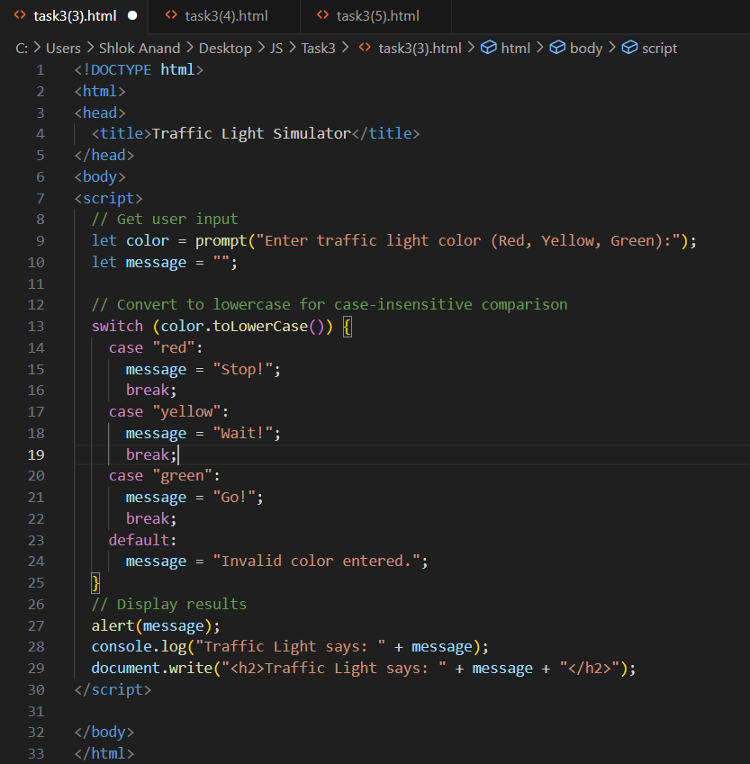

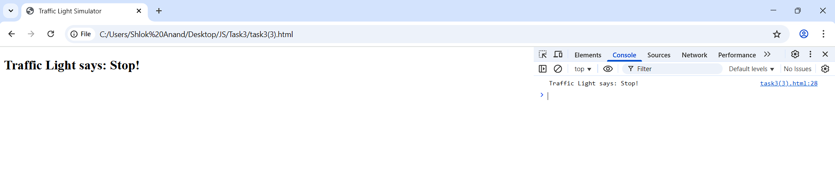

1. **ATM Simulator Ask the user for a transaction type:**

**● “withdraw”: Ask for amount; if less than balance, deduct and show new balance.**

**●”deposit”: Ask for amount; add to balance and show it.**

**● “balance”;: Show current balance.**

**Default: “Invalid transaction type”;**

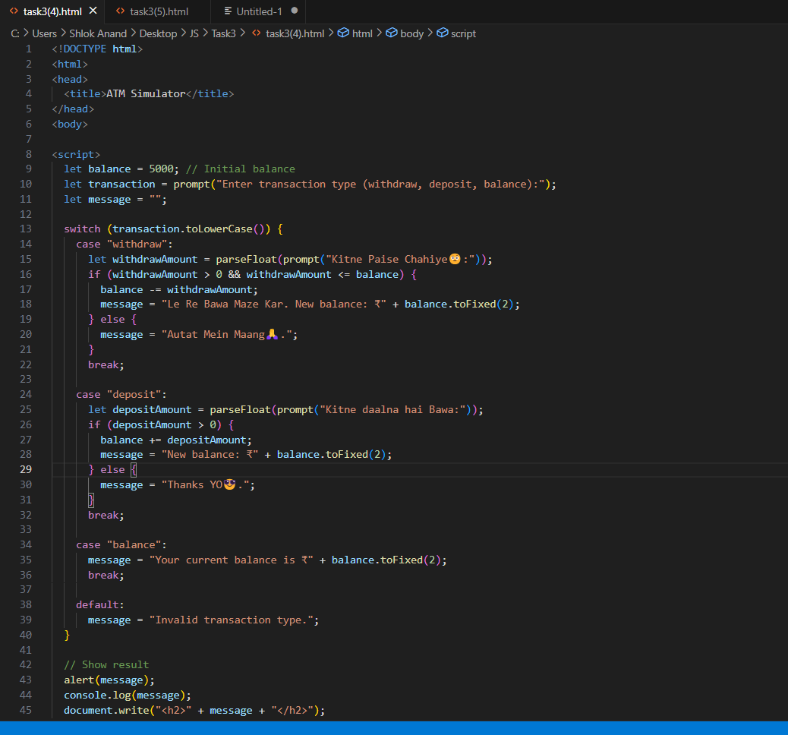

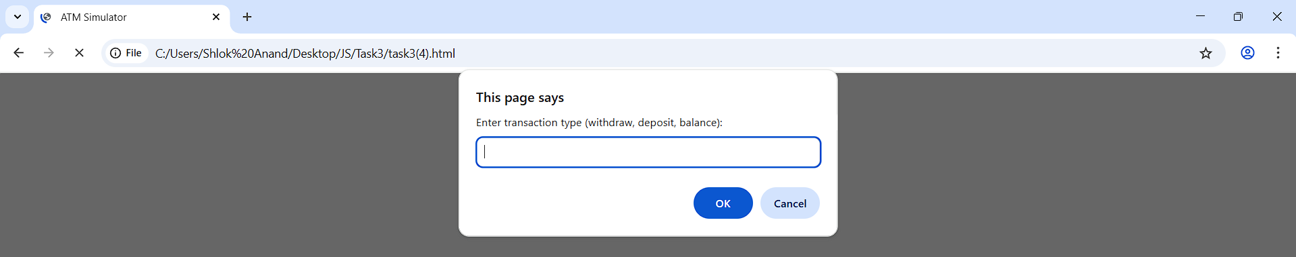

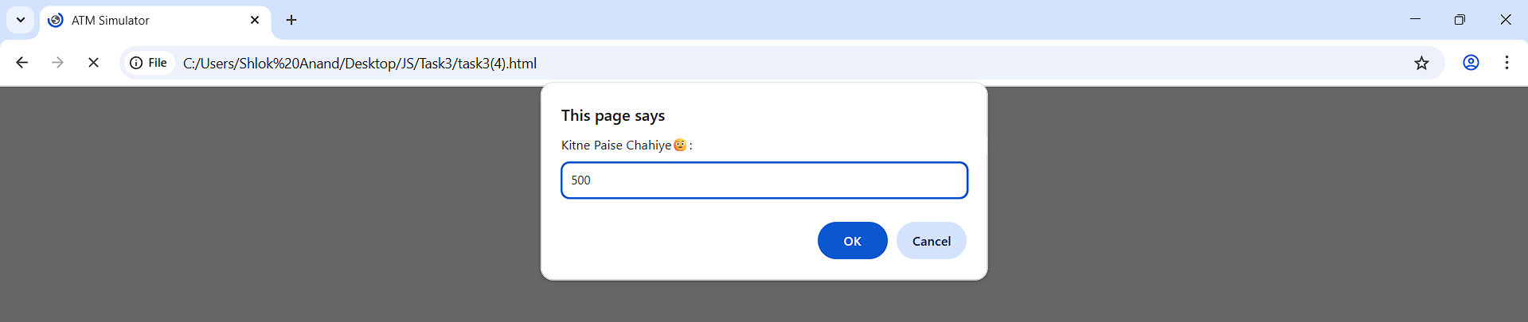

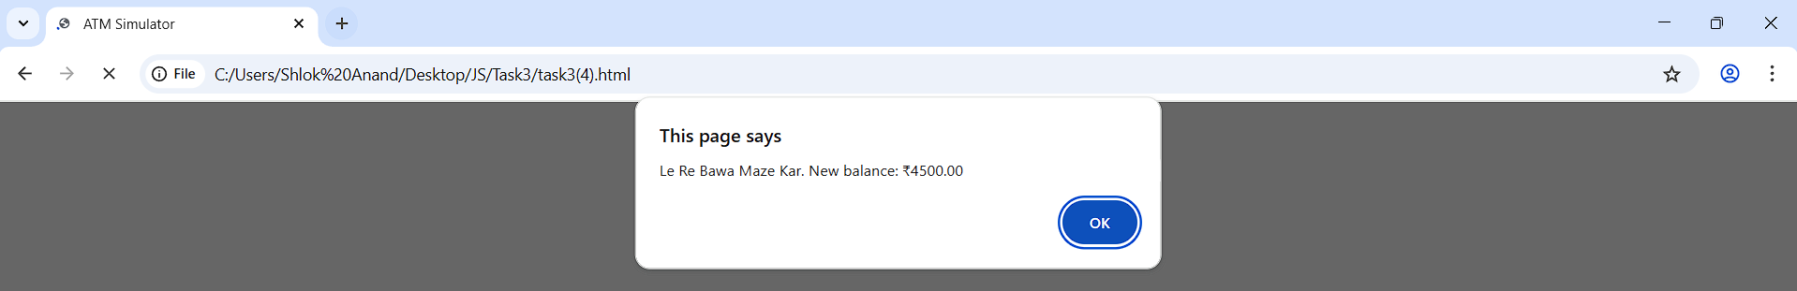

1. **AI Emotion Detector (Imperfect Inputs)**

**You are building an AI chatbot that reacts differently based on a user’s emotional state. But the only input you get is a vague sentiment score from -10 to +10, and a contextual keyword (e.g., &quot;tired&quot;, &quot;excited&quot;, &quot;confused&quot;).**

**Task: Write conditionals to determine the chatbot&#39;s response. But note:**

**● A sentiment score of 6 with the word &quot;tired&quot; is not clearly happy or**

**sad.**

**● Score -3 with &quot;confused&quot; might need empathy or redirection.**

**● Score 0 with no keyword: Unknown state—how will your bot decide?**

**Challenge: You must deal with conflicting or incomplete conditions.**

