SOFTWARE REQUIREMENT SPECIFICATION
FOR
Electronics Supply Chain Management System
Under the Subject of
Software Engineering
(Semester – I)

Submitted by
Khushi Shah (25002170210098)
Krushna Khetia (25002170210045)
Shlok Desai (25002170210023)

Ms. Nidhi Mehta
(Faculty Guide)

Dr. Meghna Parikh
(FY2-Head of Department)

Academic Year
2025-26


L. J. Institute of Engineering & Technology, Ahmedabad (LJU)

L. J. INSTITUTE OF ENGINEERING AND TECHNOLOGY
FY2-Department 2025–26

CERTIFICATE
Date:
This is to certify that the Software Engineering Work entitled “Elecrtonics Supply Chain Management System”, carried out by the group of students mentioned below under my guidance is approved for the Degree of Bachelor of Engineering (Semester-I) of L. J. Institute of Engineering and Technology (LJU) during the academic year 2025-26.

- Khushi Shah (25002170210098)
- Krushna Khetia (25002170210045)
- Shlok Desai (25002170210023)

Guide

Ms. Nidhi Mehta
FY2- Department, L.J.I.E.T.

Table of Contents

Sr. No. |  | Particulars | Page No.
1 |  | INTRODUCTION | 1
 | 1.1 | Purpose | 1
 | 1.2 | Scope | 1
 | 1.3 | Glossary | 2
 | 1.4 | Overview | 2
2 |  | OVERALL DESCRIPTION | 3
 | 2.1 | Problem Statement | 3
 | 2.2 | Existing System | 3
 | 2.3 | Proposed System | 4
 | 2.4 | Product Functions | 4
 | 2.5 | User Characteristics | 5
 |  | 2.5.1 User requirements | 5
 |  | 2.5.2 User Education Level | 5
 |  | 2.5.3 User’s Technical Expertise | 5
 | 2.6 | Constraints | 5
 | 2.7 | Assumption and Dependencies | 6
3 |  | REQUIREMENT SPECIFICATION | 7
 | 3.1 | Functional Requirements | 7
 |  | 3.1.1 Performance requirements | 7
 |  | 3.1.2 Design constraints | 7
 |  | 3.1.3 Hardware Requirements | 7
 |  | 3.1.4 Software Requirements | 7
 |  | 3.1.5 Other Requirement | 7
 | 3.2 | Non-Functional Requirements | 8
 |  | 3.2.1 Security | 8
 |  | 3.2.2 Reliability | 8
 |  | 3.2.3 Availability | 8
 |  | 3.2.4 Maintainability | 8
 |  | 3.2.5 Supportability | 8
4 |  | DIAGRAMS | 9
 | 4.1 | Use Case Diagram | 9
 | 4.2 | Data Flow Diagram | 10
 |  | 4.2.1 Level-0 DFD | 10
 |  | 4.2.2 Level-1 DFD | 11
 | 4.3 | 4.2.3 Level-2 DFD  Sequence Diagram | 12  13
 | 4.4 | Class Diagram | 14
 | 4.5 | State Diagram | 15
 | 4.6 | Activity Diagram | 16
5 |  | CONCLUSION | 17
6 |  | SCOPE OF THE PROJECT | 18

. INTRODUCTION

  - Purpose

The primary purpose of our project is to provide a robust, console-based software solution for managing the trading operations of a modern electronics retail business. This Software Requirement Specification (SRS) defines the functional and non-functional requirements for the system, which is designed to replace manual inventory tracking and billing with an automated, object-oriented approach.
The system aims to bridge the gap between inventory management (Admin side) and the purchasing experience (Customer side). It leverages core Software Engineering and Java programming concepts—specifically Inheritance, Polymorphism, Recursion, and Exception Handling—to create a stream-line workflow. The purpose extends to providing financial clarity through a "Deep Ledger" system that tracks every credit (sale) and debit (restock) to calculate real-time Net Profit or Loss.

1.2 Scope

The scope of the project encompasses the entire lifecycle of a retail transaction within a console environment.
Inclusions:
- Inventory Management: Real-time tracking of electronics (Smart Watches, TVs, PCs) using an inherited class structure (Item → Product).
- Admin Administration: A secured portal for system owners to monitor stock, update prices, and restock items via a unique "Split Supplier" logic.
- Customer Module: A browsing and purchasing interface that allows users to add items to a cart, inputs delivery details, and receives a generated invoice.
- Financial Reporting: A Ledger module that records transaction history and generates financial reports showing Total Sales, Total Stock Expense, and Net Profit/Loss.
- Logistics Logic: Automatic determination of delivery vehicles (Bike vs. Van) based on the physical size of items in the cart. (Also that is not compulsory, it can be manually overrided)
Exclusions:
- Graphical User Interface (GUI).
- Database connectivity (Data is volatile and stored in runtime structures like ArrayList can be more optimized using my SQL).
- Payment Gateway integration (Simulated via console inputs)
1.3 Glossary
Term | Definition
SRS | Software Requirement Specification.
Recursion | A programming technique used in the Main Menu to allow continuous navigation without standard loops.
Inheritance | The OOP mechanism used to derive the Product class from the Item class.
Ledger | A financial module recording all Debits and Credits(In flow and Out flow).
COD | Cash on Delivery.
Split Restock | A system feature allowing stock to be purchased from multiple suppliers, simultaneously selecting the best option available and comparing the price at which they are offering a product.
GST | Goods and Services Tax, calculated at 18% on the final bill.
Delivery charges | Charges applied when customer select for express delivery.

1.4 Overview
This document is organized to provide a detailed understanding of Electronics Supply Chain Management.
- Chapter 2 outlines the general description, analyzing the current manual problems and the proposed software solution.
- Chapter 3 details the specific Functional Requirements (what the code actually does) and Non-Functional Requirements (reliability, speed).
- Chapter 4 provides visual representations through Use Case and Data Flow Diagrams.
- Chapter 5 & 6 conclude the document with the project's impact and future scope.

2. OVERALL DESCRIPTION

2.1 Problem Statement
In the current retail landscape for electronics, many small-to-medium traders rely on manual bookkeeping or disjointed spreadsheet systems. This leads to several critical issues:
- Stock Mismatch: It is difficult to track when items like "Gaming PCs" or "LED TVs" run low, leading to lost sales.
- Pricing Errors: Manual billing often results in calculation errors regarding GST (18%) or delivery charges.
- Logistics Confusion: Deciding whether to send a small bike or a large van for delivery is often a guess, leading to fuel wastage.
- Financial Opacity: Owners do not know their immediate Net Profit or Loss without spending hours calculating receipts at the end of the month.

2.2 Existing System
The existing system is primarily Manual and Paper-based.
- Record Keeping: Transactions are written in physical ledger books.
- Inventory Check: Requires physical counting of items on shelves.
- Billing: Calculated using a calculator, receipts are handwritten.
- Supplier Management: Orders to suppliers are made via phone calls without a centralized record of cost prices.
Disadvantages:
- High probability of human error.
- Time-consuming customer checkout process.
- No security, anyone can read the physical ledger.
- Not a specific and ordered data on transactions and product inventory.

2.3 Proposed System
Our Project is a Java-based automation system designed to solve the below problems.
- Centralized Data: Uses ArrayList and Objects to store data centrally during the runtime session.
- Automated Logic:
  - Billing: Automatically adds 18% GST and calculates Delivery Charges based on item size (isLargeItem boolean).
  - Restocking: Alerts the admin when stock is < 5.
- Secure Access: The Admin Portal is protected by ID/Password (admin/1234).
- Profit Tracking: The system automatically debits money when stock is bought and credits money when items are sold.

2.4 Product Functions
The system is divided into two major functional modules:
A. Admin Portal Functions
- Authentication: Secure login using AdminCreds.
- Low Stock Alert: Scans inventory and displays items with quantities below 5.
- Split Restock System: Allows the admin to buy stock from three different suppliers (Alpha, Beta, Gamma) at varying rates to fulfill a total order quantity.
- Price Management: Capability to update the selling price of products dynamically.
- Deep Ledger Report: Generates a financial table showing Income vs. Expense and Net Profit.
B. Customer Portal Functions
- Registration: Captures Customer Name, Mobile (with 10-digit validation), and Address.
- Browsing: View product list with live stock status (e.g., "Out of Stock" or "5 Available").
- Cart Management: Add items to a cart; validation prevents adding more items than currently in stock.
- Dynamic Delivery:
  - If a large item (TV, PC) is in the cart -> Recommends "Van".
  - If only small items (Watch, Headphones) -> Recommends "Bike".
- Invoicing: Generates a detailed console receipt with Order ID, GST, Delivery Charge, and Grand Total.

2. 5 User Characteristics

2.5.1 User Requirements
- Admin: Requires a desktop/laptop with the Java Runtime Environment (JRE) installed. They need access to supplier rates and authority to set selling prices.
- Customer: Requires no specific technical gear as they operate the system under the guidance of the store terminal, or as a simulated user in this console application.

2.5.2 User Education Level
- Admin: Should understand basic retail concepts (Profit/Loss, Stocking) and keyboard navigation.
- Customer: Basic literacy to read product names and prices.

2.5.3 User’s Technical Expertise
The system is designed to be user-friendly. No coding knowledge is required to operate it. The menu uses simple integer inputs (1, 2, 3) to navigate, making it accessible to users with low technical expertise.

2.6 Constraints
- Memory Volatility: As this is a core Java project without a database, all data (sales, stock updates) is lost when the program creates an exit.
- Interface: The interface is strictly Command Line Interface (CLI). There are no mouse clicks or graphics.
- Single Session: The system is designed for a single point-of-sale terminal usage.

2.7 Assumption and Dependencies
- Assumption: The user enters valid integer inputs when requested (though try-catch blocks are implemented for basic error handling).
- Assumption: The currency is strictly in INR (Indian Rupees).
- Dependency: The system depends on the java.util.Scanner class for inputs and java.time for timestamp generation.

3. REQUIREMENT SPECIFICATION

3.1 Functional Requirements
3.1.1 Performance requirements
- Response Time: The system must respond to user inputs (menu selections) instantly (under 1 second).
- Calculation Precision: Financial calculations (GST, Profit) must be accurate to two decimal places using double precision.
- Recursion handling: The showMainMenu() recursive method must handle deep navigation without causing a StackOverflow error during typical usage scenarios.
3.1.2 Design constraints
- OOP Strictness: The system must utilize Inheritance. The Product class must extend the Item class.
- Method Overriding: The display() method must be defined in the parent class and overridden in the child class to show stock status.
- Code Structure: All input logic must be handled via the Utils static class to maintain clean code.
3.1.3 Hardware Requirements
- Processor: Intel Core i3 or higher (or equivalent AMD).
- RAM: Minimum 4GB (to run JVM smoothly).
- Storage: Minimal (<10MB) for the .class files.
- Input Device: Standard Keyboard.
3.1.4 Software Requirements
- Operating System: Windows 10/11, Linux, or macOS.
- Language: Java (JDK 8 or higher).
- Compiler: Javac.
- Execution Environment: Java Runtime Environment (JRE).
3.1.5 Other Requirement
- Mobile Validation: The system must enforce that mobile numbers are exactly 10 digits and contain only numeric characters.
- Order ID Generation: Unique Order IDs must be generated using the logic: First Letter of Name + - + Last 4 digits of Mobile (e.g., "A-9898").

3.2 Non-Functional Requirements
3.2.1 Security
- Access Control: The Admin Portal is gated. Users cannot access financial data or stock controls without the correct ID (admin) and Password (1234).
- Input Sanitization: The system prevents the entry of non-numeric characters in fields like "Mobile Number" to prevent data corruption.
3.2.2 Reliability
- Exception Handling: The system wraps critical input sections (like the Main Menu selection) in try-catch blocks. If a user enters a String instead of an Integer, the system catches the error and recursively reloads the menu instead of crashing.
3.2.3 Availability
- The system is available 24/7 as long as the hosting machine is powered on. Since it is a local console application, it does not rely on internet connectivity.
3.2.4 Maintainability
- Modular Code: The code is separated into distinct classes (AdminPortal, Ledger, TechnoTrader). This makes it easy to update the "Tax Rate" or "Supplier Logic" without breaking the Customer flow.
- Scalability: The ArrayList<Transaction> used in the Ledger allows for thousands of entries to be added dynamically.
3.2.5 Supportability
- The system includes self-explanatory error messages (e.g., "Invalid ID," "Not enough stock") to guide the user without needing external support.

4.1 USE CASE DIAGRAM

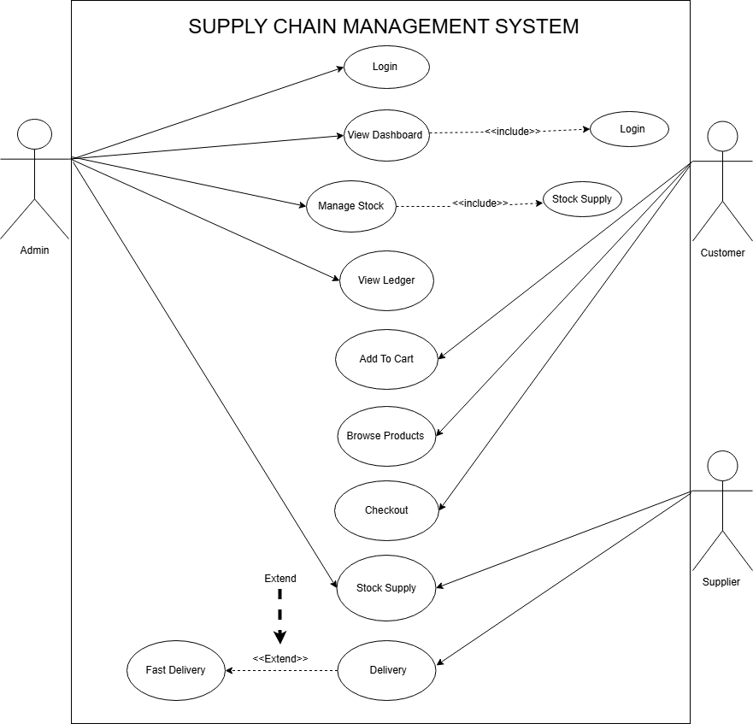

4.2 Data Flow Diagram

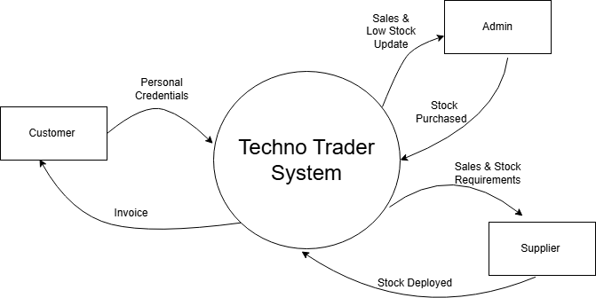
4.2.1 Level-0 DFD

4.2.2 Level-1 DFD

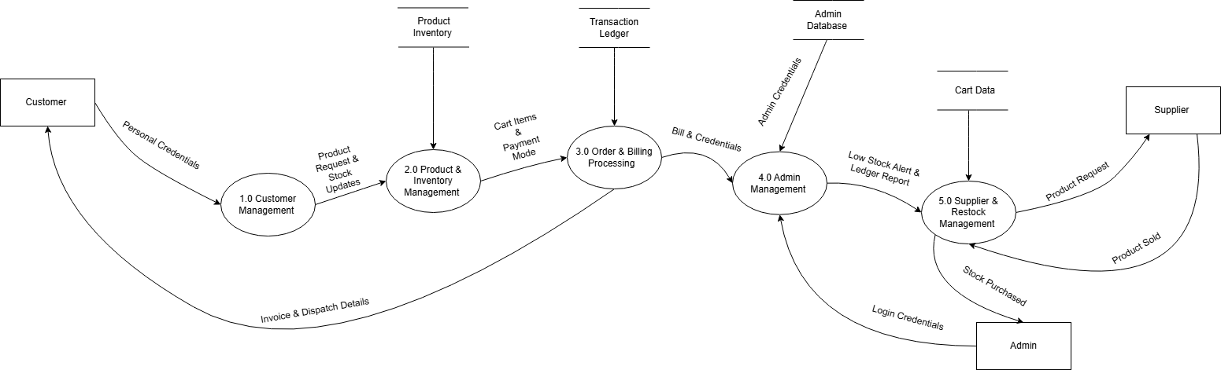

4.2.3 Level-2 DFD

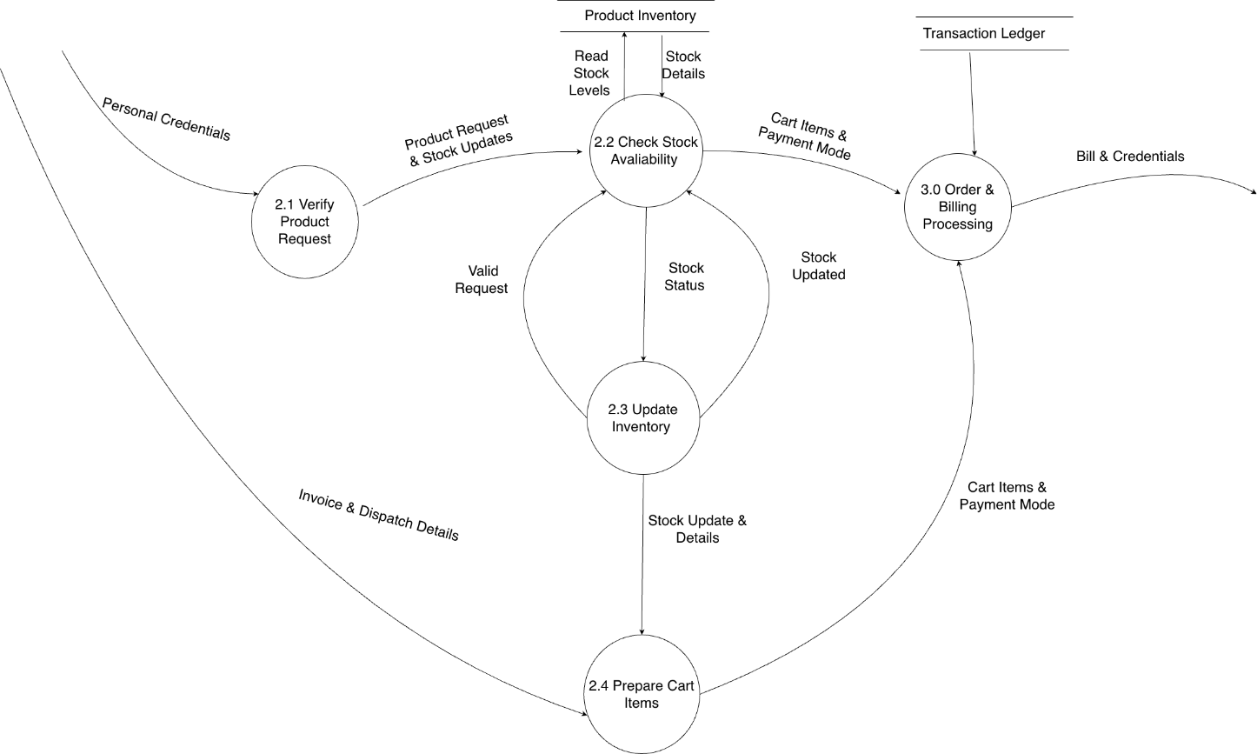

4.3 Sequence Diagram

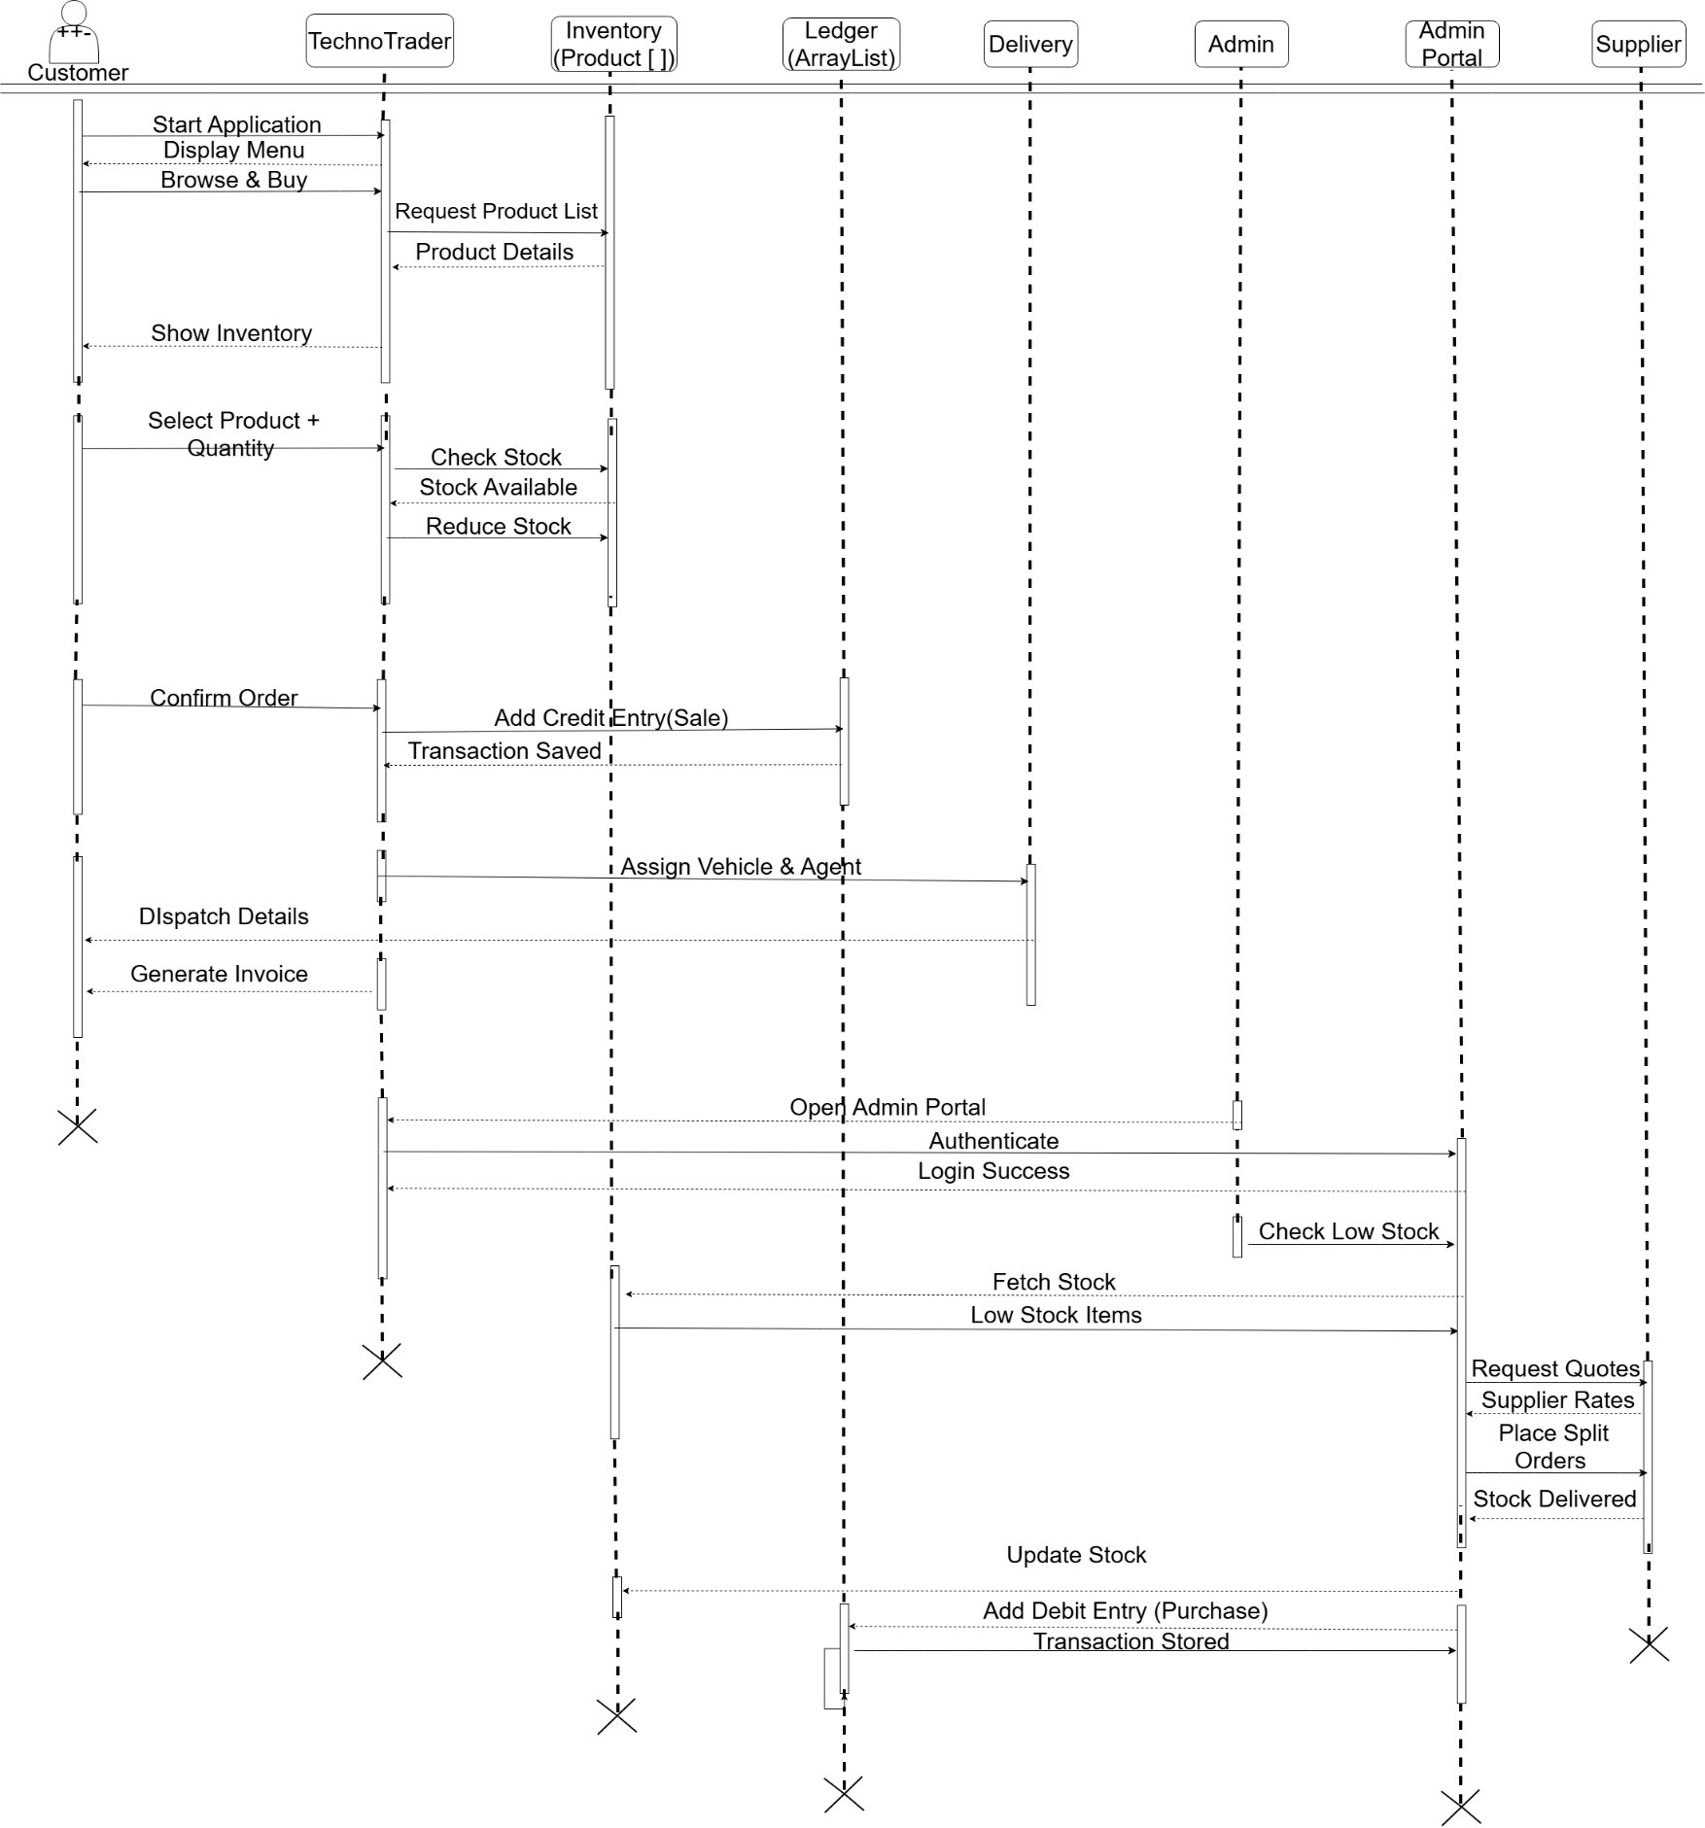

4.4 Class Diagram
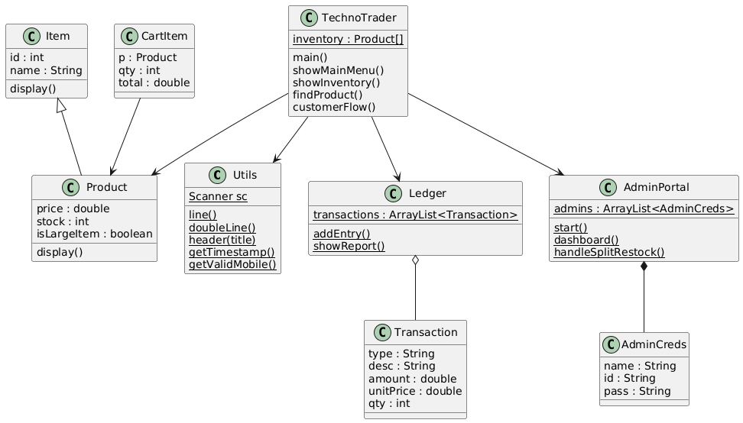

4.5 State Diagram

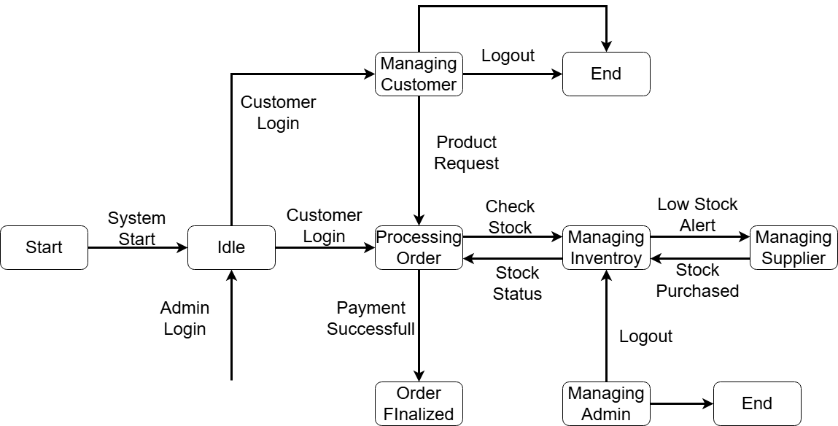

4.6 Activity Diagram
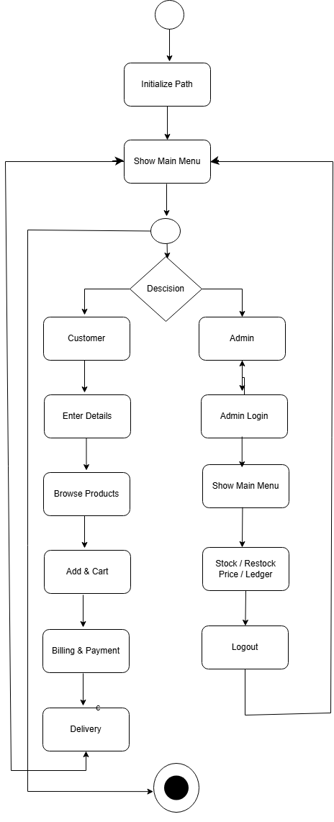

5. CONCLUSION

The ‘Electronics Supply Chain Managenment SYSTEM’ project successfully demonstrates the application of Software Engineering principles and Advanced Java concepts to address real-world retail challenges. By transitioning from a manual system to this automated console application, the project achieves significant improvements in accuracy by eliminating manual calculation errors in billing and tax computation. Furthermore, operational efficiency is enhanced through the unique "Split Restock" system, which optimizes supplier purchasing, and the "Deep Ledger," which provides an instant financial overview. The underlying software structure leverages Inheritance (Item and Product) and Polymorphism (via overridden display() methods) to ensure the codebase remains clean, reusable, and easy to maintain. Ultimately, the system meets all defined functional requirements for handling customer transactions and administrative duties within a CLI environment, serving as a robust foundation for future enterprise-level applications.

SCOPE OF THE PROJECT

While the current version of Techno Trader is a fully functional prototype, the scope for future enhancement is vast:
- Database Integration: Currently, data is volatile. Future versions will integrate MySQL or SQLite to persist inventory and sales data permanently.
- GUI Implementation: The console interface can be replaced with a JavaFX or Swing interface to provide a visual, point-and-click experience for the user.
- Multi-User Network: Implementing socket programming to allow multiple counters (Clients) to connect to a central server (Admin).
- Advanced Analytics: The Ledger can be upgraded to show graphs and visual trends of sales over time.
- Payment Gateway: Integration with real-world APIs to accept Credit Cards and UPI payments actually, rather than just recording the mode of payment.
This project lays the groundwork for these advanced features, proving the core logic is sound and ready for expansion.

