upper_tabs:

# Tabs left of dropdown menu

- include: /_upper_tabs_left.yaml

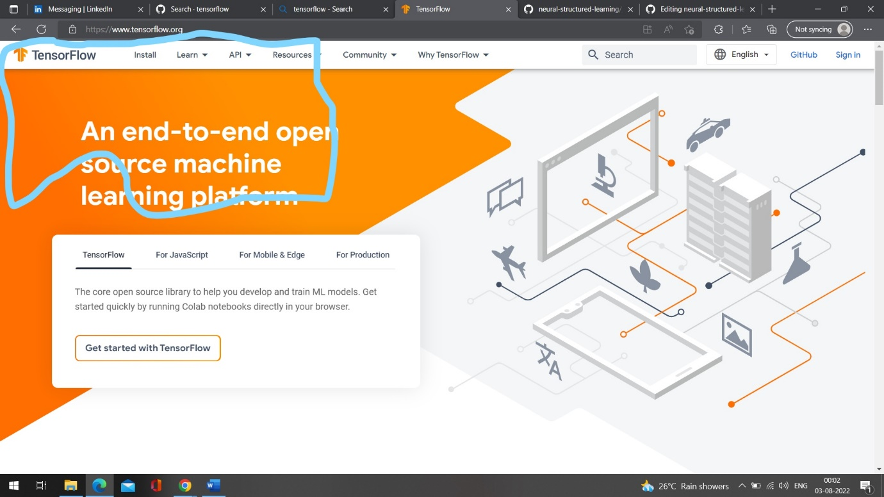

- include: /api_docs/_upper_tabs_api.yaml

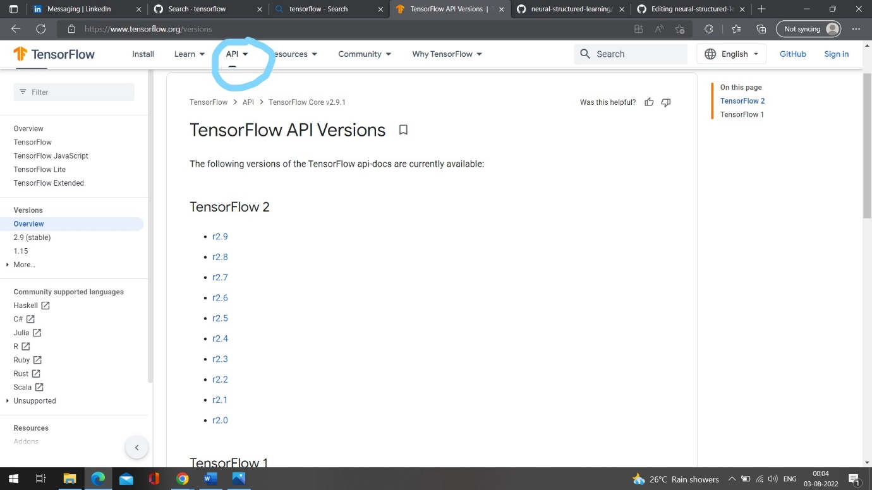

# Dropdown menu

- name: Resources

path: /resources

is_default: true

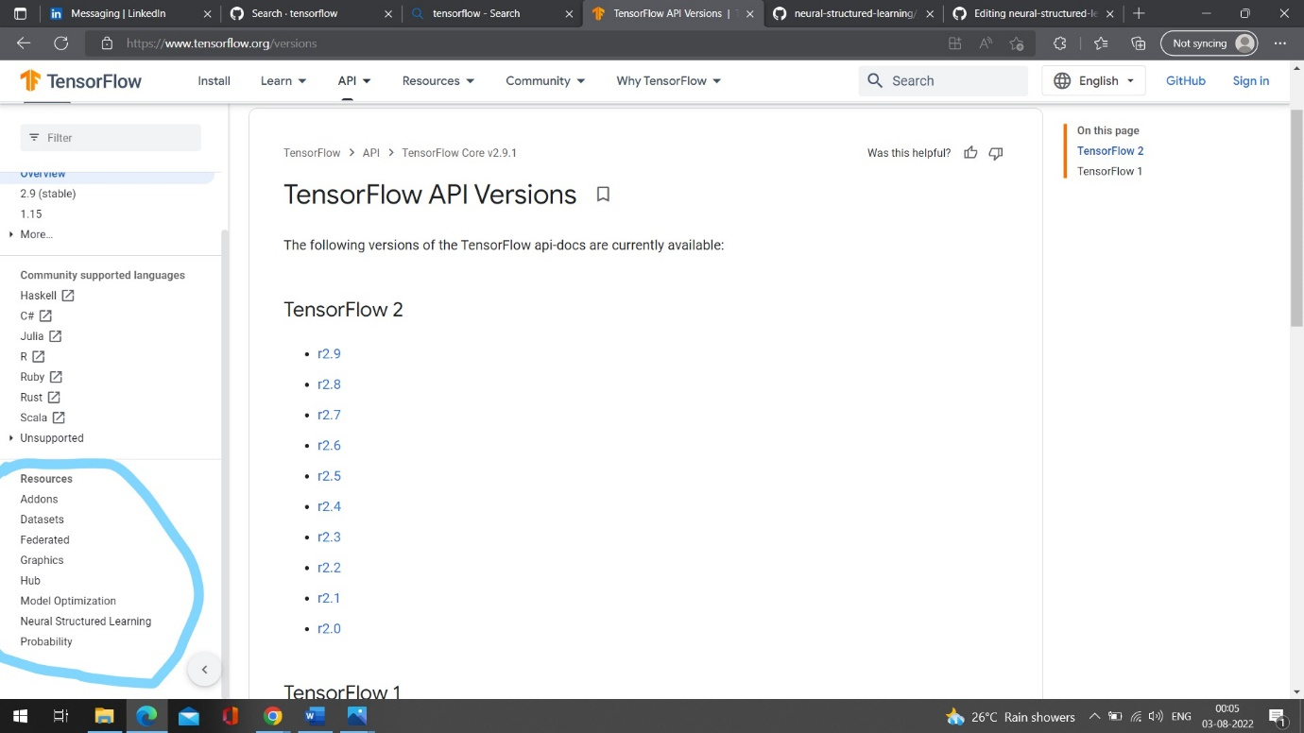

menu:

- include: /resources/_menu_toc.yaml

lower_tabs:

# Subsite tabs

other:

- name: Guide & Tutorials

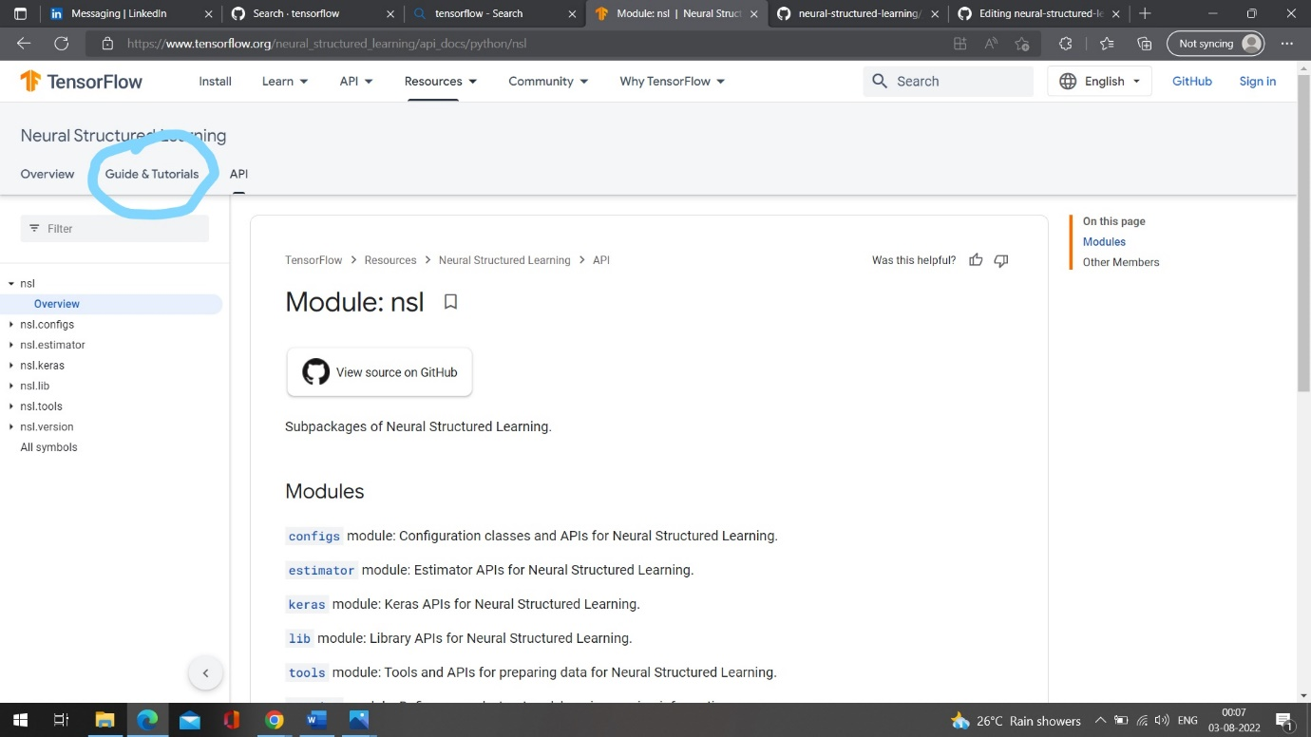

contents:

- title: Framework

path: /neural_structured_learning/framework

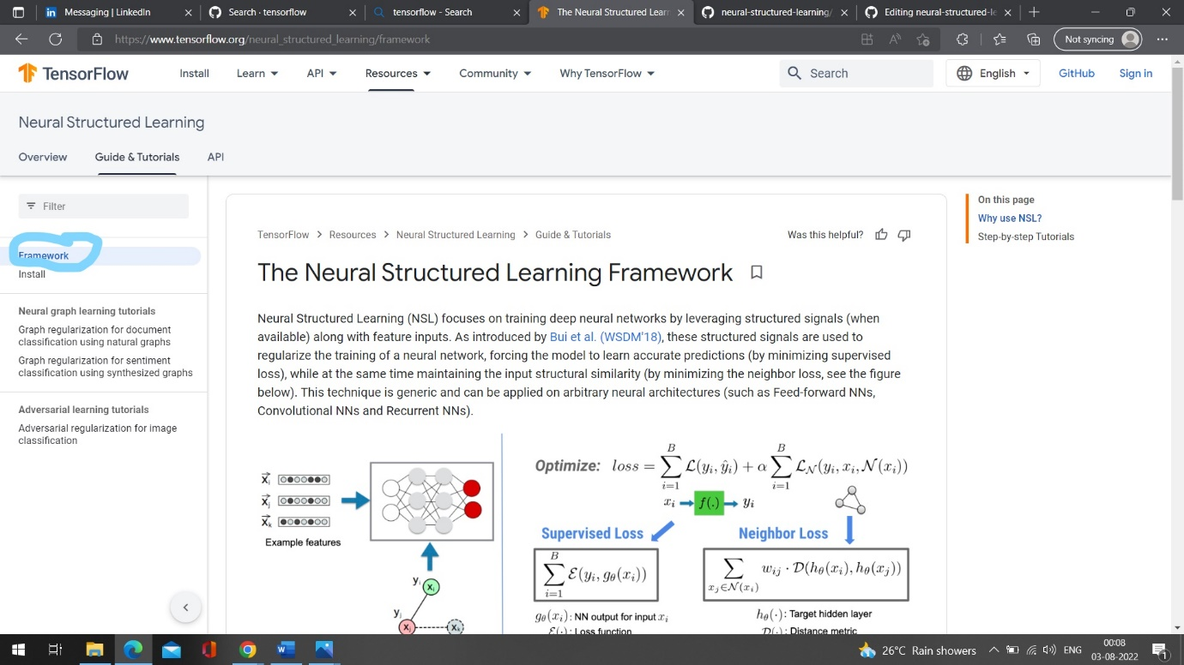

- title: Install

path: /neural_structured_learning/install

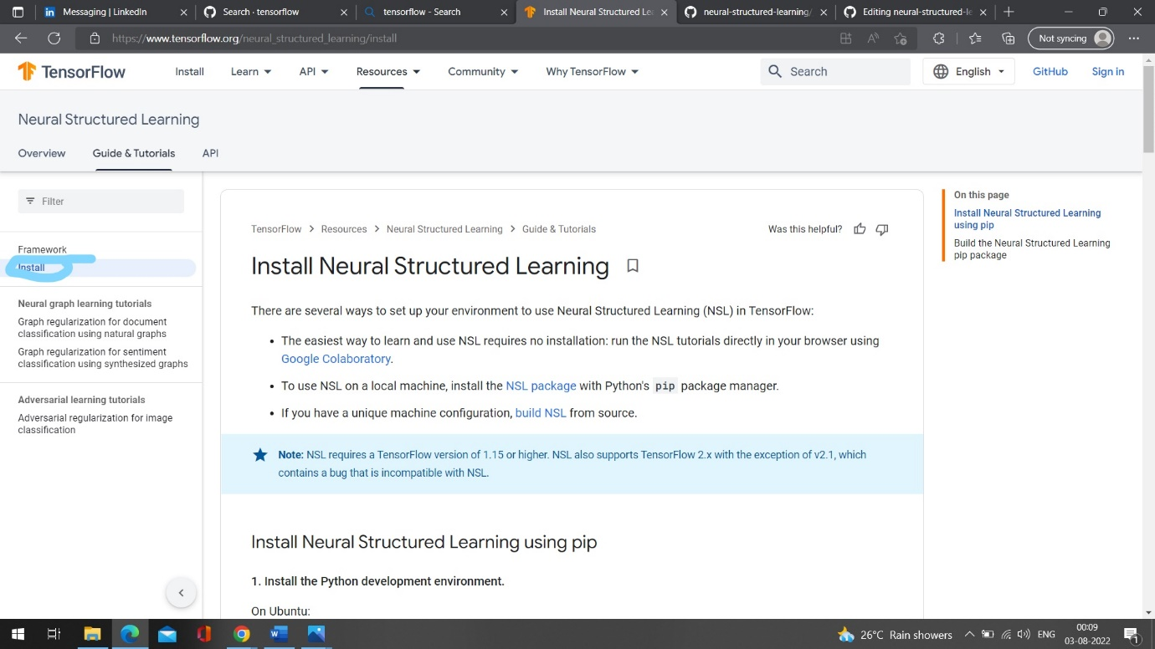

- heading: Neural graph learning tutorials

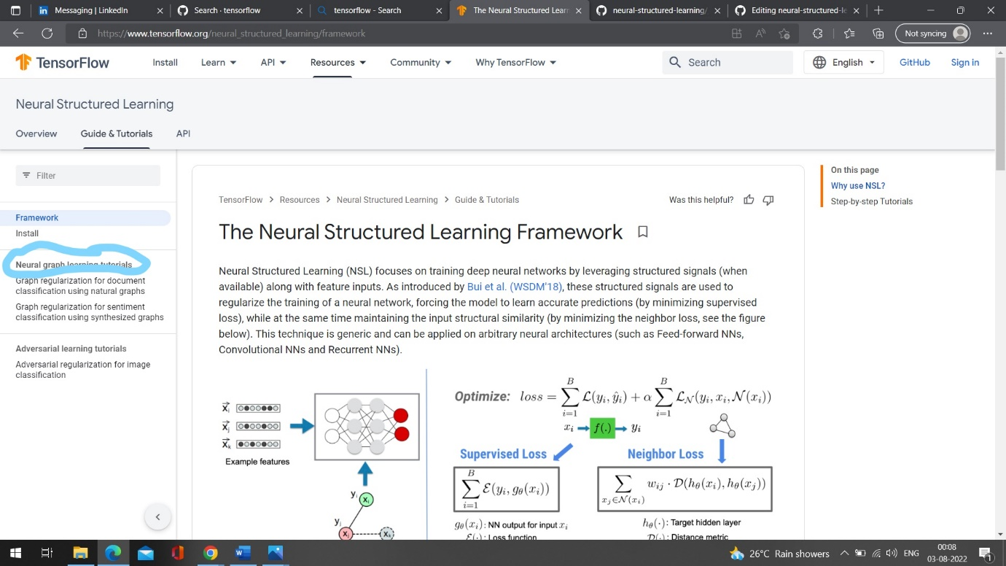

- title: Graph regularization for document classification using natural graphs

path: /neural_structured_learning/tutorials/graph_keras_mlp_cora

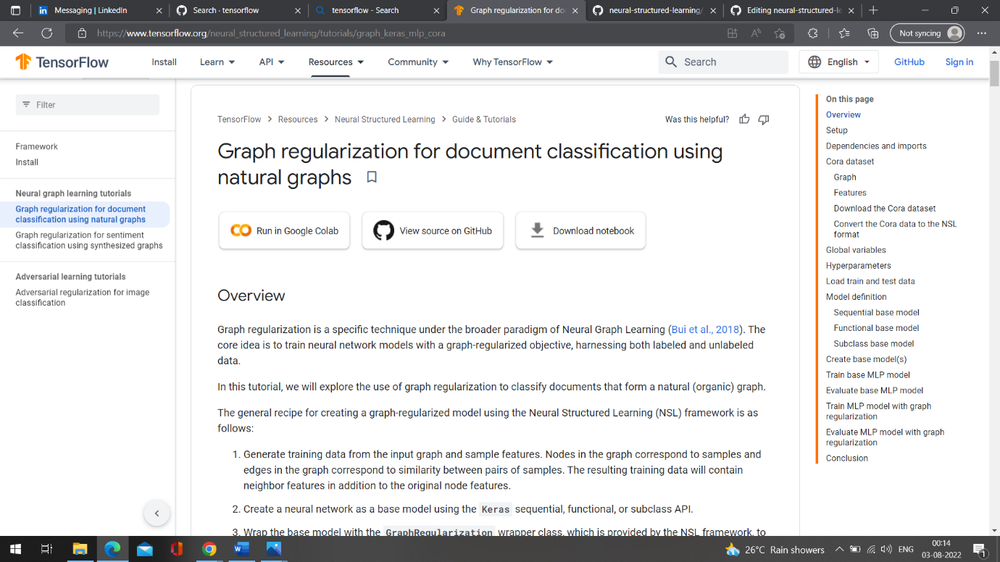

- title: Graph regularization for sentiment classification using synthesized graphs

path: /neural_structured_learning/tutorials/graph_keras_lstm_imdb

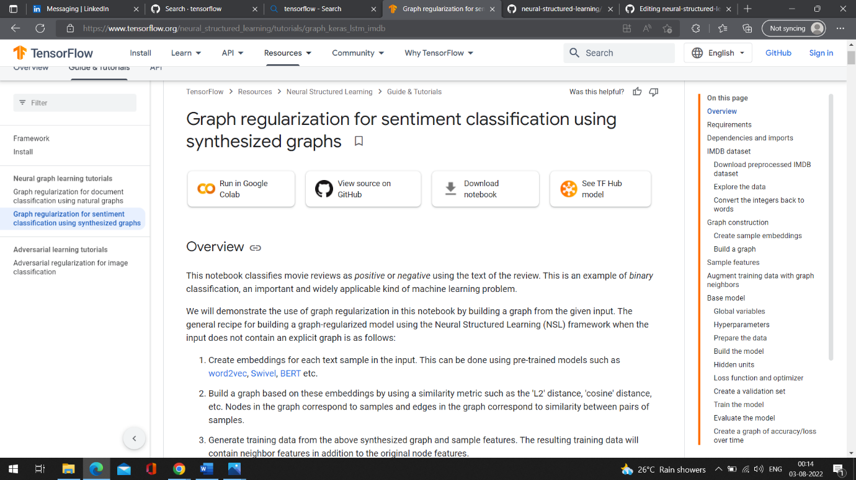

- heading: Adversarial learning tutorials

- title: Adversarial regularization for image classification

path: /neural_structured_learning/tutorials/adversarial_keras_cnn_mnist

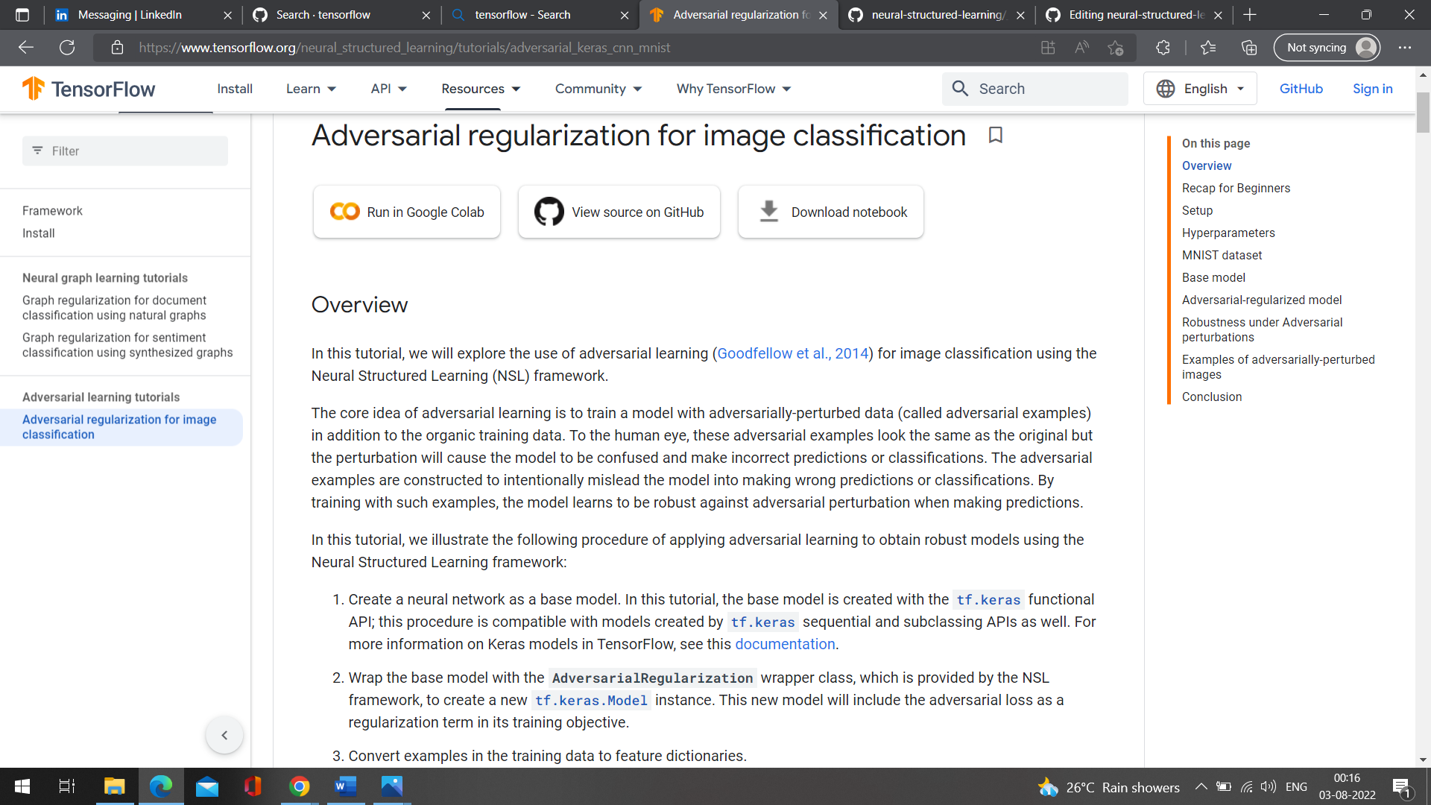

- name: API

skip_translation: true

contents:

- include: /neural_structured_learning/api_docs/python/nsl/_toc.yaml

- title: All symbols

path: /neural_structured_learning/api_docs/python/nsl/all_symbols

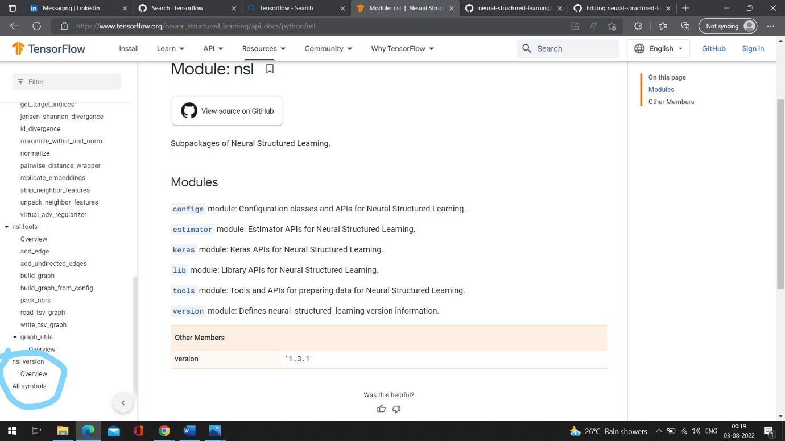

- include: /_upper_tabs_right.yaml