"""Configuration classes and APIs for Neural Structured Learning."""

from neural_structured_learning.configs.configs import AdvNeighborConfig

from neural_structured_learning.configs.configs import AdvRegConfig

from neural_structured_learning.configs.configs import AdvTargetConfig

from neural_structured_learning.configs.configs import AdvTargetType

from neural_structured_learning.configs.configs import DecayConfig

from neural_structured_learning.configs.configs import DecayType

from neural_structured_learning.configs.configs import DEFAULT_ADVERSARIAL_PARAMS

from neural_structured_learning.configs.configs import DEFAULT_DISTANCE_PARAMS

from neural_structured_learning.configs.configs import DistanceConfig

from neural_structured_learning.configs.configs import DistanceType

from neural_structured_learning.configs.configs import GraphBuilderConfig

from neural_structured_learning.configs.configs import GraphNeighborConfig

from neural_structured_learning.configs.configs import GraphRegConfig

from neural_structured_learning.configs.configs import IntegrationConfig

from neural_structured_learning.configs.configs import IntegrationType

from neural_structured_learning.configs.configs import make_adv_reg_config

from neural_structured_learning.configs.configs import make_graph_reg_config

from neural_structured_learning.configs.configs import NormType

from neural_structured_learning.configs.configs import TransformType

from neural_structured_learning.configs.configs import VirtualAdvConfig

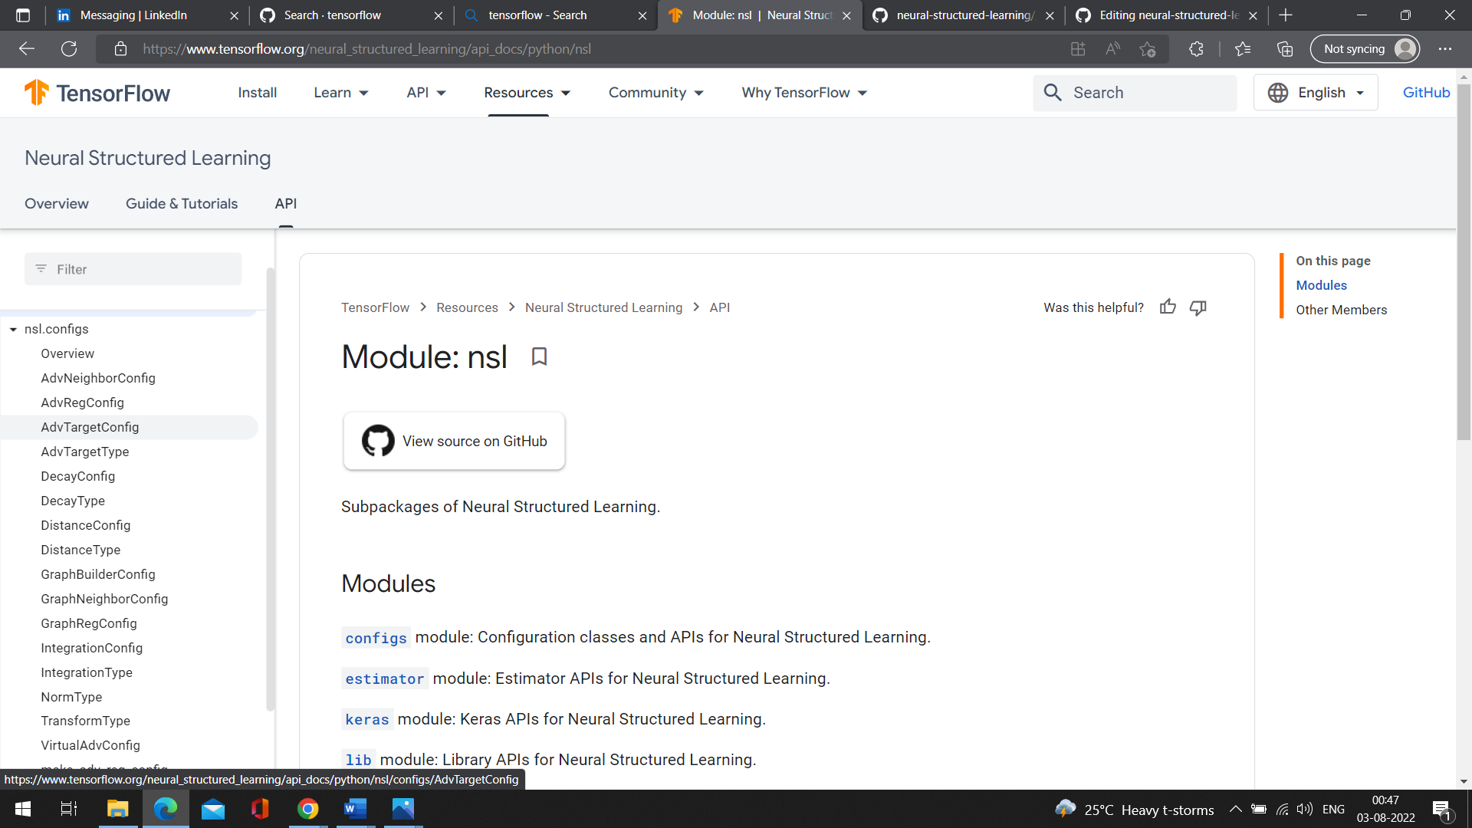

__all__ = [

'AdvNeighborConfig',

'AdvRegConfig',

'AdvTargetConfig',

'AdvTargetType',

'DecayConfig',

'DecayType',

'DEFAULT_ADVERSARIAL_PARAMS',

'DEFAULT_DISTANCE_PARAMS',

'DistanceConfig',

'DistanceType',

'GraphBuilderConfig',

'GraphNeighborConfig',

'GraphRegConfig',

'IntegrationConfig',

'IntegrationType',

'make_adv_reg_config',

'make_graph_reg_config',

'NormType',

'TransformType',

'VirtualAdvConfig',

]