EarthLENS: Earth Observation & Environmental Intelligence Platform

1. Project Overview & Scope

1.1 Problem Statement
Environmental monitoring organizations, urban planners, and agricultural analysts face significant friction when analyzing planetary-scale satellite observations. Traditional Geographic Information Systems (GIS) software suites are computationally heavy, require steep learning curves, and lack interactive web-first dashboards for instant, real-time calculation of multispectral indices.
Analysts are forced to manually download large raw satellite raster files, process multi-band GeoTIFF files across desktop workstations, and calculate indices such as the Normalized Difference Vegetation Index (NDVI) and Normalized Difference Water Index (NDWI) in siloed workflows. Furthermore, existing open-access mapping solutions suffer from visual state re-render bottlenecks, lack synchronized split-screen comparison tools for evaluating land-use changes, fail to provide automated dynamic threshold alerts for canopy degradation, and offer limited automated PDF dossier generation for field operations.

1.2 Objectives
The primary objectives of the EarthLENS Platform are to:
- 1.2.1 Automate Area of Interest (AOI) Ingestion & Vector Tracing: Design and implement a vector canvas supporting preset coordinates, custom latitude/longitude inputs, and freehand polygon/bounding-box drawing to define target operational bounds.
- 1.2.2 Enable Synchronized Split-Screen Comparison: Provide a real-time vertical swipe curtain (SideBySideLayers) to inspect True-Color Satellite RGB imagery alongside computed spectral heatmaps simultaneously.
- 1.2.3 Compute Real-Time Zonal Area & Acreage: Implement a geometric engine that transforms degree-based vector coordinates into spherical ground metrics (${\text{km}}^{2}$ and acres) using latitude cosine scaling to eliminate geographic projection distortions.
- 1.2.4 Execute On-the-Fly Multispectral Index Math: Calculate pixel-level mathematical indices for canopy density (NDVI) and surface water saturation (NDWI) dynamically across user-selected geographic bounds.
- 1.2.5 Provide Automated Anomaly Detection & Threshold Alerting: Establish a dynamic threshold evaluation engine that flags critical canopy loss and ecological degradation with visual alert badges based on customizable sensitivity parameters.
- 1.2.6 Generate 12-Month Temporal Trend Analytics: Integrate interactive time-series charts using Plotly and month-end (ME) frequency offsets to evaluate seasonal vegetation cycles against historical averages.
- 1.2.7 Automate Vector Serialization & Document Dossier Assembly: Build an automated export pipeline that serializes custom geometries to standard .geojson and .csv formats, while compiling an executive vector PDF summary report via an in-memory buffer engine.
- 1.2.8 Facilitate Cloud-Native Satellite STAC Integration: Establish an open-access satellite querying architecture utilizing the Microsoft Planetary Computer SpatioTemporal Asset Catalog (STAC) API to filter optical imagery below specified cloud cover thresholds.

1.3 Scope
Users of the System:
- Environmental & Forestry Analyst: Traces forest parcels, tracks seasonal canopy degradation, and monitors illegal deforestation.
- Agricultural & Irrigation Specialist: Assesses crop health, water table fluctuations, and vegetation stress indices across localized agricultural zones.
- Urban Planning & Disaster Authority: Uses split-screen swipe comparisons to assess urban sprawl, flood inundation zones, and post-disaster terrain shifts.
Current Scope (Phase 1):
- Interactive Folium and Esri World Imagery multi-layer basemap engine.
- Leaflet Vector Drawing tools for custom AOI polygon extraction.
- Split-screen swipe curtain comparison widget.
- Mathematical area conversion engine (${\text{km}}^{2}$ and acres) with latitude distortion correction.
- Real-time dynamic NDVI/NDWI zonal statistical modeling.
- Dynamic threshold-based canopy degradation alert badging.
- Interactive 12-month historical time-series analytics (Plotly).
- Multi-format data export engine (GeoJSON vector data, CSV metrics, and automated ReportLab PDF reports).
- State-loop suppression eliminating UI reload flickering in Streamlit.
Future Scope (Later Phases):
- Machine learning-based Land-Use/Land-Cover (LULC) multi-class segmentation (UNet/Random Forest).
- Multi-sensor Synthetic Aperture Radar (Sentinel-1 SAR) integration for all-weather, cloud-penetrating radar analysis.
- Automated satellite timelapse generation (GIF/MP4 video generation across multi-year epochs).
- Multi-region head-to-head comparative spatial dashboard.

1.4 Development Methodology / Process Planning
The EarthLENS platform is developed using the Agile Software Development Model. The project progresses through iterative sprints, enabling continuous unit testing of geospatial algorithms, rapid UI optimization, and incremental architectural expansions.
Iteration | Sprint Focus | Delivered Features / Architectural Modules
Iteration 1 | Core UI & Geospatial Base | Streamlit dashboard scaffolding, Esri World Imagery basemap integration, preset coordinate loaders.
Iteration 2 | Split-Screen Comparison | Dual-tile layer synchronization, SideBySideLayers swipe widget integration, state management.
Iteration 3 | Vector Geometry Engine | folium.plugins.Draw integration, GeoJSON vertex parsing, Shapely spherical area calculation (${\text{km}}^{2}$/acres).
Iteration 4 | Spectral Index Engine | NDVI and NDWI computation modules, colormap overlay generation, zonal statistics extraction.
Iteration 5 | Alerting & Time-Series | Anomaly threshold evaluation, reactive UI alert badges, 12-month Plotly trend line chart with ME frequency offsets.
Iteration 6 | Reporting & Export | In-memory ReportLab PDF report compilation, CSV summary exports, GeoJSON vector file serialization.
Iteration 7 | Integration & Performance | Streamlit-Folium returned_objects event filtering, memory profiling, live STAC API pipeline integration.

2. Phase 2 – Requirement Analysis

Functional Requirements
Module I: AOI & Coordinate Management
- FR-01 (Preset Selection): The system shall allow users to select from predefined regional anchors (e.g., New York, Agricultural Basins, Dense Forest Reserves) with automated viewport re-centering.
- FR-02 (Custom Coordinate Ingestion): The system shall accept custom decimal latitude and longitude coordinates and re-center the operational viewport.
- FR-03 (Vector Drawing Canvas): The system shall provide interactive on-screen drawing tools enabling users to draw custom polygons and bounding boxes.
- FR-04 (Spherical Area Calculation): The system shall convert drawn degree coordinates into physical surface area measurements (${\text{km}}^{2}$ and acres) scaled for latitude distortion.
Module II: Geospatial Rendering & Swipe Engine
- FR-05 (Multi-Layer Basemaps): The system shall provide switchable high-resolution satellite imagery (Esri World Imagery) and street cartography (OpenStreetMap).
- FR-06 (Split-Screen Comparison): The system shall provide an interactive vertical swipe slider to visually cross-examine RGB imagery against computed index layers simultaneously.
- FR-07 (Event Loop Suppression): The system shall isolate UI redraw events to vector updates, preventing continuous camera panning from triggering script re-runs.
Module III: Analytics, Anomaly & Time-Series Engine
- FR-08 (Multispectral Index Computation): The system shall calculate mean, minimum, and maximum values for NDVI and NDWI.
- FR-09 (Dynamic Anomaly Thresholding): The system shall allow users to set an NDVI minimum health threshold slider (range: $-1.0$ to $+1.0$).
- FR-10 (Alert Badging): The system shall evaluate active mean scores against user thresholds, displaying a Healthy Canopy status (green) or a Degradation Alert (red).
- FR-11 (Temporal Time-Series): The system shall generate a rolling 12-month Plotly trend curve utilizing Month-End (ME) date ranges.
Module IV: Export, PDF & Reporting System
- FR-12 (Vector GeoJSON Export): The system shall serialize user-drawn polygon coordinates into standard .geojson files for GIS export.
- FR-13 (Tabular CSV Metrics): The system shall export numerical index statistics, surface area calculations, and coordinate bounds to .csv.
- FR-14 (Automated PDF Dossier): The system shall generate an in-memory PDF intelligence dossier containing executive summary tables, geometric area breakdowns, and anomaly alerts.

3. Phase 3 – System Design & Modeling

3.1 Use Case Diagram

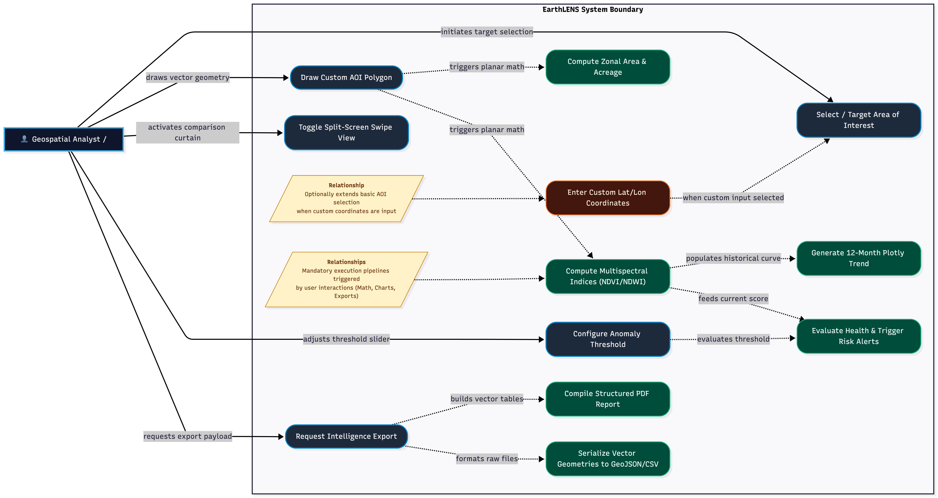

3.2 Activity Diagram

