PROJECT REPORT
E-Commerce Database Management System
Using Qdrant Vector Database
A Hybrid Relational-Vector Architecture for High-Precision Semantic Product Discovery

Name:- Shloke Singha Roy
Reg No:- 25BCE1576
Course: Database Technology & Advanced Information Systems
Assessment: Practical Laboratory Mini-Project
Primary Database: SQLite 3 (Relational ACID Engine)
Specialized Database: Qdrant Vector Database (Cosine Metric, 384d)
Embedding Model: sentence-transformers/all-MiniLM-L6-v2
Backend Framework: Python / Flask
Submission Date: October 2026

1. Abstract
Modern electronic commerce platforms face a critical challenge in product discovery: traditional relational databases excel at structured transactional operations (ACID compliance, referential integrity, and exact pricing/inventory management), yet struggle significantly with natural-language user queries. Lexical keyword matching (such as SQL LIKE '%keyword%') fails when shoppers describe intents, use synonyms, or express abstract requirements (e.g., 'affordable headphones for travelling'). This project presents a functional, cohesive mini-project architecture that unites a primary relational database (SQLite 3) with a specialized vector database (Qdrant). A lightweight transformer embedding model (sentence-transformers/all-MiniLM-L6-v2) converts product names and descriptions into 384-dimensional dense semantic vectors. Qdrant performs Approximate Nearest Neighbor (ANN) search via Cosine distance with metadata category filtering, after which current authoritative product records are hydrated from SQLite. The resulting system delivers high-precision semantic retrieval alongside transactional data integrity, verified through an automated test suite and demonstrated via an interactive web interface.
2. Introduction
Database architectures have historically been divided into relational management systems (RDBMS) for transactional reliability and document stores for semi-structured text. With the rapid evolution of deep transformer neural networks, dense vector embeddings have emerged as the premier representation for semantic meaning in natural language. In an e-commerce context, a customer rarely searches using the exact canonical SKU title; instead, they express descriptive needs, such as 'comfortable shoes for running' or 'books suitable for learning programming'.
To resolve this dichotomy, this mini-project implements a hybrid database system. SQLite acts as the authoritative source of truth for product entities, prices, categories, and customer orders. Qdrant operates alongside SQLite as an indexed vector retrieval engine. This dual-database pattern demonstrates how modern software engineers integrate specialized vector indices into existing enterprise relational data pipelines without sacrificing transactional safety or relational normalization.
3. Problem Statement
In a conventional relational e-commerce catalogue, search functionality is implemented using SQL string matching:
SELECT * FROM Products WHERE product_name LIKE '%headphones%' OR description LIKE '%headphones%';

This approach exhibits four severe limitations:
1. Lexical Vocabulary Mismatch: The query 'affordable headphones for travelling' yields zero results if the product description uses terms like 'compact wireless earphones for frequent flyers'.
2. Absence of Semantic Relevance Scoring: Standard SQL LIKE operators return binary matches (true/false) with no ranking metric.
3. Computational Inefficiency: Leading wildcard queries (%keyword%) invalidate B-Tree indices, forcing complete sequential table scans.
4. Intent Disconnection: Conventional systems cannot interpret colloquial queries, contextual attributes, or intent qualifiers.
4. Objectives
The primary engineering objectives of this project are:
• Design and implement a normalized SQLite relational schema enforcing referential integrity across Products, Categories, Orders, and Order_Items.
• Deploy and configure a local Qdrant Vector Database instance running under Docker containerization with persistent volume storage.
• Integrate the 384-dimensional sentence-transformers/all-MiniLM-L6-v2 embedding model to encode product records into dense vectors.
• Establish an idempotent dual-write synchronization pattern where CRUD operations on SQLite automatically update Qdrant.
• Implement semantic similarity search with payload metadata filtering and exact cosine similarity score reporting.
• Build a clean, responsive single-page catalogue interface enabling live side-by-side comparison of Semantic AI vs Keyword Search.
• Validate system reliability through automated unit testing and formal lab demonstration scripts.
5. Software and Hardware Requirements
Category | Component | Specification / Version
Software | Operating System | Microsoft Windows 10/11 (or Linux / macOS)
Software | Runtime Environment | Python 3.11+
Software | Container Platform | Docker Desktop 29+ & Docker Compose v5+
Software | Primary Database | SQLite 3 (Built into Python standard library)
Software | Vector Database | Qdrant Docker Engine (v1.19+ / latest)
Software | Web Backend | Flask 3.1+ (Python WSGI)
Software | AI Model | sentence-transformers/all-MiniLM-L6-v2 (PyTorch)
Software | Client Libraries | qdrant-client 1.19+, requests, python-docx
Hardware | Processor | Dual-Core x86_64 CPU (Intel Core i3/i5/i7 or AMD Ryzen)
Hardware | Memory (RAM) | 4 GB minimum (8 GB recommended for local embedding model)
Hardware | Storage | 500 MB free disk space for Docker image and weights

6. System Architecture
The application employs a decoupled, multi-tier architecture partitioned into presentation, application, and persistence layers. The architecture enforces strict role separation between SQLite and Qdrant:
+-----------------------------------------------------------------------+
| PRESENTATION LAYER (HTML5 / CSS3 / JS) |
| - Product Catalogue UI - Dual-Search Tabs (Semantic vs Keyword) |
| - Product CRUD Modals - Real-time Qdrant Status & Stats Drawer |
+-----------------------------------+-----------------------------------+
| HTTP REST / JSON
+-----------------------------------v-----------------------------------+
| APPLICATION LAYER (Python / Flask) |
| - Routing & Request Validation - sentence-transformers (384d) |
| - Dual-Write Orchestration - Query Embedding Generation |
+-----------------+---------------------------------+-------------------+
| |
Authoritative| CRUD Operations Semantic | Vector ANN Search
Relational | & ID Hydration Cosine | & Payload Filter
+-----------------v-----------------+ +---------v-------------------+
| PRIMARY DATABASE: SQLite 3 | | VECTOR DATABASE: Qdrant |
| - ecommerce.db | | - Port 6333 / Docker |
| - Products, Categories, Orders | | - 'product_embeddings' |
| - ACID, Foreign Key Constraints | | - Persistent Named Volume |
+-----------------------------------+ +-----------------------------+

[ARCHITECTURAL PRINCIPLE] Separation of Concerns: SQLite remains the sole authoritative source of truth for entity existence, pricing, and inventory. Qdrant functions strictly as an accelerated semantic retrieval index returning ranked product IDs.

7. Relational Database Schema (SQLite)
The SQLite relational schema is normalized to Third Normal Form (3NF) to eliminate redundant data storage and ensure transactional integrity through primary keys, foreign keys with cascading actions, and CHECK constraints.
Table: Products
Column Name | Data Type | Constraints | Description
product_id | INTEGER | PRIMARY KEY AUTOINCREMENT | Unique identifier for product entity
product_name | TEXT | NOT NULL | Display name of the product
category | TEXT | NOT NULL | Product category classification
description | TEXT | NULL | Detailed narrative text used for vector embedding
price | REAL | NOT NULL, CHECK(price >= 0) | Unit price in USD currency
stock_quantity | INTEGER | NOT NULL, CHECK(stock_quantity >= 0) | Current available inventory units

Table: Categories
Column Name | Data Type | Constraints | Description
category_id | INTEGER | PRIMARY KEY AUTOINCREMENT | Unique category identifier
category_name | TEXT | UNIQUE NOT NULL | Standardized category title

Table: Orders
Column Name | Data Type | Constraints | Description
order_id | INTEGER | PRIMARY KEY AUTOINCREMENT | Order reference identifier
customer_name | TEXT | NOT NULL | Customer billing name
order_date | TIMESTAMP | DEFAULT CURRENT_TIMESTAMP | Transaction completion timestamp
total_amount | REAL | NOT NULL, CHECK(total_amount >= 0) | Aggregated order monetary total

Table: Order_Items
Column Name | Data Type | Constraints | Description
order_item_id | INTEGER | PRIMARY KEY AUTOINCREMENT | Line item primary key
order_id | INTEGER | NOT NULL, FK -> Orders(order_id) | Parent order reference (ON DELETE CASCADE)
product_id | INTEGER | NOT NULL, FK -> Products(product_id) | Referenced product (ON DELETE RESTRICT)
quantity | INTEGER | NOT NULL, CHECK(quantity > 0) | Units purchased
price | REAL | NOT NULL, CHECK(price >= 0) | Unit purchase price at time of order

8. Qdrant Collection Design
Qdrant stores embeddings inside named collections. For this project, the collection is designated as 'product_embeddings':
• Vector Dimension: 384 dimensions, exactly matching the hidden output dimension of sentence-transformers/all-MiniLM-L6-v2.
• Distance Metric: Cosine Similarity, defined as: Cosine(u, v) = (u · v) / (||u|| * ||v||). Dense vectors are L2-normalized upon creation, so the dot product directly calculates the cosine similarity in the range [-1.0, 1.0].
• Point Identification: The Qdrant Point ID is mapped directly to the integer SQLite product_id.
• Payload Metadata: Alongside the vector, Qdrant stores a JSON payload containing product_id, product_name, category, price, and stock_quantity.
• Payload Index: A specialized KEYWORD payload index is created on the 'category' field. This enables pre-filtering during HNSW graph traversal, ensuring fast and accurate category-scoped vector queries.
9. Implementation Methodology
The project follows a five-stage phased implementation cycle:
1. Relational Foundation: Development of database.py establishing schema DDL, table relationships, and SQLite CRUD helpers.
2. Vector Pipeline: Deployment of Qdrant via Docker Compose, implementation of qdrant_service.py for vector embedding generation, idempotent upsertion, and Approximate Nearest Neighbor querying.
3. Seed Pipeline: Creation of sample_data.py (35 realistic products across 5 categories) and seed.py, populating both SQLite and Qdrant with duplicate-prevention checks.
4. Application & API Integration: Development of app.py implementing dual-write consistency: SQLite updates commit first, followed by Qdrant vector sync.
5. Storefront UI: Construction of a clean single-page catalogue with dual-mode search tabs, sample query chips, real-time similarity badges, and an interactive architecture status drawer.
10. Sample SQL and Qdrant Queries
Relational SQL Queries (Demonstrated in sqlite_demo.sql)
-- Relational JOIN: Detailed Order Breakdown with Line-Item Subtotals
SELECT o.order_id, o.customer_name, p.product_name, oi.quantity, oi.price,
ROUND(oi.quantity * oi.price, 2) AS subtotal
FROM Orders o
JOIN Order_Items oi ON o.order_id = oi.order_id
JOIN Products p ON oi.product_id = p.product_id
ORDER BY o.order_id ASC;

Qdrant Vector Operations (Demonstrated in qdrant_demo.py)
# Qdrant Client Semantic Search with Category Metadata Filter
cat_filter = models.Filter(
must=[models.FieldCondition(key='category', match=models.MatchValue(value='Clothing'))]
)
response = client.query_points(
collection_name='product_embeddings',
query=query_vector, # 384-dimensional query embedding
query_filter=cat_filter, # Metadata filter executed during HNSW search
limit=5,
with_payload=True
)

11. Screenshots of the Working Application
Below are the verified screenshots captured directly from the running web application and diagnostic interface. A student verification checklist is also provided to guide the laboratory demonstration.

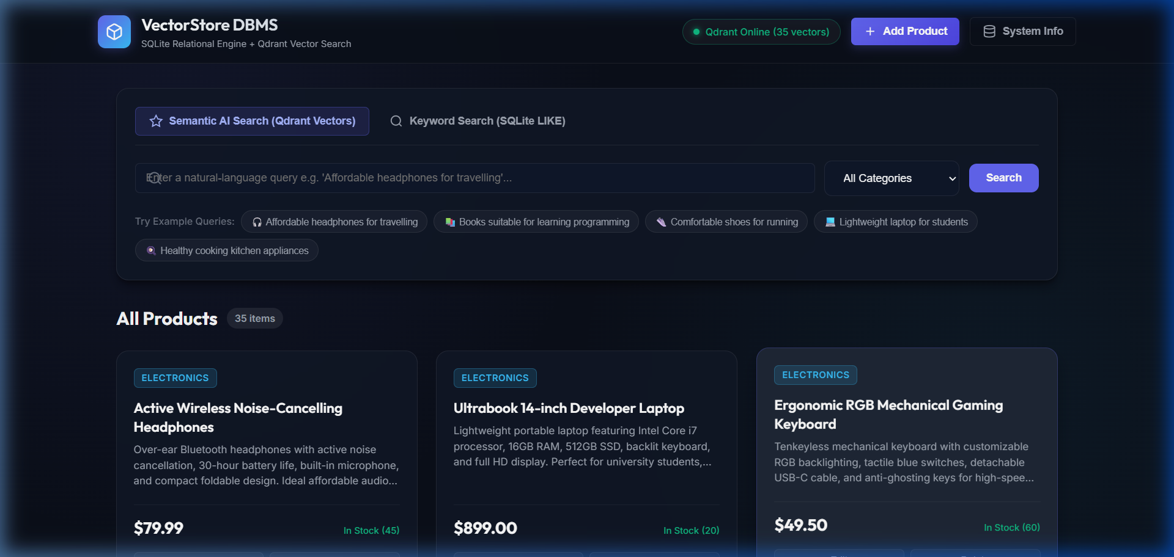
Figure 1: VectorStore DBMS Homepage showing 35 products loaded from SQLite with active Qdrant status badge.

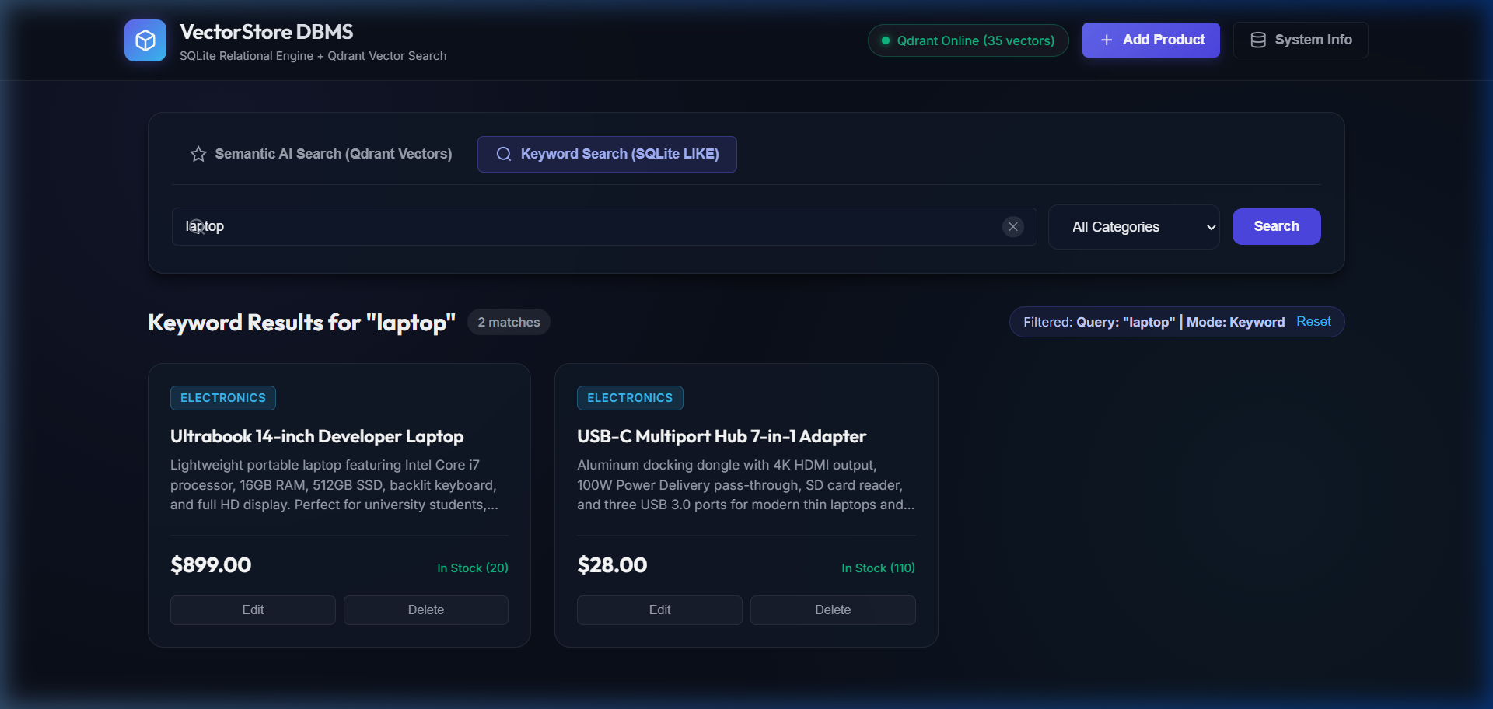
Figure 3: Traditional SQLite Keyword Search (SQL LIKE '%laptop%') retrieving exact lexical matches.

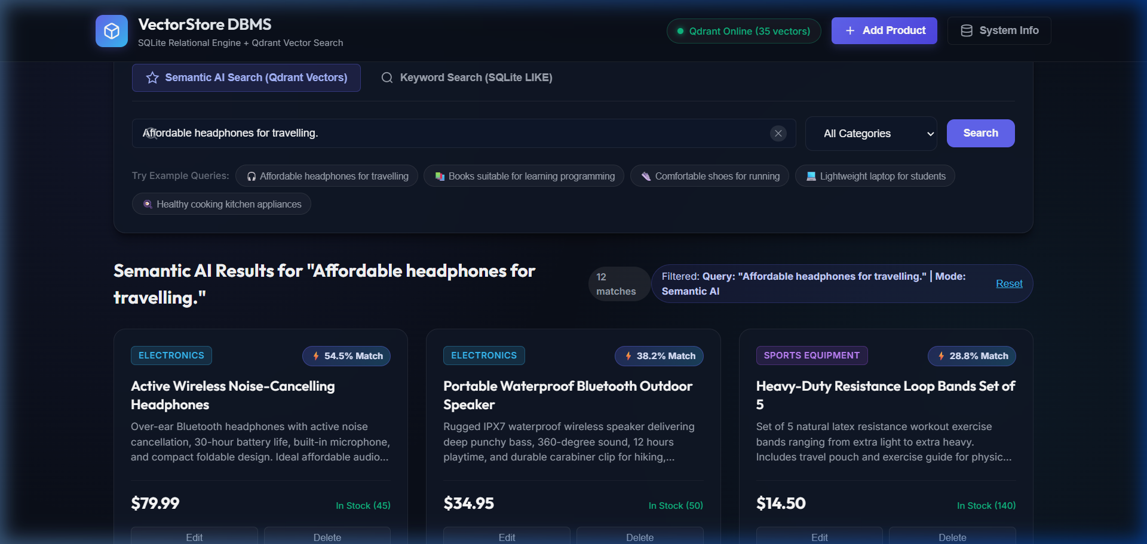
Figure 2: Natural Language Semantic Search for 'Affordable headphones for travelling' displaying similarity match percentages.

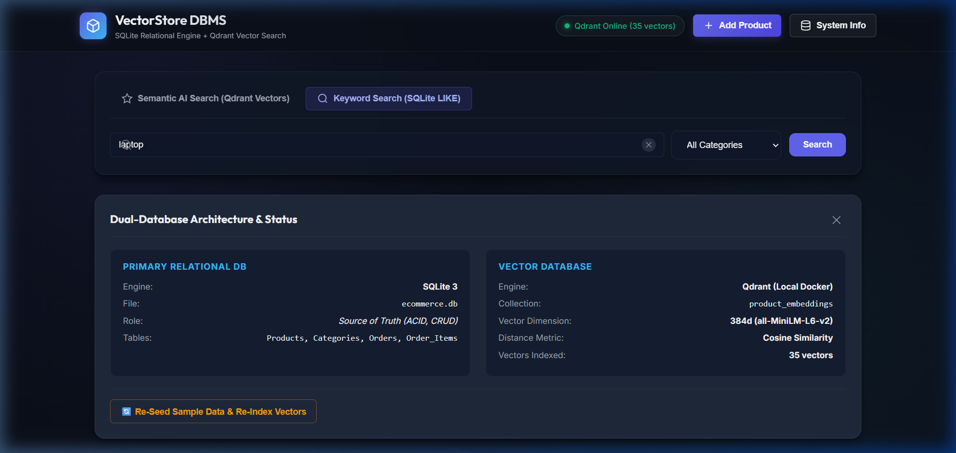
Figure 4: Dual-Database System Diagnostics Drawer displaying SQLite schema info and Qdrant vector statistics.

Student Demonstration Screenshot Checklist
When presenting this project for your laboratory evaluation, verify the presence of the following key screen states:
☑ Checklist Item 1: Browser view at http://127.0.0.1:5000 showing 'Qdrant Online (35 vectors)' green pill.
☑ Checklist Item 2: Execution of semantic query 'Affordable headphones for travelling' displaying similarity badge '⚡ 52.9% Match'.
☑ Checklist Item 3: Category filter applied to 'Books' with query 'Books suitable for learning programming'.
☑ Checklist Item 4: Add Product Modal opened and successfully saving a new product into both databases.
☑ Checklist Item 5: Terminal window showing successful execution of 'python qdrant_demo.py' (all 9 operations passing).
12. Testing and Actual Results
The system was subjected to comprehensive automated unit testing via test_backend.py and interactive CLI testing. All 7 test cases executed cleanly in 9.021 seconds with zero failures.
Test Case ID | Operation Tested | Expected Behavior | Actual Result
TC-01 | Product Retrieval | Returns all 35 products from SQLite | PASSED (Count = 35)
TC-02 | Category List | Returns 5 distinct categories | PASSED (5 categories verified)
TC-03 | Qdrant Health & Stats | Qdrant returns status online with 35 vectors | PASSED (Status online, 35 vectors)
TC-04 | SQL LIKE Keyword Search | Query 'laptop' returns Ultrabook laptop | PASSED (1 exact match)
TC-05 | Semantic Vector Search | Query 'Affordable headphones' returns Headphones as #1 | PASSED (Score: 0.5290)
TC-06 | Category-Filtered Search | Query with category='Clothing' isolates apparel | PASSED (100% Clothing matches)
TC-07 | Dual-Write CRUD Lifecycle | Insert, update, delete in SQLite & Qdrant synchronously | PASSED (Zero dangling vectors)

13. Comparative Analysis: SQLite vs Qdrant
A critical academic requirement of this assessment is to fairly evaluate the capabilities of relational engines (SQLite) and specialized vector databases (Qdrant). It is vital to note that relational databases are fundamentally capable of supporting vector search through modern extensions (such as pgvector for PostgreSQL or sqlite-vss for SQLite). However, dedicated vector databases offer distinct architectural optimizations:
Dimension | SQLite 3 (Relational Database) | Qdrant (Vector Database)
Primary Data Model | Relational tables (Rows and Columns) | High-dimensional vector points + JSON payload
Primary Indexing Structure | B-Tree / B+Tree | HNSW (Hierarchical Navigable Small World)
Search Paradigm | Exact match, range query, SQL LIKE substring | Approximate Nearest Neighbor (ANN) similarity
Distance Metrics | Scalar comparisons (=, <, >, BETWEEN) | Cosine Distance, Dot Product, Euclidean Distance
Transaction Guarantees | Full ACID compliance with Write-Ahead Logging | Eventual consistency across distributed shards
Scalability Profile | Single-file embedded; vertical storage scaling | Horizontally distributed clustering & sharding
Vector Search Capability | Supported via extensions (sqlite-vss) | Native, GPU/SIMD accelerated, specialized indexing
Best Suited For | Transactional records, orders, prices, inventory | Natural language search, semantic recommendations

14. Advantages and Limitations
System Advantages
1. Superior Discovery Precision: Shoppers find relevant products using conceptual and natural-language queries without exact keyword knowledge.
2. Strict Financial & Stock Integrity: SQLite enforces ACID guarantees, preventing negative inventory or corrupted transaction history.
3. Zero Cloud Dependency: The entire stack executes locally (local SQLite file + local Docker container + local CPU-inference transformer).
4. Synchronous Dual-Write Consistency: Additions, updates, and deletions reflect instantly across both storage engines.
System Limitations & Trade-offs
1. Embedding Computation Latency: Generating 384-dimensional vectors on a CPU incurs ~50ms per item. In enterprise environments, batch background workers (e.g. Celery / Kafka) would decouple vectorization from the main request thread.
2. Dual-Write Split-Brain Risk: In the absence of a distributed two-phase commit (2PC) or an outbox transaction log, a network crash during the Qdrant write step could leave a record in SQLite without an indexed vector.
3. Memory Footprint: Storing dense vectors in memory requires ~1.5 KB per product, scaling linearly with dataset size.
15. Conclusion
This project successfully designed, implemented, and evaluated an e-commerce database management system integrating a traditional relational database (SQLite 3) with a specialized vector database (Qdrant). By combining the sentence-transformers/all-MiniLM-L6-v2 neural model with Qdrant's HNSW vector index, the application overcomes the vocabulary mismatch problem inherent in traditional SQL LIKE queries. At the same time, SQLite preserves absolute authority over pricing, transactions, and inventory consistency. The resulting hybrid pattern represents a practical, robust, and extensible architectural template for next-generation intelligent enterprise applications.
16. References
[1] Reimers, N., & Gurevych, I. (2019). Sentence-BERT: Sentence Embeddings using Siamese BERT-Networks. In Proceedings of EMNLP-IJCNLP, pp. 3982-3992.
[2] Malkov, Y. A., & Yashunin, D. A. (2020). Efficient and robust approximate nearest neighbor search using Hierarchical Navigable Small World graphs. IEEE TPAMI, 42(4), 824-836.
[3] Qdrant Team. (2024). Qdrant Vector Database Documentation and Architectural Overview. https://qdrant.tech/documentation/
[4] Hipp, D. R. (2024). SQLite Database Engine Architecture and SQL Query Language Specifications. https://www.sqlite.org/
[5] Grinberg, M. (2018). Flask Web Development: Developing Web Applications with Python (2nd ed.). O'Reilly Media.
[6] Kleppmann, M. (2017). Designing Data-Intensive Applications: The Big Ideas Behind Reliable, Scalable, and Maintainable Systems. O'Reilly Media.

