Azure Cloud Fundamentals and Data Pipeline Implementation using ADF

Name: Shlok Kushwaha
Course: B.Tech Computer Science & Engineering
Date: 13 June 2026

Task 1: Resource Group Creation
Objective: Create a Resource Group in Azure to isolate and manage all corresponding deployment resources logically.
Description: Created a targeted cloud resource architecture sandbox by initializing a Resource Group named shlok-adf-rg deployment structured natively within the Central India data center region.
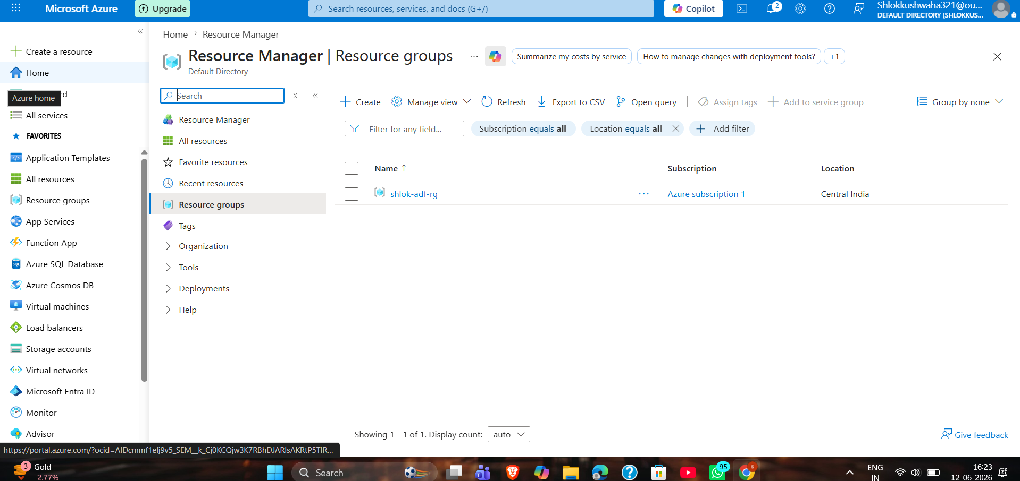

Task 2: Storage Setup
Objective: Provision an enterprise-tier Storage Account and blob object structure for persistent file host management.
Description: Created an Azure Storage Account deployment instance. Inside this storage resource context, established a secure Blob Container named source-container and successfully initialized runtime data structures by uploading the file asset source payload: Sample-Superstore.csv.
🖼️
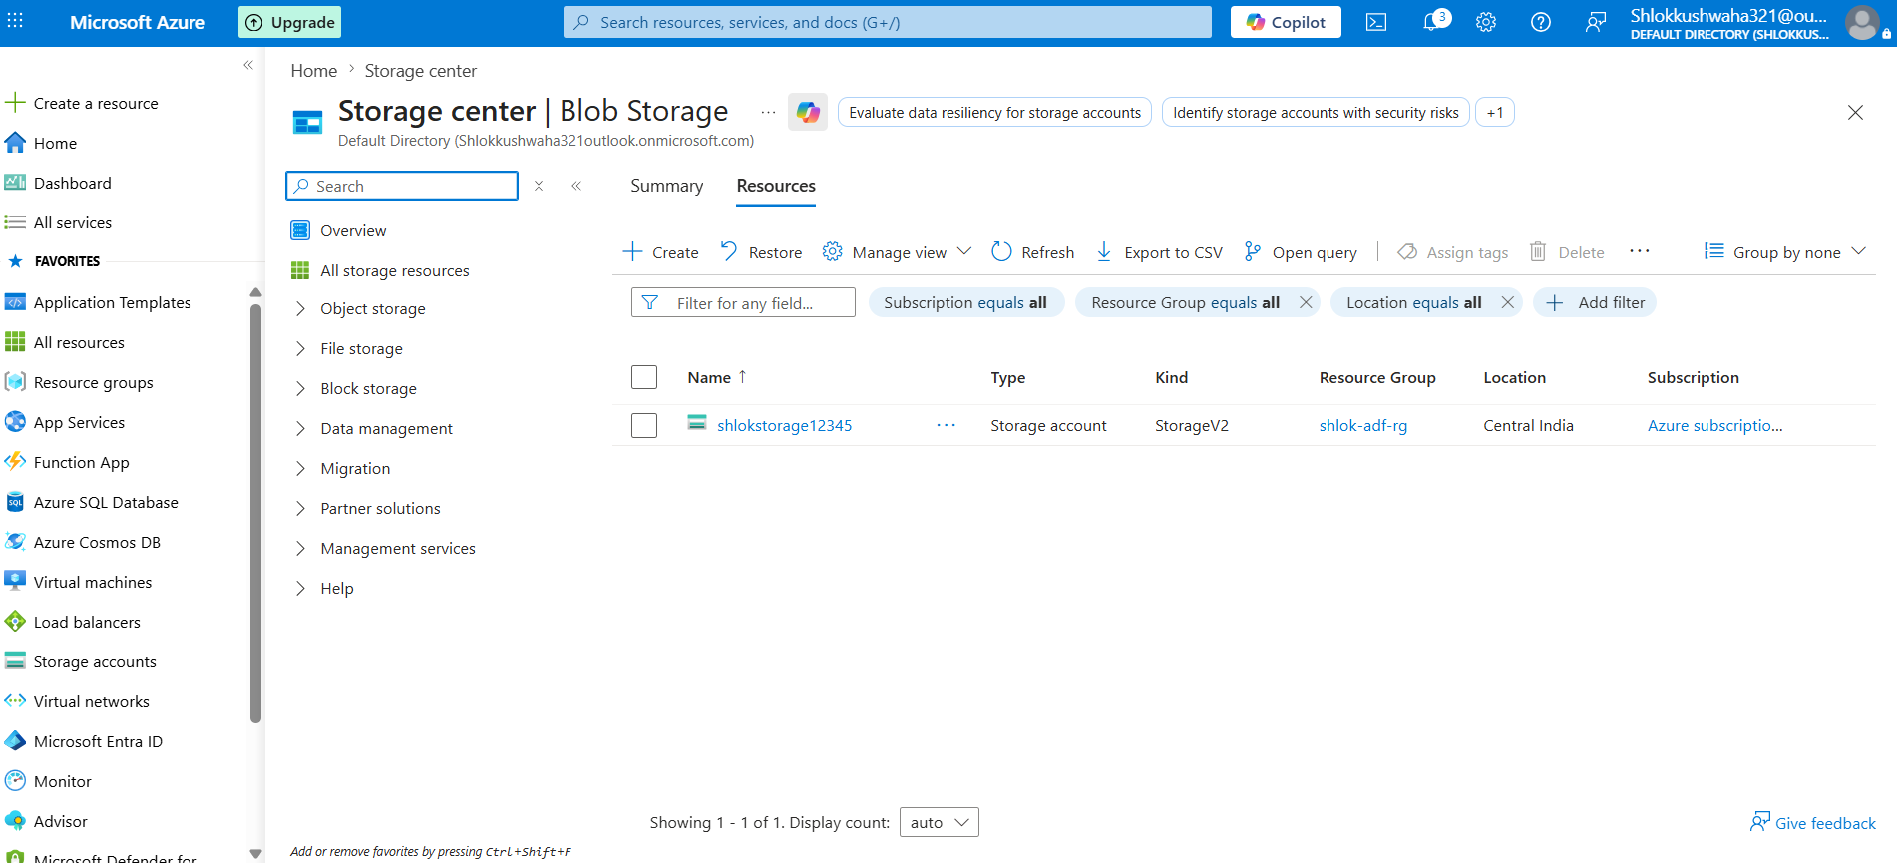

Task 3: Azure Data Factory Basics
Objective: Configure underlying operational baseline layers inside ADF including API link integration abstractions and structured datasets.
1. Linked Service Configuration
Description: Configured and validated an integration adapter layer named LS_BlobStorage acting as the secure authentication bridge tunnel to securely bind Azure Data Factory to the storage backend container space.
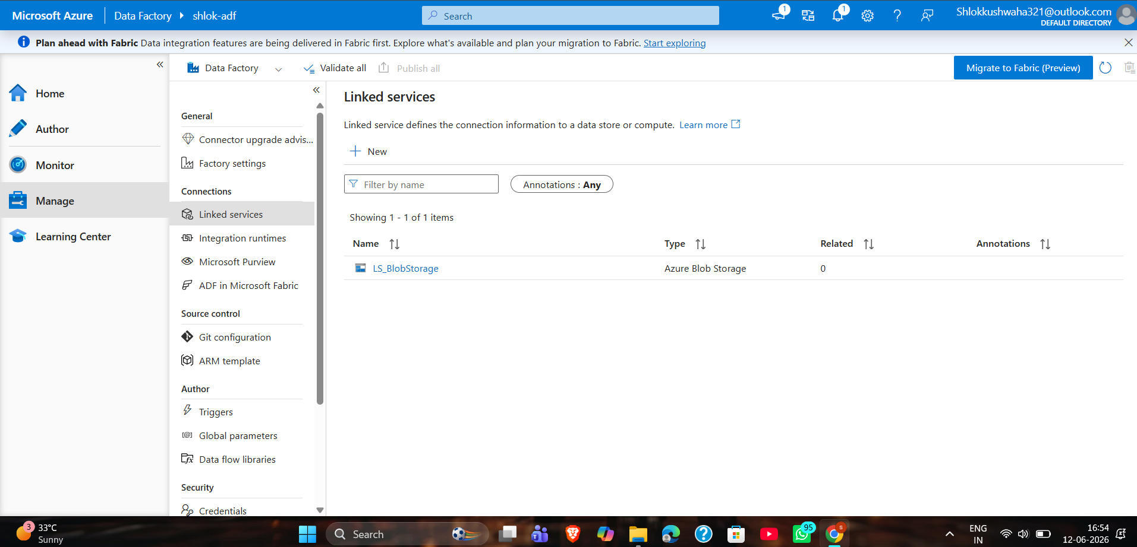

2. Source Dataset Definition (DS_Source)
Description: Initialized structural metadata map abstraction targeting the inbound raw CSV spreadsheet context stored within the storage infrastructure layer.
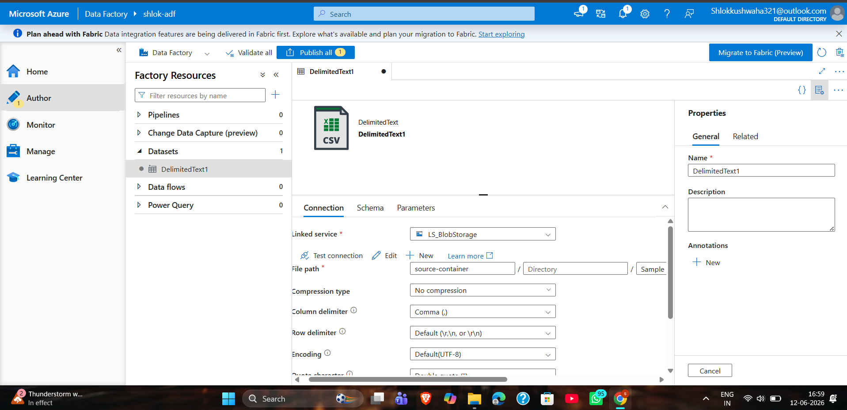

3. Destination Dataset Definition (DS_Destination)
Description: Configured logical physical destination model pointing cleanly towards outbound sink target storage location parameters.
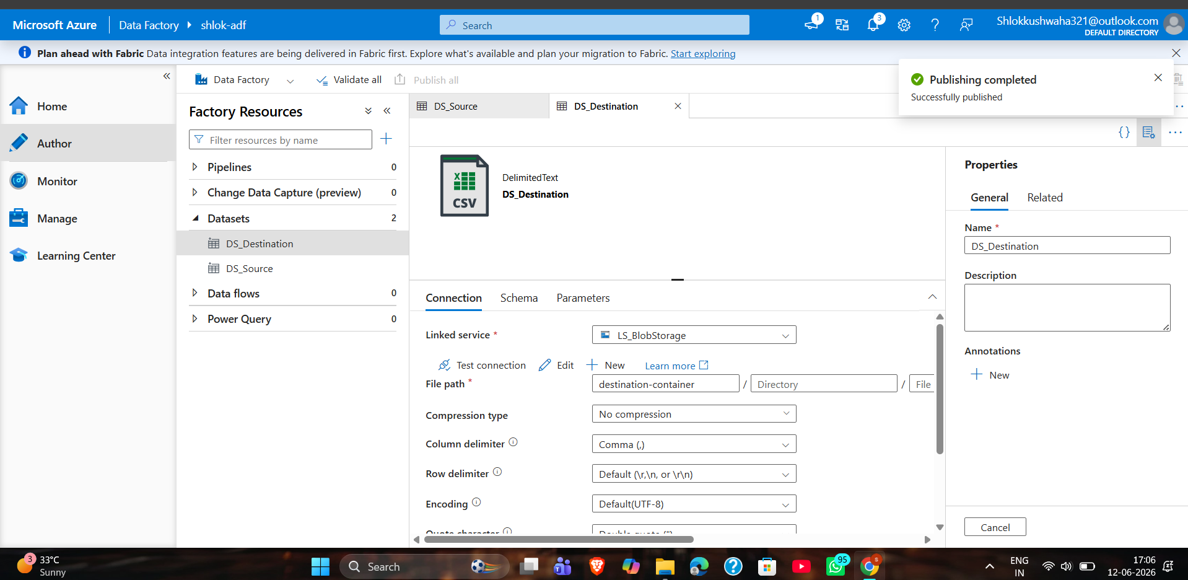

4. Get Metadata Activity Implementation
Description: Designed and deployed an upstream validation gate using the Get Metadata tool parameters to explicitly verify object integrity, path visibility, and dynamic state checks before running execution operations.
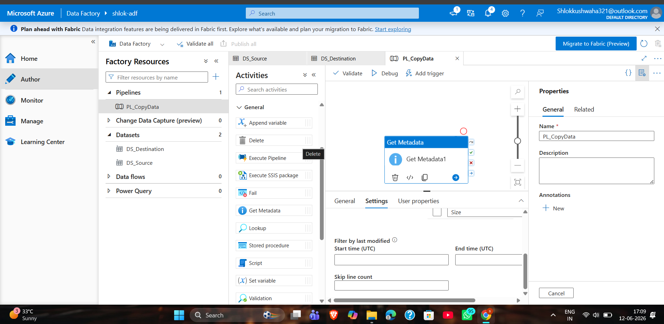

Task 4: Pipeline Development
Objective: Design an automated ETL workspace orchestration sequence to control complex linear data operations seamlessly.
Description: Assembled an operational data movement pipeline workspace flow environment. The system layout brings together all essential extraction modules sequentially: validation metrics are captured through the Get Metadata Activity, which feeds forward into the core file-transfer processing engine via the Copy Data Activity. This manages the smooth movement of data between the defined Source Dataset and its final target layout within the Destination Dataset.
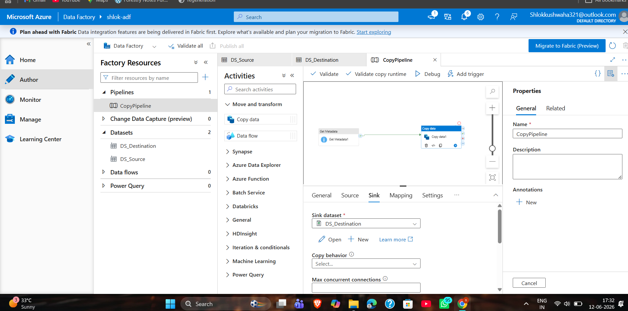

Task 5: Pipeline Execution
Objective: Trigger live sandbox environment validation runs and track activity outcomes in real time.
Description: Executed the complete end-to-end data processing workflow inside the orchestration runtime engine. The system successfully validated metadata attributes and moved structural payloads from the source blob folder to the targeted landing area without hitting any execution warnings or errors.
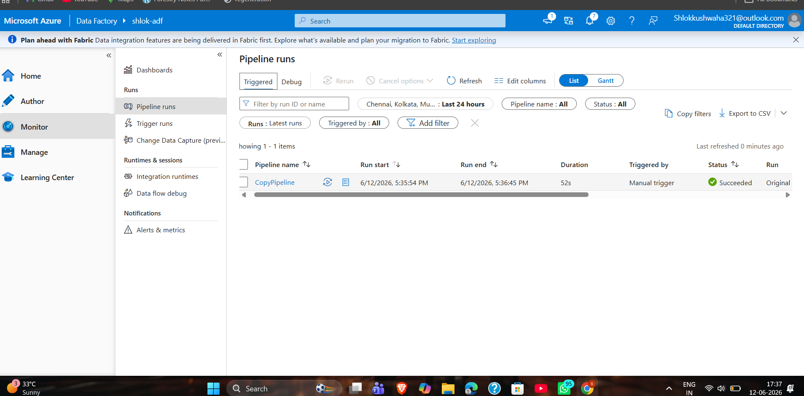

Task 6: Identity and Access Management (IAM) Roles
Objective: Configure role-based access tokens and security boundaries to lock down cross-resource environments safely.
Description: Set up strict security access boundaries by assigning official Role-Based Access Control (RBAC) rules across the storage service space, enabling clean verification for the following identity items:
• Reader Role: Assigned directory-level visibility access boundaries to target user accounts.
• Contributor Role: Granted full active modification rights over the deployment container resource profile.
• Storage Access Permissions for ADF: Assigned Storage Blob Data Contributor access tokens directly to the ADF managed system identity profile, opening up direct pipeline channels.
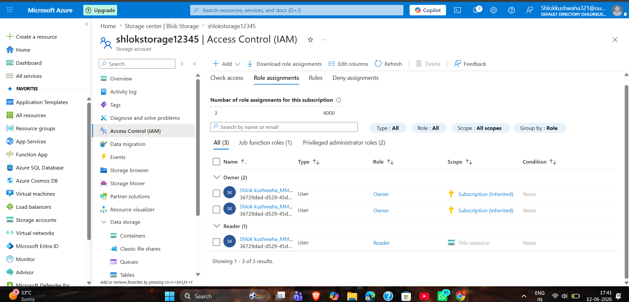
HERE ]

Mini Project: Automated Enterprise Data Pipeline Workflow
Problem Statement:
Design and implement an automated cloud-based data movement architecture capable of reading large raw comma-separated spreadsheet data from a secure cloud container space, verifying file status metadata, and safely moving the validated output dataset to a dedicated destination folder.
System Architecture Layout:
Blob Storage (Source Context) ──> Get Metadata (File Check) ──> Copy Data (ETL Engine) ──> Blob Storage (Destination Context)
Implementation Steps:
1. Provisioned an enterprise Azure Storage Account infrastructure model.
2. Uploaded raw database assets (Sample-Superstore.csv) to an isolated source container workspace.
3. Built an authenticated connection pipeline via an ADF Linked Service connection instance.
4. Defined clean schema abstractions for both Source and Destination Dataset frameworks.
5. Added a Get Metadata workflow block to safely analyze asset characteristics beforehand.
6. Linked downstream processing execution steps directly using a custom Copy Data framework.
7. Triggered a manual debug test execution to verify pipeline engine operations end-to-end.
Key Results and Key Accomplishments:
✔ Source data streams parsed and managed without data loss or corruption.
✔ Inbound metadata metrics systematically captured, processed, and validated.
✔ Target system files moved cleanly into destination container environments.
✔ End-to-end pipeline execution succeeded smoothly with 100% processing efficiency.

Project Validation Deliverables Checklist








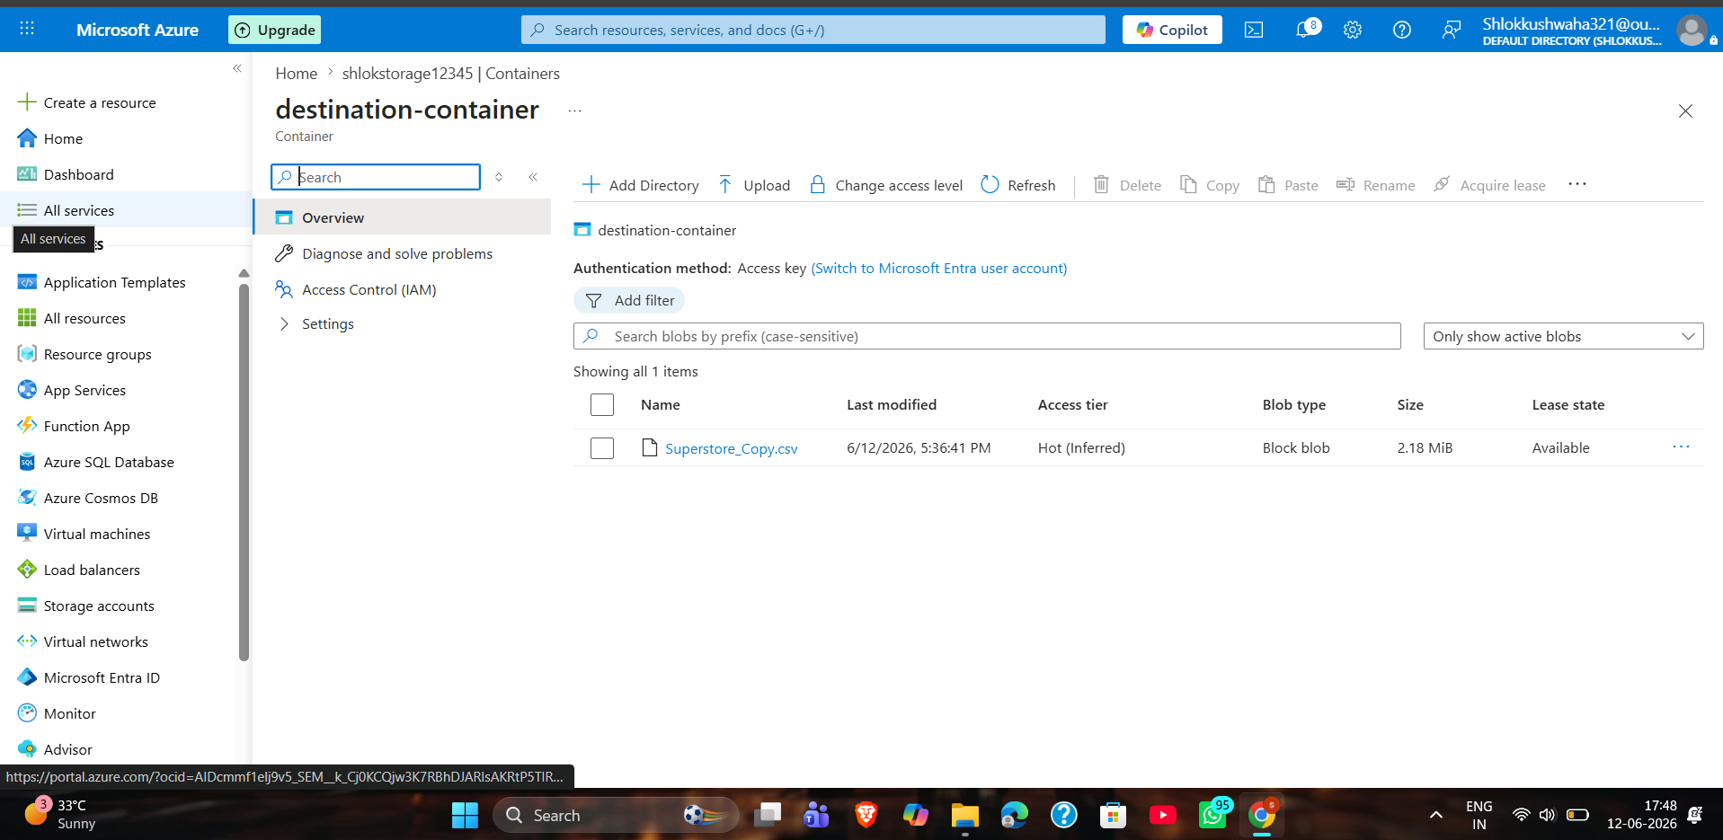

Conclusion
The cloud assignment successfully built a robust, enterprise-ready Azure Data Factory pipeline. By combining active asset structure checks (Get Metadata Activity) alongside targeted file replication tools (Copy Data Activity), the system established a reliable automated cloud pipeline flow. Correctly setting up identity access structures (RBAC Reader/Contributor roles) and providing managed identity tokens for the ADF instance ensures the implementation follows industry security best practices. The successful movement of the Sample-Superstore dataset across the storage system confirms the workspace environment is fully operational and ready for production use.

