Content Maturity, Release Lifecycle & Playlist Rotation Analysis of Spain Top 50 Songs
Research paper prepared for Atlantic Recording Corporation
Data: daily Spotify-style Top 50 snapshots for Spain, 2024-05-18 to 2025-11-27 (555 observed days, 27,750 chart entries after cleaning).

Abstract
This study builds a song-level lifecycle from 555 daily snapshots of Spain's Top 50 and uses it to answer how long songs survive, how the playlist rotates, and whether explicit content or release format changes a song's trajectory. After normalising 583 raw song/artist strings into 543 distinct songs, we observed the entry of 493 songs (the rest were already charting when the data begins) and treated songs still charting at the end as right-censored.
Main findings. The chart is quieter than the brief's premise suggests: on a typical day only 1.0 song enters (mean 1.67, or 3.3% of slots), and 29% of days have no new entry at all. Rotation is driven by a handful of "shock days" on which one artist floods the chart: 14 days (2.5% of the calendar) supply 20% of all entries, most of them one artist charting many tracks at once. Survival is sharply skewed: 43% of new entries are gone within a week, while 19% last 90 days or more; median survival is 13 days. Half of all songs (50%) hit their best-ever position on their first chart day. Explicit and clean songs show no detectable difference in lifecycle (log-rank p = 0.74; mean-days ratio 1.07, 95% CI 0.80 to 1.41). Singles outlast album tracks by a wide margin (median 26 vs 6 days; ratio 1.71, p < 0.001), but a multivariable model attributes much of that gap to album size and to album-drop dynamics rather than the single/album label itself. The popularity score lags rank by about 9 days and barely moves as songs decline, so it is a poor real-time lifecycle signal. A simple model using only a song's first week of chart data predicts 30-day survival with AUC 0.87 (naive baseline 0.74).
Scope note. The dataset covers Spain only and contains no release dates, so it cannot test claims about Spain versus UK/US rotation speed, and 'age' throughout means days since first Top 50 appearance.

1. Introduction and objectives
Atlantic Recording Corporation needs lifecycle intelligence for the Spanish market: how long content lasts, whether the playlist favours fresh or mature tracks, and how content attributes shape a song's path. The brief asks for: (1) data validation and normalisation, (2) a song lifecycle table, (3) lifecycle stage classification, (4) rotation and churn analysis, (5) content attribute versus lifecycle analysis, (6) popularity versus lifecycle maturity, (7) a KPI set, and (8) an interactive dashboard. We add survival analysis, an early-warning model, lifecycle archetypes and artist-concentration analysis.
The brief describes Spain as having faster playlist rotation than the UK/US and high freshness sensitivity. These are hypotheses about cross-market differences; with a single-market dataset we can describe Spain's rotation in absolute terms but cannot confirm the comparison.

2. Data and validation
The file has 27,800 rows and the ten columns described in the brief. There are no null cells. The checks below were run before any analysis; each anomaly and its treatment is documented so the results can be reproduced.
Check | Finding | Treatment
Days with exactly 50 rows | 554 of 555 days pass; 2025-03-01 has 100 rows | That day contains two full 50-row snapshots in different orders. Kept the first, dropped 50 rows. Neither block could be reliably assigned to another date.
Missing calendar dates | 4: 2025-03-14, 2025-03-25, 2025-07-11, 2025-08-13 | Treated as data gaps, not exits. Songs on both sides of a gap stay in the same run; the day after a gap is excluded from churn averages.
Zero popularity | 106 rows across 25 days | Treated as missing (the API returns 0 for brand-new tracks; 95% of affected entrants are album tracks). Not imputed.
Naming variants | 583 raw pairs to 543 songs | Normalised case, accents, feat./with/con tags; song ID = normalised title + primary artist. The same song is often listed with and without its featured artist.
Same song twice in a day | 0 after normalisation | No action needed.
Left-censoring | 50 songs already charting on day 1 | Excluded from entry, time-to-peak and survival statistics.
Right-censoring | 50 songs still charting on the last day | Kept in survival models as censored observations.
Re-entries | 193 songs (36%) left and returned | Tracked as separate runs; total days counts chart days. Median gap 4 days, 48% of gaps 3 days or fewer.

Re-entries are common because songs oscillate around the rank-50 boundary, so a brief exit is often noise rather than a real end of life. Analyses that need one duration per song use total days on chart and define the event as the final exit.

3. Methodology

3.1 Lifecycle construction
For each song we compute entry and exit dates, total chart days, span, number of runs, peak position, days to first reach that peak, entry and exit position, average position and volatility, days in the Top 10 and Top 25, popularity at entry, at exit and at peak, plus content attributes (explicit flag, release type, track count, duration).

3.2 Stage classification
Stages are assigned to every song-day with transparent rules based on the last seven chart days. Slope is the linear trend of position in ranks per day (negative means climbing).
- New Entry: first 7 chart days (not applied to songs already charting on day 1).
- Peak: position 10 or better, absolute slope below 0.5 and rank standard deviation of 3 or less.
- Growth: slope of -0.5 or steeper.
- Decline: slope of +0.5 or steeper.
- Mature: everything else (stable, typically mid-rank).
Rules are applied in the order New Entry, Peak, Growth, Decline, Mature. A sensitivity grid over slope thresholds (0.25, 0.5, 1.0) and volatility caps (2, 3, 4) is in Appendix B.

3.3 Rotation and churn
Daily entries are songs present today but not yesterday; exits are the reverse. Churn rate is entries divided by 50 slots. We also measure rank-level turnover and Top 10 turnover. A shock day is one with 8 or more entries (roughly the top 2.5% of days).

3.4 Statistics
Comparisons use Mann-Whitney tests with Cliff's delta, bootstrap confidence intervals for mean ratios (2,000 resamples), Kaplan-Meier curves with log-rank tests, and a Cox proportional-hazards model with a small ridge penalty. All lifecycle statistics use only songs whose entry we observed. Songs by the same artist are not independent; we did not apply cluster-robust errors, so p-values for artist-heavy segments may be somewhat optimistic.

4. Results

4.1 How long songs survive
Of 493 songs with an observed entry, 443 were seen leaving for good. Lifespans are extremely skewed (Figure 1): 26% last three days or fewer and 43% last a week or less, while 19% pass 90 days. The Kaplan-Meier median survival is 13 days, and the estimated share still charting at 7, 30 and 90 days is 60%, 39% and 22% (the KM figures are higher than raw shares because they account for songs still charting when the data ends).
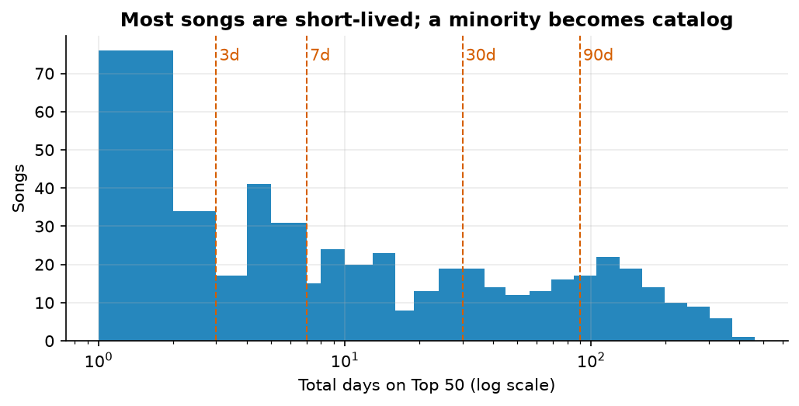
Figure 1. Distribution of total days on the Top 50 (log scale), songs with observed entry.
Entry position is the strongest single predictor of what follows. 50% of songs reached their peak on their first chart day (median days to peak 0; mean 10.3, pulled up by slow burners). Among songs that eventually reached the Top 10 (30% of entrants; 7% reached number 1), the median time to peak was 4.5 days. Songs that entered in the Top 10 had a 69% chance of surviving 30 days versus 25% for entries at ranks 11-25 and 39% for entries at 41-50 (n = 78, 108, 190).

4.2 Lifecycle stages
Across all song-days, 34% are Mature, 27% Decline, 15% Peak, 14% Growth and 9% New Entry (0.5% unclassified). Stages are sticky (Figure 2): a song in Peak stays in Peak the next day 92% of the time, in Decline 77%, and in Mature 72%. The most common exits from Mature are into Decline (16%) and back into Growth (10%), and from Decline back to Mature (20%). Songs spend on average 13.9 days in Mature and 12.3 in Decline versus 8.0 in Peak.
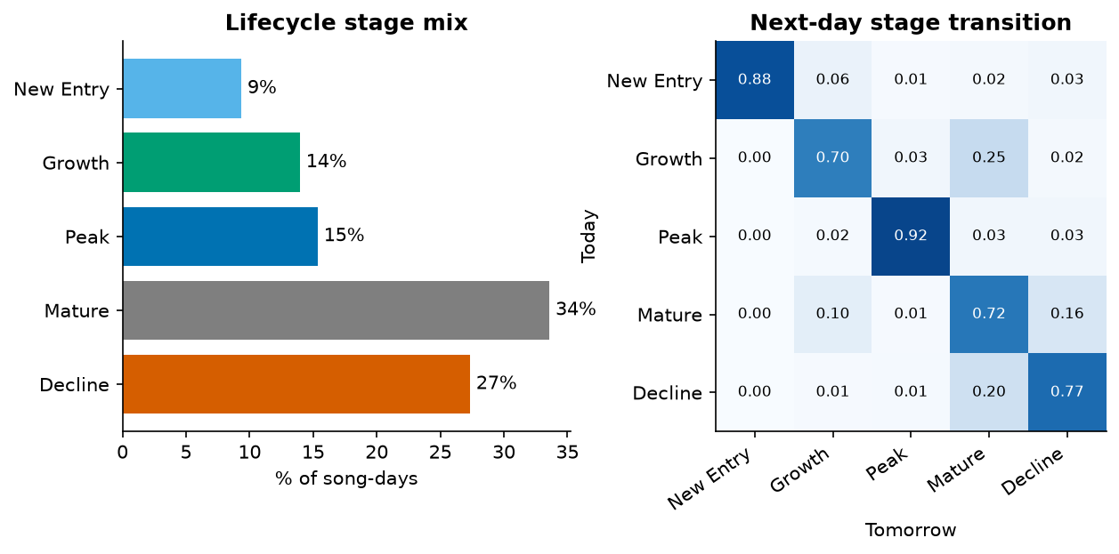
Figure 2. Stage share of song-days and next-day stage transition probabilities.
Stage shares depend on the slope threshold: at 0.25 rank/day, Decline rises to 39% and Mature falls to 18%; at 1.0, Mature rises to 53%. The volatility cap has almost no effect. The stage mix should therefore be read as relative, not absolute.

4.3 Playlist rotation and churn
Rotation is slow on most days and violent on a few. Across 550 comparable days, 1.67 songs enter per day on average (median 1.0), a churn rate of 3.3% with a coefficient of variation of 1.45. Top 10 turnover is 5.9% per day. Excluding the 14 shock days, churn falls to 2.7%.
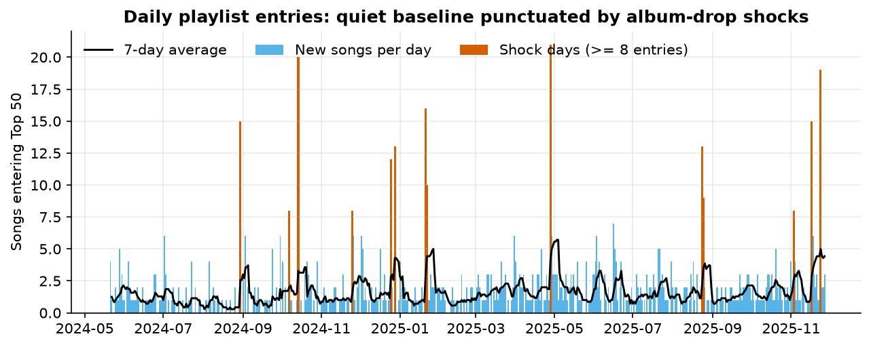
Figure 3. Daily entries. Red bars are shock days with 8 or more new songs.
10 of the 14 shock days are dominated (half or more of the new entries) by a single artist, consistent with a full-album release charting at once (the dataset has no release dates, so this is an inference from the artist mix). The other 4 (2024-12-25, 2024-12-28, 2025-01-22, 2025-08-25) spread across many artists. The eight largest are listed below.
Date | New songs | Largest single-artist share | New in Top 10
2025-04-28 | 21 | Saiko (14) | 4
2024-10-14 | 20 | Bad Bunny (20) | 9
2025-11-24 | 19 | Quevedo (17) | 10
2025-01-21 | 16 | Eladio Carrion (16) | 2
2024-08-30 | 15 | Mora (15) | 7
2025-11-17 | 15 | Rauw Alejandro (15) | 3
2024-12-28 | 13 | Bad Bunny (2) | 2
2025-08-24 | 13 | Myke Towers (11) | 1

Monthly churn ranged from 1.9% (2025-02) to 6.5% (2025-11); the highest months coincide with shock days (Figure 4). With only 18 months of data, we cannot separate seasonal effects from individual album drops, and we make no claim about summer, Christmas or festival seasonality beyond noting that 2024-12-25 and 2024-12-28 appear among the shock days. Excluding shock days, new entries cluster on Mondays and Tuesdays (2.03 and 2.22 per day) versus 0.86 on Sundays (Kruskal-Wallis p < 0.001). This may reflect release-day patterns or the timing of the snapshot; the data cannot distinguish the two.
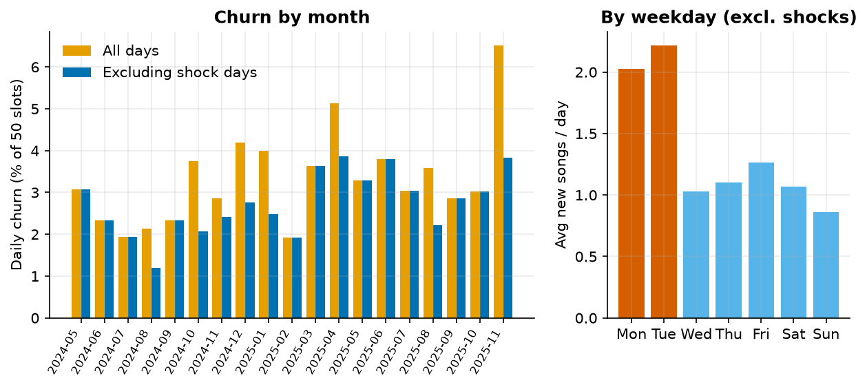
Figure 4. Average daily churn by month, with and without shock days, and new songs by weekday.
Rotation is concentrated at the bottom of the chart (Figure 5). The occupant of a top-10 rank changes on 35% of days, versus 71% for ranks 11-40 and 75% for ranks 41-50. The average absolute daily rank move is 1.83 places (0.57 in the Top 10, 2.50 at ranks 41-50); 77% of daily moves are two places or fewer.
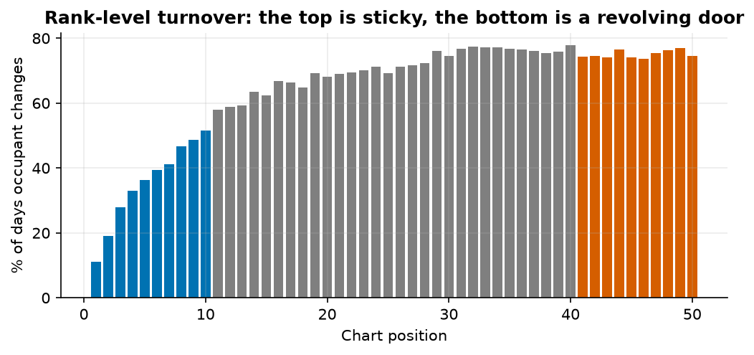
Figure 5. Share of days on which each rank changes occupant.
Artist concentration is moderate: 201 primary artists appear, the top ten account for 36% of chart slot-days (largest: Saiko, 5.6%), and the Herfindahl index is 0.020. On an average day the most-represented artist holds 4.8 slots; on 193 days one artist held five or more, with a maximum of 21.

4.4 Content attributes versus lifecycle
Explicit versus clean. Explicit songs are 44% of distinct songs and 42% of chart slot-days. Among songs with observed entry (227 explicit, 266 clean) there is no detectable difference: mean days 47.6 vs 44.3 (Mann-Whitney p = 0.78, Cliff's delta -0.01; ratio 1.07, 95% CI 0.80 to 1.41); the log-rank test gives p = 0.74. The share reaching the Top 10 is 29.5% vs 31.2% (p = 0.76), and peak position and time-to-peak are also statistically indistinguishable. The Cox hazard ratio for explicit is 1.03 (95% CI 0.84 to 1.26). The confidence interval is wide enough that differences of up to about 20-40% in average days cannot be ruled out, but there is no evidence of one.
Single versus album track. This is the clearest content effect (Figure 6). Singles average 59.0 chart days versus 34.4 for album tracks (median 26 vs 6; ratio 1.71, 95% CI 1.31 to 2.30; Mann-Whitney p < 0.001). Kaplan-Meier median survival is 28 vs 8 days and 30-day survival 48% vs 30% (log-rank p < 0.001). Yet peak position is similar (mean 21.1 vs 22.1, p = 0.35) and 33% of singles vs 28% of album tracks reach the Top 10. Album tracks therefore reach comparable heights but hold them for less time. Singles also enter lower (mean entry position 33.5 vs 28.9) and take longer to peak (median 4 vs 0 days). Singles re-enter more often (40% vs 28%).
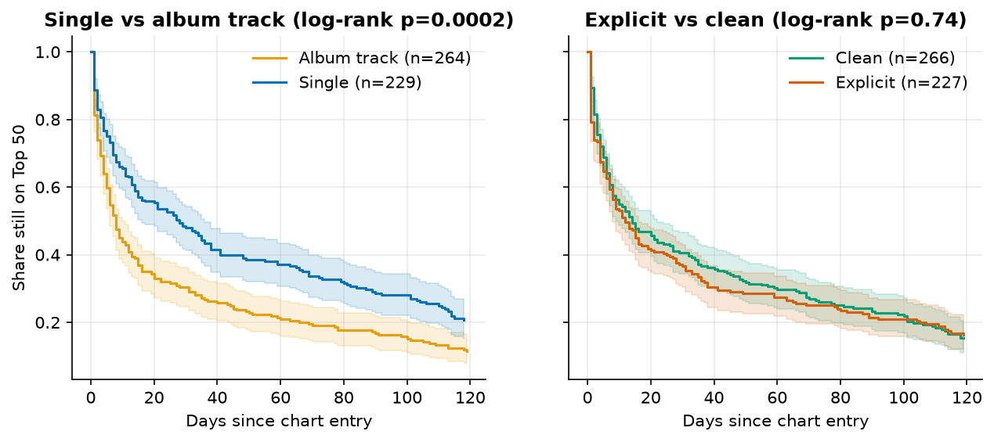
Figure 6. Kaplan-Meier survival curves with 95% confidence bands.
Album drops explain much of the album penalty. 149 songs entered on shock days, and 90% of them are album tracks (versus 38% on other days). Their median stay is 4 days versus 20.5 for other entrants (mean 21.3 vs 56.5; p < 0.001), yet their chance of reaching the Top 10 is about the same (29% vs 31%). Album-drop entries produce a brief burst, then most tracks fall away, with a few focus tracks surviving.
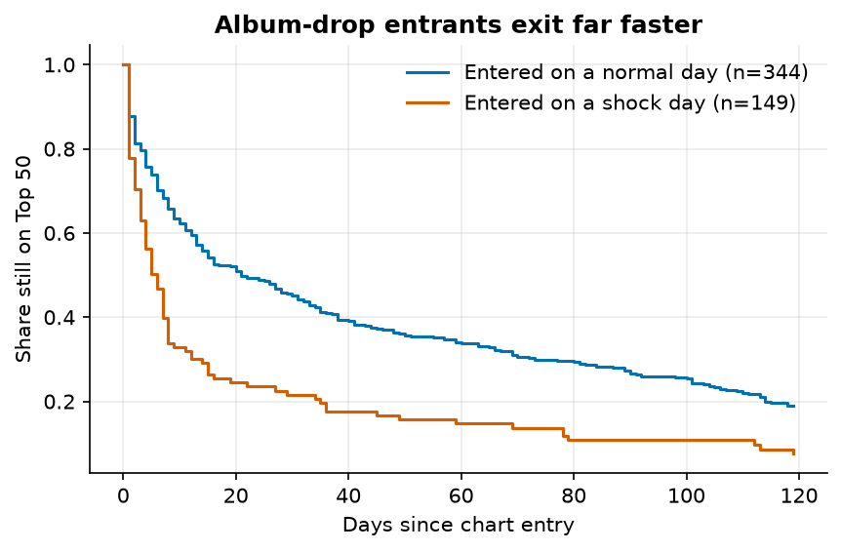
Figure 7. Survival of songs entering on shock days versus normal days.
Duration and album size. Song length has only a weak association with longevity (Spearman 0.11, p = 0.02); songs under 2.5 minutes have a median of 6.5 days versus 14 for 3.5-4 minutes, but the pattern is not monotonic. Album size matters more: the more tracks on the release, the shorter the stay (Spearman -0.26, p < 0.001); median days are 27 for one-track releases, 8 for 4-10 tracks and 5 for 11-20 tracks (Figure 8). Rank volatility is similar across sizes (mean daily-rank standard deviation 7.7 to 8.8) except for releases of 21+ tracks (11.6).
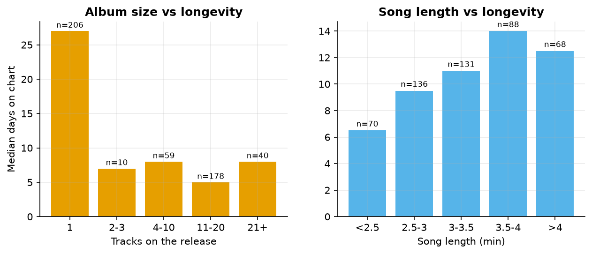
Figure 8. Median days on chart by release size and by song length.
Multivariable view. A Cox model on 493 songs adjusts for explicit flag, single flag, log track count, duration, entry position and entry popularity. Hazard ratios above 1 mean faster exit. Entry position is significant (HR 1.19 per standard deviation worse, p < 0.001), as is entry popularity (HR 0.84 per standard deviation higher, p = 0.003), and log track count (HR 1.36, p = 0.04). Once track count is included, the single flag is not significant (HR 1.30, 95% CI 0.72 to 2.35), which fits the interpretation that album size, not the label, drives the gap. These two variables overlap heavily (most singles have one track), so their separate effects cannot be pinned down precisely. Explicit and duration remain non-significant.
A missing-popularity indicator has a very large hazard ratio (9.23) because 95% of the 4.1% of songs with no popularity score in their first three days are album-drop tracks with a median stay of 1 day(s). It acts as a proxy for album-drop entrants rather than a causal effect; models without the indicator (concordance 0.63) and on complete cases give the same conclusions for the other variables (log track count HR 1.42 and 1.35; entry position HR 1.19 and 1.19). A log-linear regression on completed songs agrees on direction for entry position and track count.

4.5 Popularity versus lifecycle maturity
The popularity score does not behave like a rank signal (Figure 9). Mean popularity of newly entered songs climbs from 66.2 on day 0 to 77.0 at day 7 and 81.1 at day 21, then plateaus near 82.4. Rank peaks earlier: the median song peaks in rank on day 1 and in popularity on day 10; popularity peaks before rank in only 8% of songs (same day in 19%). The two peak times are correlated (Spearman 0.70).
There is no lead-lag signal: correlations between the daily change in popularity and the daily change in rank at lags of -3 to +3 days are all below 0.06 in magnitude. Nor does popularity decay as songs fade. In the 14 days before a song's final exit its average position slides from 36.2 to 46.4, while popularity stays between 78.2 and 79.0. Average popularity is highest in the Peak stage (86.6) and lowest in New Entry (72.4), and it is moderately related to longevity (peak popularity vs days on chart, Spearman 0.58). The score therefore describes cumulative appeal rather than current chart momentum and should not be used to trigger lifecycle decisions in real time.
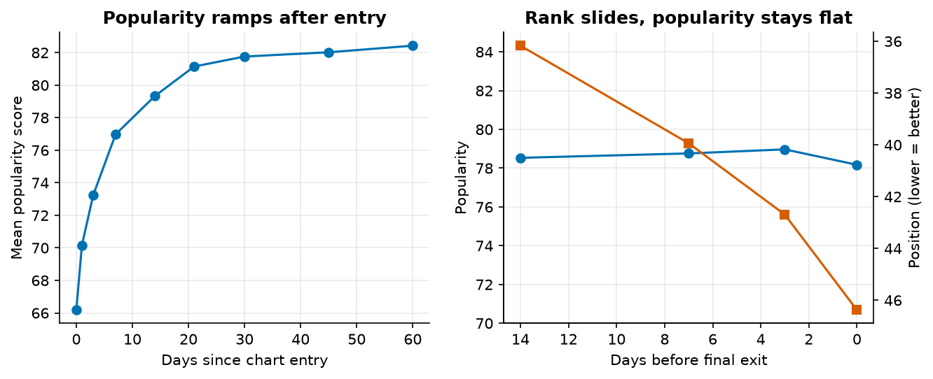
Figure 9. Popularity ramps after entry and stays flat while rank deteriorates before exit.

4.6 Early-warning model
We asked whether the first week predicts the outcome. Using 383 songs with an observed entry and at least three chart days in their first seven, and restricting to those whose 30-day outcome is observable (341), we trained on entries up to 2025-04-28 (n = 240) and tested on later entries (n = 101). Features: entry position, mean and best position, position slope and volatility, mean popularity in the window, explicit flag, release type, track count and duration.
Target | Base rate (test) | Logistic AUC | Gradient boosting AUC | Naive baseline AUC
Survives 30+ days | 50% | 0.87 | 0.82 | 0.74
Reaches Top 10 (any time) | 34% | 0.91 | 0.95 | 0.89

The naive baseline ranks songs by average first-week position. For 30-day survival the models beat it (AUC 0.87 vs 0.74); the most important feature is the first-week position slope (permutation importance 0.15 AUC points), followed by average first-week position. Content attributes carry almost no signal. The Top 10 result is partly circular, because a song's best first-week position already reveals whether it reached the Top 10, so we treat the survival result as the meaningful one. The test set is small (101 songs), so these AUCs carry wide uncertainty, and the model applies only to songs that last at least three days.

4.7 Lifecycle archetypes
K-means clustering on lifespan, peak, timing of peak, Top 10 share, volatility and entry position yields four archetypes (Figure 10). Silhouette scores are modest (0.30 for k = 4, 0.31 for k = 5), meaning the boundaries are soft; we use four because they are the most interpretable.
Archetype | Songs | Median days | Median peak | Median entry pos. | Single share | Re-entry share
Evergreen Hit | 67 | 118 | 2 | 7 | 55% | 37%
Slow Burner | 93 | 81 | 11 | 45 | 61% | 60%
Debut-and-Fade | 123 | 8 | 15 | 15 | 33% | 18%
Bottom-Chart Filler | 100 | 10 | 34 | 46 | 54% | 54%

- Evergreen Hit: enters high, peaks near the top and stays for months; the smallest group but the largest share of chart-days.
- Slow Burner: enters at the bottom, climbs for weeks and lasts long; majority singles, frequent re-entries.
- Debut-and-Fade: enters mid-chart at its best position and is gone in about a week; mostly album tracks.
- Bottom-Chart Filler: never leaves the lower half and never reaches the Top 10.
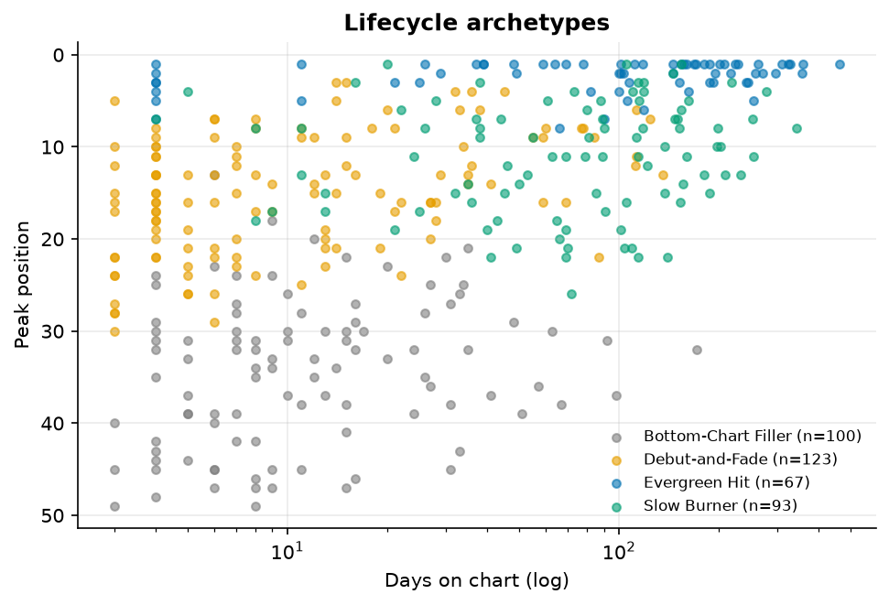
Figure 10. Lifecycle archetypes by lifespan and peak position.
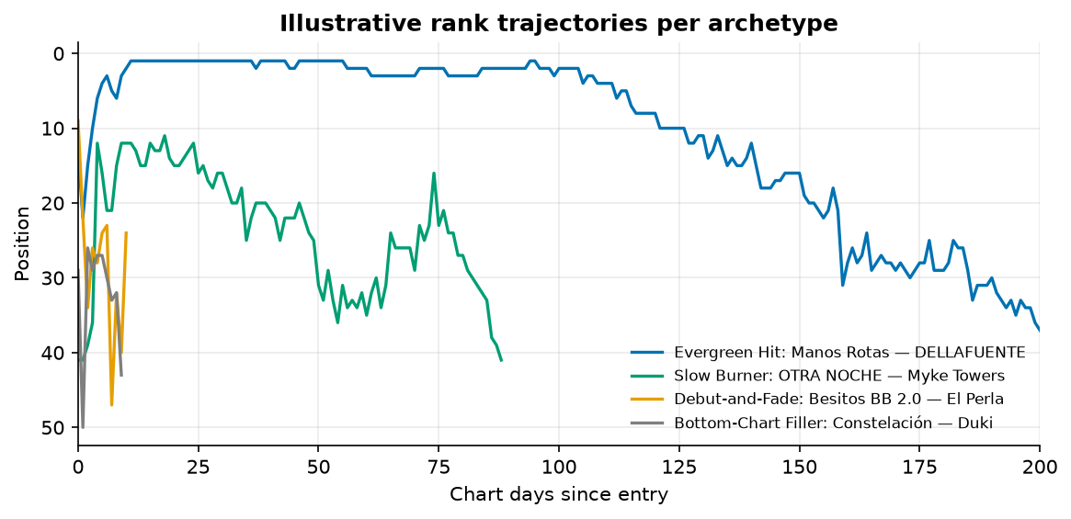
Figure 11. Example rank trajectories, one per archetype.

4.8 Fresh versus catalog balance
After a 90-day burn-in (chart age is unknown for songs already charting at the start), 28% of chart slot-days are held by songs 30 or fewer chart-days old, 11% by songs in their first week, and 42% by songs more than 90 chart-days old. The top of the chart is younger than the bottom: the average chart age of a Top 10 song is 53 days versus 109 at ranks 41-50. Spain's Top 50 is therefore more catalog-heavy than a pure freshness-driven market would be, with fresh share varying from 18% to 45% by month (Figure 12). Chart age is not release age, so this measures chart tenure only.
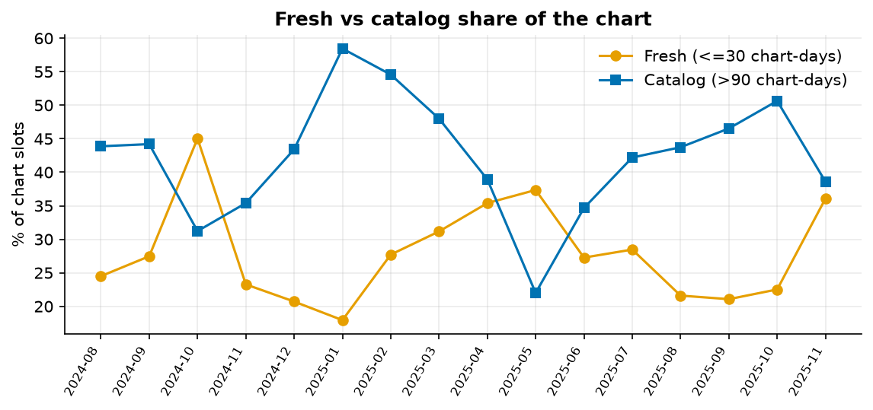
Figure 12. Fresh and catalog share of chart slots by month.

5. Key performance indicators
All KPIs are computed by the same code the dashboard uses, so filtered dashboard values reconcile with this table.
KPI | Value | Definition and reading
Average days on playlist | 45.8 | Mean chart days for songs with observed entry (median 11; KM median 13). The mean is pulled up by a long tail of evergreens.
Entry-to-peak time | 10.3 days (median 0) | Days from first appearance to best position. Most songs peak on day one; the mean reflects slow burners.
Playlist churn rate | 3.3% | New songs per day divided by 50 (1.67 songs/day). Excluding shock days: 2.7%.
Retention Stability Index | 39.4 | 100 x (1 - churn) / (1 + CV of churn); CV = 1.45. Higher is steadier. Low here because churn is spiky.
Explicit Lifecycle Score | 101 | Mean of explicit/clean ratios for average days, days in Top 10 and share reaching Top 10, times 100. 100 means identical behaviour.
Single vs Album Longevity Ratio | 1.71x | Mean days for singles / album tracks (median ratio 4.3x).
Freshness Index | 28% | Share of chart slots held by songs 30 or fewer chart-days old (after 90-day burn-in).
Catalog Share | 42% | Share of slots held by songs more than 90 chart-days old.
Top 10 turnover | 5.9% | New Top 10 songs per day divided by 10.
Median survival (KM) | 13 days | Days until half of new entries have left for good, accounting for censoring.

Segment | Avg days | KM median | Churn (own entries) | Top 10 turnover | RSI
Explicit | 47.6 | 12 | 1.4% | 2.8% | 30.5
Clean | 44.3 | 14 | 1.9% | 3.2% | 37.7
Single | 59.0 | 28 | 1.7% | 3.3% | 43.2
Album track | 34.4 | 8 | 1.8% | 2.7% | 27.8
Segment churn counts only the segment's own new entries against 50 slots, so segment values sum to roughly the overall rate.

6. Recommendations
Each recommendation is tied to the evidence above. Where the data can show an association but not a causal effect, we say so and propose a test.
- Lead with singles; use albums for a burst, not for longevity. Singles have a 28-day median survival versus 8 days for album tracks, and 48% vs 30% still charting at 30 days. Peak heights are similar, so albums are effective at earning a high debut but not at holding it. For an album release, choose one or two focus tracks to sustain after the drop, because 90% of drop-day entrants are album tracks with a median stay of 4 days. The single-versus-album gap is confounded with album size, so a staggered single-then-album rollout should be tested rather than assumed.
- Invest before and on release day, because day-one rank predicts the rest. 50% of songs peak on day one, and songs entering in the Top 10 have a 69% chance of lasting 30 days versus 25%-39% otherwise. Pre-release playlist pitching and pre-saves should be sized to land the debut position, not to fix a weak one later.
- Use a day-7 checkpoint. First-week rank slope and average position predict 30-day survival with AUC 0.87. Songs with an improving slope by day 7 are candidates for sustained spend; songs flat or falling at ranks 40-50 are likely to leave, so hold back budget. Validate on new releases before making budget rules out of it (test set of 101 songs).
- Do not read brief exits as failure, and time re-pushes to the Decline stage. 36% of songs leave and return, 48% of those gaps within three days, because ranks 41-50 turn over 75% of days. The average song slides about 10 places in its last two weeks, and a Mature song has a 16% daily chance of entering Decline. A re-push when a song first enters Decline is a reasonable test; the data show the pattern but cannot show that a re-push works.
- Make the explicit decision on creative and audience grounds, not lifecycle grounds. We found no lifecycle difference (log-rank p = 0.74, Explicit Lifecycle Score 101). Editing tracks to a clean version is unlikely to change chart tenure in Spain based on this data.
- Plan around shock days and capacity. A typical day opens only about 1 slot, so a new release competes for scarce space; 14 artist-flood days supply 20% of all entries. Consider avoiding same-week launches of a lower-priority release against a known rival album drop (an inference from slot displacement, not a tested effect), and note that new entries cluster on Mondays and Tuesdays.
- Balance the portfolio toward catalog upkeep. 42% of slots go to songs older than 90 chart-days versus 28% to songs 30 days or younger, and Evergreen Hits earn the most chart-days. Budget for sustaining the small number of songs that can reach evergreen status (17% of classified songs), rather than only launching new material.
- Do not use the popularity score as a real-time trigger. It lags rank by roughly nine days and does not fall as songs decline. Use chart position and slope.

7. Limitations
- No release dates: chart age is measured from first Top 50 appearance, so a song that released earlier and entered late looks new. Release-timing advice about days of the week cannot be derived from this file.
- Single-market data: claims that Spain rotates faster than the UK/US, or is more freshness-sensitive, cannot be tested. The absolute rotation seen here is low.
- Top 50 truncation: songs below rank 50 are invisible, so 'exits' include songs that dropped just under the cut and re-entry gaps are partly noise.
- Eighteen months: little repeat seasonality, so seasonal statements are limited to observed shock dates.
- Non-independence: songs by the same artist cluster, and album tracks arrive together. Standard errors do not account for this.
- Data handling assumptions: the first snapshot on 2025-03-01 was kept; popularity zeros were treated as missing; the normalisation rule may merge two different songs by the same primary artist with the same title (unlikely) or split versions with different titles.
- Weekday pattern: could reflect snapshot timing as well as real release behaviour.
- Early-warning results come from a small out-of-time test set and should be re-validated.

Appendix A. Definitions
- Chart day / observed day: one of the 555 dates with a snapshot.
- Total days on playlist: number of observed days the song appears (not the span between entry and exit).
- Time to peak: calendar days from first appearance to the first day of its best position.
- Left-censored: song present on the first date. Right-censored: song present on the last date.
- Shock day: a day with 8 or more new entries.
- Event (survival): final exit observed before the last date.

Appendix B. Stage sensitivity
Slope threshold | Vol. cap | New Entry | Growth | Peak | Mature | Decline
0.25 | 2 | 9% | 21% | 12% | 18% | 39%
0.25 | 3 | 9% | 21% | 12% | 18% | 39%
0.25 | 4 | 9% | 21% | 12% | 18% | 39%
0.5 | 2 | 9% | 14% | 15% | 34% | 27%
0.5 | 3 | 9% | 14% | 15% | 34% | 27%
0.5 | 4 | 9% | 14% | 15% | 34% | 27%
1 | 2 | 9% | 7% | 17% | 53% | 13%
1 | 3 | 9% | 7% | 17% | 53% | 13%
1 | 4 | 9% | 7% | 17% | 53% | 13%

Appendix C. Reproducibility
run_analysis.py rebuilds every table and statistic from data/Atlantic_Spain.csv and writes outputs/results.json. make_figures.py regenerates all figures, and app.py serves the dashboard. All random procedures use fixed seeds.

