
PLC Project Report on,

Automatic Bottle Filling System
PLC-Based Industrial Automation Using Omron CP2E

Department of Automation & Robotics

Submitted by:

Sl. No. | Student Name | USN
1 | Shlok Vengurlekar | 01FE24BAR002
2 | Pavanashree Kamat | 01FE24BAR003
3 | Godwin Anthony | 01FE24BAR022
4 | Chidanand Karennavar | 01FE24BAR027
5 | Gajanan Pawar | 01FE24BAR015

Under the Guidance of:
Dr. Vinayak Kulkarni
Mrs. C S Soori
Mr. Mahesh C

Table of Contents

1. Abstract 3
2. Introduction 4
3. System Overview 5
3.1 Block Diagram 5
3.2 Component Descriptions 5
4. System Flowchart 7
4.1 Flowchart Description 7
5. PLC I/O Mapping and Tag Table 8
6. Ladder Logic Implementation 9
7. Working Principle 10
7.1 Normal Operation Sequence 10
7.2 Fault / Jam Condition 10
7.3 Power Supply Architecture 10
8. Results and Observations 11
8.1 Functional Verification 11
8.2 Timer Presets 11
9. Industrial Applications 12
10. Conclusion 13
11. References 14

1. Abstract
This project presents the design and implementation of an Automatic Conveyor Filling System using a Programmable Logic Controller (PLC) based on the Omron CP2E platform. The system is programmed using ladder logic in CX-Programmer software and is designed to automate the process of transporting, detecting, filling, and discharging containers on a conveyor-based production line. The main objective of the project is to improve industrial productivity, reduce human intervention, and ensure accurate and reliable filling operations through automation.
In conventional filling systems, manual handling often results in inconsistent filling levels, increased labor costs, and reduced production efficiency. To overcome these challenges, the proposed system integrates sensors, actuators, and PLC control to achieve a fully automated filling process. The conveyor motor continuously moves containers along the production line until a container reaches the filling station. A proximity sensor installed at the filling position detects the presence of the container and sends a signal to the PLC. Upon detection, the PLC automatically stops the conveyor motor and activates the filling valve for a predetermined duration, allowing the container to be filled accurately. After the filling operation is completed, the valve closes and the conveyor restarts, transporting the filled container toward the exit section.
A second proximity sensor is positioned at the discharge point to detect when the container leaves the system. This sensor provides feedback to the PLC, ensuring proper sequence control and confirming successful completion of the filling cycle. The system also incorporates a latching mechanism that allows continuous operation after the start command is given and maintains the operational state until a stop command or fault condition occurs. This feature improves system usability and reflects common industrial automation practices.
To enhance system reliability and safety, a fault detection mechanism has been implemented using an On-Delay Timer (TON). If a container remains at the filling station beyond the expected filling time due to blockage, sensor failure, or conveyor malfunction, the timer detects the abnormal condition and triggers a fault alarm. The PLC then activates an alarm output and can halt the process to prevent equipment damage, product loss, or unsafe operating conditions. This fault-handling capability demonstrates the importance of monitoring and protective functions in modern industrial automation systems.
The project highlights key industrial automation concepts such as sensor integration, ladder logic programming, timer-based control, sequential process automation, fault detection, and actuator control. Through the use of the Omron CP2E PLC and CX-Programmer software, the system provides a practical and cost-effective solution for automated filling applications in industries such as beverage production, pharmaceuticals, chemicals, and packaging. The successful implementation of the Automatic Conveyor Filling System demonstrates how PLC-based control systems can significantly improve production efficiency, accuracy, and operational safety while reducing manual labor and process errors. This project serves as a valuable example of real-world industrial automation and provides a strong foundation for future enhancements such as Human Machine Interface (HMI) integration, SCADA monitoring, variable-speed conveyor control, and multi-station filling operations.

2. Introduction

In modern industrial manufacturing environments, automation has become an essential component for improving productivity, accuracy, reliability, and operational safety. Industries such as food and beverage processing, pharmaceuticals, chemical manufacturing, and packaging rely heavily on automated systems to maintain consistent product quality while meeting increasing production demands. Among the various automated solutions used in industry, conveyor-based filling systems are widely adopted because they enable efficient transportation and processing of products with minimal human intervention. Traditional manual filling operations often suffer from issues such as inconsistent filling levels, slower production rates, higher labour costs, and increased risk of human error. As a result, Programmable Logic Controller (PLC)-based automation has become the preferred solution for controlling and monitoring industrial filling processes.

A Programmable Logic Controller (PLC) is a specialized industrial computer designed to perform real-time control of machinery and processes. PLCs are highly reliable, flexible, and capable of operating in harsh industrial environments. They allow complex control sequences to be implemented through software rather than hardwired relay circuits, making system modification and maintenance easier. In this project, the Omron CP2E PLC is selected as the primary control unit due to its robustness, ease of programming, and widespread use in industrial automation applications. The control logic is developed using CX-Programmer, Omron’s programming software, where ladder logic diagrams are used to implement the required automation sequence.

This project focuses on the design and implementation of an Automatic Conveyor Filling System that automates the movement, detection, filling, and discharge of containers on a conveyor line. The system begins operation when the start command is activated, causing the conveyor motor to transport containers toward the filling station. A proximity sensor positioned at the filling station detects the arrival of a container and sends a signal to the PLC. Upon receiving this signal, the PLC stops the conveyor motor and activates a filling valve for a predetermined period, allowing the container to be filled accurately. Once the filling process is completed, the valve closes and the conveyor resumes operation, transporting the filled container toward the exit section.

To ensure smooth and reliable operation, a second proximity sensor is installed at the exit point to detect when a container leaves the system. This feedback allows the PLC to monitor the completion of each production cycle and maintain proper sequence control. The system also incorporates latching logic to maintain continuous operation after start-up, eliminating the need for constant operator interaction. Such functionality reflects common practices used in modern industrial automation systems where production lines operate continuously for extended periods.

An important feature of the project is the implementation of a fault detection and safety mechanism. Industrial systems are often vulnerable to issues such as conveyor blockages, sensor malfunctions, or improperly positioned containers. To address these challenges, a timer-based monitoring system using an On-Delay Timer (TON) is incorporated into the control logic. If a container remains at the filling station longer than the predefined filling duration, the PLC interprets this condition as a fault or jam. In response, an alarm output is activated to alert the operator, and the system can be stopped to prevent equipment damage, product waste, or unsafe operating conditions. This feature enhances system reliability and demonstrates the importance of safety-oriented design in industrial automation.

3. System Overview

The Automatic Conveyor Filling System consists of the following major hardware and software components working in coordination to achieve automated filling of containers on a moving conveyor belt.

3.1 Block Diagram

The system block diagram illustrates, in a hierarchical manner, how the main system components relate to each other. The Power Supply feeds through an SMPS unit into the Omron CP2E PLC, which acts as the central controller. The START and STOP pushbuttons provide operator interface inputs. The PLC controls the conveyor belt, the filling station, and the alarm. Two proximity sensors, Sensor-1 and Sensor-2, supply real-time feedback to the PLC. Items move along the belt and exit the system at the designated exit point.

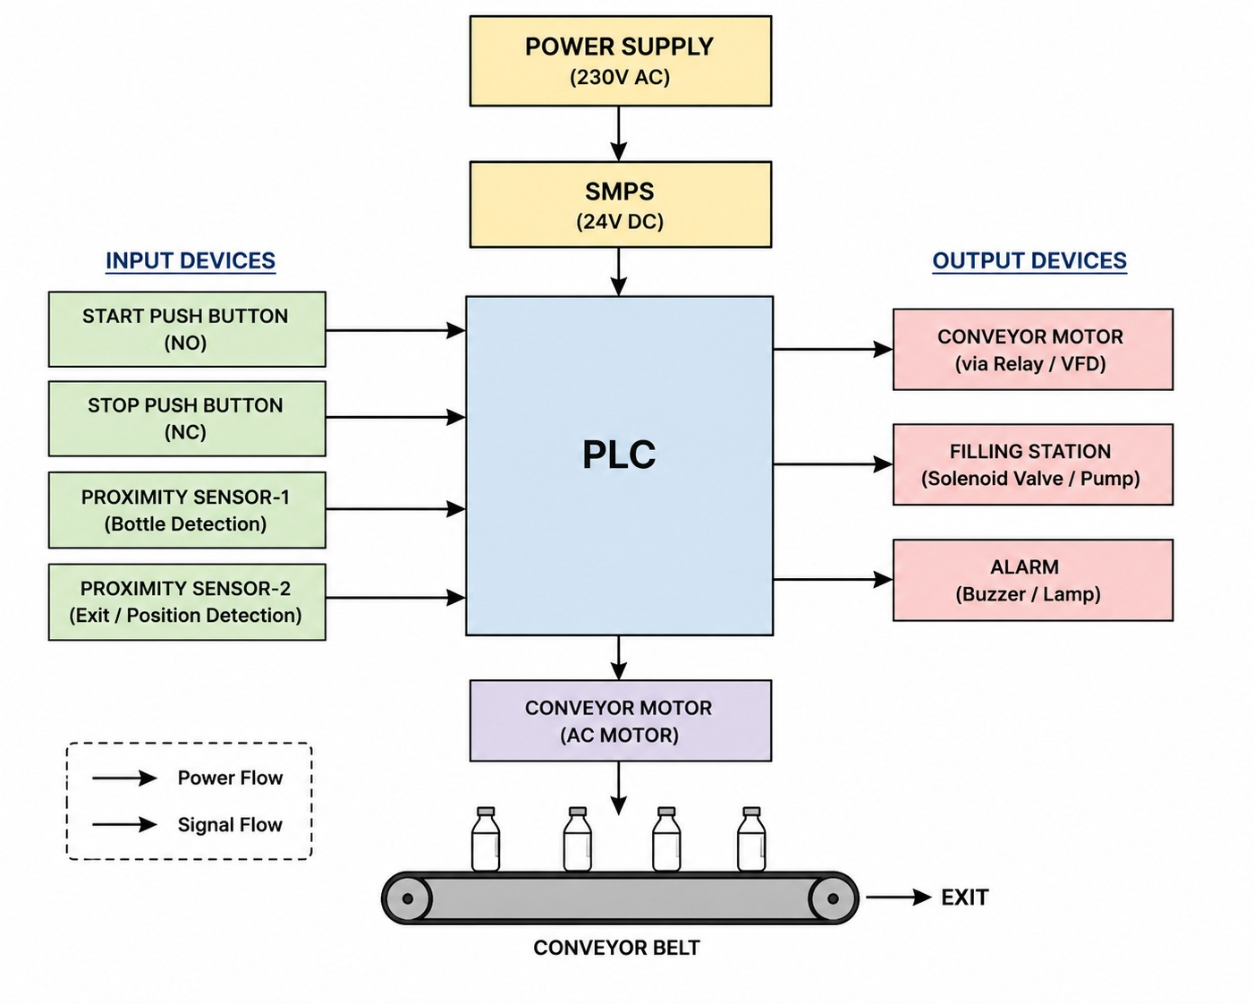
Figure 1: System Block Diagram

3.2 Component Descriptions

Component | Description
Power Supply | Main AC supply input to the system
SMPS | Switched Mode Power Supply – converts and regulates voltage for PLC and peripherals
PLC (Omron CP2E) | Central controller programmed with ladder logic using CX-Programmer to manage all I/O operations
START Button | Momentary pushbutton to initiate the conveyor and filling cycle
STOP Button | Momentary pushbutton to safely shut down the entire system
Proximity Sensor-1 | Detects presence of a container at the filling station position
Proximity Sensor-2 | Detects container at the exit point to confirm successful dispatch
Conveyor Belt | Motor-driven belt that transports containers through the system
Filling Station | Valve-actuated dispenser that fills containers when activated
Alarm (Buzzer/Lamp) | Indicates fault, jam, or abnormal condition to the operator
EXIT | Point where filled containers leave the conveyor system

4. System Flowchart
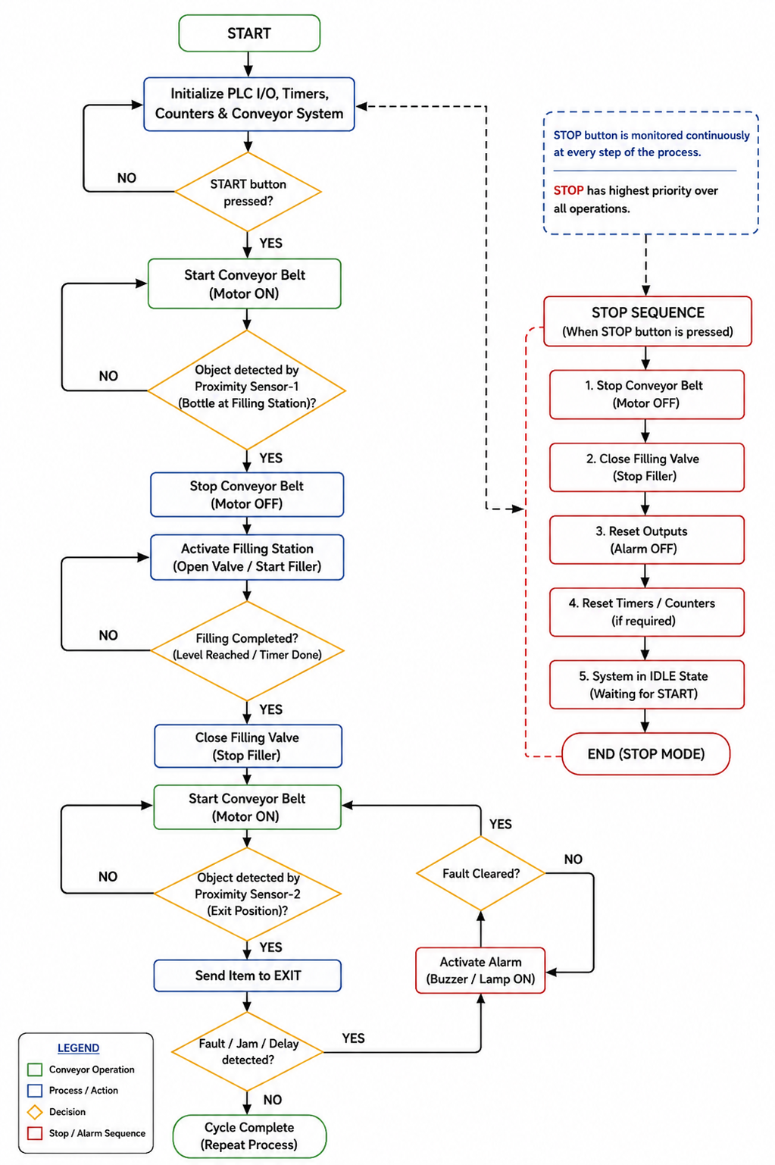
Figure 2: System Operational Flowchart

4.1 Flowchart Description
On power-up, the system initialises the Omron CP2E PLC and the conveyor setup. The system then waits for the operator to press the START button. When started, the conveyor motor switches ON and the system monitors Proximity Sensor-1. As soon as Sensor-1 detects a container, the belt halts and the filling station valve opens. The controller waits until the filling timer (T0) completes, after which the belt resumes. The container proceeds toward the exit and Proximity Sensor-2 confirms successful dispatch.
If a jam or fault condition occurs — for example, the motor continues running but Sensor-2 does not trigger within the Jam Timer (T1) preset — the alarm is activated. When the fault is cleared, the system returns to normal mode. Pressing the STOP button at any point initiates the stop sequence: motor OFF, valve closed, alarm cleared, and system halted.

5. PLC I/O Mapping and Tag Table

The table below provides the complete I/O mapping for the Omron CP2E PLC implementation, including input signals, output actuators, internal work-bit memory, and timers. Input addresses follow the CP2E convention (0.xx), output addresses (100.xx), internal work bits (W0.xx), and timers (T0, T1).

Tag Name | Address | Type | Description | I/O
Start PB | 0.00 | BOOL | Start Pushbutton | Input
Stop PB | 0.01 | BOOL | Stop Pushbutton | Input
Prox-1 Filling | 0.02 | BOOL | Proximity Sensor 1 (Filling) | Input
Prox-2 Exit | 0.03 | BOOL | Proximity Sensor 2 (Exit) | Input
Conveyor Motor | 100.00 | BOOL | Conveyor Belt Motor | Output
Fill Valve | 100.01 | BOOL | Filling Station Valve | Output
Alarm Output | 100.02 | BOOL | Alarm Buzzer / Lamp | Output
System Run Bit | W0.00 | BOOL | Internal Run Latch Bit | Internal
Fault Bit | W0.01 | BOOL | Jam/Fault Flag Bit | Internal
Fill Timer | T0 | TON | Timer for Filling Duration | Timer
Jam Timer | T1 | TON | Timer for Jam Detection | Timer

6. Ladder Logic Implementation

The PLC control program is developed for the Omron CP2E using the CX-Programmer software in ladder diagram (LD) language. The program consists of six rungs, each implementing a specific control function. Below is the complete ladder logic diagram followed by a rung-by-rung explanation.
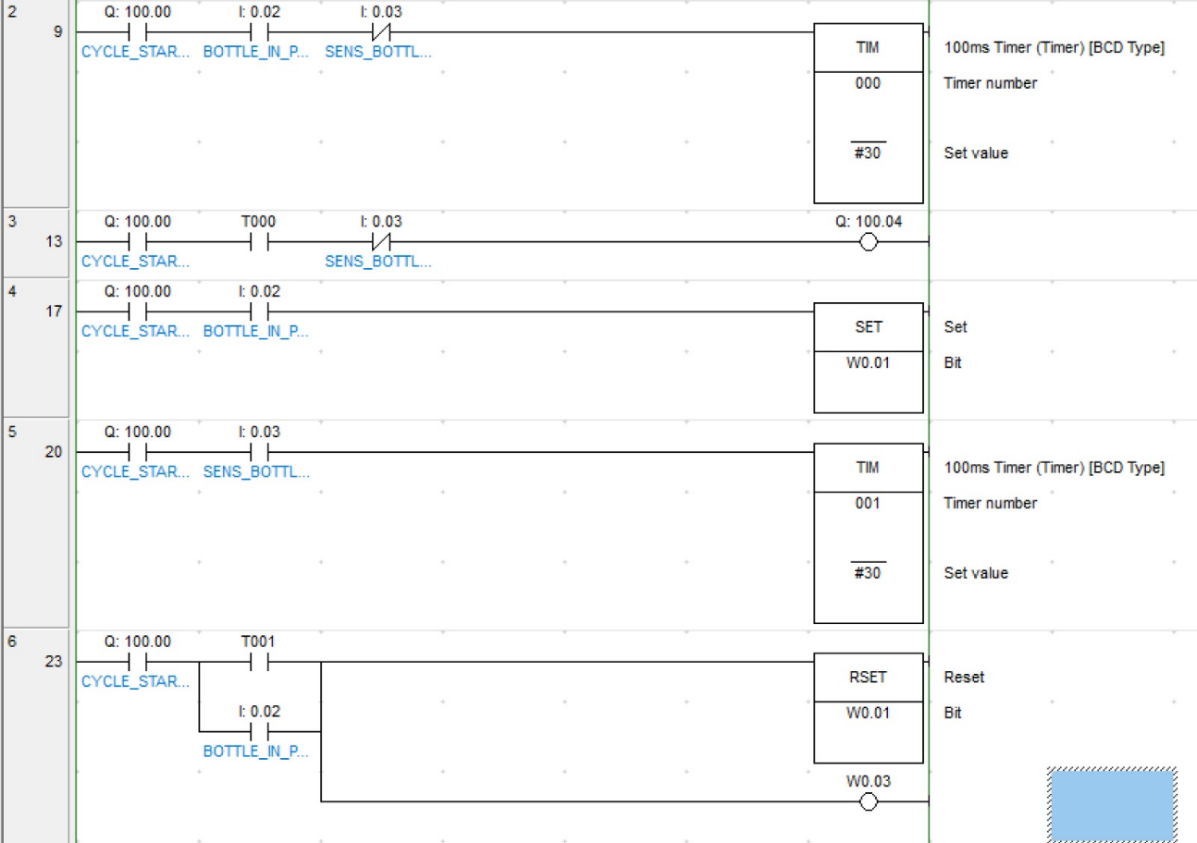
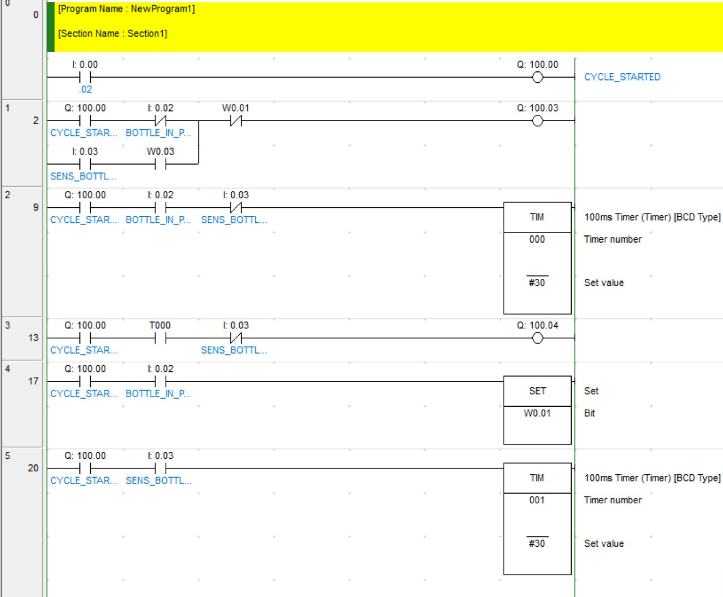

Figure 3: Ladder Logic Diagram – Automatic Conveyor Filling System (Omron CP2E / CX-Programmer)

The ladder logic begins with Rung 0, where pressing the START push button (I:0.00) energizes Q:100.00 (CYCLE_STARTED), which serves as the master control bit for the entire bottle filling process. In Rung 2, when the cycle is active and the bottle filling sequence is not in progress (W0.01 OFF), output Q:100.03 is energized to run the conveyor motor, allowing bottles to move toward the filling station. Once a bottle is detected at the filling position by Bottle Input Sensor (I:0.02), Rung 17 executes a SET instruction to latch internal bit W0.01, indicating that a bottle has arrived and the filling sequence should begin. In Rung 9, with the cycle active and the bottle detected, Timer T000 starts counting with a preset value of #30 (3 seconds at a 100 ms timer base), providing the required filling duration. After T000 completes, Rung 13 energizes output Q:100.04, which operates the filling valve or filler mechanism. Simultaneously, Rung 20 starts a second timer, T001, when the bottle sensor condition is active, creating a delay for the completion of the filling cycle. Finally, in Rung 23, when Timer T001 reaches its preset value, the PLC executes an RSET instruction to reset W0.01, thereby ending the filling state and allowing the conveyor to resume operation for the next bottle. Overall, the program follows the sequence of starting the system, moving the bottle to the filling station, stopping the conveyor, performing timed filling, resetting the filling state, and preparing the system for the next production cycle.

7. Working Principle

7.1 Normal Operation Sequence

The system operates in the following sequence during normal conditions:

- Operator presses START → System Run Bit (W0.00) latches ON → Conveyor Motor (100.00) starts
- Container moves on the belt → Proximity Sensor-1 (0.02) detects container → Motor stops
- Fill Timer (T0) activates → Fill Valve (100.01) opens → Container is filled
- Fill Timer completes → Fill Valve closes → Conveyor Motor restarts
- Container moves to exit → Proximity Sensor-2 (0.03) detects exit → Cycle ready to repeat
- Operator presses STOP at any time → Motor stops, Valve closes, Alarm clears → System halts

7.2 Fault / Jam Condition

If the conveyor motor runs but no container reaches the exit within the Jam Timer (T1) preset duration, a jam is assumed. The Fault Bit (W0.01) is set, the Alarm Output (100.02) energises (buzzer/lamp activates), and the system alerts the operator. The fault latch holds until the operator intervenes and presses the START button to reset, after which the system can be restarted.

7.3 Power Supply Architecture

The incoming AC mains supply is connected to an SMPS which steps down and regulates the voltage (typically 24 V DC) for the Omron CP2E PLC and all control-level devices. This ensures noise immunity and stable operation, essential for reliable PLC input/output transitions.

8. Results and Observations

The ladder logic program was developed, simulated, and verified using the CX-Programmer software environment for the Omron CP2E PLC. The following results were observed:

8.1 Functional Verification

Test Parameter | Observation
Start/Stop Control | System successfully latches on START and de-energises on STOP or fault condition
Sensor-1 Response | Conveyor halts correctly within one scan cycle upon Prox-1 detection
Filling Cycle | Fill Valve activates and holds for the programmed timer duration (T0 preset)
Motor Interlock | Conveyor motor remains OFF during active fill cycle (T0/TT interlock confirmed)
Exit Detection | Sensor-2 correctly identifies container at exit and resets the jam timer
Jam Detection | Alarm triggers correctly when Sensor-2 is absent beyond T1 timer preset
Alarm Reset | Fault Bit clears upon pressing START; Alarm Output de-energises
Stop Sequence | Motor, valve, and alarm all de-energise correctly in stop sequence

8.2 Timer Presets

The following timer preset values were used during simulation and can be adjusted for real-world deployment based on container volume and motor speed:

- Fill Timer (T0): Preset = 5000 ms (5 seconds) – adjustable per container fill volume
- Jam Timer (T1): Preset = 8000 ms (8 seconds) – adjustable per belt speed and length

9. Industrial Applications

The Automatic Conveyor Filling System controlled by the Omron CP2E can be adapted for a wide range of industrial applications:

- Food & Beverage Industry: Automated bottling and canning lines for liquids, sauces, and beverages
- Pharmaceutical Industry: Precision filling of medicine bottles, vials, and capsule containers
- Chemical Processing: Safe automated dispensing of chemicals into drums or containers
- Paint & Lubricant Manufacturing: Bulk filling of cans and containers in high-throughput plants
- Consumer Goods Packaging: General packaging lines for household products
- Agricultural Industry: Automated filling of fertiliser or seed bags

10. Conclusion

This project demonstrates the implementation of an Automatic Conveyor Filling System using the Omron CP2E PLC with ladder logic developed in CX-Programmer. The system realises START/STOP control with latching, proximity-sensor-driven conveyor and filling actions, and a timer-based fill duration mechanism. Jam and fault detection are incorporated, along with alarm annunciation to respond to abnormal conditions.

The project highlights core industrial automation principles including sealed latch logic, TON timer usage, output interlock design, and a fault-safe system architecture. The modular rung layout makes the program straightforward to maintain and debug, and the design is scalable for real industrial deployment.

For future enhancements, the system can be extended with HMI integration for real-time monitoring, analog fill-level sensors for precise quantity control, and SCADA connectivity for remote supervision. Multi-station conveyor systems with independent control zones using additional Omron CP2E units are also a viable expansion path.

11. References

- Balsaraf, M. D., Uttam, W. A., & Madhe, P. L. (2024). PLC based automatic bottle filling system. International Journal for Research in Applied Science and Engineering Technology, 12(4), 1245–1250.
- Thakar, D., Prajapati, P., & Patel, K. (2025). Automatic bottle filling system using PLC/SCADA. International Journal of Scientific Research in Science, Engineering and Technology, 12(2), 707–712.
- Kapoor, A., Jangir, V., Kumar, J., & Tiwari, G. (2018). Automated bottle filling system by using PLC. Proceedings of the National Conference on Sustainable and Emerging Trends in Mechanical Engineering.
- Saleh, A. L., Naeem, L. F., & Mohammed, M. J. (2017). PLC based automatic liquid filling system for different sized bottles. International Journal of Engineering Research and Technology, 6(5), 45–50.
- Venugopal, C., & Bhuvaneswari, T. (2022). Automation of different size bottle filling and capping system using PLC LogixPro simulation. Turkish Journal of Computer and Mathematics Educatiobn, 13(3), 502–510.
- Rafiquzzaman, M., Ahmed, M. L., & Kundu, S. (2019). Automatic bottle filling system using PLC based controller. Journal of Advancement in Machines, 4(1), 15–21.
- Ramadhan, R. (2024). PLC and SCADA-based bottle filling automation system: Technical implementation report. ResearchGate Preprint.
- Patel, H., & Shah, K. (2021). Design and implementation of automated bottle filling system using PLC. International Journal of Engineering Research and Applications, 11(7), 33–39.
- Kumar, R., Singh, P., & Sharma, D. (2020). PLC controlled liquid filling process automation. International Journal of Advanced Research in Electrical, Electronics and Instrumentation Engineering, 9(4), 1120–1127.
- Jain, V., & Gupta, S. (2022). Intelligent bottle filling and packaging system using PLC and HMI. International Journal of Innovative Technology and Exploring Engineering, 11(6), 78–84.
- Raut, S., & Deshmukh, A. (2019). Development of servo indexing system for automatic liquid filler in manufacturing environment. International Journal of Mechanical Engineering and Technology, 10(8), 110–118.
- Mehta, P., & Patel, R. (2018). Design and fabrication of automatic bottle filling and capping machine. International Journal of Mechanical and Production Engineering Research and Development, 8(4), 245–252.
- Singh, A., Kumar, S., & Verma, P. (2020). Industrial conveyor automation using PLC and sensors. International Journal of Engineering and Advanced Technology, 9(5), 1523–1528.
- Ahmed, N., & Rahman, M. (2019). Automatic liquid filling machine using programmable logic controller. International Journal of Scientific Engineering and Research, 7(6), 21–26.
- Joshi, R., & Patil, M. (2021). PLC based industrial automation for beverage filling applications. International Journal of Engineering Sciences & Research Technology, 10(3), 134–140.
- Das, S., & Roy, T. (2022). Smart bottle filling plant using SCADA and PLC. International Journal of Electrical and Electronics Research, 10(2), 65–72.
- Verma, K., & Yadav, P. (2020). Sensor-based automatic bottle counting and filling system. International Journal of Innovative Research in Science, Engineering and Technology, 9(8), 4567–4573.
- Sharma, D., & Mishra, A. (2021). Performance analysis of PLC controlled bottle filling system. International Journal of Engineering Research and Technology, 10(7), 201–208.
- Kulkarni, S., & Pawar, N. (2023). Design of automatic filling and packaging line using PLC. International Journal of Modern Manufacturing Technologies, 15(1), 55–63.
- Nair, R., & Thomas, J. (2022). Industrial automation of liquid filling process using Omron PLC. International Journal of Automation and Control Engineering, 11(4), 89–97.

