RF Fingerprinting Using Deep Learning

Shlomi Ben Abu Or Harush

## Introduction

### Project Goal

The goal of this project is to improve the accuracy and robustness of Radio Frequency (RF) fingerprinting using deep learning techniques, specifically transformer-based architecture. By leveraging the power of transformers, the project aims to enhance classification performance, especially in low signal-to-noise ratio (SNR) environments.

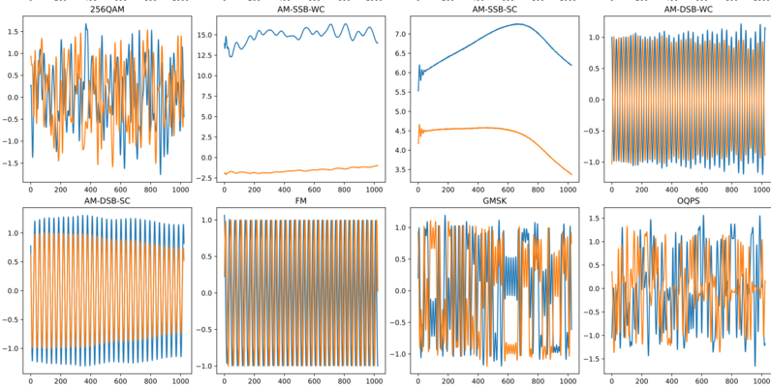

### Motivation

RF fingerprinting is a critical aspect of wireless security, used to identify and authenticate devices based on their unique RF signal characteristics. Traditional methods rely on handcrafted features and classical machine learning models, which often fail in noisy environments. Deep learning has recently demonstrated superior performance, particularly with convolutional neural networks (CNNs) and recurrent neural networks (RNNs). However, transformers have emerged as a powerful alternative due to their ability to capture long-range dependencies and model sequential data efficiently.

### Previous Work

Early RF fingerprinting techniques relied on statistical methods and feature engineering to extract relevant signal characteristics.

With the advent of deep learning, CNNs and RNNs have been employed to automatically learn features from raw RF signals.

Recent works have demonstrated the effectiveness of these models but highlighted their limitations in low snr.

Transformers, originally developed for natural language processing, have shown promise in signal processing tasks due to their self-attention mechanism and ability to learn contextual dependencies.  
  
<https://github.com/alexivaner/Deep-Learning-Based-Radio-Signal-Classification>

## Method

### Model Architecture

* Fully Connected
* Transformer Block
* Average Pooling
* Batch Normalization
* Dropout Layer
* Fully Connected
* Dropout Layer
* Fully Connected Layer
* Dropout Layer
* 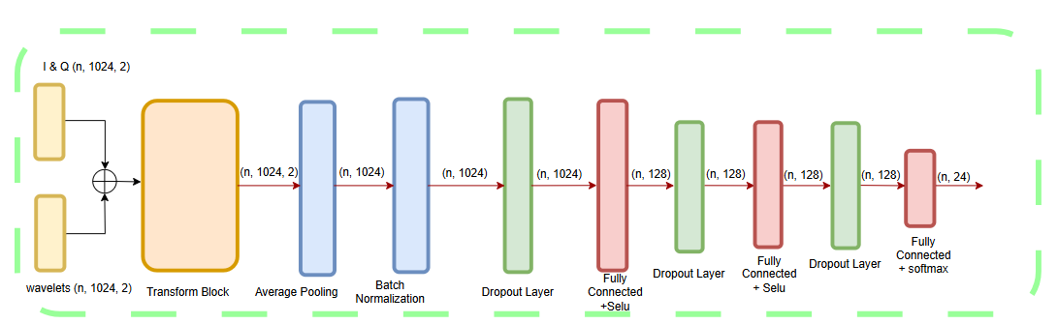fully connected + Softmax.

### Data processing

Wavelets are mathematical functions used to analyze and process signals at different scales and resolutions. They are particularly useful for decomposing a signal into different frequency components while preserving spatial (or temporal) information.

Unlike Fourier transforms, which break signals into sine and cosine components (which have infinite support), wavelet transforms use localized basis functions that adapt to the signal’s structure. This makes wavelets particularly effective in analyzing non-stationary signals, such as images, audio, or time-series data.

Some advantages using wavelets in deep learning model

* Feature Extraction

Wavelets help in extracting multi-scale features, capturing both fine details and coarse structures in images, audio, time-series data.

* Noise Reduction

Applying a wavelet transform, high-frequency noise can be separated from useful features.

* Improved Generalization

Models trained on wavelet-transformed data often generalize better as wavelets help in reducing overfitting by focusing on essential features.

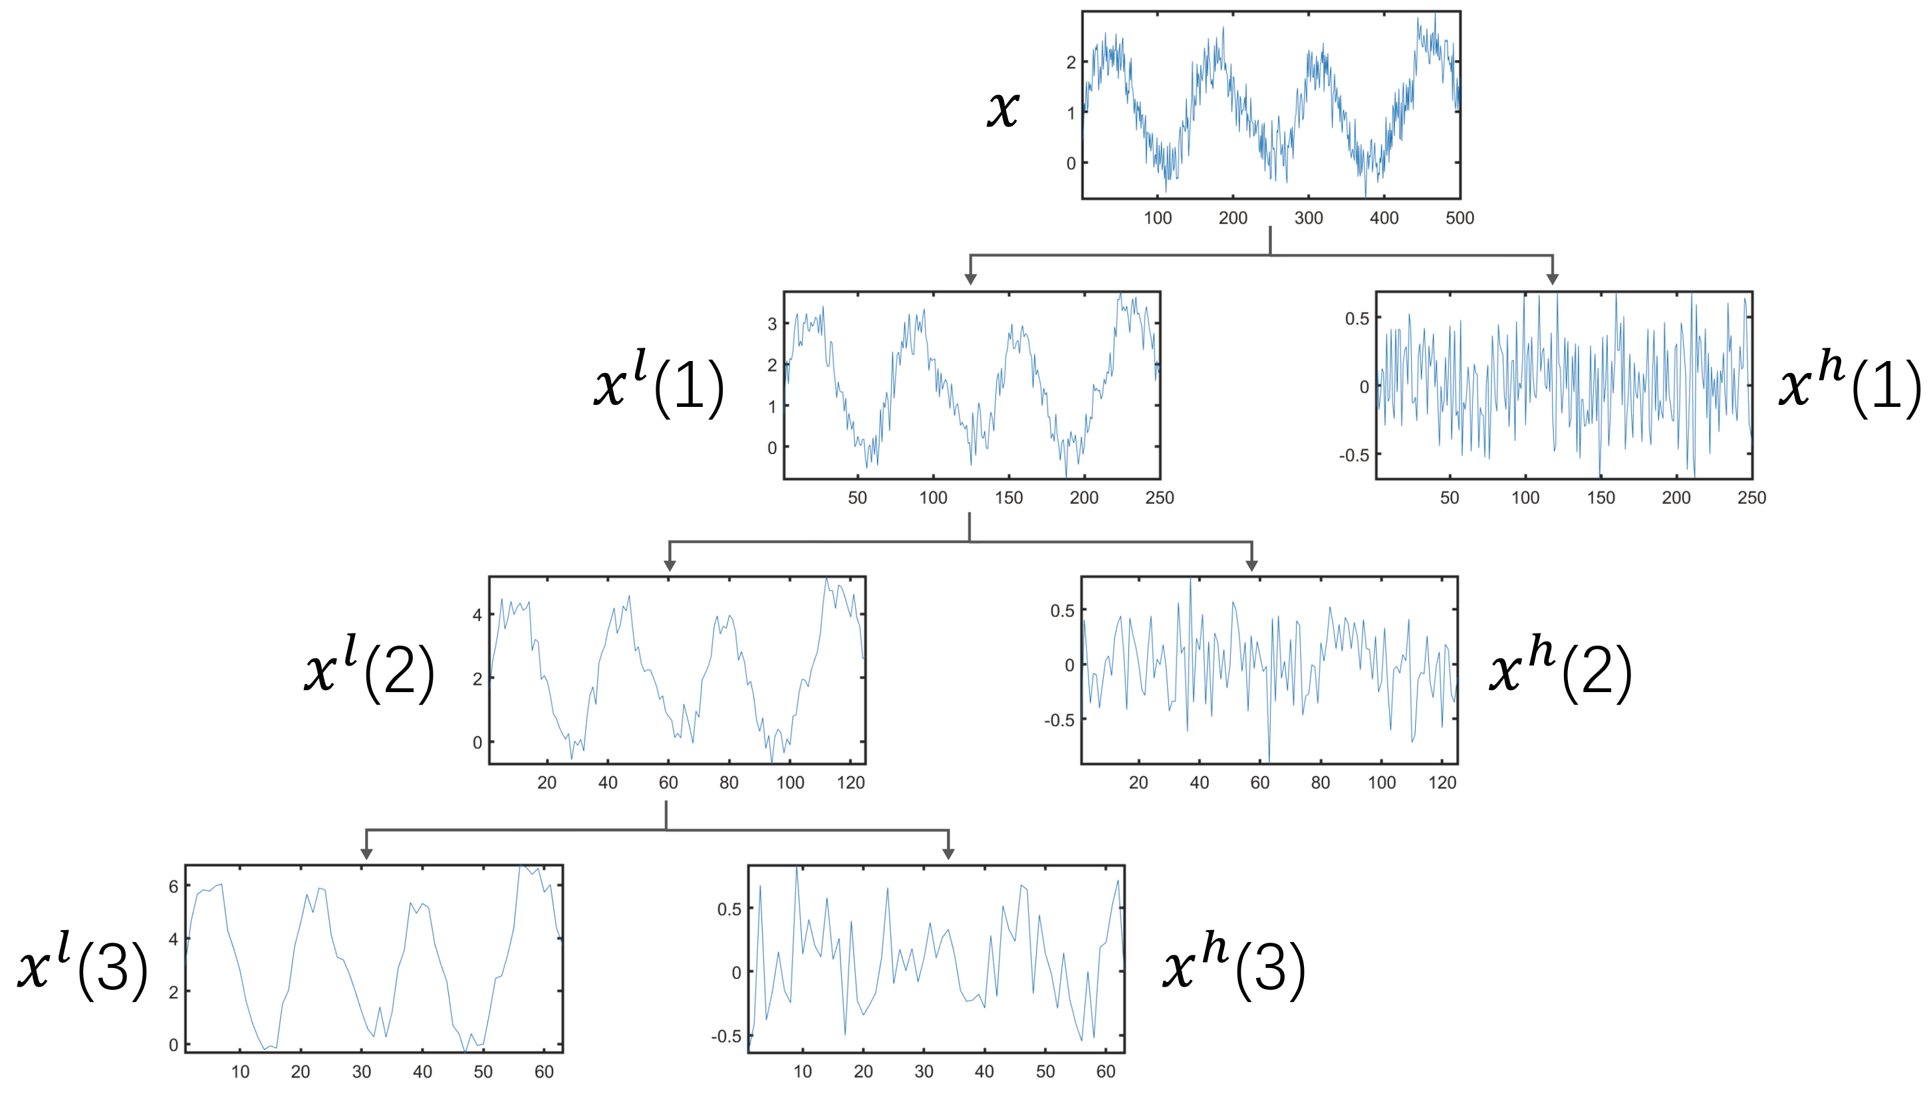

### Loss Function and Optimization

The model is trained using the cross-entropy loss function, which is well-suited for multi-class classification. The Adam optimizer is employed to efficiently update model weights and improve convergence.

## Experiments and Results

### Dataset

The experiments were conducted using the RADIOML 2018.01A dataset [1], which contains 24 different RF signal modulations.

The dataset exhibits the following structure:

* 24 modulations: OOK, ASK4, ASK8, BPSK, QPSK, PSK8, PSK16, PSK32, APSK16, APSK32, APSK64, APSK128, QAM16, QAM32, QAM64, QAM128, QAM256, AM_SSB_WC, AM_SSB_SC, AM_DSB_WC, AM_DSB_SC, FM, GMSK and OQPS.
* 26 SNRs per modulation (-20 dB to +30 dB in steps of 2dB).
* 4096 frames per modulation-SNR combination.
* 1024 complex time-series samples per frame.
* Samples as floating point in-phase and quadrature (I/Q) components, resulting in a (1024,2) frame shape.

2,555,904 frames in total.

### Experimental Setup

The model was trained in a high-performance computing environment with the following settings:  
- Training Dataset Size: 112,000 frames

- Validation Dataset Size: 28,000 frames

- Batch Size: 4096 frames/batch

- Learning Rate: 1e-6 (decay during training)

### Performance Evaluation

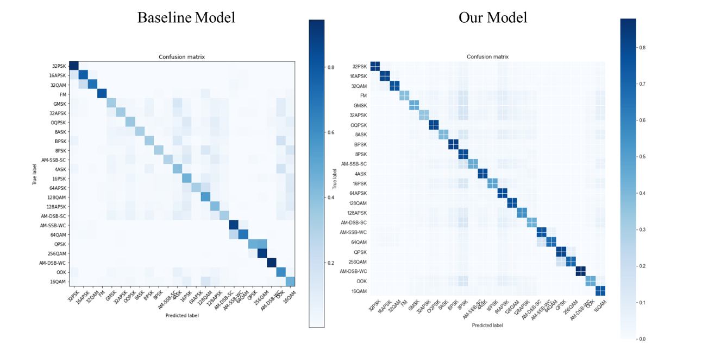Confusion Matrix: A confusion matrix was generated to assess model classification accuracy across different modulation types.

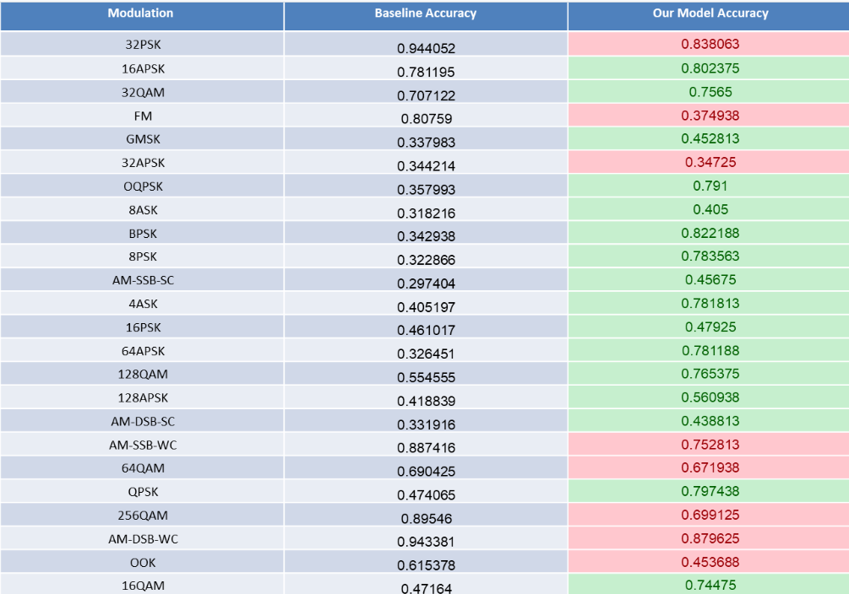It can see that our matrix is more diagonal than the baseline matrix.

We improve the accuracy for 16 classes compare to the baseline method.

We check the model for different SNR values, and as seen in the image below, the model improves detection compared to the other method and also provides good results for high SNR.

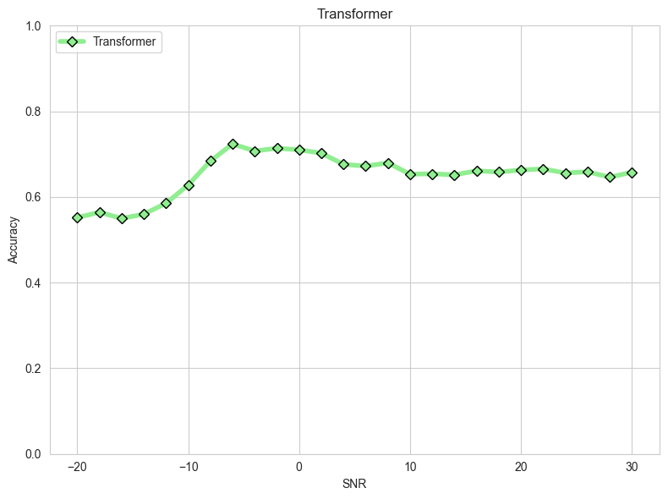

## Conclusion and Future Work

### Conclusion

This project demonstrates that transformer-based RF fingerprinting significantly enhances classification accuracy, particularly in challenging low-SNR environments. The self-attention mechanism enables the model to capture complex dependencies in RF signals, making it a promising alternative to traditional deep learning approaches.

Additionally, wavelet's transform improves the accuracy of transformer-based model.

### Future Work

Several avenues exist for further improving this approach:  
- Real-Time Classification: Optimizing model efficiency for deployment in real-world applications.  
- Baud Rate Estimation: Extending the model to estimate the baud rate for each signal, providing additional classification insights.

- Adversarial Robustness: Investigating the model’s resistance to adversarial attacks in wireless security.

## Ethics Statement

|  |
| --- |
| 1. **Introduction**  **Student names:** Shlomi Ben Abu & Or Harush  **Project Title:** "RF fingerprinting Using Deep Learning"  **Description:**  Our project aims to classify radio frequency signals in low SNR. This mission can improve wireless communication by optimizing spectrum usage. Moreover, it can enhance security by detecting unauthorized or malicious signals |
| 2. Have a large language model (LLM) answer the following questions on your project:  **2a. Three Types of Stakeholders Affected by the Project**   1. Wireless Communication Industry Professionals. 2. Regulatory Bodies and Government Agencies. 3. End Users of Wireless Devices..   **2b. Explanation for Each Stakeholder**   1. This advancement improves device authentication and security in low-SNR environments, making it valuable for wireless communication providers, security firms, and research institutions. 2. By leveraging deep learning, this project provides a more reliable method for identifying unauthorized or malicious signals, supporting cybersecurity and national security efforts. 3. As a result, users benefit from safer communication, reduced interference, and better network performance.   **2c. Responsibility for Providing the Explanation**   1. Wireless Communication Industry Professionals – The research and development teams, along with project leaders. 2. Regulatory Bodies and Government Agencies – Compliance officers, cybersecurity experts, and legal teams should communicate with regulators through official reports, policy recommendations, and advisory meetings to demonstrate the security and efficiency benefits of RF fingerprinting. 3. End Users of Wireless Devices. |
| 3. To make the AI response more ethical, it should emphasize transparency, potential biases, and real-world implications. For example, it could mention the ethical concerns of RF fingerprinting, such as its potential misuse for surveillance or privacy violations. Additionally, the response should acknowledge that AI models, including transformers, can inherit biases from training data, which might impact fairness in RF signal classification. Including a disclaimer about data sources, limitations, and the importance of responsible AI deployment would make the explanation more balanced and ethical, ensuring stakeholders understand both the benefits and risks. |

References

[1] <https://www.kaggle.com/datasets/pinxau1000/radioml2018>

[2] Farhan Tandia, Ivan Surya Hutomo: <https://github.com/alexivaner/Deep-Learning-Based-Radio-Signal-Classification>

[3] Sahu, Antorip. Gated Transformer-Based Architecture for Automatic Modulation Classification. Diss. Virginia Tech, 2024.‏

[4] Lu, Q., Yang, Z., Zhang, H., Chen, F., Xian, H.: Mrfe: a deep learning based multidimensional radio frequency fingerprinting enhancement approach for iot device identification. IEEE Internet Things J. (2024). <https://doi.org/10.1109/JIOT.2024.3414195>