RF Fingerprinting Using Deep Learning

Shlomi Ben Abu Or Harush

## Introduction

### Project Goal

The goal of this project is to improve the accuracy and robustness of Radio Frequency (RF) fingerprinting using deep learning techniques, specifically transformer-based architecture. By leveraging the power of transformers, the project aims to enhance classification performance, especially in low signal-to-noise ratio (SNR) environments.

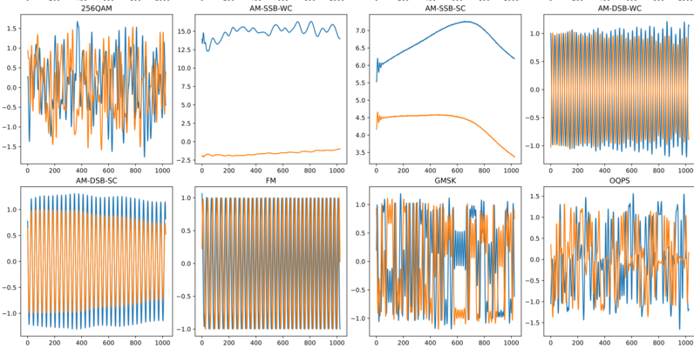

### Motivation

RF fingerprinting is a critical aspect of wireless security, used to identify and authenticate devices based on their unique RF signal characteristics. Traditional methods rely on handcrafted features and classical machine learning models, which often fail in noisy environments. Deep learning has recently demonstrated superior performance, particularly with convolutional neural networks (CNNs) and recurrent neural networks (RNNs). However, transformers have emerged as a powerful alternative due to their ability to capture long-range dependencies and model sequential data efficiently.

### Previous Work

Early RF fingerprinting techniques relied on statistical methods and feature engineering to extract relevant signal characteristics. With the advent of deep learning, CNNs and RNNs have been employed to automatically learn features from raw RF signals. Recent works have demonstrated the effectiveness of these models but highlighted their limitations in handling high-dimensional, complex signal representations. Transformers, originally developed for natural language processing, have shown promise in signal processing tasks due to their self-attention mechanism and ability to learn contextual dependencies.  
  
<https://github.com/alexivaner/Deep-Learning-Based-Radio-Signal-Classification>

## Method

### 408818598-5054246b-cc0e-4806-a8fb-90eb539aad12.pngModel Architecture

The proposed approach utilizes a transformer-based model to classify RF signals. The architecture consists of:  
- Input Layer: Raw RF signal data is fed into the model.  
- Embedding Layer: Signals are transformed into high-dimensional feature representations.  
- Transformer Encoder: Multiple self-attention layers capture temporal dependencies and learn feature relationships.  
- Classification Head: Fully connected layers followed by a softmax activation to predict the modulation type.

### Loss Function and Optimization

The model is trained using the cross-entropy loss function, which is well-suited for multi-class classification. The Adam optimizer is employed to efficiently update model weights and improve convergence.

## Experiments and Results

### Dataset

The experiments were conducted using the RADIOML 2018.01A dataset [1], which contains 24 different RF signal modulations.

The dataset exhibits the following structure:

* 24 modulations: OOK, ASK4, ASK8, BPSK, QPSK, PSK8, PSK16, PSK32, APSK16, APSK32, APSK64, APSK128, QAM16, QAM32, QAM64, QAM128, QAM256, AM_SSB_WC, AM_SSB_SC, AM_DSB_WC, AM_DSB_SC, FM, GMSK and OQPS.
* 26 SNRs per modulation (-20 dB to +30 dB in steps of 2dB).
* 4096 frames per modulation-SNR combination.
* 1024 complex time-series samples per frame.
* Samples as floating point in-phase and quadrature (I/Q) components, resulting in a (1024,2) frame shape.

2.555.904 frames in total.

### Experimental Setup

The model was trained in a high-performance computing environment with the following settings:  
- Training Dataset Size: [Specify number of samples]  
- Validation Dataset Size: [Specify number of samples]  
- Batch Size: [Specify batch size]  
- Learning Rate: [Specify learning rate]

### Performance Evaluation

Confusion Matrix: A confusion matrix was generated to assess model classification accuracy across different modulation types. The results show that the transformer-based model performs particularly well in low-SNR conditions compared to traditional deep learning methods.  
  
Training Progress:  
- Loss Curve: The model exhibits stable convergence over training epochs.  
- Accuracy Curve: The accuracy improves consistently, indicating effective learning.  
  
Comparison with Previous Methods:  
- Higher Accuracy: Improved classification rates, particularly in low-SNR conditions.  
- Robustness: Better generalization across diverse RF environments.

## Conclusion and Future Work

### Conclusion

This project demonstrates that transformer-based RF fingerprinting significantly enhances classification accuracy, particularly in challenging low-SNR environments. The self-attention mechanism enables the model to capture complex dependencies in RF signals, making it a promising alternative to traditional deep learning approaches.

### Future Work

Several avenues exist for further improving this approach:  
- Real-Time Classification: Optimizing model efficiency for deployment in real-world applications.  
- Baud Rate Estimation: Extending the model to estimate the baud rate for each signal, providing additional classification insights.

- Adversarial Robustness: Investigating the model’s resistance to adversarial attacks in wireless security.

## Ethics Statement

|  |
| --- |
| 1. **Introduction**  **Student names:** Shlomi Ben Abu & Or Harush  **Project Title:** "RF fingerprinting Using Deep Learning"  **Describe your project**, i.e. what does the project do? what does it aim to achieve? Our project aims to classify radio frequency signals in low SNR. This mission can improve wireless communication by optimizing spectrum usage. Moreover, it can enhance security by detecting unauthorized or malicious signals |
| 3. Reflect on the AI output (this section requires your independent, creative thinking. Do not use LLMs for this stage!):  3a. What do you think needs to be added/changed in the Generative AI responses, to make the explanation more ethical?  I think that make the Generative AI responses more ethical the model need to reference all the data which is based on when the answer is given. |
|  |

## References

[1] <https://www.kaggle.com/datasets/pinxau1000/radioml2018>