Digital Twin Brain simulation and manipulation of a functional brain network underlying mental disorders.
Authors:
Yunman Xia^{1, 2†}, Songjun Peng^{3†}, Juergen Dukart^{4, 5}, Liyi Qian¹, Chao Xie⁶, Shitong Xiang^{7, 8}, Spase Petkoski⁹, Zilin Li¹⁰, Joerg Hipp¹¹, Suresh Muthukumaraswamy¹², Anna Forsyth¹², Tianye Jia^{2, 7, 8}, Nilakshi Vaidya¹, Tristram, Lett¹, Xiao Chang^{1, 2, 7, 8}, Yuxiang Dai^{1, 2}, Tobias Banaschewski¹³, Gareth J. Barker¹⁴, Arun L. W. Bokde¹⁵, Rüdiger Brühl¹⁶, Sylvane Desrivières¹⁷, Herta Flor^{18, 19}, Penny Gowland²⁰, Antoine Grigis²¹, Andreas Heinz^{22, 23}, Hervé Lemaître^{21, 24}, Frauke Nees²⁵, Dimitri Papadopoulos Orfanos¹⁹, Luise Poustka²⁶, Michael N. Smolka²³, Sarah Hohmann¹³, Henrik Walter²⁷, Robert Whelan²⁸, Paul Wirsching²⁷, Zuo Zhang^{17, 29}, Lauren Robinson^{17, 30}, Jeanne Winterer^{29, 31}, Yuning Zhang³², Hedi Kebir¹, Ulrike Schmidt^{33, 34}, Julia Sinclair³⁵, Yuchen Liu⁷, Jiexiang Wang⁷, Fei Dai⁷, Longbin Zeng⁷, Yubo Hou³⁶, Huarui Wang⁷, Leijun Ye⁷, Chunhe Li^{7, 37}, Qibao Zheng⁷, Andre Marquand³⁸, Changsong Zhou³, Viktor Jirsa⁹, Jianfeng Feng^{7, 8, 37, 39-41}, Wenlian Lu^{7, 8, 37, 42*}, Gunter Schumann^{1, 2, 43-45*}, IMAGEN Consortium, STRATIFY Consortium, DTB Consortium, and environMENTAL Consortium.
Affiliations:
- Centre for Population Neuroscience and Stratified Medicine (PONS), Institute of Science and Technology for Brain-Inspired Intelligence, Fudan University, Shanghai, China.
- PONS, Department of Psychiatry and Neuroscience, Charite-Universitaetsmedizin Berlin, Germany.
- Department of Physics, Hong Kong Baptist University, Hong Kong SAR, China
- Institute of Neurosciences and Medicine, Brain & Behaviour (INM-7), Research Centre Juelich, Juelich, Germany.
- Institute of Systems Neuroscience, Medical Faculty, Heinrich Heine University, Düsseldorf, Germany.
- Department of Psychological and Cognitive Sciences, Tsinghua University, Beijing, China.
- Institute of Science and Technology for Brain-Inspired Intelligence, Fudan University, Shanghai, China.
- Key Laboratory of Computational Neuroscience and Brain-Inspired Intelligence, Fudan University, Ministry of Education, Shanghai, China.
- Institut de Neurosciences des Systèmes (INS) UMR1106, Aix Marseille Université, Marseille, France.
- Department of Psychiatry, University of Oxford, Oxford, United Kingdom.
- Roche Pharma Research and Early Development, Neuroscience and Rare Diseases, Roche Innovation Center Basel, F. Hoffmann-La Roche Ltd., Basel, Switzerland.
- School of Pharmacy, Faculty of Medical and Health Sciences, University of Auckland, Auckland, New Zealand.
- Department of Child and Adolescent Psychiatry and Psychotherapy, Central Institute of Mental Health, Medical Faculty Mannheim, Heidelberg University, Mannheim, Germany.
- Department of Neuroimaging, Institute of Psychiatry, Psychology & Neuroscience, King’s College London, United Kingdom.
- Discipline of Psychiatry, School of Medicine and Trinity College Institute of Neuroscience, Trinity College Dublin, Dublin, Ireland.
- Physikalisch-Technische Bundesanstalt (PTB), Braunschweig and Berlin, Germany.
- Social, Genetic and Developmental Psychiatry Centre, Institute of Psychiatry, Psychology & Neuroscience, King’s College London, United Kingdom.
- Institute of Cognitive and Clinical Neuroscience, Central Institute of Mental Health, Medical Faculty Mannheim, Heidelberg University, Mannheim, Germany.
- Department of Psychology, School of Social Sciences, University of Mannheim, Mannheim, Germany.
- Sir Peter Mansfield Imaging Centre School of Physics and Astronomy, University of Nottingham, University Park, Nottingham, United Kingdom.
- NeuroSpin, CEA, Université Paris-Saclay, F-91191 Gif-sur-Yvette, France.
- Department of Psychiatry and Psychotherapy, University of Tübingen, Germany; German Center for Mental Health (DZPG), Site Tübingen, Germany.
- Department of Psychiatry and Psychotherapy, Technische Universität Dresden, Dresden, Germany.
- Institut des Maladies Neurodégénératives, UMR 5293, CNRS, CEA, Université de Bordeaux, 33076 Bordeaux, France.
- Institute of Medical Psychology, Ludwig-Maximilians-Universität (LMU) in Munich, Munich, Germany.
- Department of Child and Adolescent Psychiatry, Center for Psychosocial Medicine, University Hospital Heidelberg, Heidelberg, Germany.
- Department of Psychiatry and Psychotherapy, Charité - Universitätsmedizin Berlin, corporate member of Freie Universität Berlin, Humboldt-Universität zu Berlin, and Berlin Institute of Health, Berlin, Germany.
- School of Psychology and Global Brain Health Institute, Trinity College Dublin, Ireland.
- School of Psychology, Institute for Mental Health, University of Birmingham, Birmingham, United Kingdom.
- Oxford Institute of Clinical Psychology Training and Research, University of Oxford, Oxford, United Kingdom.
- Department of Education and Psychology, Freie Universität Berlin, Berlin, Germany.
- Psychology Department, University of Southampton, Southampton, United Kingdom.
- Department of Psychological Medicine, Section for Eating Disorders, Institute of Psychiatry, Psychology and Neuroscience, King's College London, London, United Kingdom.
- South London and Maudsley NHS Foundation Trust, London, United Kingdom.
- Clinical and Experimental Sciences, Faculty of Medicine, University of Southampton, Southampton, United Kingdom.
- School of Mathematical Sciences, Fudan University, Shanghai, China.
- Shanghai Center for Mathematical Sciences, Fudan University, Shanghai, China.
- Donders Institute, Radboud University, Nijmegen, Netherlands.
- School of Data Science, Fudan University, Shanghai, China.
- Department of Computer Science, University of Warwick, Coventry, United Kingdom.
- Zhangjiang Fudan International Innovation Centre, Shanghai, China.
- Center for Applied Mathematics, Fudan University, Shanghai, China
- PONS Centre, National Center for Neurologic Disorders, Huashan Hospital, Fudan University, Shanghai, China.
- German Centre for Mental Health (DZPG), Berlin-Brandenburg site, Germany.
- Department of Psychiatry, Cambridge University, United Kingdom.
*Corresponding authors:
Gunter Schumann: gunter.schumann1961@gmail.com and gunter.schumann@charite.de
Wenlian Lu: wenlian@fudan.edu.cn
† These authors contributed equally to this work.

Abstract
Psychiatric drugs act on synapses, but their effects reach symptoms only through distributed network dynamics. We asked whether individualised spiking-network models, termed digital twin brains (DTBs), can be perturbed synaptically to probe a psychopathology-related circuit. In the IMAGEN cohort (n = 1,050) we derived the neuropsychopathology (NP) factor, a transdiagnostic task-connectivity phenotype that separated patients from controls in STRATIFY (n = 427). Calibration from 3 million to 1 billion neurons showed that simulation fidelity depends on the scale at which hyper-parameters are estimated, and simulation stability on neuron count. In 288 participants, virtual AMPA and GABA-A perturbations removed the significant case-control difference, and patients more often responded with increased NP connectivity. In two pharmacological fMRI datasets (27 healthy volunteers and 36 MDD-HC participants), drug-induced connectivity changes followed the receptor-matched model direction, and ketamine moved patients and controls in opposite directions. Simulated baseline connectivity predicted four-year symptom change in 85 participants, whereas the measured connectivity did not. DTBs provide a platform for perturbational analysis of psychiatric circuits.
Main
Mental disorders are among the largest burdens on human health, yet advances in their biology have rarely translated into individually targeted interventions. One obstacle is the mismatch between the biological level at which psychiatric treatments act and the level at which psychopathology emerges: drugs act on molecular and synaptic processes, whereas symptoms manifest through distributed neuronal circuits and large-scale brain-network dynamics¹. Linking these levels requires models that can be systematically perturbed rather than only observed. Digital Twin Brains (DTBs), by integrating individual neuroanatomy, physiology, and functional dynamics into a unified computational system, provide a potential framework for bridging these scales^{2–6}. Recent DTB frameworks can approximate large-scale neuronal dynamics using biologically constrained spiking neural networks grounded in individual anatomy and empirical BOLD signals^{6,7}. The next challenge is to move beyond descriptive simulation towards individualised models that can be systematically perturbed at the synaptic level and whose network responses can be tested against empirical pharmacological data.
Neuroimaging studies have identified widespread alterations in functional brain networks across mental disorders, including mood, anxiety, and substance use disorders, implicating circuits involved in reward processing, cognitive control, and salience attribution^{8–15}. In IMAGEN, we previously mapped the circuitry of reward anticipation and its genetic determinants¹⁶, dissociated the contributions of reward sensitivity, inhibitory control and emotional reactivity to externalising and internalising symptoms¹⁷, and identified distinct networks for externalising and internalising behaviour that predict future clinical symptoms¹⁸. However, these findings are largely observational and cannot establish how molecular and synaptic perturbations shape distributed brain networks during cognitive processing^{19,20}.
This requires a biologically grounded phenotype that can be represented and perturbed within a digital twin. Individuals sharing a diagnosis can differ substantially in their neurobiology, while similar biological alterations occur across diagnostic categories. Dimensional and transdiagnostic approaches therefore seek phenotypes that capture clinically relevant variation across diagnostic boundaries^{18,21,22}. The neuropsychopathology (NP) factor provides such a connectivity-based dimensional phenotype²³. Derived using connectome-based predictive modelling of task-state fMRI, the NP factor comprises a distributed set of functional connections whose collective strength predicts the severity of both internalising and externalising symptoms²³. Rather than distinguishing diagnoses, it captures shared dimensional variance across symptom domains, yielding a compact, behaviourally grounded circuit. Its low dimensionality allows quantification of perturbational responses under synaptic manipulation, while its grounding in identifiable functional systems keeps those responses interpretable.
Neurochemical evidence implicates altered glutamatergic and GABAergic signalling across cortex in mood and addiction disorders, supported by spectroscopy and post-mortem studies ^{24–29}. Pharmacological agents targeting these systems, including ketamine and midazolam, also induce rapid changes in symptoms and brain connectivity^{30–36}. At the network level, ketamine produces a net increase in AMPA-mediated excitatory throughput downstream of NMDA antagonism³⁰, whereas midazolam increases GABA-A-mediated inhibitory gain³⁷. We use this predefined mapping to link virtual perturbations to in vivo pharmacological data. Pharmaco-fMRI quantifies individual drug effects but cannot manipulate the underlying synaptic processes, and existing whole-brain models do not support controlled neurotransmitter-level perturbation of task-state networks in individuals^{5,38–40}.
Here we extend the DTB framework^{6,7}, from passive emulation to individualised perturbation. We first establish and independently validate a transdiagnostic NP phenotype, and then develop individualised DTBs in which the phenotype can be perturbed through excitatory and inhibitory synaptic conductance parameters. We examine these perturbations across model resolutions and participants, and test their correspondence with independent pharmacological effects and longitudinal symptom change.
Results
The analyses proceeded in five stages (Fig. 1): derivation of the NP phenotype in IMAGEN and validation in STRATIFY; calibration of DTB resolution; perturbation in 12 representative participants spanning major depressive disorder (MDD), alcohol use disorder (AUD), high symptom burden and healthy controls; extension to 288 participants; and tests against two pharmacological datasets (n = 27 and 41) and four-year symptom change (n = 85 of 288). Dataset independence and analytical dependencies are detailed in Supplementary Methods 1.
A compact cortico-subcortical network phenotype of psychopathology.
Following our previous work in 14-year-olds²³, we applied connectome-based predictive modelling to task-based functional connectomes from monetary incentive delay (MID) and stop signal task (SST) in 19-year-old IMAGEN cohort (n=1050; Table S1). Four of the six task conditions showed significant predictive performance across multiple symptom measures (Fig. 2a; Tables S2-S3). These yielded two functional connectivity profiles: a positive profile comprising 34 edges and a negative profile of 29, both concentrated within and between default mode, frontoparietal, somatomotor-frontal, limbic and cerebellar systems (Fig. 2b; Table S4). In the positive profile, stronger connectivity was associated with higher levels of both internalising and externalising symptoms, whereas in the negative profile, weaker connectivity was associated with higher symptoms.
We computed the summed connectivity strength of positive and negative profiles for each individual in STRATIFY (Table S1), yielding positive and negative NP factors. Only the negative NP factor distinguished patients from controls (225 controls and 202 patients, t(425) = 3.83, P_{Bonferroni} = 0.0003, Hedges’ g = 0.37, 95% CI = 0.18-0.56; Fig. 2c; Fig. S1). Patients had lower scores, and the factor also separated controls from each of the MDD (n = 104) and AUD (n = 98) groups (Fig. S1).
We next examined the neurochemical characteristics of negative NP connectivity-related regions using empirical PET maps⁴¹. These regions showed higher values for the glutamatergic, serotonergic, cholinergic, and cannabinoid systems (all P_corrected < 0.05; Table S5; Fig. S2), providing a neurochemical rationale for probing this NP profile through excitatory and inhibitory synaptic conductance parameters^{42,43}.
Finally, we reduced the negative NP profile to 12 edges that could be faithfully represented by the DTB (Fig. 2d). The 17 excluded edges all involved cerebellar or brainstem nodes, which have distinct cytoarchitecture and neuronal dynamics from cortical regions⁴⁴ and are not separately parameterized in the current DTB framework (Methods). The summed strength of the remaining 12 edges discriminated patients from controls to a similar extent as the full profile (t(425) = 3.38, P_{Bonferroni} = 0.0016; g = 0.33, 95% CI 0.14-0.52; Table S6; Fig. 2e), and correlated strongly with the full 29-edge profile (r = 0.72, P <0.0001; Fig. S3). Five of the 12 edges showed significant reductions in patients after FDR correction (Fig. S3; Table S6). This 12-edge circuit served as the NP factor throughout.
Calibration determines the appropriate simulation scale for each inference.
The DTB has three design dimensions that are partly confounded in a single-participant comparison: the number of simulated neurons, the spatial resolution of empirical data, and the neuronal scale at which assimilation hyperparameters are estimated. We therefore evaluated seven DTB configurations in the same 12 participants (demographic information in Table S7a), spanning region-wise and voxel-wise representations and neuronal scales from 3 million to 1 billion neurons (Supplementary Methods 2, 3; Supplementary Results 1). Two alternative brain models, the spatial autoregressive (SAR)⁴⁵ and reduced Wong-Wang (rWW)⁴⁶ models, were included as benchmarks. Neuronal activity is modelled as coupled excitatory and inhibitory populations of leaky integrate-and-fire neurons with AMPA- and GABA-A-mediated synapses (Methods; Fig. S4; Table S8).
These configurations were chosen after two screens in one healthy participant, which fixed the ends of the design: voxel-wise fidelity approached saturation at about 1 billion neurons and region-wise fidelity at about 3 million (Tables S9a, S9b; Supplementary Results 2; Fig. S5). For voxel-wise data, only hyper-parameters estimated at 100 million neurons yielded consistently high correlations with empirical BOLD (r = 0.89-0.90 across 10-million-, 100-million- and 1-billion-neuron models; Fig. 3a). In 10-million-neuron models, using 10-million-neuron hyper-parameters substantially reduced assimilation accuracy for both voxel-wise (r = 0.77; Δr = 0.12, paired t(11) = 15.65, P < 0.0001) and 1,000-region data (r = 0.69; Δr = 0.21, t(11) = 21.21, P < 0.0001). At 268 regions, however, 3-million-neuron hyper-parameters achieved similarly high accuracy (r = 0.91). Increasing the simulated neuron count from 3 million to 10 million at this resolution had a negligible effect (Δr = -0.0002), indicating that the neuronal scale required for effective assimilation depended on spatial resolution.
Whole-brain functional connectivity showed the same dependence on hyperparameter scale. With 100-million-neuron hyper-parameters, voxel-wise models achieved similar whole-brain correlations across 10 million, 100 million and 1 billion simulated neurons (r = 0.61, 0.61 and 0.59; Fig. 3b; Table S10), whereas changing only the hyper-parameter scale from 100 million to 10 million neurons decreased the correlation from 0.61 to 0.08 (Δr = 0.54, paired t(11) = 40.90, P < 0.0001). Regional models achieved r = 0.50 (1,000 regions) and 0.35 (268 regions), with no detectable difference between 3-million- and 10-million-neuron models at 268 regions (P = 0.76). Both regional DTBs exceeded the SAR and rWW benchmarks (3 M/268 versus SAR: Δr = 0.11, t(11) = 9.89, P < 0.0001; versus rWW: Δr = 0.20, t(11) = 16.14, P < 0.0001).
NP-connectivity error was lowest for the voxel-wise models using 100-million-neuron hyper-parameters (mean MSE = 0.06 ± 0.03; Fig. 3c; Table S11), with a significant effect of hyperparameter scale in the 10-million-neuron voxel-wise model (MSE 0.050 versus 0.10, paired t(11) = -2.53, P = 0.028), but no clear separation between voxel-wise and 268-region models (P = 0.355). In contrast, simulation variability decreased monotonically with the number of simulated neurons, from 0.37 ± 0.23 at 3 million to 0.13 ± 0.04 at 1 billion neurons (Spearman ρ = -0.82, P = 0.046; Fig. 3d; Table S12).
Across configurations, NP-connectivity profiles were highly similar within the 100-million-neuron hyper-parameter voxel-wise family (mean ρ = 0.90; all three pairs P < 0.0001; Extended Data Fig. 1) and the 3-million-neuron hyper-parameter regional family (ρ = 0.89, P < 0.0001), but less similar between these families (mean ρ = 0.47). The 3 M/268 and 1 B models nevertheless retained positive correspondence (ρ = 0.53, P = 0.0003).
Considering fidelity, stability, and computational cost together, we used the 1-billion-neuron voxel-wise model as the reference, since it had the lowest simulation variability, the 100-million-neuron voxel-wise model for virtual perturbation parameter exploration, and the 3-million-neuron, 268-region model for population-scale perturbation analyses, one of the two configurations that assimilated well, at substantially lower computational cost.
Individual digital twins reveal a bidirectionally tunable NP factor.
Perturbation parameter searches were performed in the tractable 100-million-neuron build, with perturbations applied as forward simulations without re-assimilation (Methods; Tables S13-S14).
We first varied AMPA conductance and identified 0.0044 as producing the strongest NP response within the predefined perturbational range (Methods). Holding AMPA conductance at 0.0044, we then varied GABA-A conductance and identified 0.0040 as the value producing the strongest NP response (Fig. 3e-f). Applying these parameters to the 12 participants across model scales produced an overall increase in NP-factor strength for both AMPA and GABA-A upregulation. In these 12 participants, however, no build showed a significant group-level AMPA effect after FDR correction, and only the 268-region builds showed a GABA-A effect (Supplementary Results 3.2; Table S15). Because GABA-A was applied on top of the AMPA-adjusted model, the GABA-A condition includes the AMPA step.
At the individual level, however, responses were heterogeneous, with some participants showing increases and others decreases in NP-factor strength. Perturbational responses converged between the 100-million- and 1-billion-neuron models (r=0.86 and 0.83, both P <0.0001; Extended Data Fig. 1), and less so between the 3-million-neuron regional and 1-billion-neuron models (AMPA r = 0.32, GABA-A r = 0.18). Half of the NP edges in 1-billion model shifted in the same direction as the summed factor, indicating that responses were distributed across the circuit (Fig. S6).
Population-scale perturbations shift the NP factor and stratify individuals.
We applied the calibrated 3-million-neuron regional DTBs to 288 participants, comprising 72 patients with MDD, 58 with AUD and 69 healthy controls from STRATIFY, and 89 individuals with high internalising and externalising symptoms from IMAGEN. The models reproduced individual whole-brain BOLD signals with moderate-to-high accuracy, and simulated FC predicted task-relevant performance more accurately than empirical connectomes (Table S16; Supplementary Results 4.1; Fig. S7). The models also captured the empirical NP-factor distribution and case-control differences (patients vs controls Welch t(118.1)=-3.36, q=0.0016, g=-0.53; patients vs high-symptom Welch t(168.4)=-3.66, q=0.001, g=-0.52; Fig. 4a-b).
Virtual perturbations shifted NP factors in patients towards control values: group differences were significant at baseline but absent after either modulation (AMPA F(2,285) = 0.95, P = 0.39; GABA-A F(2,285) = 0.85, P = 0.43; Fig. 4b-e). Individual responses were again heterogeneous and bidirectional (Fig. 4f-g), but their direction carried clinical information. Participants whose NP factor rose under both perturbations were more common among patients (89.2%) than among high-symptom individuals (69.7%) or controls (73.9%; χ²(2) = 14.17, P = 0.0008; Tables S17; Fig. 4h). This pattern was not explained by sex or site (Supplementary Results 4.3, Table S18). These participants also had lower simulated baseline NP factors (Fig. 4i) and greater symptom burden, including poorer attention and less social support (Fig. S8).
Baseline NP was inversely correlated with perturbation-induced change for both AMPA (r=-0.82) and GABA-A (r=-0.24; both P<0.0001). Oldham’s method confirmed baseline-dependent convergence for AMPA (r=-0.47, 95% CI -0.55 to -0.37, P<0.0001; variance ratio=0.37; Extended Data Fig. 2), but indicated divergence for GABA-A (r=0.59, P<0.001); 282 of 288 participants showed increased NP factors after GABA-A modulation. Thus, baseline-dependent convergence was specific to excitatory modulation.
Virtual perturbations extended beyond the NP circuit. Across the 23,436 edges among 217 modelled nodes, AMPA modulation significantly altered 69.5-83.2% of edges (FDR q<0.05), although most effects were modest (median |dz|=0.32-0.40; 6.5-12.3% exceeded |dz|=0.8; Table S19; Supplementary Results 5; Extended Data Fig. 3). Combined AMPA and GABA-A modulation produced broader and larger effects (82.8-89.7% at q<0.05; 16.0-29.0% exceeding |dz|=0.8). A depression-specific network derived from the same CPM analysis in IMAGEN also reproduced a similar case-control deficit and shift towards control values under AMPA modulation (Supplementary Results 6; Extended Data Fig. 4).
Pharmacological perturbation in vivo mirrors the model’s predictions
We tested the two pharmacological-synaptic pairings at the individual level, comparing the AMPA perturbation with ketamine and the GABA-A perturbation with midazolam. We first analysed a published three-way crossover dataset³⁴ comprising 27 healthy men (27.30 ± 6.20 years) who performed the MID task after ketamine, midazolam or placebo (Supplementary Methods 4). Because pharmacological data were available only for the MID task, NP connectivity was quantified as the summed strength of the six MID edges in the NP circuit. A second, clinical dataset extended the test beyond healthy men and one task: 25 patients with MDD and 16 controls of both sexes received ketamine and saline placebo during an emotional face evaluation task⁴⁷.
In the healthy volunteers, neither ketamine nor midazolam significantly changed NP connectivity relative to placebo at the group level (ketamine -0.20, 95% CI -0.45 to 0.05, t(25) = -1.68, P = 0.10; midazolam -0.25, t(25) = -1.38, P = 0.18; Fig. S9). Individual responses, however, were again heterogeneous. Grouping participants by response direction, as for the DTBs (both drugs increasing NP connectivity versus at least one decreasing), those with lower baseline tended to increase and those with higher baseline to decrease, consistent with the simulations (Fig. 5a-c; the grouping is sign-defined and descriptive, Supplementary Results 7.1). Baseline NP connectivity was inversely associated with midazolam-induced change (r = -0.52, P = 0.0056) and showed a similar trend for ketamine (r = -0.35, P = 0.069), although neither association was supported by Oldham’s test (Supplementary Results 7.2; Extended Data Fig. 2).
To test whether this correspondence extended beyond the predefined NP circuit, we examined the whole-brain functional connectome. Among edges showing nominal drug effects, 67.9% of ketamine-responsive edges and 71.6% of midazolam-responsive edges changed in the direction predicted by the receptor-matched DTB perturbations (node-level sign-flip permutation tests, P = 0.005 and P = 0.001, respectively; Supplementary Methods 5; Table S20; Extended Data Fig. 5).
In the clinical dataset, ketamine moved patients and controls in opposite directions among participants with usable data in both sessions (MDD = 22, controls = 14; group × drug interaction t = 3.43, P = 0.0018; Fig. 5d). Patients also showed the same baseline NP deficit seen in STRATIFY (t = -2.51, P = 0.017; Fig. 5e). Patients, whose baseline NP connectivity was lower, increased and controls decreased, extending the qualitative pattern seen in the healthy volunteers and under virtual AMPA modulation.
These neural changes were also related to clinical symptoms. Depressive severity decreased in patients (t = -4.22, P = 0.0006, Methods) but not controls (P = 0.21), and the magnitude of NP connectivity change was associated with symptom improvement (partial r = -0.56, P = 0.016; Fig. 5f; Supplementary Results 8). In addition, greater similarity between MDD patients’ ketamine-session whole-brain FC patterns and the AMPA-modulated virtual pattern derived from the STRATIFY MDD group was associated with greater symptom improvement on the MADRS (Spearman ρ = -0.56, Pperm = 0.0068, qFDR = 0.027 across the four symptom measures; Fig. 5g; Supplementary Methods 5).
Simulated baseline connectivity carries prognostic information.
Of the 288 participants with an individually fitted DTBs, 85 had symptom assessments at both age 19 and age 23 (72 high-symptom participants and 13 healthy controls) and formed the longitudinal sample. We tested whether the 12 NP edges from each participant’s baseline simulation at age 19 predicted subsequent symptom change, using the same 12 empirically measured edges for comparison.
With sex, recruitment site and mean head motion included as covariates in every model, the 12 simulated NP edges predicted four-year symptom change (ΔR² = 0.33 over the covariates, F(12,63) = 3.02, P = 0.0022; leave-one-out r = 0.32, permutation P = 0.0088; Fig. 5h,i) and added information beyond age-19 symptom load (ΔR² = 0.25, F(12,62) = 2.53, P = 0.0088), whereas the same 12 edges measured by fMRI did not (P = 0.12, Extended Data Fig. 6). Compared at matched degrees of freedom, the simulated edges added information beyond the empirical edges (ΔR² = 0.22, F(12,51) = 1.95, P = 0.049) but not the reverse (P = 0.58); at one degree of freedom the ordering reversed, the summed measured factor reaching a larger increment over the covariates than the summed simulated factor (ΔR² = 0.14, F(1,74) = 13.27, P = 0.0005 versus ΔR² = 0.06, F(1,74) = 5.18, P = 0.026). The two summed read-outs were only weakly correlated (r = 0.20, P = 0.069), and adding the summed measured factor to the twelve simulated edges improved the fit further (ΔR² = 0.07, F(1,62) = 7.94, P = 0.0065) without a significant gain in cross-validated accuracy (r = 0.32 to 0.39; Williams t(82) = 1.53, P = 0.13). The prognostic information in the simulated network therefore lies in the pattern across the twelve edges and that in the measured network in its summed magnitude, and the two are partly independent (Extended Data Fig. 6; Supplementary Results 9).
The simulated network therefore showed detectable prognostic information that was not detected in the corresponding empirical network.
Robustness
The findings were robust across model construction, spatial resolution, perturbation strength and cognitive context (Supplementary Results 10-13). Five repeated assimilations in one participant yielded near-identical NP profiles (ICC = 0.995; Fig. S10; Supplementary Results 11.2), and held-out task trials could be correctly fingerprinted without re-assimilation (four participants; 100% versus 95.8% using empirical data; Extended Data Fig. 7; Supplementary Results 11.3). Assimilation using data-driven activation-defined regions produced similar simulation results (Fig. S11; Supplementary Results 11.4). Group-level effects were preserved across different diagnostic groups (Fig. S12) and perturbation strengths in the 3-million-neuron build (Fig. S13), while individual-level response direction generalised across cognitive contexts (Extended Data Fig. 8; Table S21). AMPA-induced change in NP connectivity was unrelated to head motion (r = -0.04), whereas GABA-A-induced change showed a weak association (r = 0.20, Bonferroni-corrected P = 0.003); the empirical NP factor itself was borderline (r = 0.16, corrected P = 0.049). All population analyses were residualised for mean framewise displacement, and group effects were unchanged by this adjustment (Extended Data Fig. 9; Table S22-S23; Supplementary Results 13). All detailed statistical information were available in Table S24.
Discussion
We simulated a transdiagnostic, behaviourally relevant task-evoked functional network phenotype (i.e., NP factor) within individualised neuronal-scale digital twin brain models. By systematically perturbing AMPA- and GABA-A-mediated synaptic gain, we quantified individual-specific, bidirectional network responses and related these virtual response profiles to both pharmacological fMRI effects and longitudinal symptom trajectories. These results move digital brain models from descriptive simulation toward controlled perturbation.
The NP factor is well suited to this approach because it represents a low-dimensional, continuous, transdiagnostic circuit phenotype that relates to a broad spectrum of internalising and externalising symptoms across heterogeneous populations. It is characterised by reduced functional integration among limbic, default-mode, frontoparietal control, and cingulo-opercular networks, which jointly support reward processing, cognitive control, and attention allocation^{48–51}. Embedding this phenotype within individualised DTBs makes it possible to ask how a defined circuit configuration responds to controlled perturbation, rather than simply whether connectivity is associated with symptoms^{52,53}. Task-state modelling matters because clinically important circuit abnormalities can be context-dependent^{13,54} and may not be inferable from resting-state activity alone⁵⁵.
This task-evoked NP circuit also provides a neural readout of task performance. Across six task conditions, DTB-simulated functional connectivity predicted reaction time more strongly than empirical functional connectivity, suggesting that the model captures behaviourally informative aspects of task-state dynamics beyond reproducing measured BOLD signals. Because assimilation is restricted to task-engaged regions, much of the simulated activity is generated through model-based network propagation rather than directly fitted to noisy empirical BOLD-response measurements. The resulting dynamics may therefore preserve task-relevant structure while attenuating measurement noise and task-irrelevant variance. This interpretation requires further validation. Individual differences in the simulations also carried information about subsequent symptom change beyond baseline symptoms and empirical NP connectivity, which requires replication in a larger sample.
A central finding was the heterogeneous and bidirectional response of NP connectivity to virtual E/I perturbations. Individuals with lower baseline NP factor scores tended to show larger increases following perturbation, whereas those with higher baseline NP showed modest increases or even decreases. Interestingly, both excitatory-leaning (AMPA) and inhibitory-leaning (GABA-A) perturbations often shifted NP connectivity in the same direction within an individual model. This convergence does not imply equivalent excitatory and inhibitory mechanisms. Rather, it is consistent with nonlinear recurrent network dynamics, in which distinct synaptic control parameters can move a system toward or away from a functional operating regime depending on its initial state^{56–58}. This has been observed in prior empirical and computational modeling studies^{46,59–62}. An excitatory manipulation therefore need not increase, nor an inhibitory one decrease, connectivity at the network level.
The pharmacological datasets provided empirical tests of these bidirectional responses. Neither drug produced a robust group-mean effect on NP connectivity, but response direction varied with baseline circuit state, and in the independent clinical dataset patients with MDD, whose baseline NP connectivity was lower, increased under ketamine while controls decreased. At the individual level, however, Oldham's test did not support a relationship between baseline and drug-induced change, so the bidirectional pattern should not be read as a baseline-dependent response function. This may partly reflect the limited test-retest reliability of task-fMRI connectivity, which constrains individual-level inference in vivo but not in simulation. Correspondence between model and drug therefore indicates shared response structure rather than equivalence between simulated and drug-induced effects.
The virtual perturbations should be interpreted as systems-level manipulations of synaptic gain rather than molecular simulations of drug action. For example, although ketamine primarily antagonises NMDA receptors, its downstream increase in AMPA-mediated excitatory throughput³⁰ provides a functional rationale for modelling its network-level excitatory consequences through AMPA gain. Similarly, GABA-A modulation represents manipulation of global inhibitory synaptic gain rather than a spatially resolved simulation of a specific drug. PET receptor maps provide complementary biological context, showing involvement of receptor systems relevant to E/I regulation in regions contributing to the NP circuit^{42,43,63,64}, but their group-level nature prevents inference about individual neurochemical mechanisms. Notably, our PET analysis did not identify preferential enrichment of GABA receptor systems in NP-related regions, providing no evidence that the modelled inhibitory effects are driven by regional GABA receptor density.
An important feature of the present framework is that different aspects of model resolution affect DTB simulations differently. The neuronal scale used to estimate assimilation hyper-parameters was critical for voxel-wise modelling, with 100-million-neuron estimates required for high-fidelity assimilation, whereas 3-million-neuron estimates were sufficient for 268-region data; the number of simulated neurons primarily affected run-to-run stability; in more detailed models it also sets the number of neurons available to each population (below). Configuration should therefore match the question: 268-region models for population-scale analyses, and hyper-parameters estimated at 100 million neurons or more for voxel-wise models. Reduced-resolution models retain individualised variation but should not be assumed to be biologically equivalent to higher-resolution models, and their effect sizes should therefore be interpreted as scale-specific quantities.
Several limitations constrain the biological interpretation and clinical generalisability of the present framework. DTB simulations rely on simplifying assumptions regarding neuronal density, E/I composition, synaptic architecture and neuronal dynamics, and do not capture regional variation in cellular or laminar organisation (Supplementary Discussion). The pharmacological validation datasets were also limited: the healthy-volunteer dataset was small, male-only and restricted to a single task, the clinical dataset imaged participants after infusion only, and the 12 NP edges were selected in an IMAGEN analysis that included the 85 longitudinal participants. The population-scale sample was also modelled selectively, because digital twins were built only where diffusion and task data were both complete and patient scans were prioritised, so patients are over-represented relative to the source cohort (Supplementary Results 4.3); together with the modest size of the pharmacological and longitudinal subsamples, this limits how far the present estimates can be generalised. The current framework also omits neurotransmitter systems beyond AMPA- and GABA-A-mediated signalling and cerebellar microcircuitry. Incorporating regionally heterogeneous cellular properties, broader neuromodulatory systems and individualised brain space may improve biological specificity and facilitate future single-subject applications. These extensions carry a computational requirement that the present calibration anticipates. Each multiplies the number of neuronal populations per voxel, so that at 10 million neurons a laminar or interneuron-resolved model would leave too few neurons per population for stable dynamics, and small neuromodulatory nuclei would be represented far below their biological size. The billion-neuron implementation establishes that the framework can operate at the scale these refinements require. Pharmacological validation of GABAergic modulation was limited to healthy participants, and corresponding evidence in AUD populations remains unavailable. Assimilation stability was tested in one participant only. Substantial prospective validation in independent clinical cohorts will therefore be required to establish whether DTB-derived perturbational profiles generalise across populations and predict treatment-related outcomes.
Despite these constraints, the convergent results suggest that a compact task-evoked circuit phenotype can be embedded within individualised digital brain models and linked to explicit synaptic control parameters. The resulting perturbational responses are heterogeneous and bidirectional, show correspondence with pharmacological modulation, and contain information relevant to behavioural and longitudinal outcomes. This is a step from descriptive biomarkers toward generative models of psychiatric circuits that can be perturbed.

References
1. Braun, U. et al. From Maps to Multi-dimensional Network Mechanisms of Mental Disorders. Neuron 97, 14–31 (2018).
2. Lee, J. H., Liu, Q. & Dadgar-Kiani, E. Solving brain circuit function and dysfunction with computational modeling and optogenetic fMRI. Science 378, 493–499 (2022).
3. Jirsa, V. K., Sporns, O., Breakspear, M., Deco, G. & McIntosh, A. R. Towards The Virtual Brain: network modeling of the intact and the damaged brain. Arch. Ital. Biol. 148, 189–205 (2010).
4. Deco, G. & Kringelbach, M. L. Great expectations: using whole-brain computational connectomics for understanding neuropsychiatric disorders. Neuron 84, 892–905 (2014).
5. Shine, J. M. et al. Computational models link cellular mechanisms of neuromodulation to large-scale neural dynamics. Nat. Neurosci. 24, 765–776 (2021).
6. Lu, W. et al. Imitating and exploring human brain’s resting and task-performing states via resembling brain computing: scaling and architecture. Natl. Sci. Rev. nwae080 (2024) doi:10.1093/nsr/nwae080.
7. Lu, W. et al. Simulation and assimilation of the digital human brain. Nat. Comput. Sci. 4, 890–898 (2024).
8. Kotov, R. et al. The Hierarchical Taxonomy of Psychopathology (HiTOP): A dimensional alternative to traditional nosologies. J. Abnorm. Psychol. 126, 454–477 (2017).
9. Insel, T. R. The NIMH Research Domain Criteria (RDoC) Project: precision medicine for psychiatry. Am. J. Psychiatry 171, 395–397 (2014).
10. Caspi, A. et al. The p Factor: One General Psychopathology Factor in the Structure of Psychiatric Disorders? Clin. Psychol. Sci. J. Assoc. Psychol. Sci. 2, 119–137 (2014).
11. Vanes, L. D. & Dolan, R. J. Transdiagnostic neuroimaging markers of psychiatric risk: A narrative review. NeuroImage Clin. 30, 102634 (2021).
12. Goodkind, M. et al. Identification of a Common Neurobiological Substrate for Mental Illness. JAMA Psychiatry 72, 305–315 (2015).
13. McTeague, L. M. et al. Identification of Common Neural Circuit Disruptions in Cognitive Control Across Psychiatric Disorders. Am. J. Psychiatry 174, 676–685 (2017).
14. Zilverstand, A., Huang, A. S., Alia-Klein, N. & Goldstein, R. Z. Neuroimaging Impaired Response Inhibition and Salience Attribution in Human Drug Addiction: A Systematic Review. Neuron 98, 886–903 (2018).
15. Russo, S. J. & Nestler, E. J. The brain reward circuitry in mood disorders. Nat. Rev. Neurosci. 14, 609–625 (2013).
16. Jia, T. et al. Neural basis of reward anticipation and its genetic determinants. Proc. Natl. Acad. Sci. U. S. A. 113, 3879–3884 (2016).
17. Jia, T. et al. Neurobehavioural characterisation and stratification of reinforcement-related behaviour. Nat. Hum. Behav. 4, 544–558 (2020).
18. Ing, A. et al. Identification of neurobehavioural symptom groups based on shared brain mechanisms. Nat. Hum. Behav. 3, 1306–1318 (2019).
19. Patel, V. et al. The Lancet Commission on global mental health and sustainable development. The Lancet 392, 1553–1598 (2018).
20. McIntyre, R. S. et al. Treatment-resistant depression: definition, prevalence, detection, management, and investigational interventions. World Psychiatry Off. J. World Psychiatr. Assoc. WPA 22, 394–412 (2023).
21. Quinlan, E. B. et al. Identifying biological markers for improved precision medicine in psychiatry. Mol. Psychiatry 25, 243–253 (2020).
22. Lett, T. A. et al. Framework for Brain-Derived Dimensions of Psychopathology. JAMA Psychiatry 82, 778–789 (2025).
23. Xie, C. et al. A shared neural basis underlying psychiatric comorbidity. Nat. Med. 29, 1232–1242 (2023).
24. Ritter, C. et al. Evaluation of Prefrontal γ-Aminobutyric Acid and Glutamate Levels in Individuals With Major Depressive Disorder Using Proton Magnetic Resonance Spectroscopy. JAMA Psychiatry 79, 1209–1216 (2022).
25. Marinkovic, K., Alderson Myers, A. B., Arienzo, D., Sereno, M. I. & Mason, G. F. Cortical GABA levels are reduced in young adult binge drinkers: Association with recent alcohol consumption and sex. NeuroImage Clin. 35, 103091 (2022).
26. Prévot, T. & Sibille, E. Altered GABA-mediated information processing and cognitive dysfunctions in depression and other brain disorders. Mol. Psychiatry 26, 151–167 (2021).
27. Zhou, H. et al. Glutamate concentration of medial prefrontal cortex is inversely associated with addictive behaviors: a translational study. Transl. Psychiatry 14, 433 (2024).
28. Godfrey, K. E. M., Gardner, A. C., Kwon, S., Chea, W. & Muthukumaraswamy, S. D. Differences in excitatory and inhibitory neurotransmitter levels between depressed patients and healthy controls: A systematic review and meta-analysis. J. Psychiatr. Res. 105, 33–44 (2018).
29. Sanacora, G., Treccani, G. & Popoli, M. Towards a glutamate hypothesis of depression: An emerging frontier of neuropsychopharmacology for mood disorders. Neuropharmacology 62, 63–77 (2012).
30. Zanos, P. & Gould, T. D. Mechanisms of Ketamine Action as an Antidepressant. Mol. Psychiatry 23, 801 (2018).
31. Ren, Z. et al. Bidirectional Homeostatic Regulation of a Depression-Related Brain State by Gamma-Aminobutyric Acidergic Deficits and Ketamine Treatment. Biol. Psychiatry 80, 457–468 (2016).
32. Grabski, M. et al. Adjunctive Ketamine With Relapse Prevention–Based Psychological Therapy in the Treatment of Alcohol Use Disorder. Am. J. Psychiatry 179, 152–162 (2022).
33. Dubovsky, S. L. & Marshall, D. Benzodiazepines Remain Important Therapeutic Options in Psychiatric Practice. Psychother. Psychosom. 91, 307–334 (2022).
34. Forsyth, A. et al. Comparison of local spectral modulation, and temporal correlation, of simultaneously recorded EEG/fMRI signals during ketamine and midazolam sedation. Psychopharmacology (Berl.) 235, 3479–3493 (2018).
35. Abdallah, C. G. et al. Ketamine Treatment and Global Brain Connectivity in Major Depression. Neuropsychopharmacol. Off. Publ. Am. Coll. Neuropsychopharmacol. 42, 1210–1219 (2017).
36. Kraguljac, N. V. et al. Ketamine modulates hippocampal neurochemistry and functional connectivity: a combined magnetic resonance spectroscopy and resting-state fMRI study in healthy volunteers. Mol. Psychiatry 22, 562–569 (2017).
37. Dakwar, E. et al. A Single Ketamine Infusion Combined With Motivational Enhancement Therapy for Alcohol Use Disorder: A Randomized Midazolam-Controlled Pilot Trial. Am. J. Psychiatry 177, 125–133 (2020).
38. Breakspear, M. Dynamic models of large-scale brain activity. Nat. Neurosci. 20, 340–352 (2017).
39. Wang, H. et al. Virtual brain twins: from basic neuroscience to clinical use. Natl. Sci. Rev. 11, (2024).
40. Griffiths, J. D., Bastiaens, S. P. & Kaboodvand, N. Whole-Brain Modelling: Past, Present, and Future. in Computational Modelling of the Brain: Modelling Approaches to Cells, Circuits and Networks (eds Giugliano, M., Negrello, M. & Linaro, D.) 313–355 (Springer International Publishing, Cham, 2022). doi:10.1007/978-3-030-89439-9_13.
41. Hansen, J. Y. et al. Mapping neurotransmitter systems to the structural and functional organization of the human neocortex. Nat. Neurosci. 25, 1569–1581 (2022).
42. Brunel, N. Dynamics of sparsely connected networks of excitatory and inhibitory spiking neurons. J. Comput. Neurosci. 8, 183–208 (2000).
43. Hasselmo, M. E. The role of acetylcholine in learning and memory. Curr. Opin. Neurobiol. 16, 710–715 (2006).
44. Kandel, E. R., Koester, J. D., Mack, S. H. & Siegelbaum, S. A. Principles of Neural Science, Sixth Edition. (McGraw Hill LLC, 2021).
45. Messé, A., Rudrauf, D., Benali, H. & Marrelec, G. Relating Structure and Function in the Human Brain: Relative Contributions of Anatomy, Stationary Dynamics, and Non-stationarities. PLOS Comput. Biol. 10, e1003530 (2014).
46. Deco, G. et al. How Local Excitation–Inhibition Ratio Impacts the Whole Brain Dynamics. J. Neurosci. 34, 7886–7898 (2014).
47. National Institute of Mental Health (NIMH). Investigation of the Rapid (Next Day) Antidepressant Effects of an NMDA Antagonist. https://clinicaltrials.gov/study/NCT00088699 (2018).
48. Haber, S. N. & Knutson, B. The Reward Circuit: Linking Primate Anatomy and Human Imaging. Neuropsychopharmacology 35, 4–26 (2010).
49. Buckner, R. L., Andrews-Hanna, J. R. & Schacter, D. L. The brain’s default network: anatomy, function, and relevance to disease. Ann. N. Y. Acad. Sci. 1124, 1–38 (2008).
50. Cole, M. W. et al. Multi-task connectivity reveals flexible hubs for adaptive task control. Nat. Neurosci. 16, 1348–1355 (2013).
51. Power, J. D. et al. Functional network organization of the human brain. Neuron 72, 665–678 (2011).
52. Reid, A. T. et al. Advancing functional connectivity research from association to causation. Nat. Neurosci. 22, 1751–1760 (2019).
53. Friston, K. J. Functional and Effective Connectivity: A Review. Brain Connect. 1, 13–36 (2011).
54. Stringaris, A. et al. The Brain’s Response to Reward Anticipation and Depression in Adolescence: Dimensionality, Specificity, and Longitudinal Predictions in a Community-Based Sample. Am. J. Psychiatry 172, 1215–1223 (2015).
55. Cole, M. W., Ito, T., Cocuzza, C. & Sanchez-Romero, R. The Functional Relevance of Task-State Functional Connectivity. J. Neurosci. 41, 2684–2702 (2021).
56. Ozeki, H., Finn, I. M., Schaffer, E. S., Miller, K. D. & Ferster, D. Inhibitory stabilization of the cortical network underlies visual surround suppression. Neuron 62, 578–592 (2009).
57. Murphy, B. K. & Miller, K. D. Balanced Amplification: A New Mechanism of Selective Amplification of Neural Activity Patterns. Neuron 61, 635–648 (2009).
58. Joglekar, M. R., Mejias, J. F., Yang, G. R. & Wang, X.-J. Inter-areal Balanced Amplification Enhances Signal Propagation in a Large-Scale Circuit Model of the Primate Cortex. Neuron 98, 222-234.e8 (2018).
59. Murray, J. D. et al. Linking Microcircuit Dysfunction to Cognitive Impairment: Effects of Disinhibition Associated with Schizophrenia in a Cortical Working Memory Model. Cereb. Cortex 24, 859–872 (2014).
60. Yizhar, O. et al. Neocortical excitation/inhibition balance in information processing and social dysfunction. Nature 477, 171–178 (2011).
61. Ahmadian, Y. & Miller, K. D. What is the dynamical regime of cerebral cortex? Neuron 109, 3373–3391 (2021).
62. Bradley, C., Nydam, A. S., Dux, P. E. & Mattingley, J. B. State-dependent effects of neural stimulation on brain function and cognition. Nat. Rev. Neurosci. 23, 459–475 (2022).
63. Celada, P., Puig, M. V. & Artigas, F. Serotonin modulation of cortical neurons and networks. Front. Integr. Neurosci. 7, 25 (2013).
64. Wilson, R. I. & Nicoll, R. A. Endocannabinoid signaling in the brain. Science 296, 678–682 (2002).

Figures
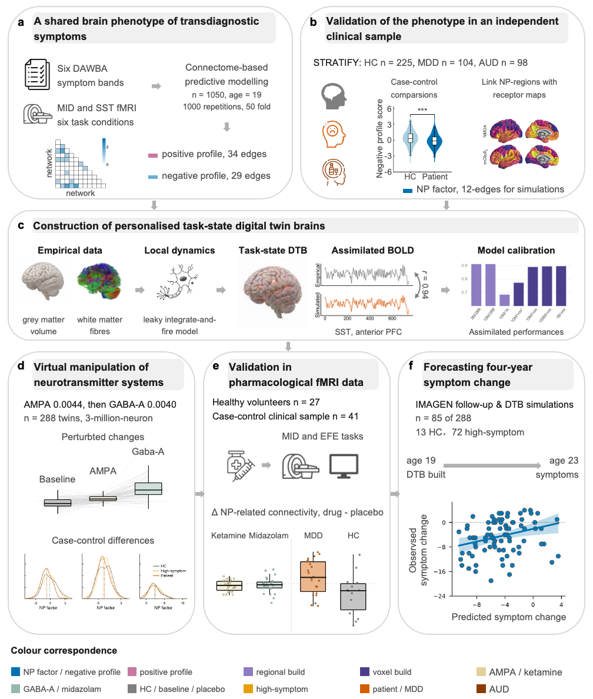
Figure 1 Analytical pipeline across five stages. Stage 1, IMAGEN discovery (n = 1,050, all analysed) and STRATIFY validation (n=427, including 225 controls, 202 patients: 104 MDD, 98 AUD). Stage 2, multiple-scale calibration experiment in 12 participants. Stage 3, 3-million-neuron individualized DTBs for 288 participants. Stage 4, pharmacological validation in healthy volunteers (n = 27 for ketamine, midazolam, and placebo conditions) and case-control (41 for placebo condition, 36 for placebo and ketamine conditions). Stage 5, 288 screened, 85 analysed (203 without usable four-year follow-up symptom data). From top to bottom, the panels show a, definition of the NP edge profiles; b, STRATIFY group differences in summed scores of NP profiles, and comparison of PET-map values between NP-related and non-NP regions using publicly available maps from a published study⁴¹; c, assimilated-region BOLD correlation across seven DTB builds; d, simulated NP factors at baseline and after AMPA or GABA-A up-regulation, and population-level group differences after perturbation; e, drug-induced changes in NP-related connectivity; and f, leave-one-out prediction of four-year symptom change from the 12 simulated NP edges (n = 85). Colours denote entities consistently across figures (see correspondence strip); stage headers are neutral grey.

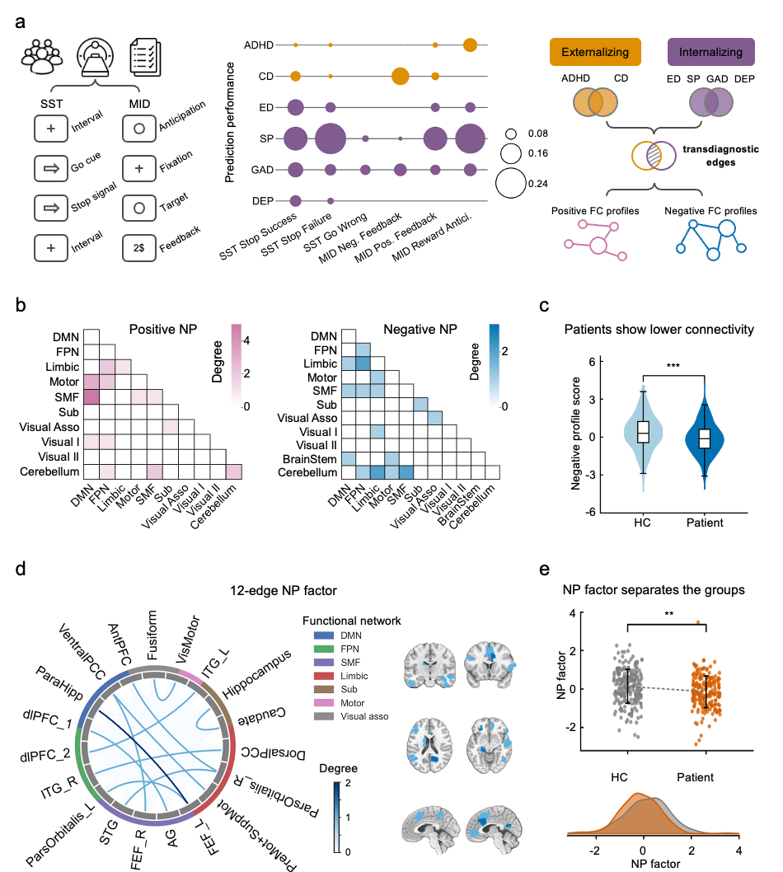
Fig. 2 A compact cortico-subcortical network phenotype of transdiagnostic psychopathology. a, Connectome-based predictive modelling of task-evoked functional connectivity against behavioural symptom scores in the IMAGEN cohort (n = 1,050). Bubble area denotes Spearman’s ρ between predicted and observed symptom scores, averaged across 1,000 cross-validation repetitions. Six task conditions (SST stop-success, stop-failure and go-wrong; MID positive feedback, negative feedback and reward anticipation) were crossed with six symptom domains (ADHD, conduct disorder, eating disorder, specific phobia, generalised anxiety and depression), yielding 36 models. P values were averaged across repetitions and corrected using Benjamini-Hochberg FDR across the 36 models; the minimum significant effect was ρ = 0.07. Task conditions predicting at least three symptom domains were retained. Edges were assigned to positive (pink) or negative (blue) profiles according to the sign of their symptom association. b, Canonical network affiliation of the two profiles; cell values are edge counts between network pairs. DMN, default mode; FPN, frontoparietal; SMF, somatomotor-frontal. c, Summed strength of the 29-edge negative profile in STRATIFY (225 controls and 202 patients), residualised for sex, scanning site and mean framewise displacement. Two-sided independent-samples Student’s t test, equal variance, Bonferroni-corrected across the two tests (the 29-edge negative profile and the 12-edge NP factor): t(425) = 3.83, P = 0.0002, P_Bonf = 0.0003, Hedges’ g = 0.37 (95% CI 0.18-0.56). d, The 12 cortico-subcortical edges retained as the NP factor after excluding 17 negative-profile edges involved with the cerebellum or brainstem; ribbon width denotes edge strength. e, Summed strength of the 12-edge NP factor, with the same residualisation and statistical test as in c: t(425) = 3.38, P = 0.0008, P_Bonf = 0.0016, Hedges’ g = 0.33 (95% CI 0.13-0.52).

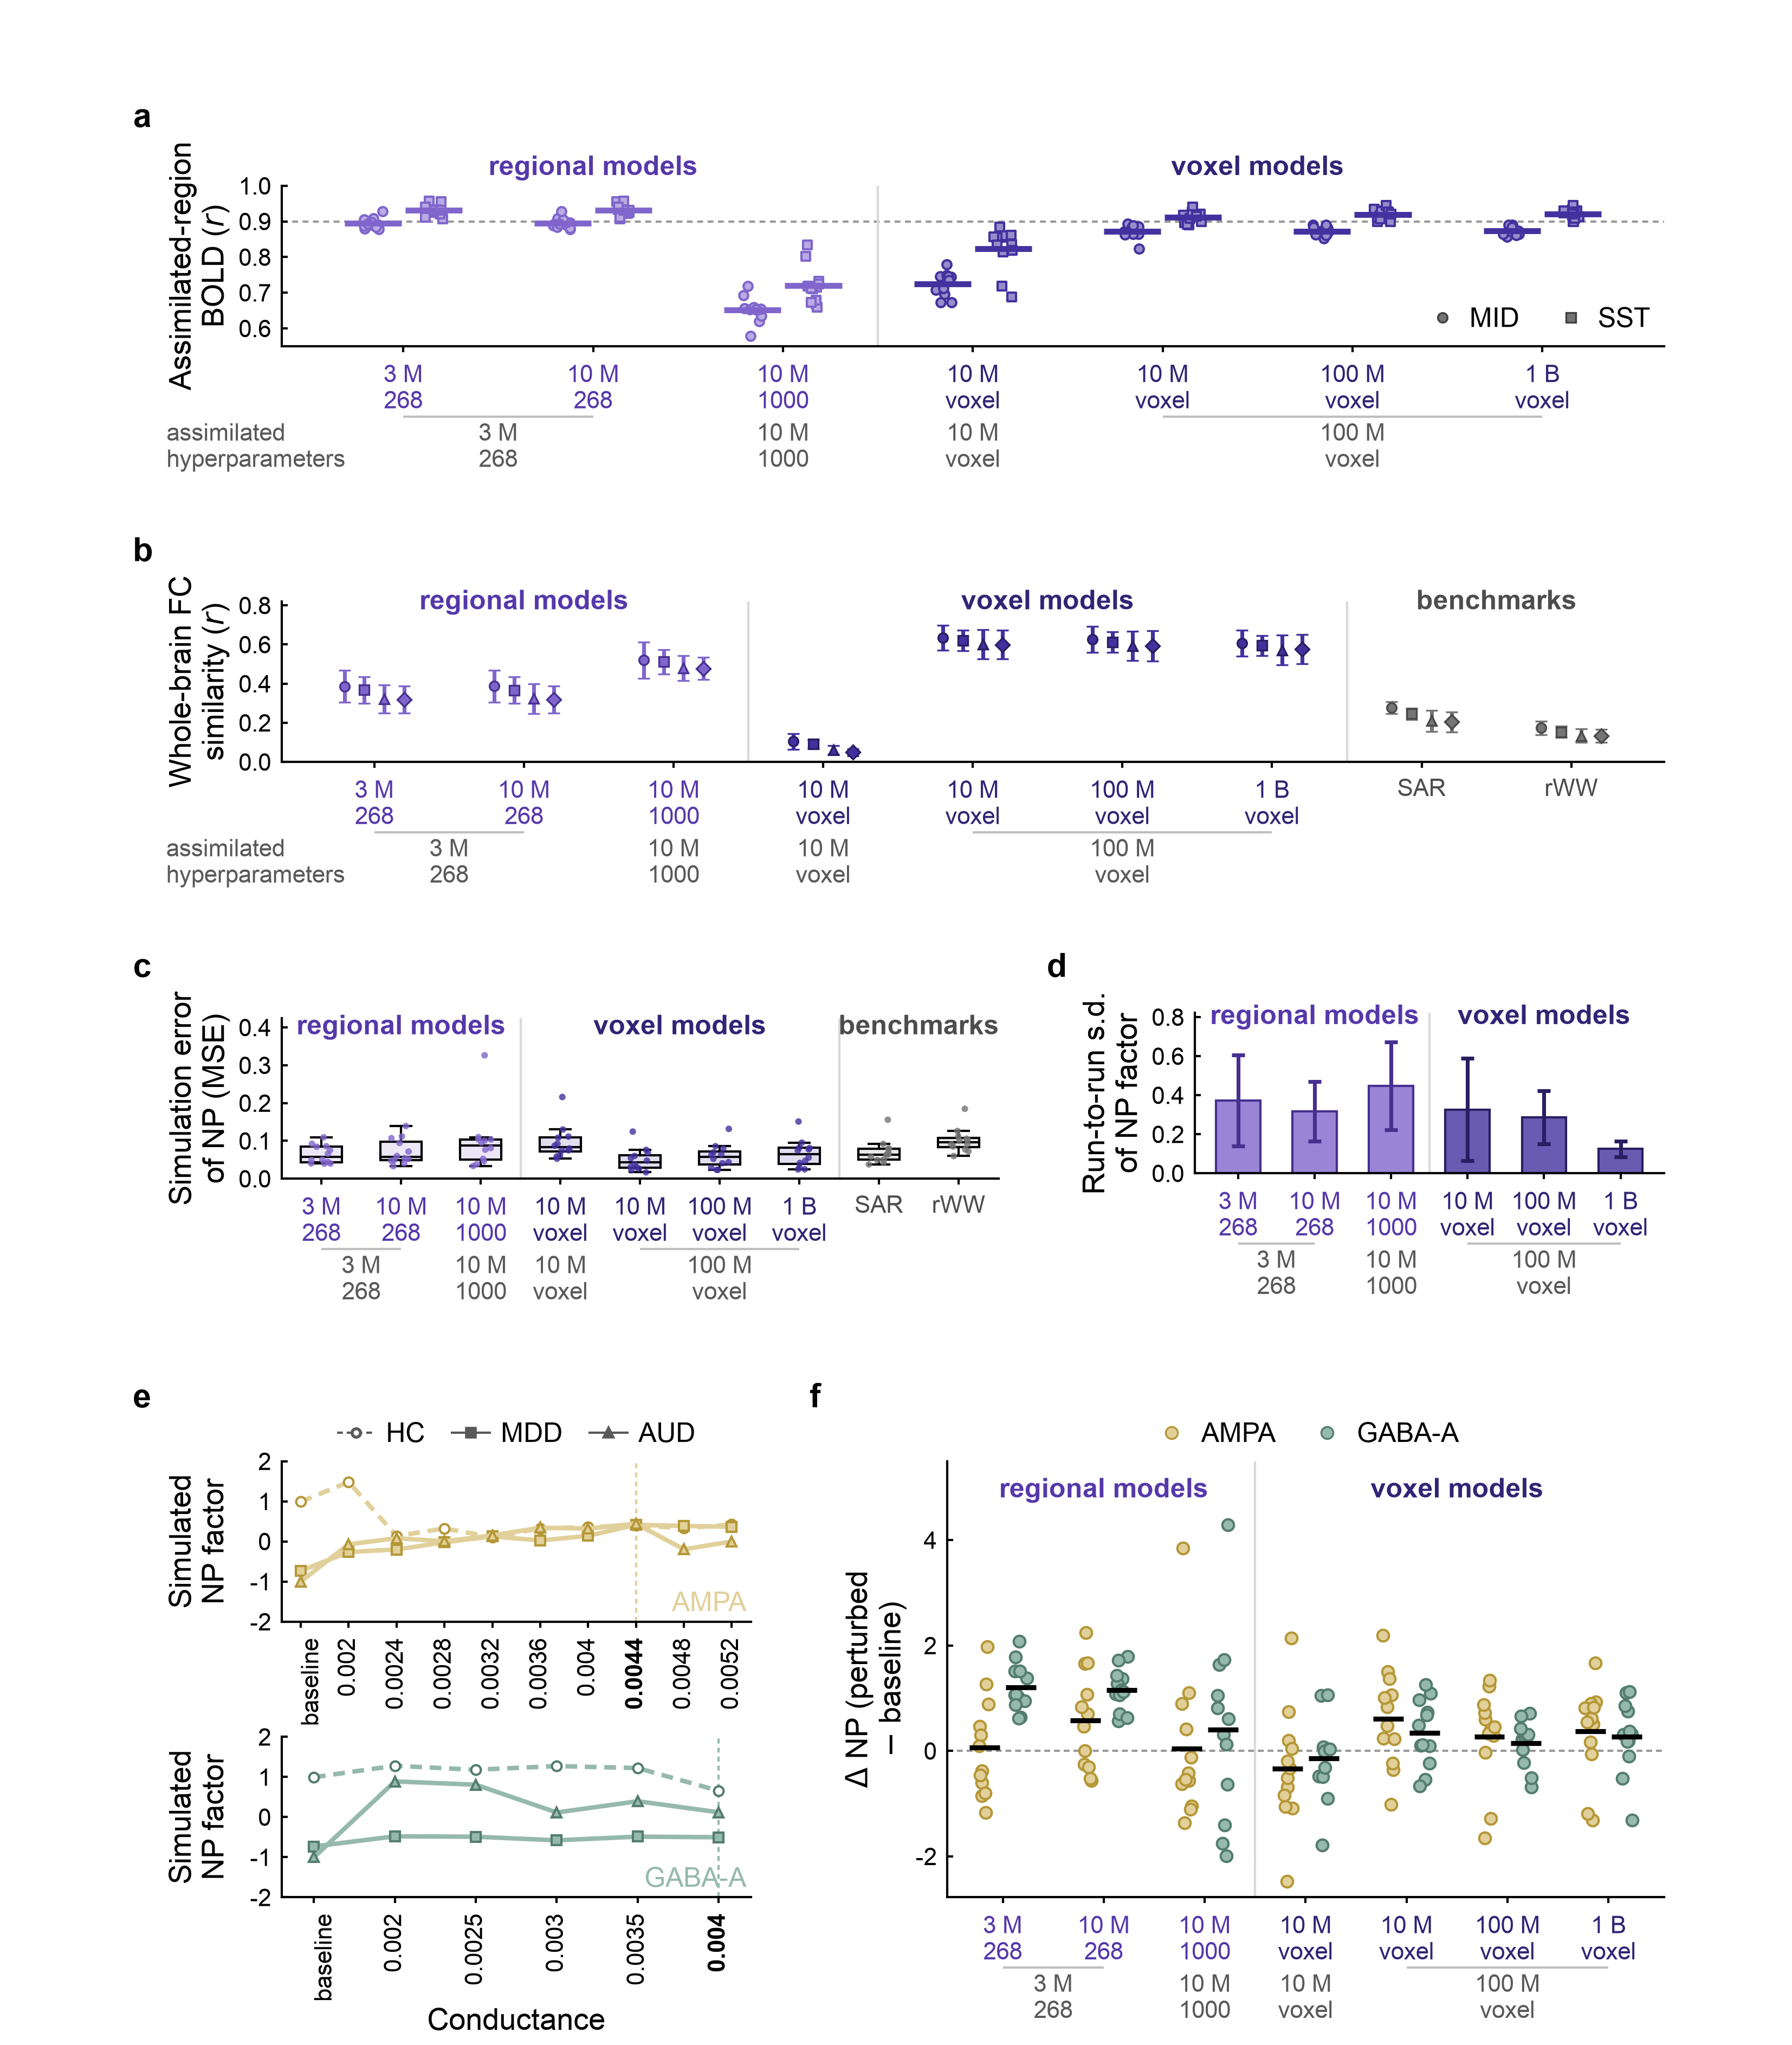
Fig. 3 Multiscale validation of the digital twin brain. Seven DTB builds are compared, differing in simulated neuron number, assimilated hyperparameters, and spatial resolution. Colour denotes model family (regional versus voxel); SAR and rWW benchmarks are grey. a, Pearson correlation between simulated and measured BOLD within assimilated regions, averaged across assimilated voxels; 12 participants × two tasks, 24 points per build; bars, group mean. b, whole-brain FC similarity, mean ± s.d. across 12 twins, quantified as Pearson's correlation between simulated and measured FC across 23,436 edges among 217 nodes for each task condition; n = 12 per point. c, simulation error of the 12-edge NP profile relative to empirical values; median, 25th-75th percentiles, and 1.5 × IQR whiskers, all 12 twins overplotted. d, run-to-run variability, quantified as the mean across twins of the within-subject s.d. of the NP factor across five repeats; error bars, s.d. across twins; the single-run 10 M voxel build using its own hyperparameters is omitted. e, NP factor across AMPA (upper; 9 settings, 0.0020-0.0052) and GABA-A (lower; 5 settings, 0.0020-0.0040) conductance sweeps in three 100-million-neuron DTBs (HC, MDD, AUD). Colour denotes perturbation; marker and dash pattern are twins; vertical dashed line and bold tick indicate AMPA 0.0044 and GABA-A 0.0040. f, change in summed NP after AMPA and GABA-A perturbation across all seven builds; points, twins; bars, group mean; n = 12 per build × perturbation.
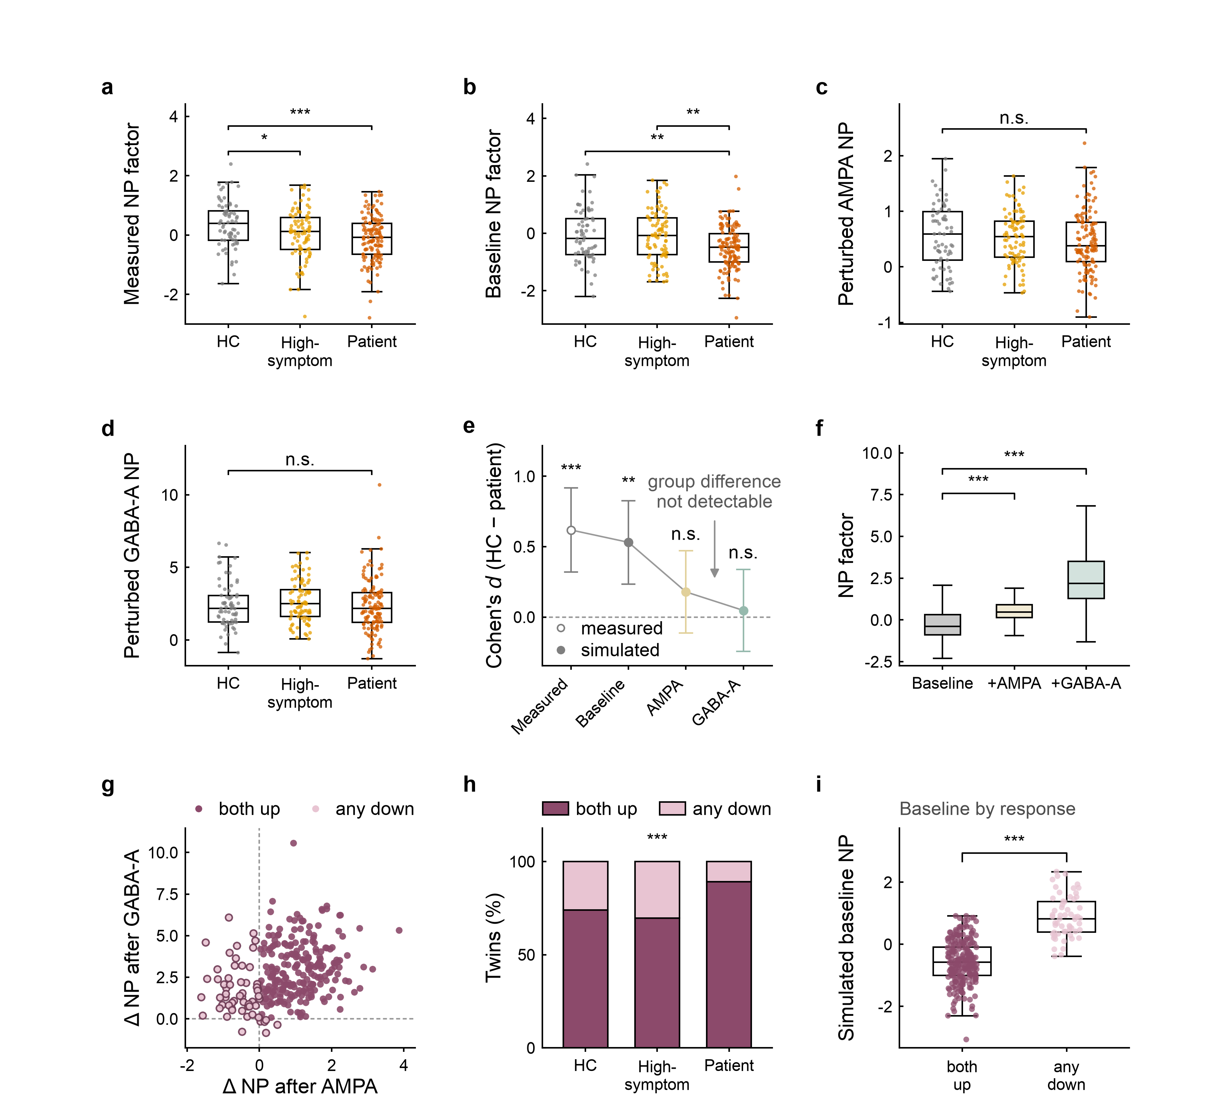
Figure 4 Virtual perturbation stratifies individuals. Sample: n = 288 digital twins (HC 69, high-symptom 89, patients 130). a-d, NP factor by group for measured (a), simulated baseline (b), AMPA (c), and GABA-A (d). NP was residualised for sex, site, and mean head motion (mean FD) and refitted on these 288 subjects. Box plots show median, 25th-75th percentiles, and 1.5 × IQR whisker. One-way ANOVA, F(2,285): a, F = 8.20, P = 0.0003; b, F = 9.22, P = 0.0001; c, F = 0.95, P = 0.39; d, F = 0.85, P = 0.43. Pairwise two-sided Welch t-tests were corrected within each panel using Benjamini-Hochberg FDR. *q <0.05, **q <0.01, ***q <0.001; n.s., not significant. e, HC-patient separation across the four conditions. Cohen’s d (95% CI), n = 69 HC versus 130 patients; two-sided t tests, uncorrected: measured, d = 0.62 (0.32-0.92), Welch t(135.0) = 4.11, P < 0.0001; simulated baseline, d = 0.53 (0.23-0.83), Welch t(118.1) = 3.36, P = 0.001; AMPA, d = 0.18 (-0.11-0.47), Welch t(137.0) = 1.19, P = 0.23; GABA-A, d = 0.05 (-0.24-0.34), Welch t(155.3) = 0.33, P = 0.74. f, within-subject effects of perturbation on the 12-edge NP factor. Paired t tests versus baseline, n = 288, df = 287, AMPA, 0.78 ± 0.93, t = 14.14, Cohen’s dz = 0.83, 234/288 increased; GABA-A, 2.74 ± 1.71, t = 27.11, dz = 1.60, 282/288 increased; both P <0.0001. Box plots show median, 25th-75th percentiles, and 1.5 × IQR whiskers; the axis is cropped to the whiskers, with 7/864 values beyond them not shown. g, change under AMPA versus GABA-A; 229/288 (79.5%) increased under both, while 59 had at least one decrease. h, response pattern by clinical group, χ²(2) = 14.17, P = 0.0008; both-up/total: HC, 51/69; high-symptom, 62/89; patients, 116/130 (89% versus 74% in HC). i, simulated baseline NP factor by response group: both-up, n = 229, -0.57; any-down, n = 59, 0.88; two-sided Welch t(92.9) = -14.74, P < 0.0001. A lower baseline in the both-up group is expected by construction, because the response score that defines the groups contains the baseline with a negative sign; the inferential test of baseline dependence is Oldham's method (Supplementary Results 4.3, Extended Data Fig. 2).
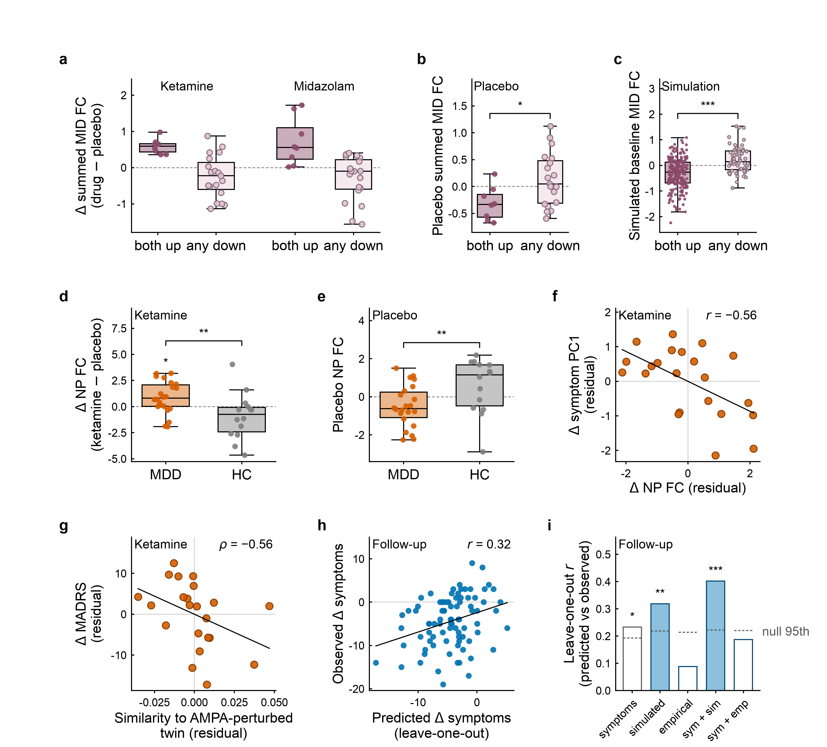
Fig. 5 In vivo pharmacology and longitudinal association. Healthy volunteers (n = 27) received placebo, ketamine and midazolam; the clinical sample (n = 36) received placebo and ketamine; the digital twins in c are the Fig. 4 sample (n = 288); and the longitudinal subsample is the IMAGEN follow-up (n = 85). Box plots show median, 25th-75th percentiles and 1.5 × IQR whiskers, with all participants overplotted; dashed lines indicate no change. Asterisks denote two-sided one-sample t-tests against zero for single-box comparisons; brackets denote the between-group test specified below. *P < 0.05, **P < 0.01, ***P < 0.001. a, Change in summed MID FC from placebo in healthy volunteers (both-up, n = 8; any-down, n = 19). Ketamine: 0.59 ± 0.21 versus -0.25 ± 0.58; midazolam: 0.72 ± 0.66 versus -0.30 ± 0.61 (mean ± s.d.). Descriptive only; no test was applied because groups are defined by the sign of the plotted quantity. b, Summed MID FC during the drug-free placebo session in volunteers, by drug response group; Welch’s t = -2.83, P = 0.01. c, Corresponding comparison in digital twins (n = 288), with groups defined by Fig. 4 (both-up, n = 229; any-down, n = 59): simulated baseline MID FC, -0.31 ± 0.58 versus 0.22 ± 0.51; Welch t = -6.95, P < 0.0001. d, Ketamine-induced change in NP FC in the clinical sample (MDD, n = 22; HC, n = 14): 0.87 versus -0.93. Group coefficient from OLS adjusted for age, sex, infusion order, and placebo-session mean framewise displacement: β = 2.43, t = 3.43, df = 30, P = 0.0018. e, Placebo NP FC in the same sample and adjusted model: β = -1.11, t = -2.51, df = 35, P = 0.017 (n = 41, all participants with a placebo session). f, Change in NP FC versus change in symptom PC1 in patients (n = 22); both axes residualised for baseline severity, age, infusion order and placebo-session mean framewise displacement: partial r = -0.56, P = 0.016, residual df = 16. g, Similarity of the ketamine state to the AMPA-perturbed digital twin versus depression symptom (assessed by Montgomery-Åsberg Depression Rating Scale)¹⁰ change (n = 22); both variables residualised for age, sex, infusion order and placebo-session mean framewise displacement: Spearman ρ = -0.56, Pperm = 0.0068, qFDR = 0.027 after Benjamini-Hochberg correction across the four symptom measures. h, Leave-one-out predicted versus observed four-year symptom change from the 12 simulated NP edges, with sex, recruitment site and mean framewise displacement included as covariates in every model (n = 85): r = 0.32, P_{perm} = 0.0088 (5,000 permutations); in-sample R² = 0.42, F(21,63) = 2.15, P = 0.0103. Negative values indicate symptom reduction; the line shows the ordinary least-squares fit with a 95% confidence band. i, Leave-one-out correlations for five model specifications, each including same covariates: age-19 symptoms alone (r = 0.23), the 12 simulated edges (r = 0.32), the 12 empirical edges (r = 0.09), and symptoms combined with the simulated or empirical edges (r = 0.40 and r = 0.19, respectively). The dashed segment above each bar marks the 95th percentile of that specification’s own permutation null (0.19 to 0.22; 5,000 permutations of the outcome with the complete leave-one-out procedure repeated). Asterisks give the permutation P of each leave-one-out correlation against that null: *P < 0.05, **P < 0.01, ***P < 0.001. Filled symbols and bars denote simulated networks; open symbols and bars denote empirical networks.
Extended Data figure legends
Extended Data Fig. 1 Cross-build agreement of the 12-edge NP profile. Each matrix shows pairwise Spearman correlations between the seven digital-twin-brain builds, calculated across the 144 cells comprising 12 subjects × 12 NP-factor edges. Rows and columns indicate model scale, parcellation and assimilated hyperparameter set; regional and voxel builds are shown separately. Profiles were averaged across repeated runs where available. a, Baseline. Agreement was higher between builds sharing the same assimilated hyperparameters than between builds using different hyperparameter sets, with correlations of 0.89 (P < 0.0001) between the two builds using the 3M hyperparameters and 0.87-0.93 among voxel builds using the 100M hyperparameters (all three pairs of P <0.0001). Agreement between these two hyperparameter families was 0.40-0.52, whereas the 10M voxel build using its own hyperparameters showed low agreement with the other builds (ρ = 0.06-0.15). b, AMPA perturbation. Agreement increased among regional builds (ρ = 0.76-0.94) and decreased among voxel builds (0.35-0.86), with correlations ranging down to -0.07. c, GABA-A perturbation. The two 268-region builds showed near-identical profiles (ρ = 0.99, P < 0.0001), voxel-build agreement remained high (0.70-0.83), and agreement between regional and voxel builds decreased to 0.11-0.44. The 10M voxel build using its own hyperparameters showed low or negative agreement with the other voxel builds (ρ = -0.19 to 0.07). Matrices show Spearman correlation coefficients; no error indicator is drawn. Exact within-participant test statistics, P values, and the multiple-comparison correction applied to each comparison (Bonferroni across the 10 build pairs where applied) are listed in Table S24.
Extended Data Fig. 2 Oldham’s test for baseline dependence in the digital-twin and pharmacological datasets. Each panel plots change against the mean of the pre- and post-perturbation NP-connectivity summed scores (Oldham’s method), which avoids the mathematical coupling inherent to a baseline-versus-change correlation. Points represent participants or digital twins; lines show ordinary-least-squares fits with 95% confidence bands, and the dashed line indicates no change. Digital twins from the Fig. 4 cohort using the full 12-edge NP factor, before and after AMPA (a) or GABA-A (b) perturbation. Spread contracted after AMPA (r = -0.47, 95% CI -0.55 to -0.37, P < 0.0001, n = 288) and expanded after GABA-A (r = 0.59, 95% CI 0.51 to 0.66, P < 0.0001, n = 288). c,d, Healthy volunteers, placebo to ketamine (c) or midazolam (d), showed no evidence of a change in between-participant variance on the motion-residualised scale used in the main text (ketamine: r = 0.29, P = 0.138, n = 27; midazolam: r = 0.30, P = 0.125, n = 27; the unadjusted analysis gives the same conclusion, r = 0.22, P = 0.264 and r = 0.25, P = 0.214). e, The clinical cohort likewise showed no evidence of a variance change from placebo to ketamine (r = 0.12, P = 0.50, n = 36). All five Oldham tests are two-sided and reported uncorrected; more statistical values are listed in Table S24.
Extended Data Fig. 3 Whole-brain perturbational effects. Whole-brain extent of virtual perturbations at n = 288. Analyses use the same 23,436 upper-triangular edges among 217 nodes across four task conditions (SST stop-success, SST stop-failure, MID feedback and MID anticipation) in 288 digital twins. Each edge was tested with a two-sided paired t test (df = 287), with BH-FDR correction across edges within each condition. a, Proportion of edges surviving FDR and increasingly stringent effect-size thresholds. Under AMPA, 69.5-83.2% of edges survived FDR, 15.9-31.2% exceeded |d_z| > 0.5 and 6.5-12.3% exceeded |d_z| > 0.8; corresponding values for GABA-A were 82.8-89.7% and 37.0-52.7%. b, Median |d_z| among significant edges; dashed lines indicate |d_z| = 0.5 and 0.8. Median values were 0.32-0.40 for AMPA and 0.45-0.59 for GABA-A. c, Net signed percentage of significant edges across 45 canonical network pairs for two representative task conditions. Red indicates a net increase and blue a net decrease. Among significant edges, 53.0-88.1% increased under AMPA and 88.8-91.2% under GABA-A. Bars show the percentage of edges meeting the criterion; no error indicators are drawn. Exact test statistics and P values are listed in Table S24.
Extended Data Fig. 4 The virtual perturbations for the depression-specific network in DTB simulations. The network comprises 27 edges selected against diagnosis in the population-scale simulations (n = 141; healthy controls n = 69, MDD n = 72). The measure is the summed connectivity of these edges. a-c, Empirical connectivity, simulated baseline, AMPA perturbation and GABA-A perturbation are compared using linear models adjusted for sex, recruitment site and meanFD (df = 136), with no correction across the four prespecified conditions. a, The diagnostic difference was present empirically (adjusted difference = 1.25, t = -4.98, 95% CI 0.76-1.75, P < 0.0001), in the simulated baseline (1.09, t = -5.13, 95% CI 0.67-1.51, P < 0.0001) and after GABA-A (1.25, t = -2.78, 95% CI 0.36-2.13, P = 0.0062), but not after AMPA (0.13, t = -0.97, 95% CI -0.13 to 0.39, P = 0.335). b, Edge-level effect sizes for the 27 network edges, oriented as controls minus MDD; 11 edges were nominally significant empirically and 12 in the simulated baseline. c, Adjusted group differences with 95% confidence intervals, corresponding to the tests in a. d, Within-subject perturbation effects pooled across groups. AMPA increased network connectivity by 0.36 ± 1.40 (66.7% of subjects; paired t(140) = 3.03, P = 0.0029), and GABA-A increased it by 2.87 ± 2.64 (87.9%; paired t(140) = 12.92, P < 0.0001). Thus, both perturbations increased connectivity of the depression-specific network, but only AMPA abolished the diagnostic difference. In d, boxes show the median and interquartile range with 1.5 × IQR whiskers, with every participant plotted. Exact t statistics, degrees of freedom and P values for all panels are listed in Table S24.
Extended Data Fig. 5 Directional agreement between simulated and empirical whole-brain drug effects. Directional concordance was assessed between drug effects in 27 healthy volunteers performing the MID task and corresponding DTB perturbations. Edges with a nominal drug-versus-placebo effect at P < 0.001 were included; matching/total edges are shown beside each marker. Circles indicate the task-matched MID model and squares the task-mismatched SST model. Filled markers indicate significance against a node-level sign-flip null (999 permutations); the dashed line denotes chance (50%) and the grey band ±1 s.d. of the null. a, For ketamine, the AMPA perturbation matched 38/56 edges (67.9%, P = 0.005) when pooled across MID conditions, compared with 25/56 (44.6%, P = 0.782) for the SST model. For midazolam, the GABA-A perturbation matched 73/102 edges (71.6%, P = 0.001), compared with 66/102 (64.7%, P = 0.003) for the SST model. b, Split-half reliability of the empirical drug-effect maps was low: 0.03-0.04 for ketamine and 0.18-0.20 for midazolam across MID conditions.Triangles indicate the theoretical maximum correlation with an empirical map of the observed reliability (√reliability). Directional agreement was tested with node-level sign-flip permutation tests against 50% agreement, two-sided and uncorrected across the four drug × task comparisons; an unadjusted binomial test on the same counts gives the same conclusion; in a, bars show 95% binomial confidence intervals, and in b the reliability bars carry no error indicator. Exact test statistics and P values are listed in Table S24.
Extended Data Fig. 6 Leave-one-out prediction of four-year symptom change under each model specification. Leave-one-out predicted versus observed symptom change (age 23 minus age 19) in 85 longitudinal participants. All models included sex, recruitment site and mean framewise displacement as covariates. a, Covariates only (r = −0.10, P = 0.6293; R² = 0.08, F(9,75) = 0.75, P = 0.6597). b, Age-19 symptoms (r = 0.23, P = 0.0286; R² = 0.24, F(10,74) = 2.31, P = 0.0201). c, 12 simulated NP edges (r = 0.32, P = 0.0088; R² = 0.42, F(21,63) = 2.15, P = 0.0103). d, 12 empirical NP edges (r = 0.09, P = 0.2236; R² = 0.30, F(21,63) = 1.26, P = 0.2399). e, Summed simulated NP (r = 0.05, P = 0.2735; R² = 0.14, F(10,74) = 1.23, P = 0.2849). f, Summed empirical NP (r = 0.21, P = 0.0372; R² = 0.22, F(10,74) = 2.12, P = 0.0335). g, Summed simulated plus summed empirical NP (r = 0.25, P = 0.0258; R² = 0.26, F(11,73) = 2.37, P = 0.0146). h, Symptoms plus 12 simulated NP edges (r = 0.40, P = 0.0008; R² = 0.49, F(22,62) = 2.69, P = 0.0012). i, Symptoms plus 12 empirical NP edges (r = 0.19, P = 0.082; R² = 0.36, F(22,62) = 1.59, P = 0.0795). Panels c and d compare the two 12-edge sets with 12 additional predictors, and panels e and f compare the two summed read-outs with one additional predictor; panel c is the specification shown in Fig. 5h. Negative symptom change denotes symptom reduction. Points represent individual participants; lines show ordinary least-squares fits with 95% confidence bands to indicate direction and are not additional statistical tests. No other error indicators are shown. Prediction used ordinary least squares with leave-one-out cross-validation, with significance assessed by 5,000 outcome permutations using the complete leave-one-out procedure for each permutation. The asterisk in each panel gives this permutation P for that specification's leave-one-out correlation: *P < 0.05, **P < 0.01, ***P < 0.001; n.s., not significant. No correction for multiple comparisons was applied across these nested specifications of the same dataset. Exact statistics, effect sizes and confidence intervals are reported in Table S24.
Extended Data Fig. 7 Digital twin brains preserve participant-specific signatures on held-out trials without re-assimilation. Four participants × 6 held-out emotional-face trials (n = 24 trials). a,b, Participant identification from empirical BOLD and digital twins, respectively; black outlines indicate the correct template and orange outlines indicate misidentification. c, Identification margin (self minus best-other correlation). Margins were higher for digital twins than empirical BOLD (0.20 ± 0.04 versus 0.16 ± 0.07; paired t-test, t(23) = 2.29, P = 0.0313). Self-correlation exceeded the best-other correlation for both empirical BOLD (0.17 versus 0.0034, P < 0.0001) and digital twins (0.20 versus 0.0047, P < 0.0001). d, Identification accuracy was 23/24 (95.8%) for empirical BOLD and 24/24 (100%) for digital twins; both exceeded the 25% chance level (one-sided exact binomial both P < 0.0001, respectively). Values are mean ± s.d.; box plots show the median and interquartile range with 1.5 × IQR whiskers, with every trial plotted, and the similarity matrices carry no error indicator. Comparisons used two-sided paired t tests and a one-sided exact binomial test, uncorrected; asterisks mark these tests (*P < 0.05, ***P < 0.001) and the exact test statistics and P values are listed in Table S24.
Extended Data Fig. 8 Virtual perturbational sensitivity across conductance and task context. a, Group-level change in NP across three AMPA and three GABA-A conductance settings in n = 288 digital twins. Bars show means with 95% confidence intervals; Cohen’s d is indicated above each bar. All settings increased NP. The main-analysis settings gave the smallest raw mean changes but the largest standardised effects (AMPA, d = 0.83; GABA-A, d = 1.60). b, Percentage of twins showing increased NP at each setting, by diagnostic group. Chi-squared P values are shown above each setting. c, Number of settings under which each twin showed increased NP; 185/288 twins (64.2%) increased under all six settings. Twin-wise changes correlated across settings within AMPA (r = 0.39-0.55) and GABA-A (r = 0.69-0.90), but less strongly between knobs (r = -0.05-0.31). d, Individual responses of three 100-million-neuron twins in the held-out emotional-face task; these are the same three participants used for the perturbation-parameter grid search, not an independent sample. AMPA increased NP in 2/3 twins and GABA-A in 3/3. e, Responses of the same twins on the reward/inhibition NP profile used in the main analysis; AMPA increased NP in 2/3 and GABA-A in 2/3. All tests are two-sided and uncorrected. Exact chi-squared statistics and P values for the per-setting group comparisons, and the paired t statistics for each conductance setting, are listed in Table S24.
Extended Data Fig. 9 Head motion does not account for group effects on NP measures. All panels include the same 288 twins (69 healthy controls, 89 high-symptom participants and 130 patients) retained after the mean-FD < 0.5 mm threshold. a, Mean framewise displacement (FD) did not differ across groups (one-way ANOVA, F (2,285) = 0.84, P = 0.431). b, Associations between FD and six NP measures. Three survived Bonferroni correction across the six measures: the empirical NP factor (r = 0.16, P corrected = 0.049), GABA-A-perturbed NP (r = 0.27, P corrected < 0.0001) and GABA-A-induced change in NP (r = 0.20, P corrected = 0.003); simulated baseline NP (r = 0.13, P corrected = 0.18), AMPA-perturbed NP (r = 0.15, P corrected = 0.067) and AMPA-induced change (r = -0.04, uncorrected P = 0.554, corrected P = 1.00) did not. c, FD was not significantly associated with any of the 12 individual empirical NP edges (all Bonferroni-corrected P ≥ 0.94). d, Group effects expressed as partial η² before and after adjustment for FD. Adding FD changed partial η² by ≤0.74 percentage points and did not alter the significance of any group effect. All tests are two-sided. In a, boxes show the median and interquartile range with 1.5 × IQR whiskers, with every twin plotted; b and c show ordinary least-squares fits with 95% confidence bands. Exact correlation coefficients and Bonferroni-corrected P values for the six NP measures and the 12 individual edges, and the partial η² values with and without adjustment for framewise displacement shown in d, are listed in Table S24.

