Supplementary Information
Digital twin brain simulation and perturbation of a functional brain network underlying mental disorder.
This file includes: Supplementary Methods 1-13; Supplementary Results 1-13; Supplementary Discussion; Supplementary Figures S1-S14.
Supplementary Methods
These Supplementary Methods provide the technical details referred to in the Methods of the main article; section numbers correspond to the cross-references given there. References cited here are listed at the end of this section.
Supplementary Methods 1. Independence of the analytical pipeline
The five-stage analytical pipeline was designed to minimise data leakage between NP definition, DTB construction, perturbation, pharmacological validation and longitudinal outcome analysis. The NP factor was derived from task-fMRI data in IMAGEN (n = 1,050, age 19) and independently validated in STRATIFY (n = 427), which was not used for NP derivation. Individualised DTBs were subsequently constructed for 288 participants using each participant’s structural and functional imaging data. Assimilation targets were selected according to task engagement independently of the NP circuit, and only 5 of the 19 NP regions were directly assimilated. Virtual perturbations were then applied to the fitted DTBs as forward simulations, without further assimilation, refitting or access to longitudinal or pharmacological outcomes.
Pharmacological validation used two independent datasets with no participant overlap with IMAGEN or STRATIFY. Longitudinal analysis used a subset of 85 participants with symptom assessments at ages 19 and 23 from the population simulation sample of 288. The longitudinal model used the 12 simulated NP edges directly as jointly entered predictors, with no weighting, feature selection or prediction model estimated outside these 85 participants (Supplementary Results 9). Age-23 symptom data were not used for NP definition, DTB fitting, perturbation or parameter estimation.
Supplementary Methods 2. Samples, task paradigms and pharmacological protocols
IMAGEN task paradigms. The MID task comprised 42 trials across three reward conditions (no win, small win and big win). Each trial consisted of a reward cue (250 ms), a fixation period (4-4.5 s), a target response and reward feedback (1,450 ms). The SST included 480 go trials, in which participants responded to the direction of an arrow, and 80 stop trials, in which they inhibited the response when a stop signal appeared approximately 300 ms after the go cue. The EFT presented angry, neutral and happy faces in a passive-viewing paradigm without responses; each emotional condition comprised four trials of 18 s. Further details are given in the original description of the IMAGEN study¹.
STRATIFY healthy controls. Healthy controls were screened with stringent criteria to minimize confounding. Participants were excluded if they had (a) any current or past mental health disorder², (b) first- or second-degree relatives with a mental health diagnosis, (c) regular use of medication for serious physical health conditions, (d) learning difficulties (for example, a Wechsler Adult Intelligence Scale verbal comprehension score below the 10th percentile) or (e) any history of recreational drug use.
Healthy-volunteer pharmacological dataset. Each participant underwent three scanning sessions (ketamine, midazolam and placebo) separated by at least 48 h to prevent carry-over effects. Each session included a 16-min resting-state fMRI scan, during which drug administration began at minute 7, followed by task-fMRI during the MID task. This version of the MID task comprised 90 trials in two conditions, no win (45 trials) and win (45 trials). Administration protocols are described in the original study³.
Case-control pharmacological dataset. Participants received a double blinded infusion of ketamine or saline placebo and crossed over to the other treatment condition approximately 2 weeks later⁴. MRI assessments were acquired approximately 2-3 and 10-11 days after each infusion and included task-fMRI during the emotional face evaluation (EFE) task, consisting of two runs of approximately 4.8 min each. The emotional face evaluation (EFE) task comprised explicit emotion-evaluation and implicit gender-evaluation blocks. During emotion-evaluation blocks, participants categorized emotional facial expressions, with positive and negative emotional faces presented in either upright or inverted orientations. Thus, trials were classified into four conditions according to emotional valence and face orientation: positive-upright (pos_up), positive-inverted (pos_down), negative-upright (neg_up) and negative-inverted (neg_down)⁵. Each condition was presented in randomized order. For the present analysis, to facilitate comparison with the MID task, we focused on the explicit evaluation of positive emotions in upright faces, defined by the contrast between positive-upright emotion-evaluation and positive-upright gender-evaluation trials. Here, we used EFE task-fMRI data acquired approximately 2 days after each infusion to provide a temporal window comparable to that represented by the DTB simulations.
Supplementary Methods 3. Single-participant calibration of model resolution
The influence of model scale was first evaluated in the DTB of an illustrative healthy control (HC01) by varying the number of neurons from 10 million to 5 billion. Performance was quantified as the mean voxel-wise Pearson correlation between simulated and empirical BOLD signals and as the correlation between simulated and empirical whole-brain FC matrices over the 217-region cortical-subcortical subset of Shen-2686 that the models simulate (23,436 edges). These experiments characterized how neuronal scale affects task-state simulation accuracy and provided an empirical basis for selecting informative yet computationally tractable resolutions.
To identify a suitable reduced resolution for population-scale simulations, reduced DTBs of 1-9 million neurons were then constructed for the same participant. In these models, individual MRI data were represented at the regional rather than voxel level, and neurons were allocated to regions in proportion to regional grey-matter volume. Voxel-wise allocation is impractical at these neuron counts because some voxels have a very small grey-matter fraction; regional allocation preserves grey-matter proportions while remaining tractable. Between-region connections were weighted by row-normalized regional structural connectivity, and all other details were as in the voxel-wise models. Performance was quantified as the mean regional Pearson correlation between simulated and empirical BOLD signals and as the correlation between simulated and empirical whole-brain FC.
Supplementary Methods 4. Selection criteria for twelve representative participants
Twelve participants were selected: three with MDD, three with AUD, three healthy controls and three with high symptom burden (Supplementary Table 7). Patients were those with the highest NP scores within their diagnostic groups, whereas healthy controls and high-symptom individuals were the IMAGEN participants with the lowest and highest summed symptom scores, respectively. The high-symptom individuals had higher summed symptom scores than the MDD and AUD participants, reflecting the dimensional nature of the measures, in which substantial symptom burden can occur without meeting criteria for a specific diagnosis⁸. All had complete T1-weighted, diffusion and fMRI data.
Supplementary Methods 5. Whole-brain perturbational effects analyses
Whole-brain FC was reconstructed on a 217-region parcellation derived from the Shen-268 atlas, yielding 23,436 unique edges. For each of four task conditions (SST stop success, SST stop failure, MID feedback hit and MID anticipation hit), modulated FC was compared with the corresponding simulated baseline using edge-wise paired t tests with FDR correction (q < 0.05). Given the large number of simulated participants (n = 288), the spatial extent of modulation was additionally quantified as the fraction of edges exceeding effect-size thresholds of |d_{z}| > 0.5 and > 0.8. AMPA modulation was evaluated relative to the simulated baseline, whereas GABA-A modulation was applied to the AMPA-adjusted state and evaluated relative to that state.
In both pharmacological datasets, empirical whole-brain FC was reconstructed on the same 217-region parcellation, and drug-induced changes were quantified relative to placebo. Among edges with nominal empirical drug effects (P < 0.001), the proportion whose direction matched the corresponding DTB AMPA- or GABA-A-mediated modulation was tested against the 50% chance level with a binomial test. Split-half Spearman-Brown reliability of the empirical drug-effect maps was estimated to characterize the reliability of the observed whole-brain changes.
Supplementary Methods 6. Composite depressive-symptom score in the clinical ketamine dataset
The MADRS is a ten-item scale of core depressive symptoms; the HAMD-17 is a widely used measure of depressive severity; and the HAMD-Bech is a unidimensional six-item measure of core (melancholic) depressive symptoms with favourable psychometric scalability. All three instruments were administered at baseline and at each imaging session under placebo and ketamine, with higher scores indicating greater severity. Principal component analysis was fitted to placebo-session scores from participants with complete data (n = 35; 22 MDD, 13 healthy controls) after z-scoring each instrument. The first principal component explained 98.9% of the total variance, with near-identical positive loadings for MADRS, HAMD-Bech and HAMD-17 (0.58, 0.58 and 0.58, respectively). The placebo-derived loadings were applied to ketamine-session scores to obtain a composite on a common scale, and symptom change was defined as ketamine minus placebo.
Supplementary Methods 7. MRI acquisition and diffusion preprocessing
IMAGEN and STRATIFY. Structural and functional MRI protocols were harmonized across sites and scanner manufacturers (Siemens, six sites; Philips, two sites; General Electric, one site; Bruker, one site), and standardized hardware for visual and auditory stimulus presentation (Nordic Neurolabs) was used at all sites. T1-weighted images were acquired with a protocol based on that of the ADNI study (https://adni.loni.usc.edu/data-samples/adni-data/neuroimaging/mri/mri-scanner-protocols/). Some parameters deliberately differed between scanner models to produce consistent contrast and quality across manufacturers; all scans were acquired in the sagittal plane with a voxel size of 1.1 × 1.1 × 1.1 mm³. Diffusion-weighted images were acquired with a 2D diffusion-weighted echo-planar sequence (TR = 15,000 ms; TE = 104 ms; field of view = 307 × 307 mm²; 60 slices; scan time 9 min 45 s; voxel size 2.4 × 2.4 × 2.4 mm³; 36 non-collinear diffusion directions at b = 1,300 s mm⁻²). Resting-state fMRI was acquired with a 2D gradient-echo echo-planar sequence (TR = 2,200 ms; TE = 30 ms; flip angle = 75°; field of view = 220 × 220 mm²; 40 slices; 164 volumes; voxel size 3.4 × 3.4 × 2.4 mm³). Task fMRI used identical parameters except for the number of volumes: 191 for the MID task, 349 for the SST and 202 for the EFT.
Pharmacological datasets. MID task-fMRI in the healthy-volunteer dataset was acquired on a 3T Siemens Skyra scanner with an echo-planar sequence (TR = 2,200 ms; TE = 27 ms; flip angle = 79°; field of view = 215 × 215 mm²; 30 slices; 410 volumes; voxel size 3 × 3 × 3 mm³). EFE task-fMRI in the clinical dataset was acquired at the NIH Functional MRI Facility on a 3T GE Healthcare scanner with an eight-channel head coil (TR = 2,500 ms; TE = 23 ms; flip angle = 90°; field of view = 240 × 240 mm²; matrix 64 × 64; 45 interleaved sagittal slices without gap; voxel size 3.75 × 3.75 × 3.5 mm³). Two EFE runs of 4.8 min were acquired per session, and the first four volumes of each run were discarded to allow for T1 equilibration. Condition-specific time series from the two runs were pooled within a single first-level model to generate task-specific functional connectomes.
Software. fMRIPrep (v20.2.3) is based on Nipype and uses Advanced Normalization Tools (ANTs, v2.3.3), the FMRIB Software Library (FSL, v5.0.9), Analysis of Functional NeuroImages (AFNI, v20160207) and FreeSurfer (v6.0.1).
Diffusion preprocessing and tractography. Diffusion-weighted images were preprocessed with FSL and MRtrix3. Eddy-current distortions and head motion were corrected with FSL eddy, and b-vectors were rotated accordingly (eddy_rotated_bvecs). Data were converted to MRtrix3 format with mrconvert, the mean b0 image was extracted with mrmath, and a brain mask was generated with bet (fractional intensity threshold = 0.3). White-matter fibre orientation distributions were estimated by constrained spherical deconvolution with response functions estimated by the Tournier method. The T1-weighted image was registered to native diffusion space with FSL flirt; a nonlinear transformation to MNI space was computed with fnirt, its inverse generated with invwarp, and the warp converted to an MRtrix-compatible format. A five-tissue-type segmentation was generated with 5ttgen, and the grey matter-white matter interface was extracted with 5tt2gmwmi as the seeding region. Whole-brain tractography was performed with tckgen using the iFOD2 algorithm and anatomically constrained tractography. Streamlines were then transformed from diffusion to MNI space to generate voxel-wise and regional structural connectivity matrices.
Supplementary Methods 8. Individualized multimodal inputs to the DTB
Grey-matter volume. Grey-matter volume was estimated by voxel-based morphometry in SPM12 (MATLAB R2020b). T1-weighted images were segmented into tissue maps, normalized to MNI space with DARTEL, modulated by the Jacobian determinants and smoothed with an 8-mm full-width at half-maximum Gaussian kernel at 3 × 3 × 3 mm³ resolution. The Jacobian-modulated values, which account for local volume changes introduced by spatial normalization, determined the number of neurons assigned to each voxel.
Structural connectivity. Tractography was performed in each participant's native diffusion space, with anatomical segmentation and the grey matter-white matter interface derived from native-space data. Streamlines were transformed to MNI space only after tractography and assigned to atlas nodes to define between-voxel coupling strengths, so that spatial normalization did not affect streamline reconstruction.
Functional BOLD signals. An individualized brain mask retained voxels that (a) overlapped both the 268-node functional parcellation⁶ and the MNI152 template, (b) had identifiable white-matter structural connections and (c) were located in cortex or subcortex. On average, approximately 12,000 voxels were retained per participant, and their BOLD time series were used as empirical targets for simulation.
Supplementary Methods 9. Assimilated regions and assimilation sensitivity analyses
For the MID task, assimilated regions comprised the orbitofrontal cortex, dorsal anterior cingulate cortex, insula, amygdala, dorsal striatum and nucleus accumbens, together with primary visual and sensorimotor cortices. For the SST, they comprised the orbitofrontal cortex, anterior and dorsolateral prefrontal cortex, dorsal anterior cingulate cortex, insula and thalamus, together with primary visual and sensorimotor cortices. For the EFT, they comprised the amygdala, dorsal striatum, hippocampus, insula, thalamus, anterior and posterior cingulate cortex, dorsolateral prefrontal cortex and orbitofrontal cortex, together with primary visual cortex. The full list is given in Supplementary Table 6. Further details of HMDA are provided in the original description⁷.
Assimilation stability. Five independent HMDA runs were performed for the MID task in one representative healthy control, and between-run agreement of the resulting NP profiles was quantified with the intraclass correlation coefficient.
Activation-defined assimilated regions. As a sensitivity analysis, assimilated regions were redefined from task-specific activation voxels in the group-level IMAGEN activation map, retaining a number of voxels comparable to that of the primary analysis.
Supplementary Methods 10. Benchmark whole-brain models
Spatial autoregressive model. Whole-brain functional covariance was derived analytically by linear diffusion over the individual structural connectome⁹. The coupling parameter was grid-searched from 0.01 to 0.99 in steps of 0.01, and the value maximizing the Pearson correlation between predicted and empirical upper-triangular FC was selected for each participant and task condition.
Reduced Wong-Wang model. Nonlinear excitatory-inhibitory population dynamics¹⁰ were simulated with GPU acceleration in cuBNM¹¹. Feedback inhibition control¹² was enabled to adjust local inhibitory weights and maintain baseline firing rates near the critical regime. The global coupling parameter G was grid-searched from 0.5 to 3.5, simulated activity was converted to BOLD signals with the Balloon-Windkessel model, and the value of G yielding the highest correlation between predicted and empirical whole-brain FC was selected for each participant and task condition.
For all three models, accuracy was evaluated against the same participant- and task-specific empirical FC targets: whole-brain reconstruction by the Pearson correlation between predicted and empirical FC, and error for the 12-edge NP circuit by MSE.
Supplementary Methods 11. Implementation of virtual perturbations
Parameter-space exploration. The two-dimensional exploration of AMPA and GABA-A conductance used mean firing rate to characterize network activation and mean coherence to distinguish asynchronous from synchronized states. BOLD stability was evaluated to exclude regimes with excessive firing and loss of dynamic BOLD fluctuations¹⁰. The resulting parameter space (Fig. S14) extended from the baseline asynchronous regime towards higher-coherence states, allowing the perturbations to probe responses across distinct dynamical regimes¹³.
Global application. Modulation was applied globally, without assumptions about selective targeting of regions or connections within the NP profile. Regional perturbations could offer greater mechanistic specificity, but such spatially selective effects cannot be inferred from systemic drug administration alone and would require additional constraints such as regional receptor density. In recurrent cortical networks, E/I balance emerges from the interaction of inhibitory interneuron recruitment^{12,14}, recurrent coupling^{12,15} and synaptic gain¹⁶, and is governed by circuit dynamics rather than receptor density alone. AMPA- and GABA-A-mediated conductance parameters were therefore treated as global dynamical control parameters rather than spatially localized proxies for drug action.
Implementation across resolutions. The conductance settings selected in the four participant calibration were applied to the twelve validation participants without re-estimation or separate optimization at each scale, and were kept fixed across resolutions, while the implementation of AMPA modulation was adapted to the model representation. In voxel-wise models, intra-voxel and inter-voxel AMPA conductance are represented separately, and AMPA perturbations were applied to inter-voxel connections with intra-voxel conductance unchanged. In regional models, in which the neurons of each region form a single population, AMPA perturbations were applied to both intra-regional and inter-regional connections. This ensured that the perturbation engaged the neuronal populations represented at each resolution while preserving the calibrated setting. GABA-A perturbations were implemented identically across resolutions. Perturbations were applied to pre-fitted DTBs as global control variables without re-assimilation, allowing us to evaluate whether the direction and magnitude of NP responses were preserved across individuals and resolutions.
Cross-task generalization. For the same three participants used for the perturbation-parameter grid search, 100-million-neuron DTBs were constructed from EFT fMRI data, and the previously identified AMPA and GABA-A settings were applied without further optimization or assimilation. NP-related FC was extracted from baseline and perturbed simulated EFT BOLD signals with the pipeline used for the MID and SST tasks, and perturbation-induced changes were compared with those in the original task contexts.
Supplementary Methods 12. Prediction of task performance from population-scale simulations.
Two sets of task-state connectomes were used: DTB-simulated FC, derived from BOLD signals generated by the 3-million-neuron DTBs, and empirical FC, derived from the scanned fMRI data. Both were extracted separately for the anticipation-hit and feedback-hit stages of the MID task. Behavioural performance was quantified as mean response time under the big-win, small-win and no-win conditions. In each of ten folds, linear models were trained on FC from nine folds and evaluated on the held-out fold; the cross-validation was repeated 100 times and accuracies were averaged across repetitions. Separate models were fitted for each combination of task stage and incentive condition, yielding six models per FC type (simulated/empirical).
Supplementary Methods 13. Validation on held-out task trials
EFT fMRI data were analysed from an independent subset of four male participants matched for scanning site (Berlin) and age (one with MDD and one with AUD, both aged 21 years, and two healthy controls aged 22 years; Table S7b). Each completed four trials per emotional block (angry, neutral and happy), yielding 12 trials per participant.
Hyperparameters were first estimated independently for each trial, without using any other trial from the same participant. Each trial-specific set was applied to noise-initialized DTBs to generate simulated BOLD time series of matched duration, and trial-level activation maps were computed from simulated and empirical BOLD signals with identical preprocessing and statistical modelling. To quantify participant specificity, activation maps from all simulated and empirical trials were correlated, yielding a 48 × 48 similarity matrix (4 participants × 12 trials), and correlations between simulated and empirical trials from the same participant were compared with those between trials from different participants using a Mann-Whitney U test.
To test whether simulated activation maps generated without re-assimilation were distinctive enough to identify individuals, participant-specific empirical templates were created by averaging the first two trials of each emotional condition. Hyperparameters estimated from these first-half trials were used to simulate the remaining trials without assimilation. Activation maps from the simulated second-half trials (4 participants × 6 trials) were correlated with all templates, and each simulated trial was assigned to the participant with the highest correlation. The same identification procedure applied to empirical second-half activation maps served as a benchmark.
Supplementary Results
Supplementary Results 1. Multi-scale validation in twelve participants
1.1 Simulation fidelity across configurations
We first examined assimilation fidelity. For voxel-wise data, only hyper-parameters estimated at 100 million neurons produced consistently high-fidelity assimilation, with correlations between simulated and empirical BOLD of r = 0.89-0.90 across 10-million-, 100-million- and 1-billion-neuron models (Fig. 3a). In 10-million-neuron models, hyper-parameters estimated at the same neuronal scale performed substantially worse when applied to voxel-wise data (r = 0.77; Δr = 0.12, paired t(11) = 15.65, P < 0.0001) or 1,000-region data (r = 0.69; Δr = 0.21, t(11) = 21.21, P < 0.0001). When the spatial resolution was reduced to 268 regions, however, 3-million-neuron hyper-parameters achieved r = 0.91, comparable in magnitude to the voxel-wise models and slightly higher than the 100-million-neuron voxel-wise builds (Δr = 0.02, t(11) = 7.72, P < 0.0001). Increasing the simulated neuron count from 3 million to 10 million within the 268-region model had only a negligible effect on assimilation (Δr = -0.0002). Thus, the neuronal scale required for effective assimilation depended on the spatial resolution of the target data.
Whole-brain functional connectivity showed a similar dependence on hyper-parameter scale. Among voxel-wise models using 100-million-neuron hyper-parameters, changing the number of simulated neurons from 10 million to 100 million or 1 billion had little effect on whole-brain similarity, with correlations of r = 0.61, 0.61 and 0.59, respectively. By contrast, the 10-million-neuron voxel-wise model using 10-million-neuron hyper-parameters achieved only r = 0.08, compared with r = 0.61 when the same model was fitted using 100-million-neuron hyper-parameters (Δr = 0.54, paired t(11) = 40.90, P < 0.0001). The regional models showed lower but still substantial correspondence with the empirical connectome (r = 0.50 for 10 M/1,000 regions and r = 0.35 for 10 M/268 regions; r = 0.35 for 3 M/268 regions). The two 268-region models were indistinguishable in whole-brain similarity despite their tenfold difference in simulated neuron count (Δr = 0.0007, t(11) = 0.31, P = 0.76), whereas the 1,000-region model showed higher similarity than the 268-region models (Δr = 0.15, t(11) = 10.91, P < 0.0001). Both regional DTBs also exceeded the SAR and rWW benchmarks (3 M/268 versus SAR: Δr = 0.11, t(11) = 9.89, P < 0.0001; versus rWW: Δr = 0.20, t(11) = 16.14, P < 0.0001). Because the benchmarks were defined at a regional parcellation and their coupling parameters were optimised against the same connectivity metric, these comparisons are reported descriptively (Fig. 3b).
NP-connectivity error was also lowest for the voxel-wise models using 100-million-neuron hyper-parameters (Fig. 3c), with a mean MSE of 0.06 ± 0.03, compared with 0.10-0.10 for models using 10-million-neuron hyper-parameters and 0.07-0.07 for the 268-region models. The difference between the two 10-million-neuron voxel-wise models, which differed only in hyper-parameter scale, was significant (MSE 0.05 versus 0.10; paired t(11) = -2.53, P = 0.028), whereas the difference between the voxel-wise and 268-region models was not (Δ = -0.010, t(11) = -0.97, P = 0.355). Thus, NP-connectivity error supported the effect of hyper-parameter scale but did not clearly distinguish spatial resolutions.
1.2 Simulation stability across configurations
Simulation stability, in contrast, was primarily related to the number of simulated neurons. The standard deviation of the summed NP connectivity across repeated simulations decreased monotonically with neuronal count (Spearman ρ = -0.82, P = 0.046), from 0.37 ± 0.23 at 3 million neurons to 0.13 ± 0.04 at 1 billion neurons. The 1-billion-neuron model therefore showed the lowest run-to-run variability (Fig. 3d).
1.3 Correspondence in simulated baseline NP connectivity across models
Simulated baseline NP profiles were compared across the 12 cross-scale participants (Extended Data Fig. 1a). Agreement was quantified as Spearman’s ρ across the 144 participant × edge cells, with participant-level significance assessed from Fisher z-transformed within-participant correlations. Builds sharing assimilation hyperparameters showed high agreement: among voxel-wise builds using the 100-million-neuron hyperparameters, pooled ρ ranged from 0.87 to 0.93 (mean 0.90), with positive within-participant correlations in all 12 participants (t(11) = 9.64-11.76, P < 0.0001). The 3-million-neuron hyperparameter regional builds similarly showed high agreement (ρ = 0.89; t(11) = 12.73, P < 0.0001). Cross-family agreement was lower but remained positive (ρ = 0.43-0.53; t(11) = 4.26-6.23, all P ≤ 0.0013). The 3M/268 build showed the highest correspondence with the 1B reference (ρ = 0.53; t(11) = 5.26, P = 0.0003). All ten participant-block permutation tests were significant at the permutation resolution limit (P = 0.0002), including after Bonferroni correction.
Supplementary Results 2. Single-participant calibration of model resolution
Model fidelity increased with neuronal scale but showed diminishing gains at the highest resolutions. In an illustrative healthy control (HC01), voxel-wise DTBs were evaluated across 10 million to 5 billion neurons using Pearson correlation with empirical BOLD signals. Performance increased with neuronal scale and exceeded r = 0.40 at 1 billion neurons for both tasks (SST: mean voxel-wise r = 0.45; MID: r = 0.42), with only minimal improvement at higher resolutions (Fig. S5; Table S9a). These results indicated that voxel-wise model performance approached saturation at approximately 1 billion neurons.
Using the same participant, we conducted a second calibration experiment in which the neuronal scale was varied from 1 to 9 million neurons. Regional mean BOLD correlations saturated at approximately 3 million neurons, exceeding 0.6, with negligible gains at higher resolutions (Fig. S5; Table S9b). Accordingly, a 3-million-neuron scale was adopted for population-scale simulations.
Together, these screens fixed the two ends of the design: voxel-wise simulation approaches saturation at approximately 1 billion neurons, and region-wise simulation at approximately 3 million neurons. The next section separates these three dimensions across twelve participants.
Supplementary Results 3. Calibration of the virtual perturbations
3.1 Individualized NP profiles are preserved at 100M resolution
Perturbational parameter search requires repeated forward simulations and therefore a model that is both faithful and computationally tractable. The 100-million-neuron voxel-wise simulation closely matched the 1-billion-neuron build in whole-brain functional connectivity (0.606 versus 0.59 averaged across the four task conditions), assimilated-region BOLD correlation (within 0.0014), and simulated NP profiles (Spearman ρ = 0.93 across 144 subject × edge cells). It was therefore used for the subsequent conductance sweeps.
We next tested whether the individualized NP circuit was preserved at this resolution. Across 1,575 simulated-empirical pairings, NP-profile mean squared error (MSE) was consistently lower for self-to-self than cross-participant comparisons in the MDD, AUD and healthy-control groups (permutation P = 0.02, 0.001 and <0.001, respectively). Thus, the 100-million-neuron model retained subject-specific variation in the NP circuit and was used for subsequent perturbation calibration.
3.2 Cross-scale consistency of virtual perturbation responses
Agreement between builds was quantified with Spearman's ρ over all 144 subject × edge cells, the same metric used for the baseline profiles. At baseline, builds sharing assimilation hyper-parameters agree at ρ ≈ 0.90 on average, and builds from different hyper-parameter families at ρ ≈ 0.31. After perturbation the two families behave differently. Within the 100-million-neuron hyper-parameter family, agreement falls under AMPA up-regulation (1 B versus 100 M ρ = 0.86, 1 B versus 10 M ρ = 0.44, 100 M versus 10 M ρ = 0.35; Extended Data Fig. 1b) and is partly retained under GABA-A up-regulation (0.83, 0.70 and 0.72). Within the 268-region family, agreement between the 3-million- and 10-million-neuron builds is essentially complete at baseline and tightens further under perturbation (ρ = 0.94 under AMPA and 0.99 under GABA-A; the two builds are not duplicate data, element-wise maximum difference 0.28). Across families, agreement between the 268-region builds and the 1-billion-neuron build remains low in both perturbed states (ρ = 0.18-0.37). At the group level the direction of the effect is not preserved across all builds. Mean change in the summed NP factor after AMPA up-regulation was -0.02 (3 M/268), 0.58 (10 M/268), 0.04 (10 M/1,000), -0.337 (10 M voxel, own hyper-parameters), 0.609 (10 M voxel), 0.273 (100 M) and 0.368 (1 B); after GABA-A up-regulation it was 1.131, 1.159, 0.399, -0.141, 0.341, 0.142 and 0.271 respectively (n = 12 per build; two-sided one-sample t tests against zero, Benjamini-Hochberg FDR across the 14 tests). After correction, no build shows a significant AMPA effect, and only the two 268-region builds show a significant GABA-A effect (10 M/268 t(11) = 10.20, q < 0.0001; 3 M/268 t(11) = 7.86, q < 0.0001).
Supplementary Results 4. Population-scale simulations
4.1 Behavioural validity of population-scale simulations
We first assessed whether the population-scale DTBs retained behaviourally relevant information from the empirical task-state data. In 287 participants with complete MID behavioural data, empirical task-state functional connectivity (FC) predicted response time (RT) across the big-win, small-win and no-win conditions for both the anticipation-hit and feedback-hit stages (all corrected P < 0.0001, Table S16; Fig. S7). FC generated by the population-scale DTBs showed a similar pattern, with all six task-stage-by-incentive models significantly predicting RT (all corrected P < 0.0001). Simulated connectivity predicted response time at least as well as empirical connectivity in all six targets (simulated mean r = 0.48 versus empirical r = 0.42; mean difference +0.06; Fig. S7). Because the six task conditions come from the same 287 participants, this comparison is not a test on independent observations and is reported descriptively. The increase in explained variance reached 9% for the best-performing model. These results indicate that the population-scale DTBs retained behaviourally relevant information.
4.2 Virtual perturbation effects within diagnostic groups
We then examined the effects of AMPA and GABA-A conductance increases within diagnostic groups. Both perturbations significantly increased mean simulated NP scores within each diagnostic group (Fig. S12). Specific statistical values were available in Table S24.
4.3 Baseline-dependent relationship of perturbational responses
We examined whether perturbation-induced changes depend on baseline NP while accounting for the mathematical coupling between baseline and change scores. Oldham’s test showed significant convergence for AMPA modulation (r = -0.47, 95% CI -0.55 to -0.37, P < 0.0001; variance ratio = 0.37, Extended Data Fig. 2) and significant divergence for GABA-A modulation (r = 0.59, 95% CI 0.51 to 0.66, P < 0.0001; variance ratio = 3.68; Extended Data Fig. 2). These associations remained after adjustment for sex, site and mean framewise displacement for AMPA modulation (r = -0.45, P < 0.0001; variance ratio = 0.39). The distribution of response types did not differ significantly across sites (χ²(8) = 14.32, P = 0.074; Table S18a). A nominal association with sex (χ²(1) = 5.29, P = 0.021; Table S18b) was attenuated after accounting for diagnostic group (t = -1.93, P = 0.055), consistent with the unequal sex distribution across diagnostic groups rather than a robust sex effect.
Comparison of included and excluded participants. Of the 414 STRATIFY participants with symptom data available, 198 entered the population-scale sample. Patients were preferentially modelled, because digital twins were built only where diffusion and task data were both complete and patient scans were prioritised (129 of 199 patients versus 69 of 215 controls; χ²(1) = 43.07, P < 0.0001), so the modelled participants had higher six-domain symptom scores overall (15.00 ± 11.38 versus 10.75 ± 9.73; two-sided Welch t(389.4) = 4.07, P < 0.0001; Hedges' g = 0.40). Within diagnostic strata, included and excluded participants did not differ in symptom severity (controls 6.96 ± 6.26 versus 6.69 ± 6.20, t(132.3) = 0.29, P = 0.77, g = 0.04; patients 19.30 ± 11.18 versus 19.21 ± 10.35, t(151.4) = 0.06, P = 0.96, g = 0.01), and the ratio of MDD to AUD did not differ between included and excluded patients (χ²(1) = 1.98, P = 0.16). The 89 IMAGEN participants in the population sample were selected by a prespecified symptom threshold and are therefore not comparable with unselected IMAGEN participants in this respect.
4.4 Robustness to network definition
To test whether the bidirectional response pattern generalises beyond the full NP definition, we re-analysed the virtual perturbations in the population-scale simulations with the network phenotype restricted to the six MID-specific NP edges. This reproduced a similar bidirectional, baseline-dependent response pattern. Dividing the 288 participants by the sign of the two changes gives 208 with increases after both AMPA and GABA-A modulation, 31 increased after AMPA but decreased after GABA-A, 35 decreased after AMPA but increased after GABA-A, and 14 decreased after both. Simulated baseline summed MID connectivity was lower in the both-up group than in the remainder (Δ = -0.516, Hedges’ g = -0.92, Welch t = -6.91, P < 0.0001; Mann-Whitney P < 0.0001; Fig. S13), and the slope of the perturbed value on the simulated baseline was below unity for both perturbations (AMPA 0.347, 95% CI 0.26 to 0.44, t versus 1 = -14.57, P < 0.0001; GABA-A 0.71, 0.52 to 0.91, t = -2.90, P = 0.004). Baseline noise biases this slope below unity (run-to-run s.d. of the summed NP factor is 0.37 at 3 million neurons), and the group comparison above defines the groups by the sign of the change score, which contains the baseline with a negative sign. Both are therefore descriptive; the inferential test of baseline dependence is Oldham's method applied to the six-edge network.
These findings demonstrate that the bidirectional, baseline-dependent E/I response pattern is present under both task restriction and the alternative network definition.
Supplementary Results 5. Virtual perturbations on whole-brain FC
Virtual modulation was applied globally to the DTBs of the population sample (n = 288) and evaluated across all 23,436 edges of the 217-region cortical-subcortical subset of Shen-268, in four task conditions. AMPA modulation altered 69.5-83.2% of edges at FDR q < 0.05 and GABA-A modulation altered 82.8-89.7% (Extended Data Fig. 3). Because paired tests at this sample size are highly powered, we report effect sizes alongside: 6.5-12.3% of edges (1,523-2,883) reached |d_z| > 0.8 under AMPA and 16.0-29.0% (3,750-6,796) under combined AMPA and GABA-A modulation, with median |d_z| among significant edges of 0.32-0.40 and 0.45-0.59 respectively (Table S19). The perturbation is therefore whole-brain in extent but graded in magnitude.
Because enhancing GABA-A from the unmodulated baseline silenced the network and left no fluctuations from which to estimate FC, the GABA-A manipulation was applied to the AMPA-adjusted model. We thus report the incremental contrast against AMPA, since comparison against baseline confounds receptor identity with working point. The effect survives this stricter comparison: 89.1-89.6% of edges under SST and 72.2-72.5% under MID (FDR q < 0.05, Extended Data Fig. 4), predominantly increases (74.2-88.5% of significant edges), median |d_z| 0.66 (SST) and 0.36 (MID).
Supplementary Results 6. Perturbational effects in a depression-specific network
Definition of the depression-specific network
Using the existing CPM results from IMAGEN dataset, we identified a depression-specific functional connectivity network by extracting edges that negatively and specifically predicted depression symptoms under the SST stop-success condition — the only task condition yielding significant predictive performance for depression specifically. Applying a weighted edge-weight threshold of -0.5 to the negatively associated edges yielded a 27-edge depression-specific network, of which only one edge overlapped with the transdiagnostic NP factor.
Group differences, model fidelity, and perturbational predictions
Analyses were restricted to MDD patients (n = 72) and healthy controls (n = 69) of population-scale simulation subsample to ensure conceptual consistency between the network definition and the validation sample.
In empirical data, MDD patients showed significantly lower summed depression-network FC than healthy controls (t(136) = -4.98, P < 0.0001; Extended Data Fig. 4), replicating the expected case-control difference in this disorder-specific circuit. DTB simulations reproduced this group difference (t(136) = -5.13, P < 0.0001). Within-group paired comparisons revealed that simulated FC did not differ significantly from empirical FC in either HC (t(65) = 0.12, P = 0.90) or MDD (t(68) = 0.65, P = 0.51), indicating adequate model fidelity at the group level.
Virtual AMPA modulation increased depression-network connectivity relative to the simulated baseline and removed group difference between MDD and controls (adjusted difference 0.13, 95% CI -0.13 to 0.39, t(136) = -0.97, P = 0.34, Cohen’s d = 0.22), consistent with the effect seen for the transdiagnostic NP factor. Virtual GABA-A modulation also raised depression-network connectivity, but the group difference persisted at essentially its baseline magnitude (adjusted difference 1.25, 95% CI 0.36 to 2.13, t(136) = -2.78, P = 0.0062, d = 0.52, against 1.09 and d = 0.80 at simulated baseline). This is a failure to normalise rather than a partial normalisation: the confidence intervals for the baseline and the GABA-A-modulated difference overlap substantially, so the data do not support a claim that GABA-A modulation reduced the group difference.
Together, these findings show that the DTB framework can be applied to a disorder-specific circuit target, and that the perturbational response can be interpreted in terms of the modelled synaptic parameters. Whether the AMPA-driven normalisation of depression-network connectivity has clinical utility remains to be tested.
Supplementary Results 7. Drug effects and response heterogeneity
Paired comparisons of summed NP-related MID connectivity under placebo, ketamine and midazolam are shown in Fig. S9. Because head motion is not balanced across sessions — mean framewise displacement is higher under midazolam than placebo (0.079 mm, paired t(26) = 2.66, P = 0.013) but not under ketamine (P = 0.82) — the group-level test is the intercept of the within-participant regression of the change in connectivity on the change in framewise displacement. Neither drug changed the summed connectivity at the group level: ketamine (t(25) = -1.68, P = 0.10), 11 of 27 participants increased; midazolam (t(25) = -1.38, P = 0.181), 10 of 27 increased. The unadjusted paired tests give the same conclusion (P = 0.11 and P = 0.43).
7.1 Definition of the response groups
The response groups shown in Fig. 5a-c are defined by the sign of each participant's drug-induced change in summed NP connectivity relative to placebo - increases under both ketamine and midazolam versus at least one decrease - following the definition used for the digital twins. No clustering algorithm is used to define them. The grouping is descriptive: no discrete subgroup structure is claimed, no within-subgroup comparisons are performed, and inference on grouping uses only the a priori diagnostic grouping available in the independent clinical sample.
7.2 Baseline dependence of the drug responses
Because a correlation between baseline connectivity and the change from baseline is mathematically coupled, baseline dependence was assessed with Oldham's method, regressing the change on the mean of the placebo and drug scores (Extended Data Fig. 2c,d). On the motion-residualised scale used in the main text, neither drug showed a significant relationship in the 27 healthy volunteers: ketamine r = 0.29 (95% CI -0.10 to 0.61, P = 0.138) and midazolam r = 0.30 (95% CI -0.09 to 0.61, P = 0.125). The between-subject variance ratios were 1.74 and 1.86 (s.d. 0.49 under placebo versus 0.65 under ketamine and 0.67 under midazolam), indicating no detectable contraction or expansion. The unadjusted analysis gives the same conclusion (r = 0.22, P = 0.264 and r = 0.25, P = 0.214). The inverse baseline-versus-change correlations reported in the main text (ketamine r = -0.36, P = 0.069; midazolam r = -0.52, P = 0.0056) are therefore not supported once the coupling between baseline and change is removed, in contrast to the digital twins (Supplementary Results 4.2).
7.3 Edge-level drug effects
Because summing edges can cancel effects of opposite sign, we also tested the six NP-related MID edges individually. Ketamine reduced FC2 (t = -2.14, P = 0.042) and midazolam showed a trend-level reduction of FC5 (t = -2.05, P = 0.051), with a comparable trend for FC5 under ketamine (P = 0.077).
Supplementary Results 8. Pharmacological comparison in a clinical sample
Within patients, NP connectivity change was associated with improvement in PC1 score derived from three depression symptom measures (partial r = -0.56, P = 0.016, df = 16, n = 22), adjusting for baseline severity measured in the session without any infusion, age, mean framewise displacement and infusion order. The association was comparable in magnitude across individual symptom measures and in the same direction (HAMD-17 r = -0.49, P = 0.039; MADRS r = -0.43, P = 0.072; HAMD-Bech r = -0.39, P = 0.108).
Baseline NP connectivity was not significantly related to symptom improvement on any scale (PC1 r = 0.25, 95% CI -0.20, 0.62, P = 0.27; HAMD-17 r = 0.24, P = 0.29; MADRS r = 0.23, P = 0.32; HAMD-Bech r = 0.19, P = 0.40; df =19, adjusted for baseline severity). These intervals are wide and compatible with moderate effects, so the analysis does not establish that baseline NP connectivity is uninformative about treatment response, only that this sample cannot resolve the question.
Supplementary Results 9. Longitudinal analyses
9.1 Cross-validated accuracy of the longitudinal models
Model specifications were compared in the 85 longitudinal participants, each fitted by ordinary least squares with sex, recruitment site and mean framewise displacement as covariates and evaluated by leave-one-out cross-validation (in-sample R², cross-validated R², leave-one-out correlation with the observed outcome and its permutation P from 5,000 shuffles of the outcome with the complete leave-one-out procedure repeated): the covariates alone (0.08, -0.17, r = -0.10, P = 0.63); the covariates with age-19 symptom load (0.24, -0.03, r = 0.23, P = 0.0286); the 12 simulated NP edges (0.42, -0.05, r = 0.32, P = 0.0088); the 12 empirical NP edges (0.30, -0.32, r = 0.09, P = 0.22); the summed simulated NP factor (0.14, -0.14, r = 0.05, P = 0.27); the summed empirical NP factor (0.22, -0.03, r = 0.21, P = 0.0372); symptoms with the 12 simulated edges (0.49, 0.03, r = 0.40, P = 0.0008); symptoms with the 12 empirical edges (0.36, -0.24, r = 0.19, P = 0.082); and the two summed factors together (0.26, -0.02, r = 0.25, P = 0.0258). Leave-one-out predictions for all nine specifications are shown in Extended Data Fig. 6. The 12 edges were selected in an IMAGEN analysis that included these 85 participants; however, the simulated and empirical models used the same edges and participants, so this selection cannot account for their difference in predictive performance.
Because an increment of twelve predictors and an increment of one predictor are not comparable, the simulated and measured read-outs were compared at matched degrees of freedom. At twelve degrees of freedom the 12 simulated edges added variance over the covariates (ΔR² = 0.33, F(12,63) = 3.02, P = 0.0022) whereas the 12 empirical edges did not (ΔR² = 0.21, F(12,63) = 1.58, P = 0.12); the simulated edges added information beyond the empirical edges (ΔR² = 0.22, F(12,51) = 1.95, P = 0.049) and the empirical edges added none beyond the simulated edges (ΔR² = 0.10, F(12,51) = 0.87, P = 0.58); and the simulated edges also added beyond age-19 symptoms (ΔR² = 0.25, F(12,62) = 2.53, P = 0.0088) while the empirical edges did not (ΔR² = 0.12, F(12,62) = 0.99, P = 0.47). At one degree of freedom the ordering reversed. The summed measured factor added variance over the covariates (ΔR² = 0.14, F(1,74) = 13.27, P = 0.0005) and beyond the summed simulated factor (ΔR² = 0.12, F(1,73) = 11.88, P = 0.0009), whereas the summed simulated factor reached ΔR² = 0.06 over the covariates (F(1,74) = 5.18, P = 0.026) and ΔR² = 0.04 beyond the summed measured factor (F(1,73) = 4.01, P = 0.049). Adjusted for the same covariates, the partial correlation with symptom change (a one-degree-of-freedom test of the summed read-out itself, not of an increment over another model) was 0.26 for the summed simulated factor (P = 0.018) and 0.39 for the summed measured factor (P = 0.0002), and the two were only weakly correlated with each other (r = 0.20, P = 0.069). The prognostic information in the simulated network therefore lies in the pattern across the twelve edges and that in the measured network in its summed magnitude, and the two are partly independent.
Finally, adding the summed measured factor to the model containing the covariates and the 12 simulated edges increased the explained variance further (ΔR² = 0.07, F(1,62) = 7.94, P = 0.0065; permutation P = 0.0066 from 5,000 shuffles) and raised the in-sample R² from 0.42 to 0.48 and the leave-one-out correlation from r = 0.32 to r = 0.39 (permutation P = 0.0018). The improvement in out-of-sample accuracy was not itself significant, however (Williams t(82) = 1.53, P = 0.13; paired t(84) = 1.35, P = 0.18 on absolute prediction errors; Wilcoxon P = 0.31). No correction for multiple comparisons was applied across these increments, because they are nested comparisons of the same data rather than independent tests; every increment is listed with its exact F and P value in Table S24.
Supplementary Results 10. Stochastic and perturbational parameter robustness
10.1 Seed robustness
Repeating the baseline simulation five times per participant, the across-repetition standard deviation of the summed NP factor fell with neuron count within the 100-million-neuron hyper-parameter family, from 0.33 ± 0.26 at 10 million and 0.29 ± 0.14 at 100 million to 0.13 ± 0.04 at 1 billion (mean ± s.d. across the 12 participants); the two 268-region builds gave 0.37 ± 0.23 at 3 million and 0.32 ± 0.15 at 10 million, and the 1,000-region build 0.45 ± 0.23 (Fig. 3d). Reliability across the five repeats at 1 billion neurons was 0.99. These values are standard deviations of the summed 12-edge factor. For the 3-million-neuron model, in which the perturbational simulations were also repeated five times, across-seed agreement of the response pattern was r = 0.56 for AMPA and r = 0.94 for GABA-A, and the group-level effect replicated in five of five seeds (AMPA: summed ΔNP 0.73 to 1.37, all P < 0.02; GABA-A: 3.02 to 3.45, all P < 0.0001).
10.2 Sensitivity to the conductance grid
We repeated the population-scale modulations at AMPA 0.0040 and 0.0048 (primary value 0.0044) and GABA-A 0.0035 and 0.0045 (primary value 0.0040), spanning approximately ±10% around the primary settings. Individual modulation-induced change in the NP factor was correlated across settings within each receptor (n = 288; AMPA r = 0.39-0.55, all P < 0.0001; GABA-A r = 0.70-0.90, all P < 0.0001). Group-level responses retained their direction and significance, the inverse association between simulated baseline NP and modulation-induced change persisted, and 75-94% of participants retained their response direction (Extended Data Fig. 8).
Supplementary Results 11. Assimilation validation
11.1 Correspondence in non-assimilated regions
As a negative control, simulations run with randomly shuffled hyperparameters produced a whole-brain mean voxel-wise correlation of approximately zero. Simulated activity in non-assimilated regions nevertheless corresponded to empirical data (r = 0.30-0.44), indicating that the correspondence is not confined to regions directly constrained by empirical BOLD signals.
11.2 Repeat-assimilation stability
Stochasticity has two sources: the assimilation procedure, which uses an ensemble Kalman filter with 30 parallel realisations, and the forward simulation, which includes Ornstein-Uhlenbeck background noise. Five independent assimilation runs were performed for the MID task in one representative healthy control at 100-million-neuron resolution. Between-run agreement of the simulated 6-edge NP profile was ICC = 0.995 (Fig. S10). Because perturbations are applied to already-fitted models, assimilation variance propagates deterministically into the response profiles through the fitted hyperparameters.
11.3 Held-out trials without re-assimilation
Although DTBs are configured to assimilate state-specific functional brain activity, we tested whether individualised DTB models retain subject-specific information in the absence of re-assimilation. To minimize potential confounds, we selected four participants matched for sex, scanning site, and age, and constructed 1-billion-neuron DTBs for them to simulate BOLD signals during the EFT. Trial-specific hyperparameters estimated from each EFT trial were used, without any re-optimization, to simulate BOLD signals of all remaining trials across the four participants. Trial-level activation maps were computed from both simulated and empirical time series using identical procedures.
Correlations between simulated and empirical trials from the same individual (self-self) were significantly higher than those between trials from different individuals (self-other) (Mann-Whitney U test, P < 0.0001, Extended Data Fig. 7). Moreover, when hyperparameters derived from the first half of the EFT were used to simulate BOLD signals in the second half, simulated trials achieved 100% fingerprinting accuracy, compared with 95.8% for empirical second-half trials (Extended Data Fig. 7). These analyses indicate that DTB models, even without re-assimilation, preserve subject-specific information and, in these four participants, identified the correct individual. More details were available in Methods.
11.4 Sensitivity to the assimilated region set
To assess whether the choice of assimilation regions influenced digital twin performance, we compared meta-analytic regions with task-specific activation-defined regions matched for assimilated voxel count. The two definitions differed substantially in anatomical composition, with the activation-defined sets containing fewer subcortical regions and greater representation of visual and motor cortex (Fig. S11a-b). Their correspondence also decreased as the activation threshold became more stringent, with 47% of reward and 21% of inhibition meta-analytic parcels showing positive activation at T ≥ 5 (Fig. S11c). Replacing the meta-analytic regions did not improve whole-brain agreement between simulated and empirical functional connectivity for the reward task: agreement was 0.71 with activation-defined regions versus 0.71 ± 0.0007 across five repeated meta-analytic assimilations for reward feedback, and 0.70 versus 0.70 ± 0.0006 for reward anticipation (Supplementary Fig. S11d). The activation-defined assimilation also altered the simulated connectome more than repeating the same meta-analytic assimilation, with pairwise correlations of 0.97–0.97 versus 0.99–0.9956, respectively (Fig. S11e). Across the whole brain, simulated–empirical agreement was highest for edges whose two endpoints were assimilated and decreased when one or both endpoints were outside the assimilated set (Fig. S11f). Consistent with this pattern, two of the 12 NP edges fell outside the variability observed across repeated meta-analytic assimilations after the region swap, and both involved an endpoint that was assimilated under the meta-analytic but not the activation-defined scheme (Fig. S11g). Together, these analyses indicate that the assimilation region definition materially affects the simulated connectome, but replacing the meta-analytic regions with activation-defined regions did not improve empirical correspondence.
Supplementary Results 12. Generalisation of perturbational responses across cognitive contexts
To test whether bidirectional NP connectivity changes following excitation-inhibition (E/I) modulation generalise across cognitive contexts, we repeated AMPA- and GABA-A-based perturbations in the Emotional Face Task (EFT), using 100-million-neuron DTBs calibrated for the same three individuals used for the perturbation-parameter grid search. NP-related functional connectivity (the same 12 edges) was computed from simulated BOLD signals at baseline and after each virtual perturbation.
Consistent with the results observed in the MID and SST contexts, virtual E/I modulation produced heterogeneous and bidirectional NP responses across individuals. Both patient models (one MDD and one AUD) showed increases in NP-related connectivity following AMPA and GABA-A perturbations. However, one healthy control showed a similar decrease in NP-related connectivity following AMPA modulation (Table S21; Extended Data Fig. 8).
Thus, heterogeneous and bidirectional responses were also observed in a further cognitive context, although the GABA-A response was not consistent across participants and the three-participant sample does not establish generalisation across tasks.

Supplementary Results 13. Head motion sensitivity analysis
Mean framewise displacement (FD) did not differ between the three groups (n = 288; one-way ANOVA F(2,285) = 0.84, P = 0.431; Kruskal-Wallis H(2) = 2.28, P = 0.32, Extended Data Fig. 9). None of the 12 empirical NP edges showed a significant association with mean FD (all Bonferroni-corrected P ≥ 0.94 across the 12 edges; strongest r = 0.10, uncorrected P = 0.078). Six measures were tested and P values were Bonferroni-corrected across them. Of the four measures of NP level, two survive correction: the empirical NP factor (r = 0.16, P = 0.0082, corrected P = 0.049; Table S22) and GABA-A-perturbed NP (r = 0.27, P < 0.0001, corrected P < 0.0001). The associations with simulated baseline NP (r = 0.13, P = 0.0306, corrected P = 0.18) and with AMPA-perturbed NP (r = 0.15, P = 0.0112, corrected P = 0.067) do not. Among the change scores, GABA-A-induced change was weakly associated with FD (r = 0.20, P = 0.0005, corrected P = 0.003), whereas AMPA-induced change was not (r = -0.04, P = 0.554). Population-scale analyses were therefore residualised for sex, site and mean FD; including FD as an additional covariate did not materially alter the main group effects (Table S23).
All detailed statistical information is available in Table S24.
Supplementary Discussion
Modelling assumptions and their scope
Mapping from grey-matter fraction to neuronal density. Neurons are allocated in proportion to local grey-matter volume using a uniform mapping across voxels, because individual-level neuronal density maps are not available for these cohorts. The relationship between grey-matter fraction and neuronal density is likely to vary across regions with neuronal size, packing density, laminar architecture and glial content, so this mapping is a practical approximation rather than a biologically exact estimate.
Excitatory-to-inhibitory ratio. GABAergic interneurons constitute approximately one-fifth of neocortical neurons, corresponding to an average ratio near 4:1, and cross-species analyses place mammalian sensory cortical ratios between roughly 3:1 and 9:1, with values near 4:1 in cats and 4-4.3:1 in macaques. A uniform 4:1 ratio is therefore used as a population-average prior⁴². Regionally resolved ratios cannot be inferred from the available MRI data.
Global rather than regional perturbation. Modulation is applied globally as a first-order approximation of systemic drug administration. Excitation-inhibition balance is locally regulated and spatially heterogeneous, and this approximation cannot capture regional differences; regional perturbation would require additional constraints such as regional receptor density.
Standard space. Individualisation is preserved despite the use of MNI space: neuron allocation uses participant-specific grey-matter volumes, coupling uses individual tractography performed in native diffusion space, and hyperparameters are estimated from each participant's own BOLD signals. Standard space provides a common scaffold required by the Shen-268 NP definition and by alignment with PET maps. Fully native-space models with individualised parcellations would be better suited to single-participant clinical applications.
Interpretation of the conductance parameters. AMPA and GABA-A conductances are biologically informed but phenomenological synaptic gain controls that move the network across operating regimes; they are not direct proxies for molecular drug action. Ketamine's network-level effect — disinhibition of pyramidal neurons and potentiation of AMPA-mediated throughput — is represented as an increase in AMPA gain, and midazolam's as an increase in GABA-A gain. The group-level PET maps provide neurochemical context at the population level and do not validate individual-level synaptic mechanisms.
References
- Abbott, L. F. (1999). Lapicque’s introduction of the integrate-and-fire model neuron (1907). Brain Research Bulletin, 50(5), 303–304. https://doi.org/10.1016/S0361-9230(99)00161-6
- Baroni, F., & Fulcher, B. (2025). Synchrony, oscillations, and phase relationships in collective neuronal activity: A highly comparative overview of methods. PLOS Computational Biology, 21, e1013597. https://doi.org/10.1371/journal.pcbi.1013597
- Brunel, N. (2000). Dynamics of sparsely connected networks of excitatory and inhibitory spiking neurons. Journal of Computational Neuroscience, 8(3), 183–208. https://doi.org/10.1023/a:1008925309027
- Deco, G., Ponce-Alvarez, A., Hagmann, P., Romani, G. L., Mantini, D., & Corbetta, M. (2014). How Local Excitation-Inhibition Ratio Impacts the Whole Brain Dynamics. Journal of Neuroscience, 34(23), 7886–7898. https://doi.org/10.1523/JNEUROSCI.5068-13.2014
- Deco, G., Ponce-Alvarez, A., Mantini, D., Romani, G. L., Hagmann, P., & Corbetta, M. (2013). Resting-State Functional Connectivity Emerges from Structurally and Dynamically Shaped Slow Linear Fluctuations. Journal of Neuroscience, 33(27), 11239–11252. https://doi.org/10.1523/JNEUROSCI.1091-13.2013
- Forsyth, A., McMillan, R., Campbell, D., Malpas, G., Maxwell, E., Sleigh, J., Dukart, J., Hipp, J. F., & Muthukumaraswamy, S. D. (2018). Comparison of local spectral modulation, and temporal correlation, of simultaneously recorded EEG/fMRI signals during ketamine and midazolam sedation. Psychopharmacology, 235(12), 3479–3493. https://doi.org/10.1007/s00213-018-5064-8
- Haider, B., & McCormick, D. A. (2009). Rapid neocortical dynamics: Cellular and network mechanisms. Neuron, 62(2), 171–189. https://doi.org/10.1016/j.neuron.2009.04.008
- Hansen, J. Y., Shafiei, G., Markello, R. D., Smart, K., Cox, S. M. L., Nørgaard, M., Beliveau, V., Wu, Y., Gallezot, J.-D., Aumont, É., Servaes, S., Scala, S. G., DuBois, J. M., Wainstein, G., Bezgin, G., Funck, T., Schmitz, T. W., Spreng, R. N., Galovic, M., … Misic, B. (2022). Mapping neurotransmitter systems to the structural and functional organization of the human neocortex. Nature Neuroscience, 25(11), 1569–1581. https://doi.org/10.1038/s41593-022-01186-3
- Hasselmo, M. E. (2006). The role of acetylcholine in learning and memory. Current Opinion in Neurobiology, Motor Systems / Neurobiology of Behaviour, 16(6), 710–715. https://doi.org/10.1016/j.conb.2006.09.002
- Isaacson, J. S., & Scanziani, M. (2011). How Inhibition Shapes Cortical Activity. Neuron, 72(2), 231–243. https://doi.org/10.1016/j.neuron.2011.09.027
- Karsten, J., Hartman, C. A., Ormel, J., Nolen, W. A., & Penninx, B. W. J. H. (2010). Subthreshold depression based on functional impairment better defined by symptom severity than by number of DSM-IV symptoms. Journal of Affective Disorders, 123(1), 230–237. https://doi.org/10.1016/j.jad.2009.10.013
- Lu, W., Du, X., Wang, J., Zeng, L., Ye, L., Xiang, S., Zheng, Q., Zhang, J., Xu, N., & Feng, J. (2024). Simulation and assimilation of the digital human brain. Nature Computational Science, 4(12), 890–898. https://doi.org/10.1038/s43588-024-00731-3
- Lundin, N. B., Sepe-Forrest, L., Gilbert, J. R., Carver, F. W., Furey, M. L., Zarate, C. A., & Nugent, A. C. (2021). Ketamine Alters Electrophysiological Responses to Emotional Faces in Major Depressive Disorder. Journal of Affective Disorders, 279, 239–249. https://doi.org/10.1016/j.jad.2020.10.007
- Messé, A., Rudrauf, D., Giron, A., & Marrelec, G. (2015). Predicting functional connectivity from structural connectivity via computational models using MRI: An extensive comparison study. NeuroImage, 111, 65–75. https://doi.org/10.1016/j.neuroimage.2015.02.001
- National Institute of Mental Health (NIMH). (2018). Investigation of the Rapid (Next Day) Antidepressant Effects of an NMDA Antagonist (Clinical Trial Registration No. NCT00088699). clinicaltrials.gov. https://clinicaltrials.gov/study/NCT00088699
- Saberi, A., Wan, B., Wischnewski, K. J., Jung, K., Sasse, L., Hoffstaedter, F., Bernhardt, B. C., Eickhoff, S. B., Popovych, O. V., & Valk, S. L. (2025). cuBNM: GPU-Accelerated Brain Network Modeling. bioRxiv: The Preprint Server for Biology, 2025.11.13.688224. https://doi.org/10.1101/2025.11.13.688224
- Schumann, G., Loth, E., Banaschewski, T., Barbot, A., Barker, G., Büchel, C., Conrod, P. J., Dalley, J. W., Flor, H., Gallinat, J., Garavan, H., Heinz, A., Itterman, B., Lathrop, M., Mallik, C., Mann, K., Martinot, J.-L., Paus, T., Poline, J.-B., … Struve, M. (2010). The IMAGEN study: Reinforcement-related behaviour in normal brain function and psychopathology. Molecular Psychiatry, 15(12), 1128–1139. https://doi.org/10.1038/mp.2010.4
- Sheehan, D. V., Lecrubier, Y., Sheehan, K. H., Amorim, P., Janavs, J., Weiller, E., Hergueta, T., Baker, R., & Dunbar, G. C. (1998). The Mini-International Neuropsychiatric Interview (M.I.N.I.): The development and validation of a structured diagnostic psychiatric interview for DSM-IV and ICD-10. The Journal of Clinical Psychiatry, 59 Suppl 20, 22-33;quiz 34-57.
- Shen, X., Tokoglu, F., Papademetris, X., & Constable, R. T. (2013). Groupwise whole-brain parcellation from resting-state fMRI data for network node identification. NeuroImage, 82, 403–415. https://doi.org/10.1016/j.neuroimage.2013.05.081

Supplementary Figures
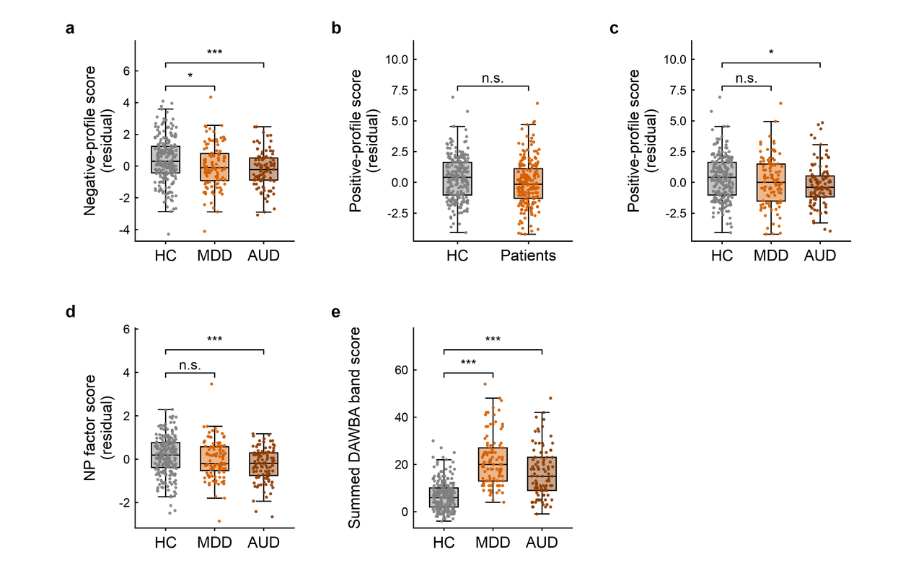
Fig. S1 Negative and positive profiles, the NP factor, and symptom severity by diagnosis in the STRATIFY validation sample. STRATIFY participants included healthy controls (HC, n = 225), patients with major depressive disorder (MDD, n = 104), and alcohol use disorder (AUD, n = 98). Profile and factor scores were residuals after regressing out sex, site, and mean framewise displacement. a, Negative-profile score: HC versus MDD, Welch (t) = 2.36, df = 205.1, P = 0.038, Hedges’ g = 0.28 (95% CI 0.06-0.49); HC versus AUD, Welch (t) = 4.14, df = 224.9, P < 0.0001, g = 0.46 (0.23-0.69). b, Positive-profile score: HC versus all patients, Welch (t) = 2.25, df = 415.1, P = 0.074, g = 0.22 (0.03-0.41). c, Positive-profile score: HC versus MDD, Welch (t) = 1.27, df = 181.5, P = 0.62, g = 0.16 (-0.06-0.37); HC versus AUD, Welch (t) = 2.45, df = 190.7, P = 0.046, g = 0.29 (0.06-0.52). d, NP factor score: HC versus MDD, Welch (t) = 1.64, df = 206.2, P = 0.21, g = 0.19 (-0.02-0.41); HC versus AUD, Welch (t) = 4.10, df = 210.9, P = 0.00012, g = 0.47 (0.24-0.70). e, Summed DAWBA band score across six domains: HC (n = 215) versus MDD (n = 103), Welch (t) = 13.38, df = 136.1, P < 0.0001, g = 1.91; HC versus AUD (n = 96), Welch (t) = 8.44, df = 126.1, P < 0.0001, g = 1.24. DAWBA scores are raw values rather than residuals. Box plots show the median, interquartile range and 1.5 × IQR whiskers, with individual observations overlaid. Two-sided Welch’s unequal-variance t-tests were used, with P values Bonferroni-corrected across the two contrasts (HC versus MDD and HC versus AUD) within each measure; for the positive profile, which was additionally compared between controls and all patients in b, correction was applied across three contrasts.
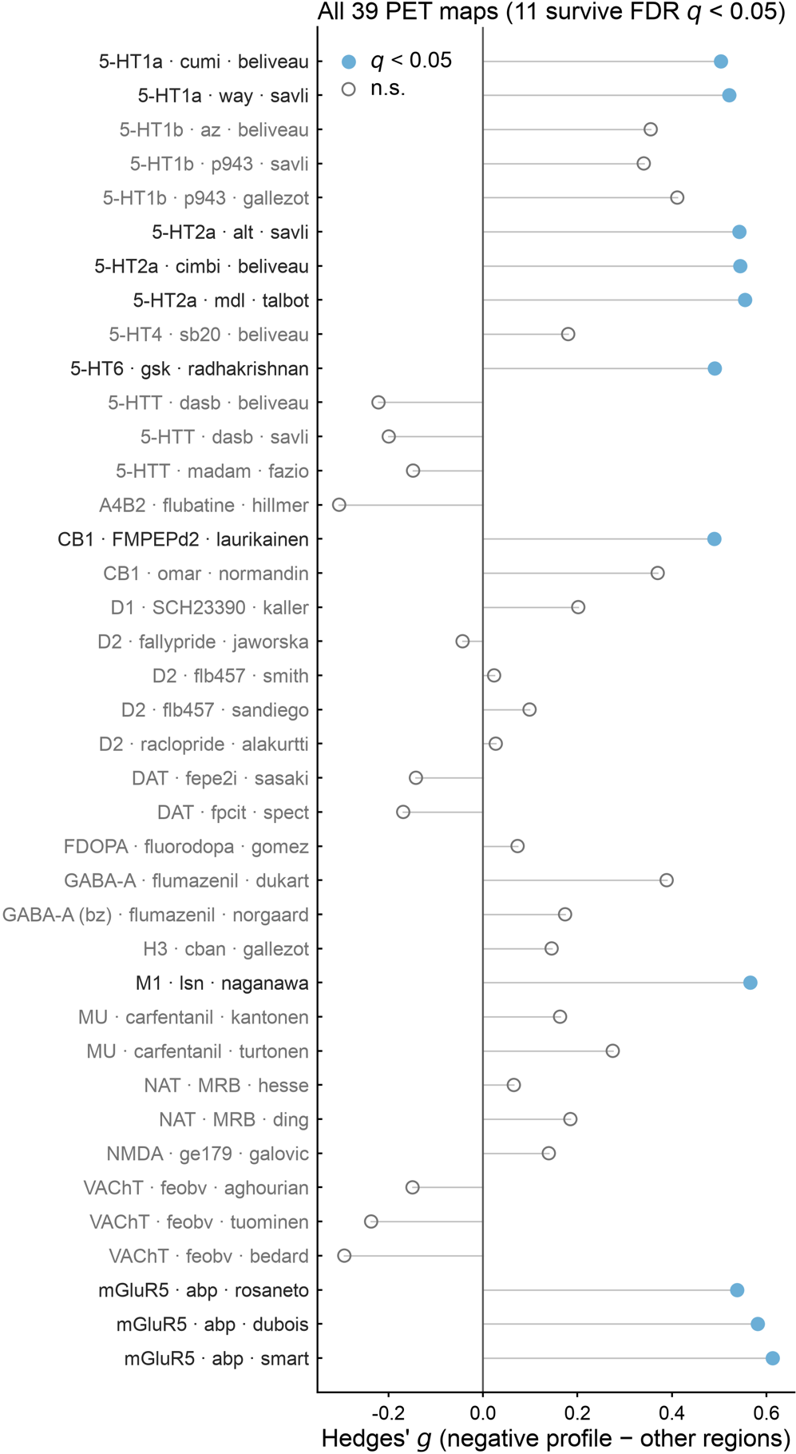
Fig. S2 PET-derived receptor availability in negative-profile regions. Each row represents one publicly PET-derived receptor map(Abbott, 1999). Regional values from the 32 regions comprising the 29-edge negative profile were compared with the remaining 236 Shen-268 regions using two-sided label-permutation tests (10,000 permutations). Eleven maps showed higher availability in negative-profile regions: 5-HT1A (Way, Savli; Hedges’ g = 0.52, q = 0.03; Cumi, Beliveau; Hedges’ g = 0.50, q = 0.039), 5-HT2A (Alt, Savli; Hedges’ g = 0.54, q = 0.03; Cimbi, Beliveau; Hedges’ g = 0.54, q = 0.03; MDL, Talbot; Hedges’ g = 0.55, q = 0.03), 5-HT6 (GSK, Radhakrishnan; Hedges’ g = 0.49, q = 0.041), M1 (LSN, Naganawa; Hedges’ g = 0.57, q = 0.03), CB1 (FMPEP-d2, Laurikainen; Hedges’ g = 0.49, q = 0.039), and mGluR5 (ABP, Rosaneto; Hedges’ g = 0.54, q = 0.03; Dubois; Hedges’ g = 0.58, q = 0.03; SMART; Hedges’ g = 0.61, q = 0.03). Hedges’ g denotes the difference in mean regional availability (negative-profile regions minus other regions). P values were corrected across 39 maps using the Benjamini-Hochberg false-discovery rate (BH-FDR); filled markers indicate maps surviving q < 0.05. Box plots show the median and interquartile range with 1.5 × IQR whiskers, with every region plotted. Exact P values for all significant receptor maps are listed in Table S24.

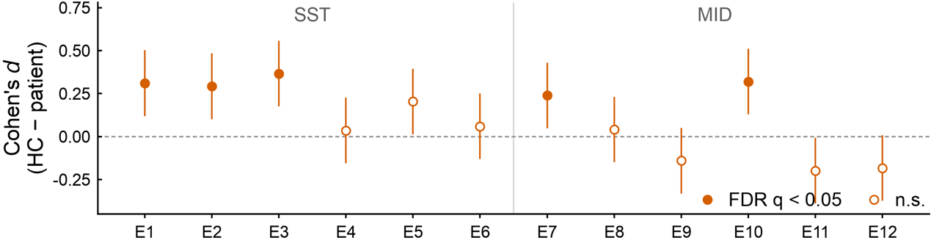
Fig. S3 Per-edge group differences (225 healthy controls v.s. 202 patients) in the NP factor in STRATIFY. Two-sided independent-samples t tests were performed for each edge, and P values were corrected across 12 edges using the BH-FDR. Five edges survived FDR correction: E1, t = 3.20, Cohen's d = 0.31 (95% CI 0.12-0.50), q = 0.0059; E2, t = 3.02, Cohen's d = 0.29 (0.102-0.48), q = 0.0081; E3, t = 3.78, Cohen's d = 0.37 (0.18-0.56), q = 0.0022; E7, t = 2.46, Cohen's d = 0.24 (0.05-0.43), q = 0.0339; E10, t = 3.30, Cohen's d = 0.32 (0.13-0.51), q = 0.0059. All five surviving edges showed higher connectivity in healthy controls, consistent with the summed scores of NP factor. Cohen’s d (healthy controls - patients) with 95% confidence intervals is shown for each of the 12 NP-factor edges; the dashed line indicates no difference. Edges are ordered by task, with six SST edges left and six MID edges right of the vertical rule. Exact uncorrected P values for all 12 edges are listed in Table S24.

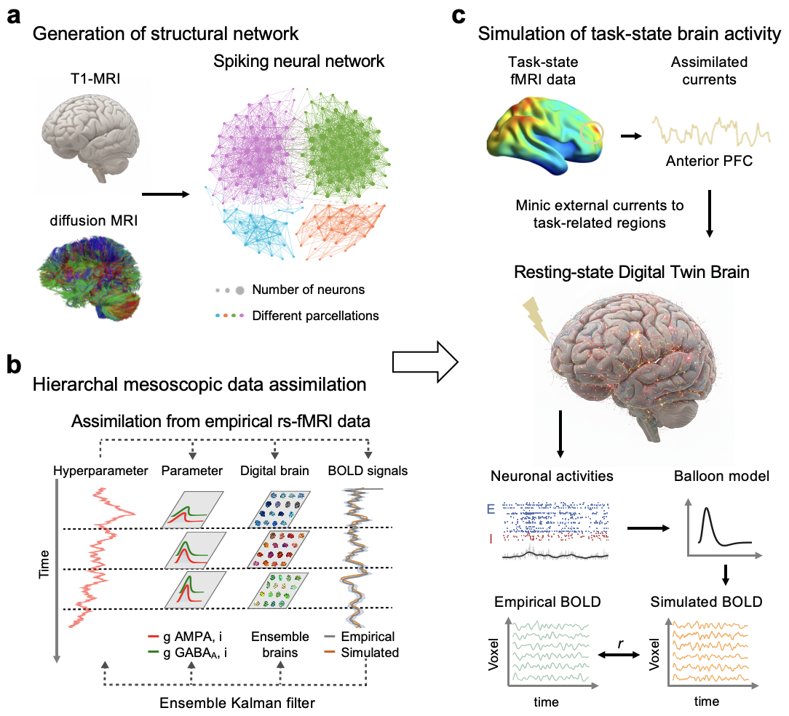
Fig. S4 Construction of individualised task-state DTB models. a, Multimodal MRI data were integrated to construct individualised spiking neural network. Diffusion tensor imaging (DTI) was used to estimate voxel-/regional-wise white-matter connectivity, defining inter-unit connection probabilities, while T1-weighted images were used to assign voxel-/regional-specific neuronal population sizes according to grey matter volume. Neuronal and synaptic structural networks were constructed at the voxel or region-wise unit, after specifying the total neuron number and the average in-degree. Network initialisation procedures were applied to prevent artificial synchronisation of neuronal spiking. Neuronal activity was simulated using the leaky integrate-and-fire model (LIF)²³, incorporating AMPA (excitatory-leaning) and GABA-A (inhibitory-leaning) synaptic conductances. b, A hierarchical mesoscopic data assimilation framework was employed to fit simulated BOLD signals to empirical fMRI data. Model hyperparameters were estimated by iteratively alternating between forward simulation and state filtering using a diffusion ensemble Kalman filter (EnKF). The EnKF used an ensemble of 30 parallel model realisations to estimate the variance of hidden states. For each voxel, AMPA and GABA-A synaptic conductances were sampled from gamma distributions, which were constrained by voxel-specific hyperparameters. As assimilation progressed over time, simulated BOLD signals converged toward empirical observations. Three representative time points are illustrated, showing the sampled parameters and ensemble models. After assimilations for all voxels, a resting-state DTB was obtained. c, Task-state DTBs were generated by assimilating task-state BOLD signals from task-engaged regions to estimate digital external input currents. These inferred inputs were then injected into the corresponding voxels of the resting-state DTB to induce task-state dynamics. For regions not directly engaged by the task, hyperparameters were fixed at their mean values of the hyperparameters estimated in the resting state. Voxel-averaged neuronal activity (mean firing rates, E means excitatory, and I means inhibitory) generated by the task-state DTB were then transformed into simulated task-state BOLD signals using the Balloon-Windkessel hemodynamic model. Model performance was quantified by Pearson's correlation (r) between simulated and empirical task-state BOLD signals. This figure is a schematic of model construction; sample size, unit of observation and error indicator are given at the panels where the corresponding quantitative results are reported elsewhere, and no inferential statistics were applied here. More details about the model construction can be found in Methods. This figure is a schematic of the modelling pipeline: no inferential statistics were applied, no error indicators are drawn and no multiple-comparison correction was required, so no test statistics or P values are reported. Sample sizes are given where the corresponding quantitative results are reported.

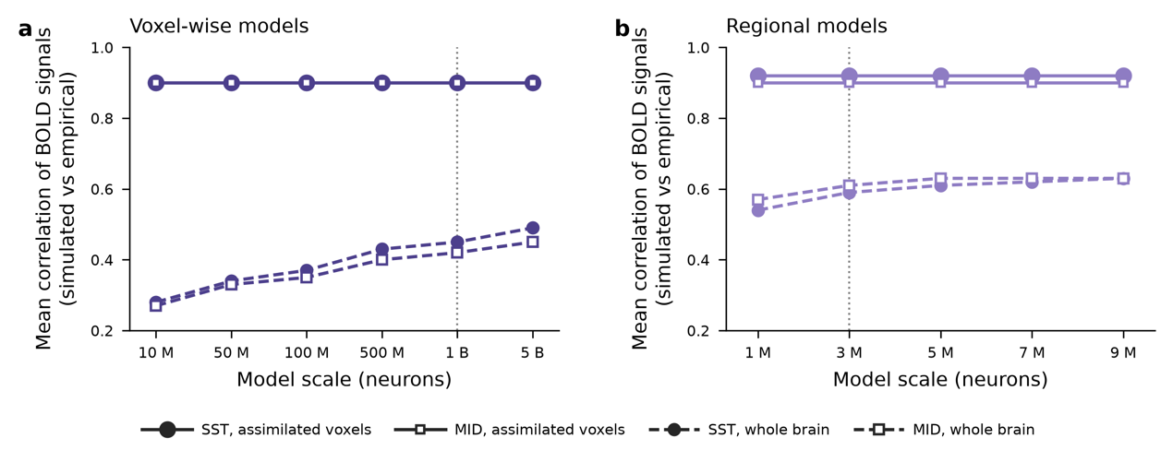
Fig. S5 Calibration of DTB neuronal scale for voxel-wise and regional simulations. a, Individualised DTB models for one healthy control across neuronal scales from 10 million to 5 billion neurons. Lines show mean Pearson’s r between simulated and empirical BOLD across MID and SST tasks. Performance plateaued at 1 billion neurons (mean voxel-wise r = 0.42 for MID and 0.45 for SST), with no further improvement at higher scales. b, Population-scale regional DTB models across 1-9 million neurons. Regional BOLD correlations plateaued at approximately 3 million neurons, with mean r > 0.6 across the two tasks. Both panels show descriptive calibration curves. Lines show the mean Pearson's r across assimilated regions and whole voxels; no error indicators are drawn, no inferential test was applied and no multiple-comparison correction was required, so no test statistics or P values are reported.

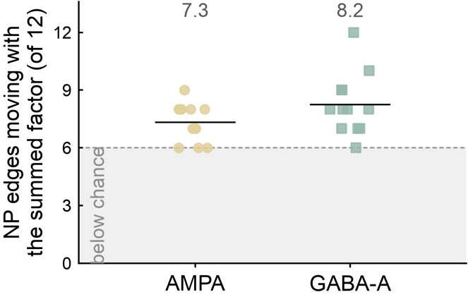
Fig. S6 Edge-level concordance with the summed NP factor. For each of 12 digital twins, the number of the 12 NP edges showing the same direction of perturbation-induced change as the group-level change was counted. Points indicate individual twins and black lines indicate group means; the dashed line denotes the chance expectation of 6/12. AMPA: 7.33 ± 0.98 concordant edges per twin (61.1%; median 7.5, range 6-9; t(11)= 4.69, P = 0.0007, Cohen’s d = 1.35). GABA-A: 8.25 ± 1.60 (68.8%; median 8.0, range 6-12; t(11) = 4.86, P = 0.0005, Cohen’s d = 1.40). No twin fell below chance; more than half of the edges followed the factor in 9/12 AMPA and 11/12 GABA-A twins. Points show individual twins and lines the group means; no error indicators are drawn. Departure from the 6/12 chance level was tested with two-sided one-sample t tests, uncorrected across the two perturbations; exact statistics are listed in Table S24.

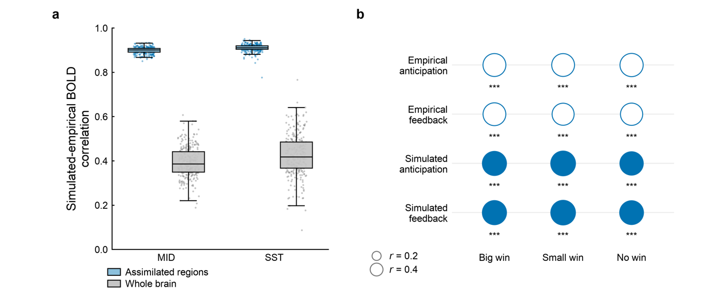
Fig. S7 Fidelity of the simulated data, from the regional BOLD time series to the behaviour the simulated connectivity predicts. a, Mean Pearson’s correlations between simulated and empirical regional BOLD time series for the monetary incentive delay task (MID) and stop-signal task (SST), evaluated in assimilated regions and across the whole brain. Boxes show the median and interquartile range, whiskers extend to 1.5 × IQR, and each point represents one participant. MID: assimilated regions, 0.90 ± 0.01 (n = 288, median 0.90, range 0.85–0.93); whole brain, 0.39 ± 0.07 (median 0.39, range 0.19–0.61). SST: assimilated regions, 0.91 ± 0.02 (median 0.91, range 0.78–0.95); whole brain, 0.43 ± 0.09 (median 0.42, range 0.09–0.77). b, Connectome-based predictive modelling (CPM) of task response time using MID task-specific whole-brain functional connectomes (reduced 217 regions). Accuracy is Spearman’s correlation between predicted and observed response time. Response time was predicted significantly in all three conditions and both task states from both empirical and simulated connectivity (n = 283, rho = 0.40 to 0.50, all P < 0.001). Simulated connectivity predicted response time at least as well as empirical connectivity in all six targets (mean r = 0.48 versus 0.42; mean difference +0.06). The comparison is across prediction targets rather than participants. All tests are two-sided and corrected by BH-FDR. ***P < 0.001, **P < 0.01, *P < 0.05, n.s., not significant. The exact test statistics are listed in Table S16.

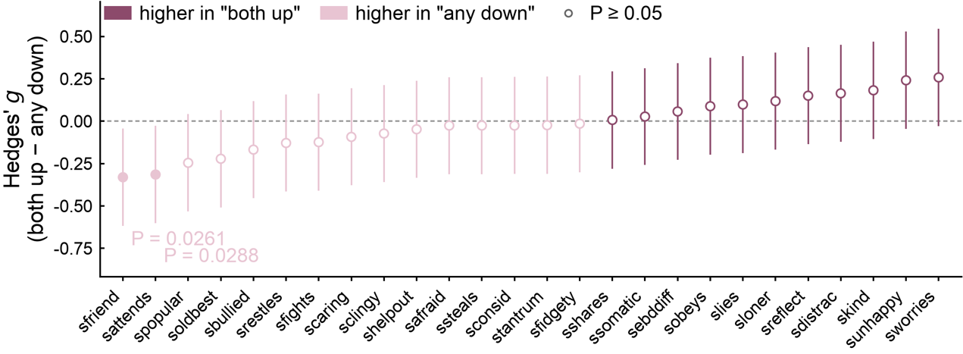
Fig. S8 SDQ item-level differences between the two response groups. Hedges’ g for the 26 SDQ items comparing twins whose simulated NP factor increased under both perturbations (“both up”, n = 228) with those in which at least one perturbation decreased it (“any down”, n = 59); error bars indicate 95% confidence intervals. Unit of observation: one subject; n = 287 twins, with one lacking SDQ data. Items are ordered by effect size; filled markers indicate nominal P < 0.05 and open markers P ≥ 0.05. Two-sided Mann-Whitney U tests were performed for each item and reported uncorrected. Two items were nominally significant, both lower in the “both up” group: sfriend (U=5966, Hedges’ g = -0.33, 95% CI -0.62 to -0.04, P = 0.026) and sattends (U=5614.5, Hedges’ g = -0.32, 95% CI -0.60 to -0.03, P = 0.029); neither survived BH-FDR correction (q = 0.374 for both).
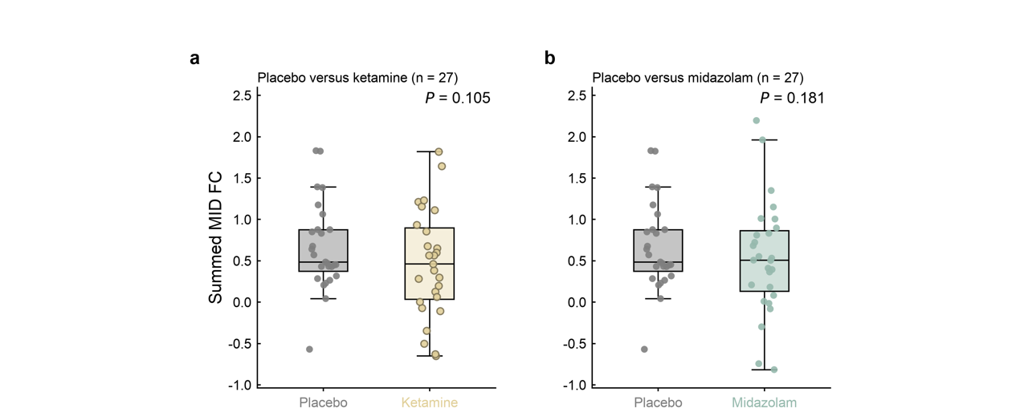
Fig. S9 Neither ketamine nor midazolam shifts summed NP-related MID connectivity in the paired placebo comparison. Box plots show the median and interquartile range with 1.5 × IQR whiskers; points represent 27 healthy volunteers. The plotted measure is the raw sum of six NP-related MID edges. In the randomised within-subject crossover design, drug-placebo differences were tested with two-sided paired tests; motion-adjusted estimates were obtained by regressing the paired FC difference on the paired framewise-displacement difference. a, Placebo versus ketamine: motion-adjusted difference -0.20 (t = -1.68, 95% CI -0.45 to 0.05, P = 0.105). b, Placebo versus midazolam: motion-adjusted difference -0.25 (t = -1.38, 95% CI -0.62 to 0.12, P = 0.181). Neither drug significantly altered the summed NP-related connectivity. The standardised composite score used in Fig. 5 is not shown because it is standardised separately within each condition, making its paired mean difference zero by construction. Group-level drug effects were tested with two-sided paired t tests against placebo, adjusted for mean framewise displacement across the two drugs.

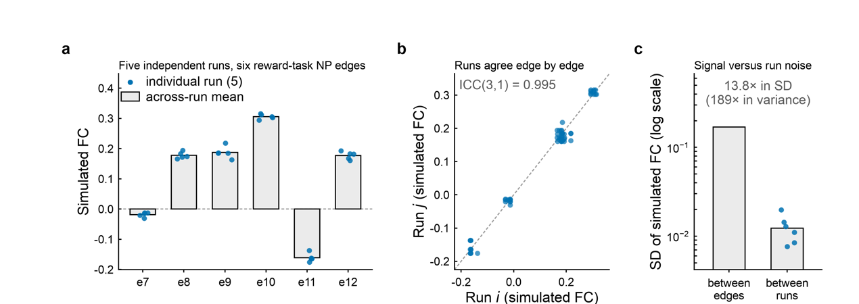
Fig. S10 Reproducibility of the assimilation procedure. Five independent HMDA assimilation runs (ensemble Kalman filter, 30 parallel realisations) were performed on the MID reward-task BOLD of one healthy control at the 100-million-neuron scale. Each run repeated assimilation and forward simulation from scratch. a, The six reward-task NP edges across runs; bars indicate across-run means and points individual runs. b, Edge-wise agreement between the 10 pairs of runs, with the identity line shown. The edge profile showed high reproducibility (ICC(3,1) = 0.9951; mean between-run correlation r = 0.996, range 0.99-0.999). c, Between-run variability relative to between-edge variability. The mean between-run s.d. was 0.01 versus 0.17 between edges, corresponding to a 13.8-fold difference in s.d. (189-fold in variance). This is a descriptive reliability analysis; repeated runs were available only for the MID edges of one subject. In a, bars show across-run means and points the individual runs; in c, the error bar is the standard deviation across the five runs. These analyses are descriptive (intraclass correlation and ratio of standard deviations); no inferential test was applied and no correction was required.

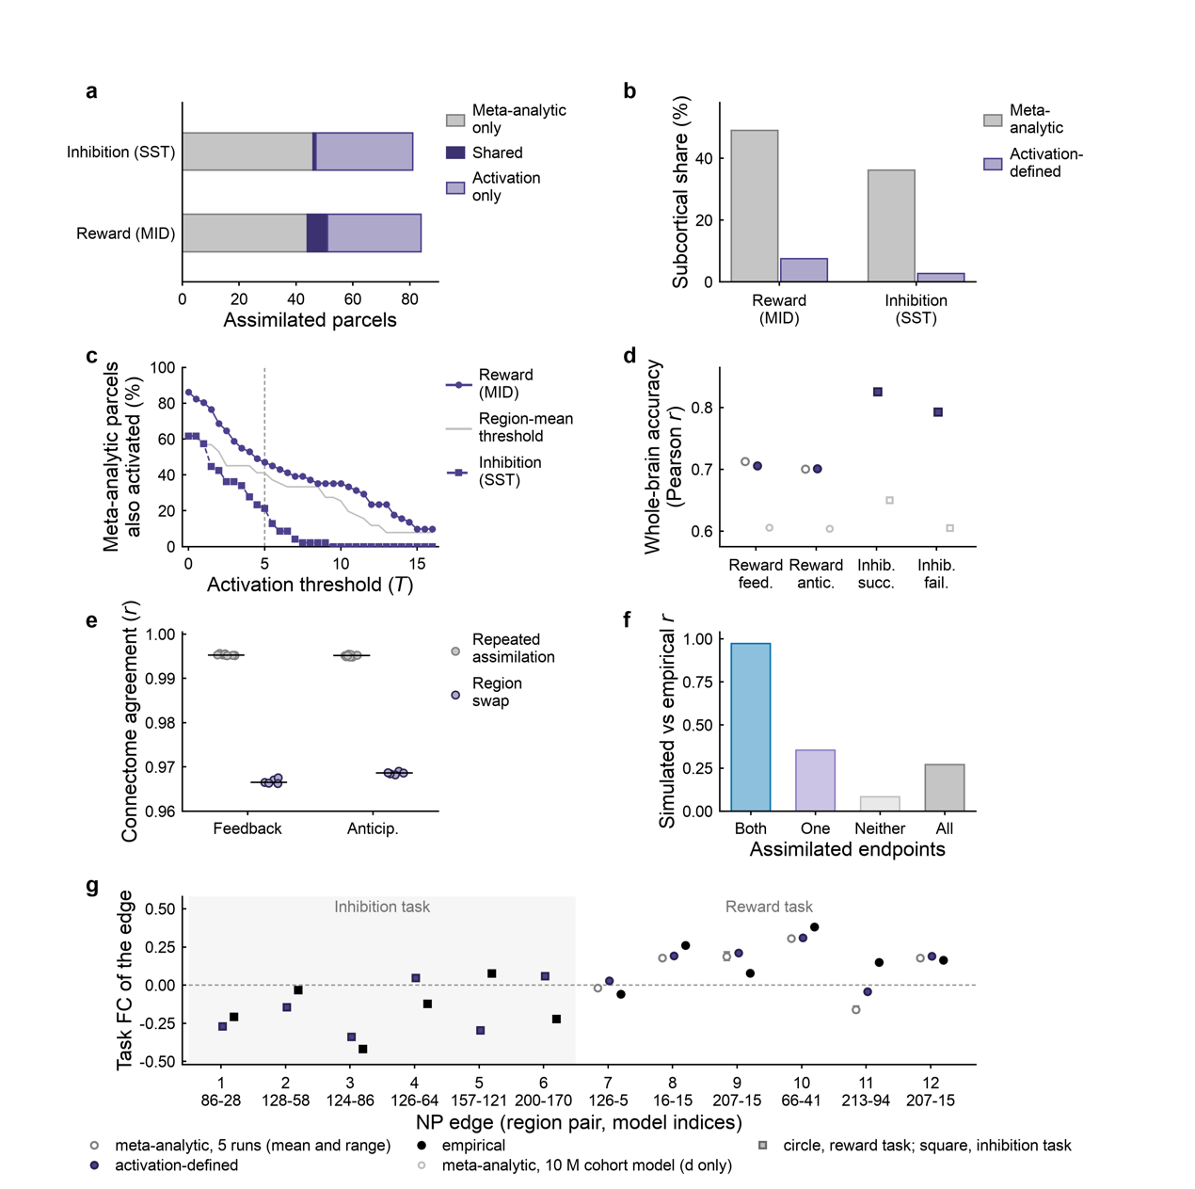
Fig. S11 Meta-analytic versus activation-defined assimilation regions. One activation-defined region set was derived separately for the reward and inhibition tasks from group-level task T maps and matched to the corresponding meta-analytic set by assimilated voxel count. Both sets were assimilated and simulated in one healthy control participant’s 100-million-neuron voxel-wise digital twin brain. a, Parcel composition of the two sets in the participant’s voxel space. b, Subcortical composition in the 217-region model space. c, Percentage of meta-analytic parcels showing positive group-level activation across increasing T thresholds. d, Whole-brain agreement between simulated and empirical functional connectivity. Replacing the meta-analytic regions did not improve agreement for the reward conditions; inhibition conditions cannot be compared directly because the activation-defined model used 100 million neurons, whereas the available meta-analytic comparator used 10 million neurons. e, Pairwise agreement between simulated connectomes. The five repeated meta-analytic assimilations were highly reproducible (r = 0.9949–0.9956), whereas the activation-defined set differed more substantially from them (r ≈ 0.97), indicating greater perturbation associated with the region definition than with repeated assimilation. f, Simulated–empirical agreement across edges grouped by the number of assimilated endpoints. Agreement was highest when both endpoints were assimilated and progressively lower when fewer endpoints were assimilated. g, The 12 NP edges; edges 7 and 11 fell outside the five-run meta-analytic range and were among edges for which the activation-defined set omitted an assimilated endpoint. All panels are descriptive; no inferential tests were performed. Spatial overlap (Dice) and run-to-run comparisons are descriptive; no multiple-comparison correction was therefore applied, and no test statistics or P values are reported. The overlap values for each assimilation set are listed in Table S24.

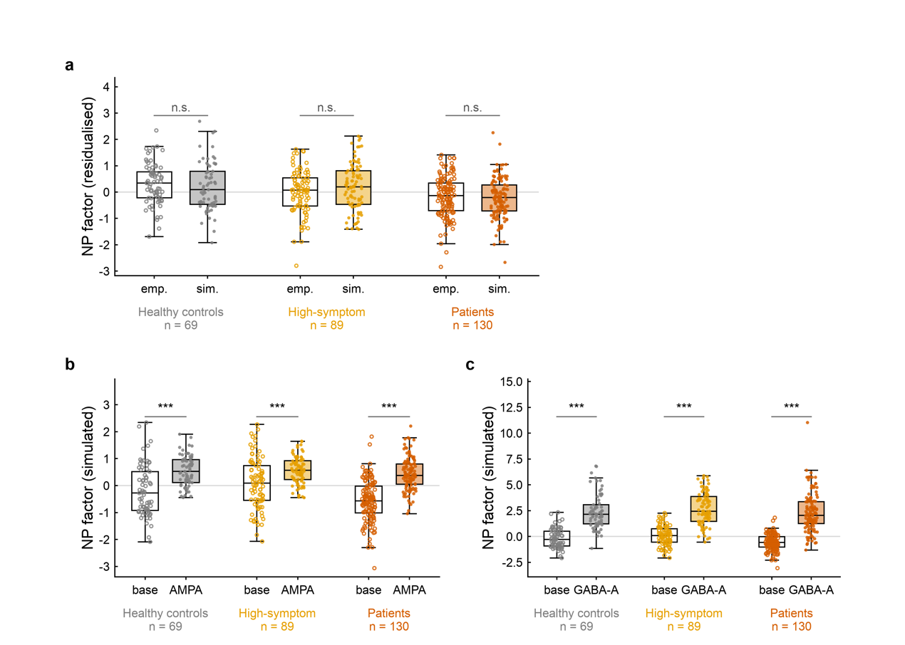
Fig. S12 NP factor scores across diagnostic groups in empirical and simulated states. All panels show the same 288 digital twins (69 healthy controls, 89 high-symptom participants and 130 patients). Boxes show the median and interquartile range with 1.5 × IQR whiskers; individual observations are plotted. a, Empirical versus simulated NP scores after residualisation for age, sex, site and mean framewise displacement. Scores did not differ within any group: healthy controls, difference = -0.12, P = 0.442; high-symptom participants, 0.19, P = 0.12; patients, -0.07, P = 0.449. b, Simulated baseline versus AMPA-perturbed scores. NP increased in all groups: healthy controls, 0.740 (P < 0.0001); high-symptom participants, 0.50 (P < 0.0001); patients, 0.99 (P < 0.0001). c, Simulated baseline versus GABA-A-perturbed scores. NP increased across all groups: 2.60, 2.63 and 2.883 in healthy controls, high-symptom participants and patients, respectively (all P < 0.0001). All comparisons are two-sided paired t-tests and uncorrected. Exact t statistics, degrees of freedom and P values for all within-group comparisons are listed in Table S24.
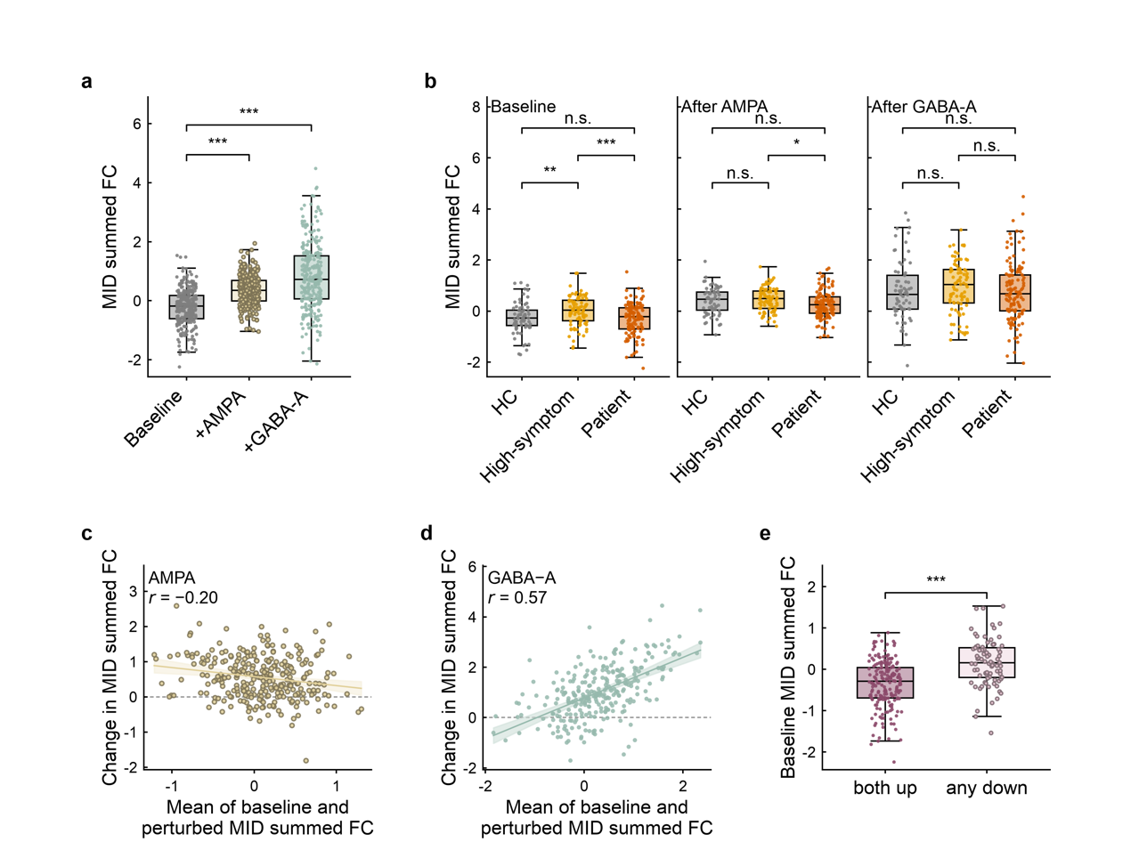Fig. S13 Bidirectional virtual responses are preserved using MID-specific NP connectivity. Virtual AMPA and GABA-A perturbations were re-analysed using the summed six MID-specific NP edges in 288 digital twins (69 healthy controls, 89 high-symptom participants and 130 patients). a, Both perturbations increased MID-specific connectivity overall (AMPA, 0.56 ± 0.61; GABA-A, 1.02 ± 1.04; both P < 0.0001), with increases in 83.0% and 84.4% of twins, respectively. b, Diagnostic group differences were present at baseline (F₂,₂₈₅ = 7.47, P = 0.0007), attenuated after AMPA (F₂,₂₈₅ = 3.75, P = 0.0246) and absent after GABA-A perturbation (F₂,₂₈₅ = 0.72, P = 0.488). c,d, Oldham’s tests showed variance contraction after AMPA (r = -0.20, P = 0.0007; ratio = 0.48) and variance expansion after GABA-A (r = 0.57, P < 0.0001; ratio = 1.23). e, Twins showing increases under both perturbations had lower baseline MID-specific connectivity than those showing a decrease under at least one perturbation (-0.35 ± 0.56 versus 0.17 ± 0.57; P < 0.0001). Response-group classification agreed with that based on the 12-edge NP factor for 75.3% of twins. Box plots show the median and interquartile range with 1.5 × IQR whiskers, with every twin plotted; c and d show ordinary least-squares fits with 95% confidence bands. Group differences were tested by one-way analysis of variance on scores adjusted for sex, site and mean framewise displacement, and baseline dependence by Oldham's method; all tests are two-sided and uncorrected. Exact test statistics and P values are listed in Table S24.
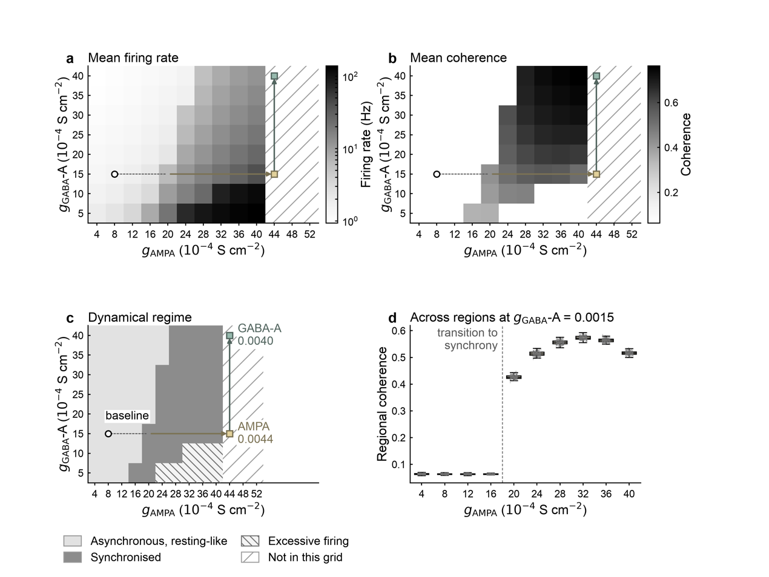
Fig. S14 Two-dimensional AMPA/GABA-A conductance sweep defining the baseline and perturbation endpoints. Each cell represents one simulation at a fixed pair of global conductances (n = 80 simulations). a, Mean population firing rate. b, Mean inter-regional coherence. c, Dynamical regimes defined by gaps in the coherence and firing-rate distributions: asynchronous (≤3.42 Hz), synchronised (5.28-39.86 Hz) and excessive firing (≥69.67 Hz). The baseline (0.0008 S cm⁻² AMPA, 0.0015 S cm⁻² GABA-A; 1.54 Hz, coherence = 0.0636) lies in the low-firing, low-coherence regime. The arrows indicate the perturbation path to AMPA (0.0044 S cm⁻²) and subsequent GABA-A (0.0040 S cm⁻²) endpoints. d, Regional coherence along the AMPA sweep at the baseline GABA-A conductance (n = 217 regions per setting). Synchronisation emerges across regions rather than sequentially, with greater regional variability after the transition. All panels are descriptive. Heat maps and regional distributions carry no error indicator, and all panels are descriptive: no inferential test was applied, no multiple-comparison correction was required and no test statistics or P values are reported.

