# Machine Learning Engineer Nanodegree

## Unsupervised Learning

## Project 3: Creating Customer Segments

## Getting Started

In this project, I analyze a dataset containing data on various customers' annual spending amounts (reported in monetary units) of diverse product categories for internal structure. One goal of this project is to best describe the variation in the different types of customers that a wholesale distributor interacts with. Doing so would equip the distributor with insight into how to best structure their delivery service to meet the needs of each customer.

The dataset for this project can be found on the [UCI Machine Learning Repository](https://archive.ics.uci.edu/ml/datasets/Wholesale+customers). For the purposes of this project, the features 'Channel' and 'Region'will be excluded in the analysis — with focus instead on the six product categories recorded for customers.

The code block below load the wholesale customers dataset, along with a few of the necessary Python libraries required for this project.

## Data Exploration

In this section, I will begin exploring the data through visualizations and code to understand how each feature is related to the others. I will examine a statistical description of the dataset, consider the relevance of each feature, and select a few sample data points from the dataset which I will track through the course of this project.

The code block below examine the summary statistic of the dataset. Note that the dataset is composed of six important product categories: **'Fresh'**, **'Milk'**,**'Grocery'**, **'Frozen'**, **'Detergents\_Paper'**, and **'Delicatessen'**.

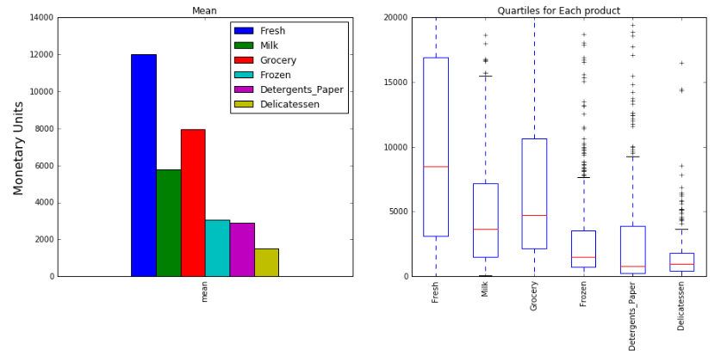

### Figures 1: population statistics, average median and quartiles for each product.

### Implementation: Selecting Samples

To get a better understanding of the customers and how their data will transform through the analysis, it would be best to select a few sample data points and explore them in more detail. In the code block below, I choose **three** indices which will represent the customers to track. I choose customers that vary significantly from one another.

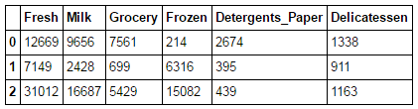

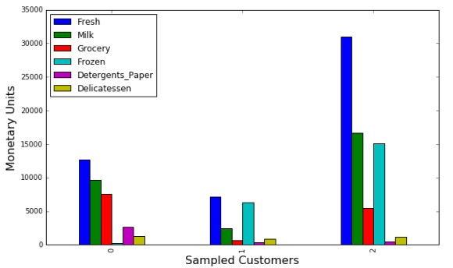

### Figures 2: sample statistics, product distribution for each sampled customer.

Consider the total purchase cost of each product category for the sample customers and the statistical description of the dataset above.  
We can conclude about the kind of establishment (customer) could each of the three samples you've chosen represent

**Customer 0**[0] : Monetary units for the 'Fresh', 'Detergents\_Paper', 'Grocery' and 'Delicatessen' are around the population average, 'Milk' is above the population average and frozen is bellow the population average. That can be a Hotel since most of the products are around the average.

**Customer 1**[130] : Monetary units for the 'Frozen' is above the population average and 'Fresh', 'Detergents\_Paper', 'Grocery', 'Milk' and 'Delicatessen' is bellow the population average. That can be a small caffe.

**Customer 2**[427] : Monetary units for the 'Delicatessen' are around the population average, 'Fresh', 'Milk', 'Frozen' is above the population average and 'Detergents\_Paper' is bellow the population average. That can be a Resturant.

### Implementation: Feature Relevance

One interesting thought to consider is if one (or more) of the six product categories is actually relevant for understanding customer purchasing. That is to say, is it possible to determine whether customers purchasing some amount of one category of products will necessarily purchase some proportional amount of another category of products? We can make this determination quite easily by training a supervised regression learner on a subset of the data with one feature removed, and then score how well that model can predict the removed feature.

In the code block below, the following is implemented :

* Assign new\_data a copy of the data by removing a feature of your choice using the DataFrame.drop function.
* Use sklearn.cross\_validation.train\_test\_split to split the dataset into training and testing sets.
  + Use the removed feature as your target label. Set a test\_size of 0.25 and set a random\_state.
* Import a decision tree regressor, set a random\_state, and fit the learner to the training data.
* Report the prediction score of the testing set using the regressor's score function.

Fresh -0.333070533605

Milk 0.173438009379

Grocery 0.699248196675

Frozen -0.278249148824

Detergents\_Paper 0.348777454691

Delicatessen -11.0236279005

The coefficients of determinations list above indicate that ~ 70 % of the variance in 'Grocery' can be explained by the other products in the data set. That signify that 'Grocery' might not be necessary as one of the features in the model, because other features can be used instead. But since 30% of the variance in 'Grocery' cannot be explained, we will use the 'Grocery' hopping that extra information will be useful.

### Visualize Feature Distributions

To get a better understanding of the dataset, we can construct a scatter matrix of each of the six product features present in the data and calculate the correlation values. If we found that 'Grocery' is relevant for identifying a specific customer, then the scatter matrix below may not show any correlation between that feature and the others. Conversely, if 'Grocery' is not relevant for identifying a specific customer, the scatter matrix might show a correlation between that feature and another feature in the data.

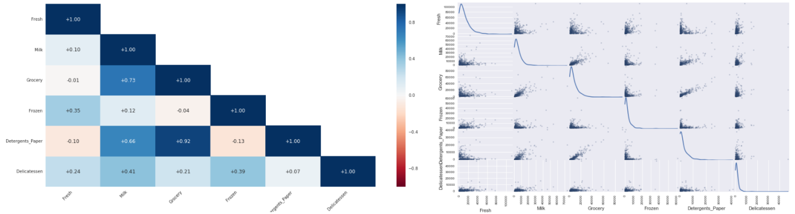

### Figures 3: We can see that Grocery and milk, detergent paper and grocery have high corelation coefficients.The other relations are quite low other features are lowly corelated. That verify our suspision about the relevance of it when we tried to predict using Decision Tree Regressor algorithm in the previous step. The data for the features is right skewed (positive skewness) which means that most of data happen to be in the first quartile.

## Data Preprocessing

In this section, I will preprocess the data to create a better representation of customers by performing a scaling on the data and detecting (and optionally removing) outliers. Preprocessing data is often times a critical step in assuring that the obtained results from the analysis are significant and meaningful.

### Implementation: Feature Scaling

If data is not normally distributed, especially if the mean and median vary significantly (indicating a large skew), it is most [often appropriate](http://econbrowser.com/archives/2014/02/use-of-logarithms-in-economics) to apply a non-linear scaling — particularly for financial data. One way to achieve this scaling is by using a [Box-Cox test](http://scipy.github.io/devdocs/generated/scipy.stats.boxcox.html), which calculates the best power transformation of the data that reduces skewness. A simpler approach which can work in most cases would be applying the natural logarithm.

In the code block below, I implement the following:

* Assign a copy of the data to log\_data after applying a logarithm scaling. Use the np.log function for this.
* Assign a copy of the sample data to log\_samples after applying a logrithm scaling. Again, use np.log.

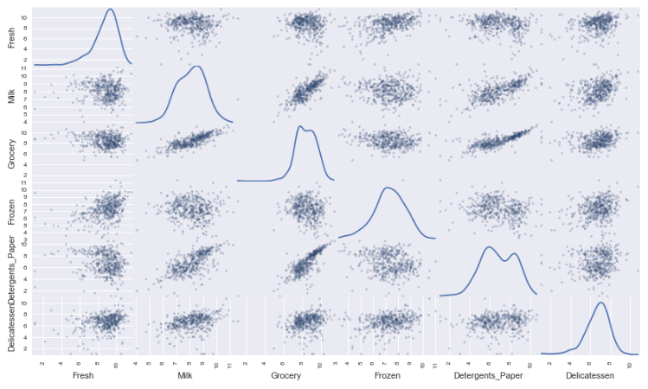

### Figures 4

### Observation

After applying a natural logarithm scaling to the data, the distribution of each feature is much more normal. For any pairs of features we have identified earlier Highly corelated features from the original data are still highly corelated after scaling data, and same goes for the lowly corelated features. They are lowly corelated after scaling..

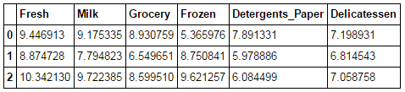

### Implementation: Outlier Detection

Detecting outliers in the data is extremely important in the data preprocessing step of any analysis. The presence of outliers can often skew results which take into consideration these data points. There are many "rules of thumb" for what constitutes an outlier in a dataset. Here, we will use [Tukey's Method for identfying outliers](http://datapigtechnologies.com/blog/index.php/highlighting-outliers-in-your-data-with-the-tukey-method/" \t "_blank): An outlier step is calculated as 1.5 times the interquartile range (IQR). A data point with a feature that is beyond an outlier step outside of the IQR for that feature is considered abnormal.

In the code block below, I implement the following:

* Assign the value of the 25th percentile for the given feature to Q1. Use np.percentile for this.
* Assign the value of the 75th percentile for the given feature to Q3. Again, use np.percentile.
* Assign the calculation of an outlier step for the given feature to step.
* Optionally remove data points from the dataset by adding indices to the outliers list.

There is plenty of outliers for each feature, but only 5 of them appear in more than 2 products [65, 66, 75, 128, 154]. I remove these outliers, because the clustering analysis that we will use later is sensitive to outliers

## Feature Transformation

In this section I will use principal component analysis (PCA) to draw conclusions about the underlying structure of the wholesale customer data. Since using PCA on a dataset calculates the dimensions which best maximize variance, we will find which compound combinations of features best describe customers.

### Implementation: PCA

Now that the data has been scaled to a more normal distribution and has had any necessary outliers removed, we can now apply PCA to the good\_data to discover which dimensions about the data best maximize the variance of features involved. In addition to finding these dimensions, PCA will also report theexplained variance ratio of each dimension — how much variance within the data is explained by that dimension alone. Note that a component (dimension) from PCA can be considered a new "feature" of the space, however it is a composition of the original features present in the data.

In the code block below, I will implement the following:

* Import sklearn.decomposition.PCA and assign the results of fitting PCA in six dimensions with good\_data to pca.
* Apply a PCA transformation of the sample log-data log\_samples using pca.transform, and assign the results to pca\_samples.

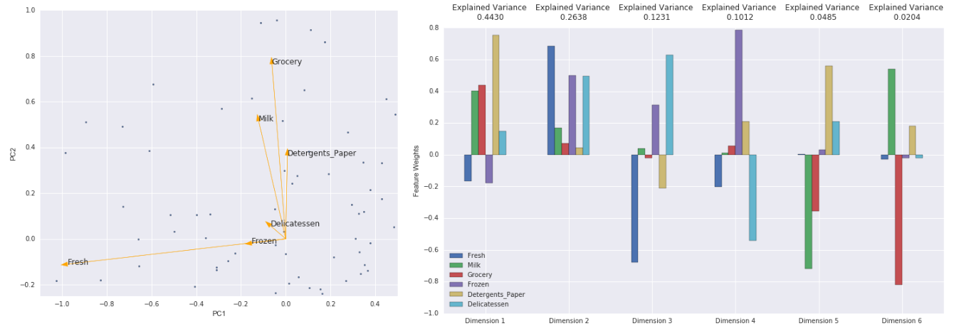

### Figures 5 : PCA dimenssions

### Question 5

How much variance in the data is explained **in total** by the first and second principal component? What about the first four principal components? Using the visualization provided above, discuss what the first four dimensions best represent in terms of customer spending.  
**Hint:** A positive increase in a specific dimension corresponds with an increase of the positive-weighted features and a decrease of the negative-weightedfeatures. The rate of increase or decrease is based on the indivdual feature weights.

From the figure and the analysis here above we can see that the first 2 dimensions explains ~70 % of the variance in the data set, where the first 4 dimensions explains ~90% of the variance.

**First dimension :** most of the variance in this dimension seems to include the Milk , Grocery and Detergent that are all positives. That is an indication that these 3 products are correlated (as we sow in the correlation analysis). When the consumption of Milk increase, Grocery and Detergent also increase.

**Second dimension :** most of the variance in this dimension is in the Fresh , Frozen and delicatessen. Interestingly, these are the features that were not expressed in the first dimension.

**Third dimension :** in this dimension we find that the Fresh and delicatessen have high weights, but with different signs, that indicate that these features are anti correlated. When the consumption of Fresh increase, the consumption of Frozen decrease.

**Forth dimension :** is similar to the Third dimension , but in this case the Groceries and the Milk have different signs

### Observation

The code below demonstrate how the log-transformed sample data has changed after having a PCA transformation applied to it in six dimensions. The numerical value for the first four dimensions of the sample points.

### 

### Implementation: Dimensionality Reduction

When using principal component analysis, one of the main goals is to reduce the dimensionality of the data — in effect, reducing the complexity of the problem. Dimensionality reduction comes at a cost: Fewer dimensions used implies less of the total variance in the data is being explained. Because of this, the cumulative explained variance ratio is extremely important for knowing how many dimensions are necessary for the problem. Additionally, if a signifiant amount of variance is explained by only two or three dimensions, the reduced data can be visualized afterwards.

In the code block below, I will implement the following:

* Assign the results of fitting PCA in two dimensions with good\_data to pca.
* Apply a PCA transformation of good\_data using pca.transform, and assign the reuslts to reduced\_data.
* Apply a PCA transformation of the sample log-data log\_samples using pca.transform, and assign the results to pca\_samples.

### Observation

In the code below we can see that the log-transformed sample data has changed after having a PCA transformation applied to it using only two dimensions.The values for the first two dimensions remains unchanged when compared to a PCA transformation in six dimensions.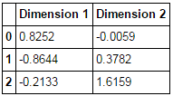

Clustering

In this section, I will use either a K-Means clustering algorithm or a Gaussian Mixture Model clustering algorithm to identify the various customer segments hidden in the data. I will then recover specific data points from the clusters to understand their significance by transforming them back into their original dimension and scale.

### Gaussian Mixture Model clustering

My choice is to use the Gaussian Mixture Models, the reason for that is the fact that the algorithm maximizes only the likelihood and therefore do not assume any specific structure, where K means have several different assumptions about the structure of the data. In this specific case we cannot assume much about the structure of the data, mainly because we do not know the data. The data include different type of customers that might have different size or buying patterns. Gaussian Mixture Models:

**Advantages**

1. The fastest algorithm for learning mixture models
2. The algorithm maximizes only the likelihood, therefore it will not bias the means towards zero, or bias the cluster sizes to have specific structures that might or might not apply.

**Disadvantages**

1. When one has insufficiently many points per mixture, estimating the covariance matrices becomes difficult, and the algorithm is known to diverge and find solutions with infinite likelihood unless one regularizes the covariance artificially.
2. This algorithm will always use all the components it has access to, needing held-out data or information theoretical criteria to decide how many components to use in the absence of external cues.

### K Means clustering:

**Advantages**

1. The problem K means try to solve is computational difficult but there are efficient and fast heuristic algorithms.
2. Simple to implement and run.
3. Easy to understand, therefore might helps to get a better understanding of the problem.

**Disadvantages**

1. The Algorithm might convergence to a local minimum that might be wrong result.
2. The numbers of clusters are given as an input, wrong number might cause poor results, and more or less clusters there really are in the data.
3. The algorithm assumes separable, spherical and similar size clusters that are separable, that might cause a failure to classify when data do not satisfy the assumptions.

resource: <https://www.quora.com/What-is-the-difference-between-K-means-and-the-mixture-model-of-Gaussian>

### Implementation: Creating Clusters

Depending on the problem, the number of clusters that are expected to be in the data may already be known. When the number of clusters is not known a priori, there is no guarantee that a given number of clusters best segments the data, since it is unclear what structure exists in the data — if any. However, we can quantify the "goodness" of a clustering by calculating each data point's silhouette coefficient. The [silhouette coefficient](http://scikit-learn.org/stable/modules/generated/sklearn.metrics.silhouette_score.html) for a data point measures how similar it is to its assigned cluster from -1 (dissimilar) to 1 (similar). Calculating the mean silhouette coefficient provides for a simple scoring method of a given clustering.

In the code block below, I will nimplement the following:

* Fit a clustering algorithm to the reduced\_data and assign it to clusterer.
* Predict the cluster for each data point in reduced\_data using clusterer.predict and assign them to preds.
* Find the cluster centers using the algorithm's respective attribute and assign them to centers.
* Predict the cluster for each sample data point in pca\_samples and assign them sample\_preds.
* Import sklearn.metrics.silhouette\_score and calculate the silhouette score of reduced\_data against preds.
  + Assign the silhouette score to score and print the result.

n\_components: 2 silhouette\_score: 0.368046586128

n\_components: 3 silhouette\_score: 0.340021153984

n\_components: 4 silhouette\_score: 0.328041604106

n\_components: 5 silhouette\_score: 0.306857762846

n\_components: 6 silhouette\_score: 0.268179994695

n\_components: 7 silhouette\_score: 0.304044733271

n\_components: 8 silhouette\_score: 0.275592391666

n\_components: 9 silhouette\_score: 0.304128104375

I tried 2 to 10 clusters. The best score was ~0.37 when the number of clusters was 2 clusters.

### Cluster Visualization

Once you've chosen the optimal number of clusters for your clustering algorithm using the scoring metric above, you can now visualize the results by executing the code block below. Note that, for experimentation purposes, you are welcome to adjust the number of clusters for your clustering algorithm to see various visualizations. The final visualization provided should, however, correspond with the optimal number of clusters.

### Figures 6: Clustering for the cleaned reduced data set

### Implementation: Data Recovery

Each cluster present in the visualization above has a central point. These centers (or means) are not specifically data points from the data, but rather theaverages of all the data points predicted in the respective clusters. For the problem of creating customer segments, a cluster's center point corresponds tothe average customer of that segment. Since the data is currently reduced in dimension and scaled by a logarithm, we can recover the representative customer spending from these data points by applying the inverse transformations.

In the code block below, I implement the following:

* Apply the inverse transform to centers using pca.inverse\_transform and assign the new centers to log\_centers.
* Apply the inverse function of np.log to log\_centers using np.exp and assign the true centers to true\_centers.

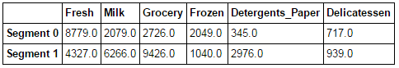

Consider the total purchase cost of each product category for the representative data points above, and reference the statistical description of the dataset at the beginning of this project.

### 

### Figures 7: Product distribution for the 2 clusters (or segments) that were identified by the analysis.

**For Segment 1** we find that Milk Grocery and Detergents\_Paper are above the population average and the other products are below. This segment might represents hotels.

**For Segment 0** All products are bellow the population average but the Fresh products are high compared to the others. Represents coffee or resturant.

### Assign the sampled customer to a specific cluster segment.

For each sampled customer we now can assign a segment that best represents it.

The code block below find which cluster each sample point is predicted to be.

Sample point 0 predicted to be in Cluster 1

Sample point 1 predicted to be in Cluster 0

Sample point 2 predicted to be in Cluster 0

**Customer 0 [0] :** Monetary units for the 'Fresh', 'Detergents\_Paper', 'Grocery' and 'Delicatessen' are around the population average, **'Milk' is above the population average** and frozen is bellow the population average. That can be a Hotel since most of the products are around the average.

**For Segment 1**we find that **Milk Grocery and Detergents\_Paper are above the population average** and the other products are below. This segment might represents hotels.

**Customer 1 [130] :** Monetary units for the **'Frozen' is above the population average and 'Fresh'**, 'Detergents\_Paper', 'Grocery', 'Milk' and 'Delicatessen' is bellow the population average. That can be a small caffe. **Customer 2 [427] :** Monetary units for the 'Delicatessen' are around the population average,**'Fresh', 'Milk', 'Frozen' is above the population average** and 'Detergents\_Paper' is bellow the population average. That can be a Resturant.

**For Segment 0** All products are bellow the population average but **the Fresh products are high compared to the others**. Represents coffee or resturant.

## Conclusion

### A/B test

\*Companies often run [A/B tests](https://en.wikipedia.org/wiki/A/B_testing) when making small changes to their products or services. The wholesale distributor wanted to change its delivery service from 5 days a week to 3 days a week, below I describe a simple A/B test that can used to appriciate which type of customers might appriciate this change.

The classification reveals additional information about the data set. The buyers does not distribute homogeneously, instead there are different patterns of buying. Fortunately enough we could detect these patterns and labels each client accordingly. One way for a new experiment will be to choose a 'test group' within each label, for example 20% from each class. For this 'test group' we can change small number of features, for example delivery time. That will enable us to compare the response to the change in the 'test group' and separately in the control group (the other 80%). The results can be different in each class, but then we can decide for each class if the change is beneficial or not.

### predictive model

Assume the wholesale distributor wanted to predict a new feature for each customer based on the purchasing information available. Bellow is a description of a simple predictive model that can be useful in this case

For prediction it is important to have some labels, this data does not include labeling. Other than the customer ID we do not really know what class or type is each customer. One way to overcome this will be to use as labels from the clustering analysis. Obviously the edges of the clusters might be problematic and might introduce error to the training. However, we can choose data points (or customers) that are closer to the center of each cluster and remove the data points on the edges. The training on these groups will provide us with a model. The model can be tested on a separate test sample (that will not be used for the training procedure).If the model performance is high enough we can use this model for prediction.

### Visualizing Underlying Distributions

At the beginning of this project, it was discussed that the 'Channel' and 'Region' features would be excluded from the dataset so that the customer product categories were emphasized in the analysis. By reintroducing the 'Channel' feature to the dataset, an interesting structure emerges when considering the same PCA dimensionality reduction applied earlier on to the original dataset.

The code block below demonstrate how each data point is labeled either 'HoReCa' (Hotel/Restaurant/Cafe) or 'Retail' the reduced space. In addition, the sampled customers are circled in the plot, which will identify their labeling.

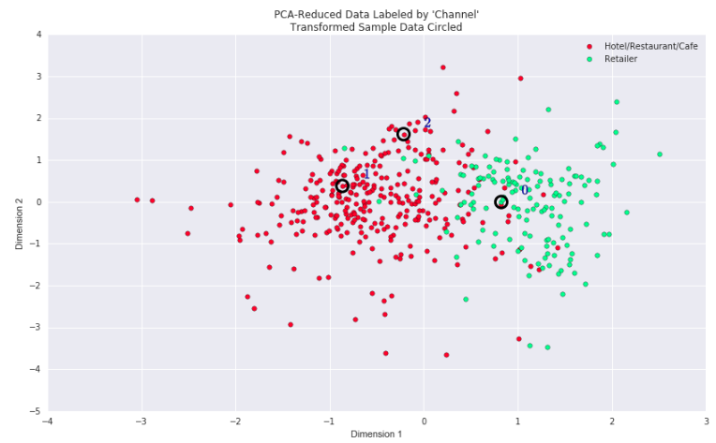

### Figure 8 : Comparison of the clasification performed by the analysis (the location in the PCA space) and the actual labeling in the data set (different collors).