Multi-Plane Wavefront Shaping (MWFS) for Optical Focusing in Dynamic Microvascular Tissue
Submitted by Omer Shenkar, September 2026
Course 480907

1. Abstract & Introduction
In multi-plane wavefront shaping (MWFS), volumetric scattering within biological tissue is modeled as a discrete set of thin phase-aberration planes separated by free-space wave propagation. Each of these planes is then corrected using a planar SLM, by introducing correction planes that are conjugated to the aberration planes [1]. This project utilizes speckle statistics to evaluate the robustness of MWFS for deep tissue imaging in dynamic biological environments, using the Strehl ratio criterion. While an optimal conjugate correction calculated at initial time $t_{0}$ achieves near-ideal phase cancellation and diffraction-limited focusing, real tissue dynamically varies over time due to microvascular motion and blood flow. This framework provides a quantitative metric for determining the operational lifetime and decorrelation dynamics of multi-plane wavefront corrections in a simulated living, time-varying tissue.

2. Mathematical Framework: Discrete Layers Optimization & Wave Propagation
To model volumetric optical scattering efficiently, the 3D tissue scattering volume of size $X x Y x Z$ is represented as a set of $M$ discrete, thin, phase-only aberration planes spaced at even intervals along the optical propagation axis $z$ [1, 2]. In this work we will use $M=2$. This multi-slice transmission matrix (TM) formulation decomposes the continuous 3D refractive index perturbation into equivalent planar phase screens, interlaced with free-space angular spectrum wave propagation [1, 5].
Therefore, light propagation through the layered medium, composed of 2 aberration layers, is represented by the following:
$$\left(1\right) u_{out, tissue}=P_{ϵ}⋅A_{2,0}⋅P_{ϵ}⋅A_{1,0}⋅P_{ϵ}⋅u_{in}$$
where $A_{i,j}$ represents the complex transmission screen of tissue layer $i$ at time $j$, $P_{ϵ}$ represents forward free-space propagation of distance $ϵ$ between layers such that $+ϵ$ is forward and $-ϵ$ is backwards. $u_{in}$ represents the illumination complex field and $u_{out, tissue}$ is the field emerging at the tissue’s edge. In our simulation, each aberration layer is derived from the integrated 3D refractive index volume and enforced to be unit-amplitude phase-only:
$$\left(2\right) A_{1,0}(x, y) = exp\left(i⋅arg\left(mask\left(x, y, ϵ\right)\right)\right)$$
where $mask (x, y, ϵ)$ is the depth-averaged complex field computed over the $ϵ$ depth window corresponding to the slice, in this example slice $A_{1}$ at time $t=0$.
After propagating through the tissue, the light’s back propagation through the SLM correction planes can be modeled as
$$\left(3\right) u_{out, system}=P_{-ϵ}⋅\tilde{A_{1,0}}⋅P_{-ϵ}⋅\tilde{A_{2,0}}⋅P_{-ϵ}⋅P_{ϵ}⋅A_{2,0}⋅P_{ϵ}⋅A_{1,0}⋅P_{ϵ}⋅ u_{in}$$
Where ${\tilde{A}}_{i,j}$is the complex conjugate of $A_{i,j}$, and they satisfy ${\tilde{A}}_{i,j}=A_{i,j}^{-1}$, and $u_{out, system}$ is the light field after back propagating through the SLM. This system is displayed in Figure 1.
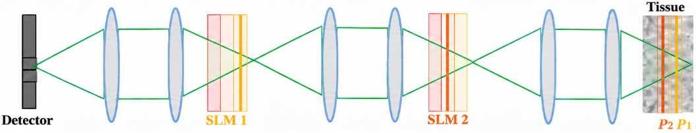
Figure 1: Schematic representation of the Multi-Plane Wavefront Shaping (MWFS) optical architecture. The 3D scattering tissue volume is discretized into 𝑀 = 2 phase-only aberration planes (Plane $A_{1}$ and Plane $A_{2}$) separated by free-space propagation distance 𝜖. A spatial light modulator (SLM) applies conjugate correction phases (SLM1, SLM2) to correct the aberrations caused by the tissue.

3. Tissue, Capillary and Blood Cells Modeling
The biological tissue volume in this project is modeled as a $35 x 35 x {15}_{um^{3}}$ block embedded with a single central capillary. This capillary diameter oscillates over time and allows the flow of up to 2 red blood cells in series (RBCs).

3.1 Aberrating Tissue Modelling
The aberrating tissue was modeled as randomly generated refractive-index spheres in a 3D volume, each contributing a smooth phase bump scaled by its index contrast. Summing and exponentiating these gives a complex transmission volume, band-limited by Fourier filtering with a spatial-support constraint (suppressing edge artifacts in the FFT propagation) and a circular NA cutoff (removing non-physical high frequencies). The fine axial sampling is then averaged into 2 coarse slabs forming the discrete phase screens. A central capillary runs along the Y-axis, perpendicular to propagation, initialized empty (uniform zero phase) until 2 RBCs enter and alter the aberration. The background and plasma refractive index was set as 1.0.

3.2 Capillary Geometry and Periodic Vasomotion
Human capillaries have baseline internal diameters ranging from 4 to 10 µm [2]. In this model, the capillary runs longitudinally through the center of the tissue volume along the Y-axis. The capillary lumen exhibits periodic vasomotion with an 8-second cycle:
$$\left(4\right) d\left(t\right)= 7- 3 cos{\left(\frac{2πt}{8}\right)}_{μm}$$
yielding a minimum constricted inner diameter of 4 µm and a maximum relaxed inner diameter of ${10}_{μm}$ [2].

3.3 RBC Morphological Deformation, Speed, and Optical Properties
Red blood cells have a resting biconcave disc diameter of $6$ to $8_{μm}$ and a volume of $\sim {90}_{fL}$ [2]. To navigate narrow capillaries, RBCs deform into axisymmetric 'bullet-like' or 'parachute-like' elongated shapes [3]; when the lumen constricts to $4_{μm}$, the cell stretches along the flow axis to $10$ to ${12}_{μm}$ while maintaining constant volume [3]. Here the RBC is modeled as a rectangle for simplicity, since the system's output depends on the sum of all tissue aberrations and it was assumed that approximate dimensions suffice. Flow velocity varies with vasomotion from $v_{RBC}=8_{\frac{μm}{s}}$ during constriction up to ${25}_{\frac{μm}{s}}$ in relaxed segments [3], with both speed and shape scaling linearly with capillary width.
At $λ = {532}_{nm}$, the RBC refractive index was set to 1.38 [2].
The simulation evaluates $17$ discrete timesteps spanning $t = 0_{s}$ to $t = 4_{s}$ sampled at $4_{Hz}$
($Δt={0.25}_{s}$). The $3D$ volume is sliced into $M = 2$ discrete phase planes: Plane $A_{1}$ (covering the entrance half $z∈ [0,Z/2]$) and Plane $A_{2}$ (covering the exit half $z∈[\frac{Z}{2}, Z]$). Since the capillary is placed at the center of the tissue, its effects are present in both aberration planes.
The simulation tracks two sequential RBCs traversing the ${35}_{μm}$ long capillary. The blood flow through plane $A_{1}$ can be seen in four different timestamps in Figure 2.
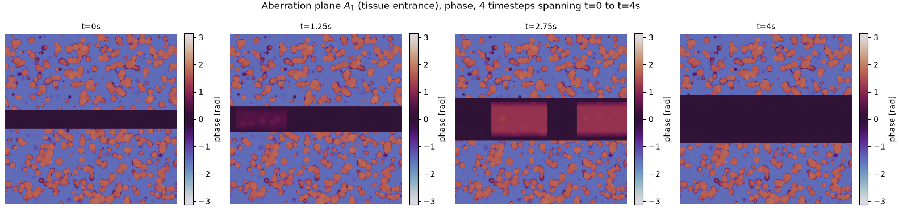
Figure 2: Plane $A_{1}$ changes over time, showing the RBC flow and capillary dilation.
RBC 1 enters the capillary at $t=0_{s}$ at $y=0_{μm}$. It moves along the Y-axis driven by the local velocity field, reaching $y={10}_{μm}$ at $t={1.25}_{s}$ and exiting the tissue volume at $t={3.25}_{s}$.
RBC 2 entry is triggered when RBC 1 passes $Y = {10}_{µm}$ (at $t = {1.25}_{s}$). RBC 2 enters at $Y = 0_{µm}$, traverses the capillary behind RBC 1, and reaches $Y = {22}_{µm}$ at $t = 4_{s}$.
This multi-cell progression creates a dynamic 3D phase perturbation that moves across the field of view, providing a testbed for wavefront shaping robustness estimation.

4. Wavefront Correction Performance: Static vs. Stale Calibration

4.1 Ideal Static Calibration ($t = 0_{s}$)
Since the correction masks ${\tilde{A}}_{1,0}, {\tilde{A}}_{2,0}$are computed for the static tissue at $t = 0_{s}$ (prior to RBC entry), the phase distortions introduced by the two aberration planes are perfectly cancelled. Under this ideal calibration, the output field $u_{out}$ achieves exact constructive interference at the focal target, forming a symmetric, high-intensity diffraction-limited Airy spot as can be seen in Figure 3. In this scenario, when propagating $u_{out}$ for additional $2ϵ$, we get an interference pattern and not a speckle, as the light is coherent and all aberrations are corrected.

4.2 Stale Calibration Decay During RBC Transit
As RBCs flow through the sample for $t>0$, equation (3) no longer holds as the modeled aberration planes are changing. For these timestamps, $u_{out}$ is modeled as:
$$\left(5\right) u_{out, systen}\left(t\right)=P_{-ϵ}⋅\tilde{A_{1,0}}⋅P_{-ϵ}⋅\tilde{A_{2,0}}⋅P_{-ϵ}⋅P_{ϵ}⋅A_{2,t}⋅P_{ϵ}⋅A_{1,t}⋅P_{ϵ}⋅ u_{in}$$
Since we do not re-calibrate the correction planes, we expect that, as the RBCs progress through the sample, the correction will become less effective, as new aberrations are introduced. Indeed, the field described by equation (5) doesn’t display a sharp, clear Airy disc as was described in section 4.1 for $t>0$, an example can be seen in Figure 3. In this scenario, when propagating $u_{out}$ for additional $2ϵ$, the result will not be a perfect interference pattern, but a speckle that is the result of the light’s coherent nature and the uncorrected aberrations.
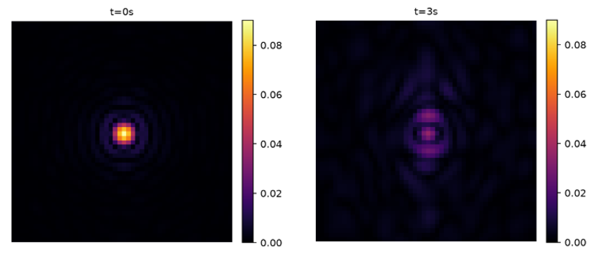
Figure 3: ${\left|u_{out}\right|}^{2}$ over time

5. Statistical Evaluation: Temporal Speckle Auto-Correlation
To quantitatively characterize the temporal stability of the scattered optical field, we first calculate the normalized temporal speckle auto-correlation function $g_{2}\left(τ\right)=\frac{<I\left(0\right)I\left(τ\right)>}{<I{\left(0\right)}^{2}>}$ across the 17 timesteps. We propagated the light for $2ϵ$ further than shown in equation (5), to image a plane conjugate to the tissue’s surface. The corrected light path whose statistics are shown in Figure 4 is modeled as:
$$\left(6\right) u_{out, corrected}\left(t\right)=P_{2ϵ}⋅P_{-ϵ}⋅\tilde{A_{1,0}}⋅P_{-ϵ}⋅\tilde{A_{2,0}}⋅P_{-ϵ}⋅P_{ϵ}⋅A_{2,t}⋅P_{ϵ}⋅A_{1,t}⋅P_{ϵ}⋅ u_{in}$$
And the uncorrected light path can be modeled as
$$\left(7\right) u_{out,uncorrected}\left(t\right)=P_{2ϵ}⋅P_{-ϵ}⋅P_{ϵ}⋅A_{2,t}⋅P_{ϵ}⋅A_{1,t}⋅P_{ϵ}⋅ u_{in}$$
Thus, we can compare the decorrelation over time for both the corrected and uncorrected paths and see the effect of our correction.
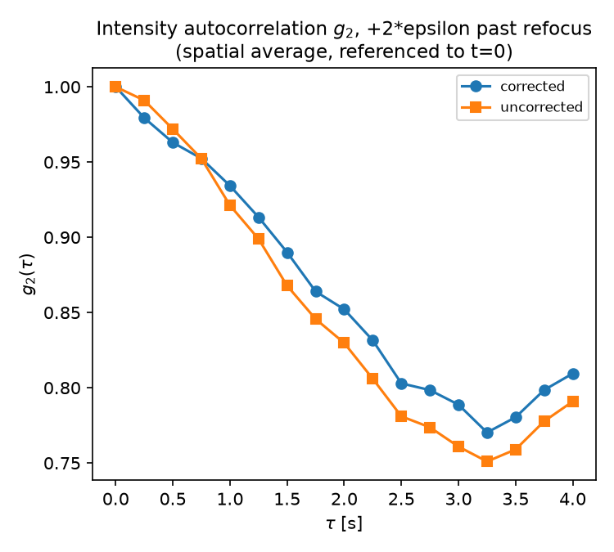
Figure 4: $g_{2}\left(τ\right)$ computed for both corrected and uncorrected light paths
We can observe that our correction mostly dampened the decorrelation effect caused by the blood flow dynamics. It should be noted that both $g_{2}(τ)$ sees to increase starting $t={3.5}_{s}$. This behavior may seem counterintuitive at first, yet it stems from the limitations of our simulation. This is the timestamp where the first RBC starts to exit the sample, leading to fewer aberrations. $g_{2}\left(τ\right)$ further increases as both RBCs exit the tissue, but does not reach a final value of $1$ since the capillary is dilated, causing a different aberration than in $t=0_{s}$, therefore the correction planes do not fully correct the final aberration planes.
We now use this insight to measure the robustness of MWFS: how effective is our light correction in the presence of tissue dynamics? To do so, we will use the Strehl ratio [1] measured on a corrected plane, conjugate to the tissue’s surface as seen in equation (6). This ratio is determined as:
$$\left(8\right) S(t)=\frac{I_{actual}(t)}{I_{ideal}}$$
We will use ${\left|u_{out, corrected}\left(0\right)\right|}^{2}$ as $I_{ideal}$. We will use ${\left|u_{out,corrected}\left(t\right)\right|}^{2}$ as $I_{actual}(t)$. We will define a successful MWFS correction for $S≥0.8$[1], and measure $S$ for different $(1-g_{2}^{uncorrected}\left(τ\right))$ values, as the uncorrected path’s correlation shows the tissue's decorrelation with no correction. This relation can be seen in Figure 5.

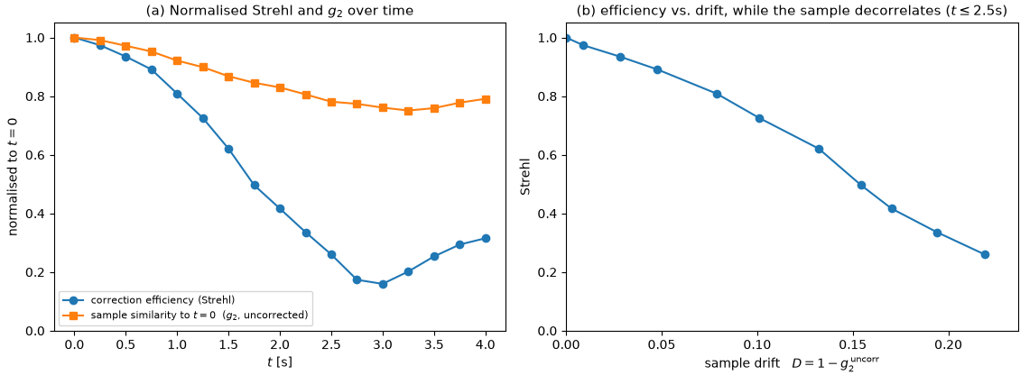
Figure 5: (a) The correction efficiency measured using the Strehl ratio and the tissue's correlation over time. (b) the relation between both parameters
An effective static correction can be achieved when the uncorrected-path correlation exceeds 0.9217, as Figure 5 (b) shows S=0.8 when $1-g_{2}^{uncorrected}(τ)=0.0783$.

6. Conclusion & Future Directions
This project demonstrates a multi-slice simulation framework coupling 3D wave propagation with dynamic biological microvasculature. We have shown that while multi-plane wavefront shaping successfully achieves near-ideal diffraction-limited focusing in static tissue, flowing red blood cells induce significant phase decorrelation. Viewing $S$ as a function of $g_{2}^{uncorrected}$ allows us to generalize our system’s robustness estimation. The simulation presented in this work is limited to specific tissue dynamics over a specific time scale, yet the use of $g_{2}(τ)$ allows us to express correction efficiency as a function of decorrelation rather than time. Because biological velocities and physiological cycles vary widely, time is an arbitrary metric for evaluating correction decay. By mapping the Strehl ratio directly to optical decorrelation ($1-g_{2}^{uncorrected}$), we decouple our system's performance from the physical speed of the tissue dynamics. This establishes a general threshold for correction failure defined on $g_{2}$ and not on time. Thus, these results may provide useful insight into estimating MWFS efficiency under different types of tissue dynamics. Future work could validate this relation for other tissue dynamics and aberration models.

7. References
[1] Levin, A., & Alterman, M. (2024). Understanding multi-layered transmission matrices. arXiv preprint arXiv:2410.23864.
[2] BioNumbers (2024). Table 10-1: Features of Blood Vessels. Harvard University Database.
[3] Bedggood, P., Ding, Y., & Metha, A. (2024). Changes to the shape, orientation and packing of red cells as a function of retinal capillary size. Biomedical Optics Express, 15(2), 558–578.

