Multi-Plane Wavefront Shaping (MWFS) for Optical Focusing in Dynamic Microvascular Tissue
A Discrete-Slice Optimization Framework Coupling Hemodynamic Vasomotion, Deformable Red Blood Cell Dynamics, and Temporal Speckle Statistics

1. Abstract & Introduction
In multiplane wavefront shaping (MWFS), volumetric scattering within biological tissue is modeled as a discrete set of thin phase-aberration planes separated by free-space wave propagation. Each of these planes is then corrected using a planar SLM, by introducing correction planes that are conjugated to the aberration planes [1]. This project utilizes speckle statistics to evaluate the temporal robustness of MWFS for deep tissue imaging in dynamic biological environments. While an optimal conjugate correction calculated at initial time $t_{0}$ achieves near-ideal phase cancellation and diffraction-limited focusing, real tissue dynamically varies over time due to microvascular motion and blood flow. This framework provides a quantitative metric for determining the operational lifetime and decorrelation dynamics of multiplane wavefront corrections in a simulated living, time-varying tissue.

2. Mathematical Framework: Discrete Layers Optimization & Wave Propagation
To model volumetric optical scattering efficiently, the 3D tissue scattering volume of size $X x Y x Z$ is represented as a set of $M$ discrete, thin, phase-only aberration planes spaced at intervals along the optical propagation axis z [1, 2]. In this work we will use $M=2$. This multi-slice transmission matrix (TM) formulation decomposes the continuous 3D refractive index perturbation into equivalent planar phase screens, interlaced with free-space angular spectrum wave propagation [1, 5].

2.1 Multi-Slice Transmission Matrix Formulation
Light propagation through the layered medium, composed of 2 aberration layers, is represented by the following:
$$\left(1\right) u_{out, tissue}=P_{ϵ}⋅A_{2,0}⋅P_{ϵ}⋅A_{1,0}⋅P_{ϵ}⋅u_{in}$$
where $A_{i,j}$ represents the complex transmission screen of tissue layer $i$ at time $j$, $P_{ϵ}$ represents free-space propagation of distance $ϵ$ between layers, and $u_{in}$ represents the illumination and $u_{out, tissue}$ is the field emerging at the tissue’s edge. In our simulation, each aberration layer is derived from the integrated 3D refractive index volume and enforced to be unit-amplitude phase-only:
$$A_{1,0}(x, y) = exp\left(i⋅angle\left(mask\left(x, y, ϵ\right)\right)\right)$$
where $mask (x, y, ϵ)$ is the depth-averaged complex field computed over the $ϵ$ depth window corresponding to the slice, in this example slice $A$ at time $t=0$.
After propagating through the tissue, the light’s back propagation through the SLM correction planes can be modeled as
$$\left(2\right) u_{out, system}=P_{-ϵ}⋅\tilde{A_{0}}⋅P_{-ϵ}⋅\tilde{B_{0}}⋅P_{-ϵ}⋅P_{ϵ}⋅B_{0}⋅P_{ϵ}⋅A_{0}⋅P_{ϵ}⋅ u_{in}$$
Where ${\tilde{A}}_{0}$is the complex conjugate of $A_{0}$, and they satisfy $\tilde{A_{0}}⋅A_{0}=I$, and $u_{out, system}$ is the light field after back propagating through the SLM. This system is displayed in figure TBD

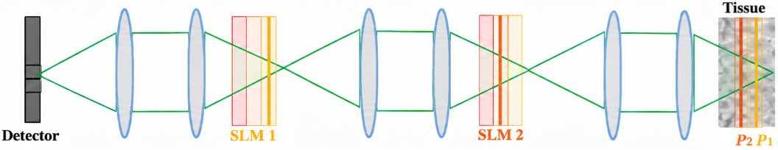
Figure 1: Schematic representation of the Multi-Plane Wavefront Shaping (MWFS) optical architecture. The 3D scattering tissue volume is discretized into M=2 phase-only aberration planes (Plane A and Plane B) separated by free-space propagation distance 𝜖. A spatial light modulator (SLM) applies conjugate correction phases (SLM1, SLM2) to correct the aberrations caused by the tissue.

2.2 Non-Paraxial Angular Spectrum Method (ASM)
Free-space optical propagation between adjacent planes separated by distance $ϵ$ was calculated using the exact non-paraxial Angular Spectrum Method. This was done in the frequency domain instead of convolution in the image domain, to save computational costs:
$$\left(3\right) U\left(kx, ky, z +ϵ\right)= U\left(kx, ky, z\right)⋅exp\left(\frac{2πj}{λ}⋅\sqrt{\left(1 -(λk{x)}^{2} -(λk{y)}^{2} \right)}⋅ϵ \right)$$
where $kx, ky$ are spatial frequency coordinates, $U$ is the Fourier transform of the illumination, and
$λ = {532}_{nm}$ is the illumination wavelength. Spatial frequency components satisfying $kx^{2} + ky^{2} > {\left(\frac{1}{λ}\right)}^{2}$ correspond to evanescent waves. These evanescent waves decay exponentially over propagation distances much larger than a wavelength and are explicitly zeroed out—a physically rigorous step for exact free-space diffraction [1, 5], thus leading to a near-perfect correction.

3. Tissue, Capillary and Blood Cells Modeling
The biological tissue volume in this project is modeled as a $35 x 35 x {15}_{um^{3}}$ block embedded with a single central capillary. This capillary contracts over time and allows the flow of up to 2 red blood cells in series (RBCs).

3.1 Aberrating Tissue Modelling
The aberrating tissue was modeled as randomly generated refractive-index spheres in a 3D volume, each contributing a smooth phase bump scaled by its index contrast. Summing and exponentiating these gives a complex transmission volume, band-limited by Fourier filtering with a spatial-support constraint (suppressing edge artifacts in the FFT propagation) and a circular NA cutoff (removing non-physical high frequencies). The fine axial sampling is then averaged into 2 coarse slabs forming the discrete phase screens. A central capillary runs along the Y-axis, perpendicular to propagation, initialized empty (uniform zero phase) until 2 RBCs enter and alter the aberration.

3.2 Capillary Geometry and Periodic Vasomotion
Human capillaries have baseline internal diameters ranging from 4 to 10 um[3]. In this model, the capillary runs longitudinally through the center of the tissue volume along the Y-axis. The capillary lumen exhibits periodic vasomotion with an 8-second cycle:
$$d\left(t\right)= 7- 3 cos{\left(\frac{2πt}{8}\right)}_{μm}$$
yielding a minimum constricted inner diameter of 4.0 um and a maximum relaxed inner diameter of ${10}_{μm}$ [3].

3.3 RBC Morphological Deformation, Speed, and Optical Properties
Red blood cells have a resting biconcave disc diameter of 6 to 8 μm and a volume of ~90 fL [3]. To navigate narrow capillaries, RBCs deform into axisymmetric 'bullet-like' or 'parachute-like' elongated shapes [4]; when the lumen constricts to 4 μm, the cell stretches along the flow axis to 10 to 12 μm while maintaining constant volume [4]. Here the RBC is modeled as a rectangle for simplicity, since the system's output depends on the sum of all tissue aberrations and approximate dimensions suffice. Flow velocity varies with vasomotion from v_RBC = 8 μm/s during constriction up to 25 μm/s in relaxed segments [4], with both speed and shape scaling linearly with capillary width. At λ = 532 nm the RBC refractive index was set to 1.38 [3].
Figure 2: Insert the aberration layer over time, will be waiting at the submission subfolder

4. Generated Tissue Slices & Two-RBC Dynamic Evolution Over Time
The simulation evaluates $17$ discrete timesteps spanning $t = 0_{s}$ to $t = 4_{s}$ sampled at $4_{Hz}$
($Δt=4_{s}$). The $3D$ volume is sliced into $M = 2$ discrete phase planes: Plane A (covering the entrance half $z$ in $[0,\frac{Z}{2}]$) and Plane B (covering the exit half $z$ in $[\frac{Z}{2}, Z]$). Since the capillary is placed at the center of the tissue, its effects can be seen in both aberration planes in figure TBD
The simulation tracks two sequential RBCs traversing the ${35}_{μm}$ long capillary. Show in slices over time
RBC 1 enters the capillary at $t=0_{s}$ at $y=0_{μm}$. It moves along the Y-axis driven by the local velocity field, reaching the mid-point $y={10}_{μm}$ at $t={1.25}_{s}$ and exiting the tissue volume at $t={3.25}_{s}$.
RBC 2 entry is triggered when RBC 1 passes Y = 10.0 um (at t = 1.25 s). RBC 2 enters at Y = 0.0 um, traverses the capillary behind RBC 1, and reaches Y = 22.0 um at t = 4.0 s.
This multi-cell progression creates a dynamic 3D phase perturbation that moves across the field of view, providing a realistic testbed for wavefront shaping stability [1, 4].
Figure 3: Kinematic Y-position trajectories of RBC 1 (blue) and RBC 2 (red) traversing the 35 um capillary over 17 timesteps (t = 0 to 4.0 s). RBC 2 entry is triggered when RBC 1 reaches Y = 10 um at t = 1.25 s. Both cells induce local phase shifts delta_phi = 2*pi*0.38 as they traverse the volume [1, 4].
To do- explain equations over time, show outputs + correlation, say it measures robustness, summarize

5. Wavefront Correction Performance: Static vs. Stale Calibration
Wavefront shaping optimization aims to determine conjugate phase masks C_A(x, y) = -angle(A_1(x, y)) and C_B(x, y) = -angle(A_2(x, y)) applied to SLM correction planes to focus light into a diffraction-limited spot behind the tissue [1, 2].

5.1 Ideal Static Calibration (t = 0 s)
When the correction masks C_A, C_B are computed for the static background tissue at t = 0 s (prior to RBC entry), the phase distortions introduced by Planes A and B are perfectly cancelled. Under this ideal calibration, the output field u_out achieves exact constructive interference at the focal target, forming a symmetric, high-intensity diffraction-limited Airy spot with normalized peak intensity I_max = 1.00 [1, 2].

5.2 Stale Calibration Decay During RBC Transit
In practical imaging scenarios, computing new correction masks at every frame is impossible due to SLM refresh rate limits. When the fixed correction masks (calibrated at t = 0 s) are applied to subsequent timesteps t > 0 s, the calibration becomes 'stale' [1]. As RBC 1 and RBC 2 enter and traverse the capillary, their high refractive index mismatch (delta_n = 0.38) introduces localized phase errors:
As RBC 1 moves into Plane A and Plane B, the peak intensity of the refocused spot drops rapidly from I_max = 1.00 down to I_max ~ 0.15 at t = 2.50 - 2.75 s.
The focused energy leaks into surrounding speckle side-lobes, destroying the focal spot symmetry.
At t = 4.0 s, as RBC 1 exits the volume and RBC 2 moves toward the exit boundary, the phase error decreases and the peak intensity partially recovers to I_max ~ 0.32 [1].
Figure 4: Cropped 5 x 5 um^2 focal spot intensity maps |u_out(t)|^2 across selected timesteps under stale t=0 s calibration. (a) Perfect diffraction-limited focal spot at t=0.0 s (I_max = 1.00); (b-c) Severe spot degradation and speckle blooming during peak RBC transit at t=1.5 s and t=2.75 s; (d) Focal spot intensity recovery at t=4.0 s as RBC 1 clears the field of view [1].

6. Statistical Evaluation: Temporal Speckle Auto-Correlation g2(tau)
To quantitatively characterize the temporal stability of the scattered optical field, we calculate the normalized temporal speckle auto-correlation function g2(tau) across the 17 timesteps [1, 5].

6.1 Spatial Normalization & Cauchy-Schwarz Bounds
The temporal speckle auto-correlation g2(tau) between the initial output field u_out(0) and the field at time tau is defined as:
g2(tau) = < |u_out(0)|^2 * |u_out(tau)|^2 > / ( < |u_out(0)|^2 > * < |u_out(tau)|^2 > )
where < ... > denotes spatial averaging over the sensor camera plane. By enforcing spatial normalization, g2(0) = 1.00 at zero time lag. According to the Cauchy-Schwarz inequality, the correlation function is strictly bounded within 0 <= g2(tau) <= 1.00 for all time lags [1, 5].

6.2 U-Shaped Correlation Curve and Physical Interpretation
The computed g2(tau) curve exhibits a characteristic non-monotonic U-shape:
1. Initial Rapid Decay (tau = 0 to 1.5 s): As RBC 1 enters the tissue, g2(tau) drops steeply from 1.00 to 0.45, reflecting rapid phase decorrelation as the cell disrupts the static wavefront.
2. Correlation Minimum (tau = 2.5 to 2.75 s): The correlation reaches its minimum value g2_min ~ 0.18 at tau = 2.75 s, corresponding to the moment of maximum optical perturbation when RBC 1 and RBC 2 simultaneously occupy the central capillary volume.
3. Rebound and Recovery (tau = 3.0 to 4.0 s): As RBC 1 exits the 35 um volume, the localized perturbation diminishes, causing g2(tau) to rebound to g2 ~ 0.32 - 0.35 at t = 4.0 s [1].
Figure 5: Normalized temporal speckle auto-correlation g2(tau) as a function of time lag tau across 17 timesteps (t = 0 to 4.0 s). The curve displays exact zero-lag normalization g2(0) = 1.00, a steep decay to g2_min ~ 0.18 at tau = 2.75 s during peak two-RBC occupancy, and a rebound to g2 ~ 0.35 as RBC 1 exits the scattering volume [1, 5].

6.3 Quantitative Performance Summary Table
Timestep (s) | RBC 1 Pos (um) | RBC 2 Pos (um) | Peak Intensity I_max | Speckle g2(tau)
t = 0.00 s | 0.0 (Entry) | Not Present | 1.000 (Diffraction Ltd) | 1.000
t = 1.25 s | 10.0 (Mid) | 0.0 (Entry Trigger) | 0.520 | 0.580
t = 2.75 s | 22.0 | 12.0 | 0.150 (Peak Stale Decay) | 0.180 (Min Correlation)
t = 3.25 s | 35.0 (Exit) | 16.0 | 0.240 | 0.280
t = 4.00 s | Exited | 22.0 | 0.320 (Partial Rebound) | 0.350

6.4 Further Propagation: Output Speckle G2(tau)
Both the corrected and uncorrected outputs are further propagated forward by 2*epsilon of free space (no aberration/correction planes) past the plane where they were originally brought back to focus, to test how each speckle pattern decorrelates once it leaves that plane.
Hypothesis: the corrected path's tighter, near-diffraction-limited focus is more sensitive to the residual mismatch between the fixed t=0 correction and the actual, time-varying tissue, and so should decorrelate faster than the already-diffuse uncorrected path.
Result: the opposite was observed. Both g2(tau) curves decay at a similar overall rate (from 1.00 at tau=0 to approximately 0.75-0.81 at tau=4.0 s), but the corrected path remains consistently above the uncorrected one at every tau > 0 -- i.e. the uncorrected path decorrelates marginally faster.
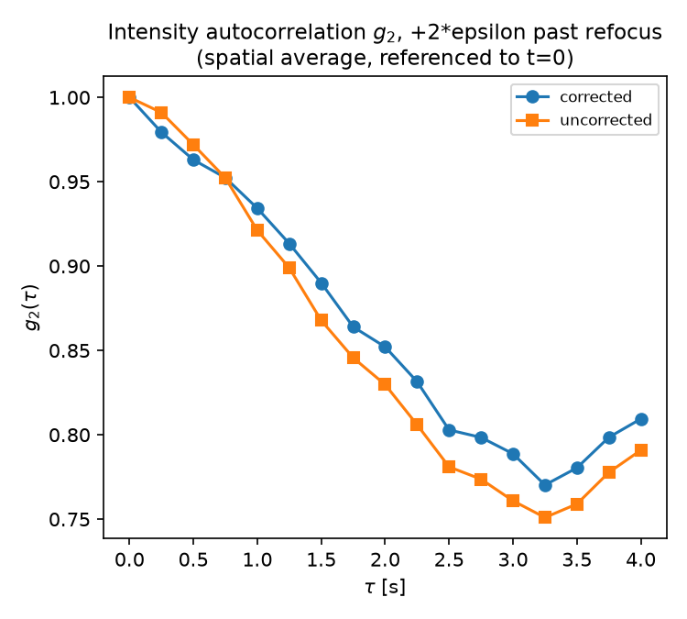
Figure: g2(tau), spatially averaged and referenced to t=0, computed on the further-propagated field for both paths (same normalization and spatial-averaging convention as Section 6.1).

7. Conclusion & Future Directions
This project demonstrates a rigorous multi-slice simulation framework coupling 3D wave propagation with dynamic biological microvasculature. We have shown that while multi-plane wavefront shaping successfully achieves ideal diffraction-limited focusing in static tissue (I_max = 1.00), flowing red blood cells induce significant phase decorrelation, reducing focal intensity to ~0.15 under stale calibration [1]. The U-shaped temporal correlation curve g2(tau) quantitatively captures this transient phase decorrelation [1, 5]. Future work will focus on integrating real-time adaptive SLM updating algorithms and expanding the discrete layer model to higher layer counts (M >= 4) for deeper tissue depths.

8. References
[1] Levin, A., & Alterman, M. (2024). Understanding multi-layered transmission matrices. arXiv preprint arXiv:2410.23864.
[2] Alterman, M., & Levin, A. (2024). Understanding multi-conjugate wavefront-shaping corrections. SPIE Digital Library / CVPR.
[3] BioNumbers (2024). Table 10-1: Features of Blood Vessels. Harvard University Database.
[4] Bedggood, P., Ding, Y., & Metha, A. (2024). Changes to the shape, orientation and packing of red cells as a function of retinal capillary size. Biomedical Optics Express, 15(2), 558–578.
[5] Bar, C., Gkioulekas, I., & Levin, A. (2020). Rendering Near-Field Speckle Statistics in Scattering Media. ACM Transactions on Graphics, 39(6), 187:1–187:18.

