**Application Instruction**

**Camping Equipment Rental Management System**

Database Group Assignment 2 Group 5

Group members: Chen Yi, Miaomiao Gao, Yixuan Chen, Chengcheng Xiong

2024-11-28 Ver 3.0

Contents

1. Application Description 3

1.1 Introduction 3

1.2 Architecture 3

2. Usage Instructions 4

2.1 Forms 4

2.2 Reports 8

2.3 Query 9

3. Installations 10

3.1 Restoring Oracle Database Using SQL*Plus and SQL Script 10

3.2 MS-Access Installation Guide 13

3.3 Backup for Access Database File 16

3.4 Backup for Oracle Database 19

# Application Description

## Introduction

This is a camping equipment rental system to help camping equipment rental companies efficiently manage their gear and rental orders. This system offers two main roles: customers and staff. Customers can browse and rent camping equipment, while staff members manage the orders and inspect the condition of the equipment when it is returned.

## Architecture

In terms of system architecture, Access is used as the user interface. Staff members can use Access to search, view, and manage orders, as well as check detailed information about the equipment. Access was chosen for its user-friendly features, which make it easy for staff to interact with the system. All system data is stored in Oracle to ensure reliable and secure data management.

The system's database design consists of ten tables ( Figure 1 ER-Diagram ). The CUSTOMERS and STAFFS tables store information about customers (such as contact details and membership status) and staff members (such as hire date and position). The CUSTOMER_NAME and STAFF_NAME tables track name information for customers and staff over time. The EQUIPMENTS and CATEGORIES tables store information about rental equipment, including details like brand name, status, and category. The ORDERS table records rental orders, while the ORDER_EQUIPMENT table contains details of the specific equipment involved in each order. For example, if a customer makes an order to rent one camping table and four camping chairs, the order information is stored in the ORDERS table, and the details of the specific equipment rented are recorded in the ORDER_EQUIPMENT table. The database also includes the NAMES table, which stores the first and last names for both customers and staff.A diagram of a company

Figure 1 ER-Diagram

Next, we will provide a detailed description of all the system features.

# Usage Instructions

## Forms

* **CATEGORIES_FORM**

Purpose: This form enables the user to input and categorize camping equipment. See Figure 2 Form.

* 1. "Home" button: Returns to the homepage.
  2. "Submit" button: Submits the data to the table.
  3. "New" button: Adds new input fields for entering additional data.

Figure 2 Category Form

* **EQUIPMENTS_FORM**

Purpose: This form allows the user to input and manage camping equipment details such as equipment ID, name, brand, rental price, and status (Available, Rented, In Repair). See Figure 3.

* 1. "Home" button: Returns to the homepage.
  2. "Submit" button: Submits the data to the table.
  3. "New" button: Adds new input fields for entering additional data.

Figure 3 Equipment Form

* **CUSTOMERS_FORM**  
  Purpose: This form enables the input of customer information, including name, email, phone number, and membership status (Active, Expired, Pending). See Figure 4. Customer Information.
  1. "Home" button: Returns to the homepage.
  2. "Submit" button: Submits the data to the table.
  3. "New" button: Adds new input fields for entering additional data.
  4. Auto-generate Customer ID: The system automatically assigns a unique ID to each customer record.
  5. "GO First" button: Show first customer information on the table.
  6. "GO Last" button: Show first customer information on the table.
  7. "Last Customer" button: Show last customer information on the table.
  8. "Next Customer" button: Show next customer information on the table.

Figure 4 Customer Information

* **ORDER_EQUIPMENT_FORM**  
  Purpose: This form allows users to input the condition of rented equipment when it is returned, determining if any penalties or repair costs apply. See Figure 5.
  1. "Home" button: Returns to the homepage.
  2. "Submit" button: Submits the data to the table.
  3. "New" button: Adds new input fields for entering additional data.
  4. "VIEW_Equipment_Category" button: Go to equipment category report.

Figure 5 ORDER_QUIPMENT_FORM

* **ODRERS_FORM**  
  Purpose: This form allows the user to input and manage rental order information such as order dates, rental amounts, and customer ID. See Figure 6.
  1. "Home" button: Returns to the homepage.
  2. "Submit" button: Submits the data to the table.
  3. "New" button: Adds new input fields for entering additional data.

Figure 6. ORDERS_FORM

* **STAFFS_FORM**  
  Purpose: This form enables the input and management of staff information, including employee name, position, hire date, and employment status (Active, Terminated). See Figure 7.
  1. "Home" button: Returns to the homepage.
  2. "Submit" button: Submits the data to the table.
  3. "New" button: Adds new input fields for entering additional data.

Figure 7 STAFFS_FORM

## Reports

* **rpt_CUSTOMERS:**  
  Purpose: Lists all customer records, including their name, contact details, and membership status (Active, Pending, Expired). See Figure 8.

Figure 8 rpt_CUSTOMERS

* **rpt_Rental_Management_Home**  
  Purpose: A navigational report with buttons allowing the user to select and access other reports or forms, including customer, equipment, and order reports. See Figure 9.

Figure 9 rpt_Rental_Management_Home

* **VIEW_NAME_HISTORY**  
  Purpose: Two report with allowing the user to look at the name history data for the updated customer name. See Figure 9.1

Figure 9.1 VIEW_NAME**_**HISTORY

## Query

* **OrderAmount**Purpose: Displays the total revenue generated from rental orders within a specified date range. Helps track financial performance over time. See Figure 10.

Figure 10 OrderAmount

* **Query_Customer_Staff**  
  Purpose: Displays the order ID along with the associated customer and staff details for each rental order. Useful for tracking which staff handled specific orders. See Figure 11.

Figure 11 Query_Customer_Staff

* **Query_Equipment_Category**  
  Purpose: Lists equipment categories along with their specific rental rates, deposits, and equipment details such as name and brand. See Figure 12.

Figure 12 Query_Equipment_Category

# Installations

## Restoring Oracle Database Using SQL*Plus and SQL Script

Step 1: Start SQL*Plus and Connect to the Database, Open a command prompt and start SQL*Plus by entering. See figure13.

*sqlplus / as sysdba*

Figure 13 Connect to Sqlplus

Step 2: Clear data if it already exists. Enter the commands below to clean up the entire tablespace, role and user data. See figure14.

*@Path/CST2355_Assignment2_group5_DB_Clean_Up.sql*

Figure 14 Clean up data

Step 3: Recovering tablespace, creating users, granting the role, and initializing system data with the SQL file. See figure 15.

*@Path/CST2355_Assignment2_group5_Recover.sql*

Figure 15 Recover all data

Step 3: Launch the Oracle SQL Developer and log in. Verify that every element was installed correctly. See figure 16.

Figure 16 All elements of system

## MS-Access Installation Guide

* Step 1: Download the Access Database File

1. Download the Access database file CST2355_Assignment1_Group5_Access_Bakup.accdb from the BrightSpace.
2. Save the file to a local directory on your computer.

* Step 2: Open the Access File

1. Open the Microsoft Access application.
2. Click on “File” > “Open” and browse to locate the CST2355_Assignment2_Group5.accdb file you downloaded.
3. Click the “Open” button to load the database. See Figure 17.

Figure 17 Open Access File

* Step 3: Use Linked Table Manager to Update Data Source Information

Upon the first run of the Access database, you may need to update the paths for linked tables to ensure they connect to the correct data source. Follow the steps below to update the data source information using the Linked Table Manager:

1. **Open Linked Table Manager**:
   * In Microsoft Access, go to the “External Data” tab in the top menu.
   * Click the “Linked Table Manager” icon, which is typically located in the “Import & Link” group. See Figure 18.

Figure 18 Open Linked Table Manager

1. **Modify Linked Table’s Connect String:**
   * In the Linked Table Manager window that appears, you will see a list of all currently linked tables.
   * Check the tables you want to update, or click “Select All” to choose all linked tables.
   * Select “Edit” button
   * Edit the “Data source name” and “Connection String” meeting your local computing environment. See Figure 19.

Figure19 Relink the tables

* Step 4: Verify the Link

1. Go back to the main database interface and open one of the linked tables to verify that it is successfully connected to the new data source.
2. If the data is displayed correctly in the table, the link update has been successful. See Figure 20.

Figure 20 Verify tables validated

* Step 5: Save and Close

1. Verify that all linked tables are connected to the correct data source.
2. Close the database file, and your configuration will be saved.

## Backup for Access Database File

* Step 1: Open Microsoft Access

1. Launch **Microsoft Access** on your computer.
2. Open the database file CST2355_Assignment2_Group5_Access_Bakup.accdb from its saved location. See Figure21.

Figure 21 Open Microsoft Access

* Step 2: Create a Backup

1. Once the database is open, click on the **File** tab in the top-left corner.
2. From the side menu, click on "**Save As**."
3. Under the "**Advanced**" section, select "**Back Up Database**."
4. In the **Save Backup As** window that appears, choose the location where you want to save the backup file. See Figure 22.

Figure 22 Create a Backup

1. Rename the file if necessary (default name will be something like CST2355_Assignment1_Group5_Access_Bakup_Backup.accdb), then click "**Save**." See Figure 23.

Figure 23 Save Backup File

## Backup for Oracle Database

**Step 1: Start SQL*Plus and Connect to the Database**

Start SQL*Plus by entering the following command. See Figure24:

*sqlplus / as sysdba*

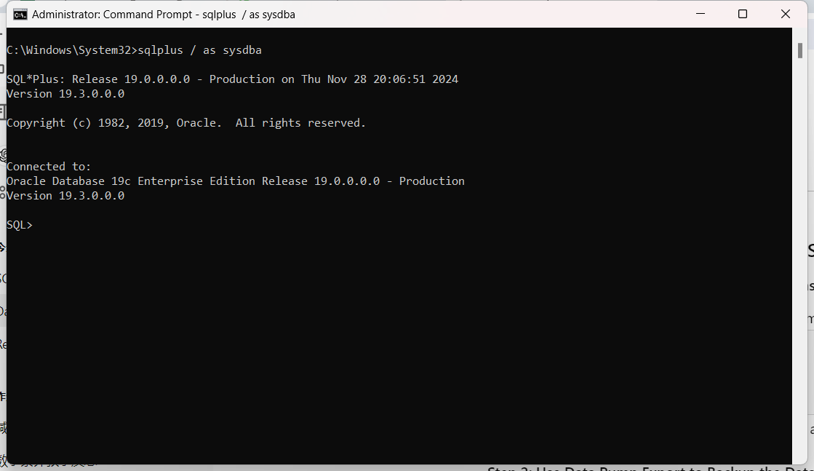

Figure 24 Sqlplus

**Step 2: Use Data Pump Export to Backup the Database.**

* 1. To back up the database, use Oracle Data Pump Export (expdp) utility from the command line. This command will create a dump file (.dmp) that contains the entire database schema.

*expdp camping/password schemas=camping directory=dump dumpfile=camping_backup.dmp logfile=camping_backup.log*

* 1. Make sure to replace camping/password, directory to meet your Oracle DIRECTORY settings. This command will export the schema camping and save the backup file to the default data pump directory. See figure25.

Figure 24 Expdb

**Step 3: Verify the Backup File**

Navigate to the directory where the dump file (camping_backup.dmp) was saved and verify its existence. See figure25

Figure 24 Verify file existence

Optionally, you can also check the log file (camping_backup.log) for details on the export operation.