Name: Shahd Mahmoud

Clock Divider (Even & Odd 50% Duty Cycle) Design & Verification

PART 1: Initial Implementation (Non-50% Duty Cycle for Odd Ratios)

1. Introduction and Objective
Clock dividers are fundamental components in digital systems used to derive lower-frequency clocks from a reference clock source. The initial objective was to design a configurable clock divider module (Clk_div) in Verilog HDL supporting variable integer division ratios (i_div_ratio) for both Even and Odd values.

2. Architecture & Design Approach (Single-Edge Toggling)
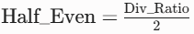
The first iteration relied exclusively on positive-edge clocking (posedge i_ref_clk) with an internal counter, a state toggle register (o_reg_div_clk), and an alternating control flag (Flag).
- Even Division Logic: The threshold is defined by
The output toggles every (Half_Even - 1) counts, resulting in a symmetrical square wave.
- Odd Division Logic: Since an odd integer cannot be evenly divided by 2 using whole clock cycles, the counter toggles the output using two alternating limits:


- State Switching: A register Flag alternates between 1 and 0 on each toggle, switching the reset condition between counter == Half_Even - 1 and counter == Half_Odd - 1.

3. Mathematical Analysis of the Duty Cycle Limitation
While this approach successfully generates the correct target frequency for both Even and Odd division ratios, it fails to achieve a 50% duty cycle for Odd numbers.
Because all state transitions occur strictly on the rising edge of i_ref_clk, the HIGH time and LOW time must both be integer multiples of the reference clock period (T_clk):
- Divide-by-3 (Div_Ratio = 3):
  - HIGH duration = 2 * T_clk
  - LOW duration =* 1 T_clk
  - Duty Cycle: 3/2 * 100\% = 66.7% (or 33.3% depending on initial polarity).
- Divide-by-5 (Div_Ratio = 5):
  - HIGH duration = 3 * T_clk
  - LOW duration = 2 * T_clk
  - Duty Cycle: 3/5 * 100\% = 60.0% (or 40.0%).

Why This Fails Standard Protocol Requirements
In high-speed SoC design, clock signals driving synchronous logic require a 50% duty cycle to ensure equal setup and hold time margins for both positive-edge and negative-edge triggered registers.

4. Initial Design Simulation & Waveform Analysis
- Figure 1.1: Even Division (Divide-by-2 Waveform)
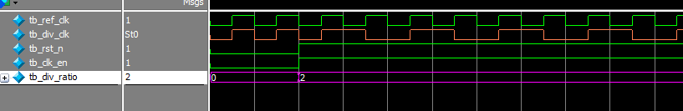

Observation: Shows a symmetric output with 1cycles HIGH and 1 cycles LOW (Exact 50% Duty Cycle).
- Figure 1.2: Even Division (Divide-by-4 Waveform)
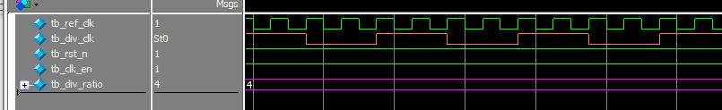

Observation: Shows a symmetric output with 2 cycles HIGH and 2 cycles LOW (Exact 50% Duty Cycle).
- Figure 1.3: Odd Division Initial Attempt (Divide-by-3 Waveform)
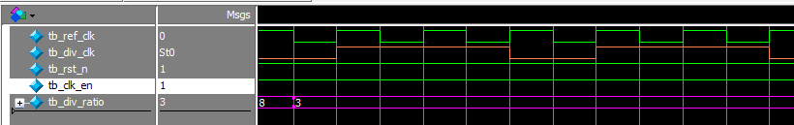

Observation: Shows 2 cycles HIGH and 1 cycle LOW, confirming the non-50% duty cycle limitation (66.7% Duty Cycle).
- Figure 1.4: Odd Division Initial Attempt (Divide-by-5 Waveform)
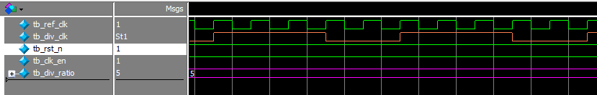

Observation: Shows 3 cycles HIGH and 2 cycles LOW (60% Duty Cycle)

Figure 1.5: Bypass Mode / Zero-Division Test (Divide-by-0 or Divide-by-1 Waveform)
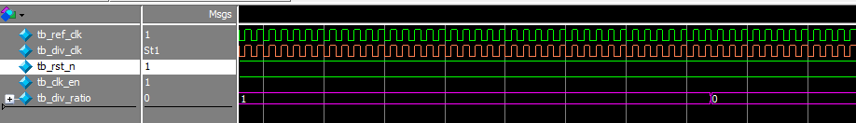
- Configuration: i_div_ratio = 8'h00 or 8'h01, i_clk_en = 1
- Observation: The internal signal ClK_DIV_EN stays 0 because the module enforces (i_div_ratio > 1'b1). As a result, the internal counter remains frozen at 0, and the output multiplexer bypasses the divider logic completely, routing i_ref_clk directly to o_div_clk.
- Result: o_div_clk perfectly mirrors i_ref_clk with zero clock division delay and maintains the original reference clock's duty cycle.

PART 2: Enhanced Architecture (True 50% Duty Cycle for Even & Odd Ratios)

1. Objective of the Redesign
To redesign the Clk_div module to guarantee a strict 50% duty cycle across all division ratios (Even and Odd) while ensuring full RTL synthesis compliance and zero STARC05 lint violations.

2. Deep-Dive: How True 50% Duty Cycle is Achieved for Odd Ratios
To achieve a 50% duty cycle for an odd integer $N$, the output clock must remain HIGH for exactly N/2 clock periods (1.5 * T_clk) for divide-by-3, (2.5 * T_clk )for divide-by-5). Because positive edges occur only at full integer periods (1.0, 2.0, 3.0……), generating a fractional 0.5 * T_clk phase pulse requires utilizing both positive and negative clock edges.

Step-by-Step Hardware Mechanism:
- Step 1: Counter Generation
A counter counts continuously from 0 to i_div_ratio - 1 on posedge i_ref_clk.
- Step 2: Positive-Edge Pulse (q1)
A comparative condition d1 = (counter < (i_div_ratio >> 1)) is fed into a positive-edge D-Flip-Flop (q1).
  - For N = 3: d1 is HIGH for 1 clock cycle (when counter == 0).
  - q1 output remains HIGH for 1 full clock cycle on posedge i_ref_clk.
- Step 3: Negative-Edge Phase Shift (q2)
The output q1 is sampled by a second D-Flip-Flop (q2) clocked on the falling edge (negedge i_ref_clk).
  - This creates an identical waveform q2 that is phase-shifted (delayed) by exactly half a clock cycle ( 0.5 * T_clk) relative to q1.
- Step 4: Phase Combination (OR Gate)
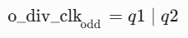
For odd division ratios, the final output is produced by combining q1 and q2 using a bitwise OR operation:

3. Mathematical Proof of 50% Duty Cycle:
- Pulse Width Extension:

- Divide-by-3 Example (N=3):
  - HIGH Duration = 1 + 0.5 = 1.5 cycles
  - LOW Duration = 3 - 1.5 = 1.5 cycles
  - Duty Cycle = 1.5/3.0 = 50.0%
- Divide-by-5 Example (N=5):
  - HIGH Duration = 2 + 0.5 = 2.5 cycles
  - LOW Duration = 5 - 2.5 = 2.5 cycles
  - Duty Cycle = 2.5/5.0 = 50.0%

4. Linting Violation Resolution (STARC05-1.3.1.3 Rule)
During SpyGlass static analysis, the initial output assignment generated a STARC05 rule violation: STARC05-1.3.1.3: Asynchronous reset signal used as non-reset signal.

Cause & Correction
The reset signal i_rst_n was directly referenced inside a combinational assign statement:
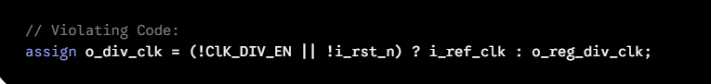

Fix Applied:
The reset signal i_rst_n was removed from the combinational Mux and restricted strictly to sequential flip-flop reset inputs. When i_rst_n is asserted low, all internal registers (counter, q1, q2) clear synchronously/asynchronously within their respective always blocks, safely forcing the output to 0 without placing i_rst_n in the data path:
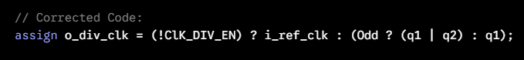

5. Enhanced Verification Results & Waveforms
Simulation cases were executed in ModelSim to confirm the redesigned dual-edge architecture:
- Figure 2.1: Corrected Divide-by-3 Waveform (True 50% Duty Cycle)
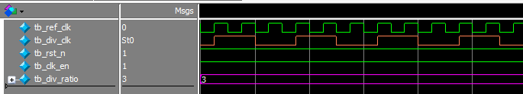

Analysis: Demonstrates q1 (pos-edge), q2 (neg-edge phase shift), and the resulting o_div_clk staying HIGH for exactly 1.5 input cycles and LOW for 1.5 input cycles.
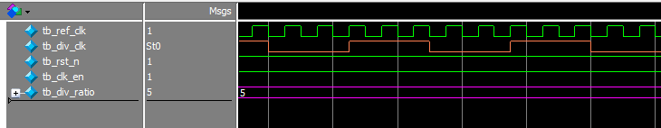
- Figure 2.2: Corrected Divide-by-5 Waveform (True 50% Duty Cycle)

Analysis: Shows output staying HIGH for 2.5 cycles and LOW for 2.5 cycles ($50\%$ Duty Cycle).
- Figure 2.3: Even Division Test Case (Divide-by-4 Waveform)
Analysis: Confirms that for Even ratios, q1 bypasses the OR gate directly to provide a clean 2-cycle HIGH / 2-cycle LOW output.

