**THE UNIVERSITY OF DODOMA**



**COLLEGE OF INFORMATICS AND VIRTUAL EDUCATION**

**DEPARTMENT OF INFORMATION SYSTEMS AND TECHNOLOGY**

**FINAL YEAR PROPOSAL**

ACADEMIC YEAR**: 2023/2024**

**TITLE: XXXXXXXXXXX XXXXXXXXXXXXXX XXXXXX XXXXXXX XXXXXXXXXXX XXXXXXXXXXXXXXXX XXXXXXXXXXXXXX**

GROUP MEMBERS

|  |  |  |
| --- | --- | --- |
| **STUDENT’S NAME** | **REGISTRATION NUMBER** | **PROGAMME** |
| 1. FIRST_NAME M. LAST_NAME | T21-0x-YYYY | Bsc-XXX/DICT/DET |
| 2. |  |  |
| 3. |  |  |
| 4. |  |  |
| 5. |  |  |

**NAME OF SUPERVISORS SIGNATURE**

Dr/Mr/Ms XXXX YYYY …………….…..

Dr/Mr/Ms XXXX YYYY …………….…..

# TABLE OF CONTENTS

**List of Tables/Figures/**

# CHAPTER ONE

**INTRODUCTION**

# 1.1 Project Overview

XXXXXX is a web-based system ……………………………………………...

# 1.2 Problem statement

The most common challenge for many people in Tanzania XXXXXXXX

XXXXXXXXXXXXXXXXXXXXXXXXXXXXXXXXXXXXXXXX

XXXXXXXXXXXXXXXXXXXXXXXXXXXXXXXXXXXXXXXXXX

XXXXXXXXXXXXXXXXXXXXXXXXXXXXXXXXXXXXXXXXXXXXXXXXXXXX

# 1.3 Objectives

**1.3.1 Main objective.**

The main objective of this project is to develop the system xxxxxxxxxxxxxxxxxxxxxxxxxx

**1.3.2 Specific objective.**

1. To ………
2. To…………
3. To……………

# 1.4 Project significance

This project …………………………………………………………………..

# 1.5 Project scope

The scope of this project ……(what will be included/not included)…………

# CHAPTER TWO

**LITERATURE REVIEW**

# 2.1 Introduction

This chapter is about………………………………………………

# 2.2 Definitions of Key Terms

Machine learning is …….

Artificial Intelligence is ………

**2.3 Theoretical Literature/Framework** (of the problem that system or artefact is trying to solve)……

# 2.4 Related (Similar) Work

From the literature, John et al. (2021) conducted a similar study which included ……

……

# 2.5 Innovation/Research Gap

XXXXXXXXXX (What is new idea, feature, technique, method, etc, that the system/model is contributing

# CHAPTER THREE

# METHODOLOGY

# 3.1 Introduction

A methodology is a formalized approach to. ………

# 3.1 Research Approach

This project will adopt (quantitative or qualitative or mixed research approach) because ……..

# 3.1 Research Method

This project is going to use (waterfall model, agile model, or any other model) . …….xxxxxxxxxxxxxxxxxxxxxxxx

# 3.2 Study Area / Location

This project will be conducted at…………. because……

# 3.3 Data Collection / Requirements Gathering

***3.3.1 Data Collection Techniques/Methods***

Data will be collected (Requirements will be gathered) using………(data collection techniques),

….

***3.3.2 Data Collection Tools***

Data will be collected (Requirements will be gathered) using…. (data collection tools), …

……………………….

**3.4 System/Requirements/Data Analysis**

System/Requirements/Data will be analyzed using (………techniques, tools, methods)….. (eg. Data model, Control Flow diagrams, State Diagrams/Sequence diagrams ERD’s/ Class Diagrams/CRC Models/Collaboration Diagrams/Use-case Diagrams/Activity Diagrams depending upon your project requirements)

**3.5 System/Model Design/Architecture**

The system/model will be designed …….. (Modularization details, Data integrity and constraints, Database design/Procedural Design/Object Oriented Design, User Interface Design

***3.5.1 Logical Design/Architecture***

This will involve………….

***3.5.2 Physical Design/Architecture***

This will involve………..(Client-Server, Cloud, ), UI, UX, etc.

**3.6 System Implementation**

The proposed project will be implemented using …(techniques, tools, methods)…... because……

***3.6.1 Coding***

The proposed project will be implemented using …(techniques, tools, methods, programming languages)…... because……

***3.6.2 Testing/Evaluation***

The proposed project will be tested using …(techniques, tools, methods)…... because……

# 3.7 System Requirements

The project will employ hardware components and software resources …………………… The following will be the system requirements for the successful deployment of the project.

## 3.7.1 Hardware Requirements

* Server Computer: Intel Processor - 2.7GHz, Memory - 6 GB, Disk Space - 500 GB.
* ……
* …...

## 3.7.2 Software Tools Requirements

* Web Server- PHP, JavaScript, XML, H
* ………
* …………….

# CHAPTER FOUR

**PROJECT TIMELINE AND BUDGET**

## 4.1 Project timeline

This is the chronological order of events that involve dates, events or……………...

Gantt chart is the most reliable tools for creating a project timeline ………..

.

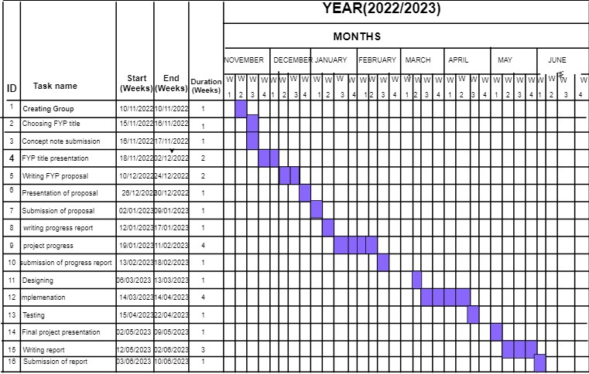

# 4.2 Project Budget

AProject budget is a tool that used by the project ……………………………………

……………………………………..

|  |  |  |
| --- | --- | --- |
| **S/N** | **Item** | **Costs** |
| 1 | Stationaries | 50,000/= |
| 2 |  |  |
| 3 |  |  |
| 4 |  |  |
|  |  |  |
|  | **Total** | **1,235,000/=** |

# REFERENCES

Meguid, S.A. and Zhu, Z.H., 1995, "A novel finite element for treating inhomogeneous solids," *International Journal Numerical Methods Engineering* **38 (2):** 1579-1592

# APPENDICES

Questionnaire Forms

Interview Questions

Project Codes

ETC