**Excel Module 1 Kickstarter Written Analysis of the Results**

1. **Overview of Project:**

## The objective of this project to analysis Kickstarter dataset and how Excel help us to analysis Louise’s dataset in short time to achieve her goal on time using Excel function and Pivot table, Pivot chart.

## With help of Excel we can visualized her Kickstarter dataset and help her to know how different campaigns fared in relation to their launch dates and their funding goal.

1. **Analysis and Challenges:**

## By looking at Kickstarter dataset for further analysis we found some data is not formatted in human readable format for example Deadline & Launched at column in dataset is Unix timestamped which need to convert into proper date format to find out what its deadline and when it launch at, also Category & Subcategory combine into one column called Category & Subcategory.

* **(Reference image as below)** 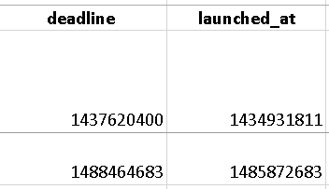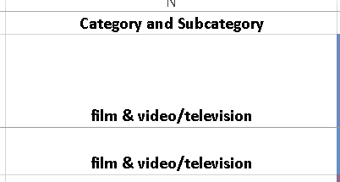
* Found some difficulty converting Unix timestamped data in to Month name and also in percentage round function for line chart, also have some difficulty in COUNTIFS() , but after doing google find the answer for the problem and able to manage the work.

1. **Results:**

## Theater campaign is doing good on month of June as it success is 100 compare to failed and canceled outcome

## There is 0 Cancellation percentage of “Outcome based on Goal” based on Subcategory “Plays”

## Limitation for Kickstarter dataset

## Data was not properly formatted

## Dataset column contain 2 separate information into one column

## We could create Pie chart for Outcome based on Goal to show percentage of each goal as number of goal list is small