Step by Step Instructions for Basic Git

1. If you haven’t already, download git from the following link – make sure you check the box saying “Add Git to PATH”

<https://git-scm.com/downloads>

1. Create a new folder on your desktop and give it any name
2. Open that folder you just made
3. Copy the folder path

1. Navigate to the terminal/command line (type cmd in the search bar and open command prompt)
2. Type “cd <path you copied>” and hit enter
3. You should see your folder name next to the carrot here

1. Open the github repository link <https://github.com/ShoM26/NeuralForge-CIS-234>
2. Click the green code button and copy the link

1. Type “git clone <link you copied>” and press enter

Next: Creating a feature branch and pushing it

1. In the command line make sure your main branch is up to date by typing the command “git pull”
2. Type “git checkout -b feature/<branch-name>” this creates and switches to your newly created feature branch.
3. Create, delete, or make edits to your files then type “git status” to see the status of your repository

1. Use the command “git add <file-name>” to add the changes/file to a commit. (Note: It is very important to make sure your files do not have spaces in the names or it git will not pick up on them as easily)
2. Once you have added the files you wanted type “git commit -m “<type your commit message>” ”

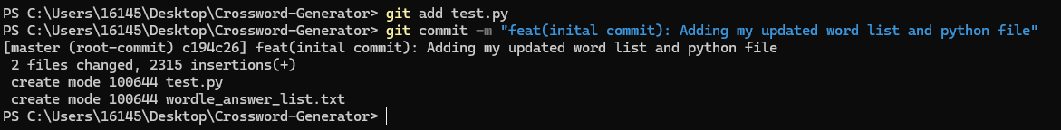

1. Push the branch to github by initially typing “git push -u origin feature/<branch-name>” after this initial push you can just type “git push”

1. navigate to the github repository (link generated by command line as seen above) or under the pull request tab in the web interface.
2. Create the pull request so that you are comparing base:main to compare:<your-branch>

1. Give it a title and short description and create pull request.
2. Let another group member know to review the changes and once they are reviewed they will be merged into main. If you have issues with merge conflicts or any other git questions send me a message and I can help you.