Q.1 Discuss the process by which Python executes a program, focusing on the stages involved from source code to execution.
Process of Python program execution
- The programmer writes Python code in a .py file
- Python reads the code line by line
- The code is checked for spelling and grammar mistakes (syntax errors)
- Python converts the code into bytecode (a simpler form the computer understands)
- The Python Virtual Machine (PVM) runs this bytecode
- While running, Python manages memory and handles errors
In short:
- Write code → Check code → Convert to bytecode → Run the program
Q.2 Discuss the fundamental features of the Python programming language that make it widely used for modern software development.
• Easy to Learn and Use
- Python has simple syntax that looks like English, making it beginner-friendly.
• Interpreted Language
- Python runs code line by line, which makes debugging easier.
• High-Level Language
- You don’t need to manage memory or hardware details.
• Cross-Platform
- Python programs can run on Windows, macOS, and Linux without changes.
• Large Standard Library
- Comes with built-in modules for file handling, math, web development, and more.
• Open Source and Free
- Python is free to use and has strong community support.
• Object-Oriented and Functional
- Supports multiple programming styles like object-oriented and functional programming.
• Dynamic Typing
- No need to declare variable types; Python handles it automatically.
• Extensive Third-Party Libraries
- Thousands of libraries for AI, data science, web development, automation, etc.
• Good for Rapid Development
- Fewer lines of code mean faster development and testing.
Q.3 Install IDLE interpreter for Python programming by following the steps mentioned below.
STEP 1: DOWNLOAD PYTHON 3.14
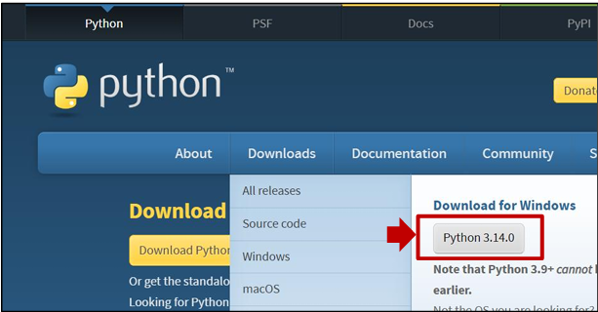
STEP 2: RUN THE .EXE FILE
Next, run the .exe file that you just downloaded.
STEP 3: INSTALL PYTHON 3.14

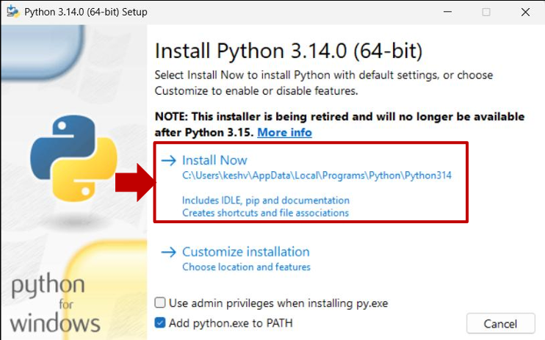 After a short period of time, your setup will be completed: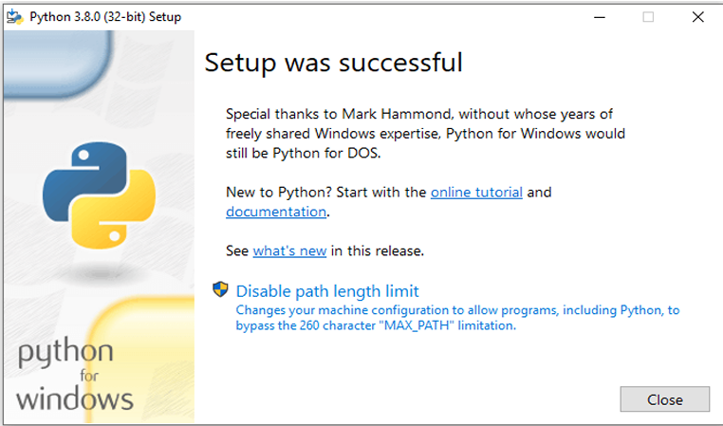
STEP 4: OPEN IDLE INTEGRATED DEVELOPMENT ENVIRONMENT FOR PYTHON
