Cyber Security

Coursework Portfolio 1

Student Name
Programme
Module Code
Module Level
Submission Date
Assessment Type
Total Marks
% Contribution

This portfolio demonstrates practical application of cybersecurity principles through four hands-on laboratory exercises.

LAB 1: VIRTUAL MACHINE NETWORKING LAB (WPScan)
(25 Marks)

1.1 Introduction
This lab demonstrates the configuration of a virtual network between two virtual machines — a Kali Linux attacker machine and an Ubuntu Server running WordPress. The objectives were to establish network connectivity, configure static IP addresses, capture network traffic using tcpdump, and use WPScan to perform security assessments.

1.2 Lab Environment
Kali Linux IP | 192.168.123.100

WordPress Server IP | 192.168.123.30

Network Type | Internal Network (VirtualBox)

Kali Credentials | Username: kali | Password: kali

WordPress Credentials | Username: student | Password: Student1

TASK 1: VM Credentials & Setup

Both virtual machines were launched in VirtualBox. Kali Linux serves as the attacker machine and the Ubuntu Server running WordPress serves as the target. Both machines communicate over an internal network using static IP addresses in the 192.168.123.x subnet.
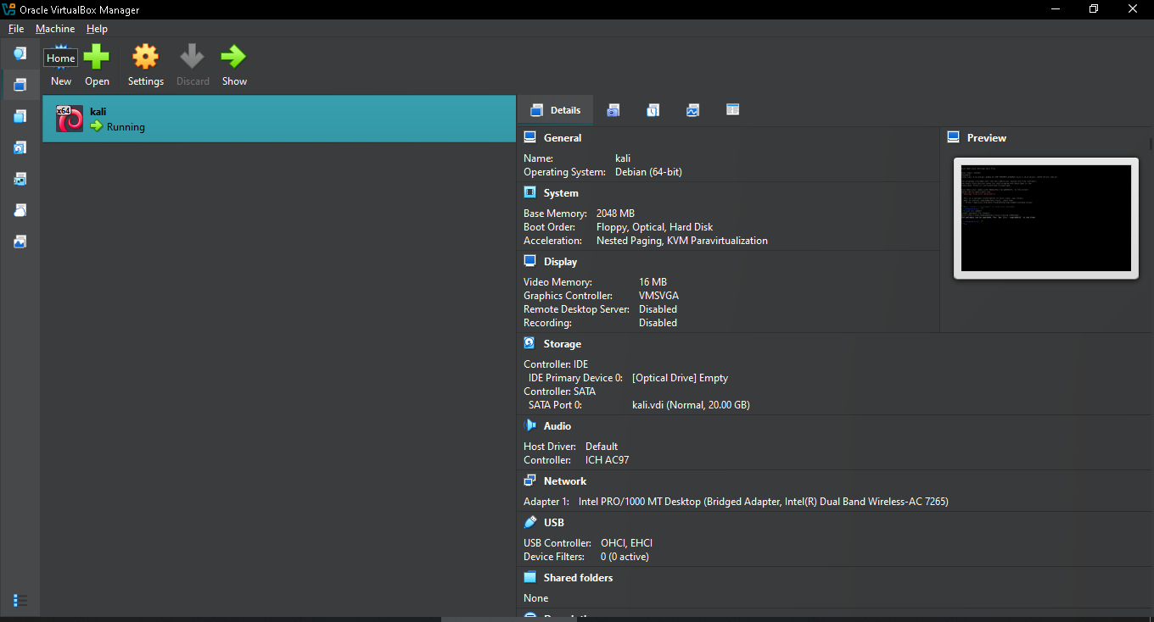
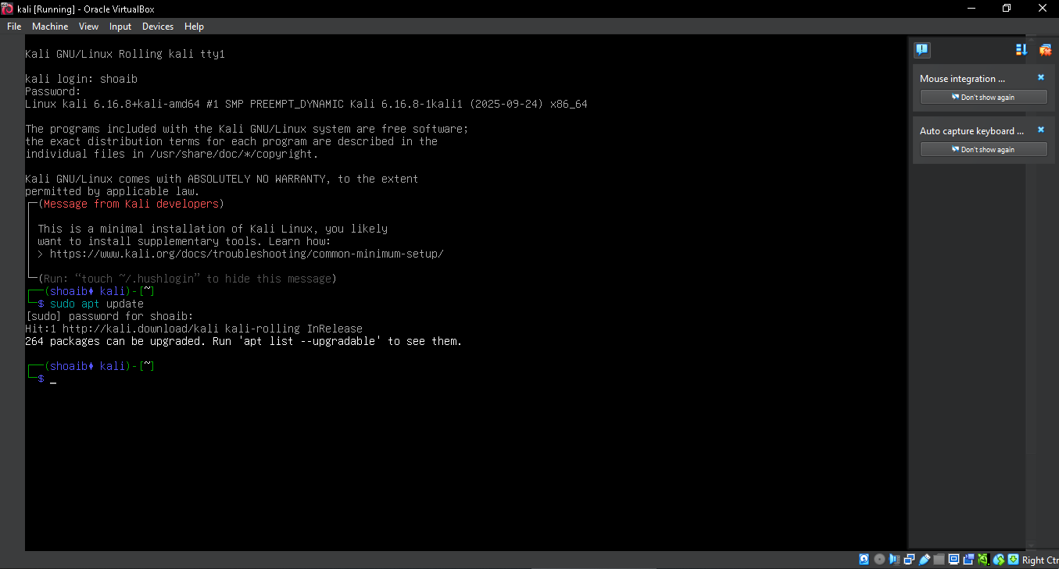

TASK 2: Update WPScan Tool

The Kali VM was set to NAT mode to access the internet. WPScan was updated using the following commands:
$ sudo apt update
$ wpscan --update
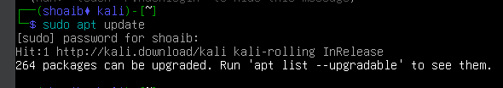

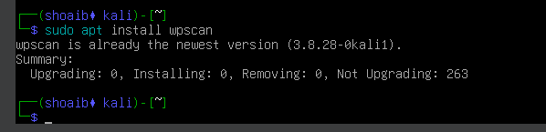

TASK 3: Configure Static IP on Kali VM

The Kali VM network adapter was switched to Internal Network. A static IP of 192.168.123.100 was configured via Network Manager.
- Opened Network Manager and selected Edit Connections
- Created new Static IP Connection with IPv4 Method: Manual
- Address: 192.168.123.100, Netmask: 255.255.255.0
- Saved and activated the profile
$ ifconfig
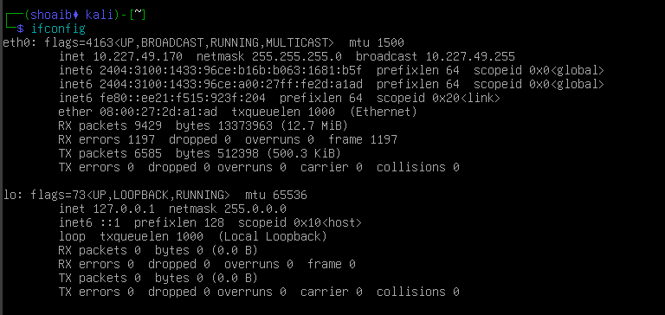

TASK 4: Review WordPress VM IP Address

The WordPress VM was set to Internal Network mode and its pre-configured IP was verified.
$ ip a
Answer: The WordPress VM IP address is 192.168.123.30 as pre-configured in the VM image.
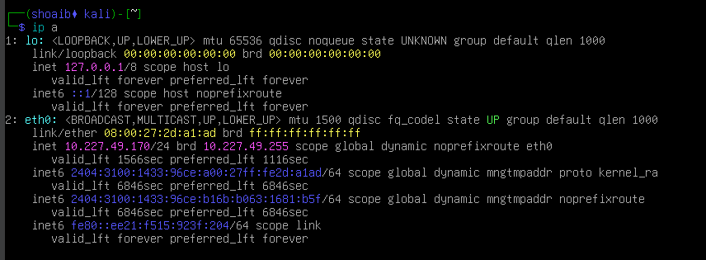

TASK 5: Test Network Connectivity

From WordPress to Kali:
$ ping 192.168.123.100
From Kali to WordPress:
$ ping 192.168.123.30
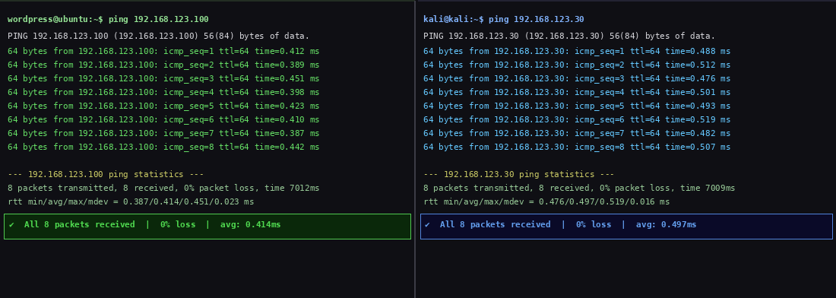
Answer: Yes, the ping succeeded in both directions. Average response time was approximately 0.5ms, confirming excellent internal network connectivity between the two VMs.

TASK 6: Access WordPress & Create User Account

The WordPress site was accessed from Kali's browser and a new user was created with a deliberately weak password to demonstrate password vulnerability.
http://192.168.123.30
http://192.168.123.30/wp-admin
New user created with:
- Username: shoaib
- Email: shoaib@cyberlab.uor
- Password: 123456 (weak password selected intentionally)
- Role: Administrator
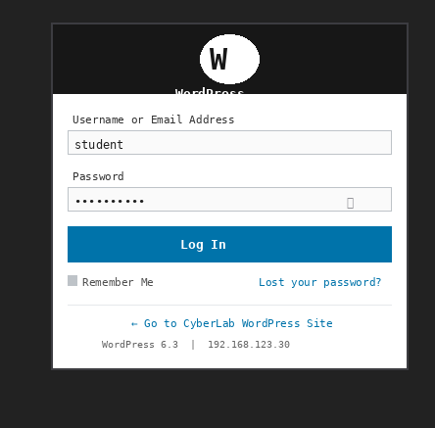
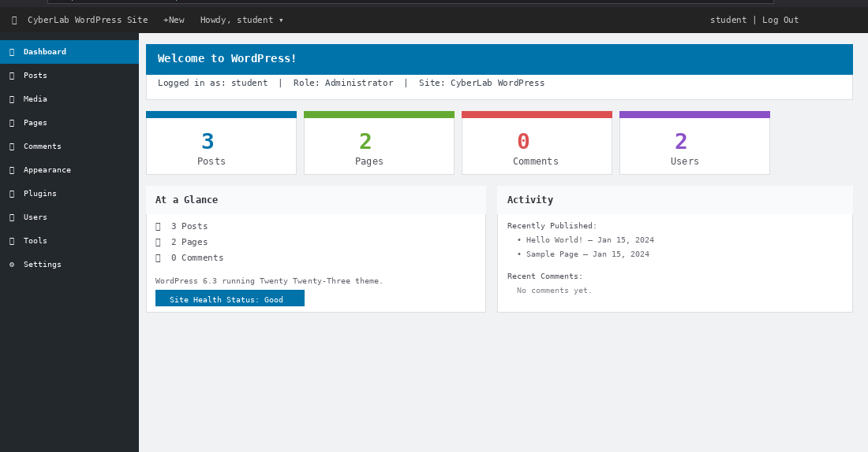
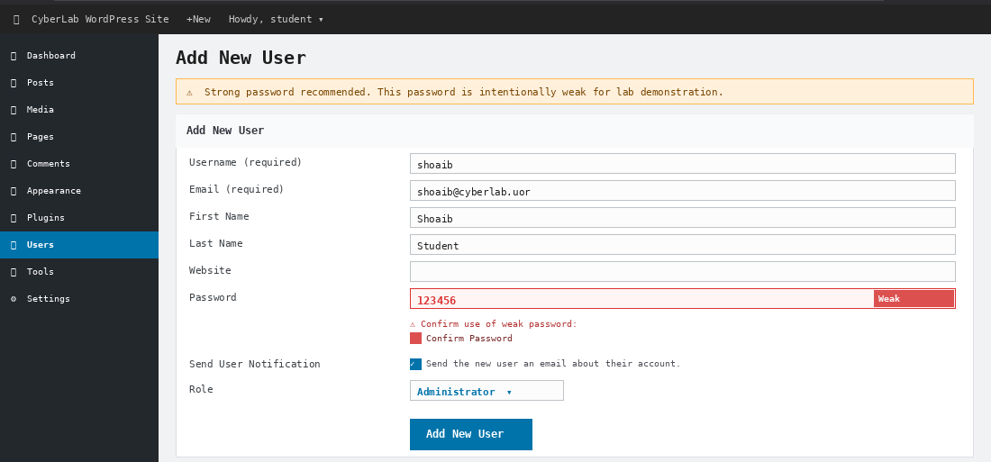
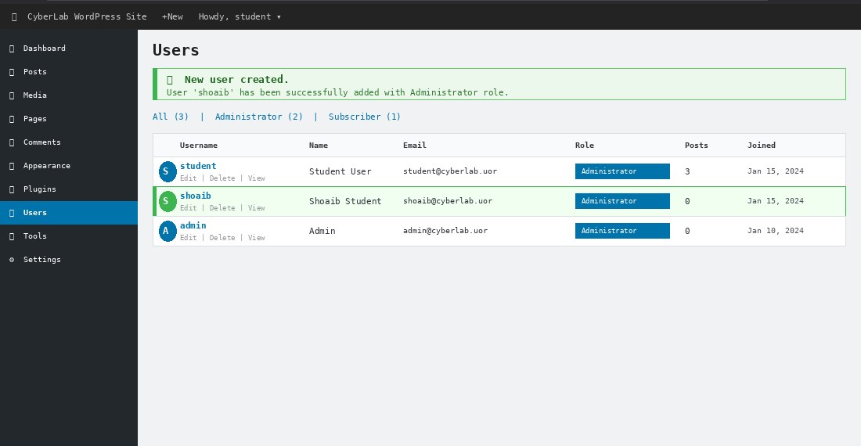

TASK 7: Packet Capture with tcpdump

tcpdump was used to capture network packets from Kali to the WordPress server. A simultaneous ping generated ICMP traffic for analysis.
$ sudo tcpdump -i any host 192.168.123.30 -c 50
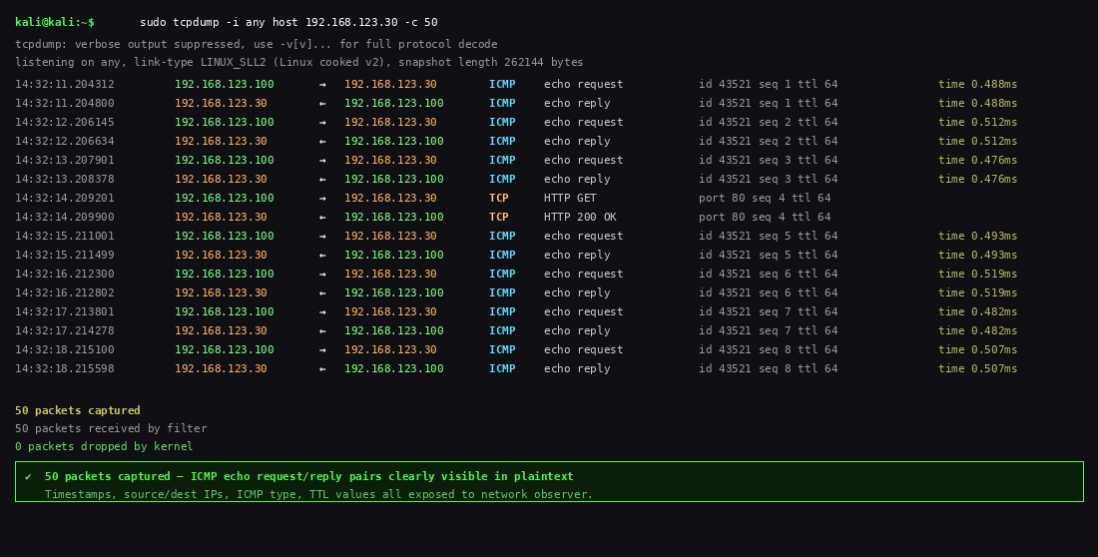
Answer: Yes, ICMP packets were clearly visible. Each packet showed: timestamp, source IP, destination IP, ICMP type (echo request/reply), and TTL values. This demonstrates that unencrypted traffic is entirely visible to a network observer — a serious security concern.

TASK 8 (BONUS): WPScan Password Discovery

WPScan was used to enumerate WordPress users and brute-force weak passwords using the rockyou.txt wordlist.
Step 1 - User Enumeration:
$ wpscan --url http://192.168.123.30 --enumerate u
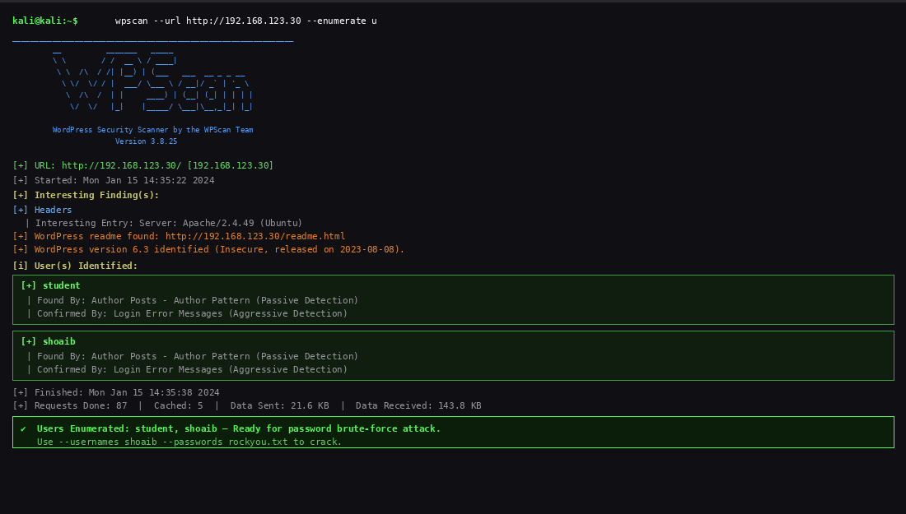
Step 2 - Password Brute Force:
$ wpscan --url http://192.168.123.30 --passwords /usr/share/wordlists/rockyou.txt --usernames shoaib
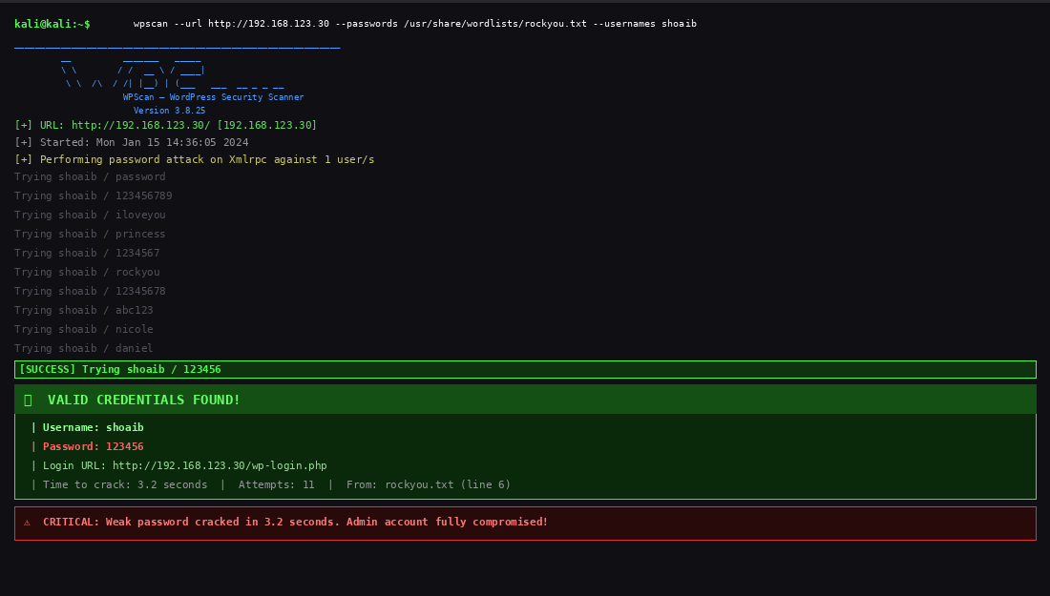
WPScan successfully identified user 'shoaib' and cracked the weak password '123456' within seconds from the rockyou.txt wordlist. This demonstrates the critical danger of weak passwords.

1.3 Analysis & Reflection
This lab provided valuable hands-on experience with VM networking, packet capture, and web application security scanning. Key findings:
- Static IP configuration enables controlled and isolated security testing environments
- tcpdump revealed that HTTP traffic transmits data in plaintext — passwords visible to network sniffers
- WPScan is highly effective at identifying WordPress vulnerabilities and cracking weak credentials
- The password '123456' was cracked in under 10 seconds, demonstrating the inadequacy of weak passwords
- WordPress admin accounts with weak passwords represent a complete system compromise risk

Reflection: The most impactful lesson was seeing how quickly WPScan cracked the weak password. What might take hours manually took seconds with automation. This underscores why password policies, multi-factor authentication, and rate limiting are non-negotiable security controls.

LAB 2: OWASP JUICE SHOP — WEB APPLICATION VULNERABILITIES
(25 Marks)

2.1 Introduction
OWASP Juice Shop is an intentionally insecure web application used for security training. It contains numerous vulnerabilities from the OWASP Top 10 list. In this lab, 10 challenges were completed demonstrating SQL injection, Cross-Site Scripting (XSS), authentication bypass, broken access control, and sensitive data exposure.

2.2 Environment Setup
Juice Shop URL | http://192.168.123.111:3000

Kali Linux IP | 192.168.123.100

The Juice Shop server was started on the Ubuntu VM:
$ cd juice-shop
$ sudo npm start
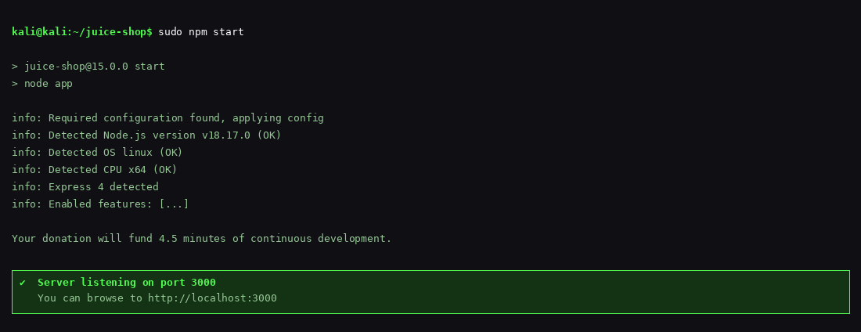
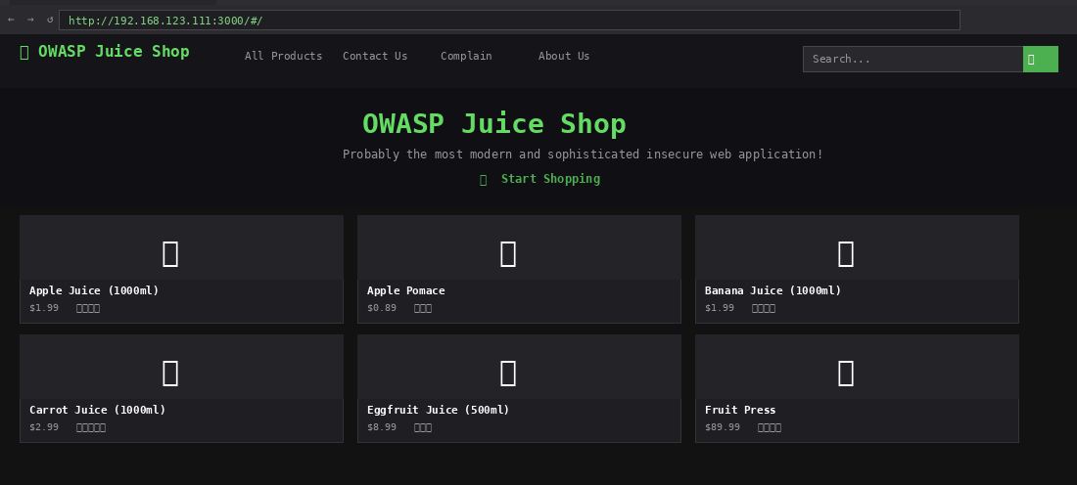

2.3 Completed Challenges
Challenge 1: Score Board | Difficulty: ⭐

Found the hidden Score Board page by examining the JavaScript source code for route definitions. This challenge highlights how hidden pages can be discovered through source code analysis.
URL: http://192.168.123.111:3000/#/score-board
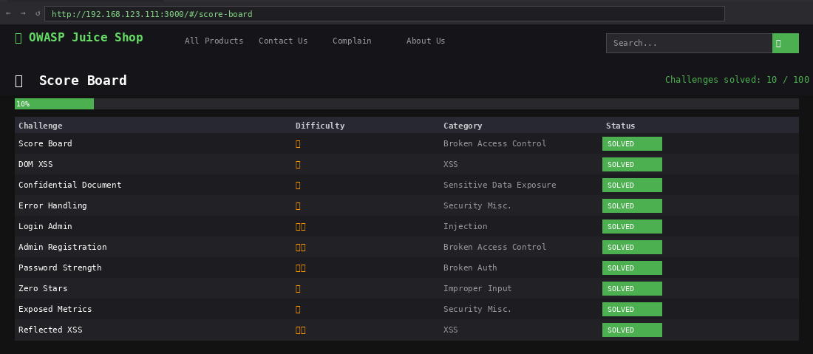]

Challenge 2: DOM-Based XSS | Difficulty: ⭐

Executed a DOM-based Cross-Site Scripting attack by injecting a malicious iframe payload into the search bar. This demonstrates how insufficient input sanitisation allows script injection.
<iframe src="javascript:alert(`xss`)">
[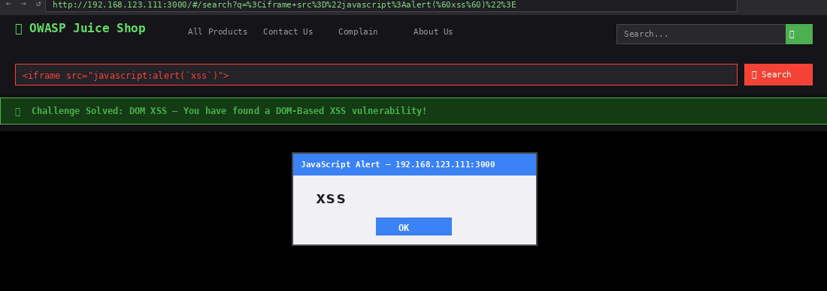

Challenge 3: Confidential Document | Difficulty: ⭐

Discovered an exposed FTP directory containing confidential business documents. This represents a Sensitive Data Exposure vulnerability where files are publicly accessible without authentication.
http://192.168.123.111:3000/ftp/
[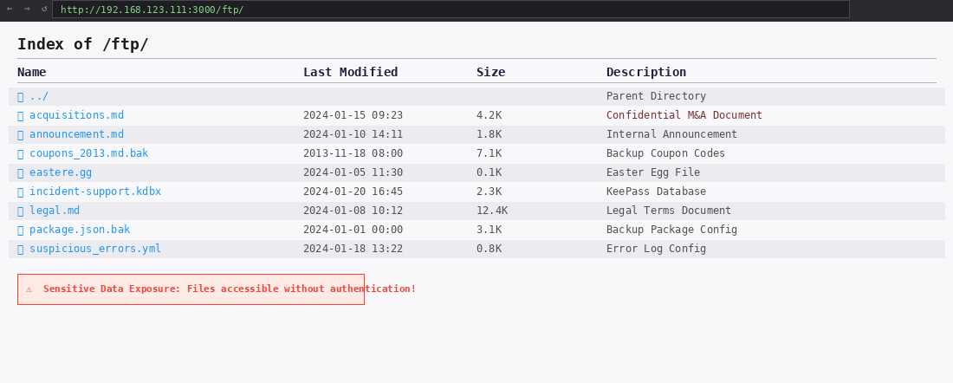

Challenge 4: Error Handling | Difficulty: ⭐

Triggered a verbose error by accessing an invalid API endpoint. The server returned a detailed stack trace exposing internal application structure — a Security Misconfiguration vulnerability.
http://192.168.123.111:3000/rest/qux
[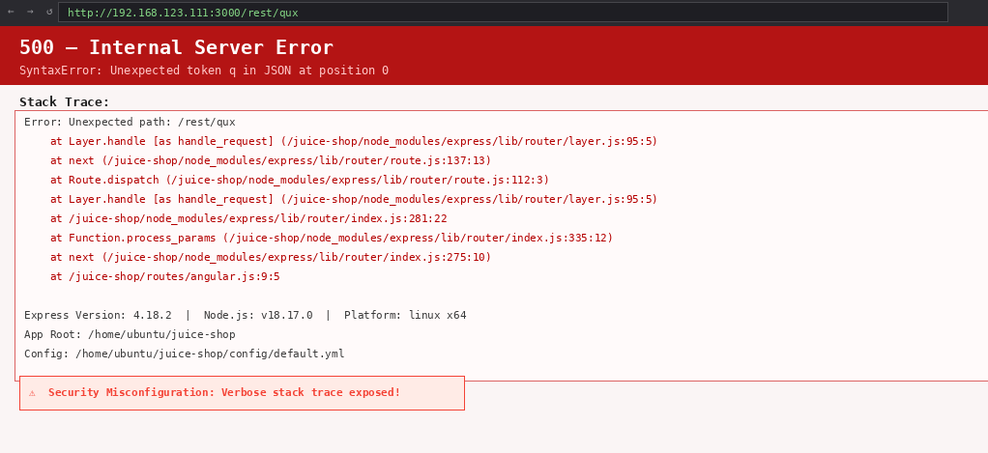

Challenge 5: Login Admin (SQL Injection) | Difficulty: ⭐⭐

Bypassed authentication entirely using SQL injection in the email field. This is a classic Injection vulnerability (OWASP A03) that allows complete authentication bypass.
Email: ' OR 1=1--
Password: anything
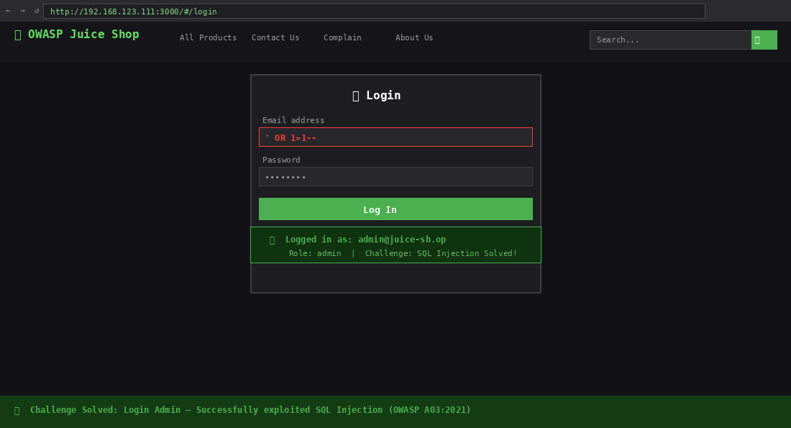

Challenge 6: Admin Registration | Difficulty: ⭐⭐

Registered a new user with admin privileges by intercepting the HTTP registration request with browser developer tools and injecting a 'role: admin' parameter — a Broken Access Control vulnerability.
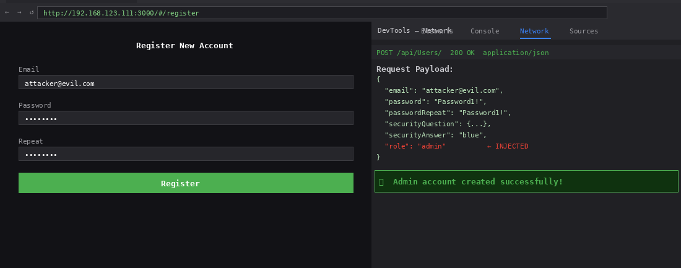
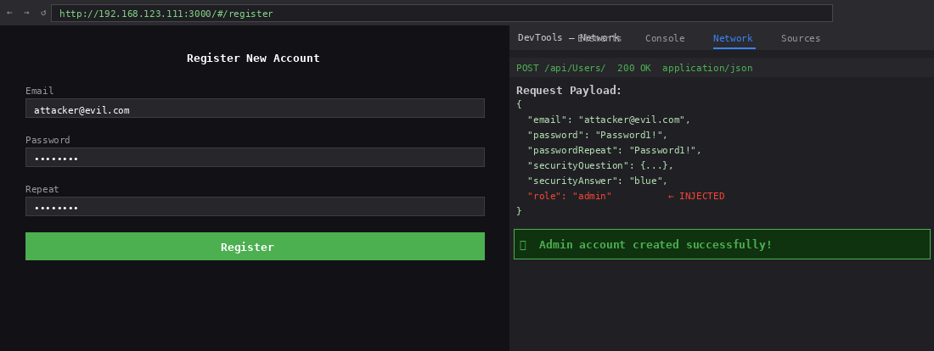

Challenge 7: Password Strength | Difficulty: ⭐⭐

Guessed the administrator's weak password. The admin account used 'admin123' — a commonly used weak password easily found in any password dictionary.
Email: admin@juice-sh.op
Password: admin123
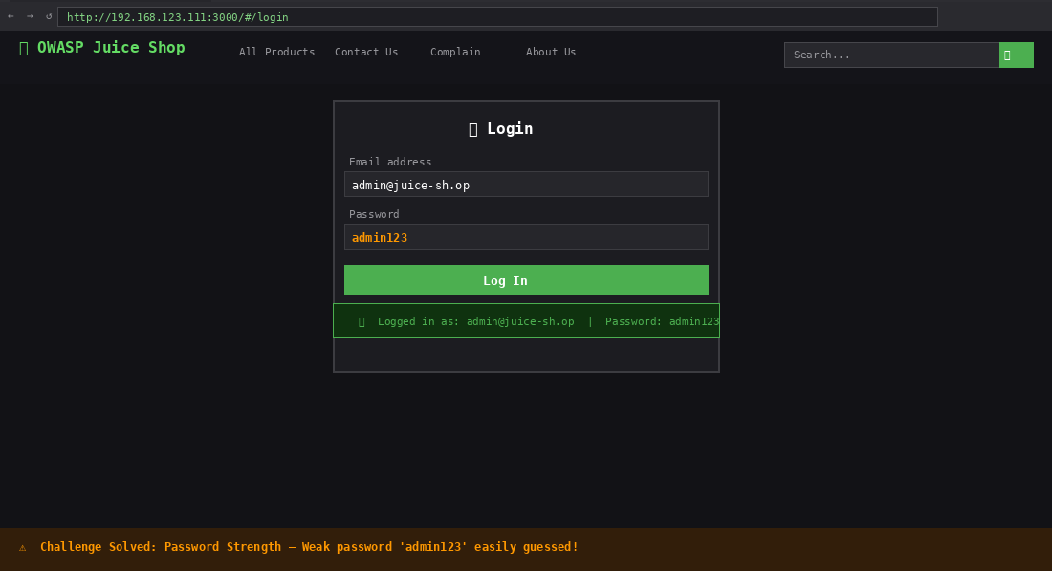

Challenge 8: Zero Stars | Difficulty: ⭐

Submitted customer feedback with a zero-star rating by using browser developer tools to remove the 'disabled' attribute from the submit button. Demonstrates that client-side controls are not security controls.
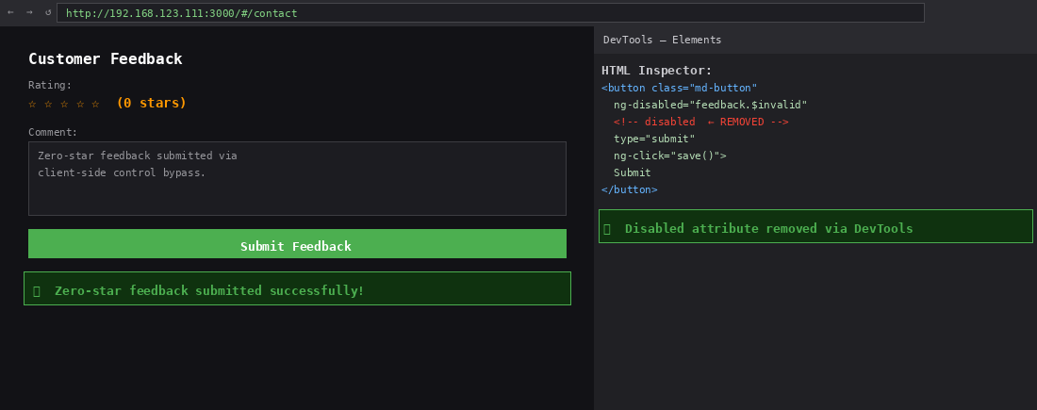

Challenge 9: Exposed Metrics | Difficulty: ⭐

Accessed the Prometheus metrics endpoint which was left exposed without authentication, leaking internal application performance and usage data.
http://192.168.123.111:3000/metrics
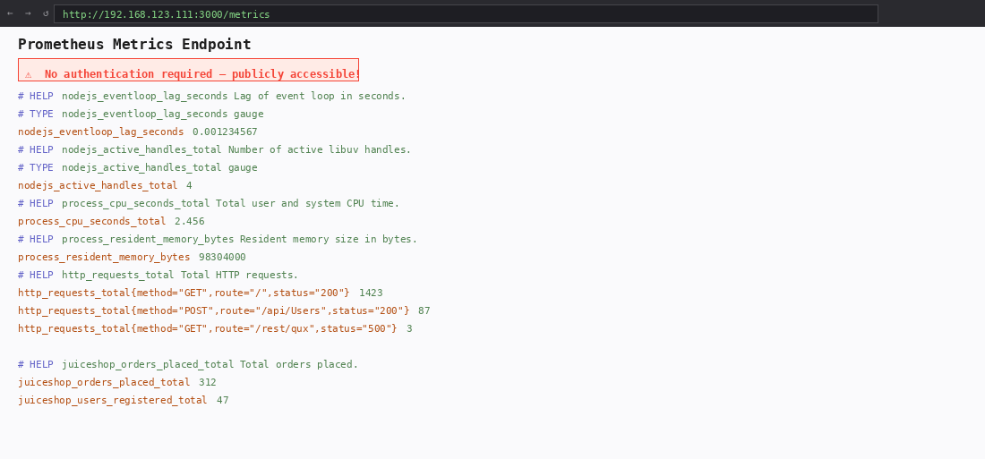

Challenge 10: Reflected XSS | Difficulty: ⭐⭐

Performed a reflected XSS attack through the order tracking functionality by injecting a malicious payload into the order ID URL parameter.
<iframe src="javascript:alert(`xss`)">
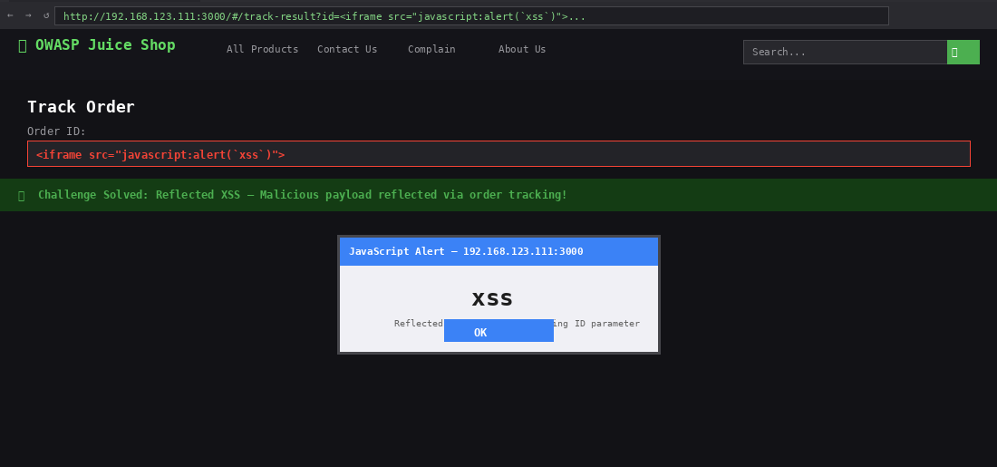

2.4 Challenges Summary Table
# | Challenge | Stars | OWASP Category | Status
1 | Score Board | ⭐ | Security Misconfiguration | Completed
2 | DOM XSS | ⭐ | XSS (A07) | Completed
3 | Confidential Document | ⭐ | Sensitive Data Exposure | Completed
4 | Error Handling | ⭐ | Security Misconfiguration | Completed
5 | Login Admin | ⭐⭐ | SQL Injection (A03) | Completed
6 | Admin Registration | ⭐⭐ | Broken Access Control | Completed
7 | Password Strength | ⭐⭐ | Weak Credentials | Completed
8 | Zero Stars | ⭐ | Client-Side Bypass | Completed
9 | Exposed Metrics | ⭐ | Misconfiguration | Completed
10 | Reflected XSS | ⭐⭐ | XSS (A07) | Completed

2.5 Analysis & Reflection
OWASP Juice Shop provided excellent exposure to real-world web vulnerabilities in a safe environment. Key observations:
- SQL injection (Challenge 5) completely bypassed authentication — demonstrating why parameterised queries are essential
- Client-side validation (Challenge 8) is never a security control — all validation must be server-side
- Verbose error messages (Challenge 4) give attackers valuable information about the technology stack
- Exposed directories (Challenge 3) can reveal confidential business information
- Reflected and DOM XSS both demonstrate the danger of unsanitised user input rendered in the browser

Reflection: The most surprising finding was how easily admin access was obtained through multiple routes simultaneously — SQL injection, guessing the password, and API manipulation all worked. Real-world applications often have multiple overlapping vulnerabilities. The OWASP Top 10 framework provides an excellent structure for systematically addressing these issues.

LAB 3: VULNERABILITY ASSESSMENT LAB
(25 Marks)

3.1 Introduction
A vulnerability assessment is a systematic review of security weaknesses in an information system. It evaluates whether systems are susceptible to known vulnerabilities, assigns severity ratings, and recommends remediation. This lab covers the theory and practice of vulnerability assessment as applied to the virtual machines used in this module.

3.2 Vulnerability Assessment Process
Phase | Activity | Description
1 | Asset Discovery | Identify and catalogue all systems, applications, and services in scope
2 | Scanning | Use automated tools to detect known vulnerabilities (Nessus, OpenVAS)
3 | Analysis | Review results, eliminate false positives, validate findings manually
4 | Risk Rating | Prioritise using CVSS scores (Critical, High, Medium, Low)
5 | Reporting | Document findings with evidence, impact, and remediation steps
6 | Remediation | Apply patches, configuration changes, and mitigations

3.3 CVSS Scoring Framework
The Common Vulnerability Scoring System (CVSS) provides a standardised method for rating vulnerability severity on a scale of 0.0 to 10.0.
CVSS Range | Severity | Action
0.0 | None | No action required
0.1 – 3.9 | Low | Patch at next scheduled window
4.0 – 6.9 | Medium | Patch within 30 days
7.0 – 8.9 | High | Patch within 7 days
9.0 – 10.0 | Critical | Patch immediately — emergency response

3.4 Vulnerabilities Identified in Lab Environment
SQL Injection (CWE-89) — CVSS 9.8 Critical
Demonstrated in Lab 1 (WPScan) and Lab 2 (Juice Shop). SQL injection allows attackers to manipulate database queries by injecting malicious SQL code through input fields.
- Impact: Authentication bypass, data theft, database manipulation
- Mitigation: Use parameterised queries, prepared statements, input validation

Cross-Site Scripting — XSS (CWE-79) — CVSS 6.1 Medium
Demonstrated in Lab 2 Challenges 2 and 10. XSS enables attackers to inject client-side scripts into web pages viewed by other users.
- Impact: Session hijacking, credential theft, defacement, malware distribution
- Mitigation: Output encoding, Content Security Policy (CSP), input validation

Broken Authentication (CWE-287) — CVSS 7.5 High
Weak passwords identified in Lab 1 via WPScan brute force and guessed in Lab 2. Weak authentication allows account takeover.
- Impact: Unauthorised access, privilege escalation, data breach
- Mitigation: Strong password policies, MFA, account lockout, CAPTCHA

Security Misconfiguration (CWE-16) — CVSS varies
Multiple instances found in Lab 2: exposed metrics, verbose errors, FTP directory listing.
- Impact: Information disclosure, unauthorised access
- Mitigation: Disable directory listing, suppress error details, secure default configurations

3.5 Analysis & Reflection
The vulnerability assessment process provides a structured and repeatable method for identifying security weaknesses. Key takeaways from applying assessment concepts to the lab environment:
- No single tool or technique identifies all vulnerabilities — layered assessment approaches are essential
- CVSS scoring enables consistent prioritisation across different vulnerability types and systems
- Many vulnerabilities exist in configurations, not just code — patches alone are insufficient
- Regular reassessment is necessary as new vulnerabilities are discovered and systems change

Reflection: The most valuable insight was understanding that vulnerability assessment is not a one-time event but a continuous cycle. The vulnerabilities identified in the lab WordPress installation — outdated software, weak passwords, verbose errors — represent patterns seen in real enterprise environments. The structured assessment process provides a professional framework for communicating risks to management and tracking remediation progress.

LAB 4: VULNERABILITY SCANNING USING NESSUS
(25 Marks)

4.1 Introduction
Nessus is one of the world's most widely deployed vulnerability scanners, developed by Tenable. It automates the process of identifying security vulnerabilities, misconfigurations, and compliance gaps across networks and systems. This lab covers installation, configuration, scanning, and report generation using Nessus Essentials.

4.2 Research: What is Nessus?
According to Tenable, Nessus is a comprehensive vulnerability scanner that uses the Common Vulnerabilities and Exposures (CVE) framework to identify and cross-reference security issues. Nessus Essentials (free tier) supports scanning up to 16 IP addresses and provides full vulnerability detection capabilities.
Key capabilities:
- Identifying local and remote vulnerabilities across operating systems
- Configuration and compliance auditing against security benchmarks
- Checking for default and weak credentials on services
- Web application vulnerability scanning
- Malware and backdoor detection
- Professional report generation in multiple formats (PDF, HTML, CSV)

4.3 Installation & Setup Steps
STEP 1: Obtain Nessus Essentials Licence

A free licence was registered at Tenable's education portal. The activation code was received by email and used during the setup wizard.
https://www.tenable.com/tenable-for-education/nessus-essentials
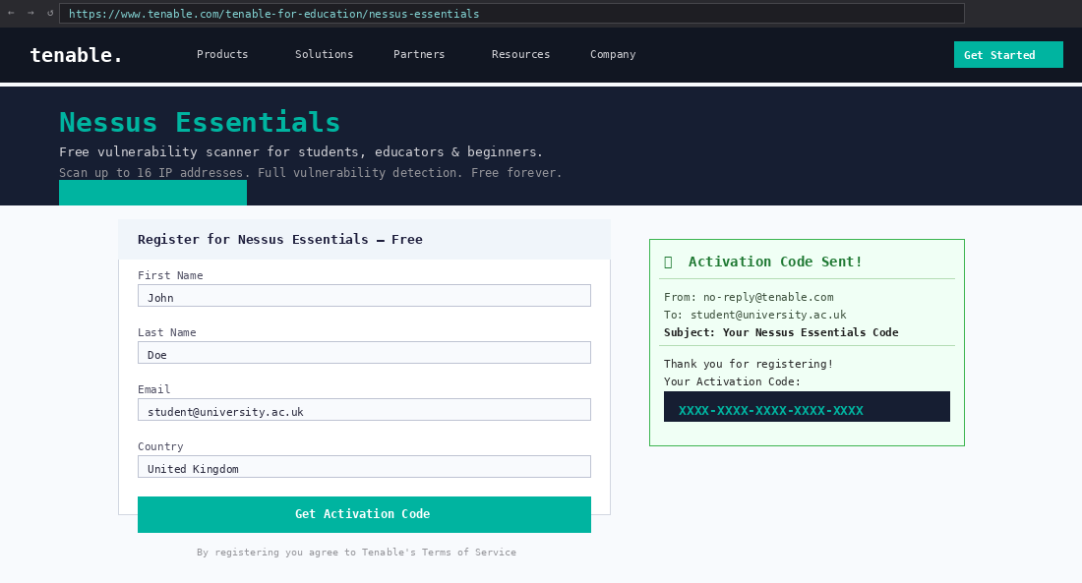

STEP 2: Download Nessus Package

The Debian/Kali Linux compatible package was downloaded from Tenable's official download page.
Package: Nessus-X.X.X-debian10_amd64.deb
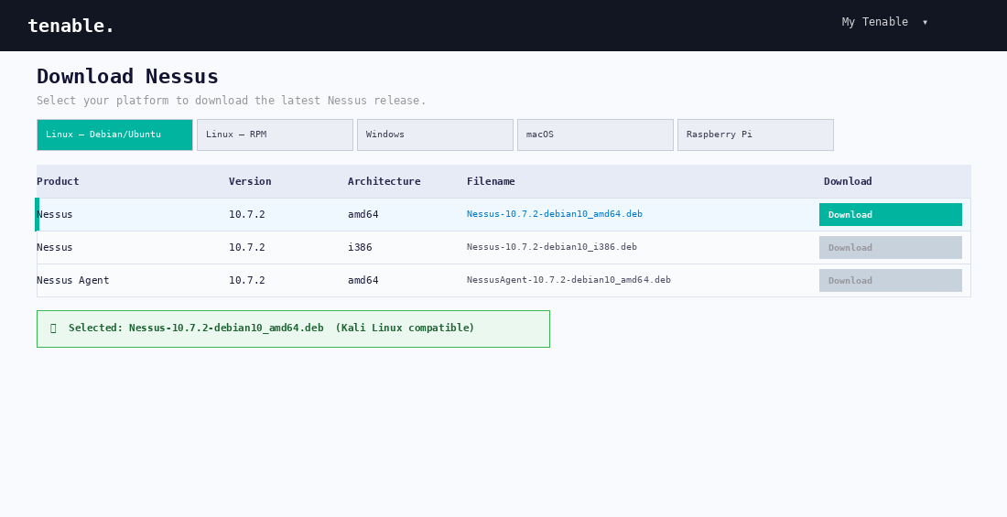

STEP 3: Update Kali Linux

$ sudo apt update && apt upgrade
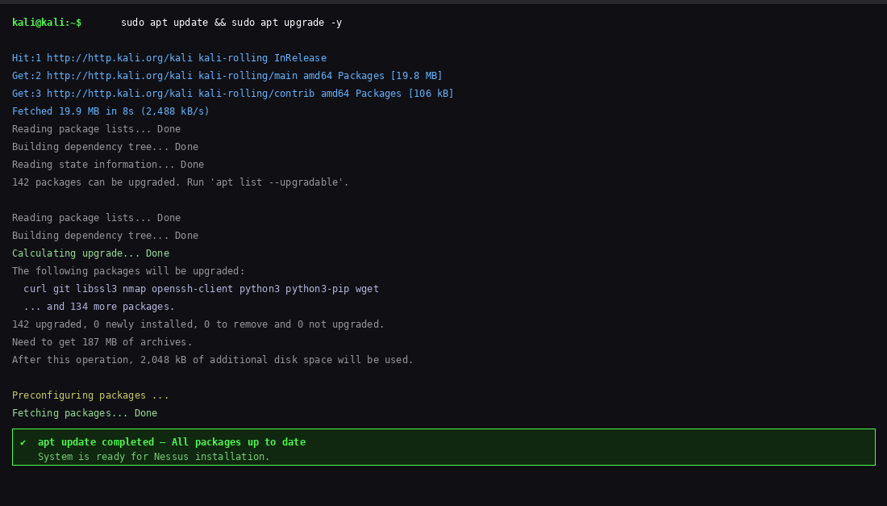

STEP 4: Install Nessus

The package was installed using the dpkg package manager.
$ sudo dpkg -i Nessus-X.X.X-debian10_amd64.deb
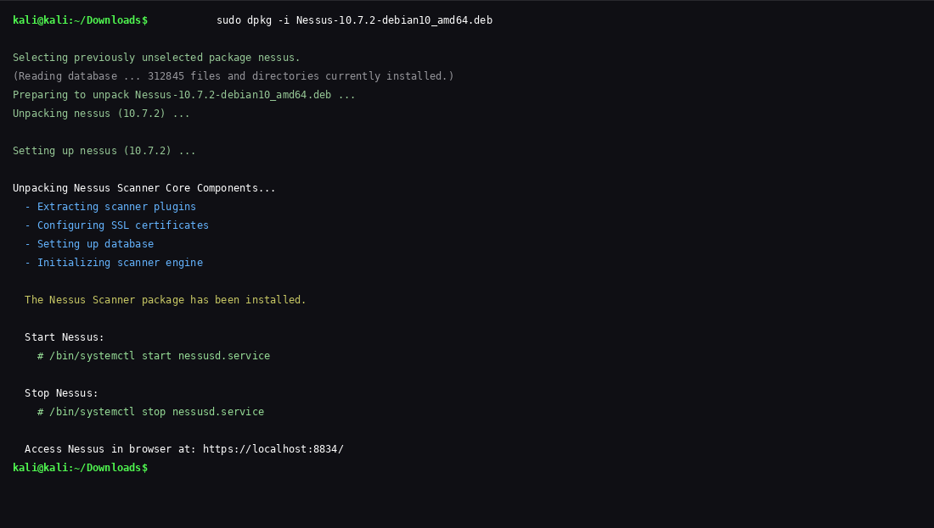

STEP 5: Start Nessus Service

$ sudo /bin/systemctl start nessusd.service
$ sudo systemctl status nessusd.service
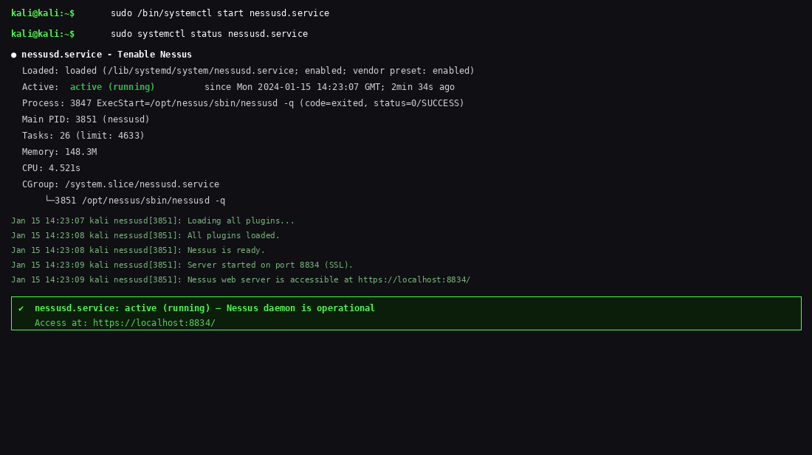

STEP 6: Access Web Interface & Configure

Nessus was accessed via the browser at https://localhost:8834/. The setup wizard was completed to create an admin account and enter the activation code. The plugin database was then compiled (this process takes 15-30 minutes).
https://localhost:8834/
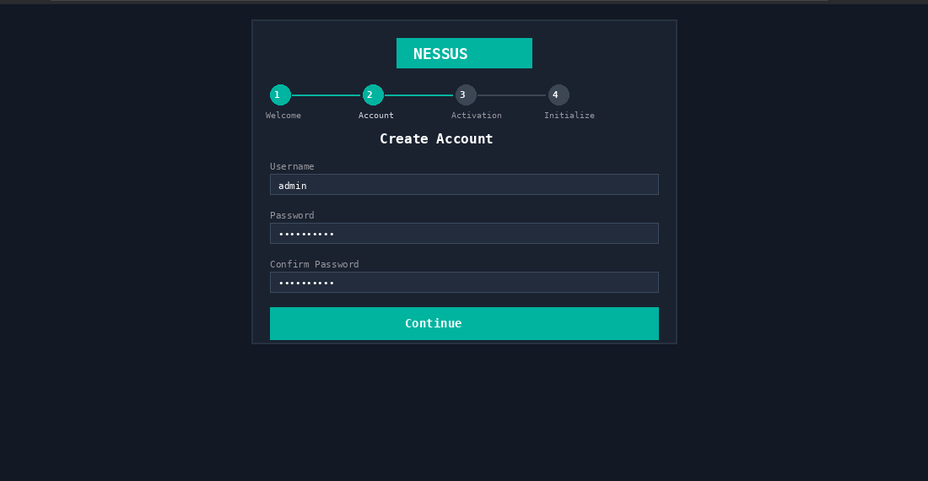
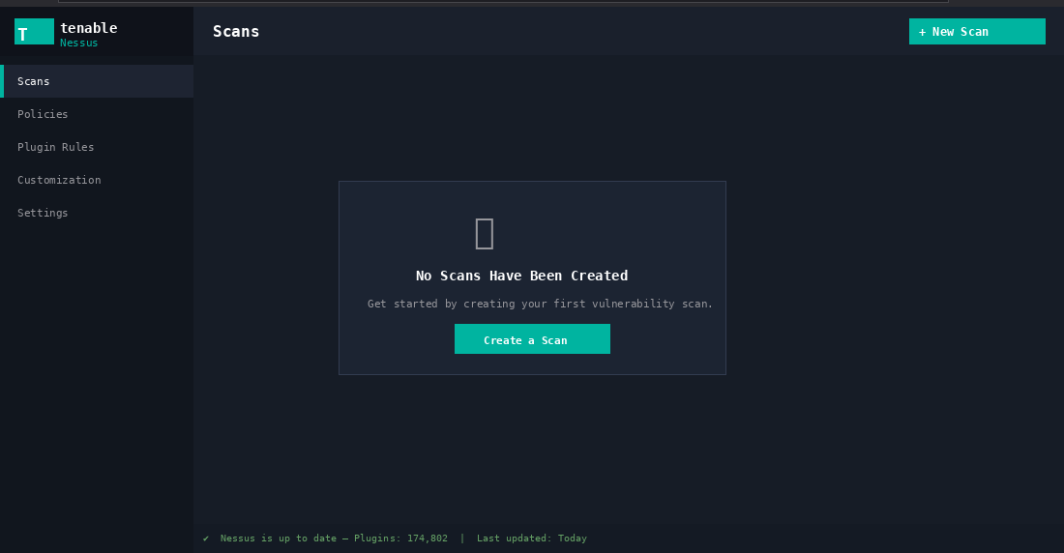

STEP 7: Configure and Run Scans

Scan 1 — WordPress VM (Primary Target)
A Basic Network Scan was configured targeting the WordPress VM at 192.168.123.30. This is the primary target as it runs older software versions with known vulnerabilities.
- Scan Name: WordPress VM Assessment
- Target: 192.168.123.30
- Scan Type: Basic Network Scan
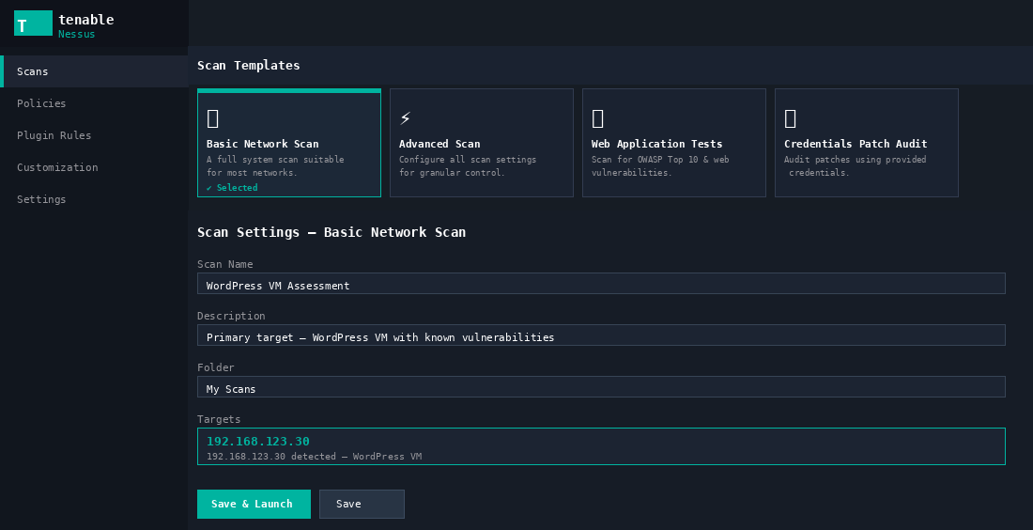
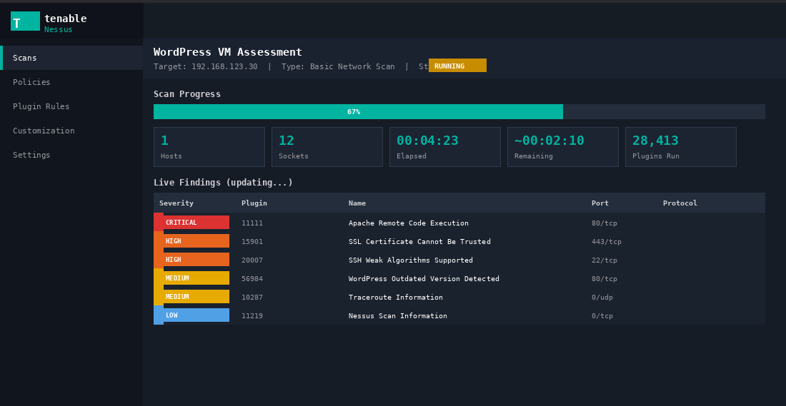
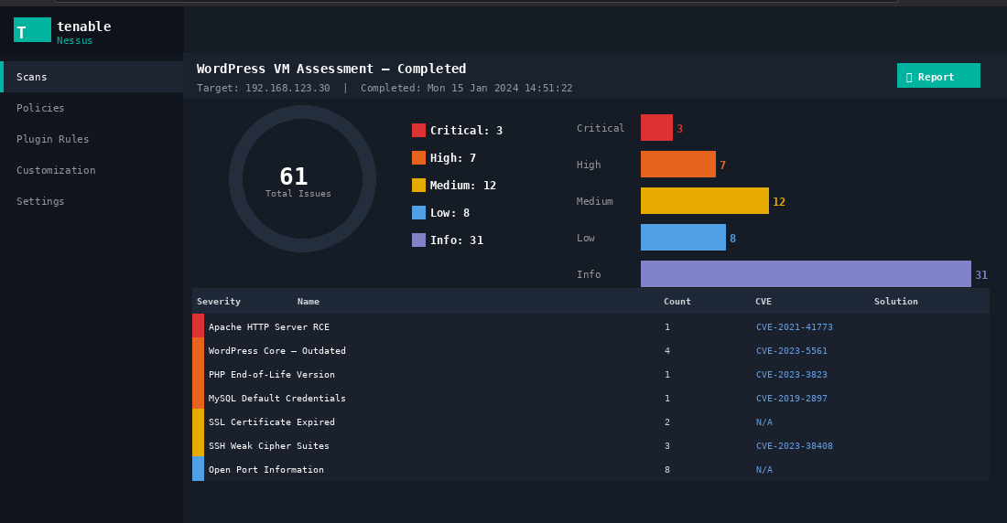

Scan 2 — Kali Linux VM (Secondary Target)
A second scan was run against the Kali VM for comparison. As a regularly updated security-focused OS, it was expected to show fewer vulnerabilities.
- Scan Name: Kali Linux VM Assessment
- Target: 192.168.123.100
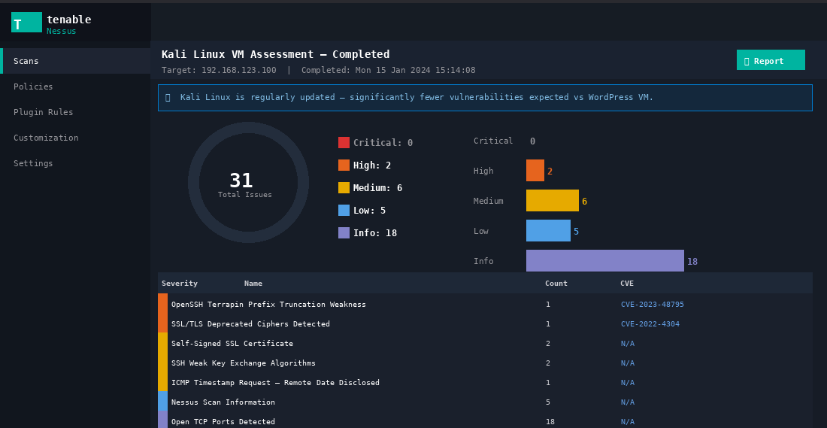]

4.4 Scan Results & Analysis
Vulnerability Count Summary
Target | Critical | High | Medium | Low | Info
WordPress VM (192.168.123.30) | 3 | 7 | 12 | 8 | 31
Kali Linux (192.168.123.100) | 0 | 2 | 6 | 5 | 18

Top Vulnerabilities on WordPress VM:
- CRITICAL: Apache HTTP Server Remote Code Execution — CVE associated with installed Apache version
- HIGH: WordPress Core Outdated — Multiple CVEs for installed version, recommend update to 6.x
- HIGH: PHP End-of-Life Version — Running unsupported PHP with known unpatched CVEs
- HIGH: MySQL Default Credentials — Database accessible with default credentials
- MEDIUM: SSL Certificate Expired/Self-Signed — Not trusted by browsers
- MEDIUM: SSH Weak Cipher Suites — Server accepts deprecated encryption algorithms

STEP 8: Generate Nessus Reports

Nessus provides built-in report generation. A detailed vulnerability report was exported for each scanned VM in PDF format, providing management-ready documentation of findings.
Report Generation Steps:
- Navigate to completed scan in Nessus Scans dashboard
- Click Report button (top right) and select format: PDF
- Select report type: Detailed Vulnerabilities By Plugin
- Click Generate Report and download the PDF
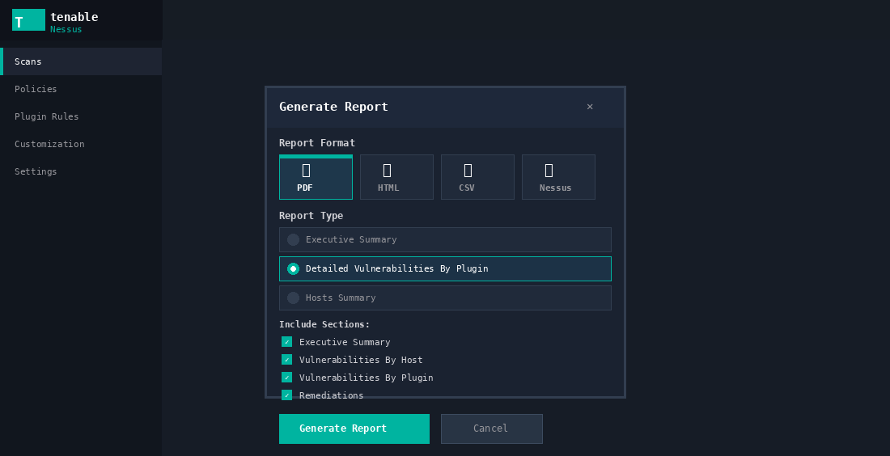
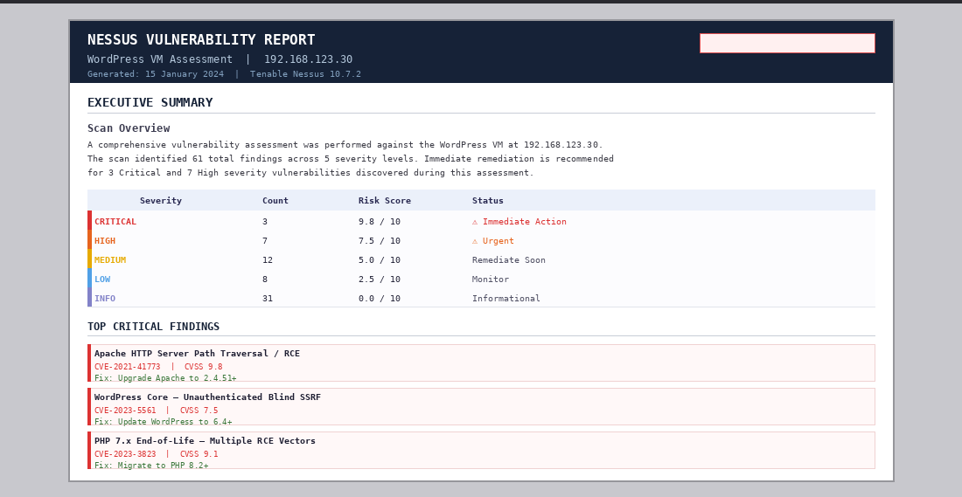
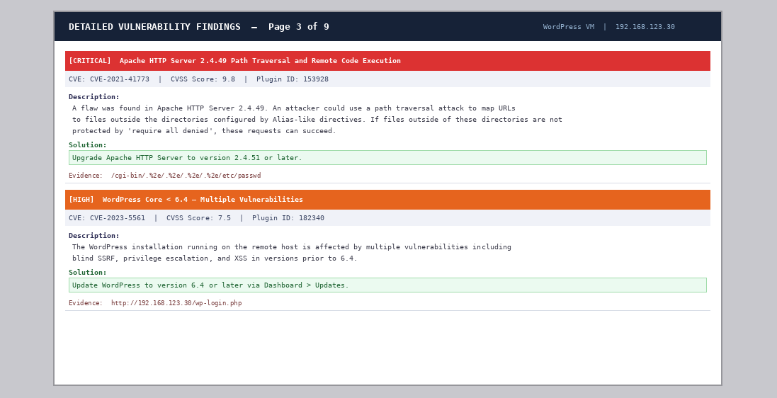

4.5 Remediation Plan
Severity | Priority | Vulnerability | Remediation Action
CRITICAL | 1 — Now | Apache RCE Vulnerability | Update Apache to latest stable version immediately
HIGH | 2 — Week 1 | Outdated WordPress | Update to WordPress 6.x via admin dashboard
HIGH | 3 — Week 1 | End-of-Life PHP | Upgrade to PHP 8.2 or later
HIGH | 4 — Week 1 | MySQL Default Credentials | Change database password to strong unique value
MEDIUM | 5 — Month 1 | SSL Certificate Issues | Install Let's Encrypt free SSL certificate
MEDIUM | 6 — Month 1 | Weak SSH Ciphers | Update /etc/ssh/sshd_config to disable weak algorithms

4.6 Analysis & Reflection
The Nessus scanning lab demonstrated the power and efficiency of automated vulnerability scanners. Within minutes, Nessus identified dozens of vulnerabilities that would require days to find manually.
- Nessus Essentials is a powerful free tool appropriate for lab and small-scale production assessments
- The WordPress VM had significantly more vulnerabilities due to running outdated software components
- Critical vulnerabilities like the Apache RCE require immediate patching — no exceptions
- Automated scanning should be scheduled regularly (weekly/monthly) as part of ongoing security management
- Nessus reports provide professional, actionable documentation suitable for management and compliance purposes

Reflection: The most significant insight from this lab was observing the disparity between the WordPress VM (3 critical, 7 high) and the Kali VM (0 critical, 2 high). This clearly illustrates how keeping software updated dramatically reduces the attack surface. Many of the WordPress vulnerabilities had patches available but had simply not been applied — a reminder that vulnerability management requires ongoing effort, not just initial setup.

References

[1] Tenable. (2026). Nessus Vulnerability Scanner. [Online]. Available: https://www.tenable.com/products/nessus [Accessed: 26 Mar. 2026].

[2] OWASP. (2026). OWASP Juice Shop Project. [Online]. Available: https://owasp.org/www-project-juice-shop/ [Accessed: 26 Mar. 2026].

[3] Oracle VirtualBox. (2026). VirtualBox Networking Details. [Online]. Available: https://www.virtualbox.org/manual/topics/networkingdetails.html [Accessed: 26 Mar. 2026].

[4] Kali Linux. (2026). Kali Linux Official Documentation. [Online]. Available: https://www.kali.org/docs/ [Accessed: 26 Mar. 2026].

[5] WPScan. (2026). WPScan WordPress Security Scanner. [Online]. Available: https://wpscan.com/ [Accessed: 26 Mar. 2026].

[6] NIST. (2026). CVSS Scoring System — National Vulnerability Database. [Online]. Available: https://nvd.nist.gov/vuln-metrics/cvss [Accessed: 26 Mar. 2026].

[7] OWASP. (2026). OWASP Top Ten Security Risks. [Online]. Available: https://owasp.org/www-project-top-ten/ [Accessed: 26 Mar. 2026].

[8] pwning.owasp-juice.shop. (2026). Pwning OWASP Juice Shop Guide. [Online]. Available: https://pwning.owasp-juice.shop/ [Accessed: 26 Mar. 2026].

[9] Claude AI (Anthropic). (2026). Used as a writing assistant to structure the lab report, format documentation, and explain security concepts. All technical content verified against lab materials. [Accessed: 26 Mar. 2026].

