12.1 -----
Microservices:
Microservices are an architectural style where applications are developed as a collection of small, loosely coupled, independently deployable services.
12.3
What is Service Discovery:
In a microservices architecture, each microservice is a standalone application with specific business functionality. Since these microservices need to communicate with each other to function as a complete application, they need to know each other’s network locations. Service Discovery comes into play here, maintaining a record of these services’ locations, helping them find each other, and enabling communication.
12.4
API Gateway
APIs are a common way of communication between applications. In the case of microservice architecture, there will be a number of services and the client has to know the hostnames of all underlying applications to invoke them.
To simplify this communication, we prefer a component between client and server to manage all API requests called API Gateway. Additionally, we can have other features which include:
• Security — Authentication, authorization
• Routing — routing, request/response manipulation, circuit breaker
• Observability — metric aggregation, logging, tracing
Spring Cloud API Gateway
Spring Cloud API Gateway is a powerful, flexible solution for routing and proxying requests to downstream services in a microservices architecture. It handles several important tasks like routing, filtering, authentication, and load balancing.
Spring Cloud Gateway Building Blocks
Spring Cloud Gateway consists of 3 main building blocks:
1. Route
2. Predicate
3. Filters
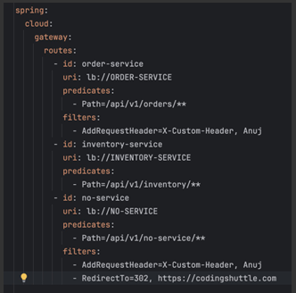

Spring Cloud Gateway Route
1. Route: Think of this as the destination that we want a particular request to route to. It comprises of destination URI, a condition that has to satisfy — Or in terms of technical terms, Predicates, and one or more filters.
Spring Cloud Gateway Predicate
2. Predicate: This is literally a condition to match. i.e. kind of “if” condition..if requests has something — e.g.
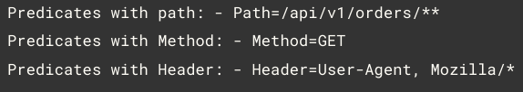
Spring Cloud Gateway Filter
3. Filter: These are instances of Spring Framework WebFilter. This is where you can apply your magic of modifying request or response. There are quite a lot of out of box WebFilter that framework provides.
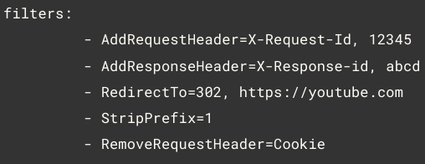
13.1
API Gateway filters intercept the request if we want apply logic pre-process of request & post-process of response then we should go for it.
They allow you to apply common cross-cutting concerns (such as authentication, logging, rate limiting, and transformation) at a centralized entry point before routing requests to microservices. There are two types of filters: 1. Global Filters 2. Route specific Filters
