Java Concurrency Part 1: Synchronizers | Java interview question | In Hindi | Simple explanation
https://www.youtube.com/watch?v=mK9o7PZ2cVo&list=PLX1XVaZeuvXerqUCxo2rFxKAfl4ITr_FT&pp=0gcJCbAEOCosWNin
Semaphore: Controlling access to shared resources
CountDownLatch: Synchronize threads with a countdown mechanism
CyclicBarrier: Coordinate multiple threads for synchronized execution
Exchanger: Facilitate data exchange between threads
Phaser: Advanced synchronization for dynamic task coordination
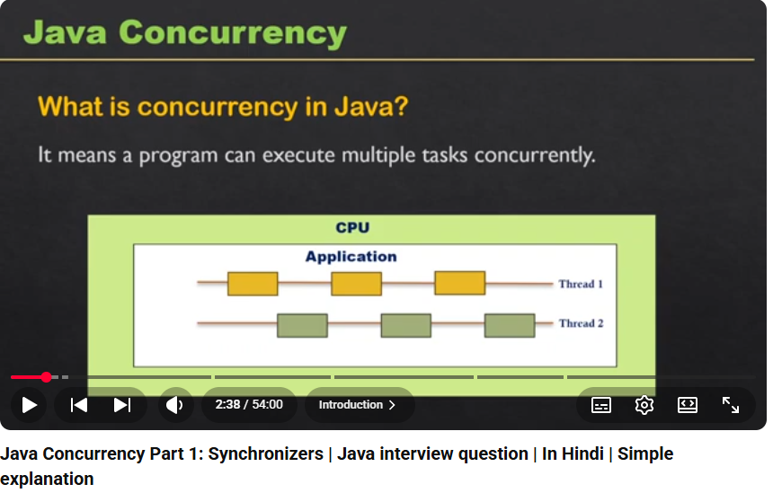
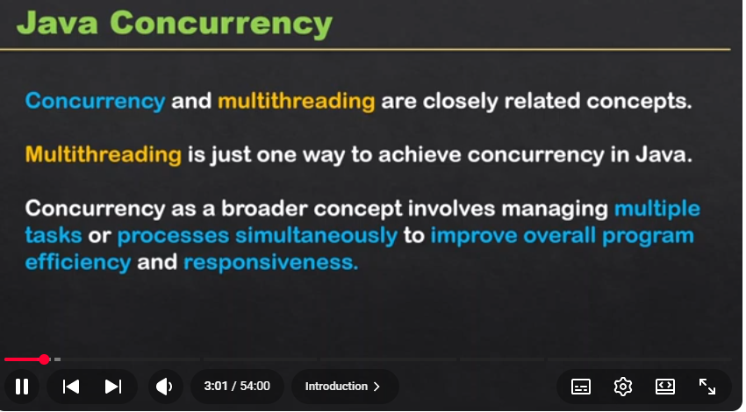
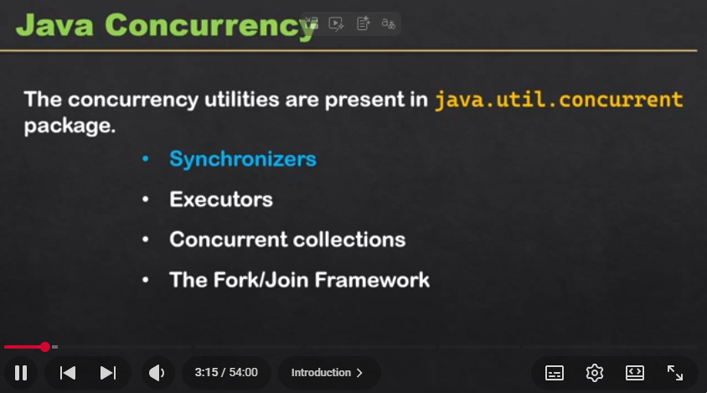
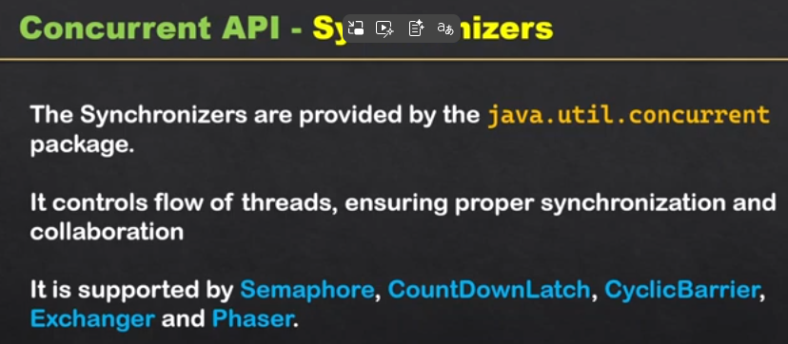
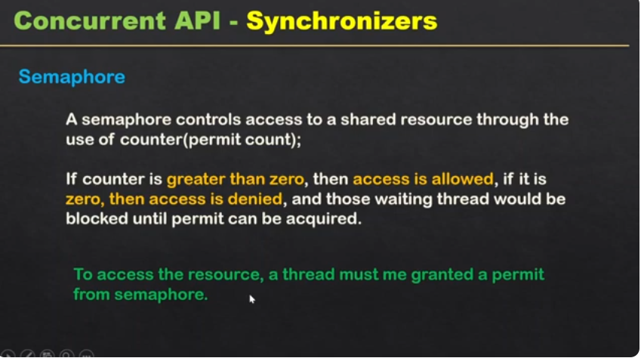
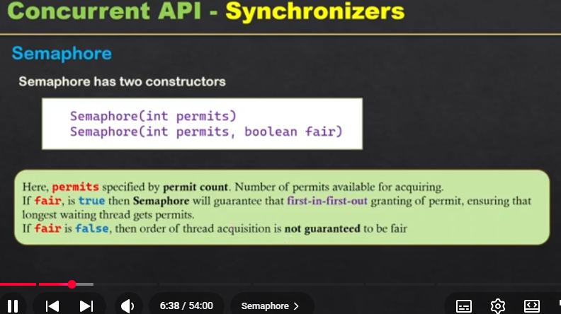
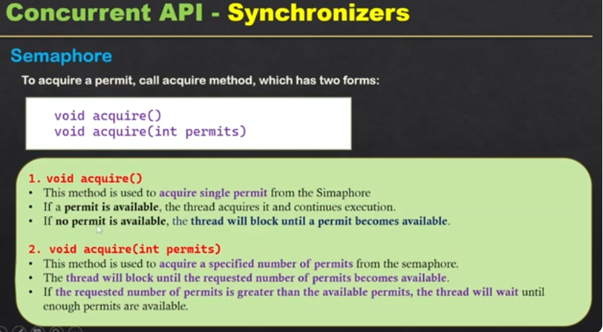
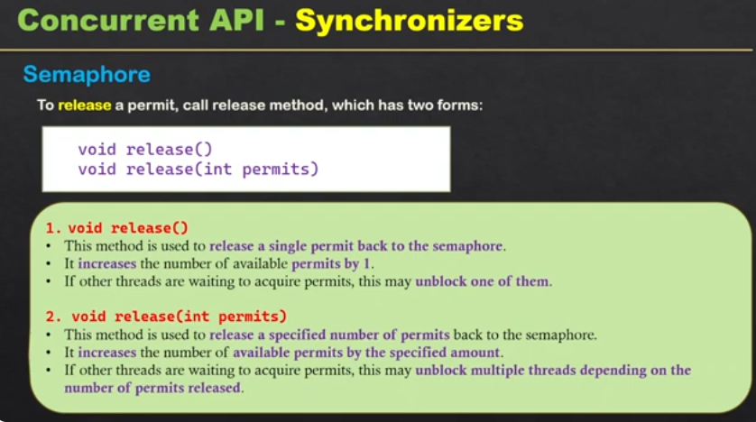
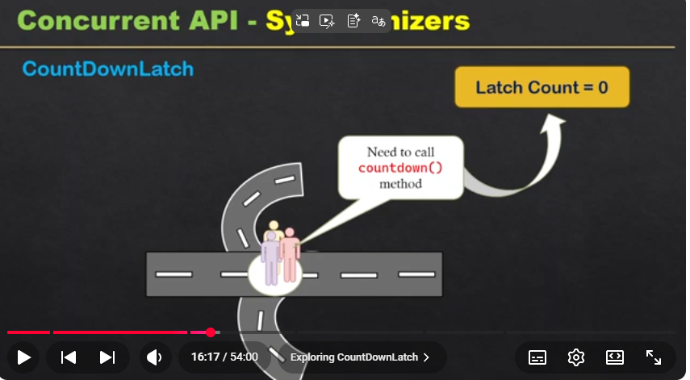
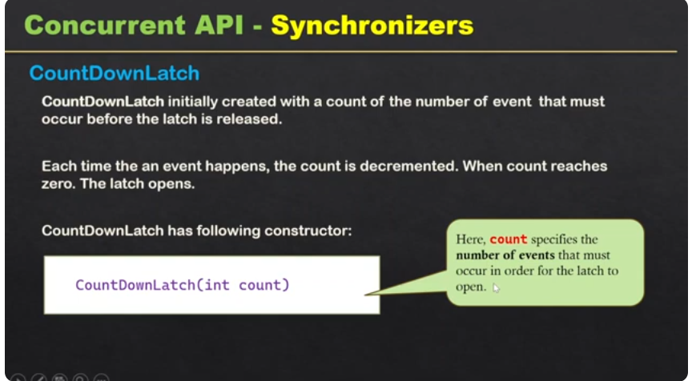
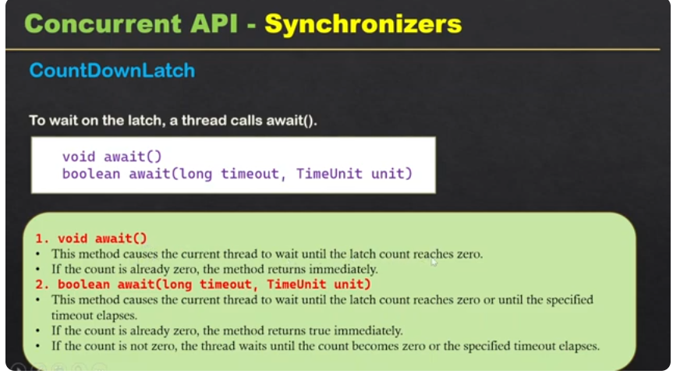

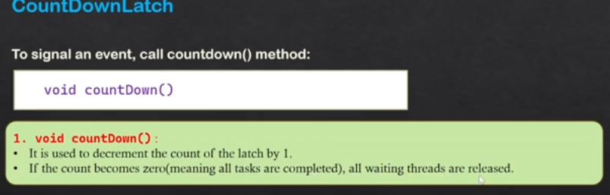

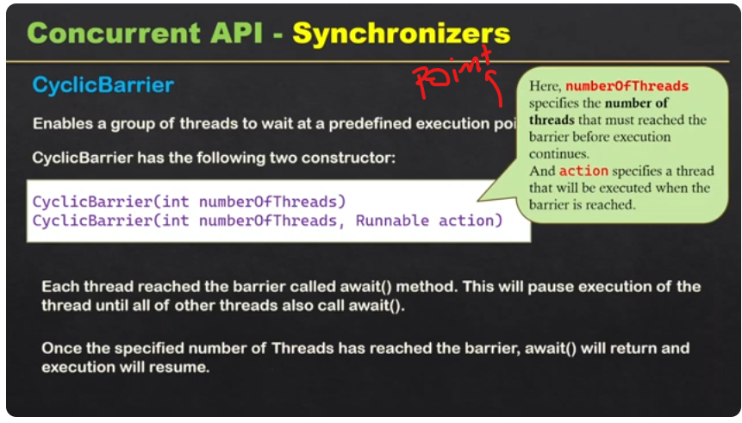

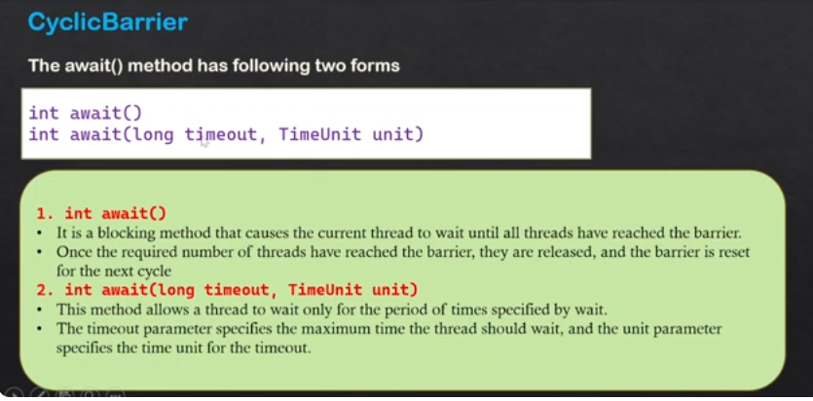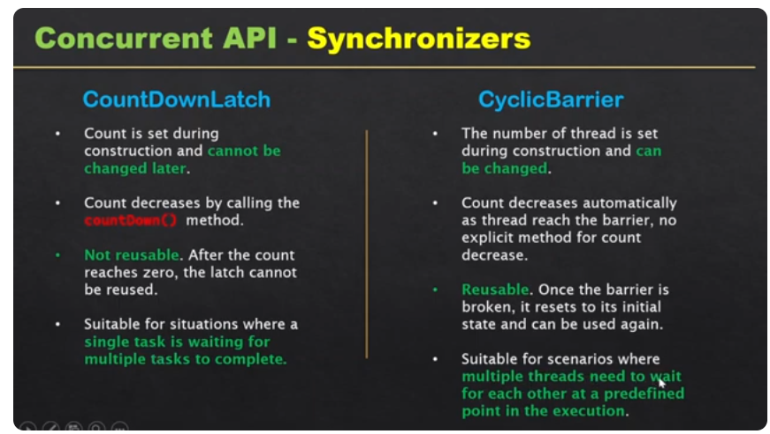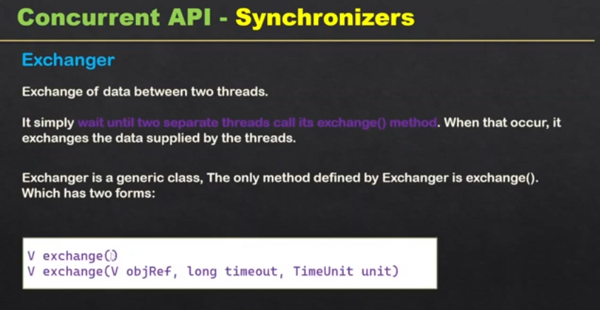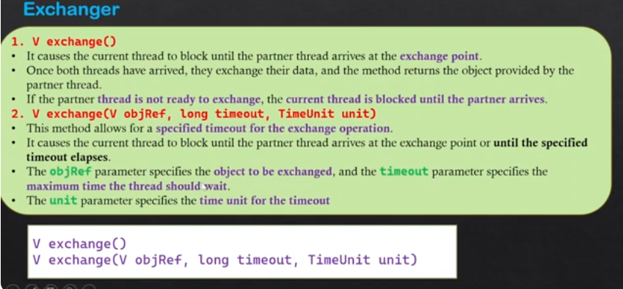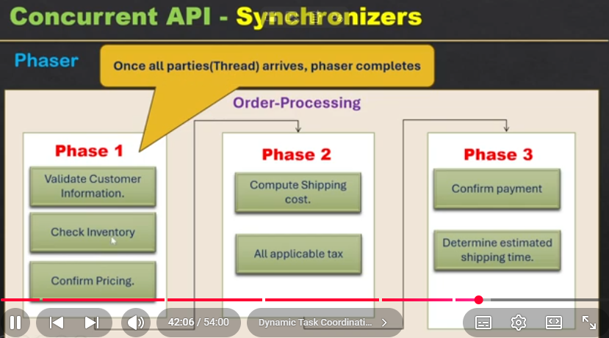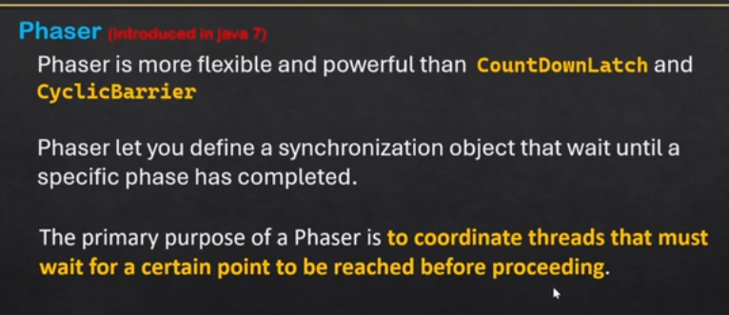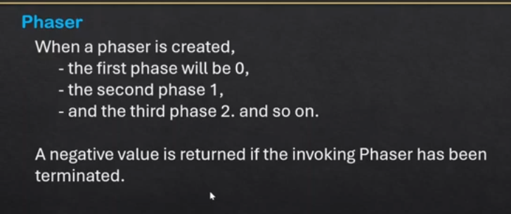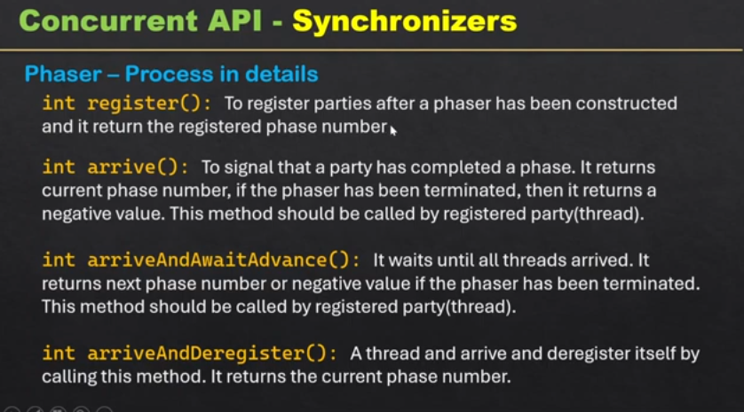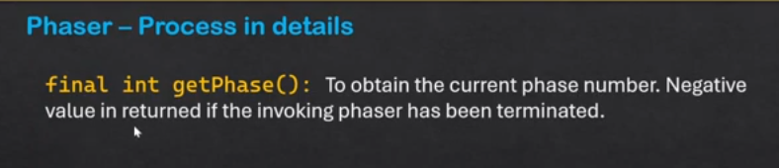

Java Concurrency Part 2: Executors | Executor Framework in java | Complete Course | In Hindi
Executor Framework: is responsible to manage Thread execution. In Execution framework at root there is interface named Executor which is responsible to execute the task.

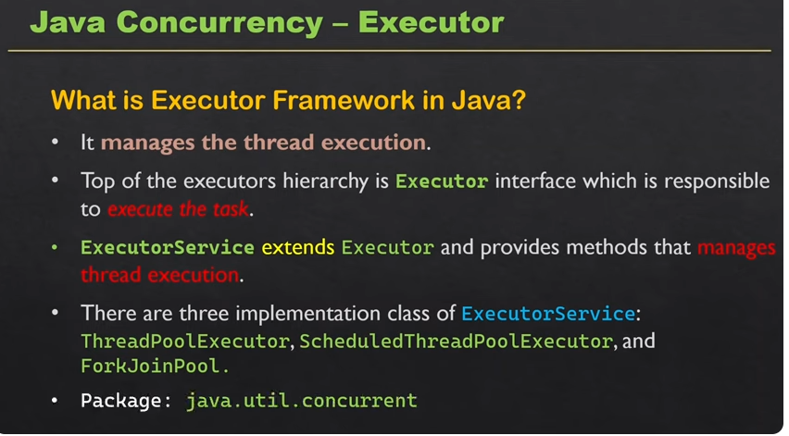
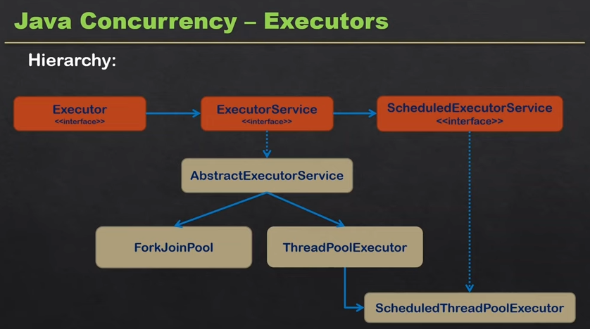
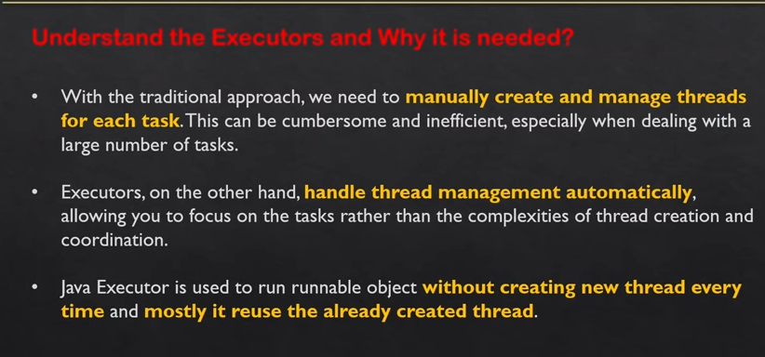
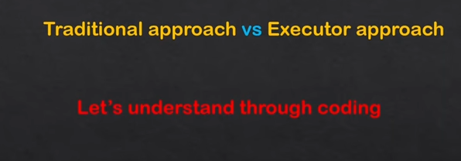
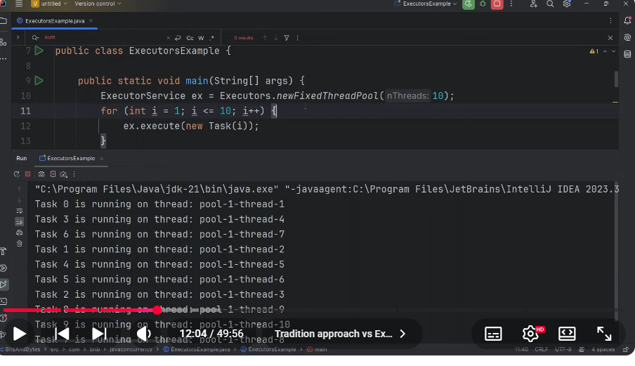Task is Runnable
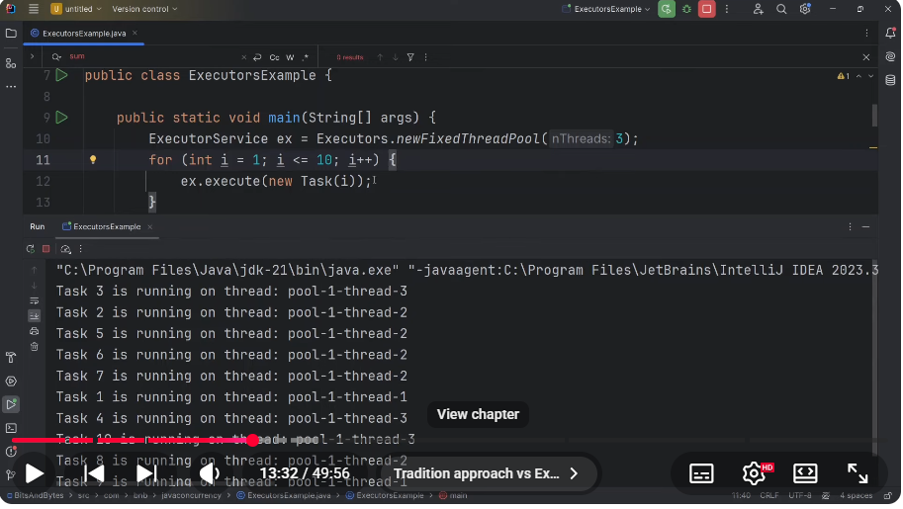
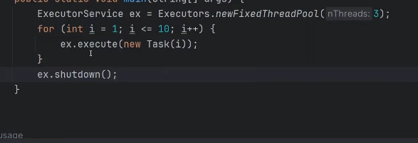
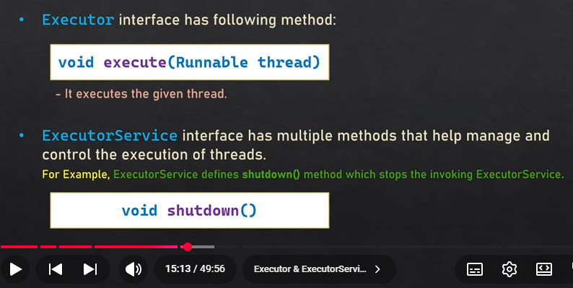
// ExecutorService ex = Executors.newCachedThreadPool(); // it create thread when each time execute methos called, thread alive for 60 secs. nno need to invoke shutdown()
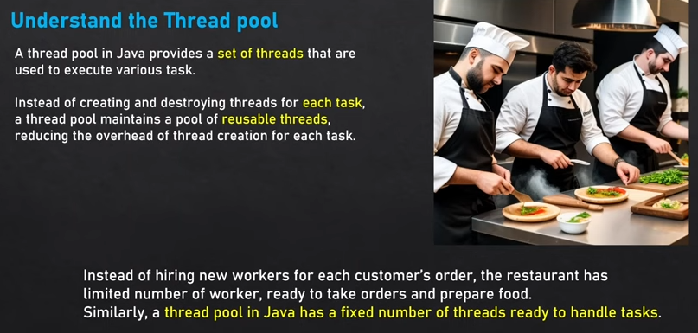
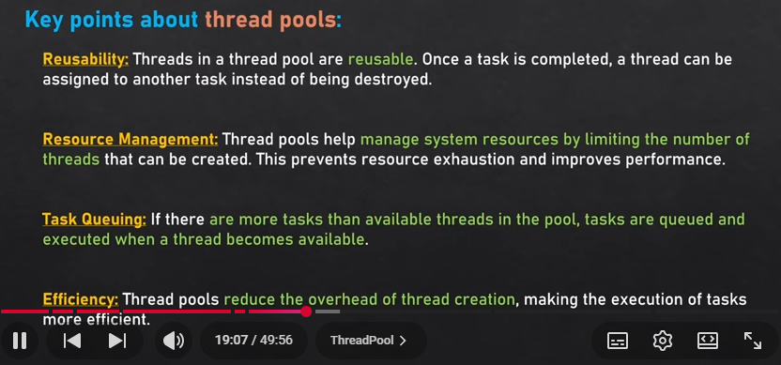
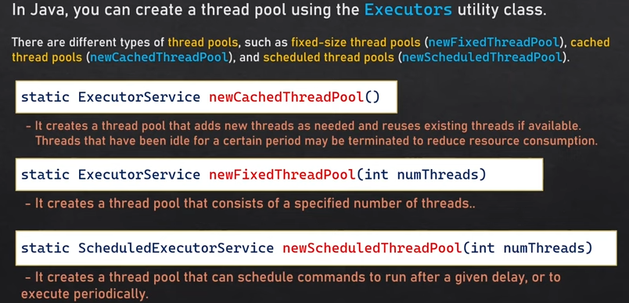
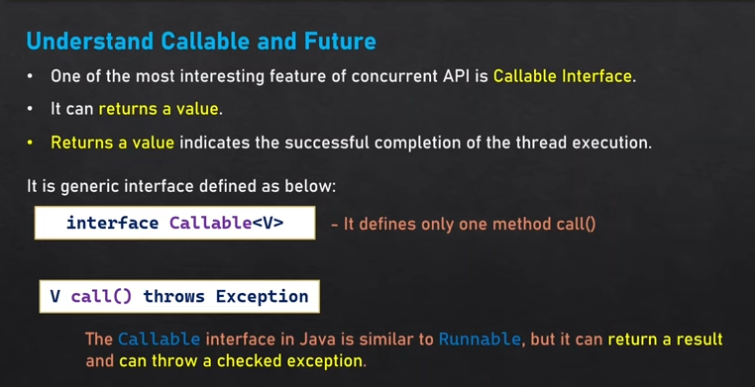
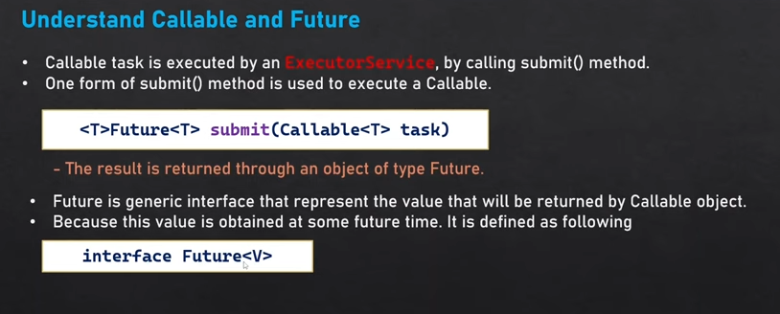
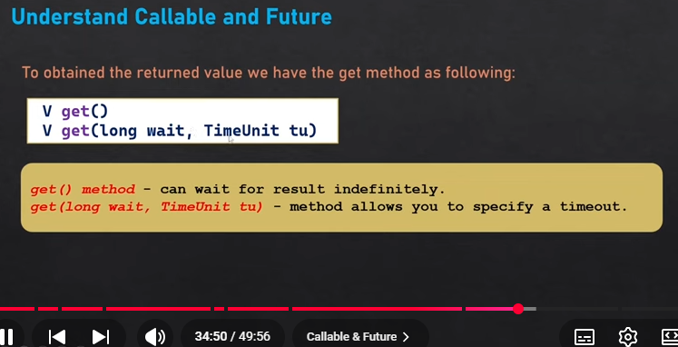
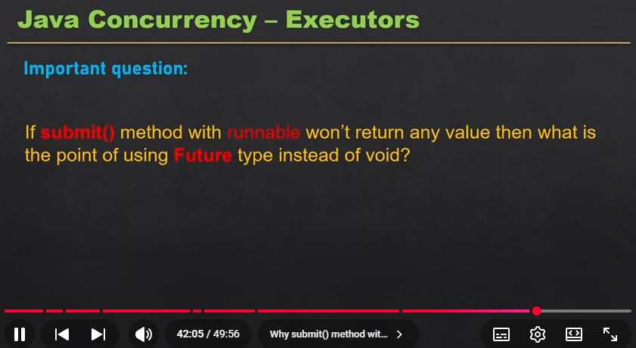
Virtual Threads — Interview Perspective
1. What is a Virtual Thread?
A lightweight thread introduced as a final feature in Java 21, managed by the JVM rather than directly mapping 1:1 to an OS thread.
2. Why were Virtual Threads introduced?
To handle high concurrency, especially applications with many I/O-bound operations, using fewer platform/OS threads and less memory.
3. Platform Thread vs Virtual Thread
Platform Thread | Virtual Thread
OS-backed | JVM-managed
Heavyweight | Lightweight
Limited scalability | Very high scalability
Higher memory usage | Lower memory usage
Good for CPU-bound tasks | Best for I/O-bound tasks
4. How does it work?
Virtual Thread
↓
JVM Scheduler
↓
Platform Thread
↓
CPU
When a virtual thread performs a blocking I/O operation, it can be unmounted from the platform thread, allowing that platform thread to execute another virtual thread.
5. How to create one?
Thread.startVirtualThread(() -> {
System.out.println("Hello");
});
Or:
try (var executor = Executors.newVirtualThreadPerTaskExecutor()) {
executor.submit(() -> {
// I/O operation
});
}
6. When should you use them?
Use Virtual Threads for:
- REST API calls
- Database operations
- Network calls
- File I/O
- Microservices handling many concurrent requests
7. When should you NOT expect benefits?
For CPU-intensive operations, virtual threads don't provide extra CPU power. They primarily improve concurrency, not raw CPU performance.

⭐ Most important interview answer
Virtual Threads in Java 21 are lightweight JVM-managed threads designed to efficiently handle a very large number of concurrent I/O-bound tasks. They reduce the cost of creating and managing threads compared to traditional platform threads, improving scalability without requiring reactive programming.

Interview keywords:
Java 21 → Lightweight → JVM-managed → High concurrency → I/O-bound → Blocking operations → Scalability → Not for CPU speed
ThreadLocal in Java — Interview Perspective
ThreadLocal is used to create a separate copy of a variable for each thread.
So, multiple threads can access the same ThreadLocal object, but each thread gets its own value.

Simple Example
ThreadLocal<Integer> count = ThreadLocal.withInitial(() -> 0);

count.set(10);

System.out.println(count.get()); // 10
If two threads use it:
Thread 1 → count = 10
Thread 2 → count = 20
Thread 3 → count = 30
They don't interfere with each other's values.

Why use ThreadLocal?
A common example is storing request-specific information:
ThreadLocal<String> userId = new ThreadLocal<>();

userId.set("user123");

System.out.println(userId.get());

userId.remove();
You might use it for:
- User/request context
- Transaction context
- Correlation/request ID
- Date formatters in older Java code
- Security context

Important methods
threadLocal.set(value); // Store value
threadLocal.get(); // Get value
threadLocal.remove(); // Remove value
threadLocal.set(null); // Set null

Why remove() is important?
In thread pools, threads are reused.
Request 1 → Thread A → userId = "ABC"
↓
Thread reused
↓
Request 2 → Thread A
If you don't remove the value, Request 2 could accidentally see Request 1's data.
Therefore:
try {
userId.set("ABC");

// business logic

} finally {
userId.remove();
}

ThreadLocal vs ScopedValue
ThreadLocal | ScopedValue
Java 1.2+ | Modern Java feature
Value belongs to thread | Value belongs to scope
Mutable | Immutable
set() / remove() required | Automatically bounded by scope
Can cause stale values with thread pools | Safer for scoped context
Useful for thread-specific state | Great for request/context propagation

⭐ Interview answer
ThreadLocal provides thread-confined storage, meaning each thread has its own independent copy of a variable. It is commonly used for request-specific or thread-specific context, but in thread pools we should call remove() to prevent stale data from being reused by another task.
Easy way to remember:
ThreadLocal → One value per Thread
ScopedValue → One immutable value per Scope

Scoped Values in Java — Interview Perspective
Scoped Values are a Java feature designed to share immutable data with methods and threads within a limited scope.
They are especially useful with Virtual Threads and are an alternative to using ThreadLocal for many use cases.

Simple example
static final ScopedValue<String> USER = ScopedValue.newInstance();

ScopedValue.where(USER, "Shoaib")
.run(() -> {
System.out.println(USER.get());
});
Output:
Shoaib
Inside the run() block, USER is available.
Outside the scope:
System.out.println(USER.get()); // ❌ No value bound

Why Scoped Values?
Imagine:
Request
↓
Service
↓
Repository
You want to pass the same user ID / request ID / security context through all these calls.
With traditional ThreadLocal:
ThreadLocal
↓
Thread
↓
Data
With Scoped Values:
Scoped Value
↓
Limited Scope
↓
Methods / Child Tasks
The value is immutable and available only during the defined scope.

Scoped Value vs ThreadLocal
Scoped Value | ThreadLocal
Immutable | Can be changed
Explicit scope | Thread lifetime based
Automatically bounded | Can cause cleanup/leak issues
Good with Virtual Threads | Traditionally thread-oriented
Value is bound for a scope | Value is associated with a thread

Important interview point
Scoped Values are useful for context propagation, such as:
- Request ID
- User/security context
- Transaction/context information
- Tracing information

⭐ Interview answer
Scoped Values provide a safe and efficient mechanism to share immutable context across methods and threads within a well-defined scope. They are particularly useful with virtual threads and can be preferable to ThreadLocal when the data should not be modified.
Remember:
ThreadLocal → thread-associated mutable data
ScopedValue → scope-associated immutable data

FORK JOIN

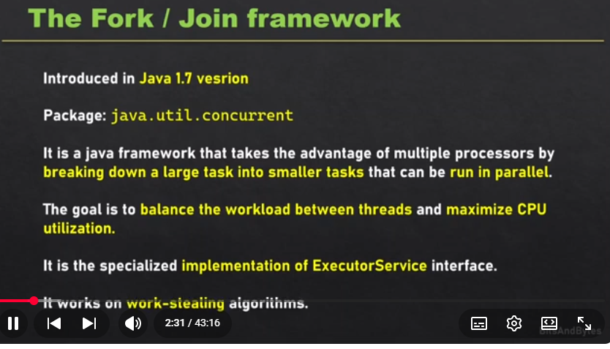
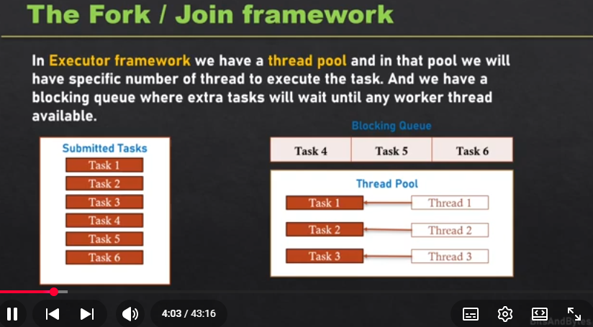
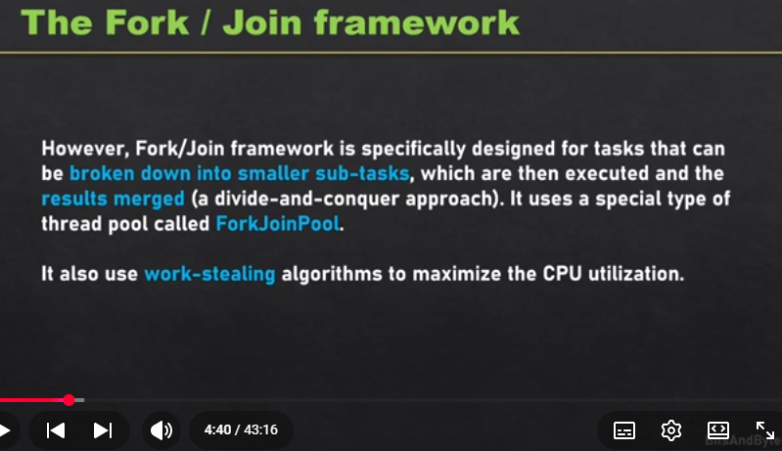
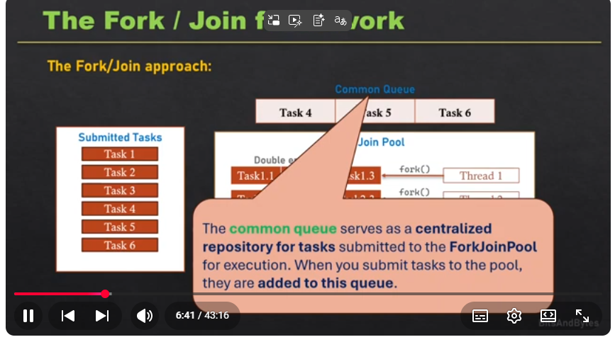
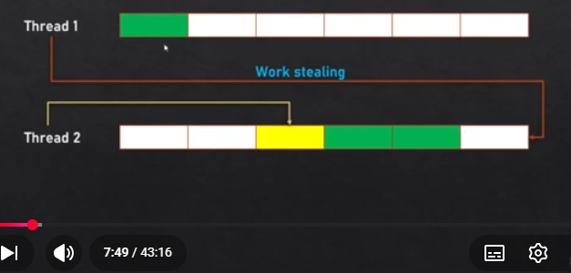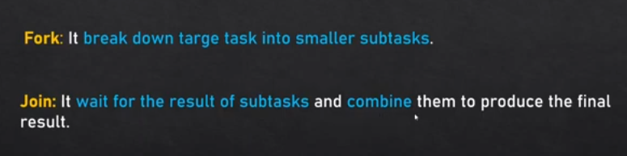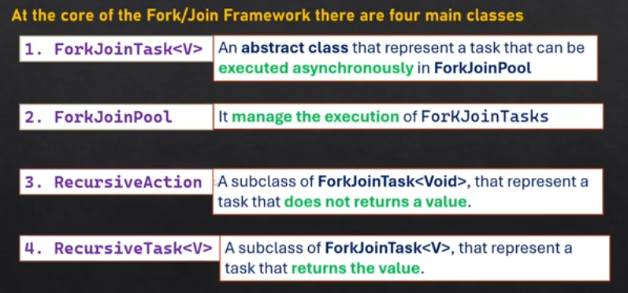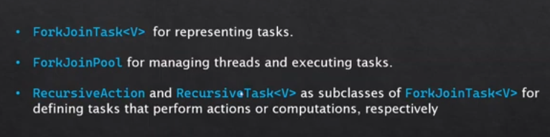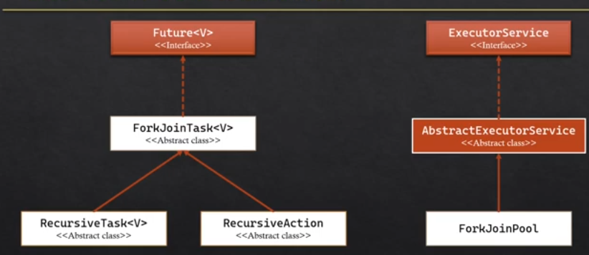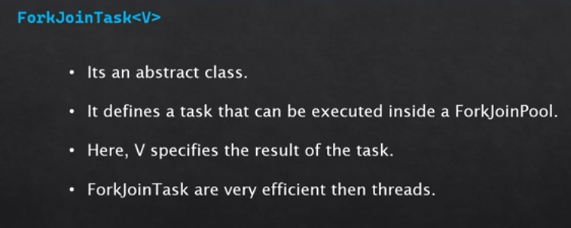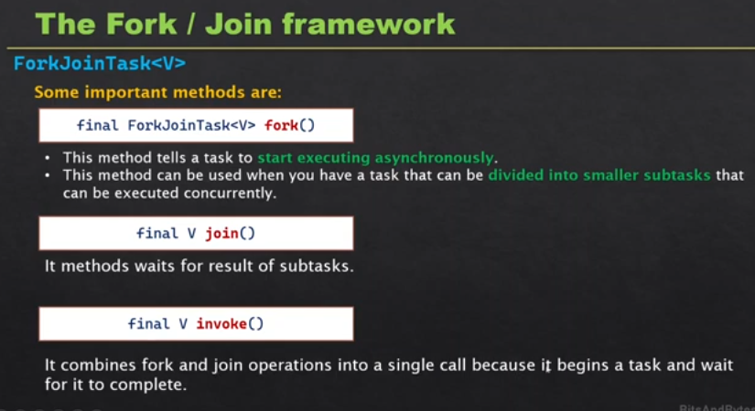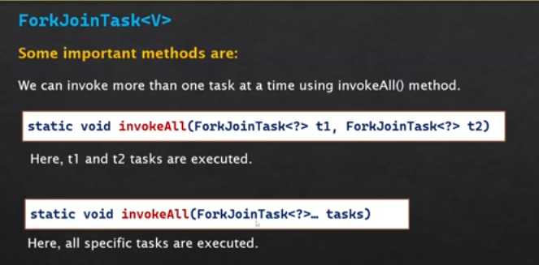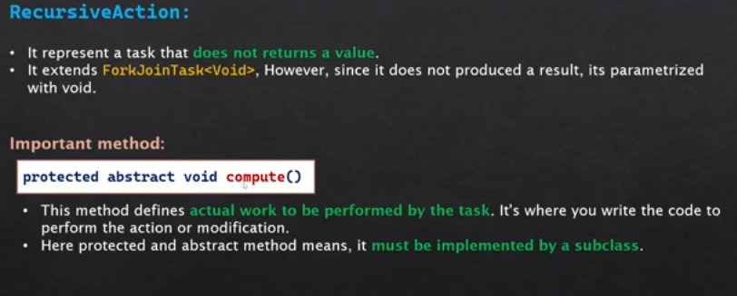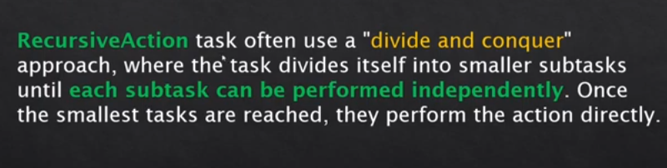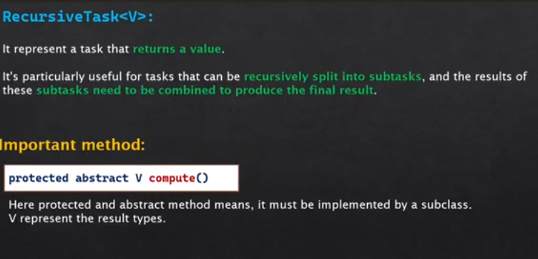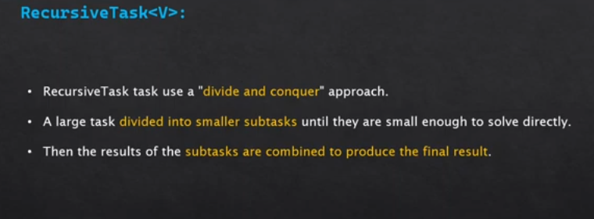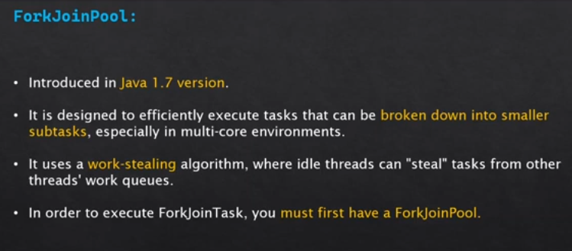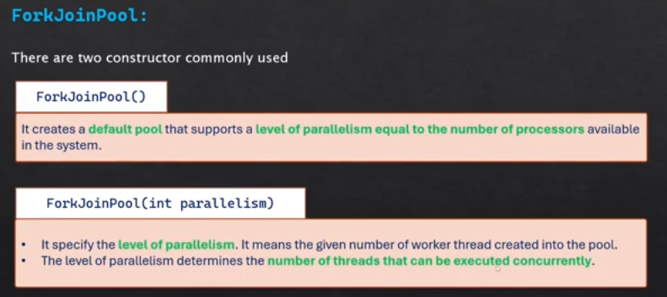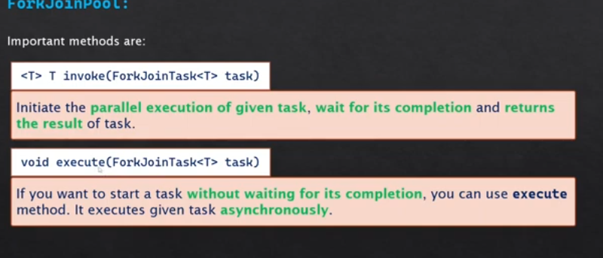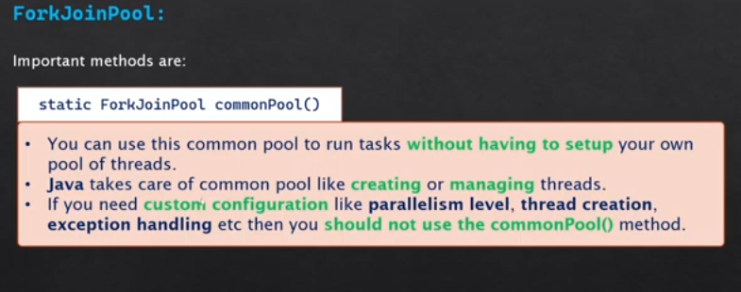

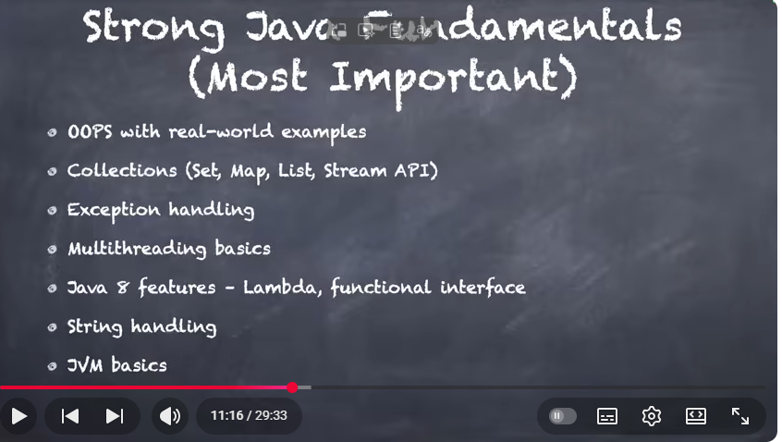

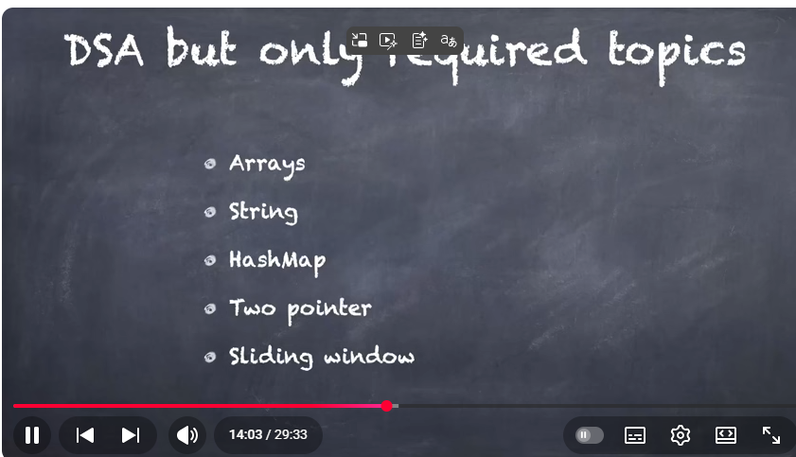
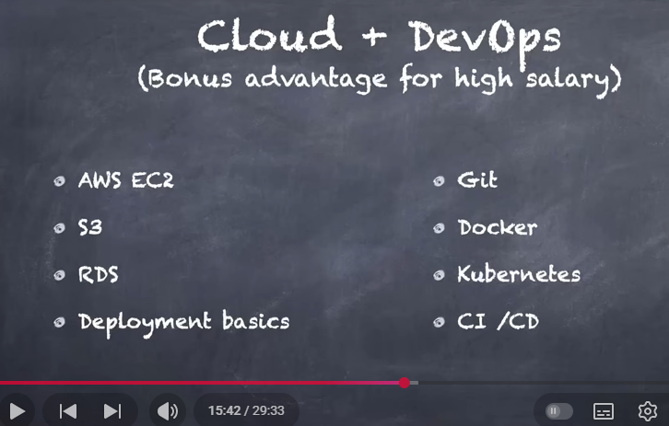
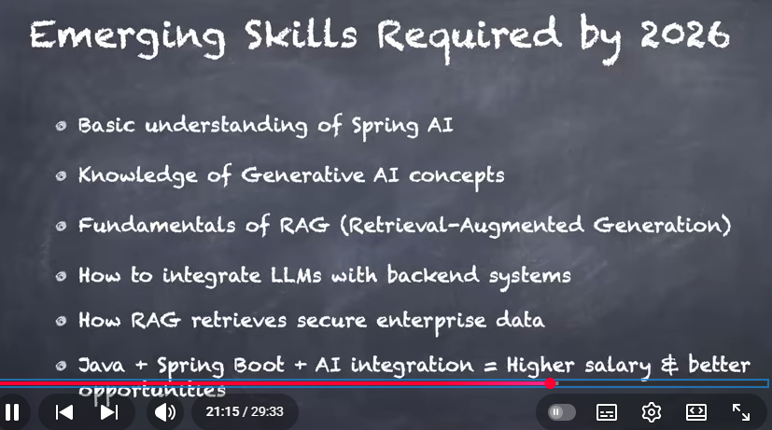
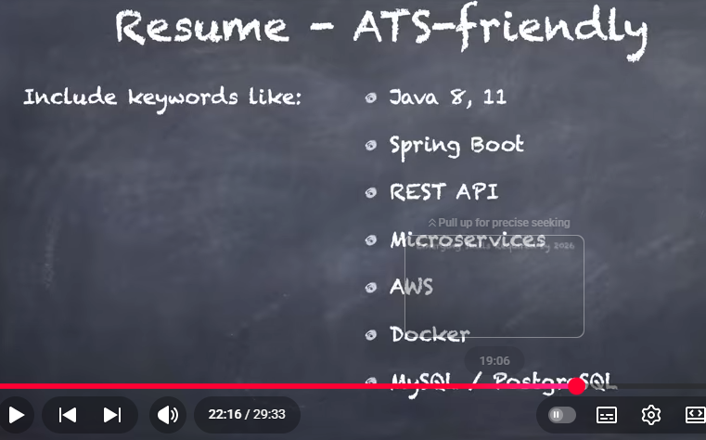
https://youtu.be/MJtfOkS06p8?list=PLX1XVaZeuvXerqUCxo2rFxKAfl4ITr_FT
roject Explanation



