https://www.youtube.com/watch?v=48bHZPzCpGg&t=36s
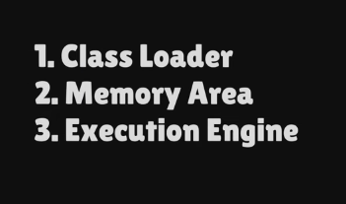
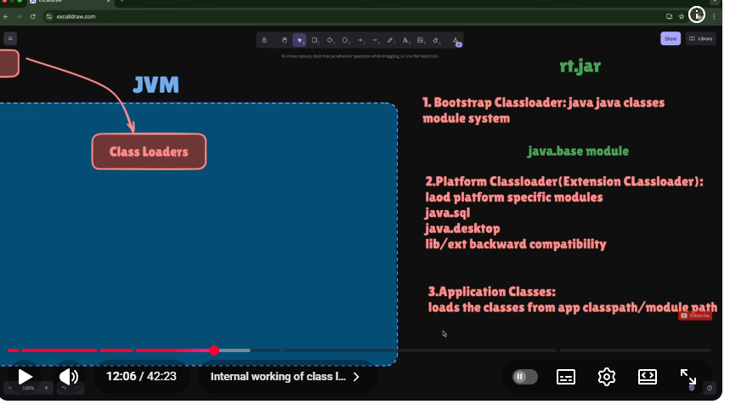
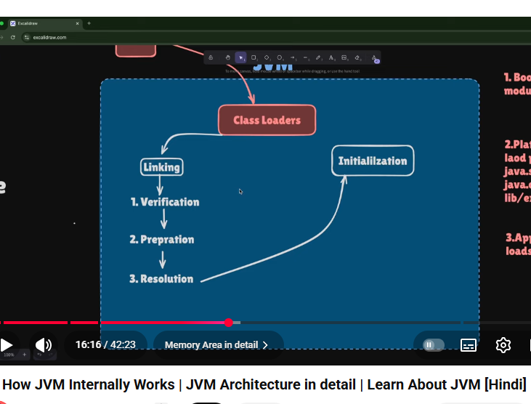
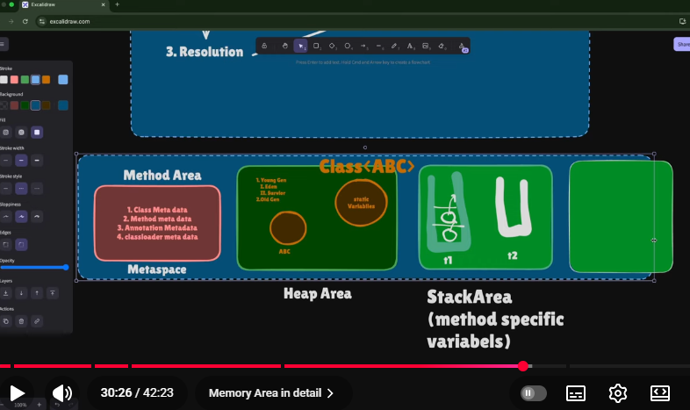
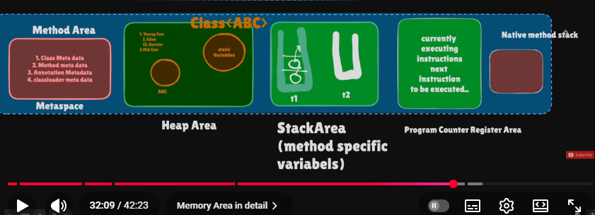
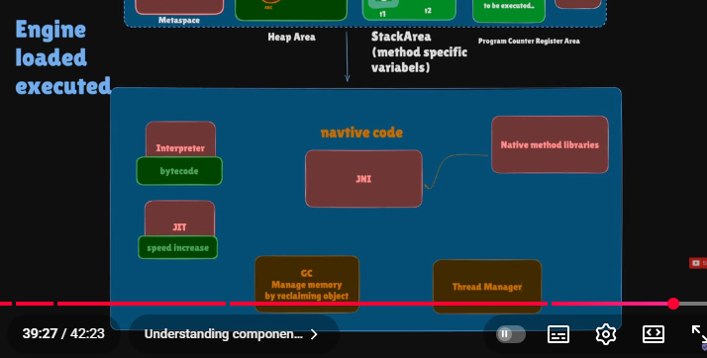
n the JVM, the PC Register (Program Counter Register) is a small memory area used to track the currently executing instruction of a thread.

✅ What it does
- Stores the address of the current bytecode instruction being executed.
- Helps the JVM know which instruction to execute next.
- Ensures correct execution when multiple threads are running.

✅ Key points
- Each thread has its own PC register (thread-specific).
- For Java methods, it contains the bytecode instruction address.
- For native methods, the PC register value is undefined.
- It does not cause OutOfMemoryError.

✅ Why it is needed
- Supports thread switching and resuming execution correctly.
- Maintains the execution flow of a Java program.

🔑 Simple definition (interview-ready)
PC Register is a per-thread JVM memory area that stores the address of the currently executing bytecode instruction.
---------------------------------------------------------------------------------------------------------------
NATIVE AREA

🔑 Interview-ready definition
Native Method Area is the JVM memory region used to execute native (non-Java) methods and manage native libraries via JNI.

Execution Engine:
🔑 Simple definition
Execution Engine is the JVM component that executes bytecode using an interpreter and JIT compiler and manages memory through garbage collection.

