Lect -01:
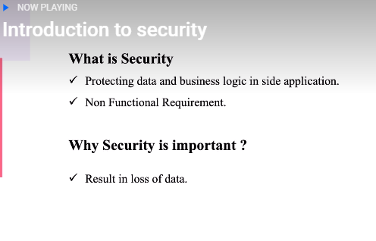
By doing @EnableWebSecurity(debug=true) in congid class.

when we fire route means hit api(usrName& Password Screen)
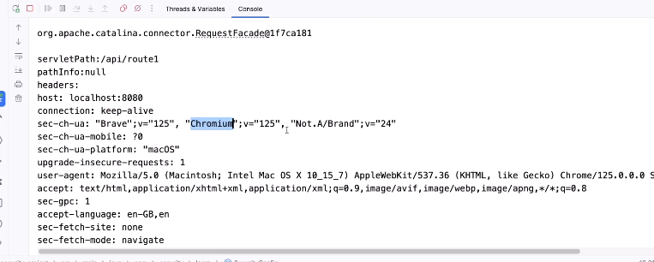
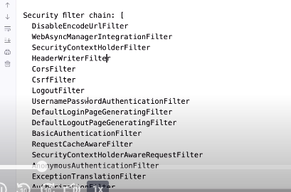
In Spring Boot / Spring Security, these four terms are related but not the same. Interviewers love this question because confusion is very common.
Below is a clear, practical, interview-ready explanation with real Spring Boot examples.

1️⃣ Authentication – Who are you?

Meaning
Authentication is the process of verifying the identity of a user.
Example: Checking username & password during login.

In Spring Security
- Happens first
- Implemented using:
  - AuthenticationManager
  - AuthenticationProvider
  - UserDetailsService

Example
UsernamePasswordAuthenticationToken authToken =
new UsernamePasswordAuthenticationToken(username, password);

Authentication authentication =
authenticationManager.authenticate(authToken);
✔ User exists
✔ Password is correct
➡ User is authenticated

2️⃣ Authorization – What are you allowed to do?

Meaning
Authorization checks permissions after authentication.
Example: Can this user access /admin API?

In Spring Security
- Happens after authentication
- Based on roles or authorities

Example
http.authorizeHttpRequests()
.requestMatchers("/admin/**").hasRole("ADMIN")
.requestMatchers("/user/**").hasAnyRole("USER", "ADMIN")
.anyRequest().authenticated();
✔ User is logged in
❌ But may not have permission

3️⃣ Authority – Fine-grained permission

Meaning
An Authority is a single permission.
Example:
- READ_USER
- WRITE_USER
- DELETE_ORDER

In Spring Security
- Represented by:
- GrantedAuthority
- Stored inside Authentication object

Example
new SimpleGrantedAuthority("READ_USER");

Method-level Security
@PreAuthorize("hasAuthority('DELETE_USER')")
public void deleteUser() {
}
✔ Very granular control

4️⃣ Role – Group of authorities

Meaning
A Role is a collection of authorities.
Example:
ROLE_ADMIN →
READ_USER
WRITE_USER
DELETE_USER

Important Spring Rule ⚠
Spring internally prefixes roles with ROLE_
Role Used | Stored As
ADMIN | ROLE_ADMIN
USER | ROLE_USER

Example
@PreAuthorize("hasRole('ADMIN')")
public void adminOnly() {
}
Equivalent to:
hasAuthority("ROLE_ADMIN")

🔄 Relationship Flow (Very Important)
Authentication
↓
User authenticated
↓
Authorization
(using Roles / Authorities)
↓
Access Granted or Denied

🧠 Key Differences (Interview Table)
Term | Question It Answers | Spring Concept
Authentication | Who are you? | Login verification
Authorization | Can you access this? | Access control
Authority | What exact permission? | GrantedAuthority
Role | Group of permissions | ROLE_XXX

⚠ Common Interview Traps

❌ Wrong
hasAuthority("ADMIN")

✅ Correct
hasRole("ADMIN")
// OR
hasAuthority("ROLE_ADMIN")

🎯 Real-World Example
User | Role | Authorities
Admin | ADMIN | READ, WRITE, DELETE
Manager | MANAGER | READ, WRITE
User | USER | READ

🔑 One-Line Summary (Interview Gold)
Authentication verifies identity, authorization verifies access, authorities define permissions, and roles are groups of authorities.

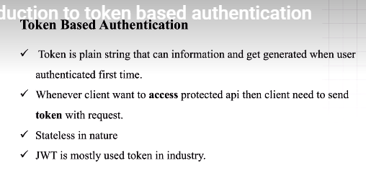
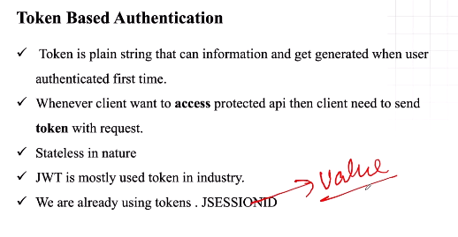
Understanding JWT Tokens
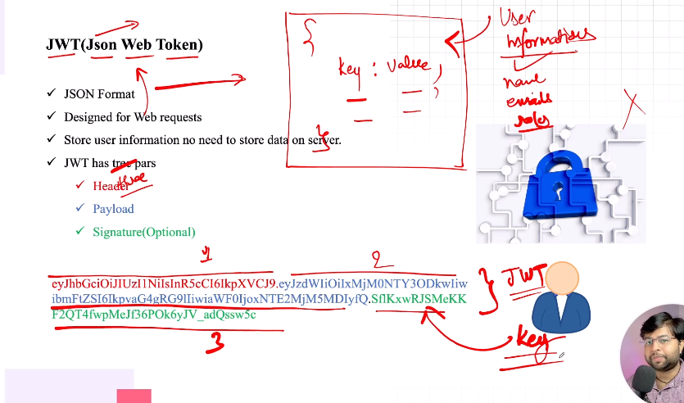
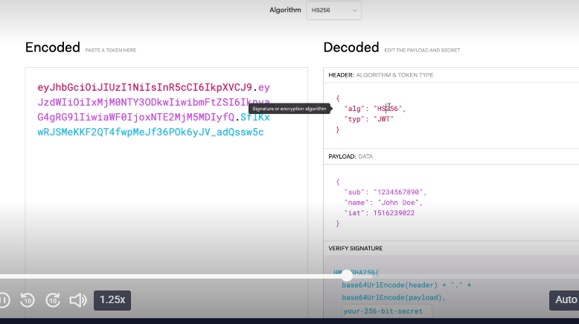

JWT Authentication Flow
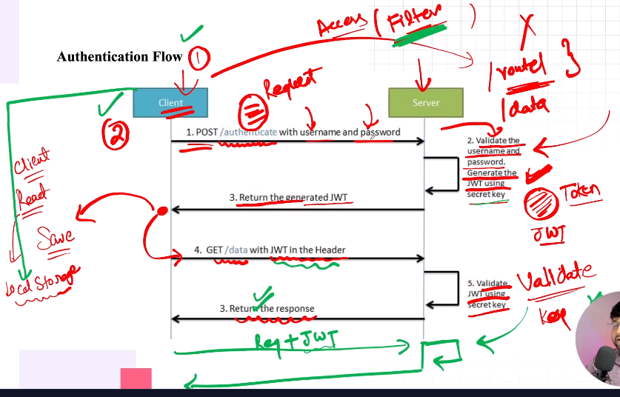
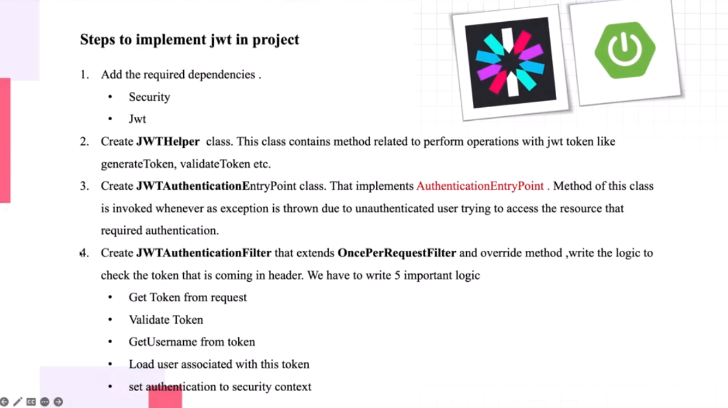
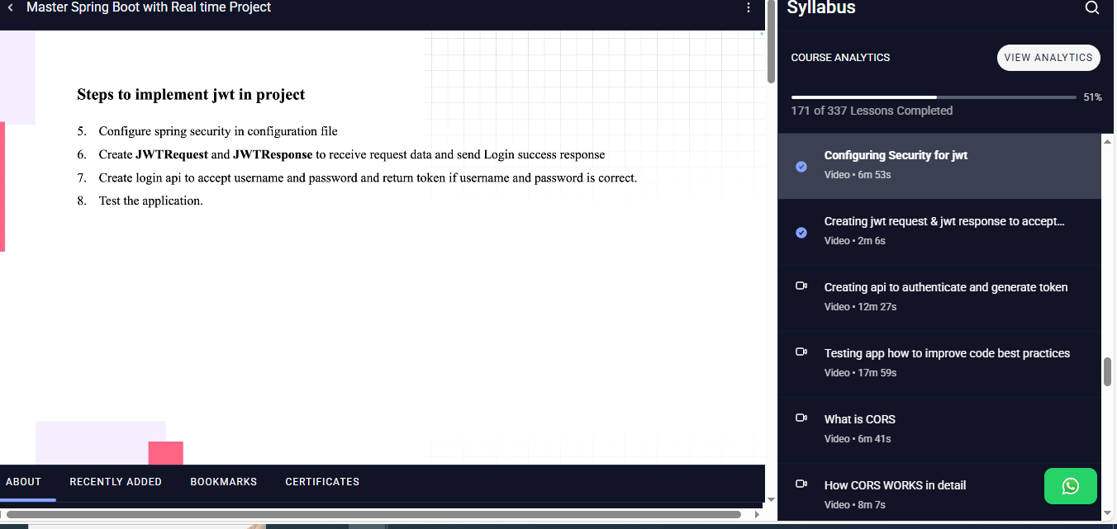
CORS: cross sight request sharing.
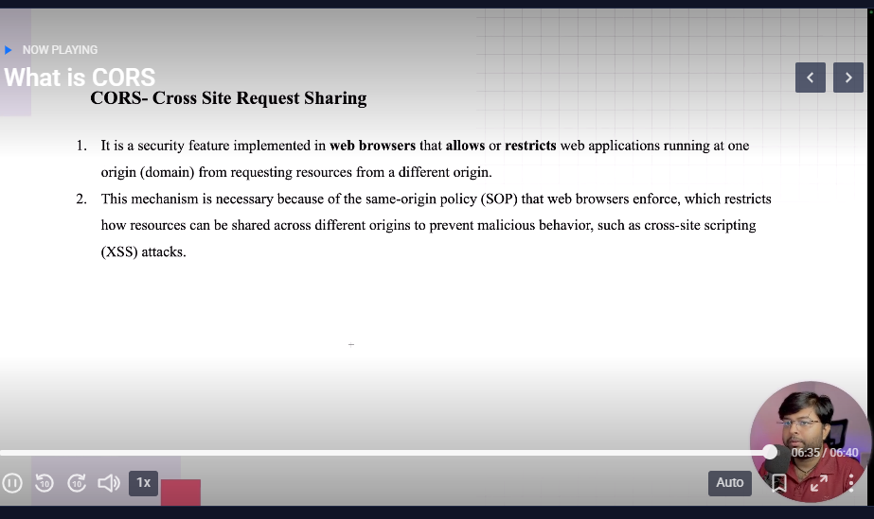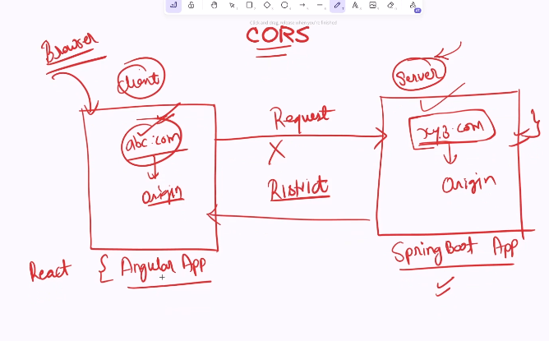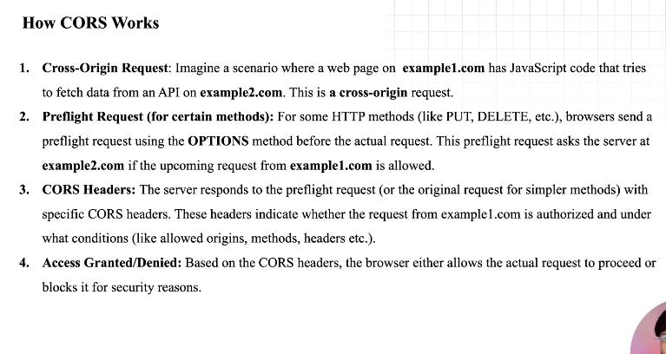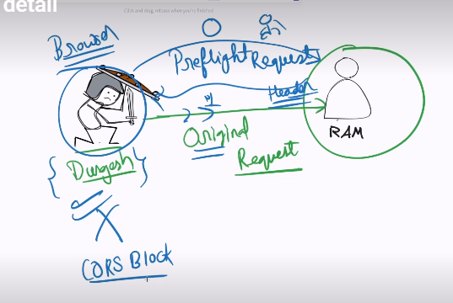
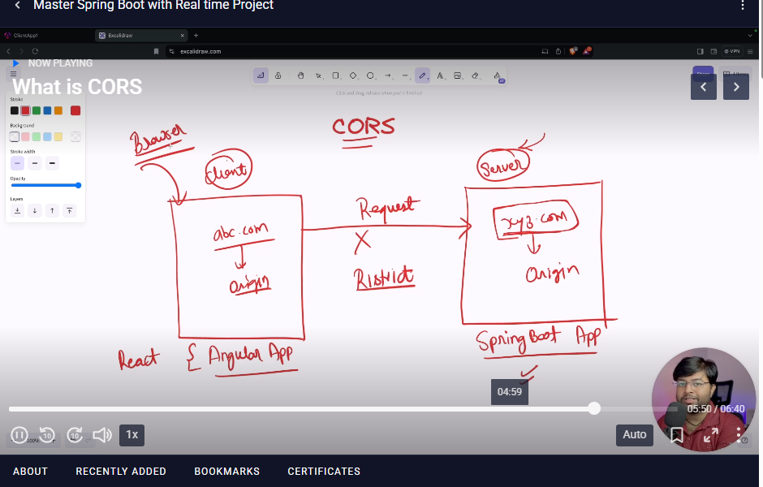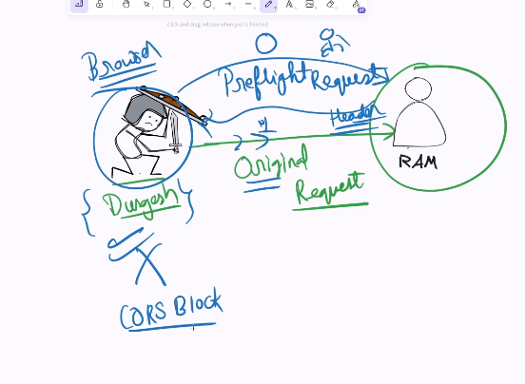
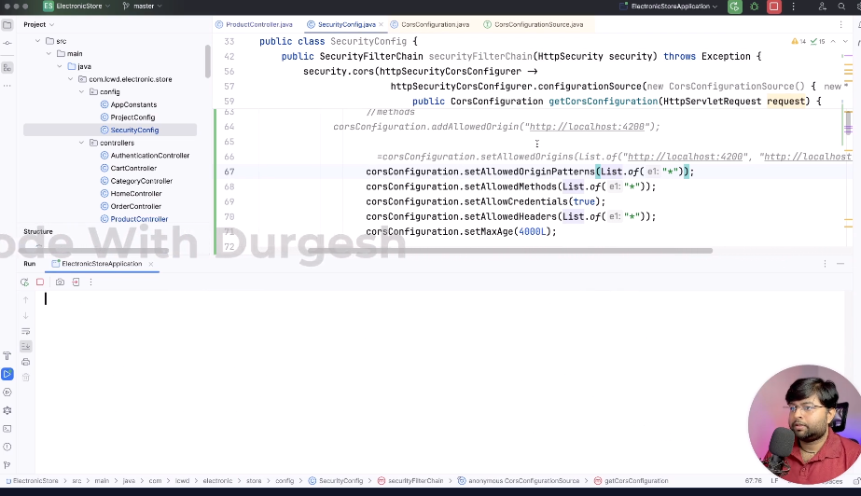
This is for global.

To protect particular controller

//@CrossOrigin(origins = "*")
public class ProductController {
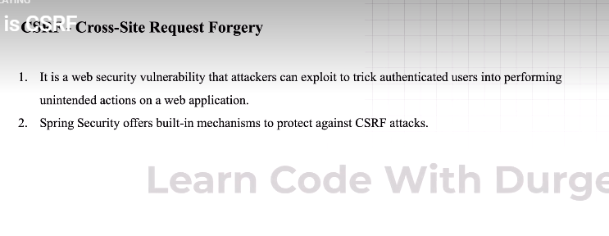
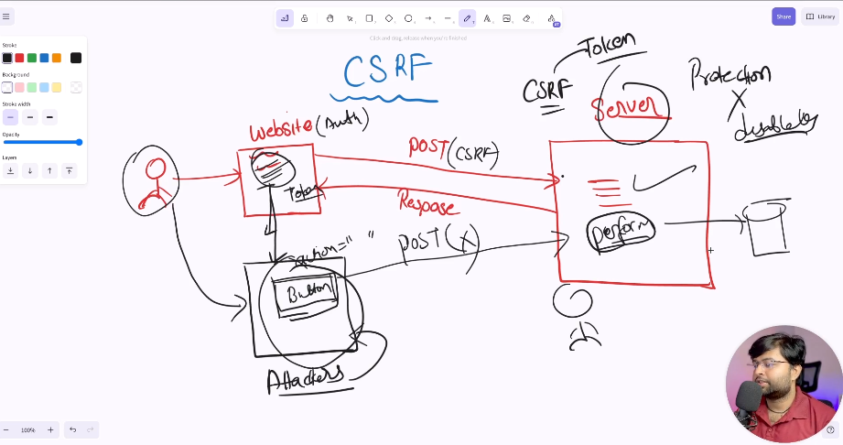
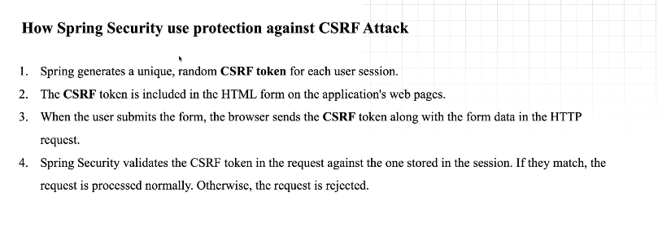
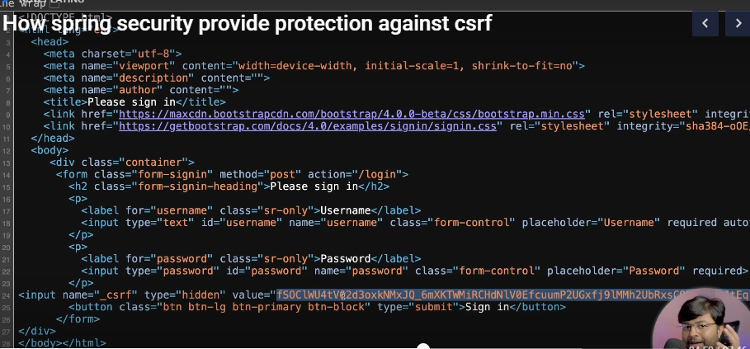
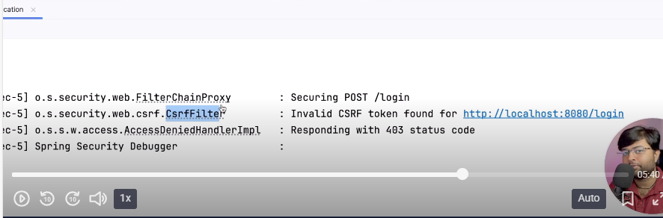
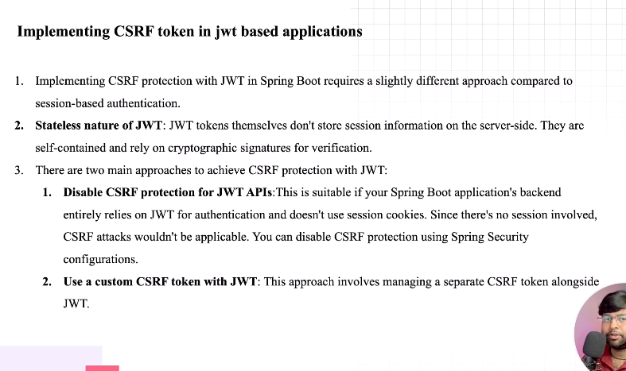
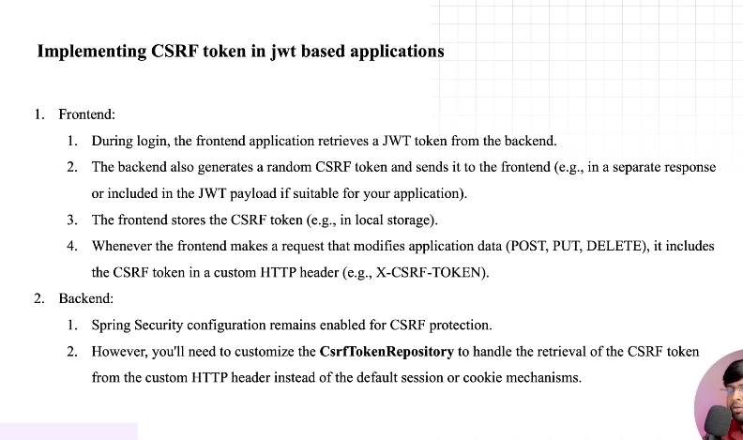

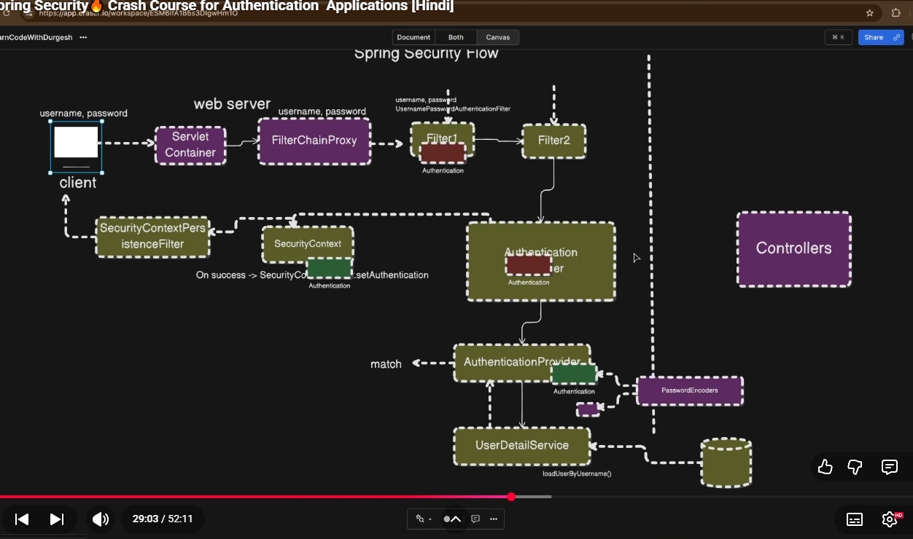
https://youtu.be/KX23d3rC-1k?list=PL0zysOflRCem2SLBwhDMok05hwLtRTRDr&t=1743
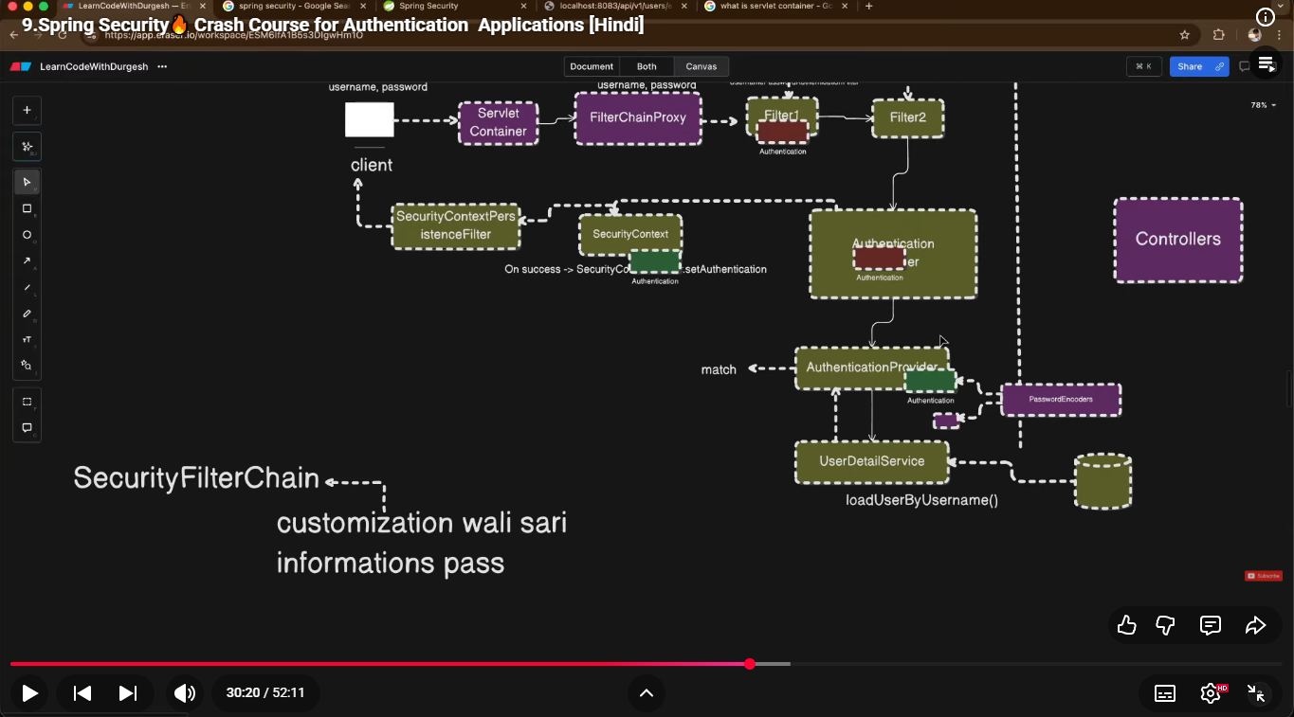
Whenever user submit requests, Web-server delegates the request to “FilterChainProxy” before executing the “controller” “FilterChainProxy” delegates incoming HTTP requests to the correct Spring Security filter chain for instance UsernamePasswordAuthenticationFilter intercepts login requests, extracts credentials, creates an authentication object, and delegates authentication to the AuthenticationManager, AuthenticationManager is the component responsible for verifying user credentials but it does not verify itself rather it find appropriate “AuthenticationProvider” then provide that authentication object to AuthenticationProvider(DaoAuthenticationProvider, JwtAuthenticationProvider, LdapAuthenticationProvider).
AuthenticationProvider fetch user information from db by using “UserDetailService” calling loadUserByUsername() method then match the password by using “PassswordEncoder”
(asswordEncoder.matches(rawPassword, user.getPassword());)., if wrong then throw
“throw new BadCredentialsException("Invalid credentials");” if succedded then return an authenticated Authentication object containing “Authentication & Authority” 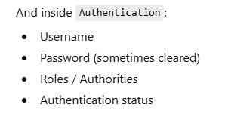 then
“SecurityContextPersistenceFilter” intercept the request & create the session & set authenticated object in “SecurityContext” with the help of “SecurityContextHolder” 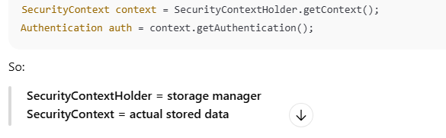
then user redirect to the success page.
If logged in user want to access protected route, check if user exist in session then authentication user from session & secure in SecurityContextHolder
. 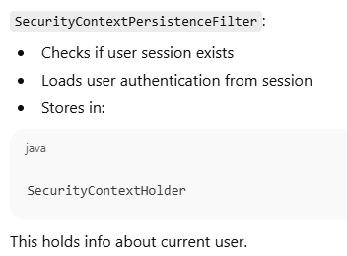
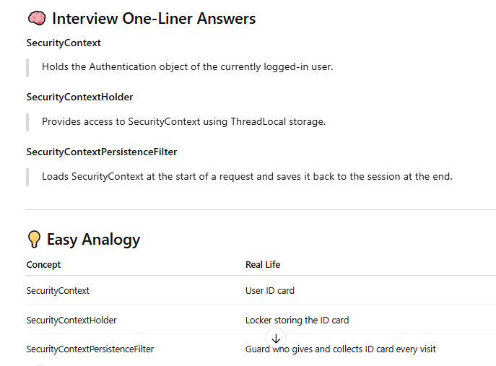
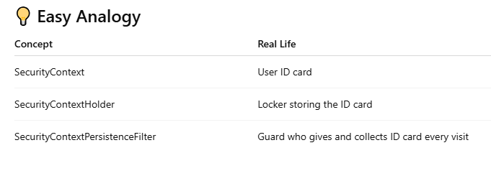
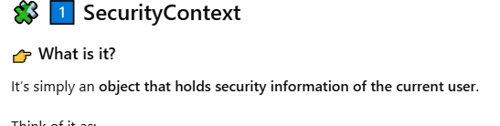
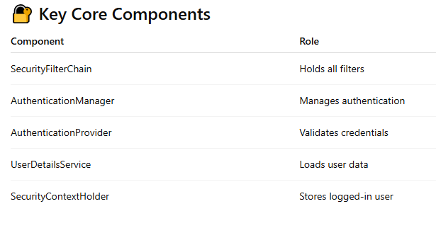
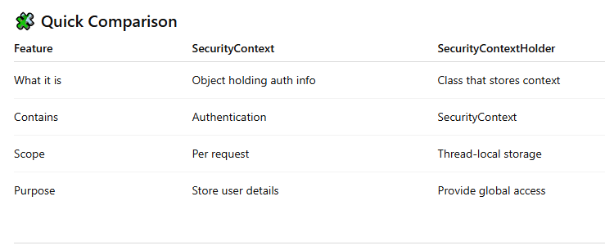
SecurityFilterChain(I)
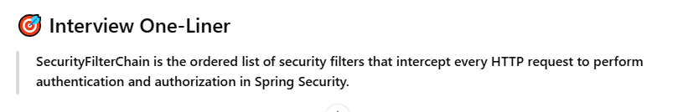
SecurityFilterChain
Defines the ordered set of security filters that process every incoming HTTP request for authentication and authorization.
SecurityContext
Holds the Authentication object representing the currently logged-in user.
SecurityContextHolder
Provides access to the SecurityContext using ThreadLocal storage per request.
SecurityContextPersistenceFilter
Loads the SecurityContext at the start of a request and saves it back (usually to the session) at the end.
AuthenticationManager
Delegates authentication requests to appropriate AuthenticationProviders.
AuthenticationProvider
Validates user credentials and returns an authenticated Authentication object.
UserDetailsService
Loads user-specific data (username, password, roles) from a data source.
UsernamePasswordAuthenticationFilter
Intercepts login requests and attempts authentication using username and password.
Authorization (in Spring Security)
Determines whether an authenticated user has permission to access a resource.

JWT
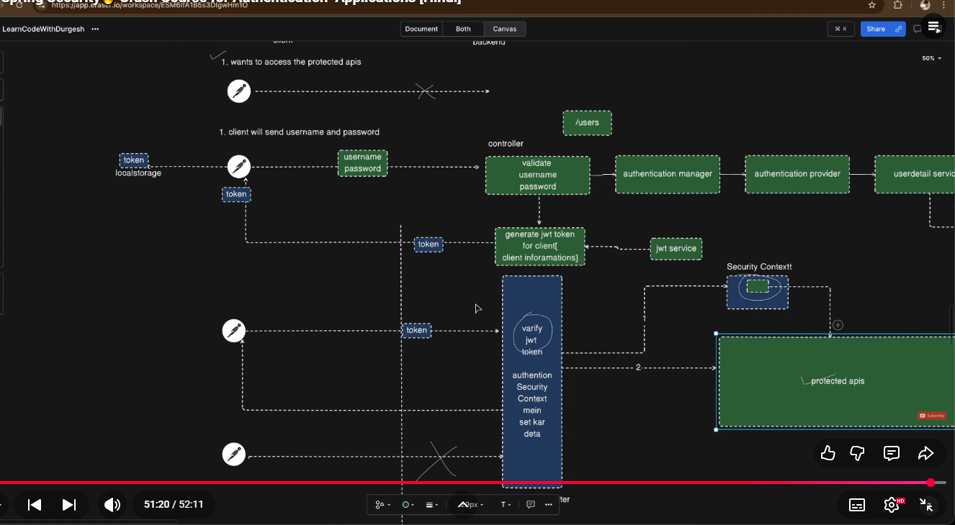
Basic Authentication – Non browser
Form based --------- - Browser
SecurityContextPersistenceFitter --- create session & set authentication object in security context with the help of SecurityContextHolder context manage & store session
What is Authention & types of authentication.
1.> Basic Authentication: In this authentication we need to send usename & password for each request that’s why is not secured way.

2.>Cookies/Session based authentication: In this authentication when we submit request with user name & password, server verify user name password if verified successfully after verifying username & password server creates sessionId that session id will be stored in database.for subsequent request server only verify session id.(Jsession ID)
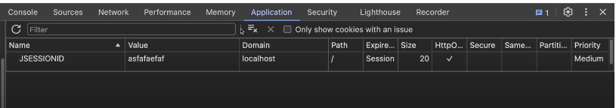
3.>JWT
4.>OAuth2
https://medium.com/%40alyragab70/authentication-types-and-techniques-eb8232eebcfb?utm_source=sp_auto_dm&fbclid=PAT01DUAPqgadleHRuA2FlbQIxMABzcnRjBmFwcF9pZA81NjcwNjczNDMzNTI0MjcAAacAD9UCEmgfLpDlCyJrQAjYrmsAFFFLC8plTj98MqQSJCfZAR82nAAYMJe7Dw_aem_EIBZYlCOLcshBXQuZCKTZw
🔑 One-Line Summary (Interview Gold)
Authentication verifies identity, authorization verifies access, authorities define permissions, and roles are groups of authorities.

