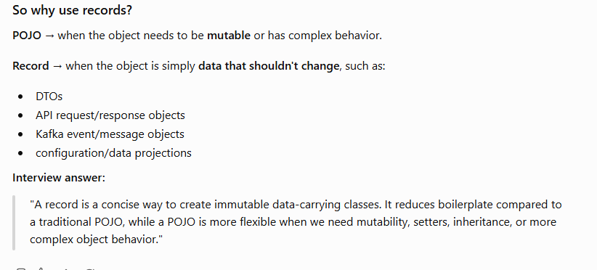
java 21 :
1.String Template
2. Unnamed Patterns and Variables (Preview)
3. Unnamed Classes and Instance Main Methods (Preview)
4. Sequenced Collections
5. Record Pattern:
6.Pattern in Switch
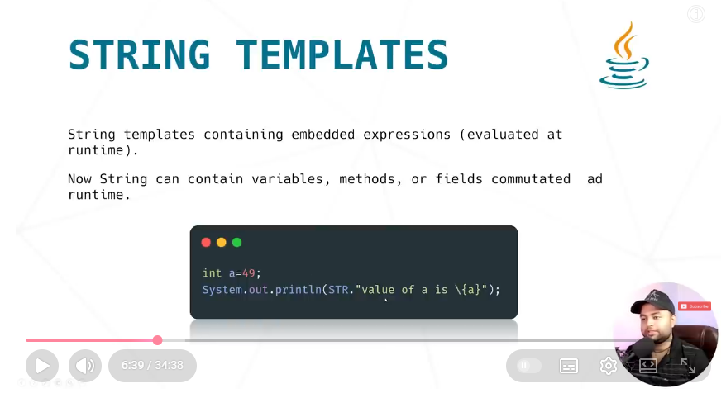
https://openjdk.org/jeps/430
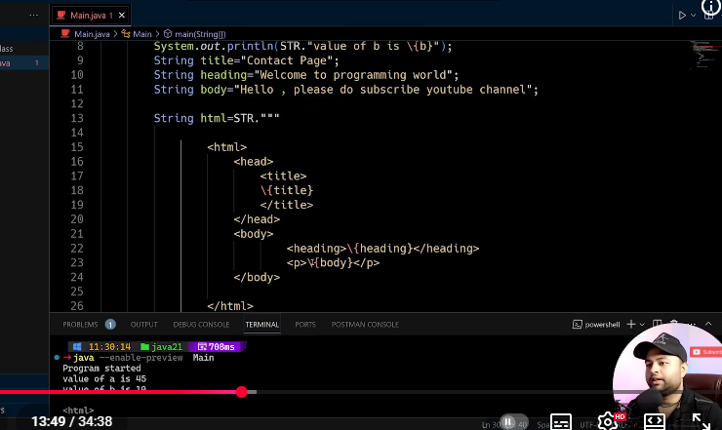
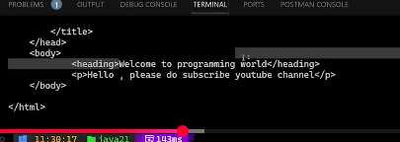
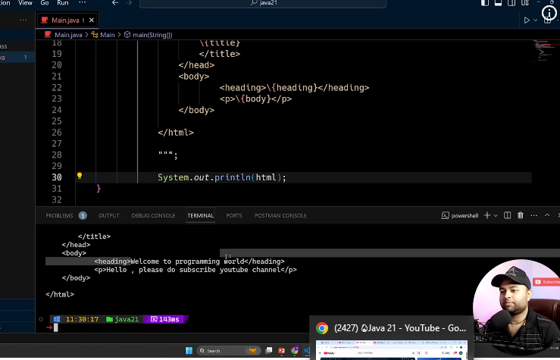
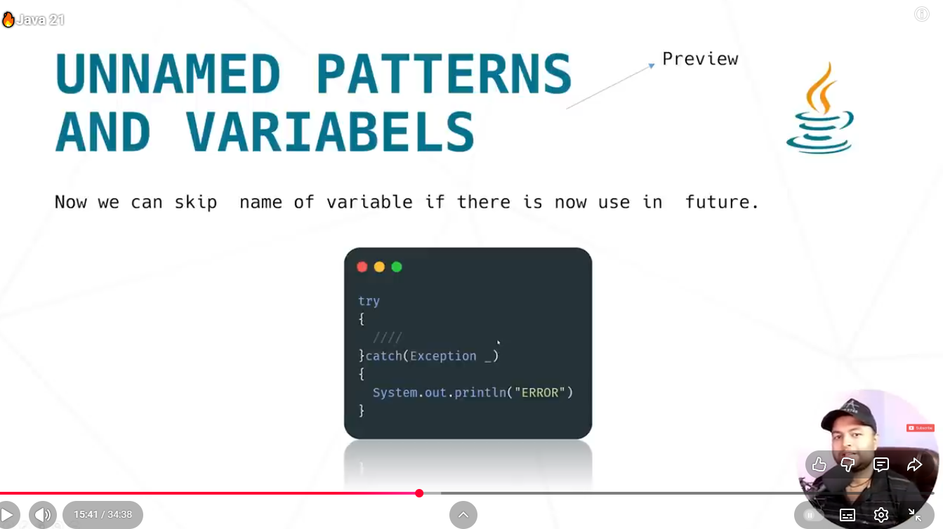
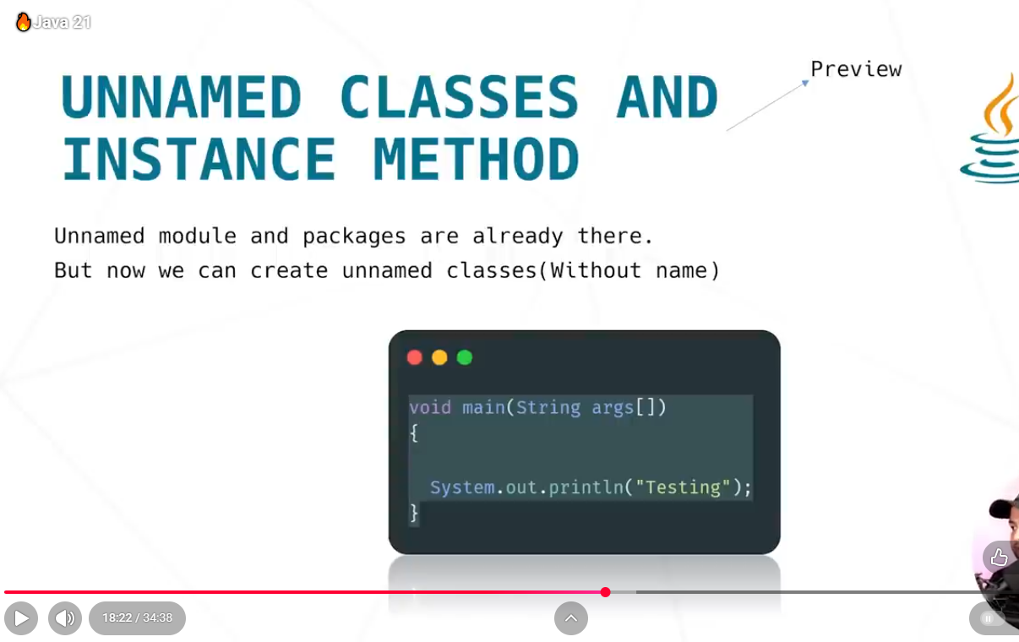
https://openjdk.org/jeps/431
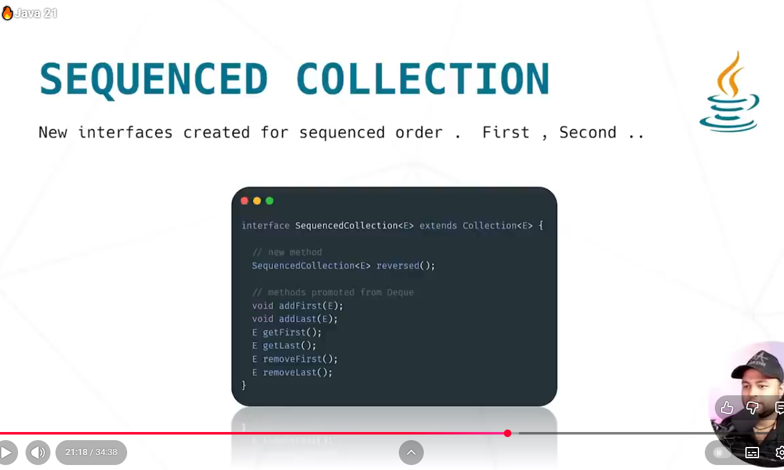
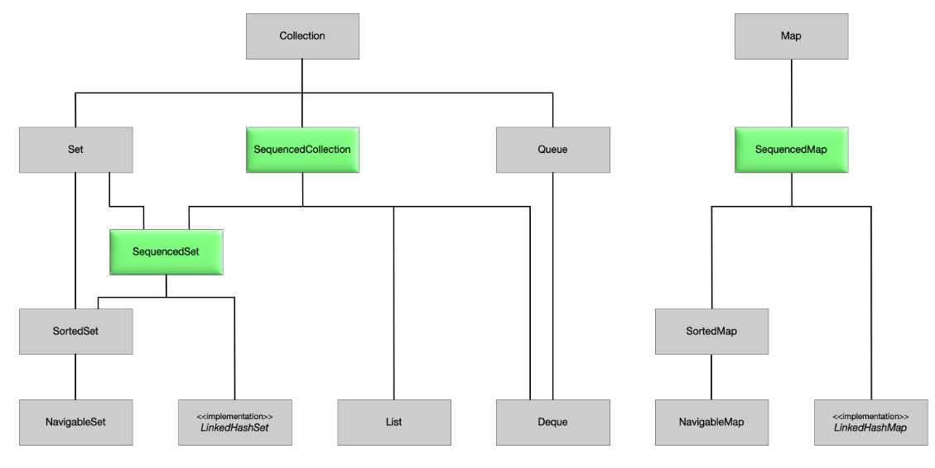
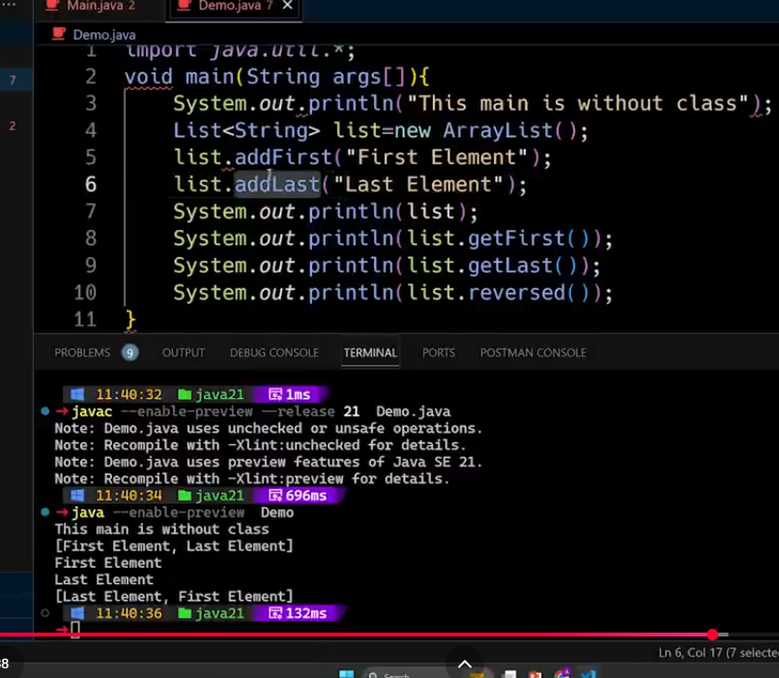
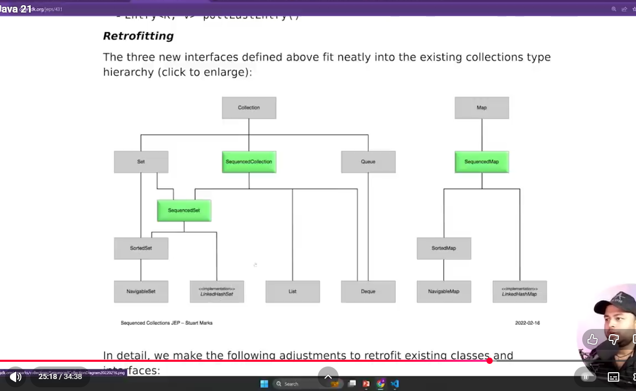
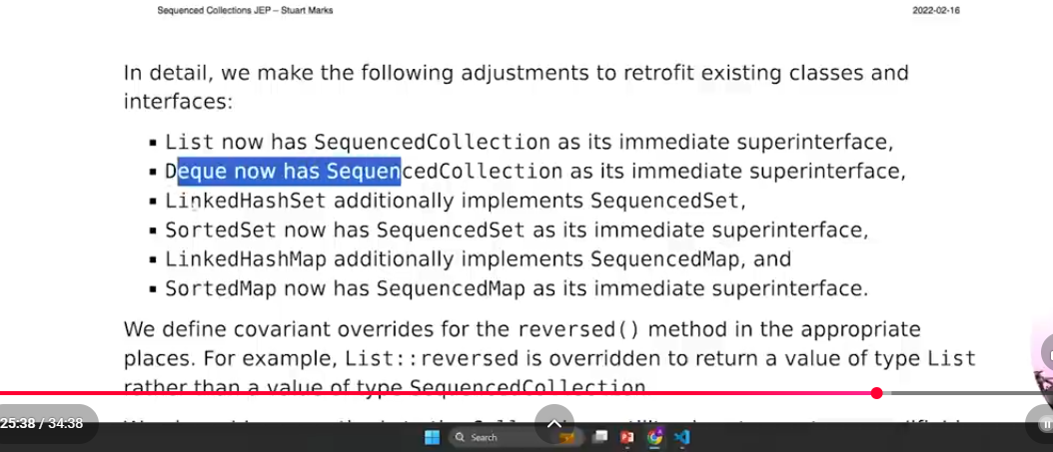
interface SequencedMap<K,V> extends Map<K,V> {
// new methods
SequencedMap<K,V> reversed();
SequencedSet<K> sequencedKeySet();
SequencedCollection<V> sequencedValues();
SequencedSet<Entry<K,V>> sequencedEntrySet();
V putFirst(K, V);
V putLast(K, V);
// methods promoted from NavigableMap
Entry<K, V> firstEntry();
Entry<K, V> lastEntry();
Entry<K, V> pollFirstEntry();
Entry<K, V> pollLastEntry();
}
The new put*(K, V) methods have special-case semantics, similar to the corresponding add*(E) methods of SequencedSet: For maps such as LinkedHashMap, they have the additional effect of repositioning the entry if it is already present in the map. For maps such as SortedMap, these methods throw UnsupportedOperationException.
The following methods of SequencedMap are promoted from NavigableMap. They support getting and removing entries at both ends:
- Entry<K, V> firstEntry()
- Entry<K, V> lastEntry()
- Entry<K, V> pollFirstEntry()
- Entry<K, V> pollLastEntry(
Record Pattern:
Enhance the Java programming language with record patterns to deconstruct record values. Record patterns and type patterns can be nested to enable a powerful, declarative, and composable form of data navigation and processing.
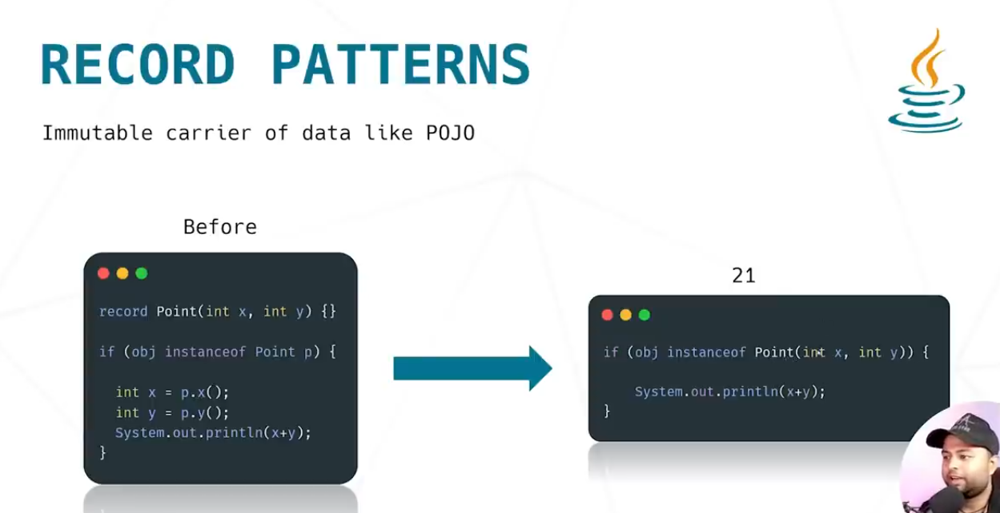
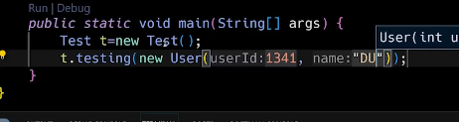
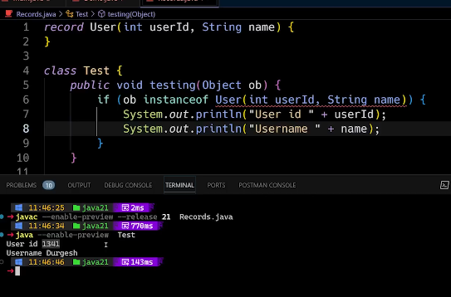
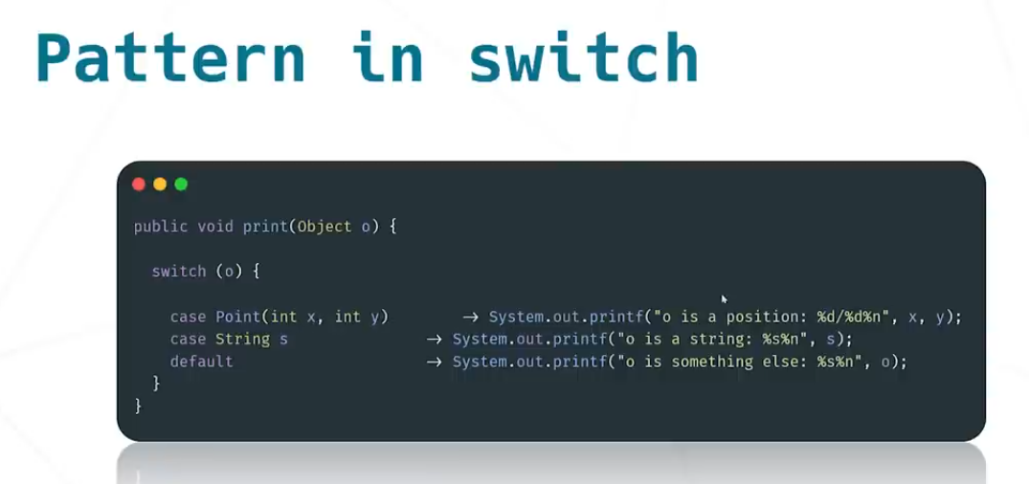
/ As of Java 21
static String formatterPatternSwitch(Object obj) {
return switch (obj) {
case Integer i -> String.format("int %d", i);
case Long l -> String.format("long %d", l);
case Double d -> String.format("double %f", d);
case String s -> String.format("String %s", s);
default -> obj.toString();
};
}

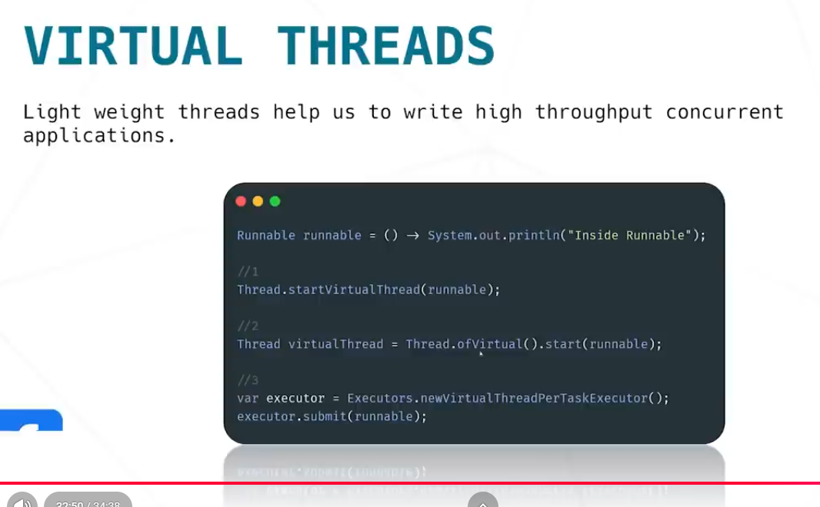
high throughput application – kam samay mein bahut jyada task katrna
bahut jyada kam ke liye we use thread & concurrency

JAVA –17
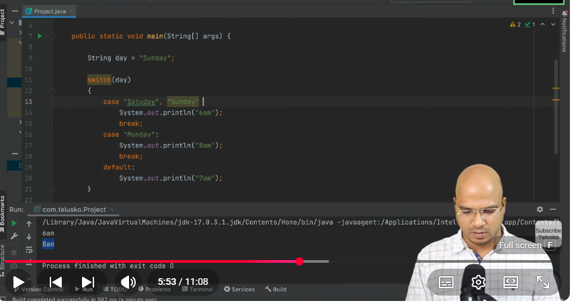
older
New : Arrow in switch:
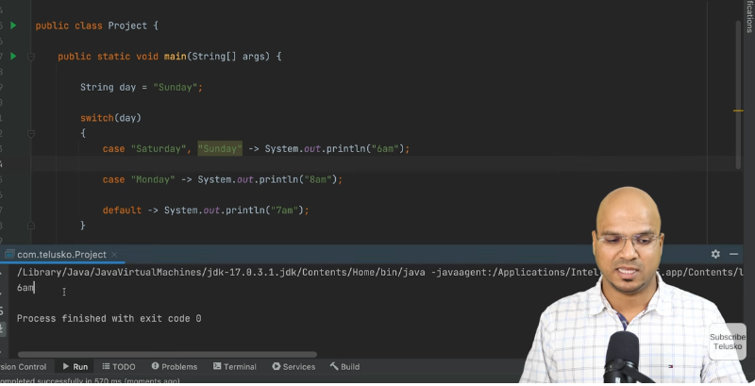
Switch As An Expression:
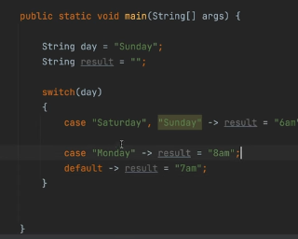
same as lambda (return statemenet rule)
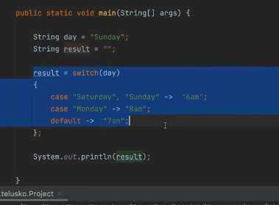
: & yieldreplace ->
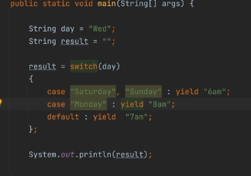

Java 10


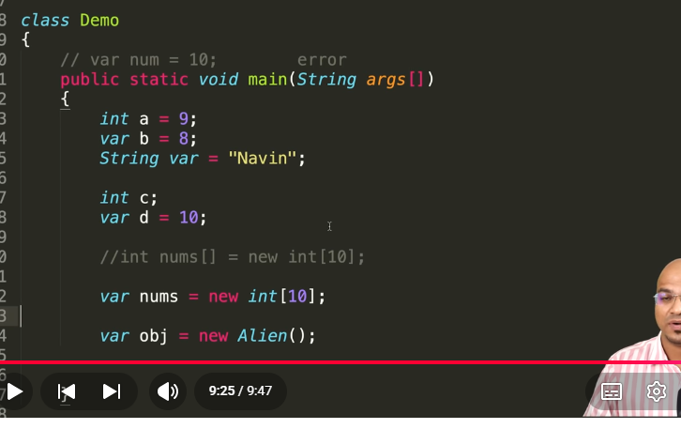
var -> it will be used as keywords & variable name but not class name.
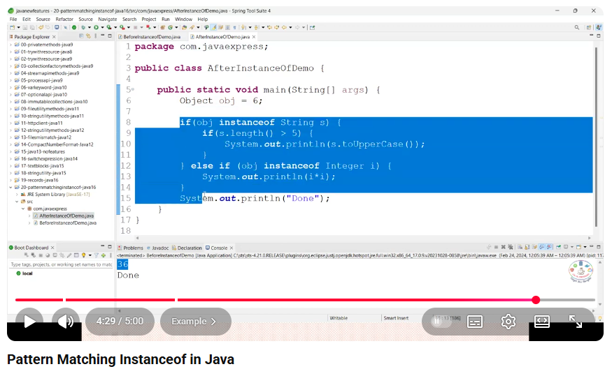

Pattern matching, record clas, sealed
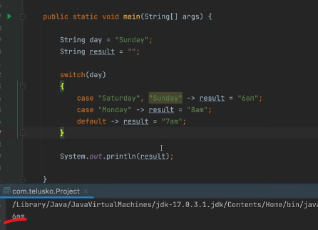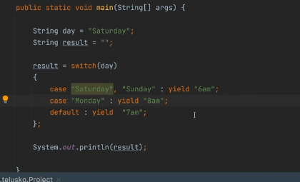
Navin Reddy ->Sealed class
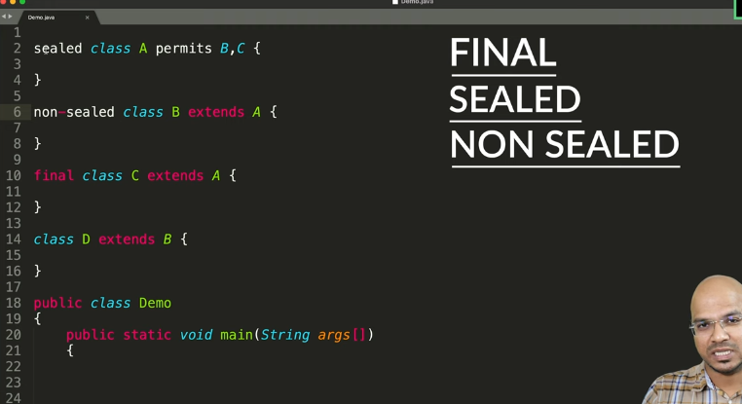
Sealed class means : If we want a class can be extended by particular class then we should use for it.
Child class of sealed class must be final, non-sealed or sealed.
Same applied to interface.
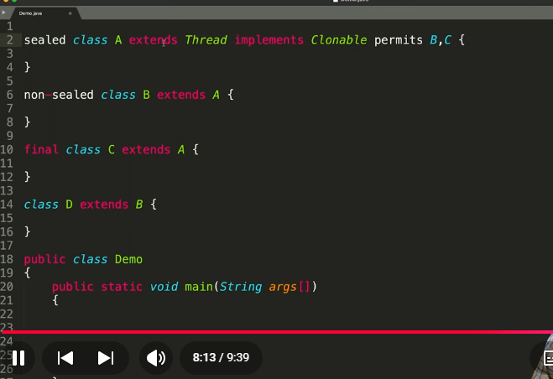
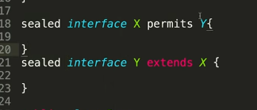
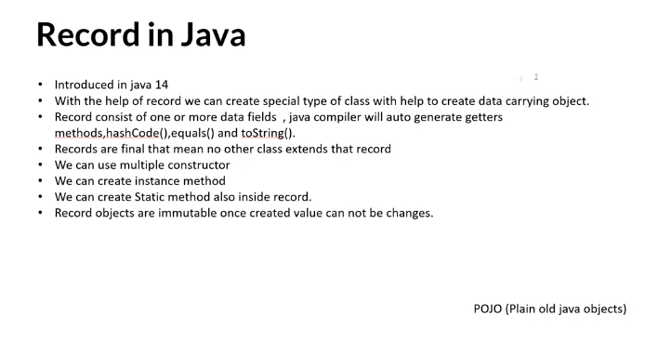
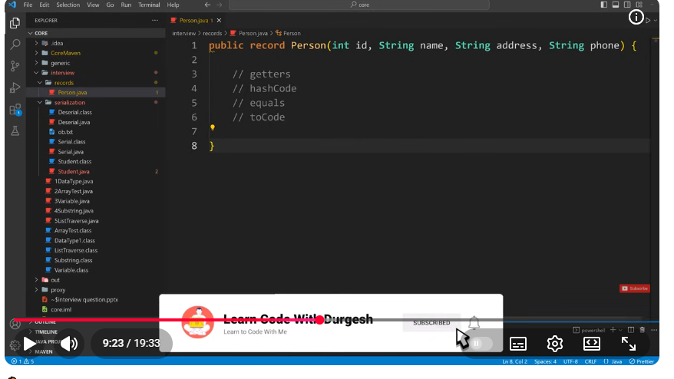
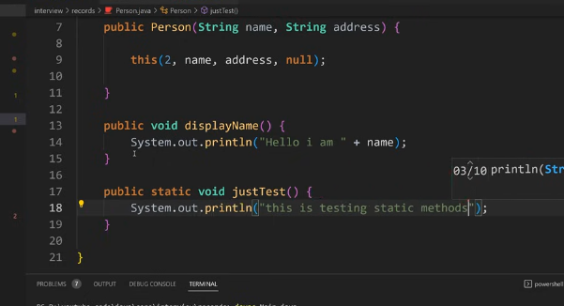
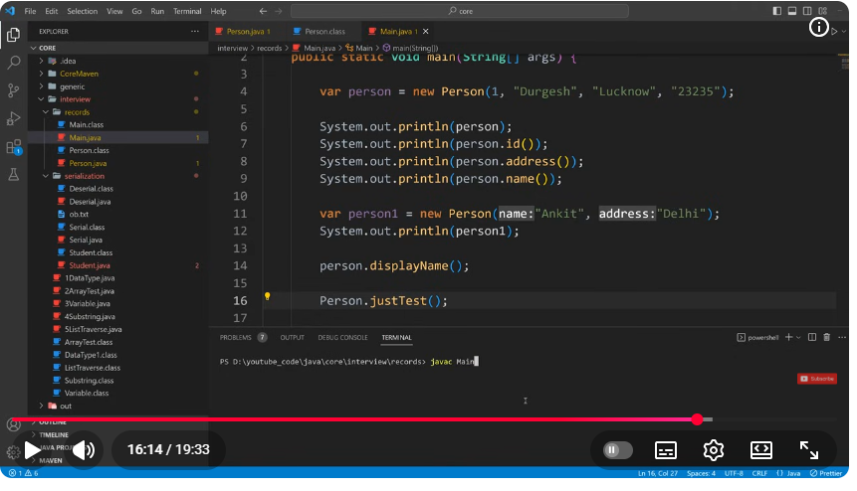
after decompile
