https://www.youtube.com/watch?v=wtK3GYR80jQ
20:52
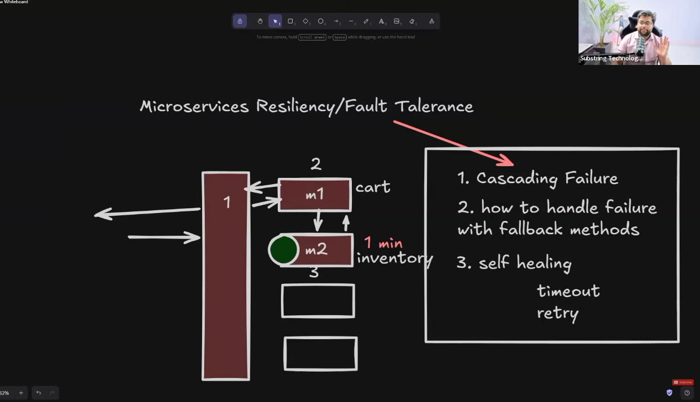


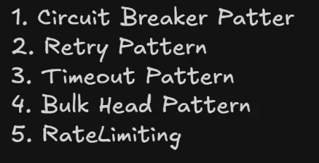
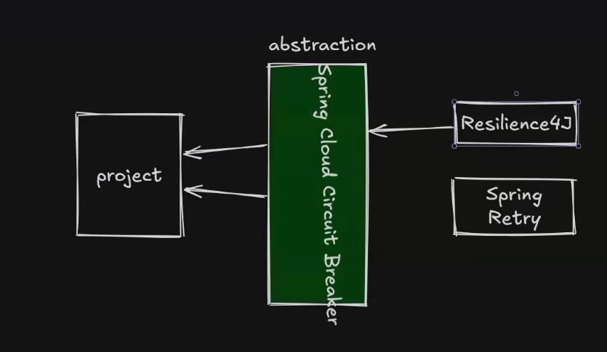
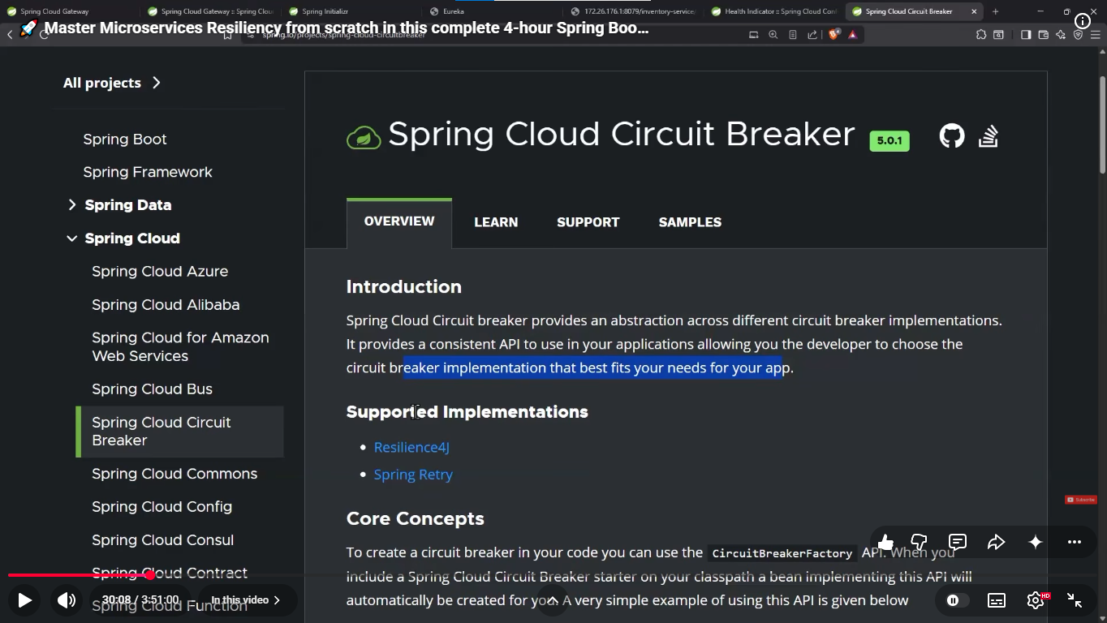
35:00
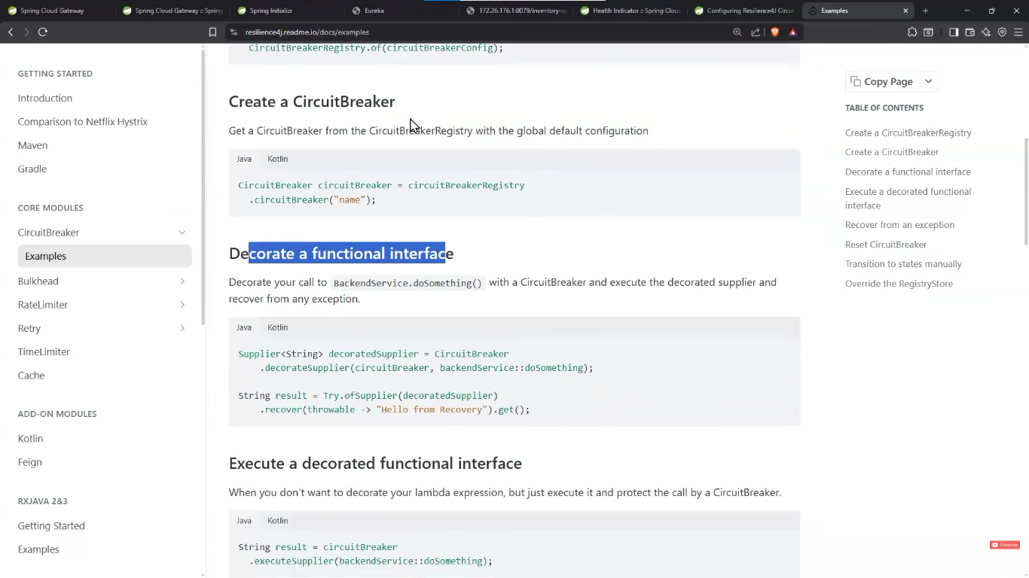
Adverse conditions
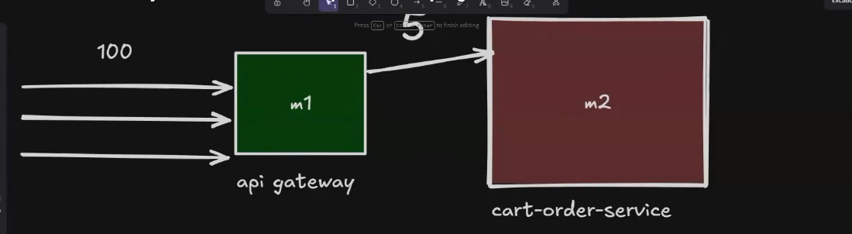
53:00
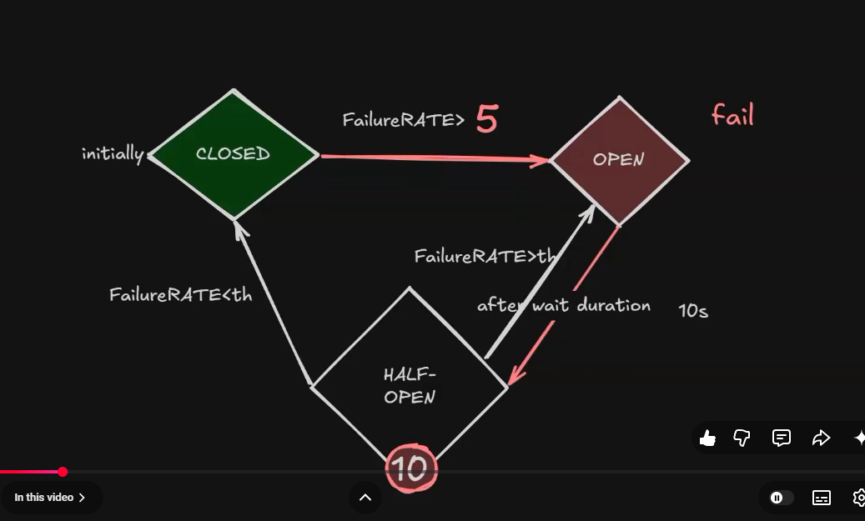
56:20


https://docs.spring.io/spring-cloud-circuitbreaker/reference/spring-cloud-circuitbreaker-resilience4j/starters.html
https://docs.spring.io/spring-cloud-gateway/reference/spring-cloud-gateway-server-webflux/gatewayfilter-factories/circuitbreaker-filter-factory.html
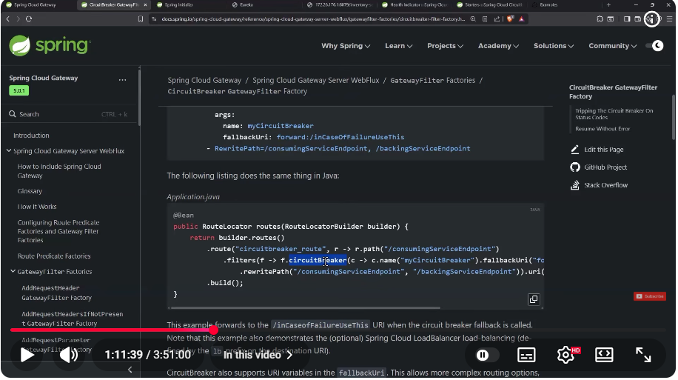
1:50:57
https://docs.spring.io/spring-cloud-openfeign/docs/current/reference/html/
https://docs.spring.io/spring-cloud-openfeign/docs/current/reference/html/#spring-cloud-feign-circuitbreaker-fallback
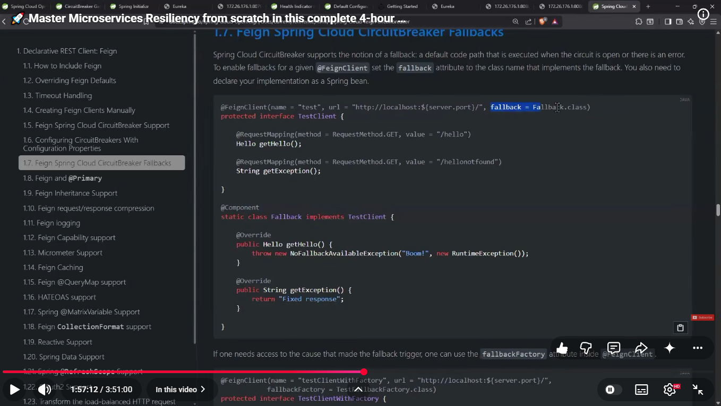
fallback on FeignClient
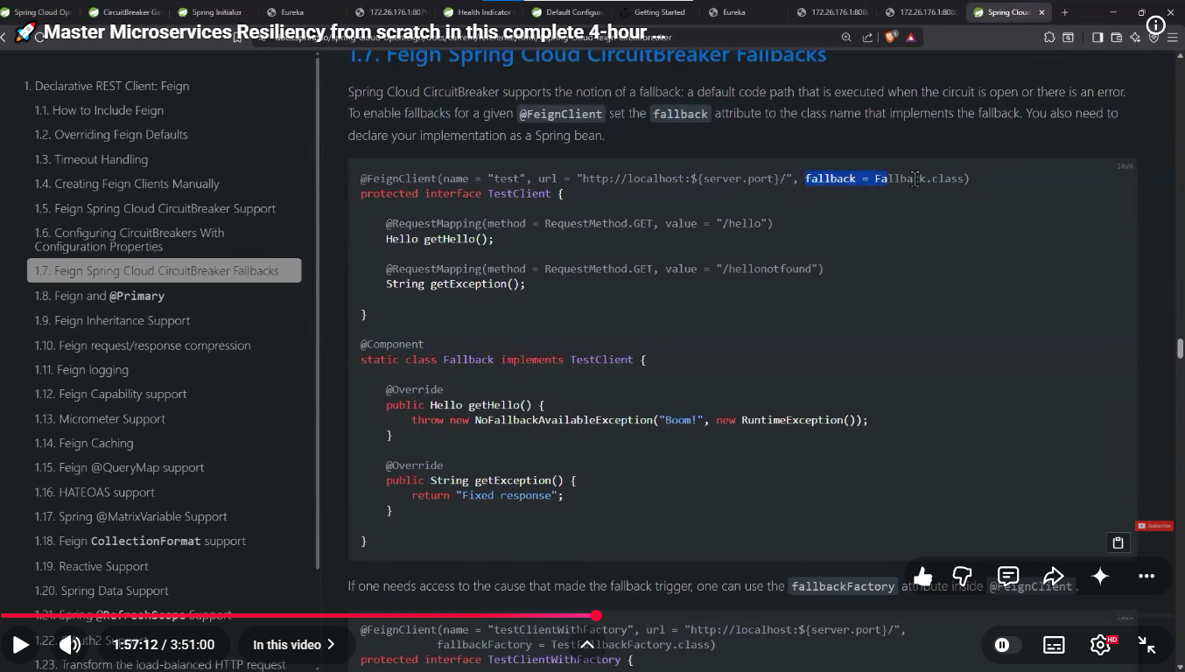
With RestTemplate -2:06:05
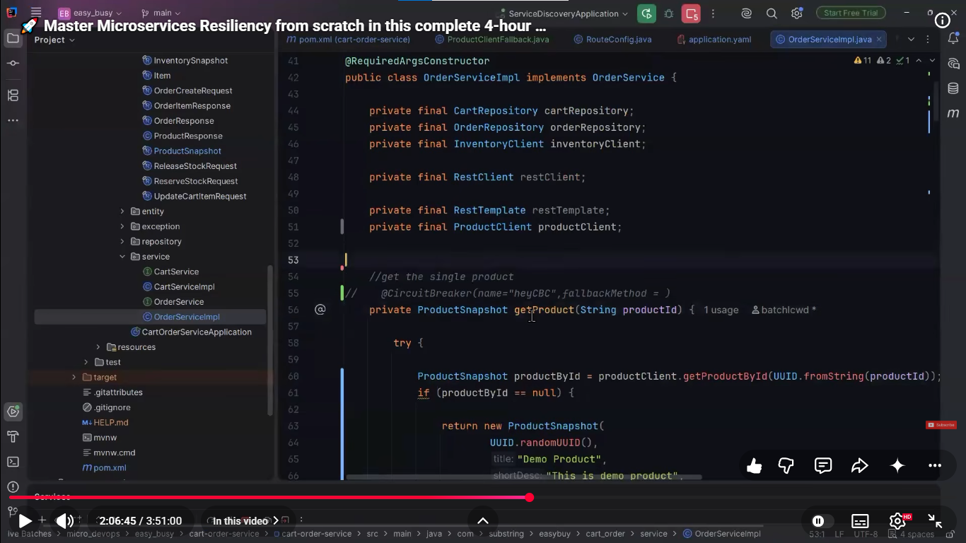
2:08

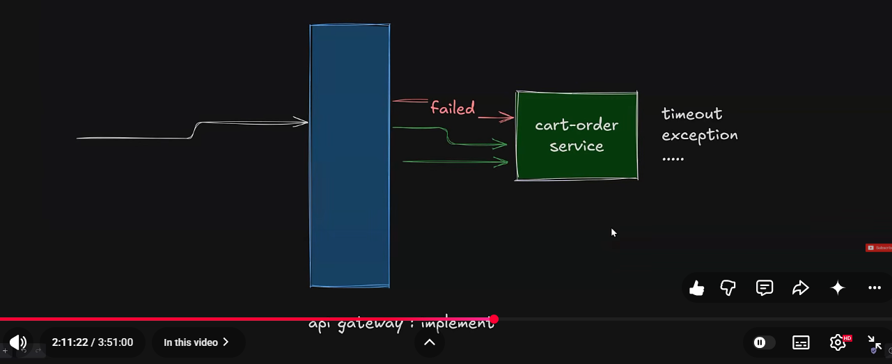
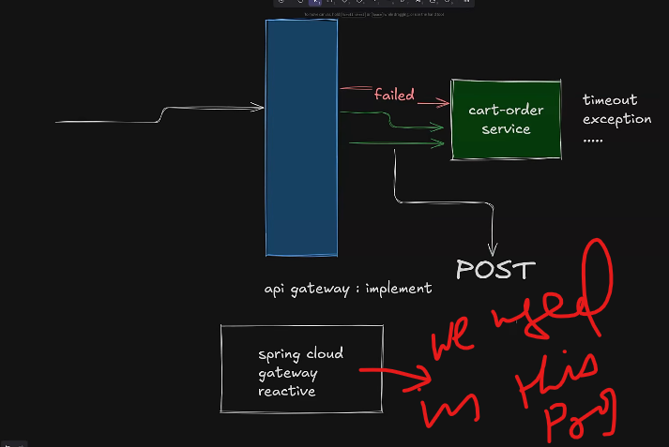
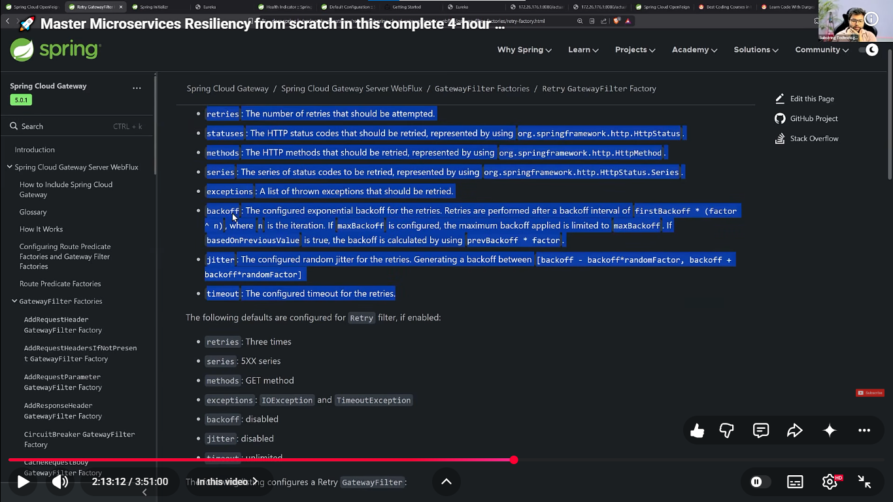
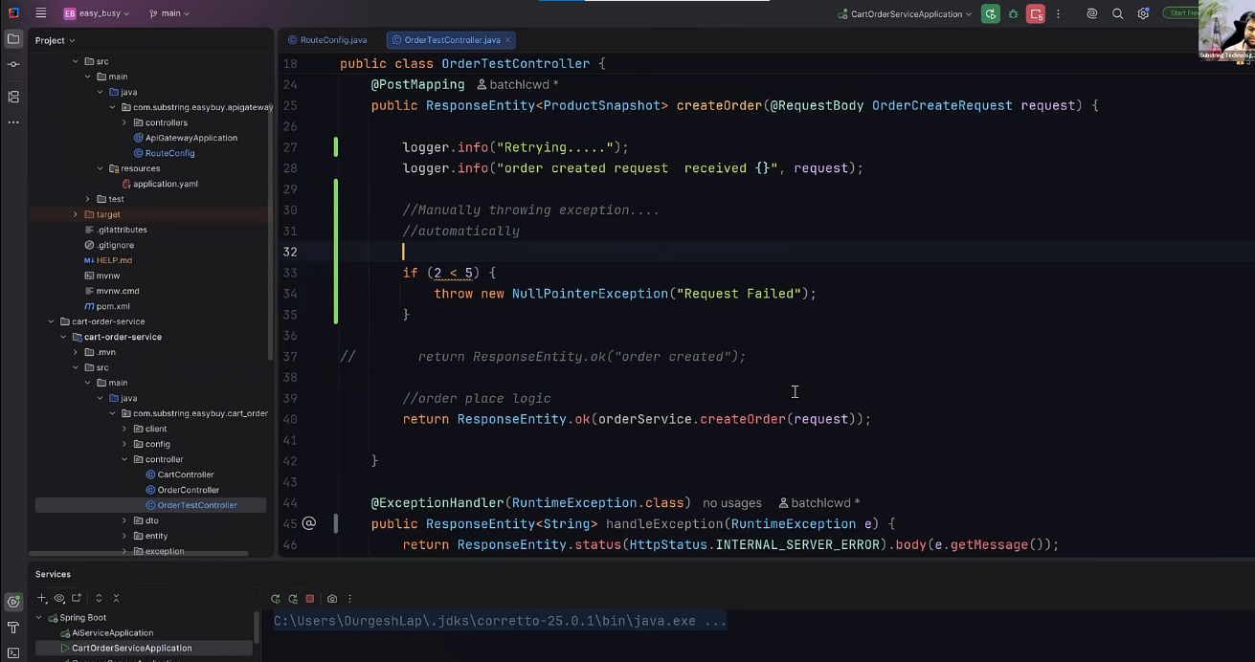
https://docs.spring.io/spring-cloud-gateway/reference/spring-cloud-gateway-server-webflux/gatewayfilter-factories/retry-factory.html
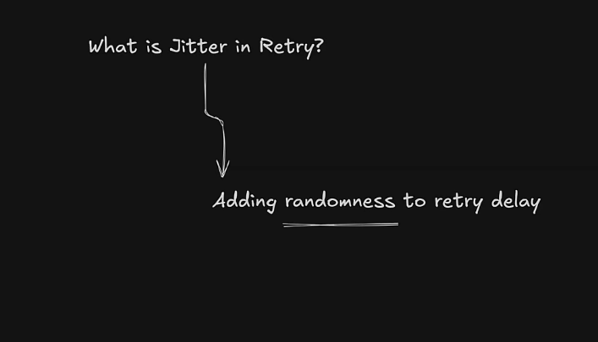
first retry then circuit breaker comes when we use together , ordwer is imp.
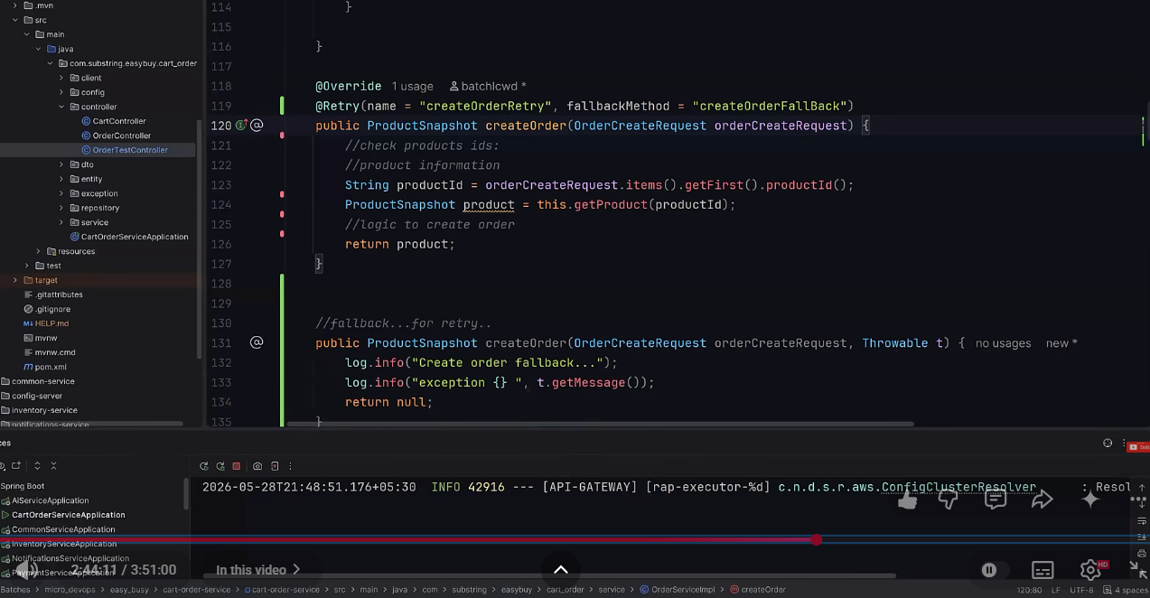
difference between resilliance & fault tolerent
They are closely related, but not the same.
Fault tolerance = continue working despite a failure.
Resilience = recover, adapt, and continue providing service despite failures.

Simple example
Imagine your Payment Service goes down.

Fault tolerance
You have two Payment Service instances:
Payment Request
|
↓
Load Balancer
/ \
↓ ↓
Payment-1 Payment-2
❌ ✅
|
↓
Payment
succeeds
Payment-1 fails, but Payment-2 handles the request.
The system continues without interruption.
That's fault tolerance.

Resilience
Now imagine the Payment Service becomes temporarily unavailable:
Order Service
|
↓
Payment Service
❌
|
↓
Circuit Breaker
|
↓
Fallback
|
↓
"Payment pending"
Later, the Payment Service recovers:
Payment Service
↓
RECOVERED
↓
Circuit closes
↓
Normal requests resume
The system handles the failure, limits its impact, and recovers.
That's resilience.

Key difference
 | Fault Tolerance | Resilience
Main idea | Survive failure | Handle + recover from failure
Failure impact | Ideally zero/transparent | May temporarily degrade service
Recovery | Usually designed into redundancy | Actively recovers/adapts
Example | Multiple instances | Retry + Circuit Breaker + Fallback
Goal | Continue working despite fault | Remain reliable before, during, and after fault

Microservices example
Fault tolerance:
Service A
|
├── Instance 1 ❌
└── Instance 2 ✅
Traffic automatically goes to Instance 2.
Resilience:
Service A
|
↓
Service B ❌
|
├── Timeout
├── Retry
├── Circuit Breaker
└── Fallback
Service A doesn't necessarily fail just because Service B failed.

How they relate
Think of it like this:
RESILIENCE
|
┌─────────────┼─────────────┐
↓ ↓ ↓
Fault Tolerance Recovery Adaptation
↓ ↓ ↓
Redundancy Retry Fallback
Replication Restart Circuit Breaker
Failover Recovery Bulkhead
So fault tolerance is one aspect/technique within a resilient system.

Interview answer
Fault tolerance is the ability of a system to continue operating when one or more components fail, usually through redundancy or failover. Resilience is the broader ability of a system to withstand failures, recover from them, and continue providing an acceptable level of service.
Easy memory trick:
🛡️ Fault tolerance = survive the failure
🔄 Resilience = survive + recover + adapt

CODE SNIPPET : https://www.youtube.com/watch?v=Gdp0eNJXwaI&list=PL-bgVzzRdaPgSkWO70qrskTKZCHA5SCai&index=14
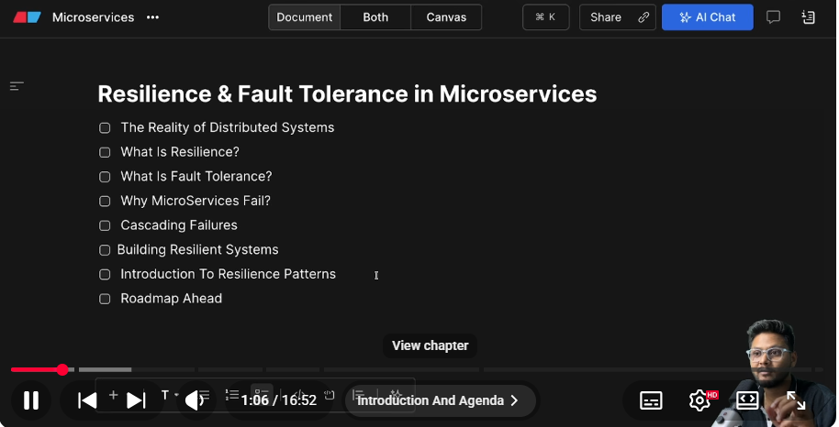
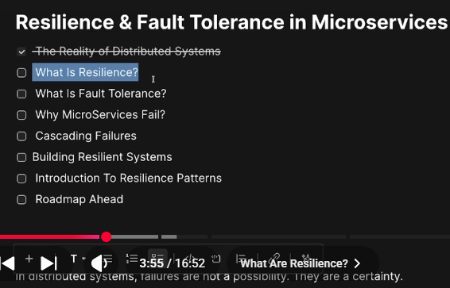
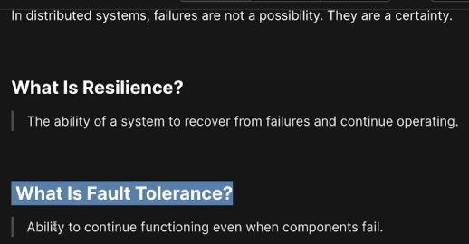
Resilience: In microservices when Order service request Inventory Service & Inventory Service is not working that means Order service cant get appropriate response from Inventory Service, Order Service should handle the response gracefully, Order Service should handle this scenario by calling default fallback implemetations.
Fault Tolerance: When there two services A & B , A request to Service B & service b is not working lets say service B has two instance one is working & one is fail in this case Service A will function normally.
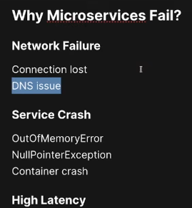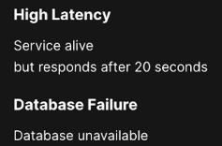
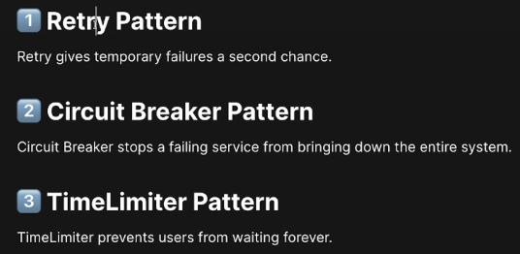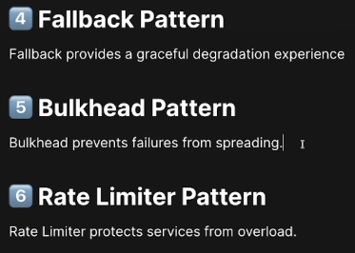
🚀 Retry Pattern in Microservices Explained | Spring Retry ✅
https://www.youtube.com/watch?v=ZjsWAbPMF0o&list=PL-bgVzzRdaPgSkWO70qrskTKZCHA5SCai&index=15
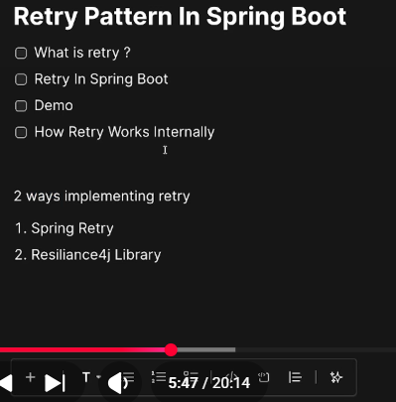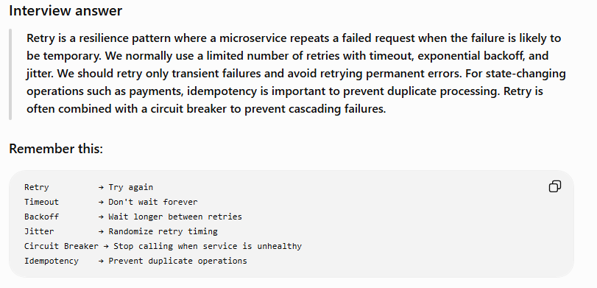
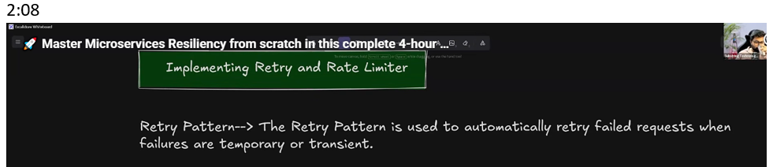
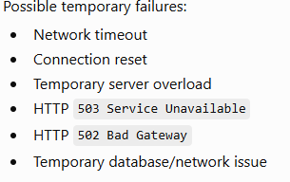backoff means how much wait before doing next try.
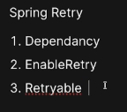Annotation in configuration class.--- Method
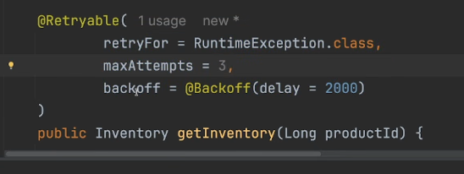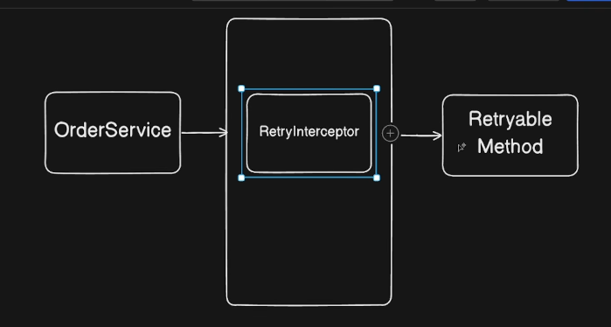Proxy pattern --AOP
https://www.youtube.com/watch?v=6eApc-IaTN4&list=PL-bgVzzRdaPgSkWO70qrskTKZCHA5SCai&index=16
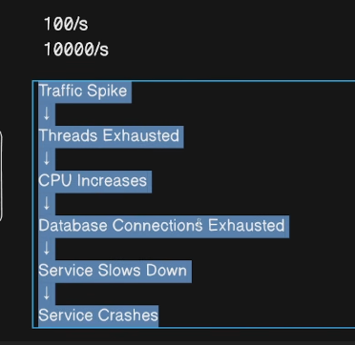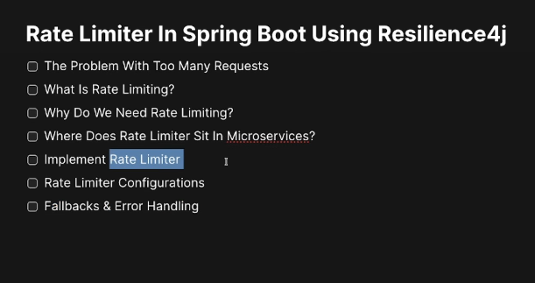

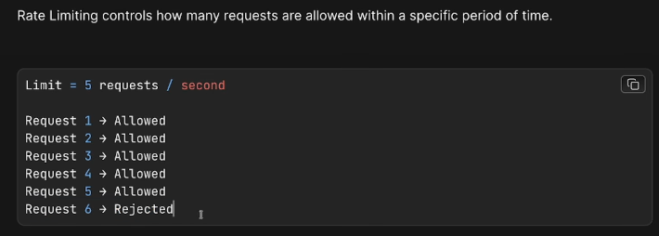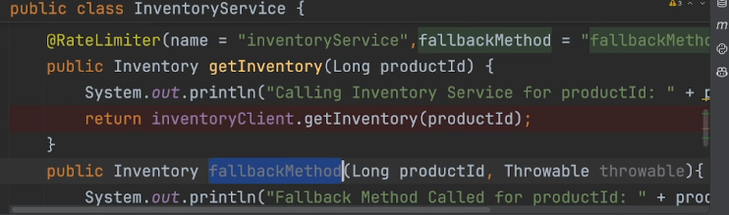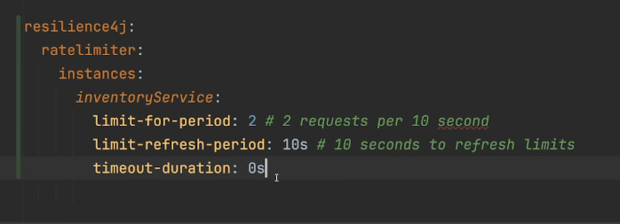
https://www.youtube.com/watch?v=Z3r5A27IEsk&list=PL-bgVzzRdaPgSkWO70qrskTKZCHA5SCai&index=17
https://www.youtube.com/watch?v=MXO0eTZ__RY&list=PL-bgVzzRdaPgSkWO70qrskTKZCHA5SCai&index=18
What happens when a downstream microservice doesn't fail—but takes forever to respond? Waiting indefinitely can block threads, exhaust resources, and slow down your entire application. That's exactly the problem the *TimeLimiter Pattern* solves. We'll understand how TimeLimiter works internally, why it requires `CompletableFuture`, how it's different from HTTP client timeouts, and how to configure it properly with real-world examples.
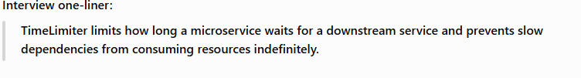
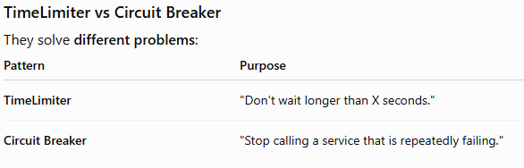
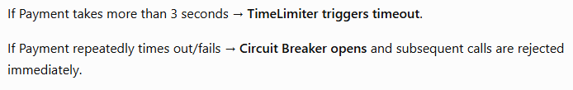
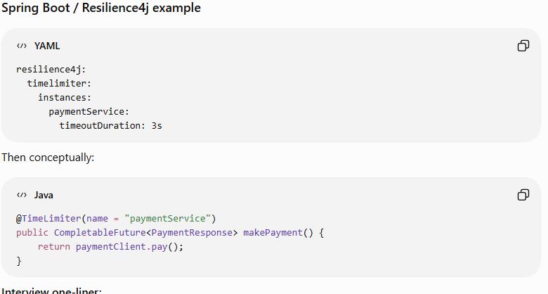
As we know in microservices one service can talk another service. If serviceA wants to communicate to ServiceB & ServiceB normally takes 3 seconds to response but it taking 30 seonds. Without a TimeLimiter, ServiceB may keep waiting for 30 seconds, consuming threads and resources resulted in system beome slow.To avoid such types of problem we need to apply TimeLimiter for ex 3 secs that means TimeLimiter triggers timeout after 3 secs.

Bulkhead Pattern in Microservices
The Bulkhead Pattern prevents one failing/slow dependency from consuming all resources of a microservice.
The name comes from ships: a ship is divided into separate compartments, so if one compartment gets flooded, the entire ship doesn't sink.

Example
Suppose your Order Service calls three services:
┌── Payment Service
Order Service ──────┼── Inventory Service
└── Notification Service
Without Bulkhead:
Payment becomes very slow
↓
100 threads waiting for Payment
↓
All Order Service threads consumed
↓
Inventory ❌
Notification ❌
Orders ❌
One dependency causes the entire Order Service to become unavailable.

With Bulkhead
Separate resources are allocated:
Order Service
|
┌─────────────┼─────────────┐
↓ ↓ ↓
Payment Inventory Notification
30 threads 20 threads 10 threads
If Payment becomes slow:
Payment → 30 threads occupied ❌

Inventory → still has 20 threads ✅
Notification → still has 10 threads ✅
So the failure is isolated.

Two common types
1. Semaphore Bulkhead
Limits the number of concurrent calls.
Maximum 10 simultaneous calls
11th request → rejected
2. Thread-Pool Bulkhead
Gives a dependency its own thread pool.
Payment → Thread Pool A
Inventory → Thread Pool B
If Payment consumes all its threads, Inventory is unaffected.

Bulkhead vs TimeLimiter vs Circuit Breaker
Pattern | Main question
TimeLimiter | "How long can I wait?"
Bulkhead | "How many resources can this dependency consume?"
Circuit Breaker | "Should I stop calling this failing dependency?"
They are commonly combined:
Request
↓
Circuit Breaker
↓
Bulkhead
↓
TimeLimiter
↓
Downstream Service
Interview one-liner:
Bulkhead isolates resources between different operations or dependencies so that failure or slowness in one dependency doesn't bring down the entire microservice.

