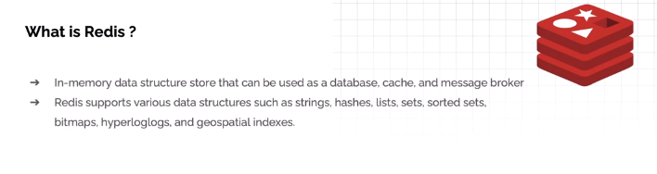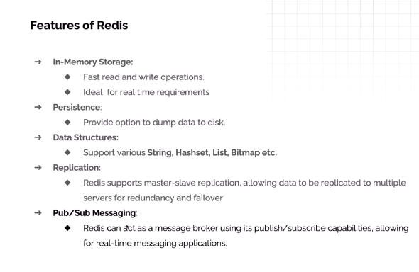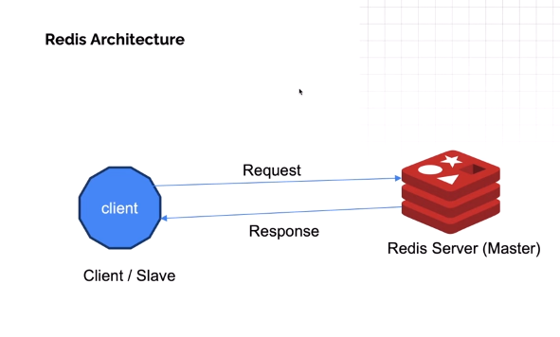

How to install in windows 11 -> https://www.youtube.com/watch?v=nB7zi88DB1Y
-------------------------
Install WSL
wsl --install
dmin
Password - ddd
wsl -l –v --check install or not
open Ubuntu—execute command
------------
wsl --install wsl -l -v
curl -fsSL https://packages.redis.io/gpg | sudo gpg --dearmor -o /usr/share/keyrings/redis-archive-keyring.gpg
echo "deb [signed-by=/usr/share/keyrings/redis-archive-keyring.gpg] https://packages.redis.io/deb $(lsb_release -cs) main" | sudo tee /etc/apt/sources.list.d/redis.list
sudo apt-get update
sudo apt-get install redis
sudo service redis-server start
redis-cli
installation in windows –
https://youtu.be/aqFFghu541I?t=1451

command –
help @server
help@connection
help @......
help @string
ACL Users
ACL whoami
Client info
client list

Echo message
https://youtu.be/aqFFghu541I?t=1699
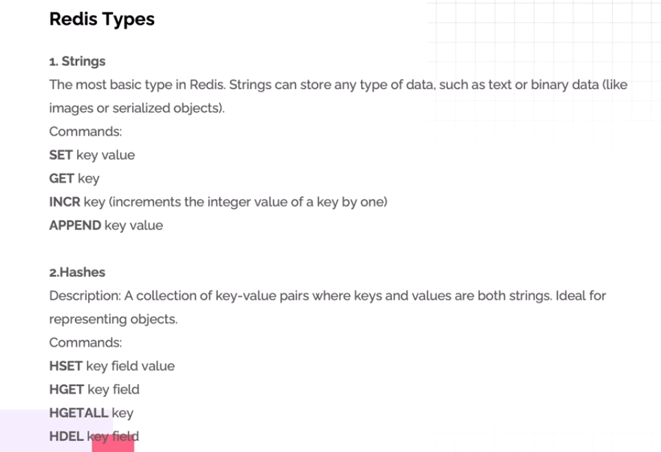
https://youtu.be/aqFFghu541I?t=2711
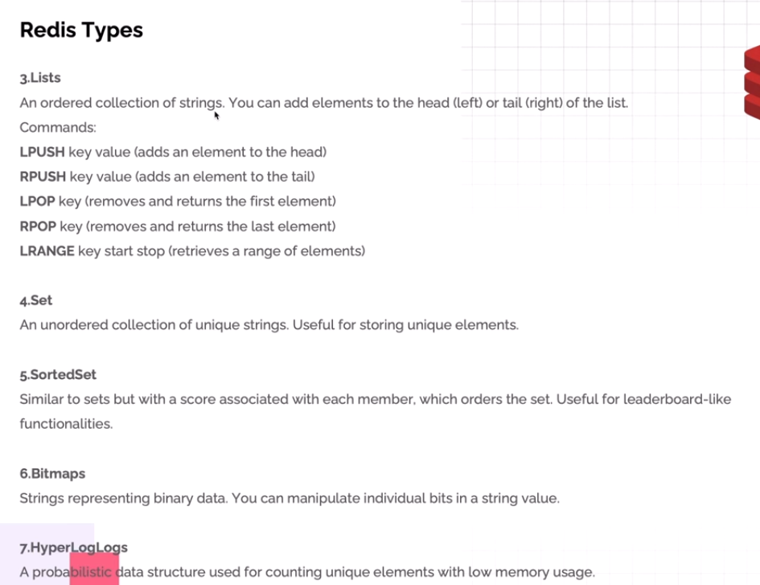
Step-by-Step Guide to Spring Boot CRUD with Redis in Hindi
https://www.youtube.com/watch?v=lXK8RS40v9c
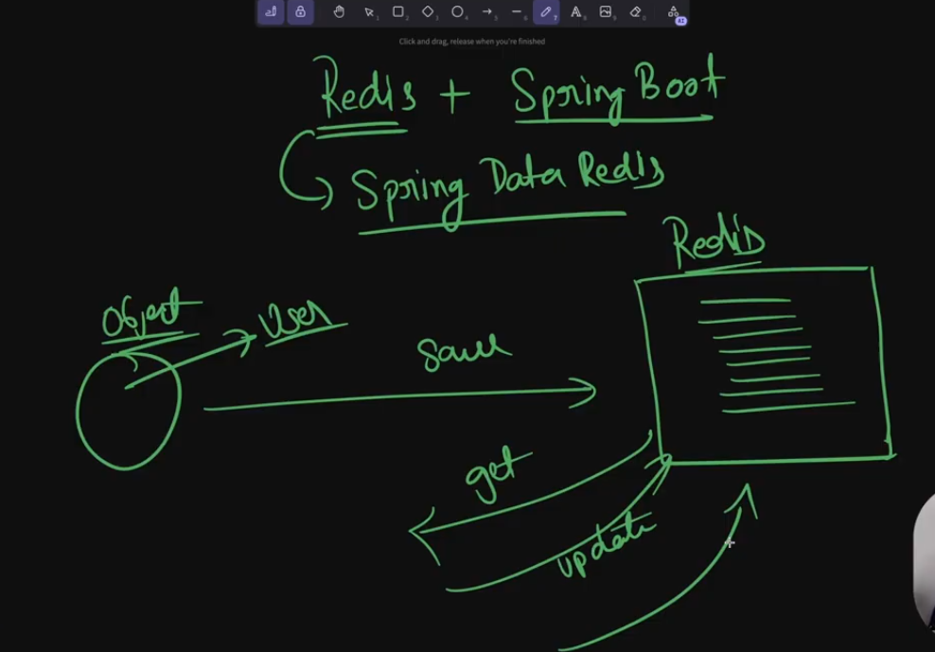
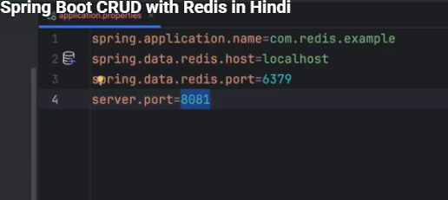
Config class
https://youtu.be/lXK8RS40v9c?t=880
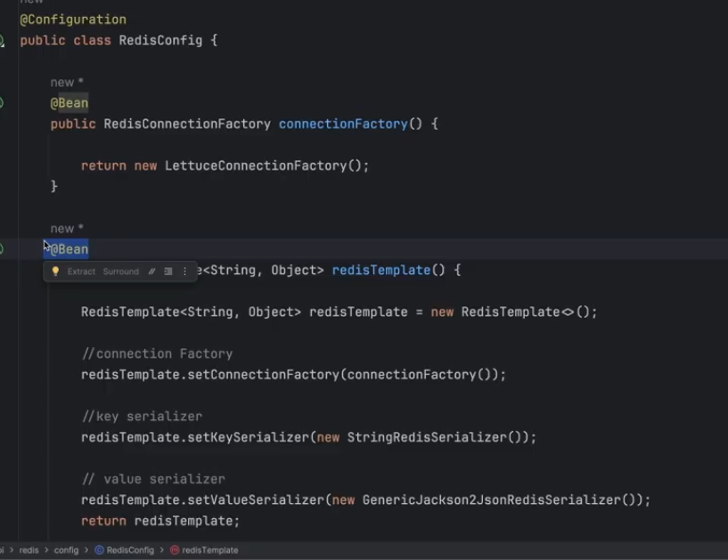
https://youtu.be/lXK8RS40v9c?t=1124
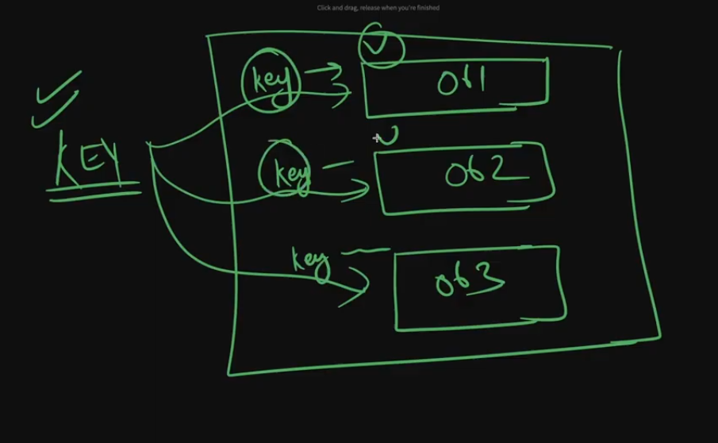
https://youtu.be/lXK8RS40v9c?t=1305 – save user
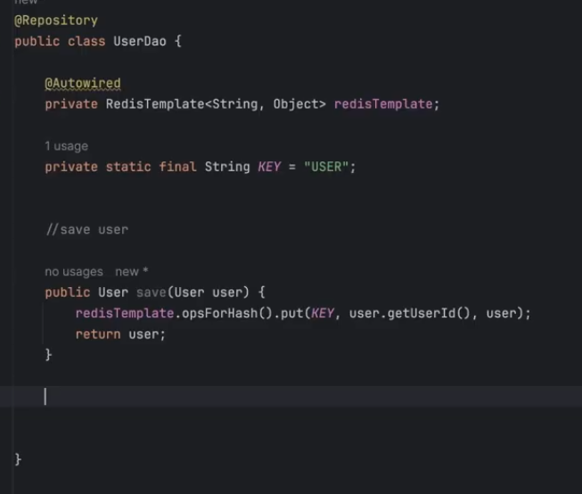
https://youtu.be/lXK8RS40v9c?t=1461
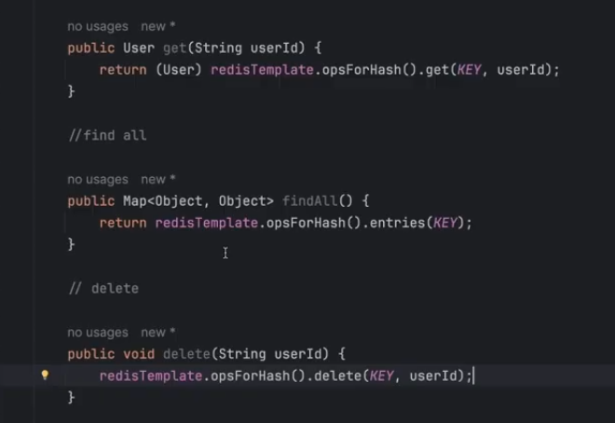
Anuj Sharma –channel
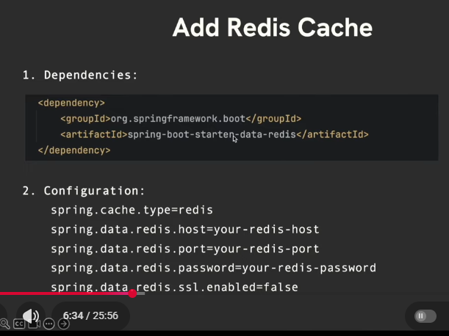

🔥 Spring Boot API with MySQL & Redis Cache Optimization | Complete Guide | Hindi
https://www.youtube.com/watch?v=RiWbgJJTC-Q
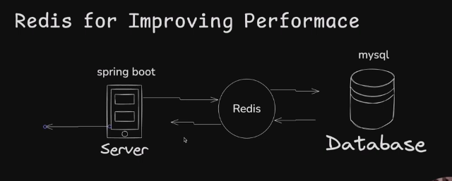
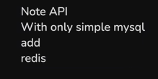
@EnableCaching – Main class
Service
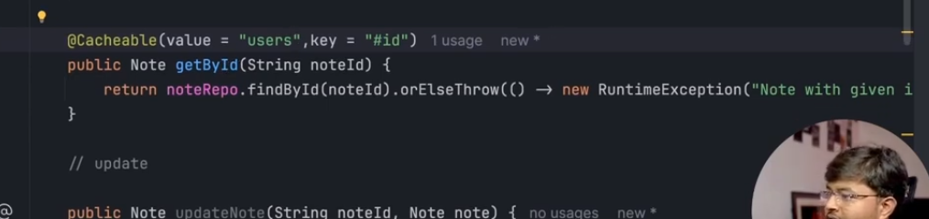
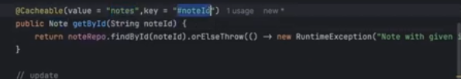
value must be serializable the value we are fetching (Note implemets Serializble)
value = “notes” : cahche region name where Note oobject will be stored & their key is : key = “#noteId”
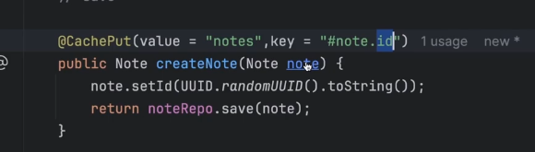
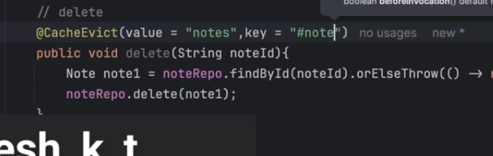
@EnableCaching
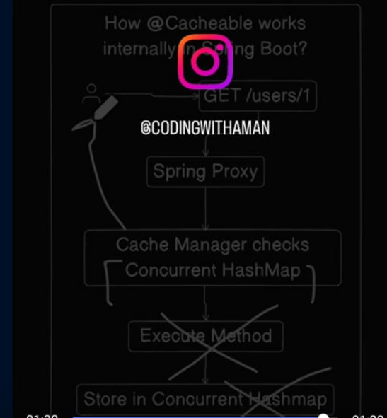
https://www.youtube.com/watch?v=jNJIWQX64Bc&t=1696s
