Scheduler
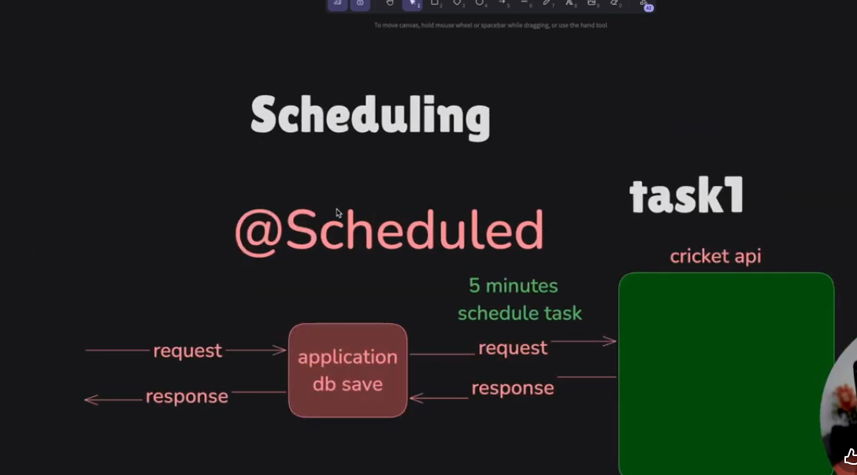
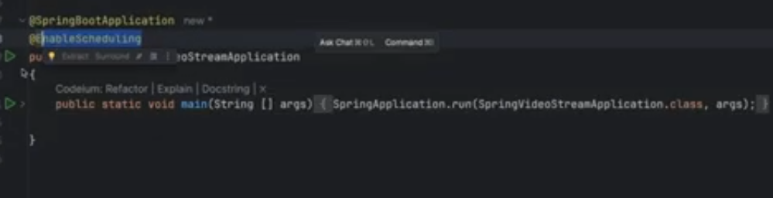
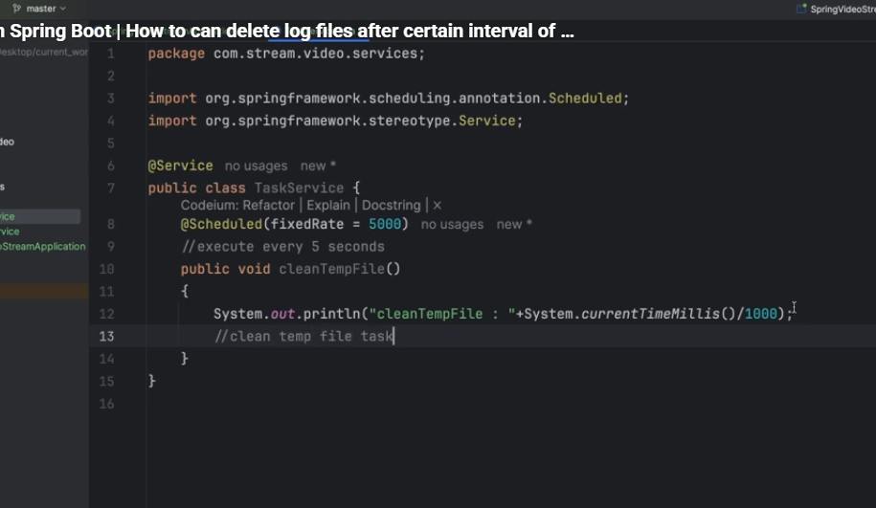
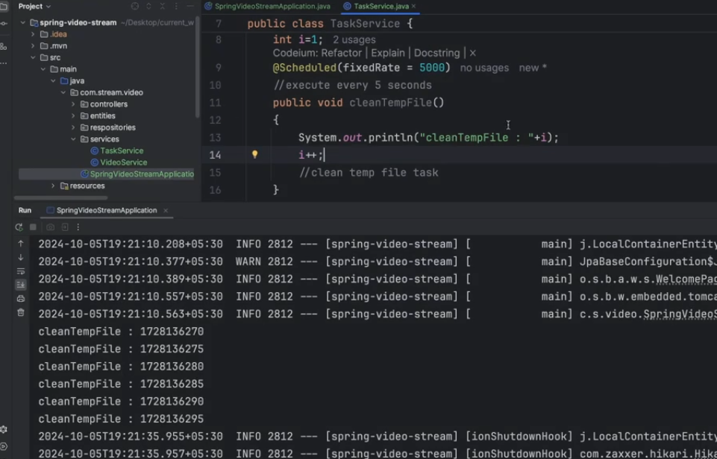
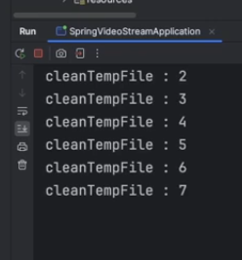
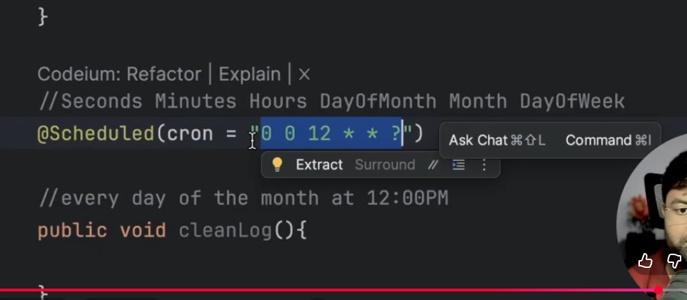
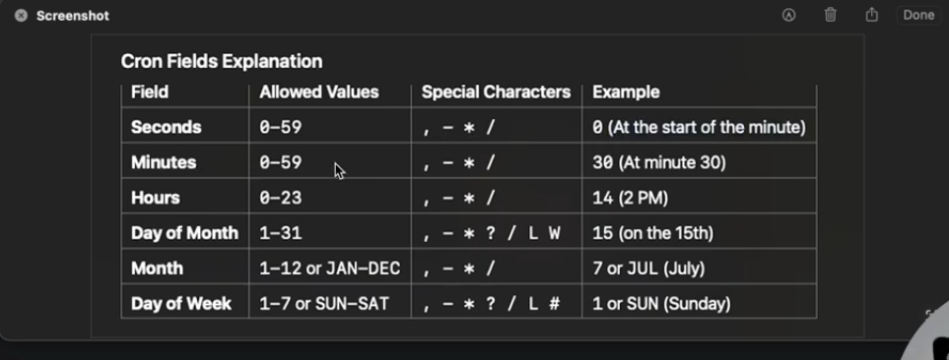
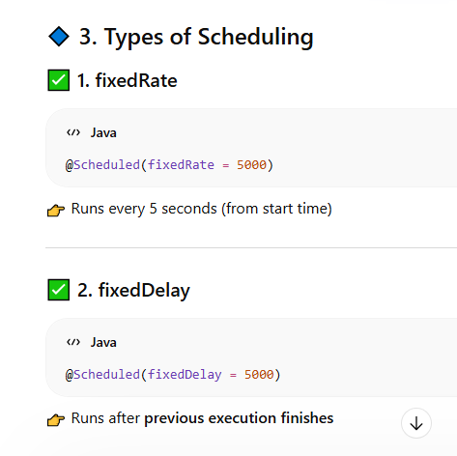
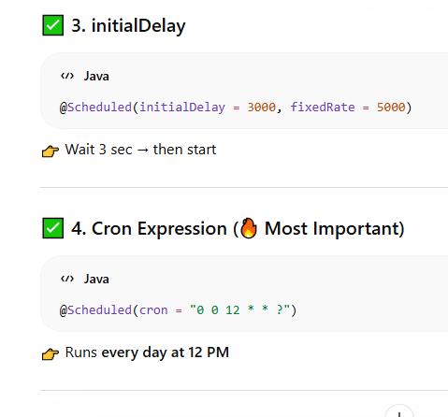
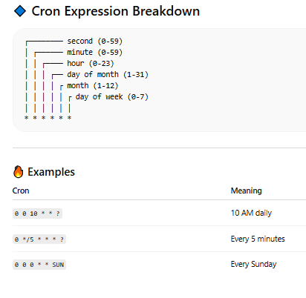
-------------------------------------------------------------------------------------------------------------------------------------

🔹 What is @Async?
👉
@Async allows a method to run in the background using a different thread.

🔥 Without @Async
public void process() {
task1(); // takes 5 sec
task2(); // waits → total 10 sec
}

✅ With @Async
@Async
public void task1() {
// runs in separate thread
}
public void process() {
task1(); // runs async
task2(); // runs immediately
}
👉 Total time reduced 🚀

🔹 1. Enable Async
@SpringBootApplication
@EnableAsync
public class DemoApplication {
}

🔹 2. Use @Async
@Service
public class EmailService {
@Async
public void sendEmail() {
System.out.println("Sending email in background...");
}
}

🔹 3. Calling Async Method
@RestController
public class UserController {
private final EmailService emailService;
public UserController(EmailService emailService) {
this.emailService = emailService;
}
@PostMapping("/register")
public String register() {
emailService.sendEmail(); // async call
return "User registered";
}
}

🔹 4. Return Types

✅ Void
@Async
public void runTask() {}

✅ Future / CompletableFuture (🔥 Important)
@Async
public CompletableFuture<String> getData() {
return CompletableFuture.completedFuture("Hello");
}

✅ Usage
CompletableFuture<String> result = service.getData();
System.out.println(result.get()); // wait for result

🔹 5. Custom Thread Pool (🔥 Important)
By default → SimpleAsyncTaskExecutor (not recommended)

✅ Configure Thread Pool
@Configuration
@EnableAsync
public class AsyncConfig {
@Bean
public Executor taskExecutor() {
ThreadPoolTaskExecutor executor = new ThreadPoolTaskExecutor();
executor.setCorePoolSize(5);
executor.setMaxPoolSize(10);
executor.setQueueCapacity(50);
executor.initialize();
return executor;
}
}

🔹 6. Important Rules (⚠️ Very Important)

❌ 1. Self Invocation Problem
public void methodA() {
methodB(); // ❌ @Async will NOT work
}
@Async
public void methodB() {}
👉 Reason:
- Same class call → bypasses proxy

✅ Fix
Call from another bean:
service.methodB(); // goes through proxy ✅

❌ 2. Private Methods
@Async
private void test() {} // ❌ won't work
👉 Must be public

❌ 3. Exception Handling
Async methods don’t throw exceptions normally
👉 Use:
@Async
public CompletableFuture<String> test() {
try {
...
} catch(Exception e) {
return CompletableFuture.failedFuture(e);
}
}

🔹 7. Real Use Cases
- Sending emails 📧
- Background processing
- File uploads
- API calls
- Notifications

🔹 8. Difference: @Async vs Scheduler
Feature | @Async | Scheduler
Trigger | Manual | Automatic
Use Case | Background task | Repeated task
Control | High | Time-based

🔥 Interview One-Liner
👉
“@Async in Spring Boot enables asynchronous execution of methods using a separate thread, improving performance by not blocking the main thread.”

🔥 Pro Interview Tip
👉 Combine:
- @Async + CompletableFuture
- @Async + custom thread pool

If you want next level:
✅ @Async + Exception handling (global)
✅ Real-world example (email + DB + API)
✅ Difference: Async vs Multithreading vs WebFlux
Just say 👍
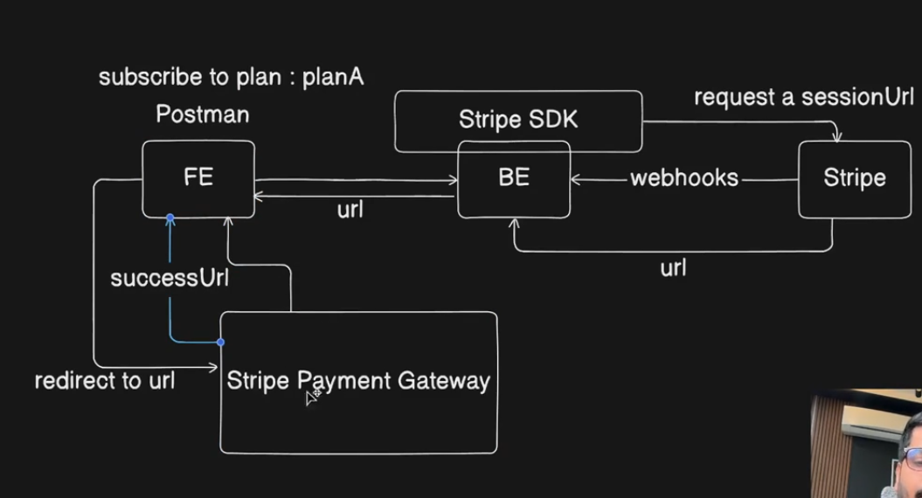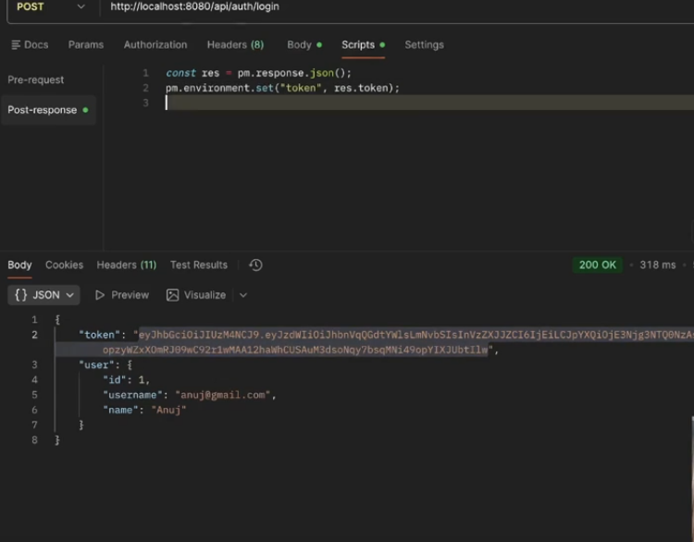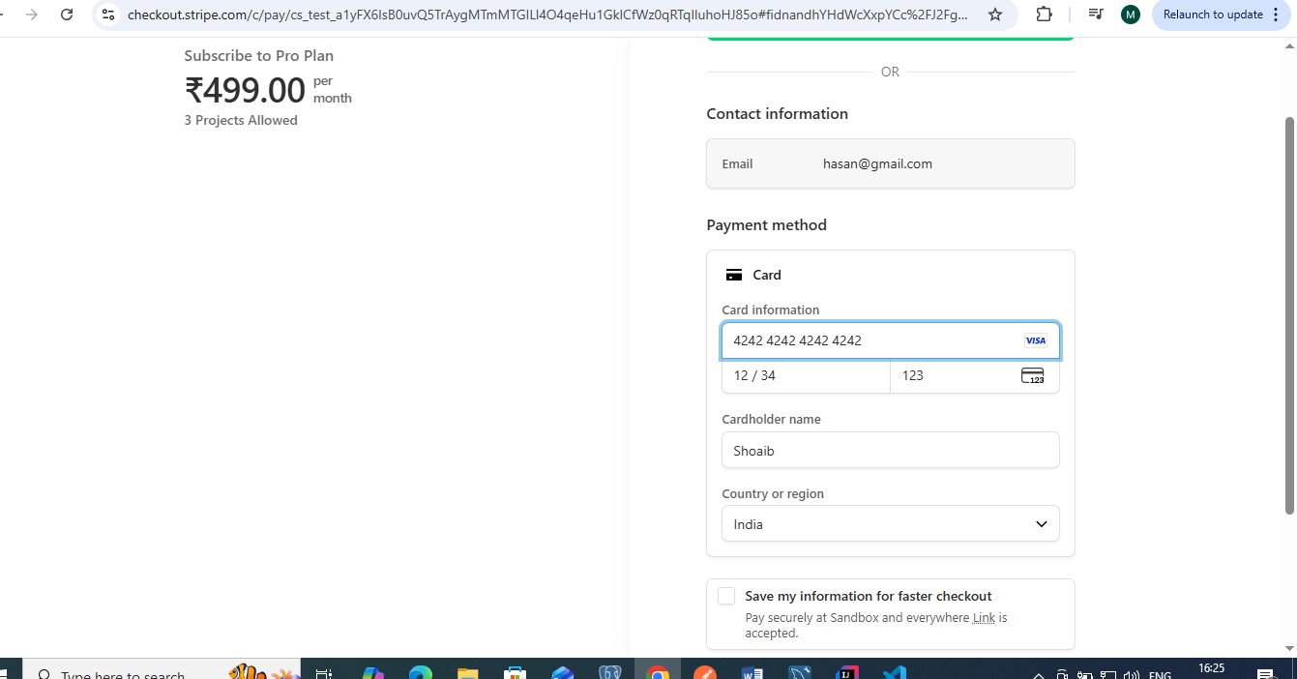
Install stripe cli
stripe login
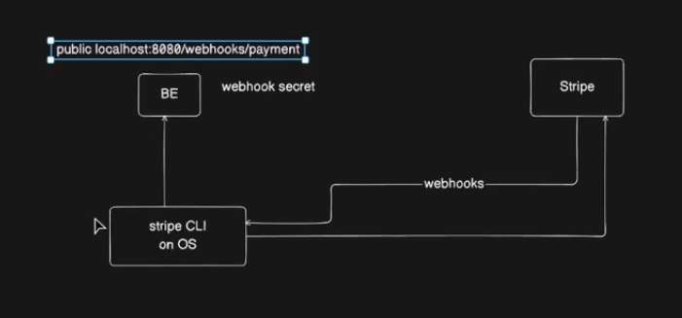when payment done successfully the stripe send request BackEnd with the help stripe CLI.
Stripe CLI works like All the request get from stripe redirect to the particular backend.
After login webhook secret key generated.
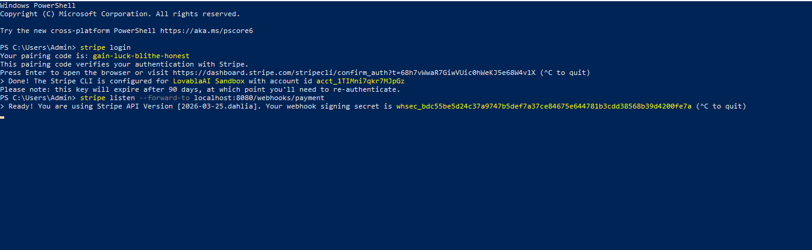
it listen all events
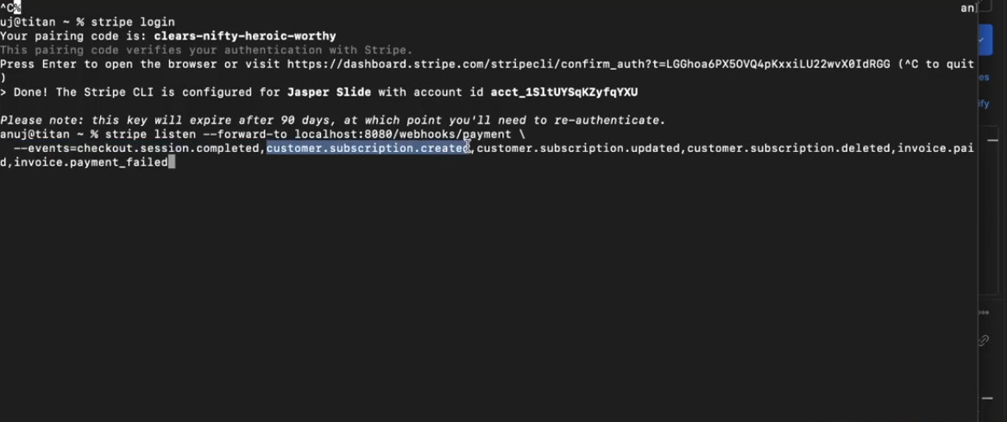it listen mentioned event
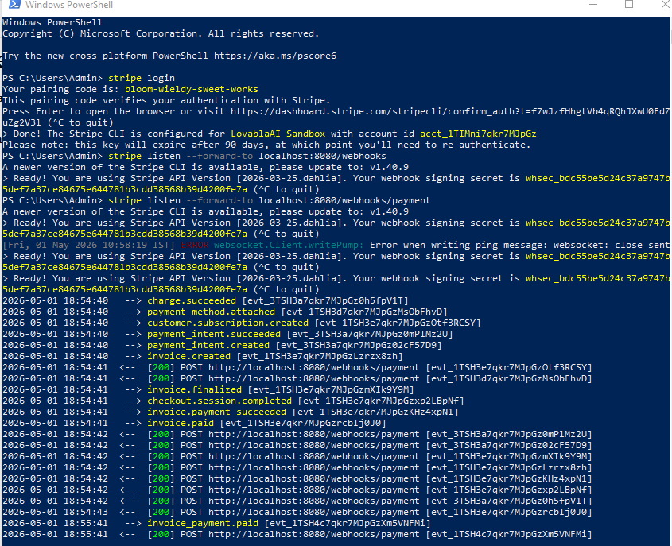
Use the Stripe CLI | Stripe Documentation
Home – LovablaAI Sandbox – Stripe [Test]
AWS Pass : ZamIrt@2026
Gmail: irtaza.shoiab@gmail.com
iru@2026

System prompt
x1xhlol/system-prompts-and-models-of-ai-tools: FULL Augment Code, Claude Code, Cluely, CodeBuddy, Comet, Cursor, Devin AI, Junie, Kiro, Leap.new, Lovable, Manus, NotionAI, Orchids.app, Perplexity, Poke, Qoder, Replit, Same.dev, Trae, Traycer AI, VSCode Agent, Warp.dev, Windsurf, Xcode, Z.ai Code, Dia & v0. (And other Open Sourced) System Prompts, Internal Tools & AI Models
Bolt GitHub
bolt.new/app/lib/.server/llm/prompts.ts at main · stackblitz/bolt.new
