Kubernetes

🎯 Real-world analogy
Think of it like:
- minikube = kitchen 🍳
- kubectl = chef 👨‍🍳
👉 Kitchen (minikube) is where cooking happens
👉 Chef (kubectl) is who controls everything

No kitchen → chef can't cook
No chef → kitchen is useless
---------------------------------------------------------------------------------------------------
🧠 Core Idea
- kubectl = tool (client / command-line interface)
- minikube = environment (local Kubernetes cluster)
They are not competitors, they work together.

-------------------------------------------------------------------------------------------------------------
⚙️ What is kubectl?
👉 kubectl is the official Kubernetes CLI tool
It is used to talk to a Kubernetes cluster.

✅ What it does:
- Run commands on cluster
- Deploy apps
- View pods, services, nodes
- Debug issues

--------------------------------------------------------------------------------------------------
🧪 What is minikube?
👉 minikube is a local Kubernetes cluster
It runs Kubernetes on your laptop using:
- VM or
- Docker

✅ What it does:
- Creates a single-node Kubernetes cluster
- Used for learning & testing
- Runs locally (no cloud needed)

Commands:
- minikube start --- to create cluster
- minikube delete
- minikube status
- minikube dashboard ----- to accesss dashboard
- kubectl create deployment my-app --image=link
- kubectl get deployments
- kubectl get pods
- kubectl delete deployment my-app
- kubectl expose deployment my-app -- type=LoadBalancer --port=80 –-- it create service
- minikube service my-app --- to use service that means we can access website
- kubectl get services
- kubectl log podName
- kubectl describe pods --- get information about pods
- kubectl set image oldDeploymentName containerName=newImageName05 - Rollout
- kubectl set image oldDeploymentName containerName=newImageName01
- kubectl rollout status deployment my-web-app
- kubectl rollout undo deployment my-web-app
Self-Healing restart container when container crashesh with down time, to avoid down time need to scale pods.
- kubectl scale deployment my-web-app --replicas=4
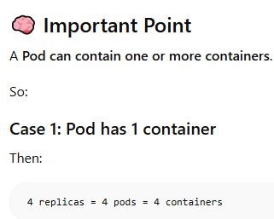 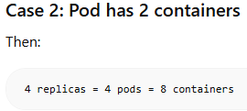
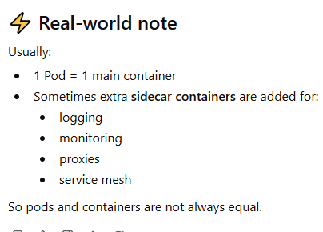

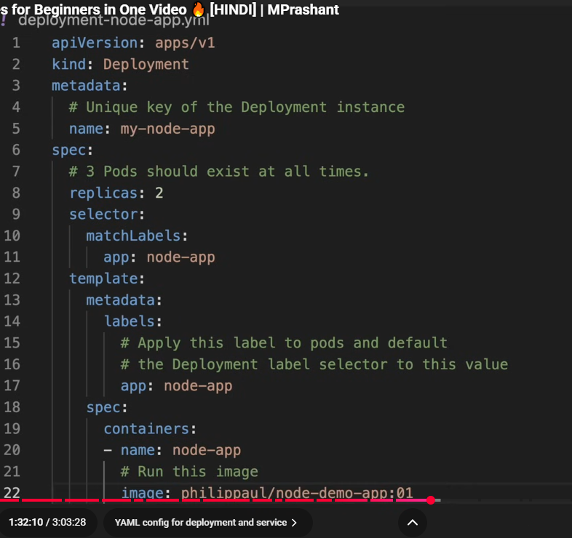
To create Deployment
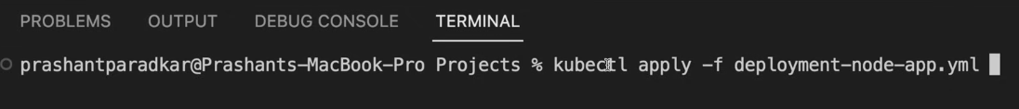
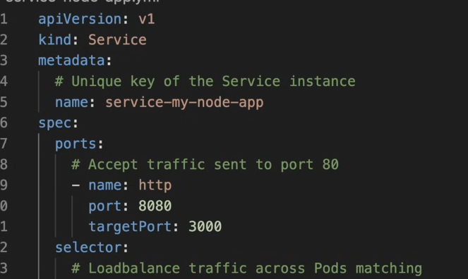
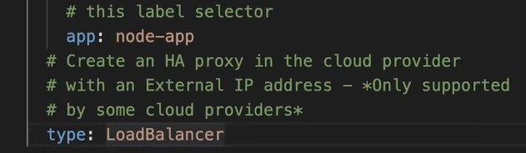
To Create Service
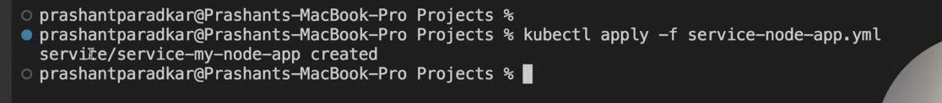
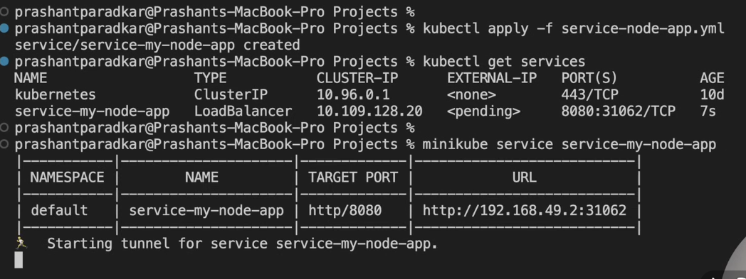

To Delete Deployment
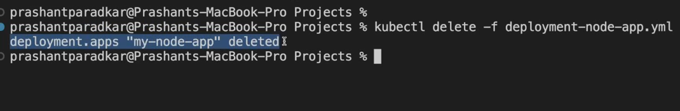
MULTIPLE CONATINER IN SINGLE POD
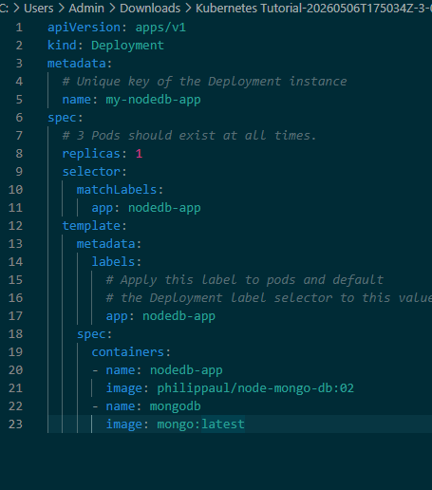
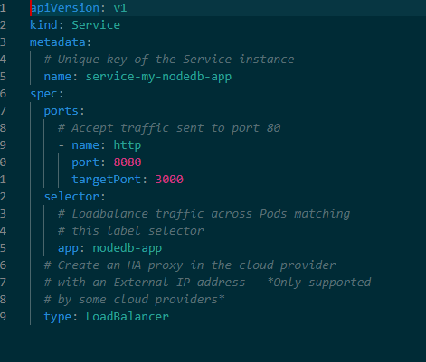
RUN EACH CONTAINER IN SEPARATE POD
This is main part to define multi container in single pod

- kubectl delete deployment redis-server runner-pool shuttle-proxy
- kubectl delete service minio-service redis-service shuttle-proxy-svc
- kubectl delete pod runner-pool-6c7d7f7568-hd8zv

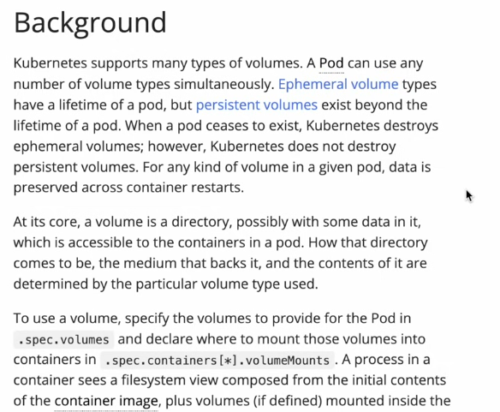
Persistent Volume
