19. Setup Kubernetes to build the Code Execution System in Lovable Clone Project
- choco install kind
- kind version
- kind get clusters
- kind create cluster --name shuttle-ai
//Create namespace
- kubectl create ns shuttle-apps
- kubectl get ns
// Inside k8s folder
- kubectl apply -f runner-pods.yml
- kubectl get pods -n shuttle-apps
// check details
- kubectl describe pod runner-pool-6c7d7f7568-7vx7n -n shuttle-apps
- kubectl apply -f infra.yml
- kubectl get services -n shuttle-apps
//set our namespace instead of default
- kubectl config set-context --current --namespace=shuttle-apps
// now we can go inside container & run certain shell command
//{1:43}
//run app & deploy from postman
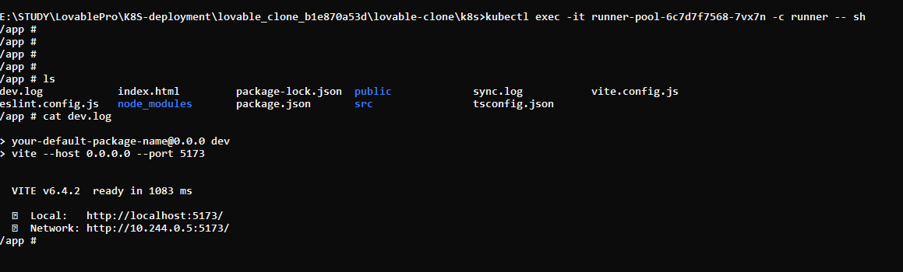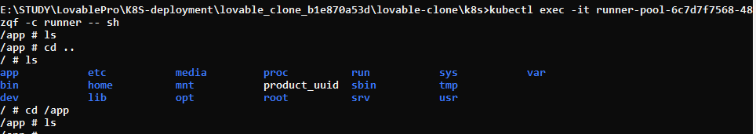
Run inside k8s folder
- kubectl exec -it runner-pool-6c7d7f7568-7vx7n -c runner – sh //{old command}
kubectl exec -it runner-pool-6c7d7f7568-csr9n -c runner -- sh //{new & updated command}
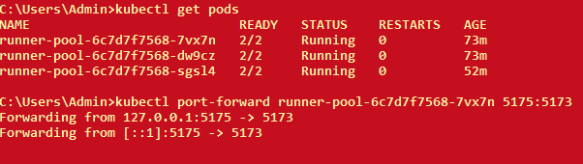
- kubectl port-forward runner-pool-6c7d7f7568-7vx7n 5175:5173


//20. Reverse proxy to handle Preview URLs added in Lovable Clone project

- kubectl apply -f infra.yml
- kubectl get services/ kubectl get svc
// Inside proxy folder
- docker build -t shuttle-proxy .
//inside proxy folder
- kind load docker-image shuttle-proxy:latest --name shuttle-ai
- kind get clusters
//Inside k8s folder
- kubectl apply -f shuttle-proxy.yml
- kubectl get pods
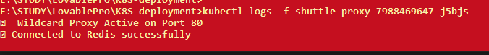
- kubectl logs -f shuttle-proxy-7988469647-j5bjs
- kubectl port-forward svc/shuttle-proxy-svc 8090:80
- kubectl port-forward svc/redis-service 6379:6379
//delete already running pod
- kubectl delete pod runner-pool-6c7d7f7568-7vx7n
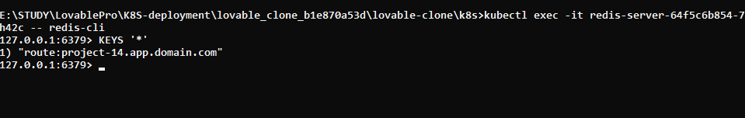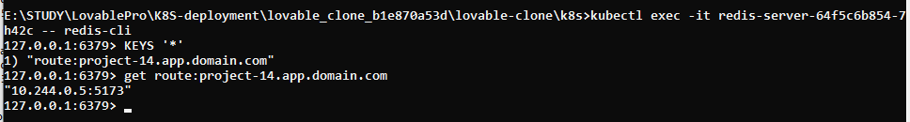
- kubectl exec -it redis-server-64f5c6b854-7h42c -- redis-cli
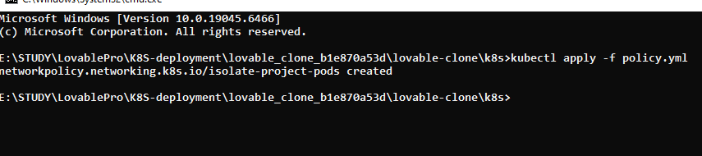
To Open hosts file – powershell(Run As Administrator) --- notepad C:\Windows\System32\drivers\etc\hosts
- kubectl apply -f policy.yml
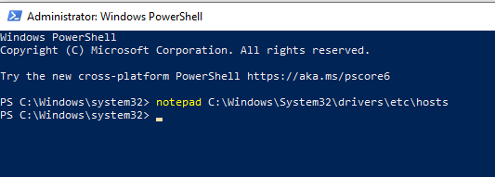
open powershell as administrator
notepad C:\Windows\System32\drivers\etc\hosts
http://project-2.app.domain.com:8090/
----------------------------------------------------------------------------------------------------------------------
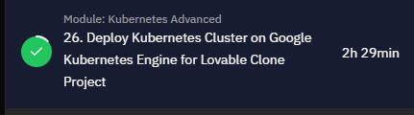
1.> >kubectl apply -f namespaces.yaml
2.> kubectl get configmaps --all-namespaces get all namespaces
3.> >kubectl get configmap lovable-shared-config -n lovable-core
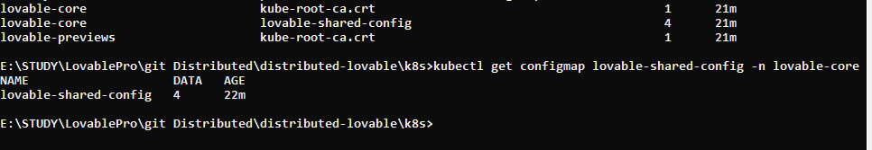
4.> kubectl describe configmap lovable-shared-config -n lovable-core
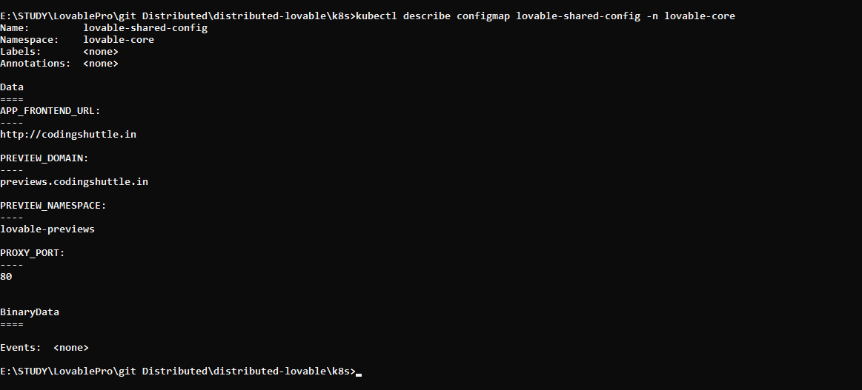
5.> kubectl create secret generic app-secrets --from-env-file=.env -n lovable-previews
6.> kubectl create secret generic app-secrets --from-env-file=.env -n lovable-core
7.> >kubectl apply -f stateful/
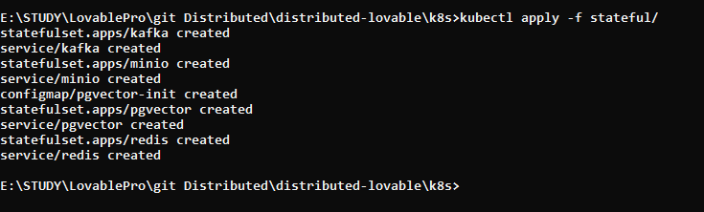
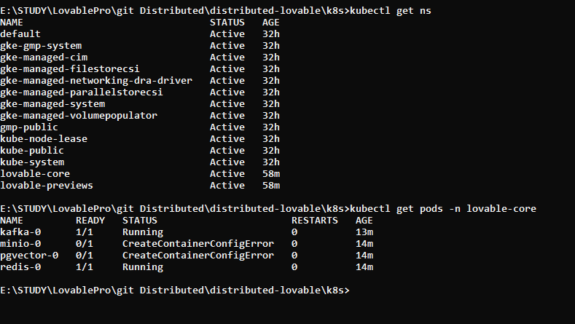
First we need to push image on git hub by using pom.xml file
docker login
e\api-gateway> .\mvnw compile jib:build
or double click on packages
8.> kubectl apply -f services/config-service.yaml
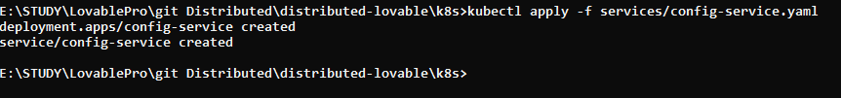
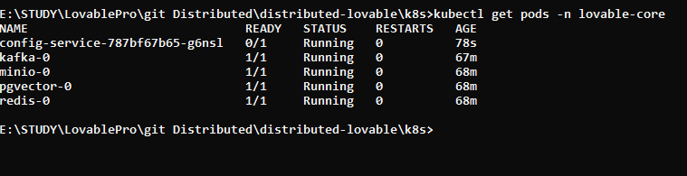
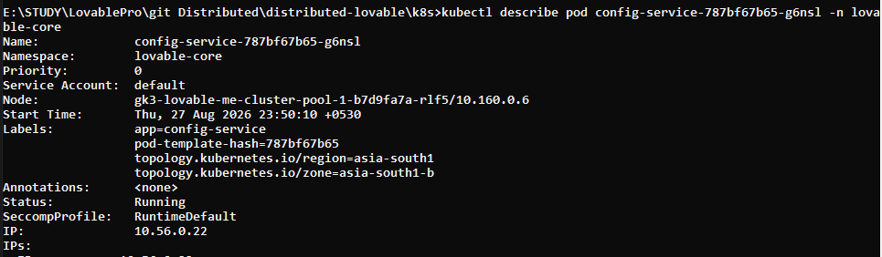
First we need to push image on git hub by using pom.xml file

9.> >kubectl apply -f services/api-gateway.yaml
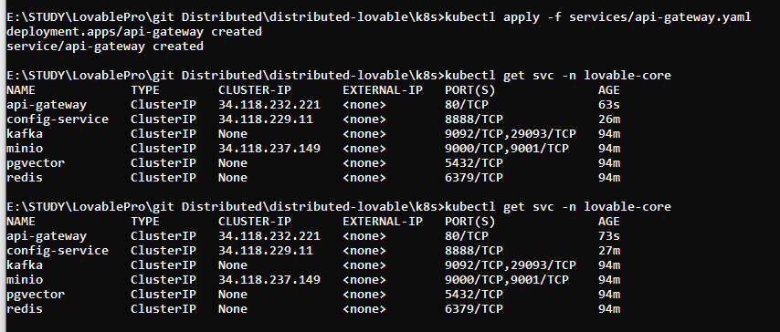
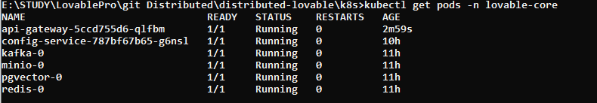
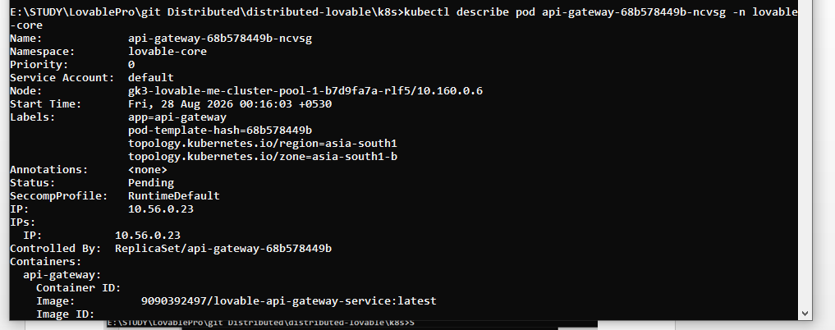
able\k8s>kubectl logs api-gateway-5ccd755d6-qlfbm -n lovable-core
10.> kubectl apply -f services/account-service.yaml
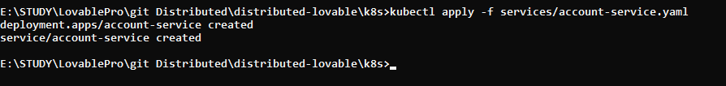
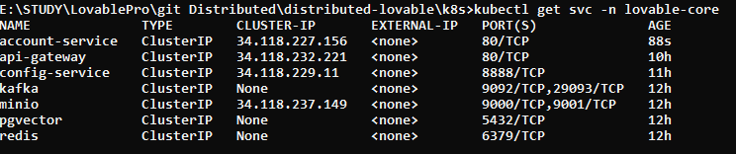
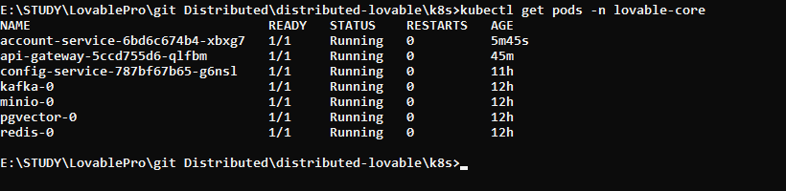
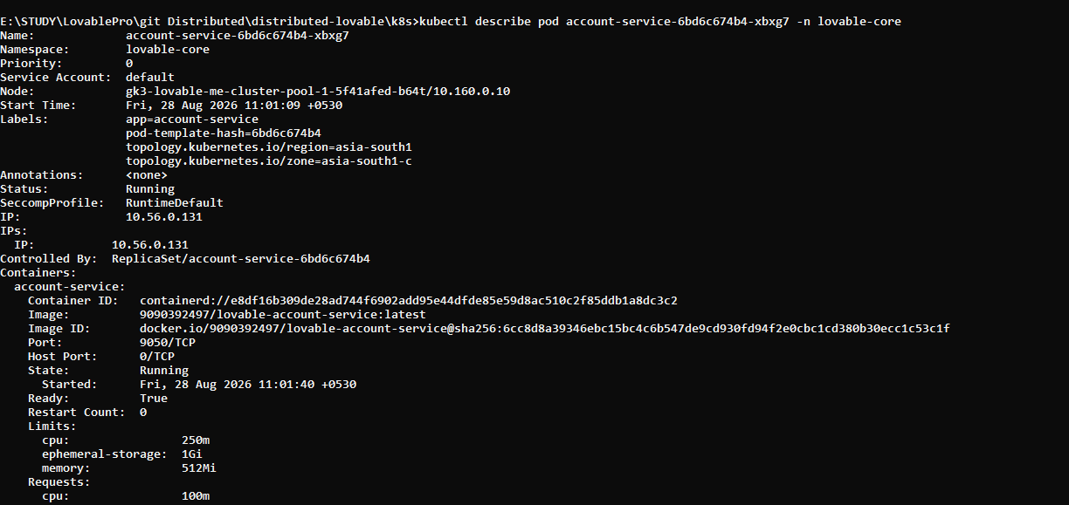
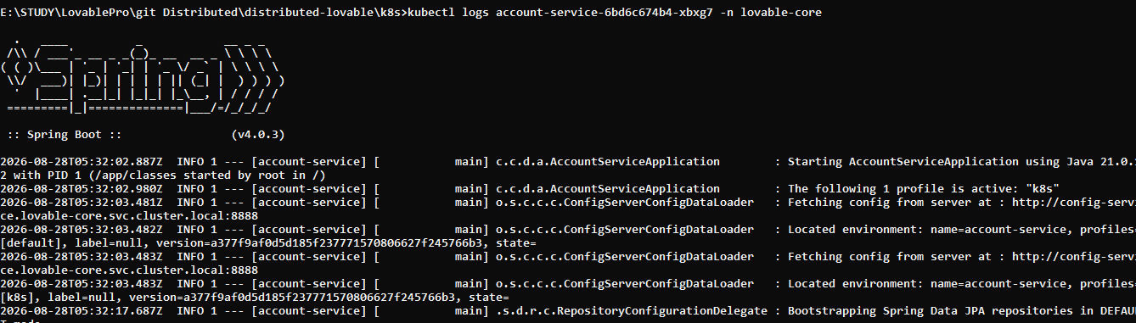
------intelligence service strted
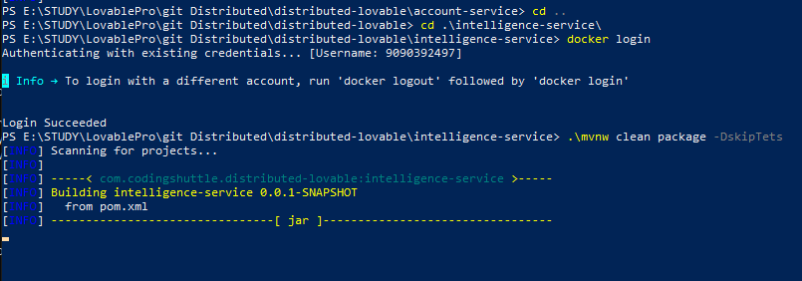
11.> >kubectl apply -f services\intelligence-service.yaml
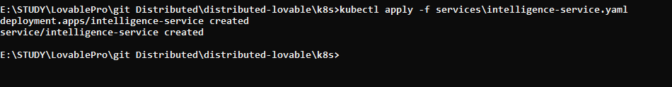
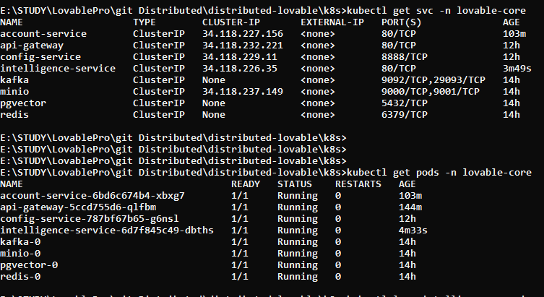
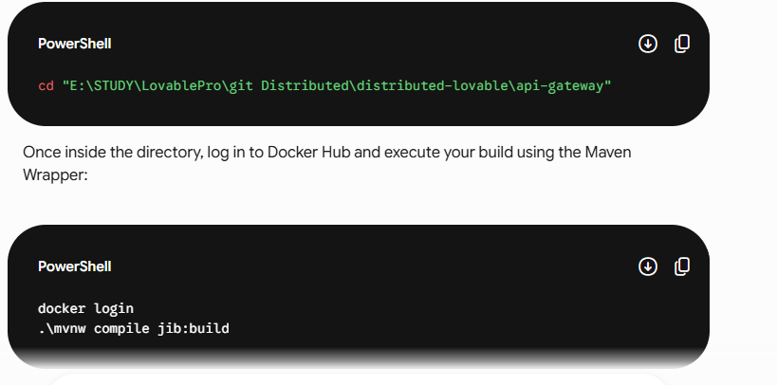
cd "E:\STUDY\LovablePro\git Distributed\distributed-lovable\api-gateway"
docker login
.\mvnw compile jib:build
E:\STUDY\LovablePro\git Distributed\distributed-lovable\account-service> .\mvnw clean package -DskipTets

why service is created after creating deployment in kubernetese
In Kubernetes, a Deployment and a Service solve two different problems.

1. Deployment → Creates and manages Pods
A Deployment is responsible for:
- Creating Pods
- Keeping Pods running
- Scaling Pods
- Updating Pods
- Restarting failed Pods
Example:
apiVersion: apps/v1
kind: Deployment
metadata:
name: my-app
spec:
replicas: 3
selector:
matchLabels:
app: my-app
template:
metadata:
labels:
app: my-app
spec:
containers:
- name: my-app
image: nginx
This creates 3 Pods.
Problem:
Pods are temporary.
Their:
- IP addresses change
- Names change
- Pods can be recreated anytime
So other applications cannot reliably connect directly to Pods.

2. Service → Gives stable networking to Pods
A Service provides:
- Stable IP address
- Stable DNS name
- Load balancing
- Access to Pods
Example:
apiVersion: v1
kind: Service
metadata:
name: my-service
spec:
selector:
app: my-app
ports:
- port: 80
targetPort: 80
This Service automatically finds all Pods with:
app: my-app
and forwards traffic to them.

Why do we create Service after Deployment?
Because:
Deployment creates Pods
Service exposes Pods
The Service needs Pods to exist so it can route traffic to them.

Real Flow
User Request
↓
Service (stable entry point)
↓
Pod 1
Pod 2
Pod 3
The Service acts like a traffic manager/load balancer.

Without Service
Suppose Deployment creates Pods:
my-app-7f8d9
my-app-6ab2c
my-app-3x9k1
Each Pod gets random IPs:
10.1.1.2
10.1.1.5
10.1.1.9
If a Pod crashes:
10.1.1.5 → deleted
new Pod → 10.1.1.15
Now clients lose connection.
Service solves this by giving one permanent endpoint:
my-service

Deployment vs Service
Feature | Deployment | Service
Creates Pods | Yes | No
Stable IP | No | Yes
Load balancing | No | Yes
Auto healing | Yes | No
Exposes app | No | Yes
Scaling | Yes | No

Common Types of Services

ClusterIP (default)
Internal communication only.
Frontend → Backend

NodePort
Exposes app on node IP + port.
<NodeIP>:30001

LoadBalancer
Creates cloud load balancer.
Used in:
- Amazon Web Services
- Google Cloud
- Microsoft Azure

Simple Analogy
Think of:
- Deployment = workers in a restaurant
- Service = reception desk
Customers talk to reception, not directly to workers.
Even if workers change, reception remains same.

Typical Kubernetes Workflow

Step 1: Create Deployment
kubectl apply -f deployment.yml
Creates Pods.

Step 2: Create Service
kubectl apply -f service.yml
Exposes Pods.

Verify
Check Deployment:
kubectl get deployments
Check Pods:
kubectl get pods
Check Services:
kubectl get svc
what is the purpose of services in kbernetese
In Kubernetes, a Service is used to provide a stable way to access Pods.
Pods in Kubernetes are temporary:
- They can crash
- They can restart
- Their IP addresses change
A Service solves this problem.

Main Purpose of Services in Kubernetes

1. Stable Network Endpoint
Pods get dynamic IPs.
Example:
Pod A → 10.1.1.2
Pod B → 10.1.1.5
If Pod B restarts:
Old IP → 10.1.1.5
New IP → 10.1.1.9
Applications would break if they connected directly to Pods.
A Service provides one permanent endpoint:
backend-service
Applications always connect to the Service instead of Pod IPs.

2. Load Balancing
A Service distributes traffic across multiple Pods.
Example:
User Request
↓
Service
↓ ↓ ↓
Pod1 Pod2 Pod3
Traffic is automatically balanced.

3. Communication Between Applications
Microservices communicate using Services.
Example:
frontend-service → backend-service
backend-service → database-service
Instead of using IP addresses.

4. Expose Applications
Services allow external users to access applications.
Example:
- Website
- REST API
- Mobile backend
Without Service, applications inside the cluster cannot be reached externally.

5. Service Discovery
Kubernetes automatically creates DNS names.
Example:
http://backend-service
Pods can discover each other easily.

Example

Deployment
apiVersion: apps/v1
kind: Deployment
metadata:
name: nginx-deployment
spec:
replicas: 3
selector:
matchLabels:
app: nginx
template:
metadata:
labels:
app: nginx
spec:
containers:
- name: nginx
image: nginx
This creates 3 Pods.

Service
apiVersion: v1
kind: Service
metadata:
name: nginx-service
spec:
selector:
app: nginx
ports:
- port: 80
targetPort: 80
The Service finds Pods using:
app: nginx
and forwards traffic to them.

Types of Services

ClusterIP (Default)
Internal communication inside cluster only.
Frontend → Backend

NodePort
Exposes app on a port of the Kubernetes node.
<NodeIP>:30080

LoadBalancer
Creates cloud load balancer.
Used in:
- Amazon Web Services
- Google Cloud
- Microsoft Azure

ExternalName
Maps Service to external DNS.
Example:
google.com

Real-World Example
Suppose you deploy:
- Frontend app
- Backend API
- Database
Services help them communicate safely.
Users
↓
Frontend Service
↓
Backend Service
↓
Database Service

Important Concept
A Service does NOT create Pods.
It only:
- Finds Pods
- Gives stable access
- Routes traffic
Pods are created by:
- Deployment
- StatefulSet
- DaemonSet

Simple Analogy
Think of:
- Pods = employees
- Service = company reception desk
Employees may change,
but the reception number remains same.
Difference between loadbalancer & port forwarding
In Kubernetes, Port Forwarding and LoadBalancer Service are both used to access applications, but they are used for very different purposes.

Quick Difference
Feature | Port Forwarding | LoadBalancer
Purpose | Temporary local access | Permanent external access
Used for | Testing/debugging | Production applications
Accessible by | Only your machine | External users/internet
Requires cloud LB | No | Yes
Automatic load balancing | No | Yes
Stable public IP | No | Yes
Works locally | Yes | Usually cloud environments
Command/manual | Manual | Kubernetes-managed

1. Port Forwarding
Port forwarding creates a temporary tunnel from your local machine to a Pod or Service.
Example:
kubectl port-forward service/my-service 8080:80
Meaning:
Your Laptop:8080 → Kubernetes Service:80
Now you can access:
http://localhost:8080

Purpose of Port Forwarding
Used mainly for:
- Development
- Testing
- Debugging
- Local access
Example:
You want to test:
- Redis
- PostgreSQL
- Spring Boot API
- MinIO dashboard
without exposing them publicly.

How Port Forwarding Works
Browser
↓
localhost:8080
↓
kubectl tunnel
↓
Pod/Service inside cluster
Traffic passes through kubectl.

Characteristics

Temporary
If terminal closes:
Connection stops

Only Accessible From Your Machine
Others cannot access it.

No Public Exposure
Safe for local debugging.

Example
Forward Pod:
kubectl port-forward pod/my-pod 8080:80
Forward Service:
kubectl port-forward service/my-service 8080:80

2. LoadBalancer Service
A LoadBalancer Service exposes your application to the outside world permanently.
Example:
apiVersion: v1
kind: Service
metadata:
name: my-service
spec:
type: LoadBalancer
selector:
app: my-app
ports:
- port: 80
targetPort: 8080
Kubernetes creates:
- External IP
- Cloud load balancer
- Public access

How LoadBalancer Works
Internet Users
↓
Cloud Load Balancer
↓
Kubernetes Service
↓
Pods

Used For
Production applications:
- Websites
- APIs
- Mobile backends
Example:
- E-commerce app
- Banking API
- Chat application

Characteristics

Publicly Accessible
Anyone with IP/domain can access it.

Permanent
Runs continuously.

Load Balancing
Traffic distributes across Pods.
Example:
Request 1 → Pod A
Request 2 → Pod B
Request 3 → Pod C

Cloud Integration
Works with:
- Amazon Web Services
- Google Cloud
- Microsoft Azure

Example Comparison

Port Forwarding
kubectl port-forward service/backend 8080:80
Access:
localhost:8080
Only you can use it.

LoadBalancer
type: LoadBalancer
Access:
http://35.201.xxx.xxx
Anyone can use it.

Real-Life Analogy

Port Forwarding
Like opening a private temporary tunnel from your laptop to the server.

LoadBalancer
Like opening a public highway to your application.

Important Notes

Port Forwarding
- Good for local development
- No external exposure
- Manual
- Temporary

LoadBalancer
- Good for production
- External/public access
- Automatic
- Permanent

Typical Usage

During Development
kubectl port-forward

In Production
type: LoadBalancer

Bonus: NodePort vs LoadBalancer
Type | Access
Port Forward | Localhost only
NodePort | NodeIP:Port
LoadBalancer | Public external IP
explain API gateway, proxy & reverseproxy

1. What is a Proxy?
A proxy server sits between a client and the internet/server.
Instead of the client directly contacting the destination server, the request first goes to the proxy.

Flow
Client → Proxy → Server

Purpose
- Hide client identity
- Control internet access
- Caching
- Security filtering
- Monitoring requests

Example
In a company network:
Employee Laptop → Company Proxy → Google
The company proxy can:
- block websites
- log traffic
- cache responses
- enforce security rules

2. What is a Reverse Proxy?
A reverse proxy sits in front of backend servers.
Clients think they are talking directly to the application, but actually requests first go to the reverse proxy.

Flow
Client → Reverse Proxy → Backend Servers

Purpose
- Load balancing
- SSL termination
- Security
- Hiding backend servers
- Rate limiting
- Caching
- Routing traffic

Example
User → Nginx Reverse Proxy → Spring Boot App
The user never directly accesses the Spring Boot server.

3. Proxy vs Reverse Proxy
Feature | Proxy (Forward Proxy) | Reverse Proxy
Protects | Client | Server
Used by | Client side | Server side
Client knows? | Yes | Usually No
Main use | Access internet securely | Manage backend servers
Example | Company internet proxy | Nginx, HAProxy

4. What is an API Gateway?
An API Gateway is a specialized type of reverse proxy used in microservices architecture.
It acts as a single entry point for all client requests.

Flow
Client → API Gateway → Microservices
Instead of clients calling many services directly:
Client → User Service
Client → Payment Service
Client → Order Service
Clients only call:
Client → API Gateway
The gateway routes requests internally.

API Gateway Responsibilities

1. Routing
Routes request to correct microservice.
Example:
/api/users → User Service
/api/orders → Order Service

2. Authentication & Authorization
Validate JWT tokens before forwarding request.
Example:
Client → Gateway (JWT validation) → Service

3. Load Balancing
Distributes requests among service instances.

4. Rate Limiting
Prevents too many requests.
Example:
100 requests/minute per user

5. Logging & Monitoring
Centralized request tracking.

6. SSL Termination
HTTPS handled at gateway level.

7. Request Aggregation
Combines responses from multiple services.

5. API Gateway vs Reverse Proxy
Feature | Reverse Proxy | API Gateway
Main Purpose | Forward traffic | Manage APIs
Works with | Any backend | Mostly microservices
Authentication | Basic | Advanced
Rate Limiting | Sometimes | Common
API Management | No | Yes
Request Aggregation | Rare | Common
Service Discovery | Usually No | Often Yes

6. Real-World Example
Suppose you have:
- User Service
- Product Service
- Payment Service
Without API Gateway:
Frontend → User Service
Frontend → Product Service
Frontend → Payment Service
Problems:
- Too many endpoints
- Security duplicated everywhere
- Hard to manage
With API Gateway:
Frontend → API Gateway → Services
Gateway handles:
- authentication
- routing
- logging
- throttling
- security

7. Common Technologies

Reverse Proxy
- Nginx
- HAProxy
- Apache HTTP Server

API Gateway
- Spring Cloud Gateway
- Kong
- Netflix Zuul
- Apigee

8. In Kubernetes
In Kubernetes:

Reverse Proxy / Ingress
Internet → Ingress Controller → Services → Pods
Examples:
- Nginx Ingress Controller
- Traefik

API Gateway
Used when:
- many microservices exist
- authentication needed
- centralized API management required

9. Simple Analogy

Proxy
Like a company receptionist helping employees access outside world.

Reverse Proxy
Like a hotel reception desk protecting and managing access to rooms.

API Gateway
Like an airport control system directing passengers/security/check-ins to many services from one entry point.
Top of Form

Bottom of Form

