**Assignment 4: My First Single Page Application Using ReactJS!**

**Assignment 4: My First Single Page Application Using ReactJS!**

**(Due: Thursday November, 16th @ 11:59 PM)**

** This assignment will combine a few things that you have learned in this class and will require a little learning on your own. Do your best and be creative.  If you need help ask sooner rather than later in slack. Myself and your classmates are here to help and do not wait to the last minute to do this assignment.

** This assignment should be done by you, this is NOT a group assignment. Any signs of cheating or sharing source code will be result in a zero for this project.

** I have listed some tutorials below, but you may need to google some on your own.

**Your Single Page Web Application:**

* Create a simple single page blog static website.
* The page should have a 2-column layout
* You should include 3 short blog posts in the “Main” sections of the page.
  + Post should include the following:
    - Title (H1)
    - Date (of the post)
    - Body (of the post)

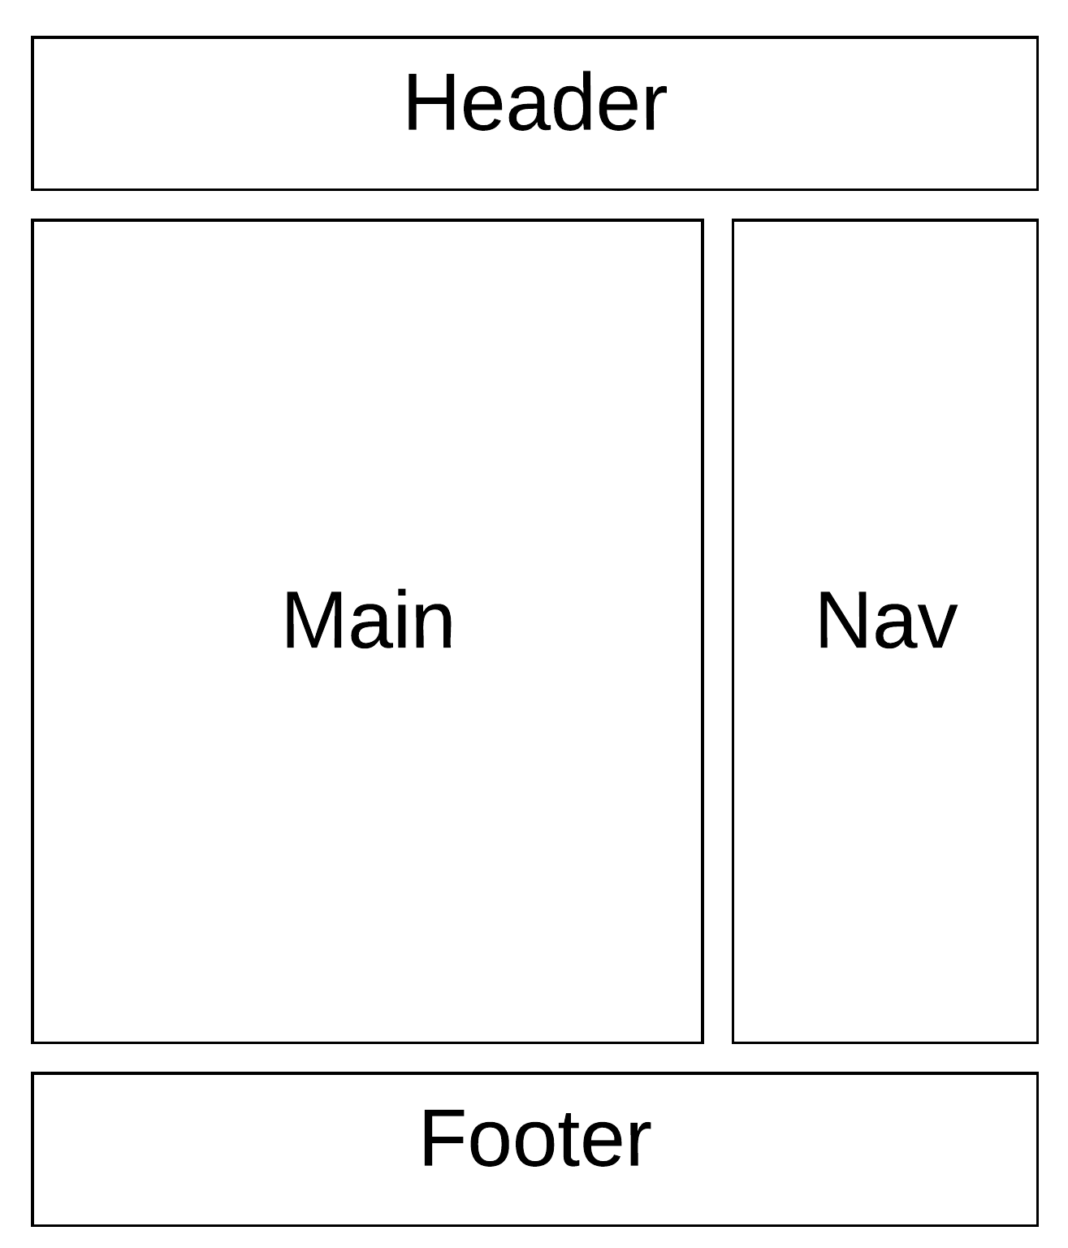

**To Submit The Assignment (Read Carefully):**

**\*\* Please follow all instructions as not following them will lead to loss of points.**

1. Create a github account.
2. Create public github repository and all all of your source code for this assignment to the repository. (See the “getting started with github” document in the “Course Documents  > Tutorials & Cheat Sheets” folder for help)
3. Make sure to add a README file to the root of your repository that describes the site you have implemented. Should include instructions on how to run your ReactJS application.
4. Create a screencast that shows me setting up and running the ReacJS web application you have created. See tutorials below for help.
5. Submit the following to the “Submit Assignment” thread in “My First Single Page Application - ReactJS”  discussion board.
   1. Link to your public github repository that contains all of the source code.
   2. Link to your screencast video.

**Tutorials:**

* **ReacJS**
  + Beginner Tutorials
    - <https://reactjs.org/tutorial/tutorial.html>
    - <https://ihatetomatoes.net/react-tutorial-for-beginners/>
    - <https://appdividend.com/2017/08/22/reactjs-tutorial-beginners-2017/>
    - <https://www.tutorialspoint.com/reactjs/>
    - <https://www.youtube.com/user/thenewboston/videos> (lots of beginner tutorials here, start from video 1)
  + <https://www.dhruvkumarjha.com/articles/building-a-static-website-using-react-js-part-1-project-setup-and-website-ui>
  + Build a website using React, Sass, Gulp and Node.js **-** <https://www.youtube.com/watch?v=nusgoj74a3Y>
* **Freeware screencast-o-matic to use for screencasting**
  + Website: <https://screencast-o-matic.com/>
  + Tutorials: <http://help.screencast-o-matic.com/>