#1:



#2:



#3:



#4:

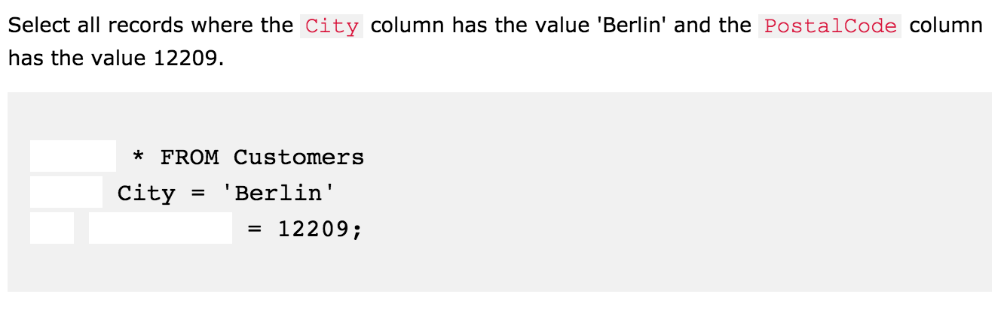

#5:

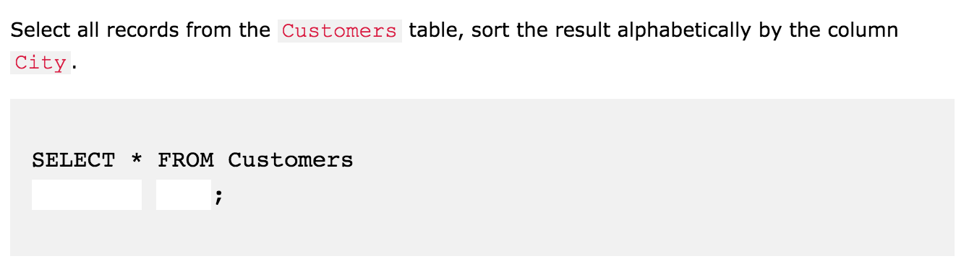

#6:

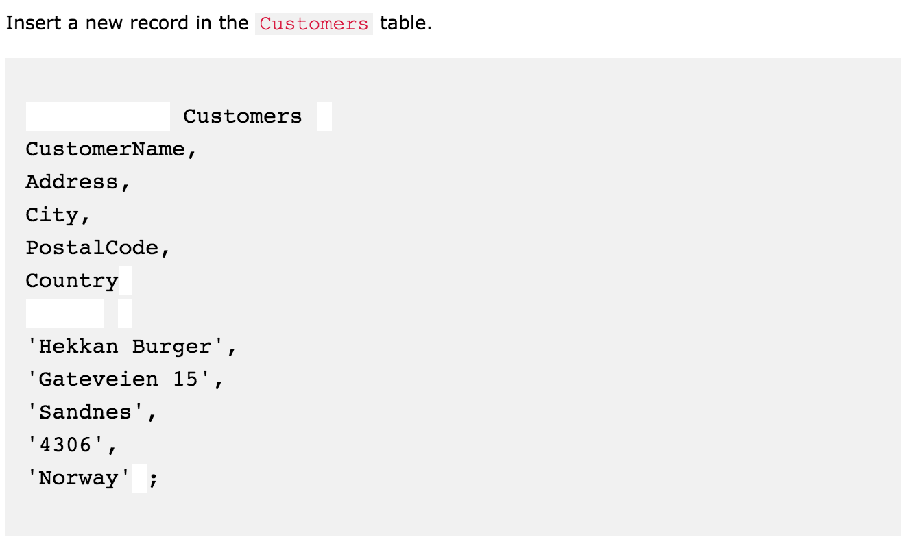

#7:



#8:



#9: