**Table_Order**

Group Members:

Ali Raza MCSF18M005(Group Leader) : Have worked on Customer Side.

Shoaib Raza MCSF19M052: Have worked on the Admin Side.

**Repository Link:**

**Commits in the Repository:**

**Current System**: the app we have developed, against this, the already work was entirely different and there was no any use of technology over there. Men like waiters collect the orders manually and then, there is bill procedure and then keeping track of all the sales was being done manually.

**Idea:** our idea was to entirely digitize the procedure, which starts from Table Booking to order of each table with menu and after selection of the food according to the customer and then showing the bill to the customer and printing the bill, also there was order status and order update to the kitchen area. The idea is to implement each and every thing on device. Like waiter have to just bring Mobile/Tablet or a fixed device on entrance or on each table according to the requirements of the restaurant, every situation can be implemented.

**What We have Done:**

After a lot of work and struggles, we are able to implement the idea, that is details are being given following. Before that let me add one thing that there are two sides one is admin side and another is for the use of customer purposes.

**1: Welcome Screen:** as the screenshot is attached, there is a welcome screen, having welcome and two buttons to go to either Admin side or Customer side.

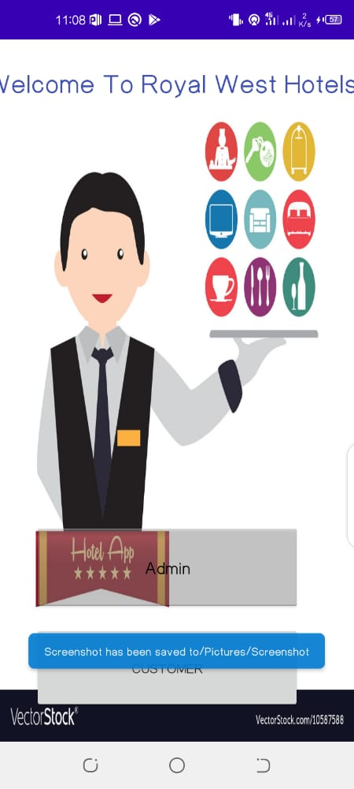

**2: Customer Side:** on clicking the customer button first, the view and control will be of customer sides.

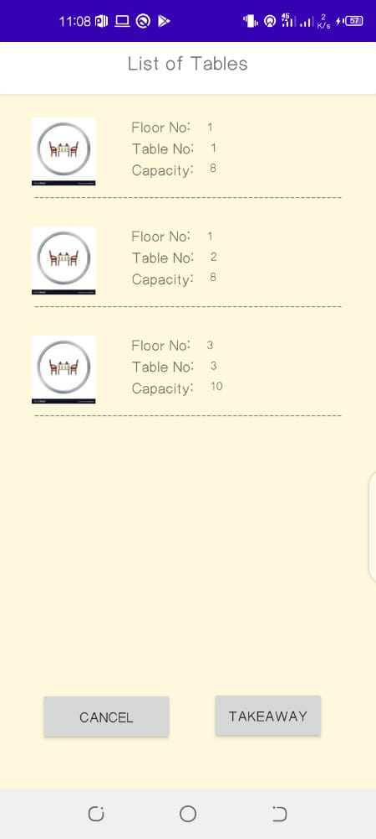

**3: Tables Selection:** in this activity all the available tables with their floor number and capacity of the table with table no. is available. As above

**4: Table Code:** after selection of the table a new activity of Table code will be opened to acquire the table code so that unauthorized person can’t book the table without any confirmation.

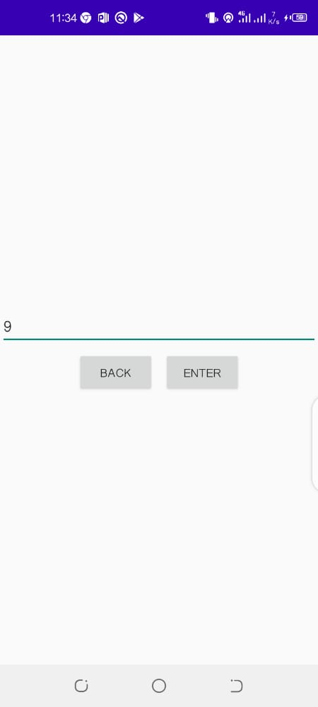

**5: Menu**: now in this activity menu is shown in the form of food types like vegetable, chicken, fast food etc.

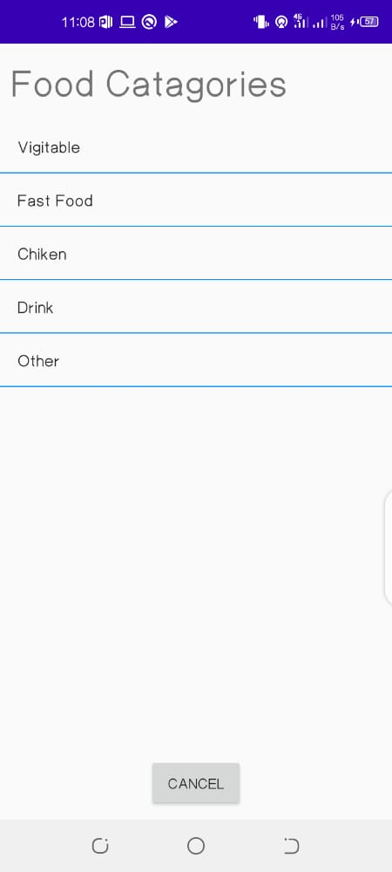

**6: Submenu:** in this part after selection of particular food type, products of that type are shown along with there prices and check boxes.



**7: Final Order**: Now after selection of the products, there will be final order shown to the user.

8:: Now bill avitivity will be shown where the bill of the products according to the order is given and then it’s printed also one implementation is to send it to kitchen area.

**Admin Side:**

**1: Login:** now in the admin side, first of all there will be login window to protect from unauthorized access.

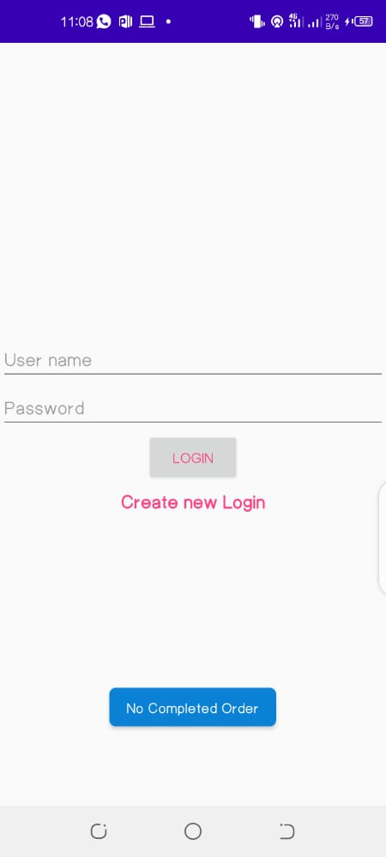

2**: Admin Activities:** Now in this section, different buttons are shown with their functionality named, like adding, deleting a table and products, and also active orders.

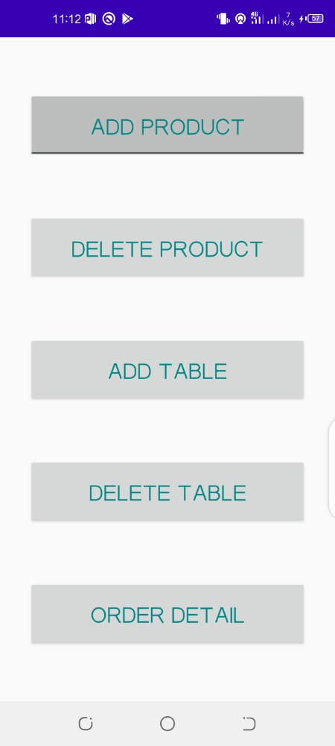

3: **Add Table:** in this activity unique table is to be added in database, using fields of floor no, table no, capacity along with table code.

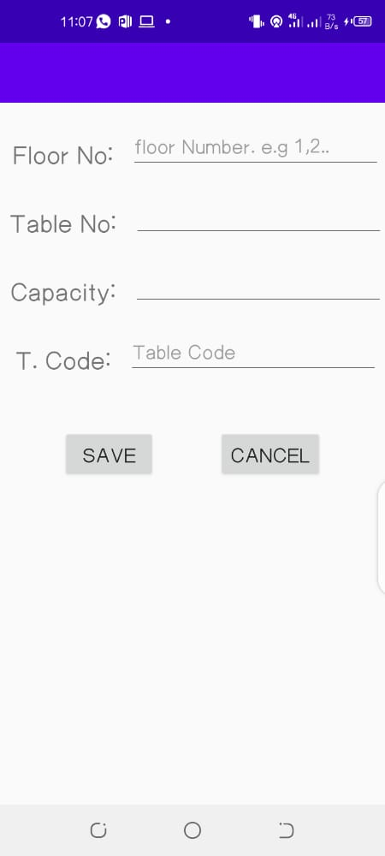

4**: Delete table:** this activity will acquire the floor no and table no. to delete the table.

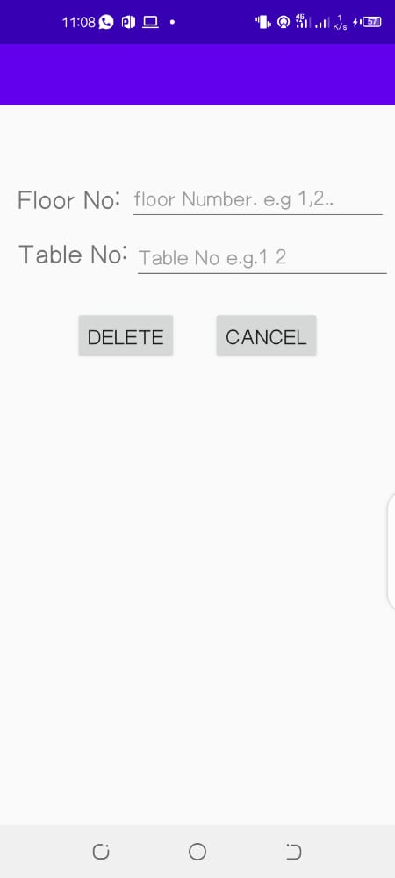

5: **Add Product**: this activity will add products to the databases with requirements of Name, Type, Price and also discount.

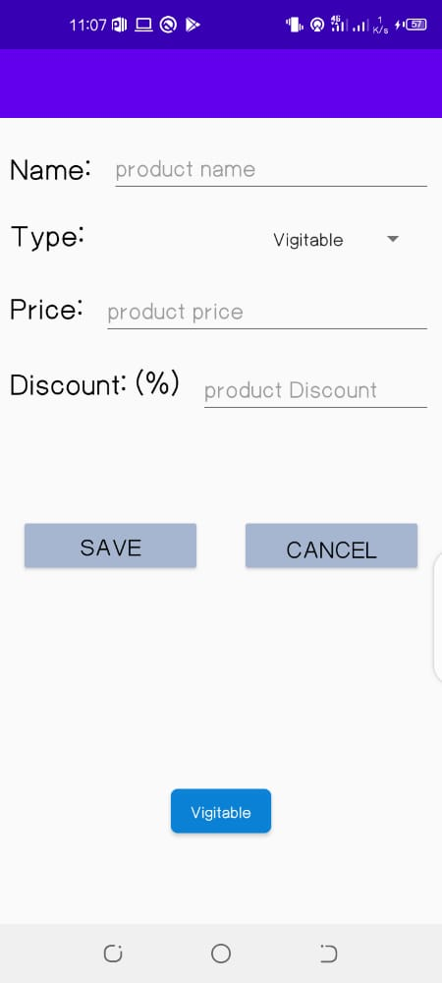

6: **Delete Product:** it will delete the product;

7: **Order List:** it will show all the active orders to the admin/kitchen side. Also completed orders to complete track of the sale.

