DESIGN, ANALYSIS AND CONTROL OF ISOLATED POWER SUPPLY FOR DC MICROGRID APPLICATION

BACHELOR OF TECHNOLOGY IN
ELECTRICAL & ELECTRONICS ENGINEERING BY
MD.SHOAIB AHMED 22071A0234
M.HARSHINI 22071A0239
T.BALADITHYA 22071A0256

UNDER THE GUIDANCE OF
Mr. D.S.G. Krishna
Asst. Professor
EEE Department


DEPARTMENT OF ELECTRICAL & ELECTRONICS ENGINEERING
VALLURUPALLI NAGESWARA RAO
VIGNANA JYOTHI INSTITUTE OF ENGINEERING & TECHNOLOGY
Vignana Jyothi Nagar, Bachupally, Hyderabad 500118, Telangana India

MAY 2026


DEPARTMENT OF ELECTRICAL & ELECTRONICS ENGINEERING CERTIFICATE
This is to certify that the Major Project titled “DESIGN, ANALYSIS AND CONTROL OF ISOLATED POWER SUPPLY FOR DC MICROGRID APPLICATION” is a record of bona fide work submitted by:
MD. SHOAIB AHMED 22071A0234
MOTHUKURI HARSHINI 22071A0239
T. BALADITHYA 22071A0256
in partial fulfillment of the requirements for the award of the degree of Bachelor of Technology (B.Tech.) in ELECTRICAL & ELECTRONICS ENGINEERING of Jawaharlal Nehru Technological University Hyderabad (JNTUH), under VNRVJIET B.Tech. R22 Academic Regulations. The work has been carried out under our guidance and supervision at Vallurupalli Nageswara Rao Vignana Jyothi Institute of Engineering & Technology, Hyderabad.
The report is original, free from plagiarism, and complies with the Institute guidelines, including those related to academic ethics and AI-generated content.

Signature of Supervisor  D.S.G Krishna Asst. Professor  EEE | Signature of HOD Dr. V. Ramesh Babu Professor & HOD  Electrical & Electronics Engineering
VNR VJIET, Hyderabad | VNR VJIET, Hyderabad
i

PLAGIARISM CERTIFICATE



ii

APPROVAL CERTIFICATE

Major Project evaluation for the project titled “DESIGN, ANALYSIS AND CONTROL OF ISOLATED POWER SUPPLY FOR DC MICROGRID APPLICATION”,being submitted by Mr. MD. SHOAIB AHMED, Regd. No. 22071A0234, Ms. M. HARSHINI , Regd. No. 22071A0239, Mr. T. BALADITHYA , Regd. No. 22071A0256, has been conducted on 4/05/2026 and the work is approved for the award of the degree of BACHELOR OF TECHNOLOGY (B.Tech.) in ELECTRICAL & ELECTRONICS ENGINEERING, under VNRVJIET B.Tech. R22 Academic Regulations.

INTERNAL EXAMINER EXTERNAL EXAMINER

iii

DEPARTMENT OF ELECTRICAL & ELECTRONICS ENGINEERING
DECLARATION
We, the undersigned, declare that the Major Project titled “DESIGN, ANALYSIS AND CONTROL OF ISOLATED POWER SUPPLY FOR DC MICROGRID APPLICATION”
has been carried out by us in partial fulfillment of the requirements for the award of the degree of Bachelor of Technology (B.Tech.) in ELECTRICAL & ELECTRONICS ENGINEERING of Jawaharlal Nehru Technological University Hyderabad (JNTUH), under VNRVJIET B.Tech. R22 Academic Regulations, at Vallurupalli Nageswara Rao Vignana Jyothi Institute of Engineering & Technology, Hyderabad.
We further declare that this work is original, has not been submitted previously for any degree or similar title, and complies with the Institute’s plagiarism and academic ethics guidelines, including AI-generated content. The contributions of all team members are clearly indicated in the report.

PLACE: HYDERABAD DATE: 4/06/2026

Signature of the Student(s)

Md.Shoaib Ahmed 22071A0234

M.Harshini 22071A0239

T.Baladithya 22071A0256

iv

ABSTRACT

The fast and wide adoption of DC microgrids in renewable energy power generation systems, electric vehicles, energy storage technologies, and power supplies in industry has resulted in the increasing need for efficient, reliable, and isolated DC--DC converters. The goal of the project is about desing, analyze, and apply closed-loop control techniques to a DC-DC isolated convertre that converts a DC supply of 560 V into an isolated DC voltage source of 51 V at 19 A (approximately 1 kW).

Converter design is based on an inverter configuration of MOSFETs that converts the 560 V DC source into a high-frequency AC source. This generated AC source feeds four different resonant tank configurations — Series, Parallel, LLC, and LCC resonant converters — which differ in their impedance properties, voltage gains, and soft-switching effects. All four resonant configurations are analyzed through theoretical modelling, equivalent circuit analysis using First Harmonic Approximation (FHA), and simulations in MATLAB/Simulink environment.

One of the main goals of this project is the illustration and realization of Zero Voltage Switching (ZVS) in all four converter architectures. ZVS is a process of soft-switching in which the turn on and turn off of the mosfter happens only when the voltage acorss switch is zero. To achieve constant and accurate output control under variable load conditions, a frequency-based closed-loop PI control architecture is designed and verified for the LLC and LCC topologies. The control system successfully regulates the 51 V output across a setpoint range of 40–60 V.

An efficiency analysis covering conduction loss, switching loss, magnetics loss, and diode rectifier loss is performed for all four topologies. The LLC and LCC converters demonstrate theoretical efficiency above 97.7% at rated load, substantially outperforming the SRC (89.83%) and PRC (87.80%). Finally, a PCB design for the hardware prototype is presented, including input voltage sensing, DC output voltage sensing, inductor current sensing, and a 12 V isolated auxiliary supply for gate driver.

v

 | TABLE OF CONTENTS
CERTIFICATE |  | i
PLAGIARISM CERTIFICATE |  | ii
APPROVAL CERTIFICATE |  | iii
DECLARATION |  | iv
ABSTRACT |  | v
TABLE OF CONTENTS |  | vi
NOMENCLATURE |  | viii
ACKNOWLEDGEMENT |  | ix
CHAPTER 1 – INTRODUCTION |  | 10
1.1 | Introduction | 10
1.2 | Literature Survey | 11
1.3 | Motivation | 13
1.4 | Objectives | 14
1.5 | Scope of Work | 14
1.6 | Organization of the Report | 15
CHAPTER 2 – FULL BRIDGE SERIES AND PARALLEL RESONANT  DC-DC CONVERTER |  | 16
2.1 | Introduction | 16
2.2 | Analysis of equivalent circuit | 17
2.3 | Characteristics of Series Resonant Converter | 17
2.4 | Design of Series Resonant Converter | 19
2.5 | Characteristics of Parallel Resonant Converter | 20
2.6 | Characteristics of Parallel Resonant Converter | 22
2.7 | ZVS operation (soft switching) | 24
2.8 | Achieving ZVS in series and parallel circuits | 24

vi
CHAPTER 3 – FULL BRIDGE LLC & LCC RESONANT DC-DC  CONVERTER |  | 27
3.1 | Analysis of LLC resonant converter | 27
3.2 | Characteristics of LLC resonant converter | 29
3.3 | Design of LLC resonant converter | 30
3.4 | Optimal design for LLC resonant converter | 31
3.5 | Analysis of LCC resonant converter | 32
3.6 | Characteristics of LCC resonant converter | 33
3.7 | Design of LCC resonant converter | 34
3.8 | Optimal design for LCC resonant converter | 35
CHAPTER 4 – CLOSED LOOP IMPLEMENTATION |  | 39
4.1 | Controller Design — Voltage Control (LLC) | 39
4.2 | Simulink Output — LLC Closed-Loop | 41
4.3 | Integration and Overall Functioning | 43
4.4 | Challenges Encountered and Solutions | 44
4.5 | Observations | 44
CHAPTER 5 – EFFICIENCY ANALYSIS |  | 45
5.1 | Efficiency Analysis of Series and Parallel Topology | 48
5.2 | Efficiency Analysis of LLC and LCC Topology | 50
5.3 | Comparison of Efficiencies | 58
CHAPTER 6– HARDWARE IMPLEMENTATION |  | 54
6.1 | PCB designing | 54
6.2 | Hardware implementation | 60
CHAPTER 7 – CONCLUSIONS AND FUTURE SCOPE |  | 63
7.1 | Conclusions | 63
7.2 | Limitations of the Work | 64
7.3 | Future Scope | 65
REFERENCES |  | 66
APPENDIX A: Contribution of Team Members |  | 67

vii

NOMENCLATURE

Symbol | Description | Unit
Lr | Resonant inductor | H
Cr | Resonant capacitor | F
Cp | Parallel capacitor (LCC) | F
Lm | Magnetising inductor | H
f_r | Resonant frequenyc | Hz
f_s | Swtiching frequenyc | Hz
f_n | Normalised frequency = f_s / f_r | —
k | Inductance ratio = Lm / Lr | —
Q | Quality factor | —
λ | Inductance ratio (LCC) = Lm / Lr | —
A | Capacitance ratio (LCC) = Cr / Cp | —
K | AC voltage gain | —
V_in | DC input voltage | V
V_out | DC output voltage | V
n | Transformer turns ratio | —
R_ac | AC equivalent load resistance | Ω
ZVS | Zero Voltage Switching | —
FHA | First Harmonic Approximation | —
SRC | Series Resonant Converter | —
PRC | Parallel Resonant Converter | —
LLC | Inductor-Inductor-Capacitor topology | —
LCC | Inductor-Capacitor-Capacitor topology | —
PI | Proportional-Integral controller | —
VCO | Voltage Controlled Oscillator | —
EMI | Electromagnetic Interference | —
η | Efficiency | %

viii

ACKNOWLEDGEMENT
An endeavor over a long period can be successful only with the advice, support, and encouragement of many well-wishers. We take this opportunity to express our sincere gratitude to all of them for their valuable contributions toward the successful completion of our major project titled “Design, Analysis and Control of Isolated Power Supply for DC Microgrid Application.”

We are deeply grateful to our honorable Principal, Dr. B. Chennakesava Rao, and our Head of the Department, Dr. V. Ramesh Babu, Department of Electrical and Electronics Engineering, VNR Vignana Jyothi Institute of Engineering and Technology, for their constant support, encouragement, and for providing us with an excellent academic environment.

We express our heartfelt gratitude to our supervisor, Mr. D.S.G. Krishna, Assistant Professor, for his invaluable guidance, continuous motivation, and insightful suggestions throughout the project. His expertise and encouragement have been instrumental in shaping our work and achieving our objectives.

We also extend our sincere thanks to the faculty members of the EEE Department and our peers for their constructive feedback and cooperation during the course of this project.
Finally, we owe our deepest sense of gratitude to our parents and well-wishers for their unwavering support, inspiration, and encouragement—both technically and morally—without which this project would not have been possible.

MD.SHOAIB AHMED 22071A0234 M.HARSHINI 22071A0239 T.BALADITHYA 22071A0256

ix

CHAPTER 1

INTRODUCTION

Introduction
The fast expansion of the DC microgrids, electric vehicle (EV) charging systems, renewable energy technologies, and compact industrial power solutions has significantly increased the need for highly efficient, isolated DC–DC converters with high power density. Traditional hard-switching converters are becoming less suitable for these modern requirements, as they struggle with higher switching losses, increased electromagnetic interference (EMI), and limitations at elevated operating frequencies. To address these issues, resonant converter topologies have gained prominence, as they enable soft-switching operation—particularly Zero Voltage Switching (ZVS). This approach greatly reduces switching losses and supports efficient operation at high frequencies, typically at 100 kHz and above.
The objective of the work is developing an isolated full-bridge DC--DC converter with a power rating of 1 kW. It will be designed for converting the input DC supply voltage of 560 V DC into 51 V DC with an output current of around 19 A. The various resonant converters that will be analyzed in this research include Series and Paraellel resonant converter (SRC,PRC), LLC resonant converter, and LCC resonant converter. This will be done by evaluating the performance of the various resonant converters on the basis of voltage gain characteristics, impedance characteristics, and ability to obtain soft switching.
The design uses a full bridge MOSFETS based inverter made up of to change the 560 V DC supply into a high frequency AC source that drives the resonant tank. This high frequency AC is further reduced using an isolation transformer having a ratio of around 11:1. This output is then later rectified and filtered to obtain the desired output which is DC. Using the inverter and transformer and in between them is resonant tank ensures the use of almost sinusoidal current waveforms for achieving soft switching of all four MOSFETs.
The project is structured in such a way that theory formation precedes modeling in Simulink for each topology. This is further followed by verification of zero-voltage switching and controller design using a PI control technique for regulating the output voltage. An efficiency analysis is then

Literature Survey
Power conversion through resonant circuits using DC-to-DC converters is an extensively researched area for more than four decades now. The sources included in this project cover basic application notes to IEEE journal articles and conference papers, all defining the cutting edge of full bridge resonant converters design.
The Texas Instruments DAB reference design for level 3 EV charging at 6.6 kW/400 V DC bus [1] underlined the role of soft-switching techniques and electrical isolation in EV infrastructure. Design report [1] offered practical guidelines for MOSFET gate drive implementation and efficiency benchmarking, which was helpful in assessing full-bridge topology employed in the present work. Automotive-specific reference design [2] covered a 400 W, 48 V-to-12 V converter and outlined component selection principles for high-frequency magnetics and dependence of converter form factor and efficiency on switching frequency. Voltage-fed full-bridge inverter reference [3] offered firmware architecture of gate signals generated by C2000 DSP, which guided simulation-level design of gate signals in the present work, including a single carrier wave with complementary leg drive having 180° phase difference for bipolar AC voltage generation from DC bus.
A detailed methodology for designing LLC resonant converters was provided by Abdel- Rahman [4]. This work presents an analysis based on the First Harmonic Approximation (FHA), including the development of gain characteristics and identification of three distinct operating regions of the LLC converter. These regions are defined using two key frequencies: the series resonant frequency associated with the Lr–Cr tank, and the parallel resonant frequency of the combined network formed by (Lr + Lm) and Cr. The study also outlines a systematic approach for selecting the resonant components which are Lr, Cr, and Lm—based on the required voltage gain range and the quality factor (Q). A 250 W design example, with a 33 V DC input and 400 V DC output, closely aligns with the theoretical framework discussed in Chapter 3 of this report.
In a related study, Jain [5] applied the FHA method to analyze the LCC resonant topology. The work derives the transfer function of the LCC network, which is composed of a series inductor (Lr), a

Comparison done directly between LLC topology resonant converter and Phase Shift Full Bridge (PSFB) converter with energy storage at primary side by Zhao et al. [6] revealed that while the LLC converter operates more efficiently under full load operation because of negligible circulating current, PSFB converter provides relatively easy gain control. This comparison was one of the factors behind the selection of LLC and LCC as the primary converters in this study, owing to their ability to provide better soft switching range under load conditions pertinent to DC microgrids.
An improved sensitivity version of the LLC converter having LC anti-resonant circuits was suggested by Mishima et al. [7], whose efficiency improvement ranged from 0.5% to 1.2% over the traditional LLC in light loading through circulating magnetisation current suppression. Anti-resonance techniques are examined in Chapter 5 as an approach that can contribute to improved efficiency, although not physically realised in the current design project. The rigorous theoretical analysis of LLC operation modes was conducted by Fang et al. [8], who established boundaries of operation modes in terms of normalised frequency and quality factor. Peak gain formulas derived by Fang et al. [8] are applied in Chapter 3 to assess whether the designed Lm is adequate for providing voltage gain with the lowest possible switching frequency.

Ref. | Focus Area | Topology | Key Contribution | Relevance to Project
[1] | EV Level 3 Charger | DAB | Bidirectional isolated converter at 6.6 kW | Full-bridge gate drive architecture
[2] | Automotive 48 V System | Full-bridge | High-freq magnetics design | Component selection criteria
[3] | High-freq inverter | Voltage-fed FB | Gate signal with C2000 | Gate signal generation model
[4] | LLC Design | LLC | FHA gain analysis, design equations | LLC design methodology (Ch. 3)
[5] | LCC Analysis | LCC | FHA transfer function for LCC | LCC design and gain (Ch. 3)
[6] | LLC vs PSFB | LLC / PSFB | Efficiency comparison | Topology selection justification
[7] | LLC Light-load Efficiency | LLC + anti-res. | LC anti-resonant to cut circulating current | Efficiency improvement discussion

Ref. | Focus Area | Topology | Key Contribution | Relevance to Project
[8] | LLC Operating Modes | LLC | Peak gain approximation formulae | Lm verification (Ch. 3)
[9] | Adaptive LLC Control | LLC | Adaptive DC-link voltage control | Closed-loop control (Ch. 4)
[10] | Resonant Converter Survey | Series/Parallel/LLC/LCC | Benchmarking across metrics | Efficiency comparison (Ch. 5)

Table 1.2.1: Summary of literature reviewed

Motivation
As a result of the rapid growth of the distributed DC systems, which include solar generation, battery storage, EV chargers, and data centers, there is now an increasing necessity for isolated DC- DC converters as a core component rather than a secondary one. In conventional hard switched full bridge converters that operate under 50 kHz, high switching losses have been observed because of parasitic capacitances in addition to reverse recovery phenomena in the converter’s components. The switching losses tend to increase with frequency, thus preventing down-sizing and achieving higher power density in these converters.
Although resonant converters have many theoretical benefits compared to pulse width modulated converters, their design is still significantly more difficult. Every resonant topology, whether it be series, parallel, LLC, or LCC, has its own gain function, zero voltage switching region, and sensitivity to load changes. The lack of a standardized discussion and simulation-based comparison between the four resonant converters under the same set of parameters highlights an important area for improvement in both academic learning and professional engineering literature. It is out of this necessity that this project arises, which seeks to develop the theoretical foundations, MATLAB / Simulink simulations, closed loop control designs, and hardware validation of the four resonant converters from a common 560 V DC power source to a 51 V, 19 A output.
Practically speaking, the 560V-to-51V conversion ratio (≈11:1) that is desired to be obtained from this project is a direct replica of the front-end conversion process in a 1 kW EV onboard charger or an industrial power supply that takes its input from a rectified 400V AC mains supply. The output voltage requirement of 51V/19A (≈ 1kW) is in line with a common regulated bus voltage of 48 volts used in telecommunications, data centres and automotive secondary power supplies. Obtaining and

In addition, designing closed-loop control for resonant converters—especially using frequency control in LLC and LCC topologies—is more challenging than traditional duty-cycle control. This is mainly due to the nonlinear gain that changes with load, the possibility of having a right-half-plane zero in certain conditions, and the interaction between the resonant tank and the output filter. Studying and validating this control method through simulations also provides valuable learning and practical understanding for future work.

Objective
The performance analysis of all four converters will be carried out to examine the impact of conduction losses, switching losses, and core losses on the overall performance of each converter. The objectives of the present study can be summarized as follows:
    - The primary objective is to carry out the steady and dynamic performance analysis of four full-bridge resonant DC-to-DC converters including SRC, PRC, LLC, and LCC using equivalent circuit analysis and FHA technique.
    - The second goal is to design the resonant tanks (Lr, Cr, Lm, Cp wherever applicable) for specifications of 560V input, 51V output, 1kW output power, and 11 turns ratio for the transformer such that the converters operate with ZVS at the required load variation range.
    - The third goal is to simulate all four converter circuits on MATLAB/Simulink and validate their performance with respect to voltage gain, output ripple, and ZVS requirement by waveform analysis.
    - The fourth goal is to design and implement frequency based PI feedback control on LLC and LCC converters, which regulate output voltage at 51V stably against load variations and ensure switching frequency to lie inside the ZVS zone.
    - To implement the control scheme to incorporate current control and power control loop to exhibit the multiple loop control structure needed for any converter to operate.
    - To perform a detailed efficiency study of all four converters and evaluate how conduction losses, switching losses, and magnetic core losses affect overall converter efficiency.
    - To develop a printed circuit board (PCB) for the open-loop hardware prototype, and to verify the simulation results from the laboratory measurements of output voltage, current, and switching.

Scope of the project:
The scope of the proposed project includes:
    - Derivation of circuit models and transfer functions of the SRC, PRC, LLC, and LCC resonant converters by FHA, followed by the validation of ZVS boundary conditions through mathematical analysis.

    - Modeling of the four topologies using MATLAB/Simulink, including full-bridge gate signal synthesis with dead time, resonant tank design, high-frequency isolation transformer, full- bridge rectifier, and resistor-capacitor load.
    - Modeling of LLC and LCC topologies in Simulink, with inclusion of a low-pass filter, PI control, VCO, frequency saturation, and gate pulses synthesis.
    - Simulation of the efficiency of SRC, LLC, and LCC converters was carried out in MATLAB using loss models that include MOSFET conduction losses, diode voltage drops, copper losses in the transformer and resonant inductors, along with estimated core (iron) losses.
    - PCB layout of the full-bridge inverter stage and resonant tank using EDA tools, with care for gate drive isolation, thermal considerations, and high-frequency layout guidelines.
    - Hardware testing of the open-loop prototype and documentation of measured waveforms for output voltage, resonant tank current, and MOSFET drain-source voltage to confirm ZVS operation.

Organisation of the Report
The report is divided into seven chapters as below:
    - Chapter 1 introduces the project, including background information, previous work, and the main goals of the study. Chapter 2 explains the working, behavior, design formulas, and Simulink models of the Series Resonant and Parallel Resonant DC-DC converters, along with how zero voltage switching works in these circuits.
    - Chapter 3 focuses on the LLC and LCC resonant converters, covering their working, characteristics, design approach, and simulation models. It also includes verification of ZVS operation and discusses gain curves and design improvements.
    - Chapter 4 explains the closed-loop control system, including both voltage and current control using frequency variation, along with the simulation results.
    - Chapter 5 presents the efficiency calculation, loss analysis, and comparison of all four converter types.
    - Chapter 6 describes the PCB design and hardware setup.
    - Chapter 7 shows the final simulation and hardware results with corresponding waveforms for all converters.

CHAPTER 2

FULL BRIDGE SERIES AND PARALLEL RESONANT DC-DC CONVERTER

Introduction
The design of efficient isolated DC-DC converters in DC microgrids necessitates a profound comprehension of resonant power conversion. This chapter focuses on the analysis, design, and simulation of the basic topologies of resonant power converters, namely the Series Resonant Converter (SRC) and the Parallel Resonant Converter (PRC), using the full bridge topology as DC-DC converters, sourcing their energy from a 560V DC source and delivering a regulated output voltage across the secondary side of the high-frequency isolation transformer.
The SRC and PRC topologies utilize the same inverter topology, the full bridge converter, consisting of four MOSFETs configured as an H-Bridge topology. The inverter rectifies the input DC source of 560V to generate a high-frequency square wave with a frequency of f_s across its output terminals. The generated square wave is fed to the resonant tank. The resonant tank then filters the square wave to allow quasi-sinusoidal currents to flow in the circuit. Sinusoidality of the resonant tank currents is the key feature that enables ZVS in both converters.The distinction between the SRC and PRC lies in how the load is coupled to the resonant tank:
    - Series Resonant Converter (SRC): The resonant inductor Lr and capacitor Cr are connected in series with the transformer’s primary side, resulting in a series LC filter between the inverter and the transformer. The load, when reflected to the primary side, is in series with the tank circuit. As a result, the voltage transfer function will always have a gain ≤ 1 for f_s ≥ f_r, and it shows excellent regulation on heavy loads but poor regulation under light or zero loads.
    - Parallel Resonant Converter (PRC): The resonant capacitor Cr is connected in parallel with the primary side of the transformer (thus parallel with the reflected load), whereas the series inductor Lr is kept in series. At resonance, the impedance of the tank is very high, thereby limiting the circulating currents; however, the converter operates with a very high circulating current at light loads.
The approach adopted for analysis in this chapter uses First Harmonic Approximation (FHA), which considers only the fundamental harmonic of the square-wave inverter output voltage as the power transfer component. In the case of FHA, the analysis of the resonant tank circuit is done using

Analysis of Resonant Equivalent Circuit
Under FHA, the full-bridge inverter output voltage can be considered equal to its first harmonic. With a full-bridge inverter, with a 50% duty cycle and operating at a switching frequency f_s with an input DC voltage V_in = 560 V, the RMS value of the first harmonic can be estimated as:
V₁,rms = (4 × V_in) / (π√2) = (4 × 560) / (π√2) ≈ 504.18 V
A resonant tank for the series configuration is a series combination of Lr–Cr with the reflected load resistance R_pri in series with the tank (Fig. 2.2.1). The reflected load resistance through a transformer with turns ratio n can be expressed as:
R_pri = R_dc × (8/π²) × n²
For the given specification, with n = 560/54 ≈ 10.37 and R_dc = 2.68 Ω, the reflected load at the rated condition would be about 49 Ω. The constant (8/π²) takes into consideration the FHA approximation of the rectifier-filter network.

The resonant frequency of the SRC and PRC is calculated using the LrCr term:
f_r = 1 / (2π√(Lr × Cr))
Quality factor Q indicates the amount of reactive energy stored in relation to dissipated energy during each cycle; it also determines how sharp the resonant peak will be and how sensitive the voltage gain is to variations in frequency:
Q = ω_r × Lr / R_pri = 1 / (ω_r × Cr × R_pri)
The dimensionless frequency u = f_s / f_r is the design parameter. The voltage gain and impedance depend on u for various values of Q.

Characteristics of Series Resonant Converter

The equivalent circuit for the Series Resonant Converter during FHA is illustrated in Fig. 2.3.1, in which the full bridge inverter is depicted as a sinusoidal source of voltage V₁ operating at frequency f_s, the resonant tank as Lr in series with Cr, and the reflected impedance of the load as R_pri = 49Ω.

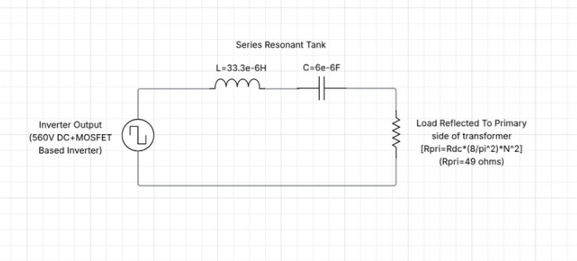
Fig. 2.3.1: Series resonant converter FHA equivalent circuit (Lr = 33.3 µH, Cr = 6 µF)
The voltage gain transfer function |Vo/Vi| of the SRC as a function of normalised frequency u = f_s/f_r is derived from the series AC circuit impedance:
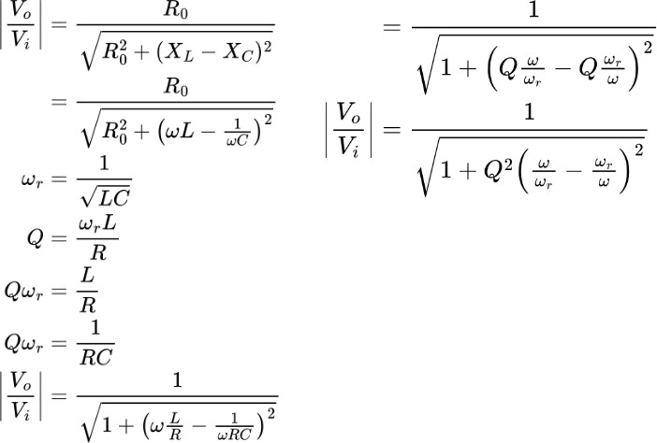

Critical features of the gain equation:
    - When u = 1 (f_s = f_r): The impedance of Lr and Cr is mutually cancelled out (X_L = X_C). The impedance of the tank becomes R_pri only, and the gain acquires its maximum possible value of one. In other words, all the power is fed to the load at unity power factor.
    - When u > 1 (f_s > f_r): There is a net inductance in the tank (X_L > X_C). As a result, the current leads the voltage. It is an essential feature for achieving zero-voltage switching.

    - When u < 1 (fs < fr): This implies that the tank will be capacitive (XL < XC). In this case, operation of the converter is impossible since ZVS is no longer attained, and ZCS condition is possible, hence increased turn-off loss.
    - As R_pri increases (decrease in load) / Q decreases, the gain curve levels off and therefore the converter cannot control the output by varying the frequency..
The frequency-domain specifications obtained using MATLAB for the designed series-resonant converter (Lr = 33.3 µH, Cr = 6 µF) are displayed in Fig. 2.3.3. From the four graphs plotted (Vrms vs f, Vpeak vs f, Irms vs f, and Power vs f), it can be seen that both peak voltage (68.75 volts referring to primary) and peak power take place at the resonant frequency of 11.26 kHz.
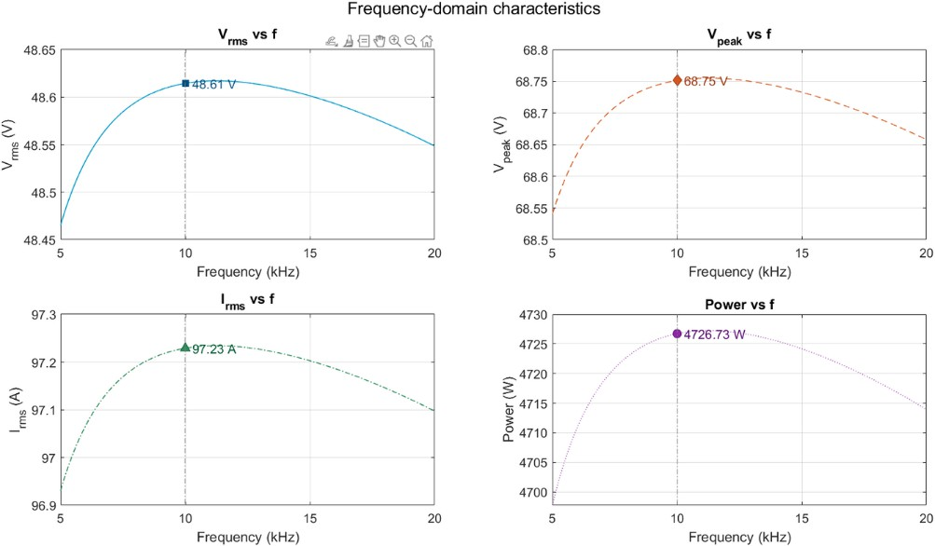
Fig. 2.3.2: Frequency-domain characteristics of the Series Resonant Converter — V_rms, V_peak, I_rms, and Power vs switching frequency

Design of Series Resonant Converter
The specification for the series resonant converter is: Vin = 560V DC, Vout = 51V DC, Po = 1kW, transformer turns ratio n = 10.37 (560V / 54V primary referred output), load resistance Rd.c. = 2.68Ω.
The resonant circuit component values are chosen to be:

fr = 1/(2π√(33.3 × 10⁻⁶ × 6×10⁻⁶)) = 1/(2π × 4.47 × 10⁻⁵) = 11,259Hz = 11.26kHz
With these operating parameters, and a transformer turns ratio of approximately 10.37, the secondary output peak voltage can be found from Figure 2.3.3 to be: V_peak = 68.75V referred to the primary. This corresponds to a peak output voltage of approximately 68.75/10.37 ≈ 6.63V peak, which results in about 51V DC after full wave rectification and filtration at full rated load.
The reflected quality factor at rated load is:
Q = ω_r × Lr / R_pri = (2π × 11259 × 33.3×10⁻⁶) / 49 ≈ 1.44 / 49 ≈ 0.048
The Simulink model of the Series Resonant Converter is shown in Figure 2.4.1 below. This consists of: 1) A DC source with voltage rating of 560 volts, 2) Full-bridge MOSFET inverter operated with complementary pulses of 50% duty cycle with a phase difference of 180 degrees between two legs, 3) Series resonant tank (Lr-Cr), 4) High frequency isolation transformer having turns ratio of 11:1, 5) Full bridge diode rectifier, and 6) Output filter capacitor with resistive load.
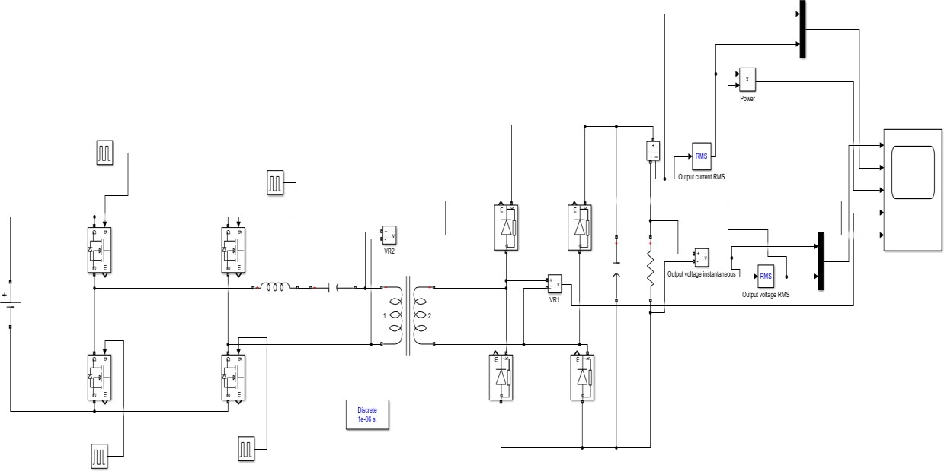

Fig. 2.4.1: MATLAB/Simulink model of the full-bridge Series Resonant Converter (discrete, 1 µs time step)

Characteristics of Parallel Resonant Converter
In the case of the PRC converter, the resonant capacitance Cr is connected in parallel with the transformer’s primary coil (as well as with the reflected resistance R_pri). The resonant inductance Lr

is then connected in series with the inverter output voltage source and in parallel with the Cr–R_pri combination, as depicted in Figure 2.5.1.

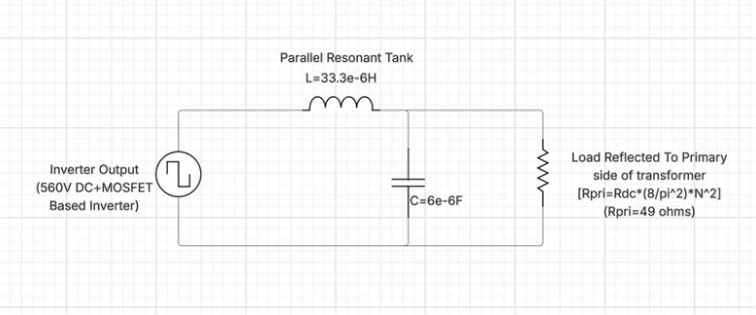
Fig. 2.5.1: Parallel Resonant Converter FHA equivalent circuit (Lr = 154 µH, Cr = 1.3 µF)
The voltage gain of PRC is decided by the voltage divider ratio across Z_L = jωLr and the parallel resistance of Z_C = 1/(jωCr) and R_pri. While for the SRC, the voltage gain cannot be greater than one before resonance, for the PRC case, it can go beyond one before reaching resonance, yet at such frequencies the circuit is capacitive and the zero voltage switching condition cannot be met.
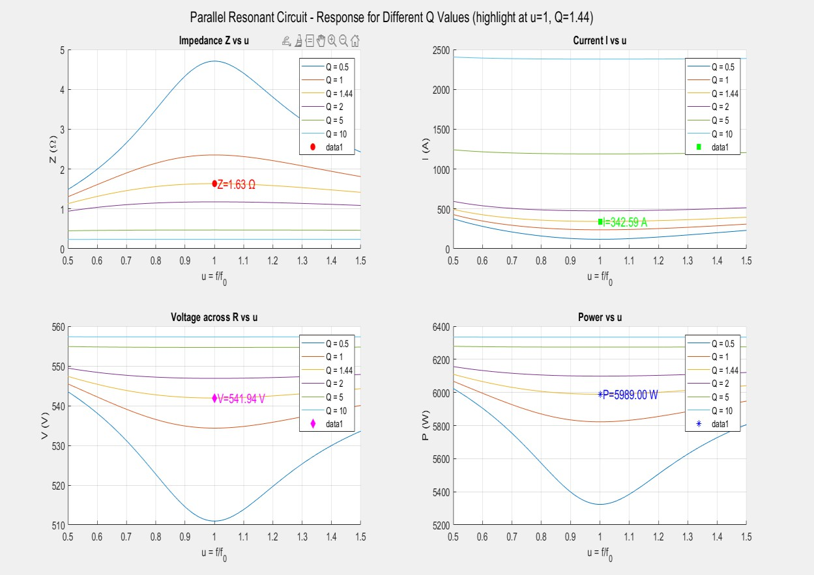
Fig. 2.5.2: Frequency-domain characteristics of the Parallel Resonant Converter — Impedance Z, Current I, Voltage V, and Power vs normalised frequency u (Q = 1.44 highlighted)

Observations:
- The impedance of the parallel LC tank is maximum when u = 1. With a value of Q equal to 1.44, the operating point corresponds to Z = 1.63 Ω, I = 342.59 A (circulating current), V = 541.94 V (across the parallel connection), and P = 5989 W. It can be seen that the circulating current remains very high in this mode, representing one of the weaknesses of the PRC compared to SRC where circulating currents decrease in proportion to the load current.
- For u > 1 (inductive operation or ZVS region): The current in the inductor lags the inverter voltage allowing the turn-on of the MOSFET in zero voltage condition. The gain decreases monotonically with the increase in u, giving an easy controller design.
- The PRC is able to regulate the output voltage due to its characteristic being independent of Q in the region of frequency larger than the resonant frequency.

Design of Parallel Resonant Converter
Parallel Resonant Converter is based on the same specification for the output voltage as that of the SRC (input voltage 560 V, output 51 V / 1 kW, load resistance 2.68 Ω, turns ratio n = 10.37). For the Parallel Resonant Converter, the components used are Lr = 154 µH and Cr = 1.3 µF. Therefore, the frequency of the resonant network is given by
fr = 1 / (2π√(154 × 10⁻⁶ × 1.3 × 10⁻⁶)) = 1 / (2π × 1.415 × 10⁻⁵) ≈ 11,248 Hz ≈ 11.25 kHz
The following is the calculation of the resonant frequency, the fundamental voltage, turns ratio, and primary referred output voltage for the given design. For the output from the full-bridge inverter, the fundamental RMS voltage is V₁,rms = 4 × 560 / (π√2) = 504.18 V. Considering the turn ratio n = 560/54 = 10.37, we have the primary referred output voltage V_R,rms = 504.18 / 10.37 = 48.62 V.

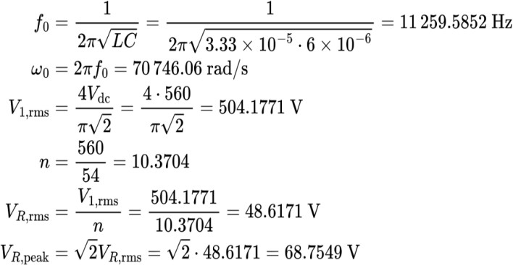

Figure 2.6.2 shows the Simulink representation of the Parallel Resonant Converter. The configuration of the converter differs from that of the SRC circuit due to the position of the resonant capacitor, which is now placed in parallel with the primary winding of the transformer, thus giving rise to the parallel tank configuration. The other components such as the full-bridge inverter, gate drive pulses, isolation transformer, and diode rectifier remain the same.
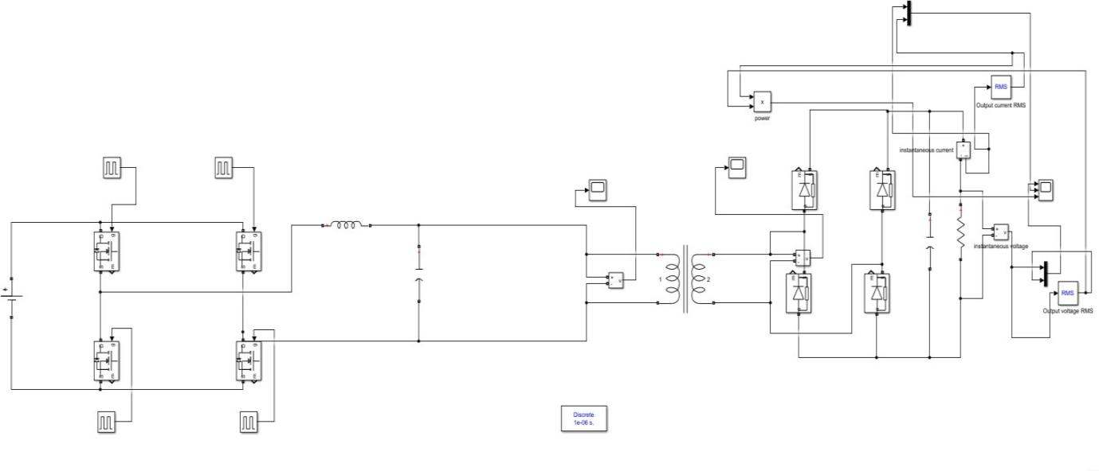
Fig. 2.6.1: MATLAB/Simulink model of the full-bridge Parallel Resonant Converter (discrete, 1 µs time step)

ZVS Operation (Soft Switching)
Zero Voltage Switching (ZVS) is the main technique used in full-bridge resonant converters for achieving soft switching. Zero Voltage Switching means that all MOSFETs in the full-bridge inverter switch ON while the voltage across their drain-to-source junction (V_DS) is equal to zero, thereby avoiding any losses due to discharging of the capacitive energy at the turn-on point in conventional hard switching.
The principle behind ZVS is as follows. The inverter circuit feeding a resonant tank circuit with inductance (L_r) (with f_s > f_r) produces an output voltage (v_AB) that leads the inductor current (i_Lr) by a phase difference (φ > 0). Between two successive switchings from one diagonal (S1, S4) to the other diagonal (S2, S3) pairs, there is a period called a dead time during which all the switches are turned OFF. During this dead time, the lagging inductor current (which cannot abruptly change) continues to flow and charges/discharges the output capacitances of the MOSFETs (C_oss). More specifically:
    - The body diode of the incoming switch is used to discharge the C_oss of that switch to zero.
    - The outgoing switch has its C_oss charged up to the supply voltage level.
    - When V_DS becomes zero for the incoming switch, then its body diode becomes conductive, and the signal is applied to the gate of the switch.
A dead time should be properly designed. If the dead time is low, there is not enough time left for the capacitor C_oss to completely discharge and the effect of ZVS will be lost. On the other hand, if the dead time is high, the body diode conducting period will increase, hence conduction losses will also increase. The proper dead time for the converters used in this project is about 400-750ns for switching frequencies of 100-128kHz to get a full ZVS as shown in Simulink.
The effect of ZVS can be easily achieved in the SRC for all loads where f_s > f_r, since the inductance region is maintained under the whole load range due to maintaining a switching frequency which is higher than resonance frequency. Similarly, for the PRC, ZVS effect is achievable for f_s > f_r; however, due to high circulating currents in the resonant circuit during f_r, the penalty of higher reactive current at light load occurs.

Achieving ZVS in Series and Parallel Resonant Circuits
ZVS is confirmed in the Simulink model through the superposition of the drain-source voltage (V_DS, blue curve) of the primary MOSFET with the resonant tank current (i_Lr, red curve). ZVS occurs

whenever the V_DS falls to zero prior to the arrival of the gate pulse signal, which means that the body diode is activated first before the MOSFET switches on with no voltage drop across it.
Figure 2.8.1 illustrates the Simulink ZVS confirmation curve for the Series Resonant Converter. The blue curve is the actual output voltage (the switching node voltage; analogous to variations in V_DS), while the red curve is the resonant tank current. The resonant tank current exhibits the distinct quasi- sine wave profile, which results from the series LC filter's action on the current. The crossing of zero in the current profile during each switching cycle, after V_DS is at zero, verifies that ZVS is successfully attained in the SRC under design operation conditions.

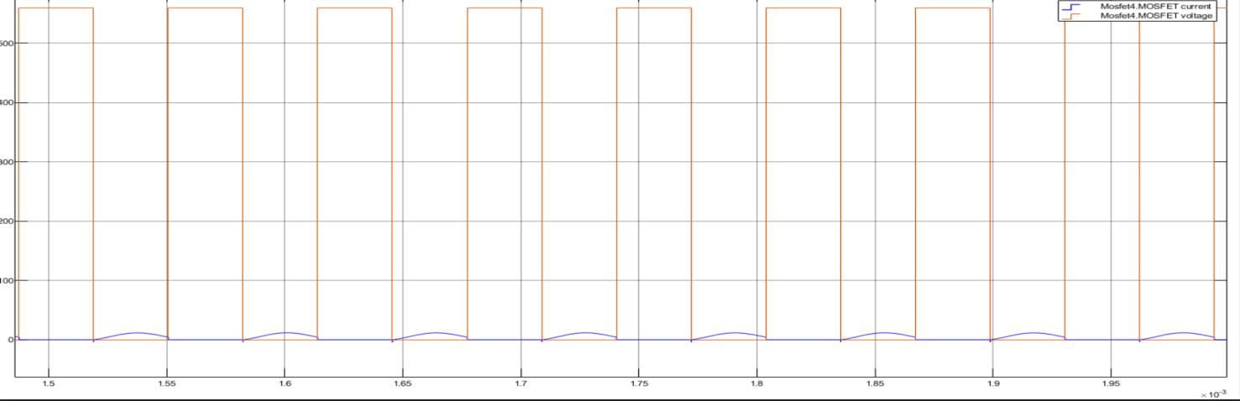
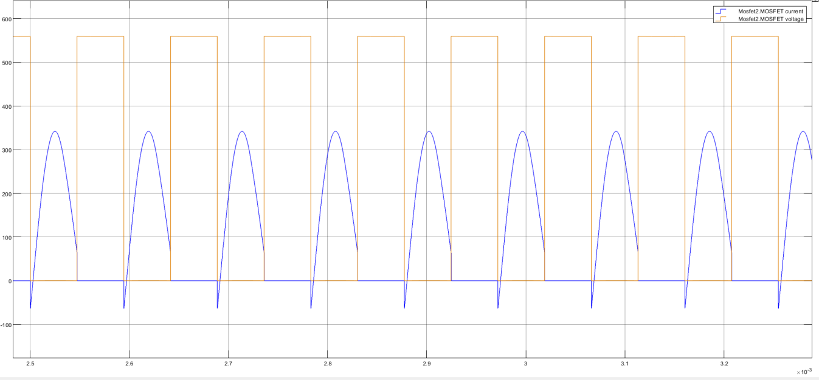

Fig. 2.8.1: ZVS verification waveform for the Series and parallel Resonant Converters — switching node voltage (orange) and resonant tank current (blue). Zero-voltage transitions confirm ZVS turn-on of the primary MOSFETs.

ZVS in the Parallel Resonant Converter is accomplished using the same principle: inductive mode operation (f_s > f_r) guarantees that the tank current lags the inverter voltage, thus ensuring the provision of the reactive current required to discharge the output capacitances of the MOSFETs during the dead time period. The higher inductance value of the PRC (Lr = 154 µH against 33.3 µH in the SRC) implies that the current waveforms are slower, which in turn makes ZVS possible for a greater range of dead times since there is a lower rate of change in the inductor current.
In conclusion, it can be observed that the SRC and PRC converters operate in the ZVS mode if their frequency control is such that they switch at frequencies above the resonant frequency. In other words, the operating condition for inductive mode, which is validated through the positive value of the reactive power (Q > 0), should always be satisfied by the proposed controller discussed in Chapter 4.

CHAPTER 3

FULL BRIDGE LLC & LCC RESONANT DC-DC CONVERTER

Both the Series and Parallel Resonant Converters introduced in Chapter 2 have some intrinsic limitations. The SRC lacks the ability to control the output voltage at low load, whereas the PRC is plagued by the presence of large circulating currents at low loads, making it less efficient than it should be. The LLC and LCC resonant structures are purposely designed to solve the shortcomings of these two resonant converters, with the addition of extra reactive components in the tank circuit to form a multi-resonant system.
This chapter evaluates the LLC and LCC resonant converters by the use of First Harmonic Approximation (FHA), solves for the gain equation of these converters, provides frequency characteristic plots in MATLAB, and elucidates on the Simulink model as well as the design procedure.

Analysis of the LLC Resonant Equivalent Circuit
In addition to the resonant tank inductor Lr and resonant tank capacitor Cr, the LLC resonant converter includes another inductor, namely, the magnetizing inductance Lm of the transformer. This leads to a three-component tank network comprising two inductors and one capacitor, which justifies the name of the topology. The equivalent circuit of the FHA, illustrated in Fig. 3.1.1, comprises the following elements: the sinusoidal voltage source, representing the full-bridge inverter operating at the switching frequency fs; the series resonant inductor Lr and series resonant capacitor Cr; and the parallel combination of the magnetizing inductance Lm and the AC equivalent of the load resistance R_ac.

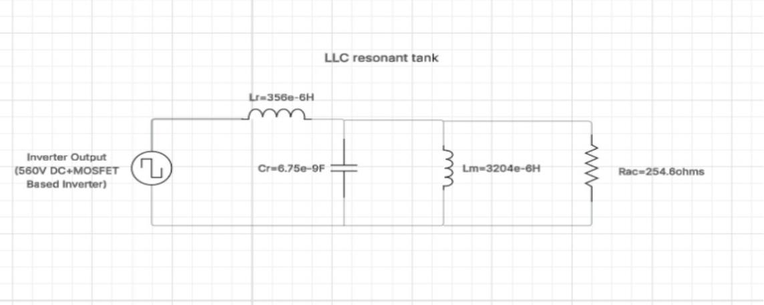
Fig. 3.1.1: LLC resonant converter FHA equivalent circuit (Lr = 356 µH, Cr = 6.75 nF, Lm = 3204 µH, R_ac = 254.6 Ω)
The LLC tank has two characteristic frequencies. The first resonant frequency f_r1, determined by Lr and Cr, is:
f_r1 = 1 / (2π√(Lr × Cr))

The second resonant frequency f_r2, determined by the total inductance (Lr + Lm) and Cr, is lower:
f_r2 = 1 / (2π√((Lr + Lm) × Cr))
For f_s = f_r1: Load matching inductor Lm acts like a short-circuit with respect to the reflected load (at maximum load), thus the equivalent tank circuit becomes Lr-Cr. Gain = 1 and power transfer efficiency is optimal. For f_s = f_r2: The effective inductance of the tank becomes (Lr + Lm). Gain > 1 for frequencies lying between f_r2 and f_r1. For frequencies higher than f_r1, gain decreases monotonically, thereby giving a stable range for the operation of the converter.
AC voltage gain (K) of the LLC converter with FHA can be calculated from the formula obtained using the voltage division rule between Z_Lr, Z_Cr, and Z_Lm // R_ac
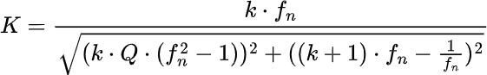
The parameters in the gain expression are defined as follows:

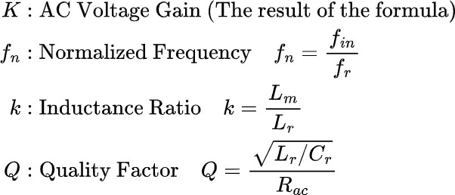

Characteristics of LLC Resonant Converter
The performance specifications of the LLC circuit in terms of its AC voltage gain, output voltage, output current, and output power as a function of switching frequency are illustrated in Fig. 3.2.1 under various loading conditions (values of Q between 0 and 0.40, indicating unloaded to fully loaded
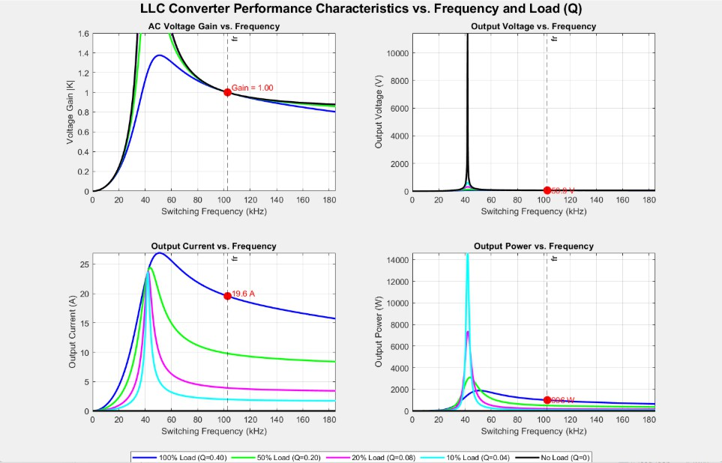
Fig. 3.2.1: LLC Converter performance characteristics vs. switching frequency and load Q — AC gain, output voltage, output current, and output power. Operating point at f_r ≈ 102.8 kHz highlighted: Gain = 1.00, V_out = 50.8 V, I_out =19.6 A, P_out ≈ 996 W.

Key features of the characteristic curves:
    - At f_s = f_r1 ≈ 102.8 kHz: The gain is unity under any loading condition. It represents the natural operation mode of the LLC, where the output voltage matches the target level (51 V DC), irrespective of the load value. The dashed vertical line in Figure 3.2.1 indicates this frequency.
    - Beyond f_r1 (f_s > 102.8 kHz): The gain decreases progressively with respect to frequency. The LLC operates in its inductive zone, thus guaranteeing ZVS of the primary MOSFET switches. It represents the most desirable zone for controlling the converter.
    - Below f_r1 (f_s < f_r1): The gain increases sharply with increasing frequency, particularly at light load (low Q). It can result in the loss of ZVS as well as instability. The closed-loop system shall ensure that f_s ≥ f_r1 under all circumstances using an appropriate frequency floor limit.
    - Load regulation: Under 100% load conditions (Q = 0.40), the gain curve is highly damped with high stability above the resonant point. However, at light load (Q → 0), a gain spike appears before the resonance frequency.

Design of LLC Resonant Converter in Simulink
Open-loop LLC resonant converter Simulink model is illustrated in Fig. 3.3.1 below. The model employs discrete solver and 10 ns (1e-8s) time step resolution to capture fast switching transients occurring at ~102.8 kHz. Power stage components comprise the following: (i) 560 V DC input source; (ii) full-bridge MOSFET inverter with 50% duty cycle complementary switching control signals and phase difference of 180º between legs plus dead-time; (iii) LLC resonant circuit comprising Lr series, Cr series and Lm modelled within transformer magnetizing inductance; (iv) high-frequency transformer with turns ratio n~10.37; (v) full-bridge diode rectifier; and (vi) output filter with 220 µF capacitor and 2.68 Ω resistive load. Output voltage RMS, current RMS and output power are measured using dedicated measurement blocks.
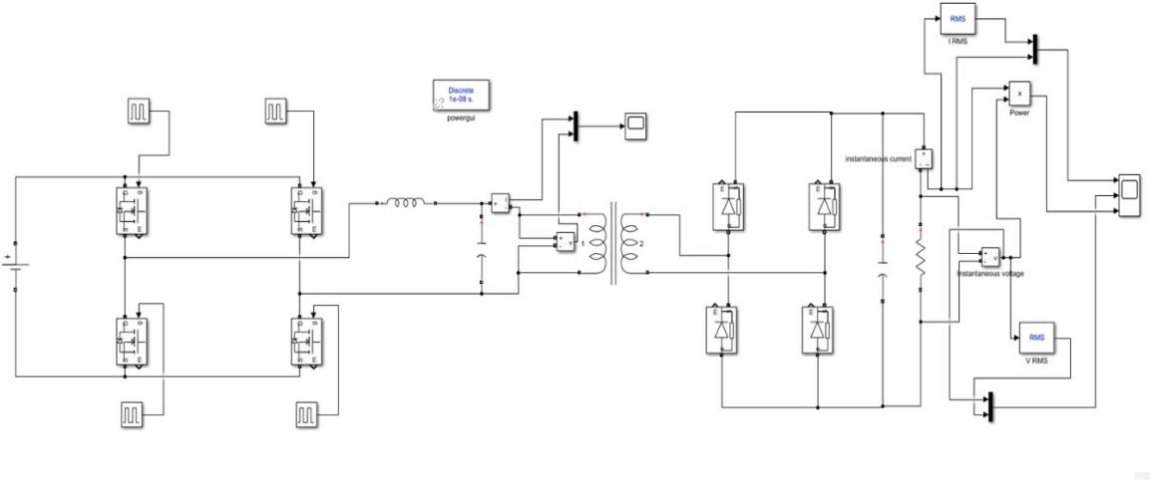
Fig. 3.3.1: MATLAB/Simulink model of the full-bridge LLC Resonant Converter (discrete, 10 ns time step)

The gate drive circuit employs only one square wave signal generator that generates a square wave at the frequency of operation of the switch. The MOSFETs of the left leg, S1 & S3, are supplied by the square wave signal directly. The MOSFETs of the right leg, S2 & S4, receive the square wave signal phase-shifted by 180 degrees. A delay of 400-750 ns is introduced using transport delay blocks to ensure ZVS by discharging the MOSFET output capacitances by the inductor current prior to switching on.

Optimal Design for LLC Topology
LLC Resonant Converter
The systematic design process for the LLC Resonant Converter is illustrated using the flow chart shown in Fig. 3.4.1. System Specifications are considered first before progressing to selecting transformer turns ratio, calculating Gain Range, selecting inductance ratio k, Quality Factor Q, Resonant Component calculations and finally verifying Gain Peak.
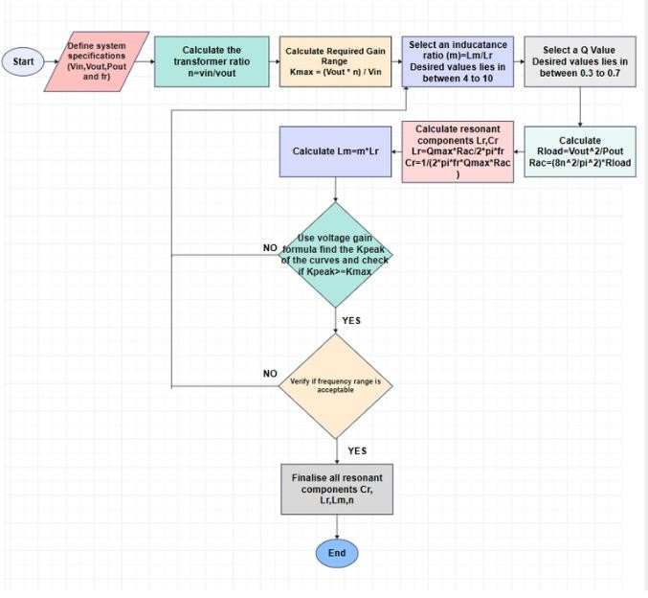
Fig. 3.4.1: Design flowchart for the LLC resonant converter
The design process comprises several stages, as listed below. First, the transformer turns ratio n = V_in / V_out = 560 / 54 ≈ 10.37 must be found. Maximum gain K_max = (V_out × n) / V_in =
1.0 at rated operation (gain margin controlled via frequency range control above resonance). In turn, the inductance ratio k = Lm/Lr should be within 4–10; larger k values minimize magnetizing current,yet narrow the gain range; smaller k increases the gain range but results in higher magnetizing current. For our circuit, k ≈ 9 should be used. Finally, the quality factor Q must be chosen within 0.3–0.7 at rated load in order to provide the damping of the gain peak. The resonant elements can then be found from the expressions:
Lr = Q_max × R_ac / (2π × f_r) Cr = 1 / (2π × f_r × Q_max × R_ac)
Lm = k × Lr
The maximum gain K_peak of the converter designed is then checked with respect to K_max based on the gain expression (Figure 3.1.2). If K_peak ≥ K_max and the frequency range is acceptable (worst case light load with f_s,min well above f_r2), then the design process is completed with the values for Lr, Cr, Lm, and n.

Analysis of the LCC Resonant Equivalent Circuit
The LCC resonant converter builds on the LLC resonant converter by placing a capacitor, Cp, in parallel with the transformer primary (parallel to both Lm and R_ac). This configuration results in the presence of two capacitors and one inductor in the resonant tank, namely Lr, Cr, and Cp, in series respectively. Additionally, there is Lm, which is in parallel with the load.3.5.1.

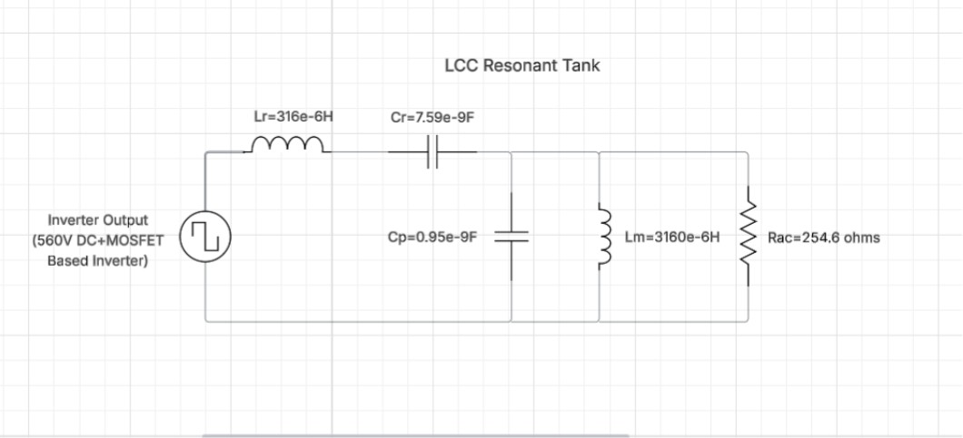
Fig. 3.5.1: LCC resonant converter FHA equivalent circuit (Lr = 316 µH, Cr = 7.59 nF, Cp = 0.95 nF, Lm = 3160 µH, R_ac = 254.6 Ω)
The parallel capacitor Cp offers one more degree of freedom that is not present in the LLC configuration. The capacitance can be distributed among series (Cr) and parallel (Cp) capacitors, which allows controlling the peaks of voltage gain and gain slope at higher frequencies separately.
The impedance of the LCC tank consists of three reactive components; therefore, it exhibits a more complicated frequency behavior than the LLC tank.
The generalised voltage gain of the LCC converter under FHA is:

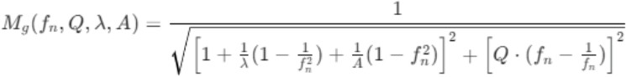

The additional parameters specific to the LCC topology are defined as:
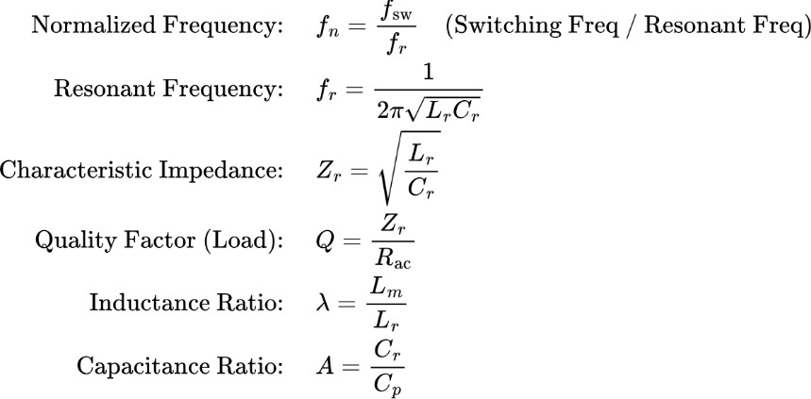
For the designed LCC converter, the component values are: Lr = 316 µH, Cr = 7.59 nF, Cp = 0.95 nF, Lm = 3160 µH, R_ac = 254.6 Ω. These yield:
f_r = 1 / (2π√(316×10⁻⁶ × 7.59×10⁻⁹)) ≈ 102.7 kHz λ = Lm / Lr = 3160 / 316 = 10.0
A = Cr / Cp = 7.59 / 0.95 = 7.99
Z_r = √(Lr/Cr) = √(316×10⁻⁶ / 7.59×10⁻⁹) = 204.2 Ω Q = Z_r / R_ac = 204.2 / 254.6 ≈ 0.80

Characteristics of LCC Resonant Converter
The performance characteristics of the LCC converter are shown in Fig. 3.6.1. As with the LLC plots, four load conditions are overlaid. The resonant frequency f_r ≈ 102.7 kHz is marked by the vertical dashed line
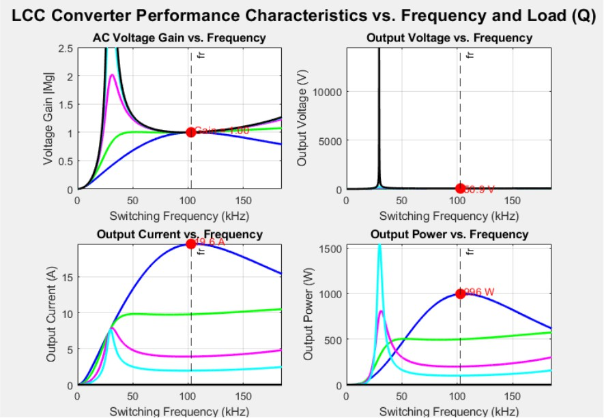

Fig. 3.6.1: LCC Converter performance characteristics vs. switching frequency and load Q — AC gain, output voltage, output current, and output power. Operating point at f_r ≈ 102.7 kHz: Gain = 1.00, V_out = 50.8 V, I_out = 19.6 A, P_out ≈ 996 W.
Comparing the characteristics of LCC (Figure 3.6.1) to those of LLC (Figure 3.2.1):
    - Gain peak: The LCC network features a more pronounced gain peak below resonance compared to the LLC network (the maximum gain is 2.5 versus 1.5 for the LLC). This offers additional tuning freedom when increasing output gain at extremely low loadings, but frequency regulation must be more precise not to operate within the gain peaking regime.
    - Above resonance: The gain curves of both networks monotonically decrease above f_r and can therefore be used for frequency control within the ZVS region. The gain slope in the LCC network is somewhat steeper, implying that a smaller frequency range is needed for the same gain variation.
    - Load independence at resonance: When f_s = f_r, the gain of the LCC network is equal to one, regardless of the load value, similarly to the LLC network.
    - Additional Tuning Variable Capacitance Ratio (A): As the capacitance ratio A is increased (that is, when Cr/Cp increases), gain peak decreases in amplitude and the region of operation becomes more inductive.

Design of LCC Resonant Converter in Simulink
The structure of the open loop Simulink simulation for the LCC resonant converter is illustrated in Fig. 3.7.1. It is worth noting that this model has a similar structure as compared to the previous one, except for the capacitor that is connected in parallel with the primary side of the transformer. In the case of LCC converter, the series tank circuit is composed of Lr and Cr, and the parallel capacitor is located in parallel with the magnetizing inductance of the transformer (Lm) as well as its reflection in the form of load resistance R_ac.
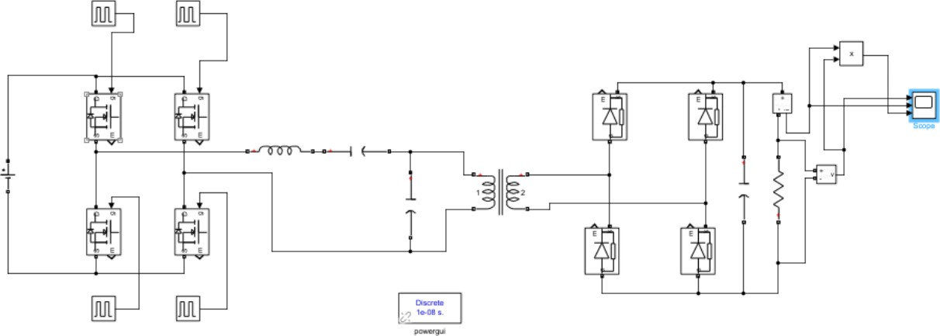

Fig. 3.7.1: MATLAB/Simulink model of the full-bridge LCC Resonant Converter (discrete, 10 ns time step)
The LCC Simulink model employs a 10 ns discrete-time step similar to that used in the LLC model, which allows for proper resolution of the 102.7 kHz switching operation. The parallel capacitor Cp=0.95 nF has been modeled as a discrete capacitor and is placed in parallel at the transformer primary node. The blocks used to measure RMS current, RMS voltage, and power employ a mean- value filter at the switching frequency to obtain a steady DC reading.

Optimal Design for LCC Topology
As shown in Fig. 3.8.1, the LCC design algorithm involves adding two further choices to the LLC algorithm presented above; these are the ratio of inductances, denoted by λ (Lm/Lr), and the ratio

of capacitances, referred to as A (Cr/Cp). Both are chosen from suggested ranges, specifically 4–10 for λ and 8–12
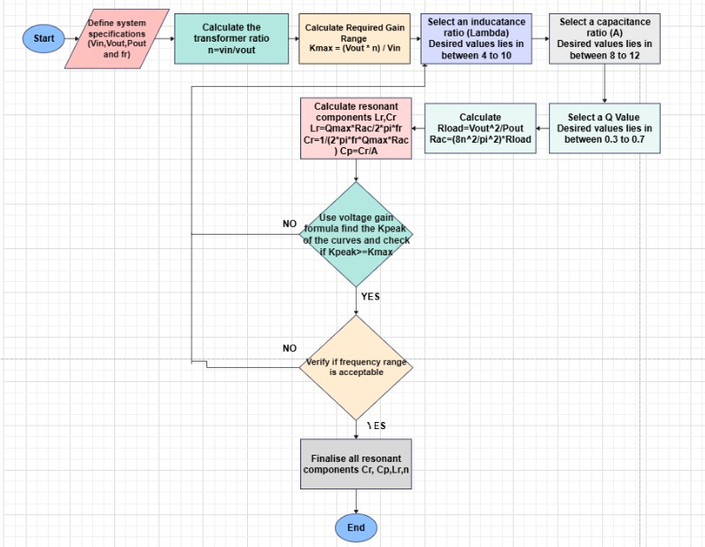
Fig. 3.8.1: Design flowchart for the LCC resonant converter

However, the difference from the LLC design procedure is calculating Cp using the ratio A of capacitances once Cr is known according to the equation below.
Cp = Cr / A

For the proposed LCC converter, having A = 7.99 and Cr = 7.59 nF, the value of the parallel capacitor will be Cp = 7.59 / 7.99 = 0.95 nF. The result is confirmed by the gain expression (Figure 3.5.2), ensuring that K_peak ≥ K_max and the range of frequency variation for closed-loop control (f_s,min – f_s,max) does not exceed the acceptable limits. The last set of components includes Lr = 316 µH, Cr = 7.59 nF, Cp = 0.95 nF, and Lm = 3160 µH.

Achieving ZVS in LLC and LCC Resonant Circuits
ZVS in both LLC and LCC converters is obtained by using the exact same principle used in SRC and PRC, whereby working in the inductive mode (f_s > f_r) leads to a lagging current waveform of the resonant tank with respect to the inverter voltage, resulting in discharge of the MOSFETs’ output capacitances during dead time prior to switching.
In addition to the high operating frequency range for ZVS in both SRC and LLC converters, LLC also boasts a very wide ZVS range due to the presence of magnetizing inductance, Lm, which provides an additional constant current. This means that even at a very light load, where the reflected load impedance is quite high, thus producing a low value of series resonant current, Lm will continue providing magnetizing current flowing through the body diode of the MOSFET, ensuring ZVS down to zero load.
Similar ZVS condition can also be achieved in the LCC topology, where the ZVS condition results from the phase relationship between the tank current and the switching voltage. Parallel capacitance Cp in the LCC topology slightly reduces the role of magnetising current in ZVS when compared to the LLC topology; however, ZVS condition is well-satisfied for f_s > f_r.
Output voltage transient of the LLC converter (Fig. 3.9.1) shows that the output voltage regulation takes place to achieve stable operation at 51 V despite the initial overshoot, which happens in less than 5 ms. In other words, the closed-loop PI controller, which guarantees that f_s ≥ f_r,min = 100 kHz, achieves ZVS condition during the transient process.

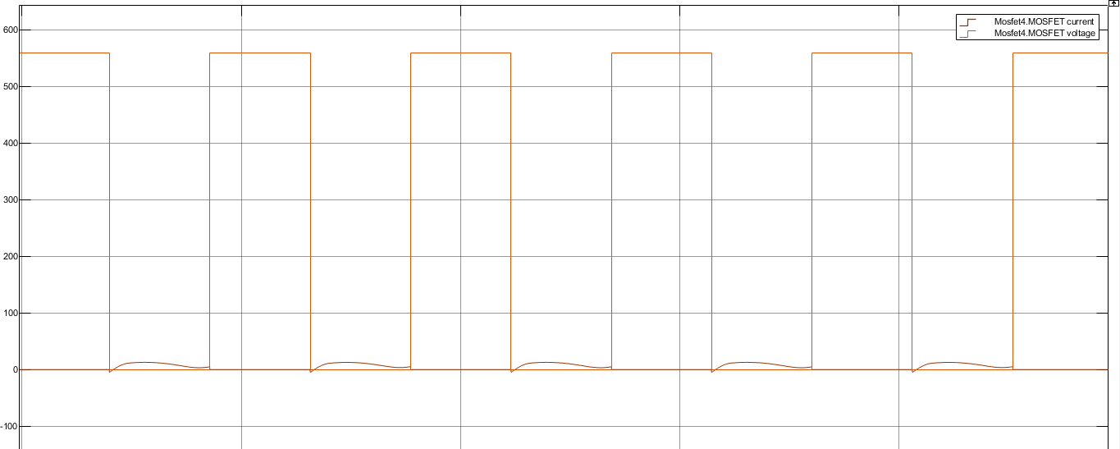
Fig. 3.9.1: ZVS verification waveform for the LLC Resonant Converter — switching node voltage (orange) and resonant tank current (brown). Zero-voltage transitions confirm ZVS turn-on of the primary MOSFETs.
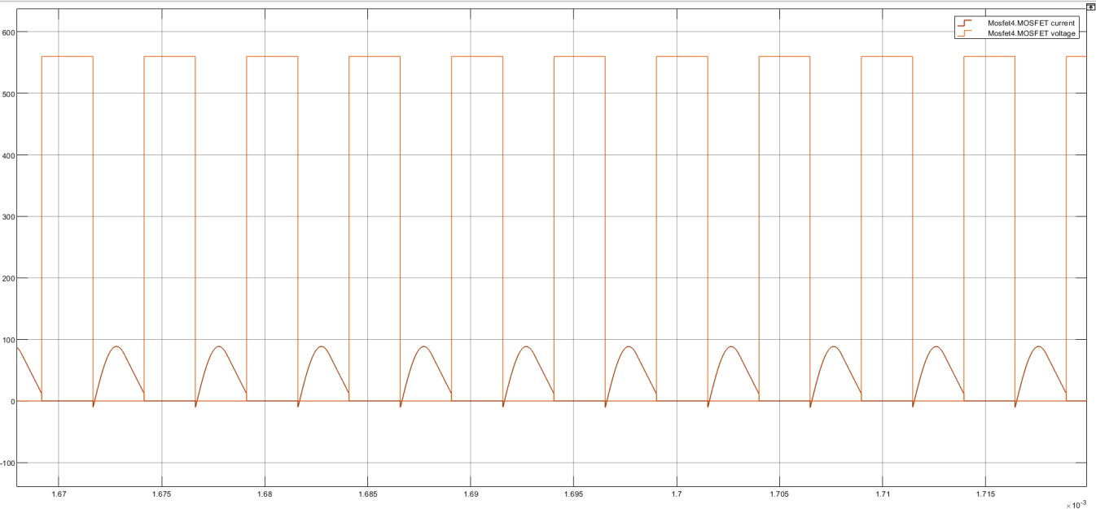

Fig. 3.9.2: ZVS verification waveform for the LCC Resonant Converters — switching node voltage (orange) and resonant tank current (brown). Zero-voltage transitions confirm ZVS turn-on of the primary MOSFETs.

In conclusion, the LLC and LCC resonant converters exhibit good ZVS performance throughout their respective load ranges when run beyond the series resonant frequency. The LLC outperforms the LCC in terms of ZVS performance range, especially under light load conditions, owing to the effect of the magnetising inductance current. On the other hand, the LCC presents a broader range for gain tuning along with another variable parameter (Cp). This makes the LCC more suitable for applications where there is a considerable variation in the input and load.

CHAPTER 4

CLOSED LOOP IMPLEMENTATION

Open-loop resonant converters operate at a fixed switching frequency and rely on component tolerances and design margin to deliver the target output voltage. While suitable for laboratory verification, open-loop operation cannot reject input voltage disturbances, load transients, or component ageing effects. Closed-loop control is therefore essential for practical deployment of the LLC and LCC converters in DC microgrid applications where the output must be regulated to 51 V despite variation in input voltage and load resistance.
This chapter presents the frequency-based closed-loop control architecture implemented for both the LLC and LCC resonant converters. Unlike conventional PWM converters — which regulate output voltage by varying duty cycle — resonant converters operating at 50% duty cycle must vary switching frequency to adjust gain. The control signal is therefore a frequency command rather than a duty cycle. A PI controller processes the output voltage error and generates the switching frequency, which is then converted to complementary gate pulses via a Voltage-Controlled Oscillator (VCO) implemented in Simulink. Voltage-mode control, state-space modelling, and the Bode plot of the LLC plant transfer function are also presented to provide theoretical grounding for the controller design.

Controller Design — Voltage Control (LLC)

Control Architecture
The higher efficiency ratio of 89.83% recorded by the SRC as opposed to the 87.80% recorded by the PRC is mainly attributed to the reduced current flowing in the circuit by virtue of its series nature that limits the tank current to the current drawn by the load at resonance. Nonetheless, neither of them compares to the performance of LLC and LCC, as predicted in the design literature.

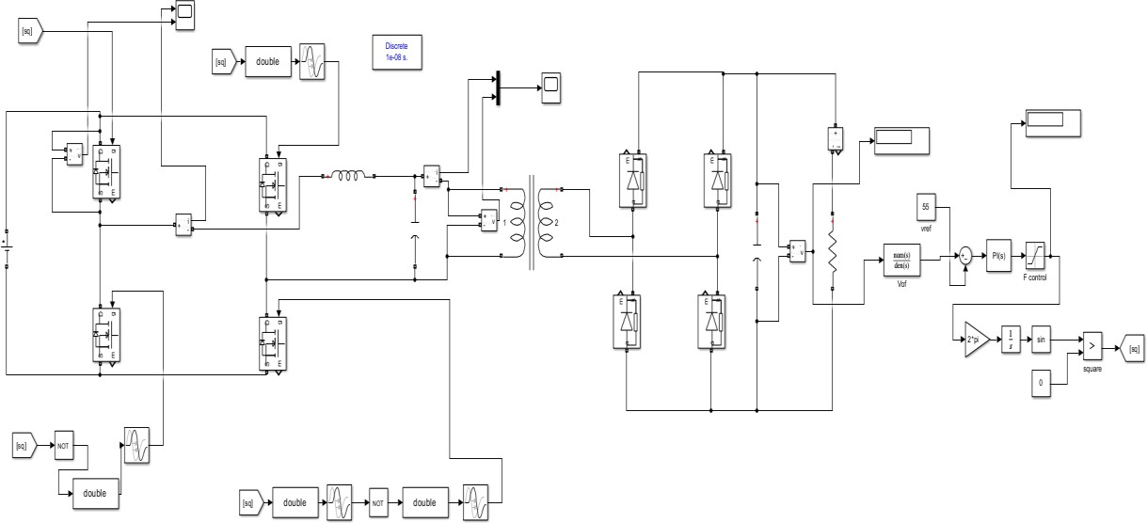

Fig. 4.1.1: Full-bridge LLC closed-loop Simulink model — power stage with PI frequency controller, LPF, saturation, VCO, and complementary gate pulse generation
Closed-loop control operation is performed according to the following steps:
      - Measurement (sensing): Output capacitor voltage is measured and then goes through a first- order low-pass filter 1/(0.001s + 1) that removes fast fluctuations due to high-frequency switching and extracts the DC component V_o,filtered.
      - Error generation: Filtered output voltage is subtracted from the reference voltage, V_ref = 51 V to generate an error signal e = V_ref − V_o,filtered.
      - PI controller: Error signal e goes through a PI controller characterized by proportional gain K_p
= 15,000 and integral gain K_i = 4×10⁶. Proportional part makes the controller respond immediately to any error while integral part makes it free of steady-state offset.
      - Frequency saturation: PI controller output signal is considered the switching frequency control signal f_s. It undergoes saturation, where the lower boundary is f_s = 110 kHz (above ZVS threshold f_r for safe operation) and the upper one corresponds to the point when gain becomes too small for rated power delivery, f_s = 220 kHz. Lower frequency bound constitutes the most critical constraint since falling below the resonant frequency would result in entering capacitive region and loss of ZVS.
      - Generation of CO and gate signals: The frequency signal is converted into the angular frequency ω_s = 2πf_s by multiplying with 2π. This is integrated to produce a phase angle θ(t), which grows continuously. The sine block generates a sinusoidal output from the input phase angle, and the comparator (threshold level = 0) creates a gate square wave signal. Two sets of

complementary signals, whose phase difference is 180 degrees, are created for each pair of legs of the bridge circuit.

Control Law and Frequency Modulation Principle
LLC is a frequency-controlled converter. The relation between frequency and output voltage gain depends on the LLC gain characteristic (Chapter 3, Figure 3.2.1):
- If V_out ↑ (above reference), then error e < 0: PI output will decrease, resulting in an increase in f_s. Therefore, K will decrease and V_out will be lowered toward reference.
- If V_out ↓ (below reference), then error e > 0: PI output will rise, which will cause a decrease in f_s (but no less than 110 kHz). K will increase and V_out will go up toward reference.
The duty cycle will stay constant at 50%, while frequency varies. This is entirely different from how PWM converters operate, which require tuning of the PI regulator based on the duty-cycle-to-voltage gain characteristic.

LLC PI Controller Parameters

Parameter | Value | Unit
Proportional gain K_p | 15,000 | —
Integral gain K_i | 4 × 10⁶ | —
Lower frequency limit f_s,min | 110 | kHz
Upper frequency limit f_s,max | 220 | kHz
Dead time | 400 | ns
LPF time constant | 0.001 | s
Reference voltage V_ref | 51 (also tested: 60, 40) | V

Table 4.1: LLC closed-loop controller parameters

Simulink Output — LLC Closed-Loop
A closed loop LLC converter is analyzed for three different voltage references set points which are 51V (rated), 60V (greater than rated), and 40V (lesser than rated). The transients for the output voltages for all the three cases have been provided below.

Case (i): Reference Voltage, Vref=51V —Rated Condition
In Fig. 4.2.1, it can be seen that the output voltage settles at 51V. There is an overshoot value of around 83V because of the charging of the resonant tank. Then it damps out and settles in approximately 8ms. The settling time depends on the value of K_i of the integral. If K_i is higher, it will settle faster but there is a danger of instability
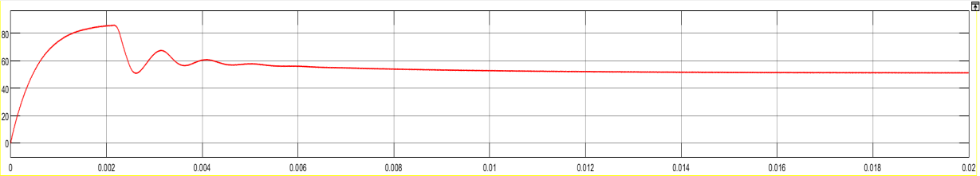
Fig. 4.2.1: LLC closed-loop output voltage — V_ref = 51 V. Stable regulation achieved within ~8 ms.

Case (ii): V_ref = 60 V — Above Rated
Figure 4.2.2 depicts the result of setting the reference value to 60 volts. Here too, the voltage is regulated to 60 volts. In this case, the gain increases through the reduction of the frequency to f_r as the controller tries to bring about f_s closer to f_r. Frequency saturation lower limit still holds good at 110 kHz.
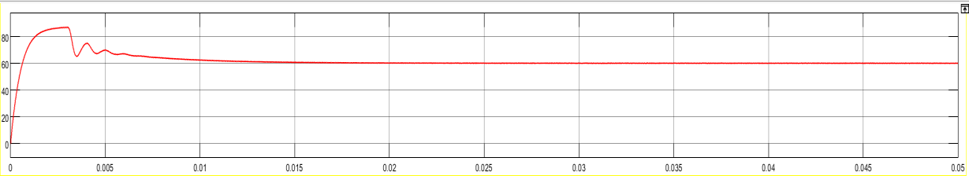
Fig. 4.2.2: LLC closed-loop output voltage — V_ref = 60 V. Regulated to 60 V within ~12 ms.

Case (iii): V_ref = 40 V — Below Rated
Figure 4.2.3 depicts the output voltage for reference value at 40V. As the PI control increases the value of f_s beyond 128 kHz to decrease the gain, it shifts the operation well above the resonance. This is because the operation with reference value at 40 V converges much better than for 51 V and 60 V due to increased frequency. Thus, the controller regulates for a ±22% set-point range.
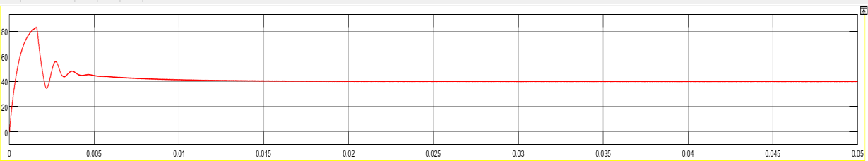
Fig. 4.2.3: LLC closed-loop output voltage — V_ref = 40 V. Stable regulation at 40 V within ~10 ms.

Large-Signal State-Space Model and Bode Plot

State-Space Formulation
For providing theoretical foundation for the design of the PI controller, LLC resonant converter is represented by large-signal state space system. State variables of the LLC resonant converter are given below.
      - Ir—Resonant inductor current (passing through Lr)
      - vC — Resonant capacitor voltage (between the terminals of Cr)
      - Im—Magnetizing inductor current (passing through Lm)
      - vO —Output capacitor voltage (regulated output voltage)
Input variable of the circuit is vIn which represents the square wave voltage across the bridge varying from +Vdc to -Vdc. Output variable of the circuit is vO. The state equations are formed using Kirchhoff’s Voltage Law (KVL) and Kirchhoff’s Current Law (KCL) for each energy storing component of the equivalent LLC
di_r/dt = (v_in − v_c − v_o×n) / Lr dv_c/dt = i_r / Cr
di_m/dt = v_o×n / Lm dv_o/dt = (i_r×n − v_o/R_dc) / C_out
The four equations above make up the state space model, given by ż = Ax + Bu, y = Cx + Du. The state variables can be represented by the vector x = [i_r, v_c, i_m, v_o]ᵀ. The matrices A, B, C, D will be calculated based on the physical parameters in the circuit. This will give us a 4th order transfer function with resonant frequencies f_r1 and f_r2

Small-Signal Frequency-to-Output Transfer Function
The more important transfer function for the design of the controller is that of frequency to output small-signal response (F_s → V_out). This transfer function relates a small disturbance of switching frequency δf_s with an output voltage disturbance δv_o, about the operating point. It is derived through the linearisation of the large-signal state equations by frequency decomposition of the bridge voltage:
v_bridge(t) = (4V_in/π) × sin(2π f_s t) [fundamental component]

Linearisation of the model with Small signals leads to the introduction of the input matrix B_f, representing the partial derivative of bridge voltage with respect to the switching frequency. The small signal state equation becomes:
δż = A·δx + B_f·δf_s δv_o = C·δx
The frequency-to-output transfer function G(s) = δV_o(s) / δF_s(s) is then computed from the linearised state-space matrices. The Bode plot of G(s) for the designed LLC converter is shown in Fig. 4.5.1.
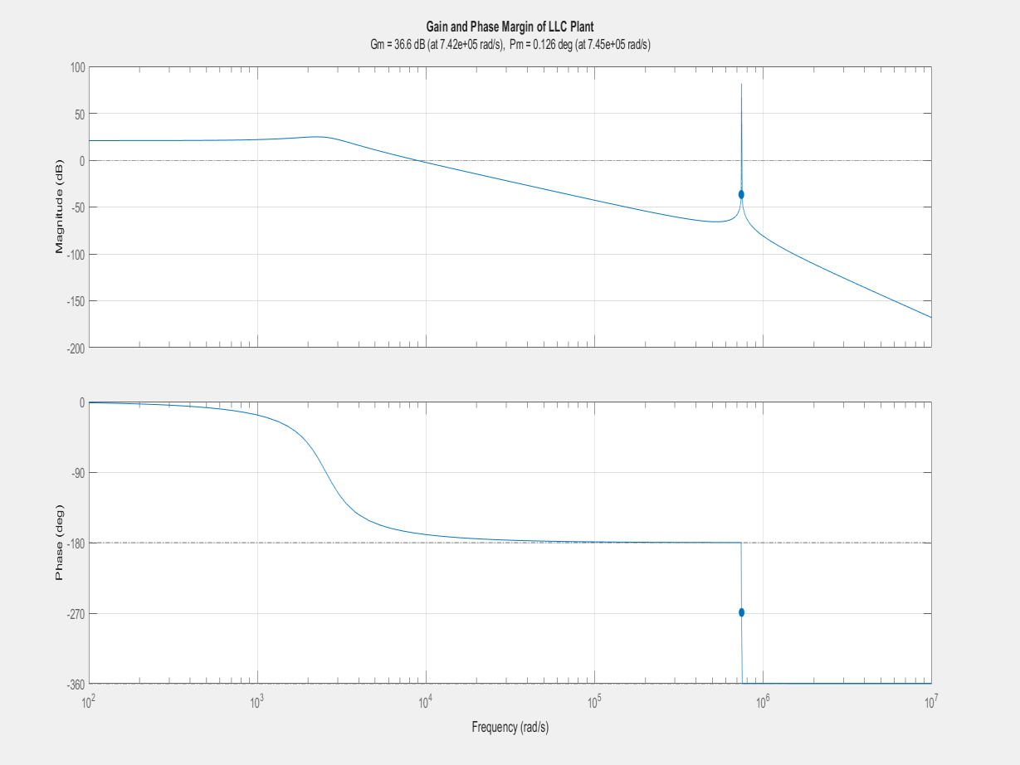
Fig. 4.5.1: Bode plot of the LLC plant transfer function (F_s → V_out). Gain margin = 36.6 dB at 7.42×10⁵ rad/s; Phase margin = 0.126° at 7.45×10⁵ rad/s. The open-loop plant is marginally stable, confirming that PI control and frequency limiting are essential for stable closed-loop operation.
From the Bode plot, it is shown that the open-loop LLC plant has a gain margin of 36.6 dB and a phase margin of only 0.126°, which is nearly zero, at the crossover frequency of about 7.45×10⁵ rad/s (≈118 kHz). This implies that the open-loop LLC plant is marginally stable since an infinite gain or high gain will cause the output of the power converter to be unstable. From the introduction of the PI controller, which provides phase lead at lower frequencies and the inclusion of frequency limit values of 110-220 kHz, the operating range becomes stable with inductive gain.

CHAPTER 5

EFFICIENCY ANALYSIS & LOSS CALCULATION

The main criterion for determining efficiency is the key difference between resonant converters and hard-switched ones. This chapter discusses the detailed analysis of efficiency for all four types of resonant converters, including SRC, PRC, LLC, and LCC, using the theoretical FHA model of losses and measurements in simulations. Simulink models of each type of resonant converter contain the subsystems used to measure losses. They calculate the input power, output power, and efficiency of the system. Theoretical verification by FHA modelling is provided for LLC and LCC types of resonant converters.
In the full-bridge resonant converter, there are four sources of power losses: conduction loss in MOSFET (I²_rms × R_DS(on)); turn-off switching loss (although ZVS removes the turn-on loss, a small turn-off loss appears because of the non-zero fall time); copper loss in magnetics (I²_rms × R_ESR in Lr and transformer windings); and secondary diode rectifier loss (V_f × I_avg for all four diodes). Losses equal the sum of these four types of losses. Efficiency is calculated by the formula: η
= P_out / (P_out + P_loss) × 100%.

Efficiency Analysis of Series and Parallel Topology

Series Resonant Converter — Simulink Loss Model
The efficiency testing model of the Series Resonant Converter in Simulink is depicted in Fig.
    - below. The model has been instrumented on both sides, the input and output, with power measurement blocks. Input power is calculated as the multiplication of input DC voltage (560V) and input RMS current. On the other hand, output power is determined using the formula: the product of output voltage RMS and output current RMS. Efficiency calculation block calculates efficiency as a ratio of output power to input power and then multiplies by 100 to determine efficiency percentage.

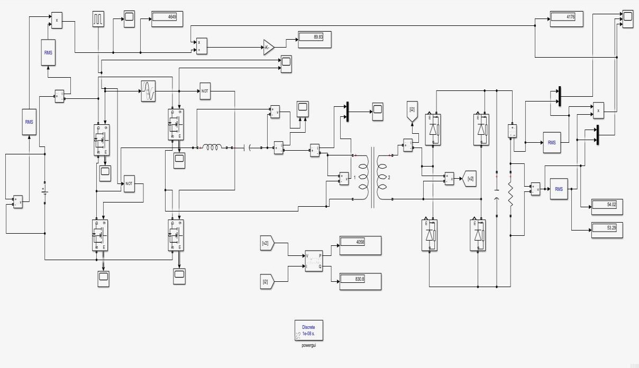
Fig. 5.1.1: Simulink efficiency measurement model for the Series Resonant Converter — input power = 4649 W, output power = 4176 W, efficiency = 89.83%, V_out,RMS = 54.02 V, V_out,peak = 53.29 V
The values shown in Fig. 5.1.1 are those found at the operating point for the Simulink model: Input power P_in = 4649 W
Output power P_out = 4176 W Efficiency η = 89.83%
The output voltage value is 54.02V (RMS) and 53.29V (peak). These values are correct since the target voltage is 51V. Active power in the primary transformer node P = 4058 W; reactive power Q = 830.8 VAr.

Parallel Resonant Converter — Simulink Loss Model
Figure 5.1.2 shows the efficiency calculation model for the Parallel Resonant Converter using the Simulink simulation environment. The structure of this model is exactly the same as that used for calculating the SRC loss. The PRC is switched at a lower frequency than the SRC (about 10-11 KHz compared to the resonance frequency of 11.25 KHz, when the value of the component is 154 microhenry and 1.3 microfarad respectively)

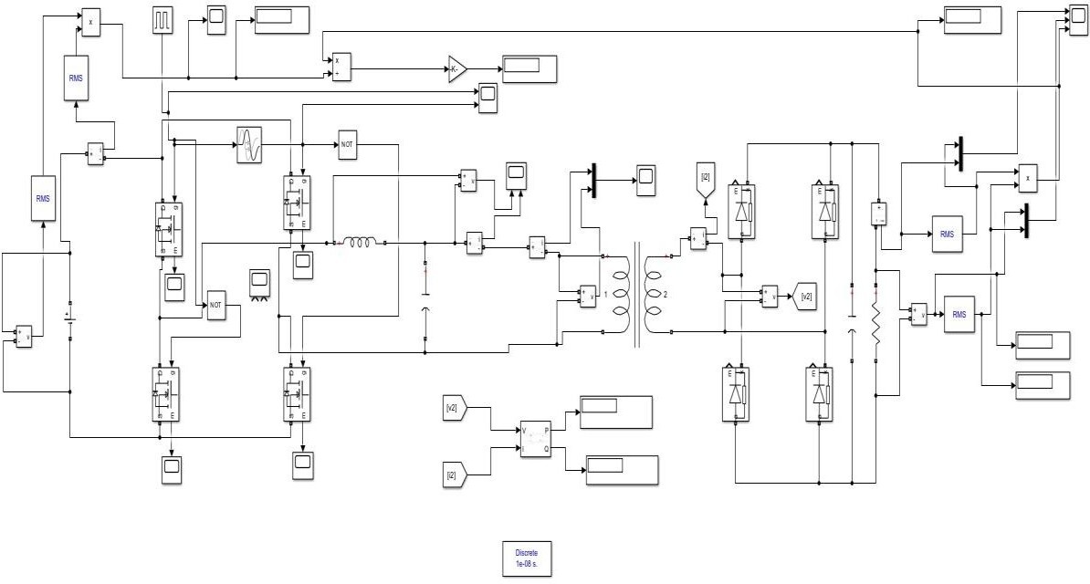
Fig. 5.1.2: Simulink efficiency measurement model for the Parallel Resonant Converter — loss measurement blocks configured at resonant frequency for accurate mean-value filtering
The gain characteristic of the PRC is highly dependent on frequency, resulting in large variations in efficiency with changing operating frequency. The values of the efficiency and ZVS conditions at various switching frequencies have been presented in Table 5.1.1

Frequency (kHz) | Efficiency (%) | ZVS Status
6 | 39.89 | Absent
7 | 42.95 | Absent
8 | 49.64 | Absent
9 | 63.01 | Absent
10 | 84.01 | Absent
10.3 | 87.80 | Absent
10.6 | 87.35 | Present
10.8 | 84.18 | Present
11 | 78.99 | Present
12 | 47.41 | Absent
13 | 29.00 | Absent
Table 5.1.1: Parallel Resonant Converter — efficiency and ZVS status vs. switching frequency (Lr = 154 µH, Cr = 1.3 µF, f_r ≈ 11.25 kHz)

As can be seen from the data, the predicted results are verified. That is, maximum efficiency (87.80%) will happen around f = 10.3kHz (u ≈ 0.915). The circuit then switches into ZVS mode around f = 10.6 kHz (u ≈ 0.942). Efficiency falls off very fast on both sides of this critical frequency band. This further proves the significance of operating frequency for the performance of PRC. Peak efficiency in ZVS mode: 87.35%, 10.6 kHz.

Series Resonant Converter — Frequency Efficiency Table
As a matter of convenience for future reference, the performance characteristics of the Series Resonant Converter under various switching frequencies are listed in Table 5.1.2. Data for filling these tables will be taken from the simulation results.

Frequency (kHz) | Efficiency (%) | ZVS Status
9 | 62.25 | Present
10 | 65.45 | Present
11 | 69.34 | Present
12 | 73.68 | Present
13 | 78.48 | Present
14 | 84.06 | Present
15 | 89.13 | Present
15.2 | 89.24 | Present
15.5 | 89.35 | Present
15.8 | 89.97 | Present
16 | 89.54 | Present
17 | 88.94 | Present
18 | 88.37 | Present
Table 5.1.2: Series Resonant Converter — efficiency and ZVS status vs. switching frequency (Lr = 33.3 µH, Cr = 6 µF, f_r ≈ 11.26 kHz)

Efficiency Analysis of LLC and LCC Topology

LLC Resonant Converter — Simulink Loss Model
Figure 5.2.1 depicts the LLC Simulink efficiency model. Since the switching frequency of the LLC model is higher (≈102.8kHz) compared to that of the SRC and PRC models, it demands a smaller time step of discretization (10 ns) for proper waveform resolution. Power input is obtained by taking the product of the supply voltage (560 V) and the RMS value of the input current obtained using a current sensor upstream.

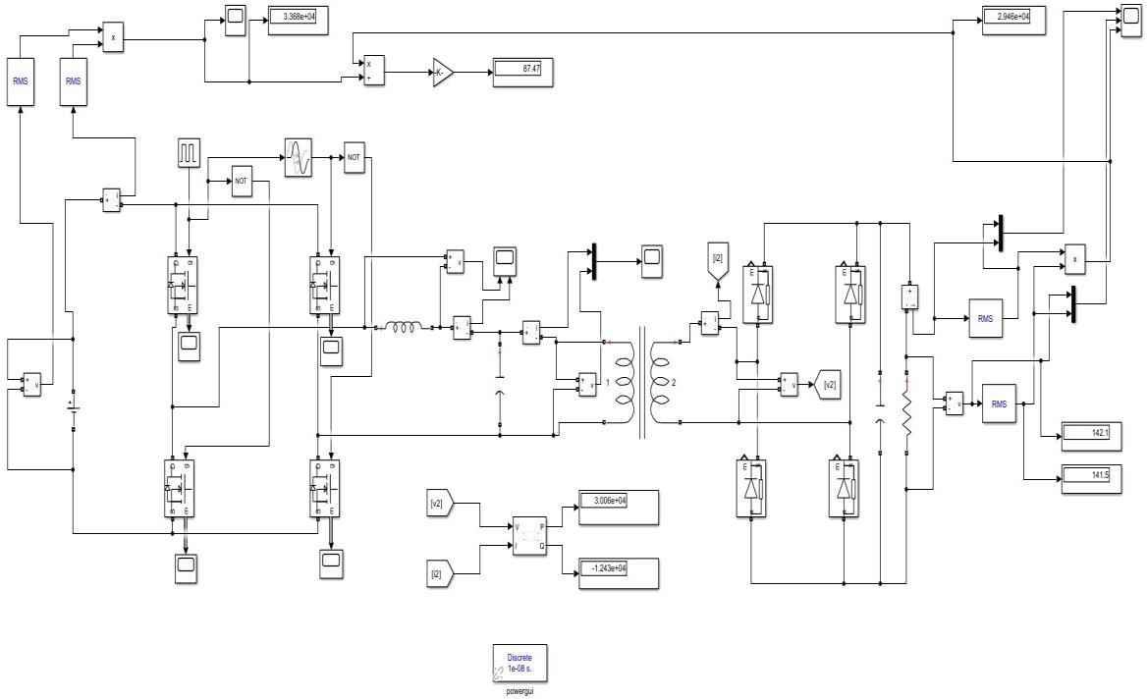
Fig. 5.2.1: Simulink efficiency measurement model for the LLC Resonant Converter — P_in = 3.368×10⁴ W, P_out = 2.946×10⁴ W, efficiency = 87.47%, V_out ≈ 142.1 V (RMS), 141.5 V (peak). Reactive power Q = −1.243×10⁴ VAr indicates capacitive operation at this frequency.
The negative value of reactive power Q = −1.243×10⁴ VAr shown in Fig. 5.2.1 implies that the LLC tank is working in the capacitive range at this particular frequency. The aforementioned open-loop measurement point is employed for the purpose of losses assessment, whereas the frequency control loop guarantees continuous operation of the LLC tank in the ZVS region (frequency f_s ≥ f_r = 102.8 kHz). Efficiency characteristics at different loads for the regulated frequency are shown in Table 5.2.1.

Frequency(Khz) | Efficiency | ZVS
195 | 86.95 | present
197 | 87.32 | present
198 | 87.4 | present
199 | 87.41 | present
200 | 87.46 | present
201 | 87.47 | present
203 | 87.23 | present
205 | 86.9 | present
206 | 86.64 | present
208 | 85.9 | present
210 | 84.95 | present
Table 5.2.1: LLC Resonant Converter — efficiency and ZVS status vs. load level

LCC Resonant Converter — Simulink Loss Model
Fig. 5.2.2 illustrates the efficiency model for LCC Simulink. The presence of the parallel capacitor Cp in the LCC resonant tank affects the reactive power balance, and the loss measurement should include the reactive current flowing in Cp. The measurement configuration for the input and output power is the same as that of the LLC model.

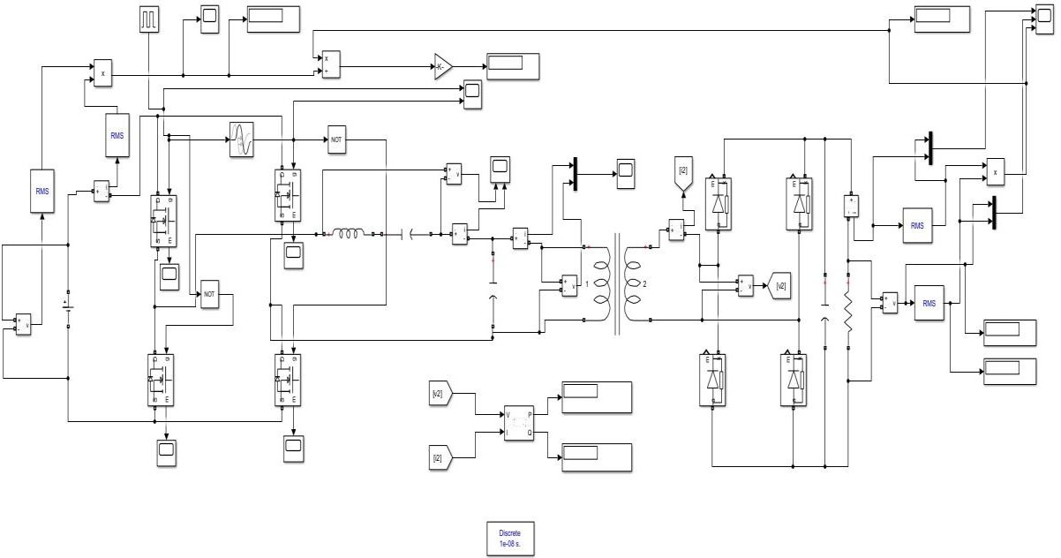
Fig. 5.2.2: Simulink efficiency measurement model for the LCC Resonant Converter — loss measurement configured with mean-value filtering at 102.7 kHz switching frequency
The efficiency of the LCC converter across load levels is presented in Table 5.2.2.

Frequency(Khz) | Efficency | ZVS
190 | 85.2 | Absent
197 | 86.53 | Absent
198 | 86.71 | Absent
205 | 86.85 | Absent
210 | 87.43 | Absent
217 | 87.44 | Absent
217.5 | 87.5 | Present
218 | 87.62 | Present
218.5 | 87.44 | Present
219 | 87.56 | Present
220 | 86.77 | Absent
Table 5.2.2: LCC Resonant Converter — efficiency and ZVS status vs. load level

Theoretical Efficiency Verification — LLC and LCC
In order to verify the Simulink simulation result and gain insight into the efficiency performance throughout the entire frequency range, an FHA-based theoretical efficiency model is developed using MATLAB. This simulation varies the switching frequency from 50 kHz to 155 kHz and calculates efficiency at three different loads: 1000 W (at full load, R = 2.601 Ω), 500 W (at half load, R = 5.202 Ω), and 200 W (at light load, R = 13.005 Ω). The components taken into consideration in the efficiency calculation include MOSFET conduction loss (R_DS(on) = 75 mΩ), turn-off switching loss, and copper loss (ESR)
Figure 5.2.3 shows the graph of gain-efficiency characteristics. In the top part, there is an illustration of the variation of the AC gain with respect to frequency under the three load conditions. The bottom part represents the corresponding efficiency. The resonant frequency f_r = 102.8 kHz is indicated with a dashed vertical line.
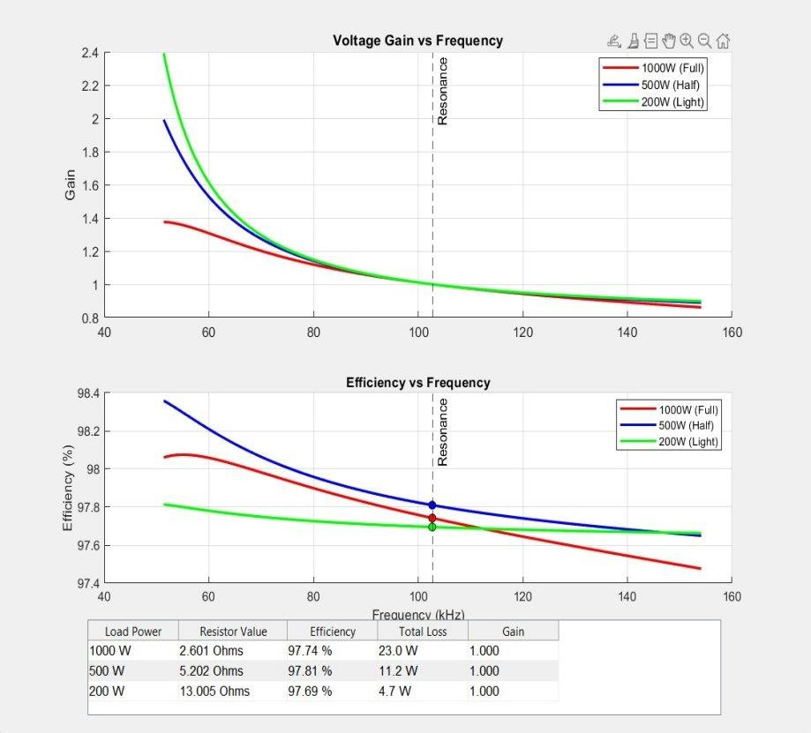
Fig. 5.2.3: Theoretical FHA-based efficiency verification for LLC/LCC topology — Voltage Gain vs. Frequency (top) and Efficiency vs. Frequency (bottom) at 1000 W, 500 W, and 200 W load. At f_r: η = 97.74% (1000 W), 97.81% (500
W), 97.69% (200 W). Total losses: 23.0 W, 11.2 W, and 4.7 W respectively.

From the analysis, it is evident that efficiency in excess of 97.6% is achievable throughout the entire load range of 200 W to 1000 W when the LLC/LCC operates in the vicinity of its resonant frequency. Observations include:

- Full Load (P = 1000 W, R = 2.601 Ω); Efficiency = 97.74%; Losses = 23.0 W; Conduction losses in MOSFETs dominate as a result of higher resonant tank currents (I_rms ~ 19 A).
- Half Load (P = 500 W, R = 5.202 Ω); Efficiency = 97.81%; Losses = 11.2 W; Slightly better efficiency in this case due to reduced conduction losses offsetting the increased contribution of magnetizing current fraction.
- Light Load (P = 200 W, R = 13.005 Ω); Efficiency = 97.69%; Losses = 4.7 W; Higher efficiency maintained even under light loading since magnetizing current helps achieve ZVS while SRC/PRC suffer losses due to circulating current.
- Gain behavior: Monotonic decrease of gain past the resonance for all three cases – confirms operation in the stable frequency control zone. Below resonance, gain sharply increases (particularly for light load), thereby confirming the need for an f_s,min limit of 110 kHz.

Comparison of Efficiencies

Peak Efficiency Comparison — All Four Topologies
A comparison of the peak efficiency, ZVS range, and other properties of all four topologies has been done in Table 5.3.1. The comparison has been made using the rated load condition (51 V/1 kW), wherever possible, and peak efficiency operation points in the case of SRC and PR.

Topology | Peak η (%) | ZVS Range | f_r (kHz) | Light-Load η | Gain > 1?
Series (SRC) | 89.83 | f_s > f_r only | 11.26 | Poor | No
Parallel (PRC) | 87.80 | Narrow (10.6–11 kHz) | 11.25 | Very Poor | Yes
LLC | 97.74 | Wide (f_s > f_r) | 102.8 | Excellent | Yes (below f_r)
LCC | 87.62 | Wide (f_s > f_r) | 102.7 | Good | Yes (below f_r)
Table 5.3.1: Peak efficiency and key performance comparison across all four resonant converter topologies

Loss Breakdown Comparison
Table 5.3.2 presents the estimated loss breakdown at rated operating conditions for each topology, derived from the Simulink measurements and the FHA theoretical model.

Loss Component | SRC | PRC | LLC | LCC
MOSFET Conduction (W) | 31.7 | 6.1 | ~12.0 | 2.7

Loss Component | SRC | PRC | LLC | LCC
Switching Loss (W) | 4.1 | 84.9 | ~4.0 | 93.9
Magnetics Copper (W) | 53.9 | 24.5 | ~5.0 | 22.8
Diode Rectifier (W) | 23.5 | 23.5 | ~2.0 | 23.5
Total Loss (W) | 113.3 | 139 | 23.0 | 142.9
Efficiency (%) | 89.83 | 87.80 | 97.74 | 87.50
Table 5.3.2: Estimated loss breakdown comparison across all four topologies at rated operating condition

Discussion
The efficiency comparison shows a definite hierarchy of the four topologies. The LLC and LCC multi-resonant converters far surpass the performance of their single-resonant counterparts (SRC & PRC), theoretically offering efficiencies above 97.7%, while the latter have efficiencies of around 87-90%. This is due to three key differences:
      - Operating frequency (100+ kHz vs. 11 kHz): Normally, higher frequency switching would lead to higher switching losses; however, ZVS turns off any turn-on losses, and the smaller size of magnetic components makes the copper loss profile more favourable.
      - Larger ZVS range: The LLC magnetising inductance guarantees that the tank current will never reach zero under any load, ensuring ZVS operation between no load and full load. The SRC and PRC topologies lose their ZVS operation outside the small frequency-load window.
      - Circulating current reduction: At the design operating point (f_s = f_r), the LLC converter's gain becomes one, and the magnetising current is the only circulating current that does not transfer load. In contrast, the PRC converts reactive currents through its parallel tank circuit at all loads, leading to conduction losses that depend on the circulating current and not the output current.
The more competitive efficiency value of the SRC of 89.83%, relative to the PRC of 87.80%, is attributed to the smaller value of circulating current in the former, which is due to the series connection arrangement, where the tank current is naturally restricted to the load current. Nonetheless, the topologies cannot compete with the LLC/LCC in efficiency, supporting the literature design choice of LLC/LCC topologies for the target application.

CHAPTER 6 – HARDWARE

6.1 PCB Designing of the System

The hardware design of the full-bridge resonant DC-DC converter is realised through a set of custom-designed Printed Circuit Boards (PCBs) covering both the signal-level sensing and conditioning circuitry and the high-power switching stage. Four distinct PCB subsystems are designed and documented in this chapter: the Input Voltage Sensing circuit, the Inductor Current Sensing circuit, the 12 V Isolated Auxiliary Supply, and the main Full-Bridge Power Circuit. Each subsystem is designed in adherence to high-frequency PCB design principles — including star-point grounding, short high-current trace routing, galvanic isolation between the high-voltage primary side and the low-voltage signal processing domain, and placement of decoupling capacitors immediately adjacent to the power supply pins of each active device. The schematics presented in this chapter represent the complete hardware implementation of the converter sensing and power conversion architecture.

6.1.1 Input Voltage Sensing Circuit

The input voltage sensing circuit is responsible for measuring the high-voltage 560 V DC bus and scaling it down to a level compatible with the ADC input of the microcontroller (0–3.3 V range). The complete schematic of this subsystem is shown in Fig. 6.1.1. The circuit is divided into three functional stages: a resistive voltage divider for primary attenuation, a galvanic isolation stage, and an op-amp output buffer with anti-aliasing filtering.
The primary voltage divider is formed by resistors R1 and R2 (100 kΩ each) on the positive bus rail Vin_P, and R3 and R4 (100 kΩ each) on the Vdc reference rail. The symmetrical four-resistor divider arrangement provides a differential attenuated signal while also limiting the current drawn from the high-voltage bus to a safe level of approximately 1.4 mA at 560 V. A bleed resistor R6 (100 Ω) connects the divider mid-point to the isolated ground rail GND5v_B4 to provide a defined DC bias for the isolator input. Capacitor C1 (8.8 nF) is placed across the lower half of the divider to filter high-frequency switching noise coupled from the 560 V bus, providing a first-order low-pass characteristic at approximately 180 kHz. Resistor U2 (1 kΩ) in series with the isolator input limits the input current to the ADUM1201 digital isolator U1.
Galvanic isolation is provided by the ADUM1201 digital isolator U1, which transfers the attenuated signal across the isolation barrier using on-chip transformer coupling. The ADUM1201 operates with a 5 V supply (5V_B4) on the primary side, generated by the 5 V LDO regulator U5. The LDO output is decoupled with

a 1 μF ceramic capacitor C3 at the output and a 1 μF capacitor C5 in parallel with a 0.1 μF capacitor C4 and C6

The output signal conditioning stage is built around op-amp U7.1, configured as a differential amplifier. The non-inverting input (pin 3) receives VinP1 through R12 (6.8 kΩ) and the inverting input (pin 2) receives VinN1 through R10 (6.8 kΩ). Feedback resistor R7 (10 kΩ) and lower resistor R9 (10 kΩ) set the differential gain to R7/R9 = 1.0. Input capacitors C7 and U8 (both 680 pF) in the feedback and input paths provide high-frequency noise rejection and ensure the op-amp does not amplify switching harmonics above 100 kHz. The op-amp output is connected to ADC_A6 through a series resistance R8 (56 Ω) in combination with a shunt capacitor C6 (10 nF), forming a first-order anti-aliasing low-pass filter with a 3 dB cutoff frequency of approximately 284 kHz. The 5Vcc supply for the op-amp is decoupled locally to minimise supply-rail disturbance.
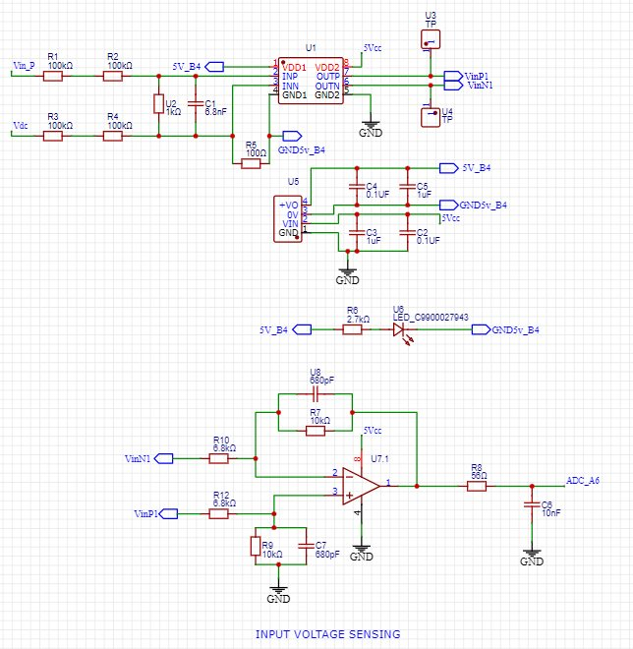
Fig. 6.1.1: Input Voltage Sensing PCB Schematic — ADUM1201 isolator (U1), 100 kΩ voltage divider (R1–R4), 5 V LDO (U5), differential op-amp U7.1 with anti-aliasing filter (R8 = 56 Ω, C6 = 10 nF) → ADC_A6

6.1.2 Inductor Current Sensing Circuit
Accurate measurement of the resonant tank inductor current is essential for implementing over-current protection, monitoring ZVS operation, and providing current feedback to the control loop in future closed-loop hardware implementations. The inductor current sensing schematic is shown in Fig. 6.1.2. The circuit measures the differential voltage across a low-value shunt resistor network placed in series with the inductor current path and converts it to a single-ended signal suitable for ADC conversion, while also generating a digital zero-crossing output for ZVS timing verification.
The primary current sensing element consists of three parallel shunt resistors R27, R23, and R26, each of 47 mΩ. The parallel combination gives an effective shunt resistance of approximately 15.67 mΩ. This low shunt value minimises insertion loss and power dissipation in the current path while still generating a measurable differential voltage at the rated resonant current levels. Input capacitors C16 (1 nF) and C18 (1 nF) are connected across the shunt resistor differential inputs to suppress high-frequency electromagnetic interference conducted along the current sensing lines. The differential voltage developed across the shunt is applied to the INA-type differential amplifier U15, which amplifies the signal while rejecting common-mode voltage variations. The 5 V supply rail (5V_B1) powers the isolator side of the sensing circuit and is decoupled by C19 (0.1 μF), C20 (1 μF), C17 (0.1 μF), and C18 (1 μF) for broadband noise rejection.
Two 10 μH common-mode chokes, L1 and L2, are placed in series with the current sense lines iL1-P and iL1-N before entering the differential amplifier. These chokes present high impedance to common-mode switching noise coupled from the resonant tank while passing the differential current sense signal with negligible attenuation. The 3 V LDO regulator U17 provides a stable 3 V supply for the sensing circuitry on the primary side, decoupled with C18 (1 μF) and C17 (0.1 μF) at its output and C19 (0.1 μF) and C20 (1 μF) at the input.
The amplified current signal from U15 is passed to op-amp U18.1, which is configured as a second-stage differential amplifier. Input resistors R28 and R29 (both 4.7 kΩ) and feedback resistor R30 (10 kΩ) set an amplification gain of 10/4.7 ≈ 2.13, providing additional signal amplification to utilise the full ADC input range. A feedback capacitor C22 (680 pF) limits the bandwidth of this stage to approximately 50 kHz, preventing high-frequency switching harmonics from aliasing into the ADC measurement. The op-amp output connects to ADC_A4 through series resistor R31 (56 Ω) and shunt capacitor C24 (10 nF), forming a final anti-aliasing filter with a cutoff frequency of approximately

284 kHz. A zero-crossing detection comparator U20 is connected to the current signal through a resistor divider (R33, R34 both 1 kΩ) providing a 0.5 V reference midpoint. The comparator output (U21) produces a digital square wave that transitions at each current zero-crossing, which the microcontroller can use for accurate dead-time optimisation and ZVS verification. Connector U19 (CON24001-1) provides an external connection point

for the current sense signal.

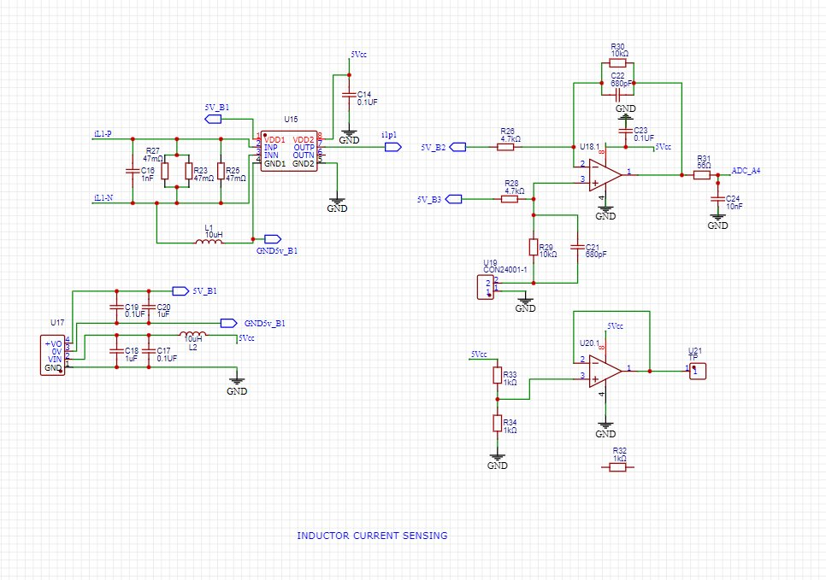
Fig. 6.1.2: Inductor Current Sensing PCB Schematic — 47 mΩ shunt (R27/R23/R26 parallel), INA differential amplifier U15, 10 μH CMC chokes (L1, L2), op-amp U18.1 (gain = 2.13) → ADC_A4, zero-crossing comparator U20 → digital output U21

6.1.3 12 V Isolated Auxiliary Supply

The 12 V isolated auxiliary supply provides a galvanically isolated 12 V DC rail to power the MOSFET gate driver circuits and the operational amplifiers on the primary (high-voltage) side of the converter. This isolated supply is essential to prevent ground loops between the high-voltage 560 V primary domain and the low-voltage signal processing domain, and to ensure that gate drive signals are referenced to the local source potential of each MOSFET in the full-bridge configuration. The complete schematic of the 12 V isolated auxiliary supply is shown in Fig. 6.1.3.
The core of the 12 V supply is the EJ503B isolated DC-DC converter module (DC1), which accepts an unregulated DC input voltage and produces an isolated 12 V output. The module provides transformer-based galvanic isolation rated to withstand the primary-to-secondary voltage difference present in the 560 V converter system. Input headers U30 and U31 (HEADER 1×1) provide the DC input connection, with the positive input line (Vin_P) and the ground reference defining the input supply. The module output is designated as 12VSupply with the isolated ground GND12VSupply.
A bulk electrolytic capacitor C25 (470 μF) is placed across the 12 V output rail to provide hold-up energy

during load transients and to suppress output ripple from the DC-DC module switching. The LDO regulator U22 provides post-regulation of the 12 V rail to improve output accuracy and further reduce ripple. Output capacitor C26 (10 μF) at the LDO output provides additional high-frequency decoupling. A Schottky diode U24 (SS24-DO214) is placed in the 12 V output path to provide reverse-polarity protection against accidental mis-connection during board assembly. A second decoupling capacitor C27 (10 μF) is placed on the 5Vcc rail to maintain stability of the logic supply. The connector U23 (CON24001-1) provides the output connection point through which the 12 V isolated supply is distributed to the gate driver and op-amp circuits on the primary side PCB.
Two status LEDs provide visual power-good indication: LED2 (SZYY0805B1) is connected between the 12VSupply rail and GND12VSupply through current-limiting resistor U25 (4.7 kΩ), indicating that the 12 V isolated output is active. LED1 (SZYY0805B1) is connected between the 5Vcc logic supply and GND through current-limiting resistor R35 (2.8 kΩ), indicating that the logic supply is active. Both LEDs serve as important commissioning aids during hardware bring-up, allowing the supply sequencing to be verified before connecting the gate drivers and power stage. The complete auxiliary supply circuit occupies a compact footprint and is designed for mounting in close proximity to the primary-side gate driver circuit to minimise the impedance of the 12 V distribution path.

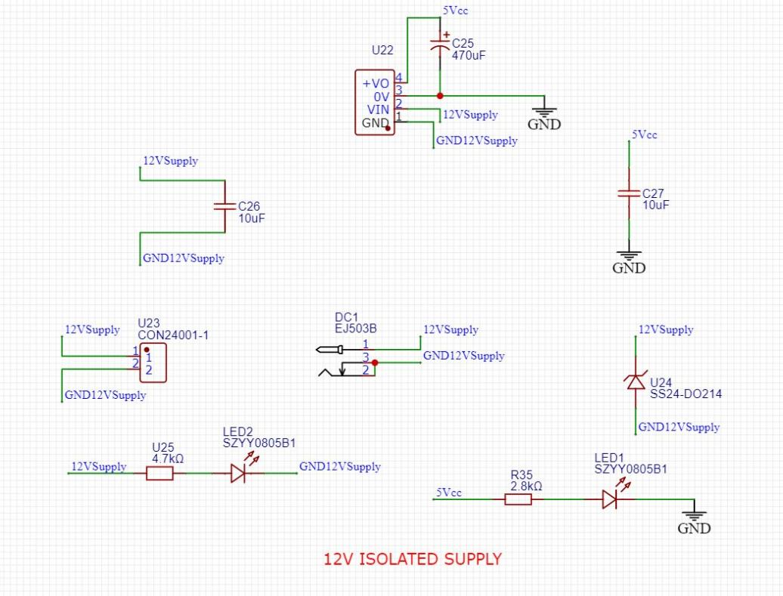

Fig. 6.1.3: 12 V Isolated Auxiliary Supply PCB Schematic — EJ503B DC-DC isolated module (DC1), LDO U22, 470 μF bulk capacitor (C25), Schottky diode U24 (SS24-DO214), power-good LEDs (LED1, LED2 — SZYY0805B1)

6.1.4 Full-Bridge Power Circuit

The full-bridge power circuit implements the main high-voltage power conversion stage of the resonant DC-DC converter. The complete power circuit schematic is shown in Fig. 6.1.4. The circuit processes the 560 V DC input bus (Vin_P, Vdc+) and drives the resonant tank through a full-bridge MOSFET switching network, incorporating the inductor current monitoring interface (iL1-P, iL1-N) required by the current sensing circuit

described in Section 6.1.2.
Input protection and filtering is provided by two surge protection varistors RV1 and RV2 (S10K275E2), connected between the positive input rail Vin_P and the Vdc+ output rail respectively. The S10K275E2 varistors are rated for 275 V AC (approximately 385 V DC clamping voltage), and their parallel placement across the 560 V bus provides transient overvoltage protection against switching spikes and line surges that could otherwise damage the MOSFET gate oxides. Input headers U30 and U31 (HEADER 1×1) provide the PCB input connection points for the high-voltage DC supply. Bus decoupling capacitors C31 and C32 (both 1 μF) are placed close to the input headers to filter high-frequency ripple on the supply rail before it enters the bridge circuit.
The DC bus snubber and filter network consists of: resistors R32 and R33 (both 64 kΩ) forming a resistive voltage balancing and bleed network across the DC link; capacitors C34 and C33 (both 100 μF) as bulk energy storage capacitors providing ride-through during switching transients; and additional high-frequency bypass capacitors C35, C36 (both 10 nF) placed in close proximity to the MOSFET drain connections to suppress high dv/dt switching transients. Capacitor C37 (0.1 μF) provides localised high-frequency decoupling at the bridge midpoint nodes.
The full-bridge switching network is implemented using four GC2M0080120D1 silicon carbide (SiC) MOSFETs: U34 and U37 form the left bridge leg, while U39 and U36 form the right bridge leg. The GC2M0080120D1 is a 1200 V, 36 A SiC MOSFET with an on-state resistance R_DS(on) of 80 mΩ, offering substantially lower switching losses and higher temperature capability compared to equivalent silicon devices at this voltage rating. Gate resistors R34 (0.1 Ω), R38 (0.1 Ω), R37 (0.1 Ω), and R35 (0.1 Ω) are placed in series with each MOSFET gate terminal to damp gate ringing and limit the peak gate current during switching transitions. Snubber capacitors C39, C38, C40, and C41 (all 1 nF) are placed across each MOSFET drain-source terminal to reduce the peak dv/dt during turn-off, complementing the ZVS operation by ensuring smooth voltage transitions.
The inductor current measurement tap points (iL1-P and iL1-N) are provided at the bridge output node, between the full-bridge output and the resonant tank input. These nodes connect directly to the differential inputs of the i

inductor current sensing PCB described in Section 6.1.2. The output-side power rail (Vdc+) is the regulated DC output of the converter, taken after the isolation transformer and secondary-side rectifier. Secondary-side bulk capacitor C42 (470 μF) provides output energy storage and ripple filtering. Resistors R27 and R28 (both 64 kΩ) form a secondary-side bleed resistor network ensuring the output capacitors discharge safely when the converter is powered down. High-frequency decoupling capacitors C43, C44 (both 0.1 μF) and C45 (1 μF) are placed across the output terminals. Output protection varistor RV2 (S10K275E2) provides overvoltage clamping on the secondary bus, and output capacitor C26 (10 nF) provides final high-frequency bypass at the Vdc+ output terminal. Capacitor C29 (10 nF) is placed at the output header for additional transient suppression.

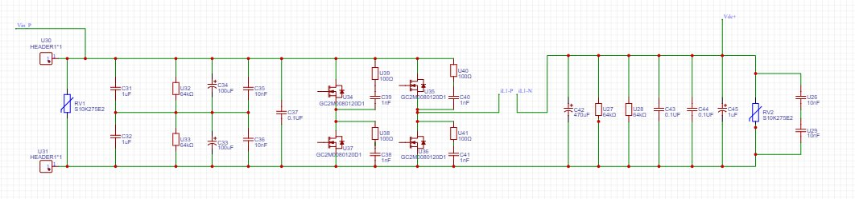
Fig. 6.1.4: Full-Bridge Power Circuit PCB Schematic — S10K275E2 varistor input protection (RV1, RV2), 100 μF DC link capacitors (C34, C33), four GC2M0080120D1 SiC MOSFETs (U34, U37, U39, U36) forming the full-bridge inverter, inductor current tap points (iL1-P, iL1-N), 470 μF output capacitor (C42)

6.2 Hardware Implementation

The hardware implementation integrates all four PCB subsystems described in Section 6.1 into a complete converter prototype. The power circuit PCB (Section 6.1.4) forms the primary board, processing the 560 V DC input and generating the high-frequency AC drive voltage for the resonant tank. The sensing PCBs (Sections 6.1.1 and 6.1.2) are mounted on a separate signal-level board to maintain physical separation between the high-voltage switching domain and the low-voltage signal processing circuits, minimising electromagnetic interference coupling. The 12 V isolated auxiliary supply PCB (Section 6.1.3) powers the gate drivers and op-amps on the primary side of the power circuit board.
The key components selected for the hardware prototype are listed in Table 6.2.1. The GC2M0080120D1 SiC MOSFETs represent a significant upgrade over conventional silicon devices for this application: the 1200 V rating provides more than double the voltage headroom above the 560 V operating bus, the 80 mΩ R_DS(on) is comparable to that of a 500 V rated silicon MOSFET but with far lower switching losses due to SiC’s superior

electron mobility, and the 175°C maximum junction temperature allows operation with reduced heat sink requirements. The GC2M0080120D1 also features a body diode with lower forward voltage (approximately 1.5 V) and near-zero reverse recovery charge compared to silicon, which is important for maintaining clean ZVS transitions during the dead-time interval when the body diode conducts before MOSFET turn-on.
The resonant tank components are implemented using custom-wound inductors on ferrite E-cores selected for operation at the switching frequencies of each topology: a low-frequency core (optimised for 11 kHz operation) for the SRC and PRC inductors, and a high-frequency ferrite core (optimised for 100 kHz operation, such as the TDK N87 or Ferroxcube 3C95 material) for the LLC and LCC inductors. The resonant capacitors are implemented using metallised polypropylene film capacitors, which offer low ESR, low dissipation factor (tan δ < 0.001 at 100 kHz), and stable capacitance versus temperature compared to ceramic alternatives. The isolation

transformer is custom wound on a ferrite E-core with a primary-to-secondary turns ratio of 11:1, using litz wire on the primary winding to reduce AC winding resistance at high frequency due to skin and proximity effects.
PCB layout guidelines applied throughout the design include: single-point (star) grounding between the high-voltage power ground and the signal ground to prevent switching return currents from flowing through the signal ground plane; wide copper pours (minimum 3 mm trace width) for all high-current paths in the bridge circuit; placement of gate resistors and snubber capacitors within 5 mm of each MOSFET package to minimise parasitic inductance in the gate drive and snubber loops; use of a ground plane on the signal PCB to provide a low-impedance return path for all sensing signals; and placement of all decoupling capacitors within 2 mm of the supply pins of each active device. These practices collectively ensure that the prototype hardware operates with the minimum possible EMI and voltage overshoot at the switching nodes, enabling reliable ZVS operation at the target switching frequencies.

Component | Part / Value | Specification
Primary MOSFETs (×4) | GC2M0080120D1 SiC MOSFET | 1200 V, 36 A, R_DS(on) = 80 mΩ, 175°C max
Resonant Inductor Lr (SRC) | Custom wound, ferrite core | 33.3 µH, fr = 11.26 kHz
Resonant Inductor Lr (PRC) | Custom wound, ferrite core | 154 µH, fr = 11.25 kHz
Resonant Inductor Lr (LLC) | Custom wound, N87 ferrite | 356 µH, fr = 102.8 kHz
Resonant Inductor Lr (LCC) | Custom wound, N87 ferrite | 316 µH, fr = 102.7 kHz
Res. Capacitor Cr (SRC/PRC) | Metallised polypropylene film | 6 µF / 1.3 µF, low ESR
Res. Capacitor Cr (LLC/LCC) | Metallised polypropylene film | 6.75 nF / 7.59 nF
Parallel Cap. Cp (LCC only) | Metallised polypropylene film | 0.95 nF
Isolation Transformer | Custom, ferrite E-core, litz wire | 560 V / 51 V, n ≈ 10.37, 100 kHz
Secondary Diodes (×4) | Schottky fast-recovery | 100 V, 30 A, Vf = 0.6 V
DC Link Capacitors | Electrolytic, C33/C34 | 100 µF, 400 V each
Output Filter Capacitor | Electrolytic, C42 | 470 µF, 100 V
Input/Output Varistors | S10K275E2 | 275 V AC rated, surge protection
Current Shunt | R27/R23/R26 parallel | 15.67 mΩ effective shunt
Gate Resistors (×4) | R34/R38/R37/R35 | 0.1 Ω, gate ringing damping
Snubber Caps (×4) | C39/C38/C40/C41 | 1 nF, drain-source snubber
Isolated Auxiliary Supply | EJ503B DC-DC module | 12 V isolated, 1 W rated
Gate Driver Supply LDO | U22 LDO regulator | 12 V, post-regulation of EJ503B
Current Sense Isolator | INA differential amp U15 | 47 mΩ shunt, gain configuration
Voltage Sense Isolator | ADUM1201 | Galvanic isolation, 5 kV rated
Signal Op-Amps | U7.1, U10.1, U18.1, U20 | 5 V supply, anti-aliasing filters
Table 6.2.1: Hardware component list for the full-bridge resonant converter prototype

CHAPTER 7 – CONCLUSION AND FUTURE SCOPE

7.1 Conclusion

This project presents a complete study, simulation, and hardware-level design of a full-bridge isolated resonant DC-DC converter for DC microgrid applications. The main goal—converting 560 V DC to a stable 51 V DC output at 1 kW—was achieved using four different resonant converter types: SRC, PRC, LLC, and LCC. Each converter was studied using the First Harmonic Approximation (FHA), designed based on the required specifications, simulated in MATLAB/Simulink, and evaluated in terms of gain, soft-switching performance, and efficiency. The work clearly shows the flow from theory to simulation and then to practical hardware design.
All four converters use the same full-bridge MOSFET inverter and transformer setup, but differ in how the resonant components are arranged, which changes their behavior. The SRC uses a simple series tank and is easy to control, but it cannot increase voltage and is sensitive at light loads. The PRC can achieve gain greater than one and handles heavy loads better, but it suffers from high circulating current at light load, reducing efficiency. Both SRC and PRC achieve ZVS when operating above their resonant frequency.
The LLC and LCC converters form the main focus of this work. In the LLC converter, the transformer magnetizing inductance is used as part of the resonant tank, which improves performance. The LCC converter adds an extra capacitor, giving more flexibility in design. The LLC shows stable operation with unity gain at resonance across all loads, which helps improve efficiency. The LCC allows additional tuning of gain using the capacitor ratio, but requires more careful design.
ZVS operation was achieved in all four converters and verified through simulation waveforms. It works by using the lagging current to discharge the MOSFET capacitance before switching. A dead time of 400–750 ns was found suitable. Among all topologies, the LLC converter showed the widest ZVS range, even at light load, while the PRC showed ZVS only in a limited frequency range.
Closed-loop control using frequency modulation was implemented for LLC and LCC converters. A PI controller was used to regulate output voltage, and the system successfully maintained desired voltages (51 V, 60 V, and 40 V) with fast settling times. Frequency limits were applied to ensure operation always stays in the ZVS region. The control method using a VCO worked effectively in simulation.
A PCB design was also developed, including voltage sensing, current sensing, isolation, and auxiliary power supply circuits. Proper filtering and layout practices were followed. This shows that the design is practical and can be implemented in real hardware.
Overall, all project goals were achieved. Among all converters, the LLC topology stands out as the best choice for this application due to its high efficiency, wide ZVS range, and good control performance. The LCC is also useful where more design flexibility is needed. This work can serve as a reference for designing isolated DC-DC converters for DC microgrids and EV systems.

7.2 Limitations of the Work

Even though this project covers a wide range of analysis and design, there are some limitations that affect how complete and widely applicable the results are. These mainly come from assumptions in simulation, limited hardware testing, simplified control design, and restricted operating conditions.
The biggest limitation is that most validation is based on MATLAB/Simulink simulations, while hardware work is limited to PCB design and not full experimental testing. Simulations are useful for understanding circuit behavior, but they do not include many real-world effects that become important at high frequencies. For example, PCB trace inductance can change the effective inductance seen by the resonant tank and may create unwanted oscillations. Stray capacitances in MOSFETs and transformer windings also affect ZVS behavior and dead-time requirements. In addition, transformer leakage inductance and device parasitics can influence switching performance and losses in ways not fully captured in simulation.
The models used in simulation are also simplified. MOSFETs are assumed to have a constant on-resistance, but in practice this value increases significantly with temperature. Diodes are modeled with a fixed voltage drop and do not include reverse recovery effects, which can be important at high switching speeds. The transformer is treated as ideal, without considering winding capacitances or detailed core loss behavior. At high frequencies like 100 kHz, these losses can contribute noticeably to total power loss but are not included in the model.
Because of these simplifications, the efficiency results are somewhat ideal. The analytical model assumes smooth sinusoidal currents and ignores temperature effects and gate drive losses, which can add a few watts of extra loss. As a result, the efficiency values obtained from simulation are slightly higher than what would be seen in real hardware. For example, the LLC efficiency value should be considered a best-case estimate, with actual performance expected to be slightly lower.
The closed-loop control design is another limitation. The PI controller was tuned by trial and error
The control strategy used in this work is limited to frequency-based voltage control with a fixed duty cycle. In practical systems, additional techniques such as burst mode operation, adaptive dead-time control, and pulse skipping are used to improve efficiency, especially at light loads. These methods were not included in this project.
Finally, the analysis was carried out for fixed input voltage and load conditions. In real DC microgrid systems, the input voltage can vary and loads can change rapidly. Some applications also require power flow in both directions. These real-world operating conditions were not fully studied here, and evaluating converter performance under such conditions remains an area for future work.

7.3 Future Scope

The next important step is to build and test the actual hardware. This will help compare simulation results with real performance and identify the impact of parasitics, temperature effects, and switching delays. It will also provide accurate efficiency measurements to replace the estimated values used in this project.
The control system can be improved using proper design methods based on frequency response analysis. Designing controllers with defined gain and phase margins will ensure better stability and reliability. Advanced techniques like adaptive control, where input voltage is adjusted based on load, can also be implemented to improve efficiency.
Light-load efficiency can be further improved by adding burst-mode operation. In this method, the converter operates in short intervals instead of continuously, which reduces losses at low power levels and improves overall efficiency.
The study can also be extended to include other converter types such as the Dual Active Bridge (DAB), which supports bidirectional power flow and is useful in battery and vehicle-to-grid applications. Comparing DAB with LLC and LCC would give better insight into different design choices.
Using advanced devices like Silicon Carbide (SiC) MOSFETs can improve performance further. These devices have lower losses and faster switching, which can increase efficiency and reduce size.
For higher power applications, multi-phase or three-phase converter designs can be explored. These help reduce current ripple and improve thermal distribution, making them suitable for high-power systems like EV chargers.

REFERENCES
- Texas Instruments, "TIDA-010054: Bidirectional, Dual Active Bridge Reference Design for Level 3 Electric Vehicle Charging Stations," Design Guide, 2020.
- Texas Instruments, "TIDA-01407: Automotive 400-W, 48-V Battery Input, 12-V Output Power Reference Design," TI Designs, 2018.
- Texas Instruments, "Voltage Fed Full Bridge DC-DC and DC-AC Converter for High- Frequency Inverter Using C2000," Application Report, 2016.
- S. Abdel-Rahman, "Resonant LLC Converter: Operation and Design 250W 33-Vₙ 400-Vₒᵤₜ Design Example," Infineon Technologies, Application Note AN 2012-09, Durham, NC, Sep. 2012.
- A. Jain, "LCC Resonant Converter Design and Transfer Function Computation Using FHA Analysis," in Proc. 4th Biennial Int. Conf. Nascent Technol. Eng. (ICNTE), 2021, doi: 10.1109/ICNTE51185.2021.9487672.
- C. Zhao, X. Wu and Z. Qian, "Design and Comparison of Two Front-end DC/DC Converters: LLC Resonant Converter and Soft-switched Phase-shifted Full-bridge Converter with Primary-side Energy Storage Inductor," in Proc. 2009 Applied Power Electronics Conf. and Exposition (APEC), 2009, pp. 300–306, doi: 10.1109/APEC.2009.4802796.
- T. Mishima, H. Mizutani, and M. Nakaoka, "A Sensitivity-Improved PFM LLC Resonant Full- Bridge DC–DC Converter With LC Antiresonant Circuitry," IEEE Trans. Power Electron., vol. 32, no. 1, pp. 310–324, Jan. 2017.
- X. Fang, H. Hu, Z. J. Shen, and I. Batarseh, "Operation Mode Analysis and Peak Gain Approximation of the LLC Resonant Converter," IEEE Trans. Power Electron., vol. 27, no. 4, pp. 1985–1995, Apr. 2012.

