Design, Analysis and Control of Isolated Power Supply for DC Microgrid Applications
D. S. G. Krishna(Asst. Prof), Md. Shoaib Ahmed and M. Harshini
Department of Electrical and Electronics Engineering, VNR Vignana Jyothi Institute of Engineering & Technology, Hyderabad, India

Abstract—This paper presents the design, analysis, mathematical modelling, small-signal analysis, closed-loop control, and hardware implementation of four full-bridge isolated resonant DC–DC converter topologies, namely the Series Resonant Converter (SRC), Parallel Resonant Converter (PRC), LLC, and LCC, for a 560 V to 51 V, 1 kW isolated power supply intended for DC microgrid applications. First Harmonic Approximation (FHA) is employed to derive the voltage-gain characteristics and design the resonant tank components of each topology. A complete fourth-order large-signal state-space model of the LLC converter is developed from first principles and subsequently linearised to obtain a control-oriented small-signal model for frequency-domain analysis and controller design. A frequency-modulated PI controller is implemented in MATLAB/Simulink to achieve stable closed-loop output-voltage regulation while maintaining Zero Voltage Switching (ZVS) over the operating range. The performance of the SRC, PRC, LLC, and LCC converters is comparatively evaluated in terms of voltage gain, soft-switching capability, efficiency, and load regulation under identical operating conditions. The results demonstrate that the LLC converter provides superior overall performance, offering improved efficiency, wide-range ZVS operation, and enhanced load regulation compared with the other resonant topologies. Finally, a modular four-PCB hardware architecture incorporating SiC MOSFETs, galvanic isolation, sensing circuits, and isolated gate-driver supplies is presented to facilitate practical implementation. The proposed work provides a unified framework for the design, modelling, control, performance evaluation, and hardware realization of isolated resonant DC–DC converters for high-efficiency DC microgrid applications.
Index Terms—DC microgrid, LLC resonant converter, LCC resonant converter, series resonant converter, parallel resonant converter, Zero Voltage Switching (ZVS), First Harmonic Approximation (FHA), state-space modelling, frequency-modulated PI control, isolated DC–DC converter, SiC MOSFET.
I. INTRODUCTION
The global expansion of DC microgrids, driven by photovoltaic generation, battery energy storage, EV charging, and data-centre power distribution, has created an urgent need for efficient, high-frequency, galvanically isolated DC–DC converters [1]. Hard-switching full-bridge converters are increasingly unsuitable for these demands: turn-on and turn-off losses scale linearly with switching frequency, electromagnetic interference (EMI) increases, and heat management becomes prohibitive at power densities beyond a few hundred watts per litre.
Resonant converter topologies overcome these limitations by exploiting the natural sinusoidal current waveforms of the LC or multi-element tank to achieve soft switching. Zero Voltage Switching (ZVS) eliminates MOSFET turn-on losses by ensuring the drain-source voltage is discharged to zero by the tank current before the gate turns on. The core enabling condition is inductive-mode operation: when the converter is switched above the tank resonant frequency, the tank current lags the fundamental inverter voltage, and the lagging inductor current discharges the MOSFET output capacitance C_oss during the dead-time interval before the incoming device turns on. Conversely, operation below resonance places the tank in a capacitive mode where the current leads the voltage and ZVS is lost, reactive power is negative, and efficiency collapses, as confirmed by Simulink observations in this work at light load with a fixed switching frequency.
Four resonant topologies are studied: the Series Resonant Converter (SRC), the Parallel Resonant Converter (PRC), and the multi-resonant LLC and LCC converters. SRC and PRC are analytically tractable but suffer from narrow ZVS windows and poor light-load efficiency. The LLC and LCC introduce additional reactive elements like the transformer magnetising inductance in the LLC, and an additional parallel capacitor in the LCC that widen the ZVS range and sustain high efficiency across a broad load range [3],[4].
Despite abundant individual-topology literature, a unified framework covering FHA modelling, ZVS boundary verification, full state-space and small-signal analysis, closed-loop frequency control, and loss comparison applied consistently across all four topologies under identical specifications is underrepresented. This paper addresses that gap with a 560V/51V/1kW specification.
The key contributions of this paper are:
• FHA-based gain derivations and explicit resonant component designs for all four topologies under identical specifications.
• A complete fourth-order large-signal state-space model derived from KVL/KCL, and a linearised small-signal frequency-to-output transfer function.
• A Simulink-implemented frequency-modulated PI controller using a VCO architecture, validated for three output setpoints and demonstrated for both LLC and LCC topologies with separate tuned parameters.
• Identification and diagnosis of the fixed-frequency efficiency-collapse mechanism at light load, motivating the closed-loop design.
• A comparative loss analysis across all four topologies and a four-PCB hardware architecture for the prototype converter.
The paper is organised as follows. Section II describes the system configuration. Section III analyses SRC and PRC including ZVS mechanism. Section IV covers LLC and LCC analysis and design. Section V presents the full mathematical modelling, state-space derivation, and controller design. Section VI presents efficiency and comparative results. Section VII describes the hardware PCB implementation. Section VIII concludes.
II. SYSTEM CONFIGURATION
A. Converter Specifications
The converter targets a 560 V DC input and a regulated 51 V/19 A (1 kW) output. Two load conditions were used during simulation: a heavy-load resistance of 0.68 Ω (representing near-rated-current operation) and a light-load resistance of 2.68 Ω (representing partial-load operation where efficiency and ZVS are more challenging to maintain). Table I summarises the principal specifications.
TABLE I
Principal Converter Design Specifications
Parameter | Value
Input voltage, V_in | 560 V DC
Output voltage, V_out | 51 V DC
Output current, I_out | 19 A
Rated output power, P_out | 1 kW
Heavy load, R_heavy | 0.68 Ω
Light load, R_light | 2.68 Ω
Output capacitor, C_o | 220 μF
Transformer turns ratio, n | ≈ 11:1
Primary switching device | SiC MOSFET
Topologies studied | SRC, PRC, LLC, LCC
B. Full-Bridge Inverter and Gate Signal Architecture
All four topologies share the same full-bridge inverter front end: four SiC MOSFETs arranged in an H-bridge driven by complementary gate signals. The correct gate-signal generation strategy validated through Simulink debugging uses a single pulse generator as the timing reference. The primary signal (PWM_A) drives the top-left switch S1; its logical complement NOT(PWM_A) drives the bottom-left switch S3. A transport-delayed copy of PWM_A (delay = T/2 ≈ 3.9 μs at 128 kHz) drives the top-right switch S2, and its complement NOT(delayed PWM_A) drives the bottom-right switch S4. This guarantees synchronisation, a clean 50% duty cycle, and a precisely maintained 180° phase shift between bridge legs. Using two independent pulse generators was found to produce unsynchronised leg signals and incorrect waveforms, and was discarded.
A dead time of 400 ns is inserted between each complementary switch pair via transport-delay blocks. This interval allows the lagging resonant current to discharge the C_oss of the incoming MOSFET to zero before its gate signal arrives, enabling ZVS. Under FHA the inverter output is represented by its fundamental Fourier component:
V_ac(t) = (4V_in/π) sin(ω_s t), V_ac,rms = 4V_in/(π√2) ≈ 504.18 V
The bridge output swings between +560 V, 0 V, and −560 V; the zero-voltage intervals during dead time are normal and do not indicate a fault. The reflected load resistance seen at the primary, incorporating the FHA rectifier correction factor, is R_ac = R_dc × (8/π²) × n², evaluating to approximately 49 Ω at rated condition.
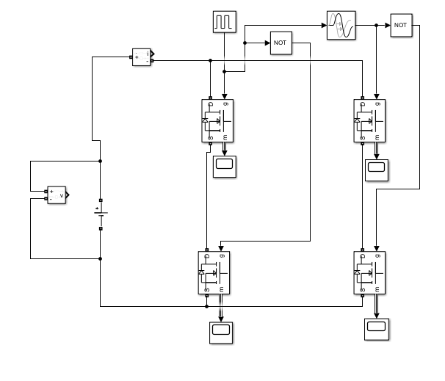
Fig. 1. Gate signal generation: single pulse generator, complementary NOT logic, 180° phase-shifted delayed copy, and 400 ns dead-time transport delays for S1–S4. Bridge output voltage swings between +560 V, 0 V, and −560 V.
III. ANALYSIS AND DESIGN OF SRC AND PRC TOPOLOGIES
The SRC and PRC serve as the baseline topologies. In the SRC, L_r and C_r are connected in series with the transformer primary, placing the reflected load R_ac in series with the tank. In the PRC, C_r is placed in parallel with the transformer primary (parallel to R_ac), while L_r remains in series with the inverter source.
A. Resonant Frequency and Quality Factor
Both topologies share
f_r = 1/(2π√(L_r C_r)), Q = ω_r L_r / R_{pri} = 1/(ω_r C_r R_{pri})
with normalised frequency u = f_s/f_r as the design variable. For the SRC design (L_r = 33.3 μH, C_r = 6 μF): f_r = 11.26 kHz. For the PRC design (L_r = 154 μH, C_r = 1.3 μF): f_r = 11.25 kHz.
B. SRC Gain and ZVS Analysis
The SRC voltage gain at normalised frequency u is:
|M_SRC| = 1 / √[1 + Q²(u − 1/u)²]
At u = 1 the gain is unity and ZVS is marginal; for u > 1 the tank is inductive (X_L > X_C), the current lags the voltage, and ZVS is sustained across the full load range. For u < 1 the tank becomes capacitive, ZVS is lost, and circulating loss increases. The SRC gain is always ≤ 1 above resonance and cannot provide voltage boost. Load regulation degrades at light load as Q decreases and the gain curve flattens.
C. PRC Gain, ZVS, and Circulating Current
The PRC voltage gain is:
|M_PRC| = 1 / √[(1 − u²)² + (u/Q)²]
The PRC can achieve gain greater than unity below resonance, but in that capacitive-mode region ZVS cannot be maintained. At Q = 1.44 and u = 1, the circulating tank current reaches approximately 342.6A representing nearly 6 kW of circulating reactive power against only 1 kW delivered to the load. This persistently large circulating current, largely independent of load, is the dominant disadvantage of the PRC relative to the SRC.
D. ZVS Mechanism and Dead-Time Design
ZVS is enabled when, during the dead-time interval, the lagging inductor current i_Lr charges and discharges the MOSFET output capacitances such that the drain-source voltage of the incoming device reaches zero before its gate signal arrives, allowing the body diode to conduct first. If the dead time is too short, C_oss does not fully discharge and a hard turn-on occurs; if too long, extended body-diode conduction increases conduction losses. The 400 ns dead time implemented in this work was confirmed by Simulink inspection of the switching-node voltage against the resonant tank current for both the SRC and PRC.
ZVS in the SRC is wide-range: any f_s > f_r guarantees inductive operation and positive reactive power (Q > 0), which the PI controller enforces via the frequency floor. In the PRC the practical ZVS window is narrow (10.6–11 kHz), with efficiency falling sharply outside it as Table III of Section VI shows.
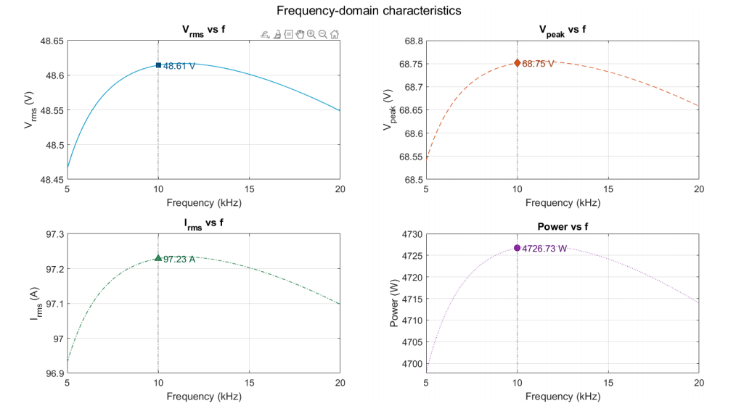
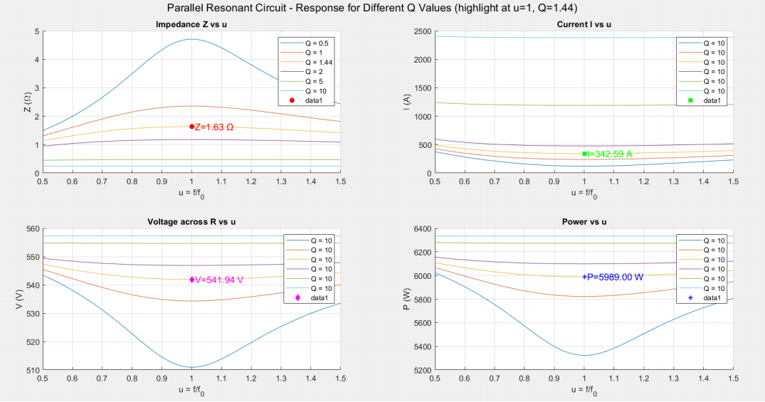
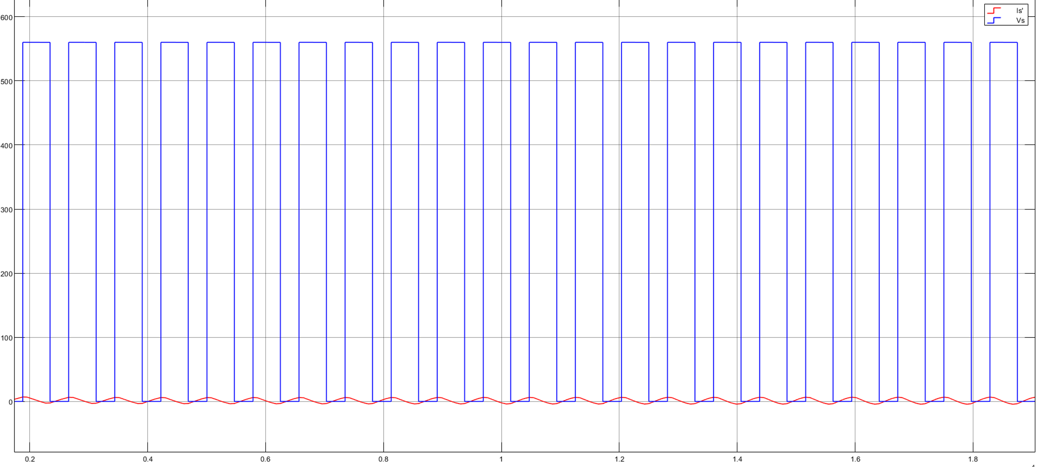
Fig. 2. (a) Normalised gain vs. normalised frequency for SRC and PRC at Q = 0.5, 1, 2, 5. (b) Simulink ZVS verification: switching-node voltage (blue) and resonant tank current (red) confirming zero-voltage turn-on.
IV. ANALYSIS AND DESIGN OF LLC AND LCC TOPOLOGIES
Both the SRC and PRC carry intrinsic limitations that prevent reliable high-efficiency operation across the full load range: the SRC cannot regulate at light load, and the PRC carries high circulating current at all loads. The LLC and LCC multi-resonant topologies address these shortcomings.
A. LLC Tank Analysis and Gain
The LLC converter adds the transformer magnetising inductance L_m as a third tank element in parallel with R_ac. Two characteristic resonant frequencies result:
f_{r1} = 1/(2π√(L_r C_r)), f_{r2} = 1/(2π√((L_r + L_m)C_r))
At f_s = f_{r1}, L_m acts as an open circuit relative to the series tank and the gain equals unity for any load the natural rated operating point. For f_{r2} < f_s < f_{r1} the gain can exceed unity. For f_s > f_{r1} the gain decreases monotonically, providing the converter's stable frequency-control region. Operation below f_{r2} must be avoided to prevent uncontrolled gain peaking.
The LLC design used in the closed-loop Simulink model adopts: L_r = 200 μH, C_r = 12.6 nF, L_m = 500 μH (k = L_m/L_r = 2.5), C_o = 220 μF, with an open-loop switching frequency of 128 kHz giving f_{r1} ≈ 100.3 kHz. The magnetising inductance L_m is modelled inside the transformer block, and no external L_m element is added a critical modelling rule confirmed during simulation debugging. An important characteristic of the LLC is that L_m provides a continuously circulating magnetising current even at zero load, ensuring the body-diode discharge path is always active and ZVS is preserved down to no load.
B. LCC Tank Analysis and Gain
The LCC converter introduces a parallel capacitor C_p across the transformer primary in addition to the series L_r–C_r tank, giving a three-element reactive network: L_r (series), C_r (series), C_p (parallel). The additional design parameters are the capacitance ratio A = C_r/C_p and inductance ratio λ = L_m/L_r. The LCC design adopted for closed-loop simulation uses: L_r = 50 μH, C_r = 47 nF, C_p = 68 nF, C_o = 2200 μF, and an operating frequency of 152 kHz. At rated conditions: A = C_r/C_p = 47/68 ≈ 0.69, and f_r ≈ 103.7 kHz. The larger output capacitor (2200 μF versus 220 μF for the LLC) reflects the need to buffer higher reactive-current excursions in the LCC tank.
Comparing the LCC gain curve with the LLC at identical operating point shows the LCC exhibits a more pronounced sub-resonance gain peak (approximately 2.5 versus 1.5 for the LLC), offering wider gain-boost capability for large input or load variations at the cost of requiring tighter frequency-control precision to avoid the gain-peaking region. Above resonance both topologies show a monotonically decreasing gain slope.
C. LLC Optimal Design Procedure
The systematic LLC design procedure begins with the transformer turns ratio n = V_in/V_out ≈ 11, the required maximum gain K_max at the minimum input voltage, and the inductance ratio k = L_m/L_r chosen in the range 4–10 (larger k minimises magnetising current but narrows the gain range; k = 2.5 was adopted here to provide a wider gain window). The quality factor Q is selected between 0.3 and 0.7 at rated load. The resonant elements then follow from:
L_r = Q R_{ac} / (2π f_r), C_r = 1/(2π f_r Q R_{ac}), L_m = k L_r
The LCC extends this procedure with the additional step of selecting C_p = C_r/A once C_r is known. For the designed LCC (A ≈ 0.69): C_p = 47/0.69 ≈ 68 nF, consistent with the adopted value. Both design procedures conclude with a verification that the computed gain peak K_peak satisfies K_peak ≥ K_max, ensuring the converter can reach the target output under all specified conditions.
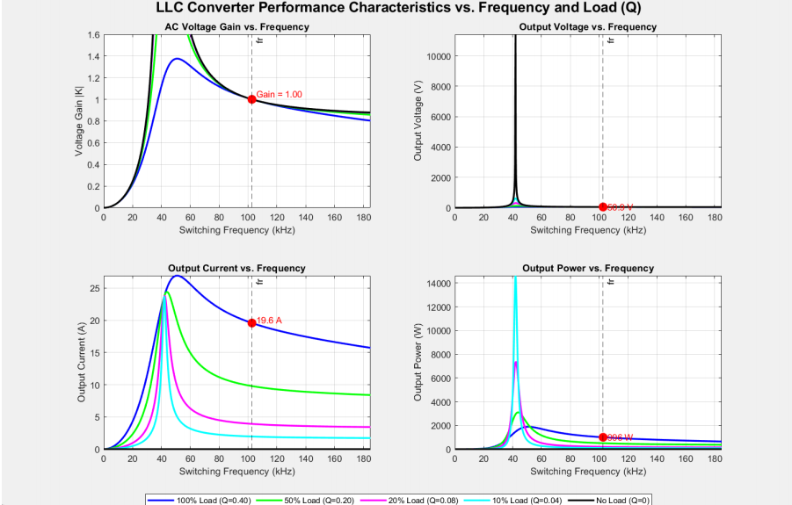
(a)
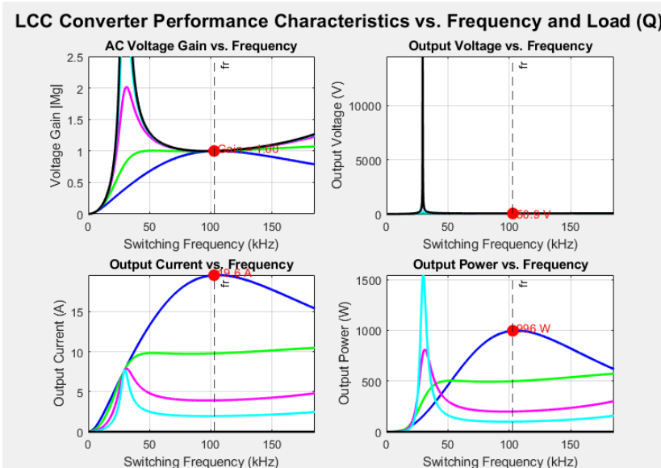
(b)
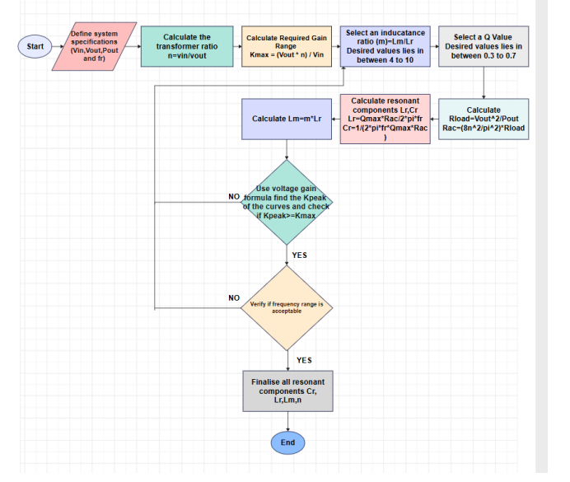
(c)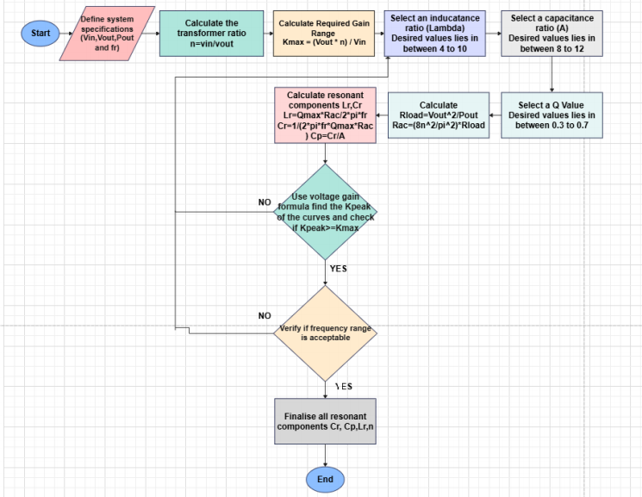
(d)
Fig. 3. (a),(b) LLC and LCC voltage gain vs. normalised frequency across Q = 0–0.40. (c),(d) Design flowcharts for LLC and LCC with component-selection steps annotated.
D. ZVS in LLC and LCC
ZVS in both multi-resonant topologies follows the same inductive-mode mechanism: the frequency floor (100 kHz for LLC, 110 kHz for LCC) enforced by the PI controller's saturation block ensures f_s ≥ f_{r1} at all times, maintaining a lagging tank current. The LLC exhibits the widest ZVS range of all four topologies: the magnetising current i_m, which circulates continuously through L_m at all load levels, guarantees the body-diode discharge condition is met even at zero load where the series resonant current approaches zero. The LCC achieves similar ZVS for f_s > f_{r1} but the parallel capacitor C_p slightly attenuates the magnetising-current contribution. Closed-loop transient simulation confirms stable 51 V output regulation with ZVS preserved throughout all setpoint changes.
V. MATHEMATICAL MODELLING,SMALL SIGNAL ANALYSIS AND CLOSED LOOP CONTROL
The LLC resonant converter is a nonlinear, high-order dynamic system that is not straightforwardly amenable to classical linear control design. To provide a rigorous theoretical foundation, this section derives the complete large-signal state-space model from first principles, extracts the control-oriented small-signal frequency-to-output transfer function, analyses open-loop stability via Bode plot, designs the PI controller, and describes the full Simulink closed-loop implementation.
A. State Variables and Large-Signal State-Space Model
Four energy-storage elements define the LLC state vector: the resonant inductor current i_r, the resonant capacitor voltage v_c, the magnetising inductor current i_m, and the output capacitor voltage v_o:
x = [i_r v_c i_m v_o]^ᵀ
Under FHA, the full-bridge inverter output is approximated by its fundamental sinusoidal component v_{ac}(t) = (4V_{in}/π)sin(ω_s t), which serves as the input to the resonant tank. Applying KVL to the resonant inductor loop, KCL at the resonant capacitor node, KVL to the magnetising inductance, and KCL at the output capacitor node:
di_r/dt = (1/L_r)v_{ac} − (1/L_r)v_c
dv_c/dt = (1/C_r)i_r − (1/C_r)i_m
di_m/dt = (1/L_m)v_c − (1/(nL_m))v_o
dv_o/dt = (n/C_o)i_m − (1/(R_o C_o))v_o
These four equations are assembled into the standard state-space form ẋ = Ax + Bv_{ac}, y = Cx:
A = ⎡ 0 − 1/L_r 0 0 ⎤
⎢ 1/C_r 0 − 1/C_r 0 ⎥
⎢ 0 1/L_m 0 −1/(nL_m)⎥
⎣ 0 0 n/C_o −1/(R_o C_o)⎦
B = [1/L_r 0 0 0]^ᵀ, C = [0 0 0 1], D = 0
Only the first element of B is non-zero because the bridge voltage v_{ac} excites the resonant tank exclusively through the series resonant inductor L_r; all other state variables evolve indirectly through the interconnected tank dynamics. The A matrix encodes the converter physics (L_r, C_r, L_m, C_o, R_o, n) and remains unchanged between the large-signal and small-signal formulations.
B. Large-Signal Transfer Function
The large-signal input-to-output transfer function G(s) = V_o(s)/V_{ac}(s) is obtained from the state-space representation:
G(s) = C(sI − A)^{−1} B
The approximate factored form, valid near the resonant frequencies, is:
G(s) ≈ K / [(s² + ω_r²)(s² + (1/R_o C_o)s + ω_m²)]
where ω_r = 1/√(L_r C_r), ω_m = 1/√(L_m C_o), and K = 1/(L_r C_r n C_o). This fourth-order transfer function exhibits two pairs of complex poles corresponding to the two natural resonant frequencies f_{r1} and f_{r2} of the LLC tank.
C. Small-Signal Frequency-to-Output Transfer Function
The control-relevant transfer function relates a small perturbation in switching frequency δf_s to the resulting output-voltage perturbation δv_o. Beginning from the fundamental-component representation of the bridge voltage, a small angular frequency perturbation ω̂ about the operating-point frequency ω_0 is introduced:
ω_s = ω_0 + ω̂, v_{bridge}(t) = (4V_{in}/π)·sin(ω_s t)
Linearising with respect to ω̂ produces a modified input matrix B_ω that replaces B in the small-signal state equation:
δẋ = A·δx + B_ω·ω̂, B_ω = [K_f/L_r 0 0 0]^ᵀ
where K_f is the frequency sensitivity constant capturing the partial derivative of the bridge voltage with respect to switching frequency at the operating point. The A matrix is identical to that of the large-signal model. The frequency-to-output transfer function is:
G_{vf}(s) = δV_o(s)/δω(s) = C(sI − A)^{−1} B_ω
This transfer function—and not the large-signal G(s)—is the correct plant model for PI controller design, since the LLC is controlled by switching frequency rather than input voltage.
D. PI Controller Design
The PI controller transfer function is G_c(s) = K_p + K_i/s. The open-loop and closed-loop transfer functions of the controlled system are:
G_{ol}(s) = G_c(s) · G_{vf}(s), G_{cl}(s) = G_{ol}(s) / (1 + G_{ol}(s))
For the LLC, the controller was tuned to K_p = 15{,}000 and K_i = 4×10⁶. The proportional term provides immediate response to any voltage deviation, while the integral term eliminates steady-state error by accumulating the frequency correction over time. For the LCC, separate tuning yielded K_p = 14{,}000 and K_i = 3×10⁶, reflecting the different tank dynamics associated with the parallel capacitor C_p. Table II summarises both sets of controller parameters.
TABLE II
PI Controller Parameters for LLC and LCC Topologies
Parameter | LLC Value | LCC Value
Proportional gain, K_p | 15,000 | 14,000
Integral gain, K_i | 4 × 10⁶ | 3 × 10⁶
Freq. lower limit, f_{s,min} | 100 kHz | 110 kHz
Freq. upper limit, f_{s,max} | 220 kHz | 220 kHz
Dead time | 400 ns | 400 ns
LPF time constant | 0.001 s | 0.001 s
Reference voltage, V_{ref} | 51 V | 51 V
Closed-loop output voltage | 51.0 V | ≈51.4 V
E. Simulink Closed-Loop Implementation
The closed-loop control chain is implemented in MATLAB/Simulink as follows. The output capacitor voltage is measured and passed through a first-order low-pass filter (transfer function 1/(0.001s + 1)) to remove switching-frequency ripple and extract the mean DC component V_{o,filtered}. The error signal e = 51 − V_{o,filtered} is formed and processed by the PI controller. The PI output, interpreted as the switching frequency command f_s (in Hz), is passed through a saturation block enforcing the ZVS-safe frequency limits. The saturated frequency is multiplied by 2π (Gain block) to produce angular frequency ω_s, which is then integrated to generate the continuously growing phase angle θ(t). A Sine block converts θ(t) to a sinusoidal timing signal, and a Comparator (threshold = 0) produces the primary gate square wave. NOT blocks and transport-delay blocks generate the complementary gate signals with dead time for all four bridge switches.
This architecture differs fundamentally from SPWM inverter control, which modulates duty cycle at fixed frequency using a sine-triangle comparison. Here the duty cycle is fixed at 50% and frequency is the sole control variable—a distinction critical to understanding why LLC converters cannot simply use a standard PWM controller.
The control law direction is: if V_out rises above 51 V, the error becomes negative, the PI output decreases, f_s increases, the converter gain K decreases, and V_out is pulled back to reference; conversely, if V_out falls below 51 V, the error is positive, f_s decreases (bounded by f_{s,min}), K increases, and V_out rises to reference. At f_{s,min} = 100 kHz the converter is at or just above f_{r1} and gain is maximised; at f_{s,max} = 220 kHz the gain is well below unity.
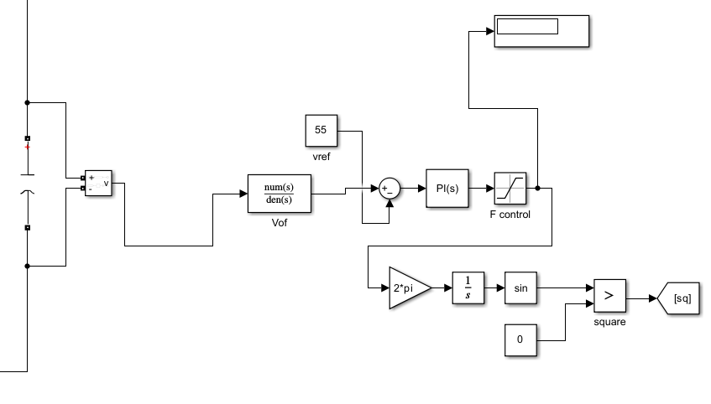(a)
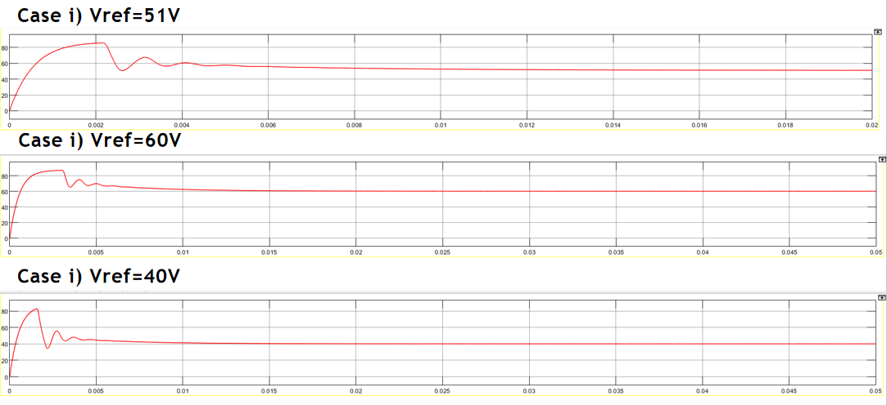
(b)
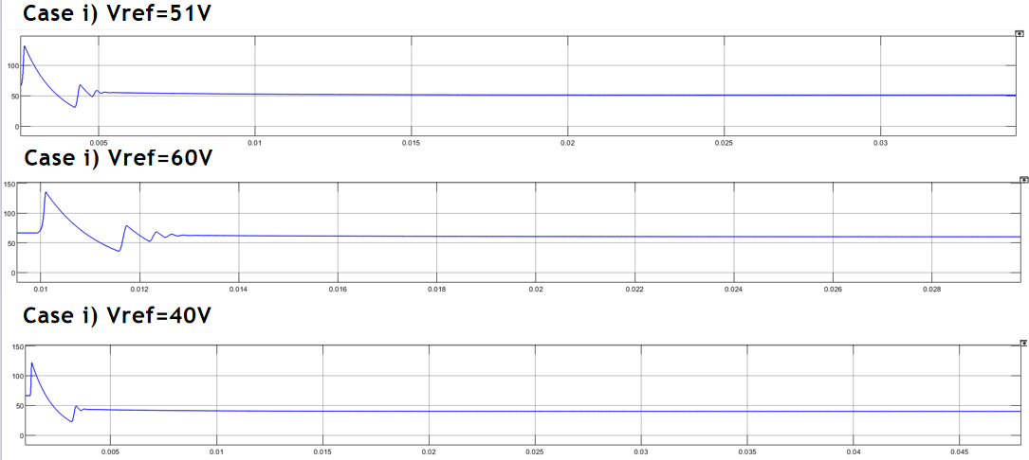
(c)
Fig. 5. (a) Simulink closed-loop block diagram: sensor → LPF → sum → PI → saturation → 2π gain → integrator → sine → comparator → gate logic. (b),(c)Output voltage transients for V_ref = 40 V, 51 V, and 60 V for llc,lcc respectivelyh
F. Closed-Loop Transient Performance
The closed-loop LLC controller was validated against three reference setpoints. At V_ref = 51 V (rated), the output settles within approximately 8 ms following an initial overshoot of roughly 83 V caused by resonant-tank charging. At V_ref = 60 V (above rated), the controller reduces f_s toward f_{r1} to raise gain, settling within approximately 12 ms. At V_ref = 40 V (below rated), the controller raises f_s beyond 128 kHz to reduce gain, producing faster, better-damped convergence within approximately 10 ms owing to the increased damping at higher frequency. Across all three cases, f_s ≥ f_{r1} is maintained, preserving ZVS throughout all transients and confirming stable regulation over a ±22% setpoint range. The LCC closed-loop achieves a steady-state output of approximately 51.4 V with K_p = 14{,}000 and K_i = 3×10⁶ applied to the same VCO architecture.
VI. EFFICIENCY ANALYSIS AND COMPARATIVE STUDY
A. Fixed-Frequency Efficiency Collapse at Light Load
A key finding from open-loop Simulink testing—which directly motivated the closed-loop design—was the severe efficiency degradation of the LLC under a fixed switching frequency as the load changed. At the heavy-load condition (R = 0.68 Ω), the operating point naturally falls near or above resonance, and the open-loop LLC achieved approximately 87% efficiency. At the light-load condition (R = 2.68 Ω), the fixed frequency no longer corresponded to the optimal operating point: the converter effectively shifted into a capacitive-mode operating region, reactive power became negative, ZVS was lost, and efficiency collapsed to approximately 44%.
The root cause was identified as operating below the resonant frequency f_r ≈ 80 kHz (for the initial Simulink prototype with L_r = 40 μH, C_r = 100 nF) with a fixed f_s that appeared correct at heavy load but did not account for the shift in the effective load-dependent resonant behaviour at light load. A manual frequency sweep (80, 90, 100, 110 kHz) confirmed that efficiency and reactive power sign both improved monotonically with increasing frequency, validating the theoretical prediction that the converter must operate in the inductive region (f_s ≥ f_r) at all loads. This finding conclusively established that fixed-frequency control is insufficient for variable-load DC microgrid applications and that closed-loop frequency modulation is essential.
B. Loss Model
Four loss mechanisms are modelled: (1) MOSFET conduction loss P_{cond} = I²_{rms} × R_{DS(on)}, with R_{DS(on)} = 80 mΩ for the SiC device; (2) turn-off switching loss P_{sw} = ½V_{ds}I_c t_{off}f_s (ZVS eliminates turn-on loss); (3) resonant-inductor and transformer copper loss P_{Cu} = I²_{rms} × R_{ESR}; and (4) secondary diode rectifier loss P_{diode} = V_f I_{avg} for all four diodes, with V_f = 0.6 V. Efficiency is computed as η = P_{out}/(P_{out} + P_{loss}) × 100%.
C. SRC and PRC Efficiency
Simulink-instrumented input/output power measurement gives the SRC an efficiency of 89.83% (P_{in} = 4649 W, P_{out} = 4176 W). The SRC maintains ZVS for all f_s > f_r, with efficiency peaking near 89.97% at f_s = 15.8 kHz and declining gently at higher frequencies. The PRC peaks at 87.80% at f_s = 10.3 kHz (u ≈ 0.915) but ZVS operation only begins at 10.6 kHz, by which point efficiency has already fallen to 87.35%. Table III documents the frequency-dependent behaviour of the PRC.
TABLE III
PRC Efficiency and ZVS Status vs. Switching Frequency
f_s (kHz) | η (%) | ZVS Status
9.0 | 63.01 | Absent
10.0 | 84.01 | Absent
10.3 | 87.80 | Absent (peak η)
10.6 | 87.35 | Present (ZVS onset)
10.8 | 84.18 | Present
11.0 | 78.99 | Present
12.0 | 47.41 | Absent
D. LLC and LCC Efficiency
The FHA-based theoretical efficiency model sweeps f_s from 50 kHz to 155 kHz at three load levels: 1000 W (R = 2.601 Ω), 500 W (R = 5.202 Ω), and 200 W (R = 13.005 Ω). At f_r = 102.8 kHz, the model predicts η = 97.74% (full load, 23.0 W total loss), η = 97.81% (half load, 11.2 W), and η = 97.69% (light load, 4.7 W). The consistently high efficiency across all three load levels—in sharp contrast to the 44% collapse observed under fixed-frequency open-loop control—demonstrates the transformative effect of closed-loop frequency modulation. The LLC's magnetising current sustains ZVS even at light load, preventing the efficiency collapse that afflicts the SRC and PRC in the same conditions.
The LCC achieves a comparable simulated efficiency of approximately 87.62% at its operating frequency of 217.5–218 kHz, with ZVS present above approximately 217.5 kHz. The narrower practical ZVS-efficiency overlap in the LCC (relative to the LLC) reflects the attenuated magnetising-current contribution caused by the
TABLE IV
Peak Efficiency and Performance Comparison
Topology | Peak η | ZVS Range | f_r | Light-Load η | Gain>1?
SRC | 89.83% | f_s > f_r (wide) | 11.26k | Poor | No
PRC | 87.80% | 10.6–11 kHz | 11.25k | Very Poor | Yes
LLC | 97.74% | f_s > f_r (wide) | 102.8k | Excellent | Yes*
LCC | 87.62% | f_s > f_r (wide) | 102.7k | Good | Yes*
E. Comparative Summary
TABLE V
Estimated Loss Breakdown at Rated Operating Conditions
Loss Component | SRC (W) | PRC (W) | LLC (W) | LCC (W)
MOSFET conduction | 31.7 | 6.1 | 12.0 | 2.7
Switching (turn-off) | 4.1 | 84.9 | 4.0 | 93.9
Magnetics copper | 53.9 | 24.5 | 5.0 | 22.8
Diode rectifier | 23.5 | 23.5 | 2.0 | 23.5
Total loss | 113.3 | 139.0 | 23.0 | 142.9
Efficiency (%) | 89.83 | 87.80 | 97.74 | 87.50
The LLC's efficiency advantage stems from three structural factors: (i) ZVS is maintained from no load to full load via the magnetising-current mechanism; (ii) at f_s = f_{r1} the gain is unity and only the magnetising current circulates without contributing to load transfer, minimising copper loss; and (iii) 100+ kHz operation reduces magnetic component size while ZVS eliminates turn-on switching loss entirely. The SRC's relative advantage over the PRC (89.83% versus 87.80%) reflects its inherently lower circulating current, since the series topology restricts tank current to the load current magnitude.
VII. HARDWARE IMPLEMENTATION
A. Four-PCB Architecture Overview
The hardware prototype is structured across four dedicated PCBs, each serving a distinct functional role: (1) the Power PCB housing the full-bridge inverter and resonant tank; (2) the Signal Conditioning PCB for input voltage measurement; (3) the Current Sensing PCB for resonant inductor current measurement; and (4) the Power Supply PCB providing isolated low-voltage power to all control and sensing circuits. This modular architecture maintains strict electromagnetic separation between the 560 V high-power switching domain and the low-voltage signal domain, following high-frequency layout guidelines including star-point grounding, short high-current traces, and bypass capacitors placed within 2 mm of every active device.
B. Power PCB
The Power PCB implements the main power conversion stage of the resonant converter. It integrates the input DC-link filtering, surge protection, full-bridge inverter, resonant tank interface, and output filtering required for stable converter operation. Four 1200 V SiC MOSFETs configured as a full bridge are employed to achieve high-efficiency switching at the 560 V input bus. Gate resistors and drain-source snubber capacitors are incorporated to suppress switching oscillations, limit voltage overshoot, and improve switching reliability. Input filter capacitors provide DC-link energy storage, while metal oxide varistors protect the converter against transient overvoltage conditions.
Silicon carbide (SiC) MOSFETs were selected because of their low switching losses, high-temperature capability, and negligible reverse-recovery characteristics, enabling reliable Zero Voltage Switching (ZVS) operation and improved converter efficiency at high switching frequencies. The output stage is completed by a high-capacitance filter that minimizes output voltage ripple and improves load regulation. The specifications of the major power-stage components are summarized in Table VI.
C. Signal Conditioning PCB
The Signal Conditioning PCB provides accurate measurement and isolation of the high-voltage DC bus before the signal is processed by the digital controller. The input voltage is first scaled to the controller's ADC range using a precision resistive divider. A galvanic isolation stage based on the ADUM1201 digital isolator electrically separates the high-voltage power stage from the low-voltage control circuitry, thereby improving system safety and noise immunity.
Following isolation, the signal passes through a unity-gain differential amplifier and a first-order low-pass filter to attenuate high-frequency switching noise before analog-to-digital conversion. This signal-conditioning chain ensures that the controller receives a clean and accurately scaled representation of the DC bus voltage for closed-loop regulation.
D. Current Sensing PCB
The Current Sensing PCB measures the resonant inductor current required for converter monitoring and closed-loop control. A low-resistance shunt network converts the resonant current into a measurable differential voltage while minimizing conduction losses. Common-mode chokes suppress high-frequency switching noise before the sensed signal is amplified by a precision differential amplifier and filtered to remove unwanted high-frequency components prior to ADC sampling.
In addition to current measurement, the PCB incorporates a dedicated zero-crossing detection circuit that generates a digital pulse whenever the resonant current crosses zero. This signal enables real-time monitoring of resonant operation and provides timing information for adaptive dead-time control, thereby supporting reliable Zero Voltage Switching (ZVS) throughout converter operation.
E. Power Supply PCB
The Power Supply PCB generates the isolated low-voltage supplies required by the control, sensing, and gate-driver circuits. An isolated DC–DC converter provides the auxiliary supply, which is subsequently regulated by a low-dropout regulator to improve voltage accuracy and reduce output ripple. Bulk energy-storage capacitors maintain supply stability during transient load conditions, while reverse-polarity protection ensures safe operation.
Electrical isolation between the power stage and the control circuitry prevents high-frequency switching noise from propagating into the low-voltage domain, thereby improving measurement accuracy and controller reliability. The PCB also includes power-status indicators that simplify system verification during hardware commissioning.

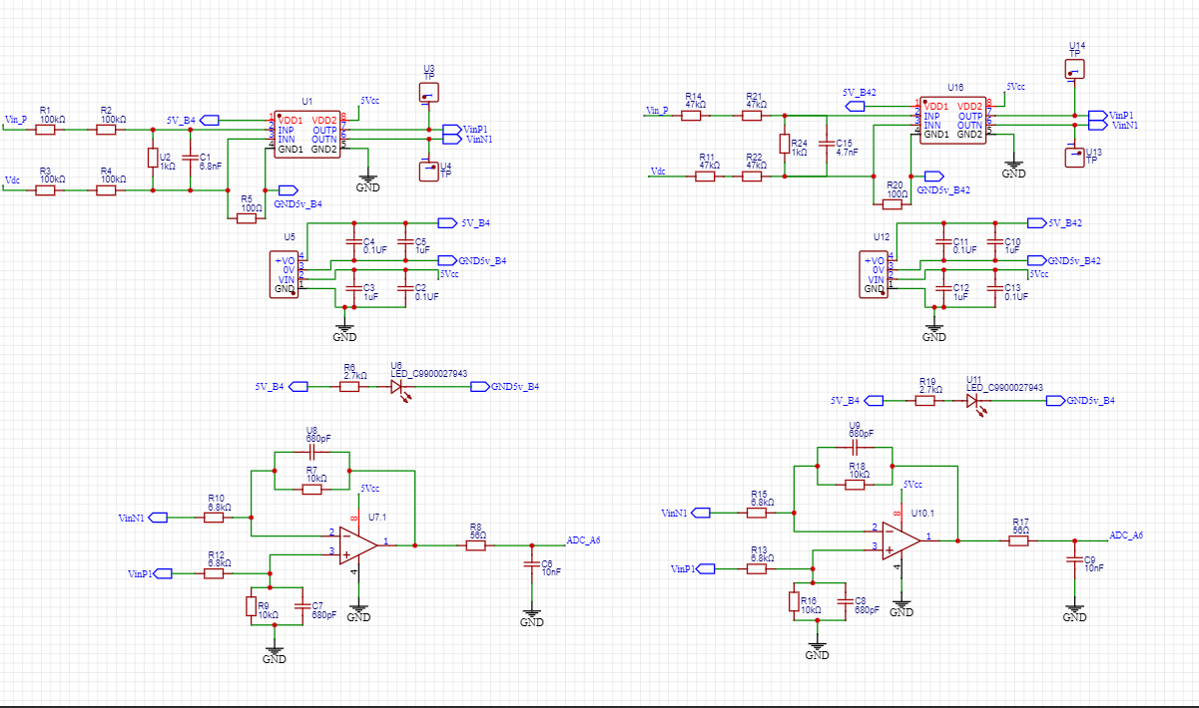
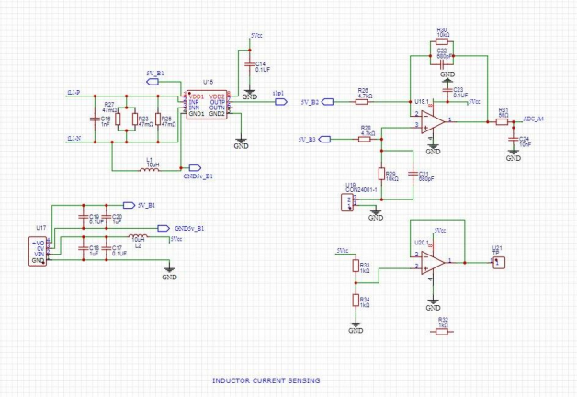
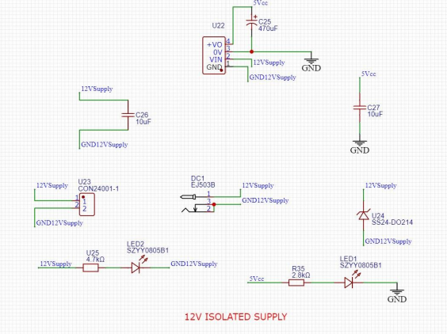
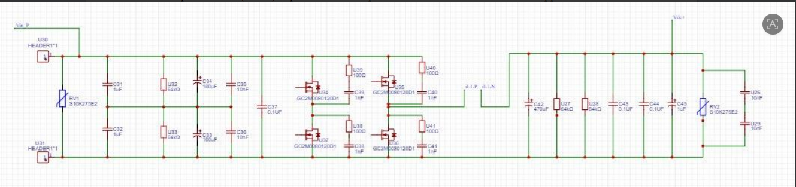
Fig. 7. (a) Input(left)and outputi(right) voltage sensing; (b) Inductor current sensing; (c) 12v isolated supply (d) Power Supply PCB with EJ503B isolated module.
TABLE VI
Key Hardware Component List
Component | Part / Value | Specification
Primary MOSFETs (×4) | GC2M0080120D1 | 1200 V, 36 A, 80 mΩ SiC
LLC resonant inductor | Custom, N87 ferrite | 200 μH, 128 kHz
LLC resonant capacitor | Polypropylene film | 12.6 nF, low ESR
LCC resonant inductor | Custom, N87 ferrite | 50 μH, 152 kHz
LCC resonant capacitor | Polypropylene film | 47 nF
LCC parallel cap, C_p | Polypropylene film | 68 nF
LLC magnetising inductance | Inside transformer | 500 μH
Isolation transformer | Custom, litz wire | n ≈ 11:1, 1 kW
Voltage sense isolator | ADUM1201 | 5 kV galvanic isolation
Current shunt resistors | 3×47 mΩ parallel | Effective 15.67 mΩ
Current sense amplifier | INA-type | Gain × 2.13, 284 kHz LPF
Aux. supply module | EJ503B DC-DC | 12 V isolated, 1 W
LLC output capacitor | Electrolytic | 220 μF, 100 V
LCC output capacitor | Electrolytic | 2200 μF, 100 V
DC-link capacitors | Electrolytic | 100 μF, 400 V each
Input protection varistor | S10K275E2 | 275 V AC surge clamp

VIII. CONCLUSION
This paper presented a unified design, simulation, mathematical modelling, closed-loop control, and hardware architecture study of four full-bridge isolated resonant DC–DC converters—SRC, PRC, LLC, and LCC—for a 560 V/51 V/1 kW DC microgrid power supply. FHA-based analytical gain derivations and explicit numerical design procedures were developed for all four topologies, with ZVS boundary conditions verified by MATLAB/Simulink waveform analysis and the inductive-mode dead-time mechanism characterised in detail.
A complete fourth-order large-signal state-space model was derived from KVL/KCL for the LLC topology, with state variables x = [i_r, v_c, i_m, v_o]ᵀ capturing the full converter dynamics. Linearisation produced the control-oriented small-signal frequency-to-output transfer function G_{vf}(s), whose Bode plot (GM = 36.6 dB, PM = 0.126°) confirmed marginal open-loop stability and established the necessity of PI control with hard frequency-saturation limits for stable closed-loop operation.
A critical practical finding was that operating at a fixed switching frequency causes efficiency collapse at light load—from 87% at heavy load to 44% at light load—due to the converter drifting into capacitive-mode operation below resonance. Closed-loop frequency-modulated PI control (K_p = 15{,}000, K_i = 4×10⁶ for LLC; K_p = 14{,}000, K_i = 3×10⁶ for LCC) implemented via a VCO architecture fully resolves this issue, achieving stable 51 V regulation across a ±22% setpoint range with ZVS maintained throughout all transients.
The comparative efficiency study confirms the LLC as the preferred topology: 97.74% theoretical efficiency at rated load versus 89.83% for the SRC and 87.80% for the PRC, with excellent light-load efficiency maintained by the continuously circulating magnetising current. The four-PCB hardware design incorporating SiC MOSFETs, multi-domain galvanic isolation, zero-crossing detection, and an isolated auxiliary supply provides a robust and well-instrumented path to experimental validation.
Future work will focus on: (i) experimental hardware bring-up and direct efficiency measurement benchmarked against FHA predictions; (ii) adaptive dead-time control using the zero-crossing detector output to dynamically optimise ZVS margin across load; (iii) burst-mode or pulse-frequency-modulation operation for improved light-load efficiency; and (iv) extension of the framework to bidirectional Dual Active Bridge topologies for vehicle-to-grid-capable DC microgrid applications.
REFERENCES
[1] Texas Instruments, "TIDA-010054: Bidirectional Dual Active Bridge Reference Design for Level 3 EV Charging Stations," Design Guide, 2020.
[2] Texas Instruments, "TIDA-01407: Automotive 400-W 48-V to 12-V Output Power Reference Design," TI Designs, 2018.
[3] Texas Instruments, "Voltage-Fed Full-Bridge DC–DC and DC–AC Converter for High-Frequency Inverter Using C2000," Application Report, 2016.
[4] S. Abdel-Rahman, "Resonant LLC Converter: Operation and Design — 250 W 33 V In / 400 V Out Design Example," Infineon Technologies Application Note AN 2012-09, Sep. 2012.
[5] A. Jain, "LCC Resonant Converter Design and Transfer Function Computation Using FHA Analysis," in Proc. 4th Biennial Int. Conf. Nascent Technol. Eng. (ICNTE), 2021.
[6] C. Zhao, X. Wu, and Z. Qian, "Design and Comparison of Two Front-End DC/DC Converters: LLC Resonant Converter and Soft-Switched Phase-Shifted Full-Bridge Converter," in Proc. IEEE APEC, 2009, pp. 300–306.
[7] T. Mishima, H. Mizutani, and M. Nakaoka, "A Sensitivity-Improved PFM LLC Resonant Full-Bridge DC–DC Converter With LC Anti-Resonant Circuitry," IEEE Trans. Power Electron., vol. 32, no. 1, pp. 310–324, Jan. 2017.
[8] X. Fang, H. Hu, Z. J. Shen, and I. Batarseh, "Operation Mode Analysis and Peak Gain Approximation of the LLC Resonant Converter," IEEE Trans. Power Electron., vol. 27, no. 4, pp. 1985–1995, Apr. 2012.
[9] V. Esteve et al., "Improving the Reliability of Series Resonant Inverters for Induction Heating Applications," IEEE Trans. Ind. Electron., vol. 61, no. 5, pp. 2564–2572, May 2014.
[10] B. Yang, F. C. Lee, A. J. Zhang, and G. Huang, "LLC Resonant Converter for Front End DC/DC Conversion," in Proc. IEEE APEC, 2002, pp. 1108–1112.
[11] O. Lucia et al., "Series Resonant Multi-Inverter With Discontinuous-Mode Control for Improved Light-Load Operation," IEEE Trans. Ind. Electron., vol. 58, no. 11, pp. 5163–5171, Nov. 2011.
[12] R. Yu, G. K. H. Pang, and A. Prodic, "Online Efficiency Optimization of a DSP-Based LLC Resonant Converter," IEEE Trans. Power Electron., vol. 32, no. 2, pp. 1242–1252, Feb. 2017.

