PROJECT REPORT
Customer Shopping Behavior Analysis
Python | SQL Server (SSMS) | Power BI
Submitted by: ______________________
Date: October 2026

1. Introduction
Understanding how customers shop helps a retail business decide what to stock, how to price, and whom to target with offers. This project analyses a customer shopping behavior dataset of 3,900 transactions. The data was cleaned and prepared in Python, stored in Microsoft SQL Server and queried with SQL in SSMS to answer ten business questions, and finally visualised in an interactive Power BI dashboard.

1.1 Objectives
- Clean and prepare the raw customer data for analysis.
- Load the cleaned data into SQL Server.
- Answer ten business questions on revenue, discounts, subscriptions, shipping, products and customer segments using SQL.
- Build an interactive dashboard that shows the key metrics at a glance.

1.2 Tools and Technologies
Tool | Purpose
Python (Pandas, NumPy, Seaborn, Matplotlib) | Data loading, cleaning and feature engineering in Jupyter Notebook
SQLAlchemy and PyODBC | Connecting Python to SQL Server and loading the DataFrame
SQL Server and SSMS | Storing the data and running analytical queries
Power BI Desktop | Dashboard and visualisation

2. Dataset Description
The dataset (customer_shopping_behavior.csv) contains 3,900 rows and 18 columns. Each row is one customer purchase. Key columns are listed below.
Column | Description
Customer_ID | Unique ID of the customer
Age, Gender | Demographic details of the customer
Item_Purchased, Category | Product bought and its category (Clothing, Accessories, Footwear, Outerwear)
Purchase_Amount_(USD) | Amount spent on the purchase
Location, Size, Color, Season | Customer state and product attributes
Review_Rating | Rating given by the customer
Subscription_Status | Whether the customer is a subscriber (Yes / No)
Shipping_Type | Standard, Express, 2-Day Shipping, Free Shipping, Next Day Air, Store Pickup
Discount_Applied, Promo_Code_Used | Whether a discount or promo code was used
Previous_Purchases | Number of earlier purchases by the customer
Payment_Method, Frequency_of_Purchases | How the customer pays and how often they buy

3. Data Cleaning and Preparation (Python)
The following steps were carried out in a Jupyter Notebook before loading the data into SQL Server.

3.1 Loading and Viewing the Data
The CSV file was read into a Pandas DataFrame named customer and the first rows were checked with head().
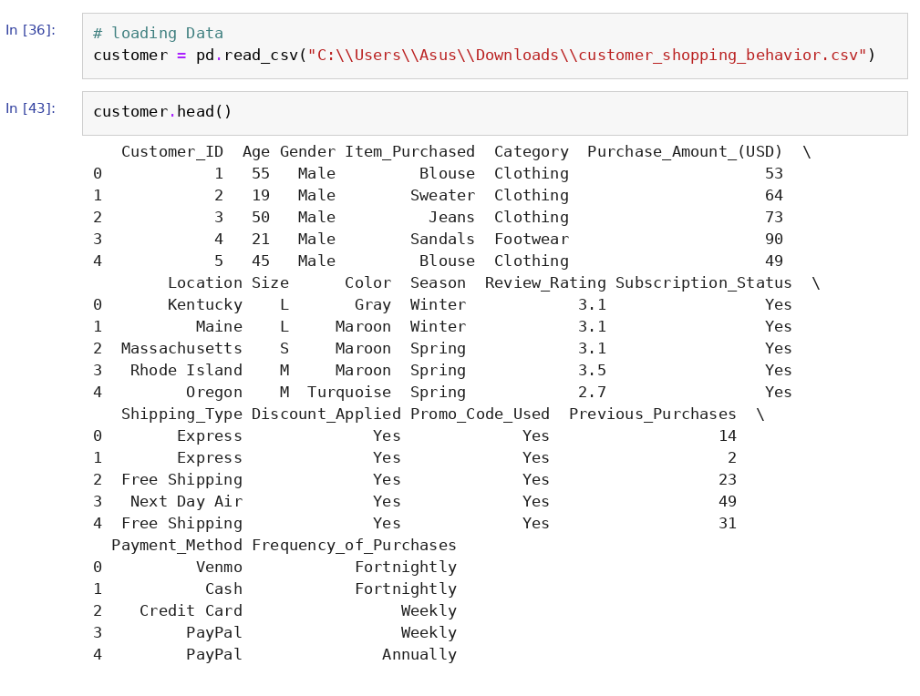
Figure 1: Loading the dataset and viewing the first five rows

3.2 Data Structure
info() shows 3,900 rows and 18 columns with their data types. Review_Rating is the only column with fewer non-null values.
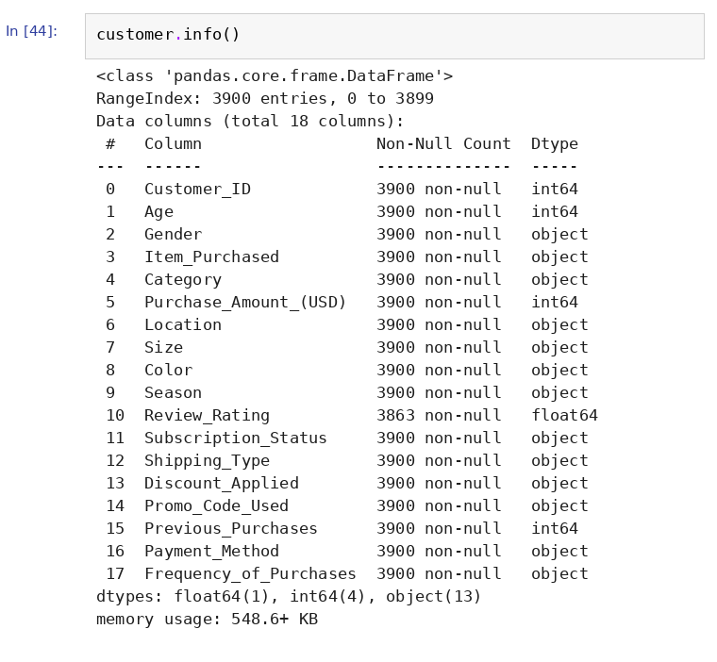
Figure 2: DataFrame info

3.3 Statistical Summary
describe() gives the summary statistics of the numeric columns: the average age is about 44, the average purchase amount is about $59.76 and the average review rating is about 3.75.
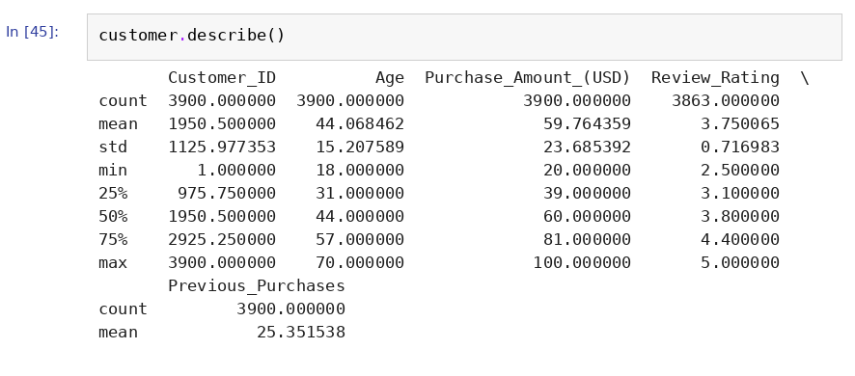
Figure 3: Summary statistics

3.4 Checking Missing Values
isna().sum() shows that Review_Rating has 37 missing values. All other columns are complete.
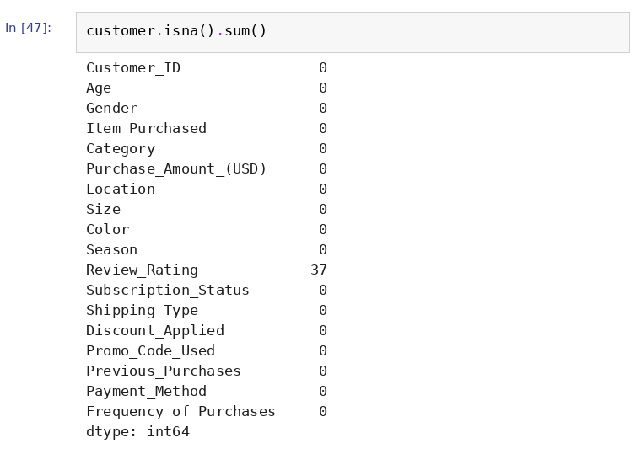
Figure 4: Missing values per column

3.5 Missing Value Treatment
The 37 missing ratings were filled using the average rating of the same Category (group-wise imputation), so that the filled value reflects similar products.
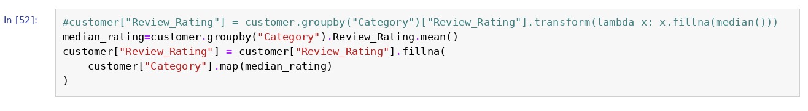
Figure 5: Filling missing Review_Rating by category

3.6 Standardising Column Names
Spaces in column names were replaced with underscores, names were converted to lowercase, and Purchase_Amount_(USD) was renamed to purchase_amount so that the columns are easy to use in SQL.
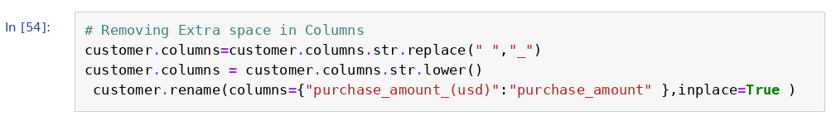
Figure 6: Cleaning column names

3.7 Creating the Age_group Column
A new column Age_group was created with pd.qcut() by splitting age into four equal-sized groups: Young_Adult, Adult, Middle_age and Senior.
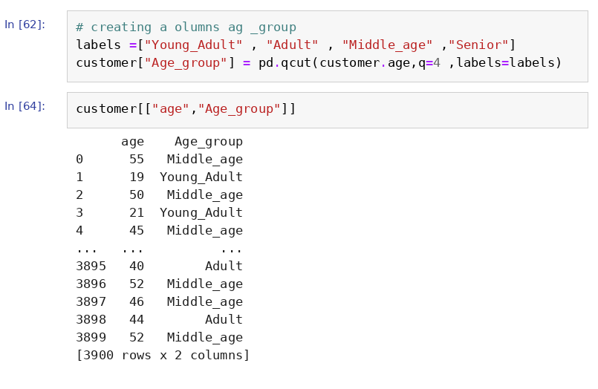
Figure 7: Creating age groups

3.8 Purchase Frequency in Days
Frequency_of_Purchases was converted to a numeric column purchase_frequency_days (for example Weekly = 7, Monthly = 30, Quarterly = 90, Annually = 365).
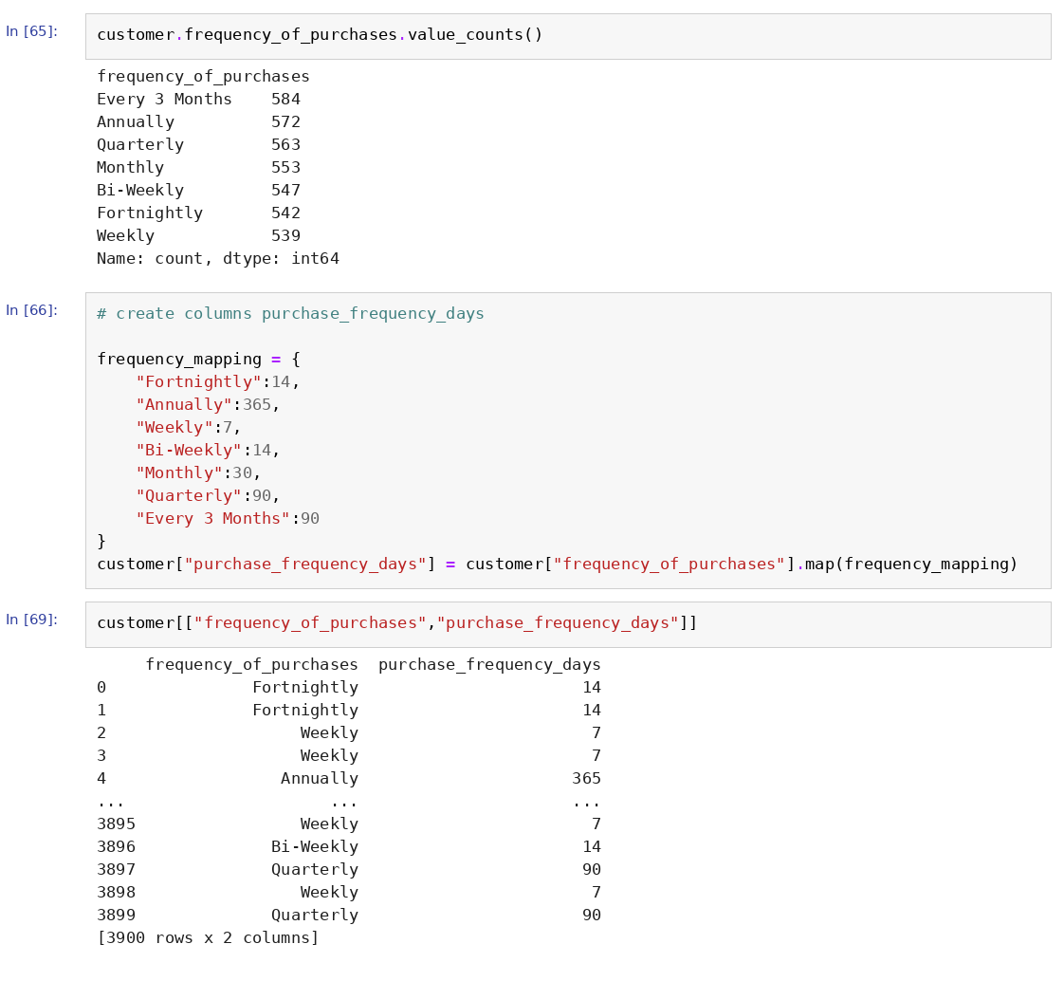
Figure 8: Mapping purchase frequency to days

3.9 Removing a Redundant Column
Discount_Applied and Promo_Code_Used matched in every row (the check returned True), so promo_code_used was dropped. After cleaning, the DataFrame has 3,900 rows and 19 columns.
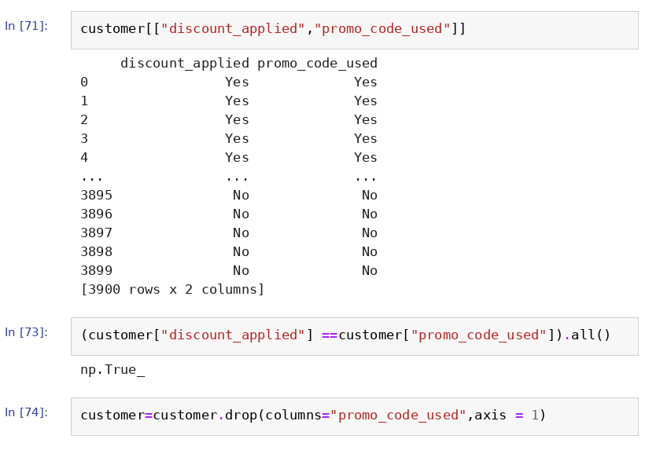
Figure 9: Checking and dropping Promo_Code_Used

4. Loading Data into SQL Server
A database named customer_behavior was created in SQL Server (SSMS). The cleaned DataFrame was loaded into a table named customer using SQLAlchemy with the PyODBC driver (ODBC Driver 18 for SQL Server) and Windows Authentication.
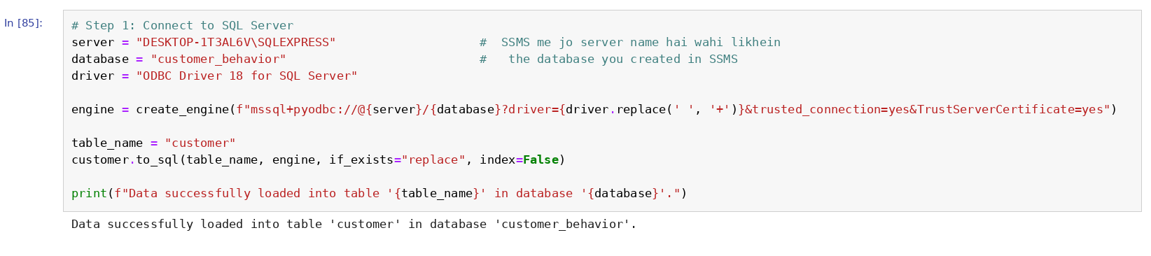
Figure 10: Loading the DataFrame into SQL Server from Python
The table was verified in SSMS with the following query:
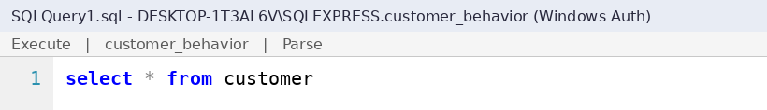
Figure 11: Verifying the customer table in SSMS
Result screenshot: paste the output of SELECT * FROM customer here (Results pane in SSMS)

5. SQL Analysis
Ten business questions were answered with SQL queries in SSMS. For each question, the query is shown followed by a space for the output screenshot from SSMS.

Q1. What is the total revenue generated by male vs. female customers?
Approach: Sums Purchase_Amount for each gender using GROUP BY.
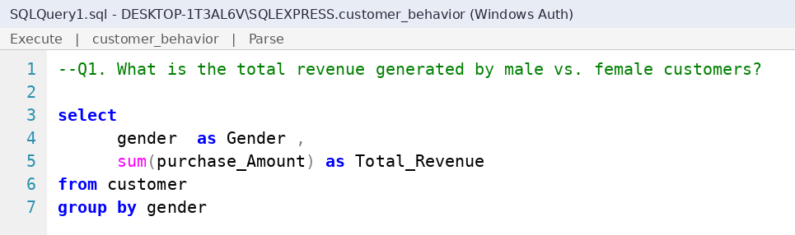
Figure 12: SQL query for Q1
Result screenshot: paste the SSMS output of Q1 here

Q2. Which customers used a discount but still spent more than the average purchase amount?
Approach: Filters Discount_Applied = Yes and compares Purchase_Amount with the overall average using a subquery.
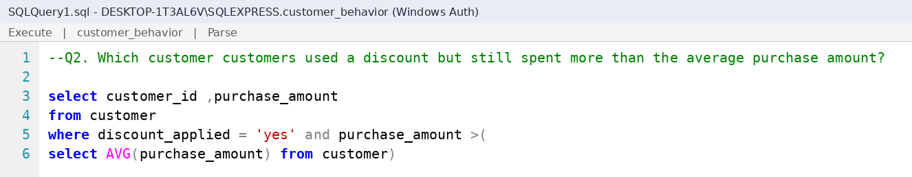
Figure 13: SQL query for Q2
Result screenshot: paste the SSMS output of Q2 here

Q3. Which are the top 5 products with the highest average review rating?
Approach: Groups by Item_Purchased, takes the rounded average Review_Rating, and returns TOP 5 in descending order.
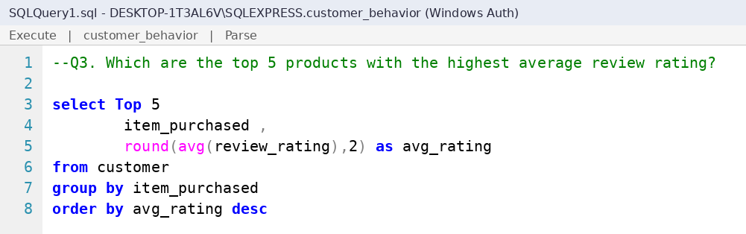
Figure 14: SQL query for Q3
Result screenshot: paste the SSMS output of Q3 here

Q4. Compare the average Purchase Amounts between Standard and Express Shipping.
Approach: Filters the two shipping types and calculates the average purchase amount for each.
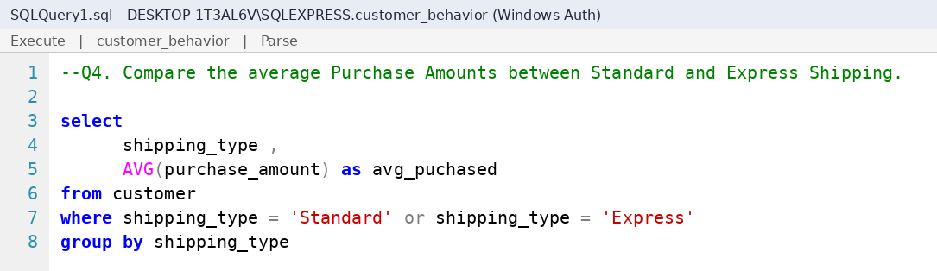
Figure 15: SQL query for Q4
Result screenshot: paste the SSMS output of Q4 here

Q5. Do subscribed customers spend more? Compare average spend and total revenue between subscribers and non-subscribers.
Approach: Groups by Subscription_Status and reports customer count, average spend and total revenue.
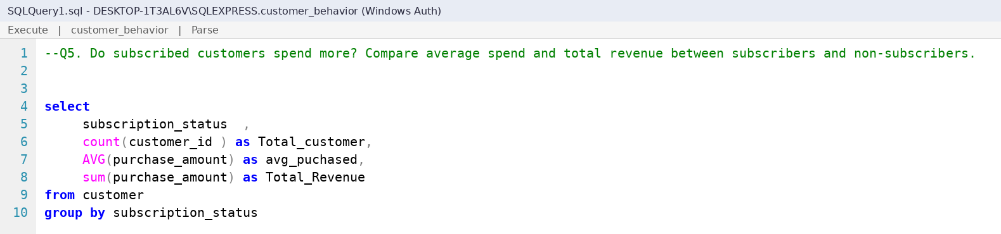
Figure 16: SQL query for Q5
Result screenshot: paste the SSMS output of Q5 here

Q6. Which 5 products have the highest percentage of purchases with discounts applied?
Approach: Uses SUM(CASE WHEN ...) divided by COUNT(*) to get the discount percentage per product, then returns TOP 5.
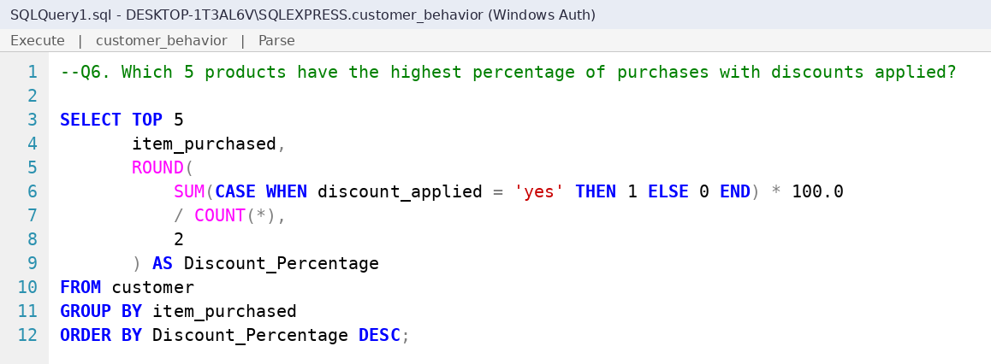
Figure 17: SQL query for Q6
Result screenshot: paste the SSMS output of Q6 here

Q7. Segment customers into New, Returning, and Loyal based on their total number of previous purchases, and show the count of each segment.
Approach: A CASE expression inside a subquery labels customers: 1 previous purchase = New, 2 to 10 = Returning, above 10 = Loyal. The outer query counts each segment.
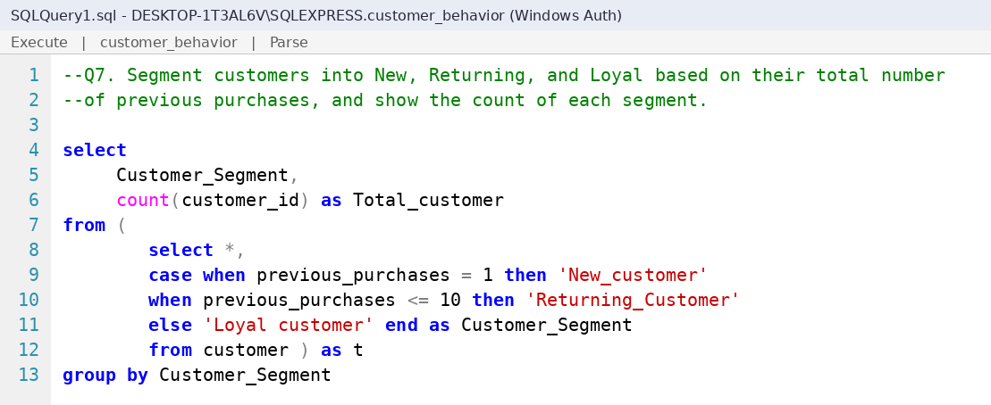
Figure 18: SQL query for Q7
Result screenshot: paste the SSMS output of Q7 here

Q8. What are the top 3 most purchased products within each category?
Approach: Uses DENSE_RANK() OVER (PARTITION BY Category ...) to rank products inside each category and keeps ranks 1 to 3.
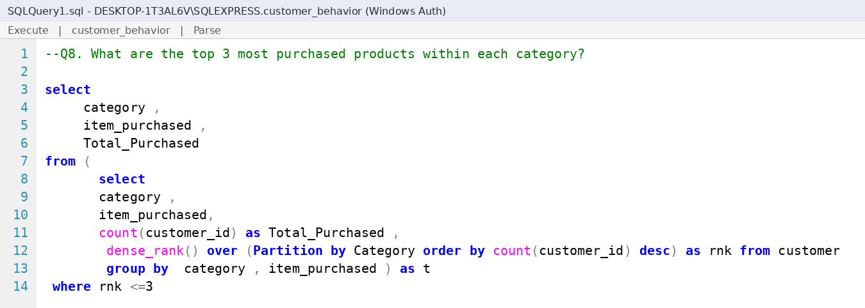
Figure 19: SQL query for Q8
Result screenshot: paste the SSMS output of Q8 here

Q9. Are customers who are repeat buyers (more than 5 previous purchases) also likely to subscribe?
Approach: Filters Previous_Purchases > 5 and counts repeat buyers by Subscription_Status.
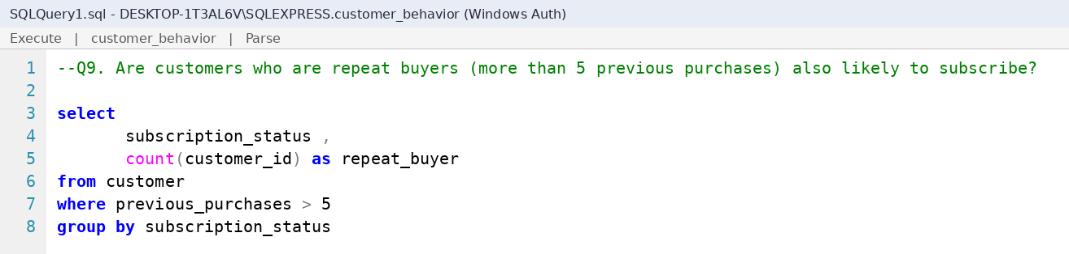
Figure 20: SQL query for Q9
Result screenshot: paste the SSMS output of Q9 here

Q10. What is the revenue contribution of each age group?
Approach: Divides each age group's revenue by total revenue and multiplies by 100 to get a percentage.
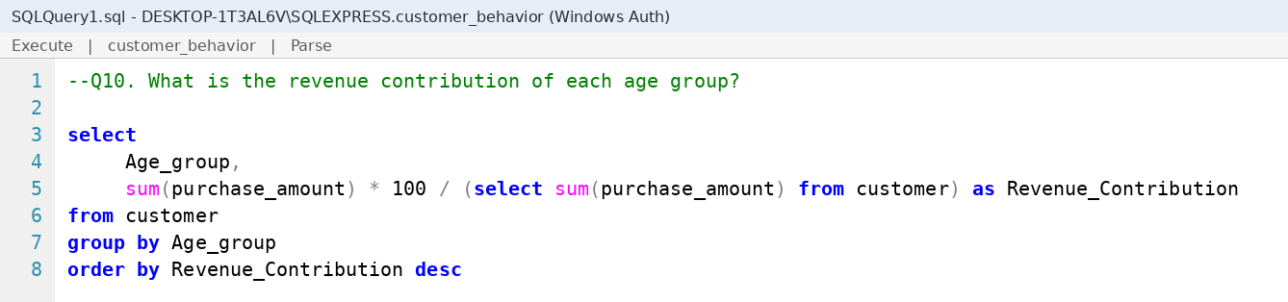
Figure 21: SQL query for Q10
Result screenshot: paste the SSMS output of Q10 here

6. Power BI Dashboard
The data from the customer table was imported into Power BI Desktop (Get Data > SQL Server database) and an interactive dashboard titled "Customer Behavior Dashboard" was built.
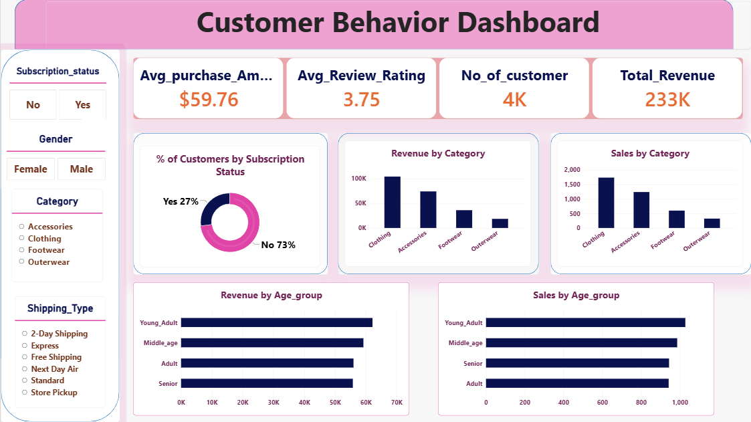
Figure 22: Customer Behavior Dashboard

6.1 Key Performance Indicators
KPI | Value
Average Purchase Amount | $59.76
Average Review Rating | 3.75
Number of Customers | About 4K (3,900)
Total Revenue | About 233K

6.2 Dashboard Components
- Slicers: Subscription Status, Gender, Category and Shipping Type allow the user to filter every chart.
- Donut chart: share of customers by subscription status.
- Column charts: Revenue by Category and Sales by Category.
- Bar charts: Revenue by Age Group and Sales by Age Group.

7. Key Insights from the Dashboard
- Only 27% of customers are subscribers; 73% are non-subscribers. This shows a large opportunity to convert regular buyers into subscribers.
- Clothing is the top category in both revenue and number of sales, followed by Accessories, Footwear and Outerwear.
- The Young_Adult group contributes the highest revenue and sales, with Middle_age close behind. Adult and Senior groups are at a similar, lower level.
- The average purchase amount is about $59.76 and the average review rating is 3.75 out of 5, which leaves room to improve customer satisfaction.

8. Business Recommendations
Based on the analysis and the dashboard, the following actions are recommended. Items marked with a query reference should be confirmed with the SQL output before they are put into practice.
Area | What the data shows | Recommendation
Subscriptions | Only 27% of customers are subscribers; 73% are not. | Run a subscription drive with member-only discounts, early access and free shipping. Use Q5 (spend of subscribers vs non-subscribers) and Q9 (do repeat buyers subscribe) to target the customers most likely to join.
Product focus | Clothing leads in both revenue and sales; Accessories is second; Outerwear is the lowest. | Keep strong stock levels and new designs in Clothing, bundle Accessories with Clothing purchases, and use seasonal campaigns to lift Outerwear. Use Q8 to find the top 3 products in each category.
Target age groups | Young_Adult brings the highest revenue and sales; Middle_age is close behind. | Focus marketing on Young_Adult and Middle_age customers, and use loyalty offers to re-engage Adult and Senior customers. Use Q10 to see each group's revenue share.
Discount strategy | Discounts and promo codes are always used together in this data. | Move from blanket discounts to targeted ones. Use Q6 to find products that depend most on discounts, and Q2 to find big spenders who still used a discount, then test smaller discounts on them.
Loyalty programme | Customers are grouped as New, Returning and Loyal (Q7). | Offer a second-purchase coupon to New customers to turn them into Returning ones, and give Loyal customers points, early access or special rewards.
Shipping | Six shipping options are offered. | Use Q4 to compare Standard and Express spend. If Express customers spend more, offer free or discounted Express shipping above a minimum order value.
Customer satisfaction | The average rating is 3.75 out of 5, and 37 ratings were missing. | Promote the top-rated products from Q3, review the low-rated ones for quality or sizing issues, and ask every customer for a rating after delivery.
Gender mix | Male customers make up about 68% of transactions (2,652 of 3,900). | Run campaigns and widen the product range to attract more female customers. Use Q1 to compare revenue by gender.
Data collection | The dataset has no purchase date. | Capture the purchase date and customer location in the future so trends, seasonality and regional performance can be analysed.

9. Conclusion
This project covered the full analytics workflow: cleaning data in Python, storing it in SQL Server, answering ten business questions with SQL, and presenting the results in a Power BI dashboard. The dashboard shows that the business earns about 233K in total revenue, that Clothing and the Young_Adult segment drive the most revenue, and that the subscriber base is still small. These findings can guide decisions on inventory, targeted promotions and subscription campaigns.

Future Scope
- Add a time dimension (purchase date) to study trends and seasonality.
- Build a customer segmentation or churn model using machine learning.
- Automate the pipeline so the dashboard refreshes when new data arrives.

