XBOT EV
TASK 3
Automation: Workflow Design
WhatsApp Conversation Architecture • Backend/API Design • Fallbacks • Security • Governance
Proposed design for the XBOT EV hiring assessment

1. Executive Overview
This submission presents a proposed WhatsApp automation design for XBOT EV covering the two required customer intents: checking the official price of a specified bike model and booking a test ride.
The design combines conversational AI with controlled backend validation, server-side persistence, fallback handling, human handoff, security, observability, and governance.
Design guardrail
AI understands the customer; the backend validates business rules; PostgreSQL stores the source of truth. This is an implementation-oriented design and does not claim that the bot, APIs, database, or integrations are already live in production.

Assessment scope at a glance
Area | Proposed design response
Primary channel | WhatsApp via Twilio WhatsApp API
Intent 1 | Official bike price enquiry
Intent 2 | Test-ride booking with explicit confirmation
Business logic | FastAPI + Python
Source of truth | PostgreSQL for catalog, slots, bookings, and status
Exception handling | Guided fallback plus human handoff

2. Channel Decision — WhatsApp vs Voice
WhatsApp is selected for this assessment because the two required intents benefit from structured text, visible confirmations, persistent conversation context, and straightforward recovery when information is missing or invalid.
Evaluation criterion | WhatsApp | Voice
Structured data capture | Strong | Moderate
Visible booking confirmation | Strong | Limited
Error correction / retry | Straightforward | More complex
Demo clarity for assessment | Strong | Moderate
Additional speech stack | Not required | ASR + TTS required
Selected for this design | Yes | No
Decision
Use WhatsApp as the proposed customer channel, with Twilio WhatsApp API as the messaging gateway. Voice remains a valid future channel, but it adds speech-recognition, text-to-speech, latency, interruption, and testing complexity that is unnecessary for this assessment scope.

3. System Architecture & Master Flow Diagram
The architecture separates the customer-facing conversation from backend business logic and persistent data. The controlled path is: Customer → WhatsApp → Twilio webhook → FastAPI backend → intent routing → business logic → PostgreSQL / optional integrations → response, logging, or human handoff.
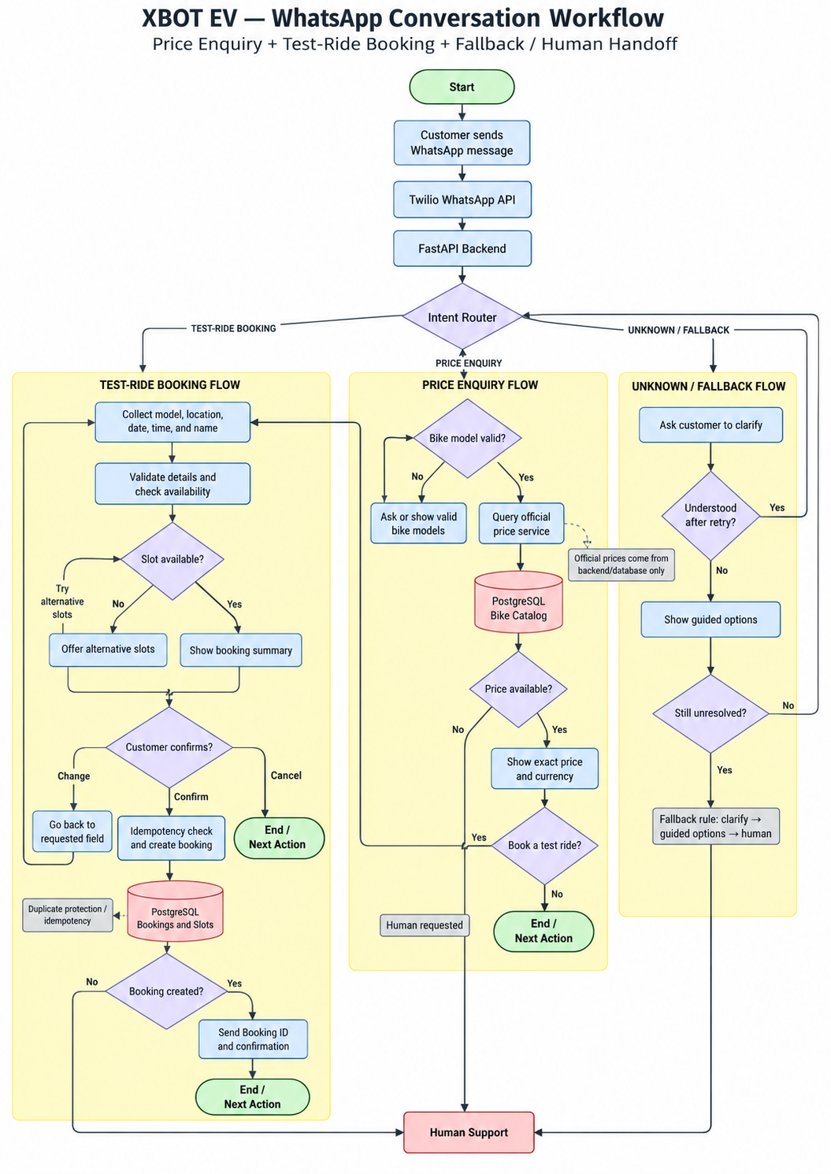
Figure 1. XBOT EV WhatsApp master conversation workflow — price enquiry, test-ride booking, fallback handling, and human handoff.

4. Price Enquiry Intent — Detailed Logic
Purpose
Allow a customer to request the official price of a specific XBOT EV model. AI can interpret the wording, but it must never invent or guess a price.

Step | Logic
1. Receive enquiry | Customer asks for the price of an XBOT EV bike model.
2. Extract model | Identify the model name from the customer message.
3. Validate model | Backend checks the model against the approved XBOT EV bike catalog.
4. Missing / invalid model | Ask the customer to select or provide a valid model; do not guess.
5. Retrieve official price | Backend reads the price from the approved pricing source / PostgreSQL catalog.
6. Price unavailable | Do not invent a value; offer human support.
7. Price available | Show the exact official price and currency.
8. Next action | End the interaction or continue into the test-ride booking flow.
Source-of-truth rule
Official pricing must come from a controlled backend data source. The language model is not an authoritative pricing system.

5. Test-Ride Booking Intent — Detailed Logic
Purpose
Collect the required booking details, validate them, check availability, show a summary, and require explicit customer confirmation before any booking is created.

Step | Logic
1. Receive request | Customer asks to book a test ride.
2. Collect details | Capture selected model, preferred location, date, time, and customer name.
3. Validate model | Confirm the selected XBOT EV model is valid.
4. Validate date | Require a valid future date.
5. Validate time | Require a supported operating window / available booking window.
6. Check availability | Query the booking source of truth for the requested slot.
7. Slot unavailable | Offer alternative available slots.
8. Show summary | Display model, location, date, and time before creation.
9. Customer decision | Allow Confirm, Change, or Cancel.
10. Confirm | Run an idempotency / duplicate check, then create the booking.
11. Change | Return to the requested field, update it, and show the summary again.
12. Cancel | Stop without creating a booking.
13. Booking success | Return the confirmed booking ID and confirmation only after backend success.
14. Booking failure | Do not claim success; offer retry or human support.
Persistence & duplicate-protection rule
The booking is created through the backend and stored server-side in PostgreSQL. Repeated confirmations or network retries must return the existing booking result rather than create a second booking.

6. Fallback & Edge-Case Handling
The fallback design prevents guessing, endless loops, duplicate bookings, and false success messages. The system should fail safely and escalate when automation should stop.
Scenario | Safe system response | Why it matters
Bike model missing | Ask which XBOT EV model the customer means. | Prevents guessing.
Invalid bike model | Show valid XBOT EV models and ask again. | Avoids false product information.
Price unavailable | Do not invent a price; offer human support. | Protects pricing accuracy.
Past / invalid date | Ask for a valid future date. | Prevents invalid bookings.
Invalid / unavailable time | Show supported hours or alternative available slots. | Keeps bookings realistic.
Customer cancels | Stop without creating a final booking. | Prevents accidental bookings.
Duplicate confirmation | Return the existing booking result. | Prevents duplicate bookings.
Customer changes details | Update the requested field and show the summary again. | Allows safe corrections.
Booking creation fails | Do not say confirmed; offer retry or human support. | Keeps status truthful.
Booking succeeds; message fails | Keep the booking; retry only the notification. | Prevents a second booking.
Repeated misunderstanding | Clarify, show guided options, then escalate if unresolved. | Prevents endless fallback loops.
Customer asks for human | Transfer with conversation summary and booking context. | Avoids restarting from zero.

Fallback escalation rule
1st misunderstanding | 2nd misunderstanding | 3rd unresolved attempt
Ask the customer to clarify. | Show guided options: Check bike price • Book a test ride • Talk to support | Transfer to human support with current conversation context.
Loop-prevention rule
The system must never remain in an endless “I didn’t understand” loop.

7. Proposed Tool / API Stack
The stack below separates messaging, AI understanding, business logic, persistence, automation, observability, security, and human support. All components are proposed for this assessment; no live integration is claimed unless explicitly demonstrated.
Layer | Proposed tool | Role / justification | Guardrail
Channel | Twilio WhatsApp API | Receives WhatsApp messages and sends replies through webhooks. | Verify webhook signatures; use HTTPS.
Backend | FastAPI + Python | Owns validation, business logic, API requests, and booking operations. | Business decisions stay server-side.
Database | PostgreSQL | Durable source of truth for models, prices, slots, bookings, and status. | No browser-only storage or AI-generated official values.
AI / NLP | OpenAI API with Structured Outputs | Classifies intent and extracts structured fields from natural language. | Must not invent prices, availability, booking IDs, or success.
Workflow automation | n8n | Handles secondary automation such as dealer alerts, CRM updates, email, and follow-up. | Not the booking source of truth.
Availability | Internal slot system (PostgreSQL); optional Google Calendar API | Checks availability; optionally creates a calendar event after confirmed booking. | Calendar is downstream / optional, not authoritative unless designed that way.
Observability | Structured application logs | Records request/conversation IDs, intent, tools, result, errors, latency, and timestamps. | Avoid unnecessary PII in logs.
Secrets | Environment variables or secret manager | Protects API keys, database credentials, and webhook secrets. | Never hard-code or expose secrets publicly.
Human handoff | Internal CRM / support queue | Transfers unresolved or customer-requested conversations with context. | Pass summary, model, current step, and escalation reason.
Architecture principle
n8n and AI can assist the workflow, but confirmed booking state and official business data remain controlled by the backend and PostgreSQL.

8. Security, Privacy & Governance
Security and governance are part of the design because the workflow handles customer information, backend APIs, booking data, third-party integrations, and AI-driven language understanding.
Control | Implementation | Why it matters
HTTPS & secure webhooks | Use HTTPS for API traffic and verify incoming webhook signatures. | Reduces fake-request and interception risk.
API keys & secrets | Store keys, database passwords, and webhook secrets server-side in environment variables or a secret manager. | Prevents credential exposure.
Customer data / PII | Collect only information needed for the test ride; store securely and restrict access. | Reduces unnecessary privacy exposure.
Least privilege | Give staff and system components only the permissions required for their responsibilities. | Limits the impact of misuse.
Input validation & rate limiting | Reject malformed requests and apply sensible rate limits. | Reduces bad data, overload, and abuse.
Data retention & safe logging | Keep only required customer/operational data and define a production retention policy. | Avoids indefinite unnecessary retention.
AI governance | Allow AI to classify/extract, while official prices, availability, IDs, and booking status come from validated services. | Reduces hallucination and unsafe automated actions.
Auditability & change control | Record key events and review important workflow/business-rule changes before production use. | Supports QA, investigation, and traceability.
Governance summary
AI understands language. Backend services enforce business rules. PostgreSQL stores authoritative state. Human support receives cases that should leave automation.

9. Short Case Study

9.1 Business Problem
XBOT EV customers may contact the company to ask for bike prices or arrange a test ride. If these requests are handled manually, customers may wait for responses, staff may repeat the same answers, and booking details can become inconsistent.

9.2 Proposed Solution
The proposed solution is a WhatsApp-based XBOT EV bot supporting two primary intents: provide the official price of a selected bike model, and book a test ride. AI is used to understand customer language and intent; official prices, slot availability, booking IDs, and booking status come from controlled backend services and server-side data sources.

9.3 Workflow Design
For a price request, the bot identifies and validates the model, then retrieves the official price from the backend source of truth. For a test-ride request, it collects required details, validates date and time, checks slot availability, shows a summary, and asks for explicit confirmation before creation. The customer can Change, Cancel, or request Human Support. Duplicate protection prevents repeated confirmations or network retries from creating multiple bookings.

9.4 Reliability, Safety & Governance
The design separates AI understanding from deterministic business logic. Fallback handling, human handoff, secure secret management, minimal customer-data collection, logging, auditability, and controlled backend actions reduce hallucination risk and keep booking outcomes traceable.

9.5 Business Value & Expected Benefits
- Faster responses to common price enquiries.
- More consistent use of official pricing data.
- Fewer incomplete or invalid test-ride booking attempts.
- Reduced duplicate-booking risk through idempotency controls.
- Better handoff to human support when automation should stop.
- Clearer operational records for support, QA, and troubleshooting.
Evidence statement
These are expected benefits of the proposed design, not claimed production results.

Assessment Deliverable Map
Required deliverable | Where it appears | Status
Flow diagram covering both intents + fallback / edge cases | Sections 3, 4, 5, and 6 | Covered
Proposed tool / API stack with justification | Section 7 | Covered
Short case study | Section 9 | Covered

