|  |  |  |
| --- | --- | --- |
| **Tech Saksham**  Final Project Report  **REALTIME CHAT APP** |  |  |

**“Computer Science Department Portal”**

**“AP IIIT RGUKT RK VALLEY”**

|  |  |
| --- | --- |
| **ROLL NO** | **NAME** |
| R170835 | K.Bhavani |
| R170755 | T.Shoba Devi |

|  |  |
| --- | --- |
|  |  |
| Poova Ragavan Velumani | Trainer Name |
|  | Master Trainer |

**ABSTRACT**

Chat application is a feature or a program on the Internet to communicate directly among Internet users who are online or who were equally using the internet. Chat applications allow users to communicate even though from a great distance. Therefore, this chat application must be real-time and multi platform to be used by many users. The development of information and communication technologies are rapidly making one of the reasons for Indonesia, especially Bandung to develop this chat application. That's because Indonesia does not always rely on outsiders. It is important for Indonesia to develop this chat application for themselves.This chat application in the manufacture begins with the collection of relevant data that will be displayed in the web and mobile versions. The programming language used to build server is JAVA SCRIPT and MYSQL.

**INDEX**

|  |  |  |
| --- | --- | --- |
| **Sr. No.** | **Table of Contents** | **Page No.** |
| 1 | Chapter 1: Introduction | 1 |
| 2 | Chapter 2: Services and Tools Required | 4 |
| 3 | Chapter 3: Project Architecture | 7 |
| 4 | Chapter 4: Architecture Blocks Detail Working | 10 |
| 5 | Conclusion | 13 |
| 6 | References | 14 |
| 7 | Code | 15 |

**CHAPTER 1**

**INTRODUCTION**

* 1. **Overview**

|  |  |
| --- | --- |
|  |  |
| **1.1.1 WWW(World Wide Web)** |  |

The Internet is a global wide

Area network that connects computer system across the world. The Internet provides different online services.



The World Wide Web is a set of all

The websites connected to the internet worldwide. It is

Also known as WWW or Web. It is a system of interlinked hypertext documents accessed via the internet. We can access a webpage by the use of a web browser and navigate between them by using hyperlinks.

**4**

**1.1.2Why web application?**

Web applications have become an essential component of business in today’s world. By using the web applications, businesses can now develop and become simpler, and achieve their objectives much faster. These applications can help target numerous clientele and customers at a time.

Organizations are rapidly embracing this aspect of the internet by creating web applications with the help of developers to meet their business demands, Web applications are important for a number of reasons.

* + 1. **How does the Web work?**

**1.1.3.a User Flow**

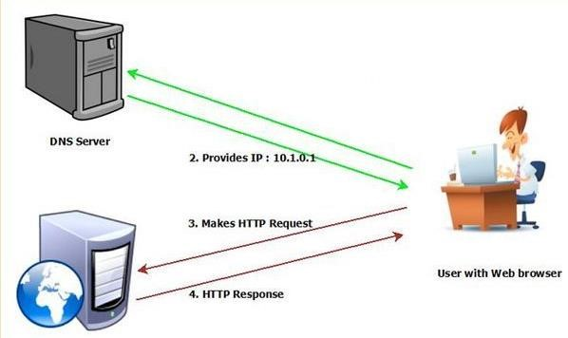

**1.1.3.b Developer flow**

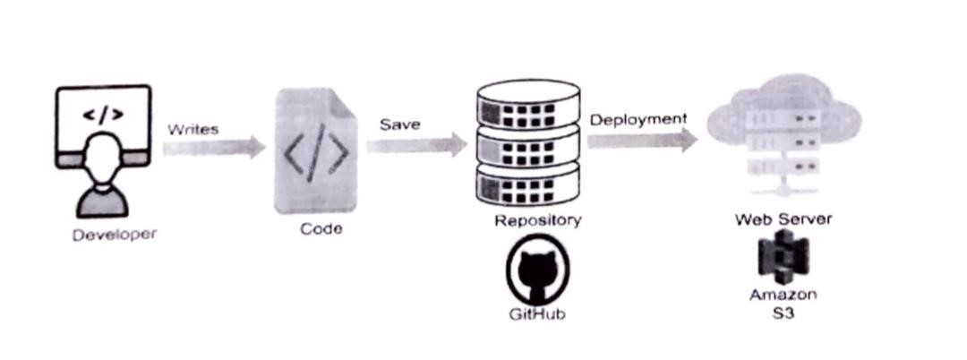

* 1. **Feature**

This portal introduces a new web-based department portal, which combines all useful features in other commercial systems and implements new functions. Its powerful features and friendly user interfaces allow teachers and students to handle their works in a convenient, efficient, and systematical way. In addition, this system also has very good portability and extensibility.

* 1. **Advantages**
* Chatting is the textual or multimedia conversation over the Internet. It is a real-time communications between two users via computer. It is widely interactive text based communication process that takes places over the Internet..
* Speed. A chat application allows you to message or contact a person in real-time
* Familiarity.
* Privacy

• Convenienc

* 1. **Scope**

The chat app provides a better and more flexible chat system. Developed with the latest technology in the way of providing a reliable system. The main advantage of the system is instant messaging, real-world communication, added security, etc. This application may find the best demand in the market for most organizations that aim to have independent applications..

* 1. **Future Work**

As this website has many features like management, providing resources and giving user convenience we can further develop this to help users/customers to chat with their his/her desired person with his/her privacy.which will be useful to the communicate in their friendly environment. We can also add a new feature where we can take offline chats and will create an interaction between friends as they required.

**CHAPTER 2**

**SERVICES AND TOOLS REQUIRED**

**2.1 Services Used**

**Hardware Configuration:**

Client Side:

|  |  |
| --- | --- |
| Ram | 512 MB |
| Hard disk | 10 GB |
| Processor | 1.0 GHz |

Server side:

|  |  |
| --- | --- |
| Ram | 1 GB |
| Hard disk | 20 GB |
| Processor | 2.0 GHz |

**Software Requirement:**

|  |  |
| --- | --- |
| Front end | HTML ,CSS ,jquery ,java script,Bootstrap |
| Server side Language | PHP |
| Database server | MYSQL |
| Web Browser | Firefox ,Windows or any equivalent OS |
| Operating system | Ubuntu , Windows or any equivalent OS |
| Software | xampp |

**2.2 Tools and Softwares used**

**Frontend : HTML and CSS3, Bootstrap**

**Backend : PHP**

**Database : MySQL**

**Tool : Xampp**

* + 1. **HTML:**

HTML stands for **Hyper Text Markup Language.**

HTML is the standard markup language for Webpages.

HTML elements are the building blocksof the

HTML Markup. HTML elements consist of start tag, end tag and content in between them.

* + 1. **CSS3:**

**CSS** stands for **Cascading Style Sheets.** It describes how HTML elements are to be displayed on screen, paper or in other media. CSS saves a lot of work. It can control the layout of multiple web pages all at once.

* + 1. **PHP:**

**PHP** stands for **Hypertext preprocessor**. It is a server-side scripting language that is embedded in HTML. IT is used to manage dynamic content, database, session tracking, even build entire ecommerce sites. It is integrated with a number of

popular databases including MySQL, PostgreSQL, Oracle, Sybase, Informix and Microsoft SQL Server.

**2.2.4 MySQL:**

**MySQL** is a freely available open-source

Relational Database Management System

(RDBMS) that uses Structured Query Language (SQL). SQL is the most popular language for adding, accessing and managing content in a database. **MySQL** is an essential part of almost every open-source PHP application

**CHAPTER 3**

**PROJECT ARCHITECTURE**

**3.1 Architecture**

**USER FRONTEND BACKEND**

|  |  |  |
| --- | --- | --- |
|  | **HTML 5** | **PHP**    **Database** |

**CHAPTER 4**

**ARCHITECTURE BLOCKS DETAIL WORKING**

**4.1 Blocks**

 **4.1.1 Installing the xampp**

**4.1.2 Adding links to the page**



**4.1.3 Designing the web page**



**4.1.4 Creating a database**

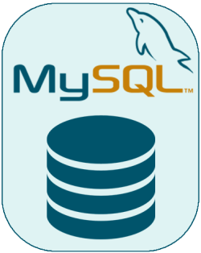

**4.1.5 run a query**

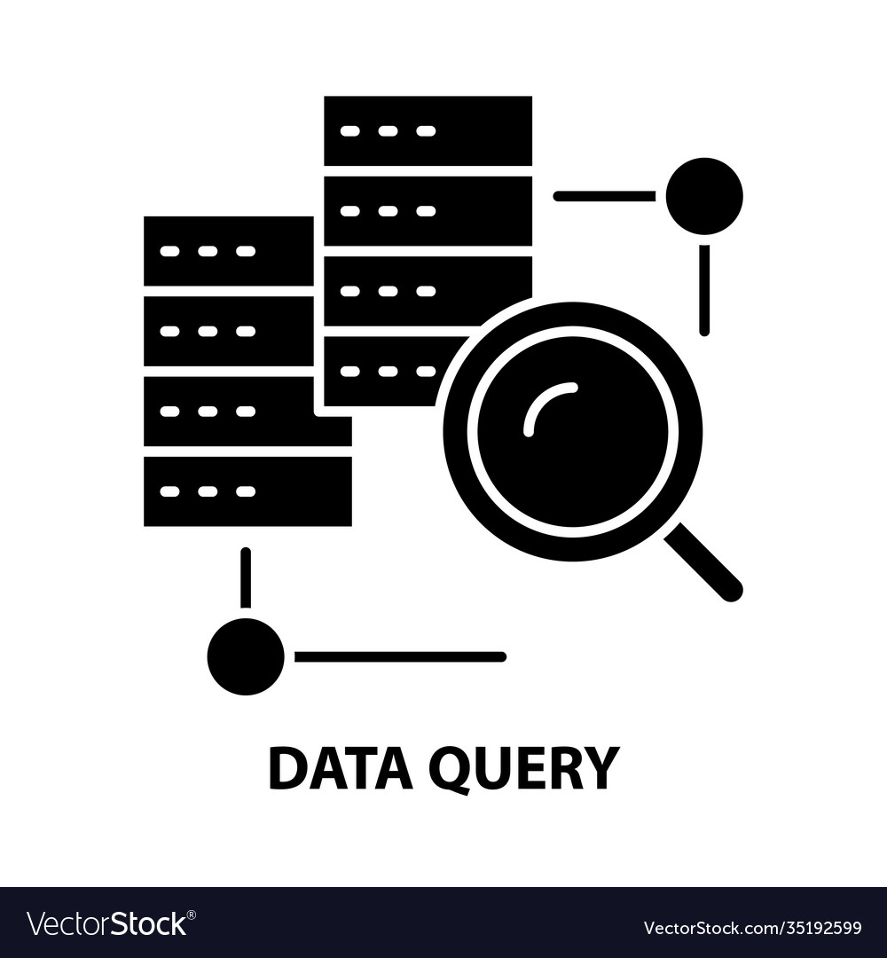

**CONCLUSION**

The chat app provides a better and more flexible chat system. Developed with the latest technology in the way of providing a reliable system. The main advantage of the system is instant messaging, real-world communication, added security, etc. This application may find the best demand in the market for most organizations that aim to have independent applications.

**REFERENCES**

For PHP https://www.w3schools.com/php/default.asp https://www.sitepoint.com/php/ https://www.php.net/ https://www.killerphp.com/ http://www.tutorialspoint.com/php/ For MySQL https://www.mysql.com/ http://www.mysqltutorial.org For XAMPP https://www.apachefriends.org/download.htm

**CODE**

**Please Provide Code through Git Hub Repo Link**

**https://github.com/Bhavani-09/Project_Techsaksham**

**https://github.com/Shoba-755/Techsaksham**