Workflow of the proposed model

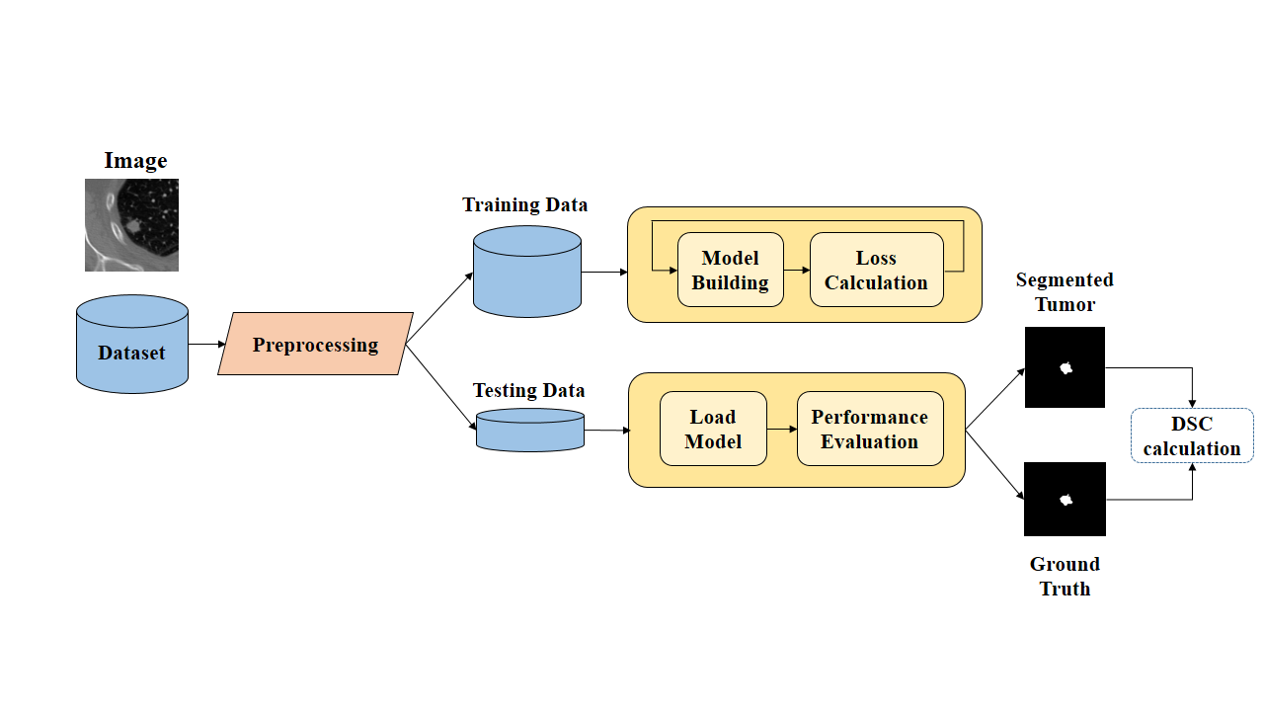

Proposed Architecture for Lung Nodule Segmentation

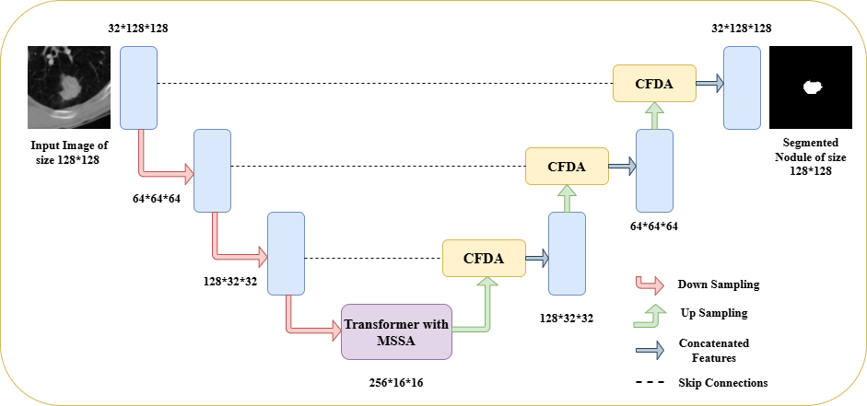

Transformer with Original Multi Head Self Attention Mechanism (a) and Transformer with Modified Multi Scale Shared Attention Mechanism (b)

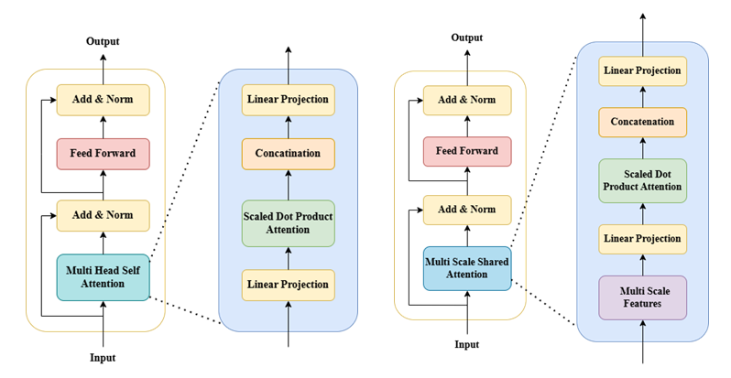

Multi-Scale feature extraction method (a) and Expanded Scaled Dot Product Attention Mechanism (b)

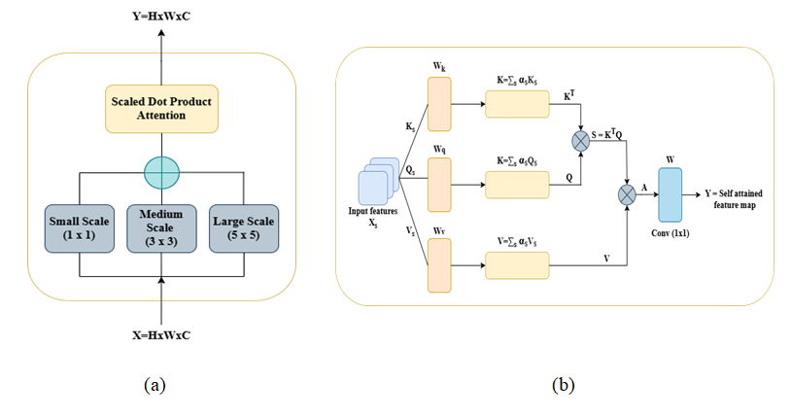

Cross Fusion Dual Attention Mechanism

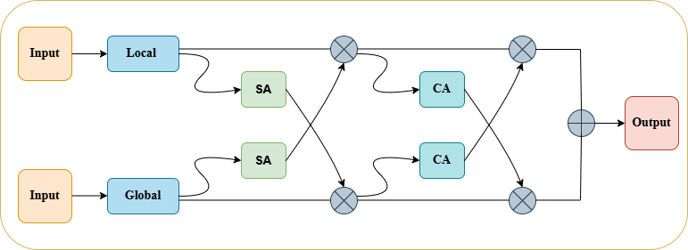

Spatial Attention Mechanism (a) and Channel Attention Mechanism (b)

