To,
The Director General,
Bureau of Indian Standards (BIS),
Manak Bhavan, 9 Bahadurshah Zafar Marg,
New Delhi- 110002, India

Production data for BIS Standard Marked _____Product Name__________ : Indian Standard No.
We have examined the books of accounts and the relevant records of _________________________________ having its factory at _______________________________________________________________ registered office at ___________________________________, for the period _Date/Month/Year to Date/Month/Year_and as per the information shared with us and explanations provided to us, we certify the month-wise production statement for BIS standard marked Product Name__________ : Indian Standard No. produced for the period _Date/Month/Year to Date/Month/Year as per below:
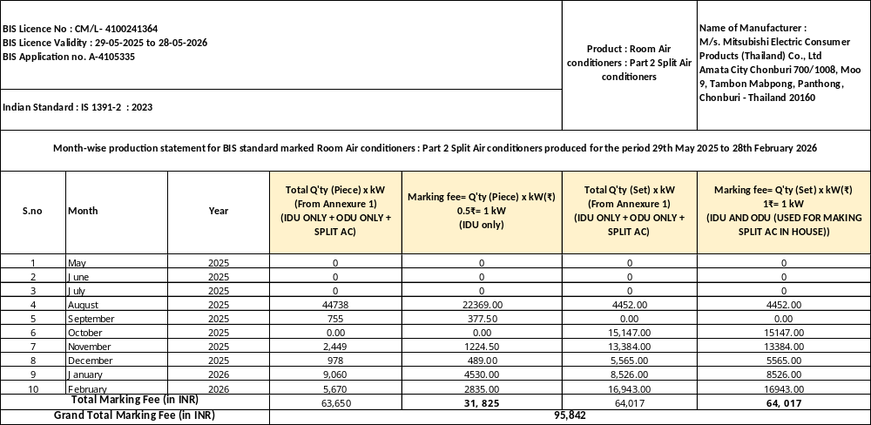
This certificate is issued for determining the marking fee payable to the Bureau of Indian Standards, at the specific request of M/s. ___________________________________________

For and on behalf of __________
Firm Registration No.:

Place: Partner
Date: Membership No.

UDIN:
Disclaimer
  - This certificate is not intended for general circulation or publication nor is it to be reproduced for any purpose other than outlined above or as may be required under any law for the time being in force.
  - The Firm does not assume any responsibility or liability for losses occasioned to the subject or any other parties as a result of the circulation, publication, reproduction or use of this certificate contrary to the purposes of this certificate.
  - The fees payable to the Firm for this certificate is not contingent in whole or in part on the conclusions reached herein.

