Recommendations Report for Reducing Power Imports to Bend, Oregon

**November 20, 2012**

**Authors**

**Zach Wahl, Nathan Anderson, Molly Winterrowd,**

**Trevor Bramwell, Tyler Franklin**

# EXECUTIVE SUMMARY

The purpose of this report is to provide recommendations to the community of Bend, Oregon on reducing their energy imports by 1 Megajoule/second (MJ/s). We, as a team, analyzed five different solutions. They are as follows, in order of viability; transit optimization, exchange of domestic incandescent light bulbs for LED/CFL light bulbs, hydropower, biofuels and a photovoltaic solar power station. This order has be derived from cost benefit analysis of each solution. Start up costs, job creation, and payback periods have also been factored in. It is for these reasons we feel that transit optimization is the most efficient way to lower Bend, Oregon’s dependence on outside energy by one megajoule per second.

**TABLE OF CONTENTS**

|  |  |
| --- | --- |
| Executive Summary  List of Tables and Figures | 2  3 |
| Introduction | 3 |
| Background | 3 |
| Proposed Solutions:  **A.** Light Bulb Exchange | 4 |
| **B.** Hydropower | 7 |
| **C.** Transit Optimization | 9 |
| **D.** Biofuels | 11 |
| **E.** Solar Power | 14 |
| Analysis | 15 |
| Conclusion and Recommendations | 16 |
| References | 16 |
| Appendix | 20 |

**LIST OF FIGURES AND TABLES**

|  |  |
| --- | --- |
| Figure C.1: Worker population density map | 10 |
| Figure D.1: General layout of a biomass generation plant | 22 |
| Figure D.2: Biomass to electricity flow chart | 22 |
| Figure D.3: Small scale prefabricated biodiesel production system. | 23 |
| Figure E.1: Annual payback of 1 MW solar facility | 23 |

**INTRODUCTION**

The purpose of this report is to provide recommendations to the community of Bend, Oregon to reduce energy reliance by 1 megajoule per second (MJ/s). As a team, we prepared five solutions to accomplish the goal of reducing Bend’s dependence on outside power:

1. Exchanging Light Bulbs
2. Hydropower
3. Transit Optimization
4. Biofuels
5. Solar Power

Each solution will discuss these aspects of their implementation:

* Cost benefit analysis
* Negative Factors
* Payback Period
* Job Creation

**BACKGROUND**

Here are a few demographics about Bend, Oregon:

* Population: 77,905
* Households: 31,596
* Land Area: 33.01 Sq. Miles
* Percent High School Graduate or Higher: 90.2%
* Percent in Labor Force: 68.9%
* Local River: Deschutes River

Bend, Oregon has a large amount of available energy resources. Everything from wind and solar energy, to hydroelectric and biomass. The city currently relies on several of these energy resources already.

**PROPOSED SOLUTIONS**

*A. Exchanging Light Bulbs*

Solution one proposes exchanging incandescent light bulbs with LED (Light-Emitting Diodes) or CFL (Compact Fluorescent Light) light bulbs in households, focusing on the Bend, Oregon community. With the amount of energy and money it would save for one household, the residents of Bend will want to change their light bulbs to more efficient ones and thus save money and energy while doing so.

*Materials*

The materials required for this solution are the high efficiency bulbs and an educated and informed public. In order to cut 1 MJ/s worth of energy, the population of Bend, Oregon will have to be willing to change their light bulbs.

*Implementation*

It would take approximately 150 homes to save 1 MJ/s worth of energy if each household replaced 30 light bulbs with either LED or CFL bulbs. Incandescent light bulbs are inefficient and up to 98% of the energy they consume is wasted as heat, not light [1]. By using another source of light, such as CFL or LED bulbs, the energy in a home may be cut by three-fourths of the original lighting bill per home [1].

Currently in Bend, Oregon there is a program by Energy Star where home builders are encouraged to build energy star efficient homes. However, this plan only works for new houses being built, where older houses still contain incandescent lights. In order to make all of Bend energy efficient by exchanging the type of light bulb used, we will need homeowner’s cooperation [2].

Two possible methods to achieve this goal will be discussed. If method 1 fails, then method 2 will be put into action.

1) Educate and advertise

If the public was aware of the efficiency of LED and CFL light bulbs, people would want to change them on their own because of the great benefit. This option is to educate the public into knowing how light bulbs work and how LED and CFL bulbs are more energy efficient than incandescent bulbs. By educating the public, homeowners will exchange their light bulbs because they understand the positive financial outcome. The other part of this program is to advertise more in the Bend area. By promoting light bulbs (such as Energy Star Qualified Light Bulbs) on the radio, TV commercials, or billboards, people will be aware of the benefits and most likely will exchange for the better, more energy efficient bulb [3].

2) Incentive Program

If people don’t change the light bulbs on their own, then Method 2 will be put into action. To motivate people to participate in a bulb exchange, we propose an incentive program where people can trade up to 5 incandescent light bulbs for CFL or LED light bulbs at a reduced cost. The idea of this program is to show homeowners the benefit of exchanging light bulbs for more energy efficient ones. In the end, the homeowners will want to get more efficient light bulbs on their own because the outcome shows lower overall cost and energy use reduced [3].

*Cost Benefit Analysis*

This section provides analysis of the costs and benefits of the proposed solution of exchanging light bulbs. The benefits and negative factors differ between the LED and CFL bulbs; therefore, it is necessary to evaluate each bulb type individually.

**Costs per Bulb:**

* + LED: on average, $30.00 [4]
  + CFL: on average, $15.00 [4]
  + Incandescent: on average, $2.50 [4]

**Annual Operating Cost:**

This analysis is based on the assumption that one household uses on average of 30 incandescent bulbs at a cost of 329 dollars per year [5].

* + LED: on average, $33.00 [4]
  + CFL: on average, $77.00 [4]
  + Incandescent: on average, $329.00 [4]

**Annual Overall Cost:**

Below shows how long a light bulb lasts if left on for 24 hours a day

* LED: on average, would last 2,084 days or 5.7 years
* CFL: on average, would last 334 days
* Incandescent: on average, would last 50 days

Therefore, for one year, each homeowner would need 0.18 LED bulbs, 1.10 CFL bulbs or 7.3 incandescent bulbs per light bulb socket [5]. The annual overall cost shown below includes operation cost and light bulb cost.

* + LED: on average, it would cost $195.00 per year
  + CFL: on average, it would cost $572.00 per year
  + Incandescent: on average, it would cost $876.50 per year

After comparing initial costs, operating costs and overall cost the cheapest to most expensive solution per year would be LED, CFL and then incandescent light bulbs.

To supply 150+ homes a year, with each household replacing 30 lightbulbs, it would cost $29,300 per year if using just LED bulbs, $85,800 per year if just using CFL bulbs and $57,500 per year if using a 50/50 mix of LED & CFL bulbs .

**Cost of Implementation:**

It would take approximately 150+ homes to save 1 MJ/s worth of energy, if each household replaced 30 light bulbs with either LED or CFL bulbs [4].

**A) Educate and advertise**

* + - Advertisements: $7,500+ [6], [7]
    - Light bulbs (4,500): $57,500

**B) Incentive Program:**

* + - Light bulbs: $57,500
    - Money returned: $25,000
    - Incandescent bulbs traded: $11,250 [4]

*Benefits:*

The benefits of LED and CFL light bulbs are significantly higher than the benefits of incandescent light bulbs. A few of the main benefits are listed below as to why LED and CFL bulbs are better.

LED:

* + Have an incredible life span of 50 times that of an incandescent light bulb [5]
  + Very durable [5]
  + Uses 6-8 Watts of energy compared to the 60 Watt incandescent bulb [5]
  + Reduces air pollution and greenhouse emissions [5]
  + One energy efficient bulb replaces 50 incandescent bulbs [5]
  + The bulbs run cooler and are safer to use with delicate lamp shades [4]
  + Uses less power (watts) per unit of light generated (lumens) [5]
  + Lowers electric bill [4]
  + Energy consumption decreases- less weight in waste [5]

CFL:

* + The life span of a CFL light bulb is on average 8 times longer than that of incandescent light bulbs [5]
  + Uses 13-15 Watts of energy compared to the 60 Watt incandescent bulb [5]
  + Costs less than incandescent bulbs per year [5]
  + Lowers electric bill [4]
  + Lower energy consumption decreases- less weight in waste [5]

*Negative Factors:*

Although the good outweigh the bad, CFL light bulbs are still not better than LED lights, but both rise above the average incandescent lights.

LED:

* + Most expensive light bulb option (per unit) [4]
  + The availability of these bulbs are more limited [3]

CFL:

* + Contains mercury, which is a toxic gas [5]
  + Require specific disposal methods [5]
  + Not very durable [5]
  + Sensitive to humidity [5]
  + Take a while to turn on/warm up [4]
  + Can emit an odor, smoke or catch on fire [5]

*Payback Period:*

The payback period of these solutions is very good. Since most money should be spent by the homeowners and not the city of Bend, the only money used would be for advertising and educating. To get returns on the money, it would take a homeowner 1 month to see a reduction in lighting bill, but not a full return on money spent for the bulbs. It would take approximately 1 year to gain all money back and then it is all profit (This depends on the amount of bulbs installed per one home) [1].

*Jobs Created:*

The amount of jobs created is based on the amount of people it would take to advertise and educate the public as needed in option a or man the exchange of light bulbs as needed in option b. Approximately 8 jobs for option a, and 5 jobs for option b depending on the demand of help needed by the city of Bend [6], [7].

*B. Hydropower*

This section will propose the usage of a small conduit hydroelectric power station for the city of Bend. A small conduit hydroelectric power station is a facility that produces between 1 and 20 megawatts of power. This station will include the implementation of a turbine rated at 1.6 Mega joules / second, and a small powerhouse to house the turbine. The site chosen for construction is the Outback Reservoir located off Skyliners Rd. An eleven mile pipeline from the Bridge Creek intake facility to the reservoir is already in place, providing the necessary infrastructure. The intake facility sits at an elevation of 3,000 feet above the chosen site, providing the necessary energy required for the water to spin a turbine.

*Cost Benefit Analysis*

This section will analyze the costs and benefits of the proposed hydroelectric station.

*Costs:*

* 1.6 MW turbine ~ $100,000 [12]
* 50 ft. by 35 ft. by 12 ft. power station ~ $35,000
* 20 inch pipe ~ $2500
* Energy production cost of $0.02 per kilowatt
* Total construction cost: $137,500

*Benefits:*

* Renewable energy that has zero emissions [10].
* 90% energy to electricity conversion, the highest conversion ratio on the planet [10]
* Free fuel source, water [10]
* Low maintenance, required once every 20 or so years [8]
* Very reliable [10]
* Lowest energy production cost per kilowatt of all energy sources available [10]

*Negative Factors:*

Negative factors involved with hydropower are addressed here.

**1)** **Environmental Impact:**

We don’t foresee any environmental impact as the potential site has already been disturbed during the original pipeline construction [8].

**2)** **Impeding Community Water Flow:**

The available flow through the turbine system would not exceed the flow required for community drinking needs [8]. However, turbine output will experience a significant decrease in the summer months [8].

*Payback Period:*

The power station is expected to pay off construction debts and operating expenditures within a year. Furthermore, the station is estimated to generate up to $12 million in revenue in under fifty years [8].

*Jobs Created:*

A small conduit hydropower station would require 1-2 full time employees to monitor operations [11].

## *C. Transit Optimization*

This section will discuss the positives and negatives of optimizing the transit system in the city of Bend, Oregon. To provide some background information; of commuters in Bend, approximately 53% travel alone for a total distance of 10 miles on their daily commute [15]. The total number of commuters in bend is 28,642 [13]. These 53% of commuters use roughly 11.09 MJ/s of energy (See Appendix for Equation); more than enough to reduce 1 MJ/s from. To reduce the energy input by the requested amount, it would require roughly 10% of the aforementioned commuters to refrain from driving to their work. The goal is to convince 10% of this subset of commuters to use public transit as means of transportation to get to work. As of now, approximately 0.6% of commuters in Bend use public transit, which shows that there is room for improvement.

*Methods:*

Two possible options to achieve this goal will be discussed:

1.) The first method is to implement fareless transit. A good example of fareless transit can be found in Corvallis, Oregon. As of February 1, 2011, Corvallis implemented fareless riding in its transit system by imposing a Transit Operations Fee [16]. This fee, which is charged to utility customers, is $3.73 for single-family residential customers and costs more for businesses, varying on the trips generated for that location [17]. The process is fairly easy to implement; it is applied on residents’ water bill which reduces the need for additional processing of fees. During the first year of fareless transit in Corvallis, the amount of riders increased by 37.9% [16]. For the amount of power reduction needed for Bend, the city would need an approximate 10% increase in usage. The method suggested for the city will be based off of the existing infrastructure in Corvallis. For a graph on the increase of Corvallis’ ridership increase, see the Appendix.

2.) Another option is to acquire a new bus and implement a new route. Comparing existing routes with one of the worker dense areas of the city (See Fig. C.1), two bus routes currently travel through this area, numbers 3 and 11 (See Appendix for Routes). Having a dedicated bus running through this area will provide incentive to use public transit.

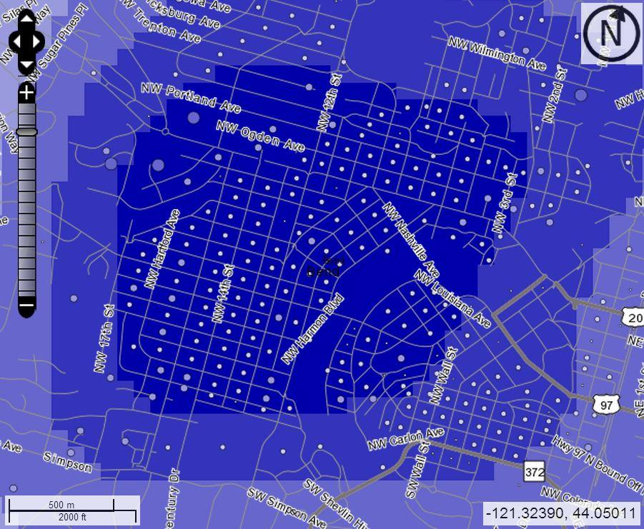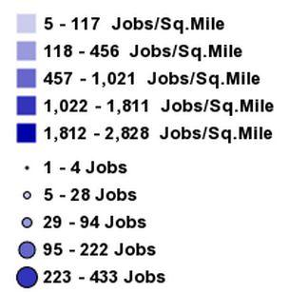

**Figure C.1:** Worker population density map for one of the three worker dense areas of Bend, Oregon [14].

*Cost Benefit Analysis:*

This section will analyze the costs and benefits of the proposed optimization.

*Costs:*

Method 1:

* Transit Operating Fee will charge residents and businesses a fee

Method 2:

* 1 Large, Heavy-Duty Transit Bus ~ $300,000 – $400,000 [19]
* Cost of Operation ~ $350,000/yr [18]

*Benefits:*

Method 1:

* No need to change infrastructure
* Less Traffic
* Less $$CO_{2}$$ emissions
* Divert tax revenue that previously supported transit towards other tax revenue services such as police, fire, library, parks and/or recreation [17]

Method 2:

* Easier access to transit

*Negative Factors:*

Negative factors involved with transit optimization are addressed here:

Method 1:

* Fee imposed on utility customers

Method 2:

* Possible route complexity

*Payback Period:*

Depending upon which method is selected, the payback period is either nonexistent or a large amount of time. If fareless transit is implemented, there will not be a noticeable cost difference to the City of Bend. However, if a new bus is acquired and dedicated to a new route, the payback period will depend on the amount of state and government funding that can be obtained in addition to revenue generated from ticket sales.

*Jobs Created:*

Method 1 would not create any new jobs. It does not alter the existing infrastructure of the City Government, therefore, there is no room for expansion. Method 2 would create one new job for a bus driver.

*D. Biofuels*

The following is a quick description of biofuels, their creation, usage, and feasibility in the greater Bend area. Biofuels are fuels that come from biological material like wood or plant oil. This makes biofuel a very renewable and green source of energy. In researching Bend, Oregon we have found that the most lucrative and locally available sources of biofuel are biodiesel and biomass.

Biodiesel can be made primarily from vegetable oil and provides a cleaner burning renewable alternative to petroleum based diesel fuels. Biomass is left over woody material from the production of lumber or forest maintenance. To convert biomass into electricity it is simply burned as a heat source to make steam. This pressurized steam is piped into a turbine which turns a shaft connected to a generator.

As Deschutes County is the fastest growing county in Oregon [5], it is in need of alternatives to regular fuels in both the automobile and power generation sectors.

***Biodiesel****:*

The following proposal is for the creation of a stand alone waste oil recycling facility producing an excess of 850 gallons of biodiesel per 24 hour period. [25]

*Cost Benefit Analysis:*

As with any renewable energy solution there are large start up costs associated with the equipment necessary to produce biodiesel on a large scale. However this will be offset by the relatively low operating cost and the low cost of the fuel created.

*Costs:*

Start up and recurring expenditures

* $15,000-55,000 startup [25]
* Continued cost of supplementary additives ($0.05/Gal) [25]
* Disposal of residual waste (depends on facility)
* If the biodiesel is used as heating oil for domestic heat a tank heater will need to be installed in the holding tank

*Benefits:*

Positive attributes to using biodiesel.

* Can be accomplished on both small and large scales
* There are many outfits offering several different configurations of small to large prefabbed production facilities
* Cleaner auto/heavy equipment $$CO{}_{2}$$ emissions [25]
* Creates outlet for used oil that restaurants currently have to pay to dispose of

*Negative Factors:*

Problems with biodiesel as a viable solution.

* Startup costs can be very high for a large operation
* Inexpensive raw material supply is subject to fluctuation due to reliance on a supply of waste oil
* Fresh vegetable oil can be used to create biodiesel however, it is more expensive than free waste oil and will push the payback period out significantly
* Uses electricity in creation of clean fuel

*Payback Period:*

Depends on operation size and availability of free oil. Average will be 1-2 years.

*Jobs Created:*

Depends on the size and type of operation (large/small scale and commercial/private) though even a large operation will require only a few employees.

***Biomass****:*

This second biofuel option, viable for the Bend area, will necessitate the building of a large woody biomass burner facility. The burner will be able to run on many different plant based fuel sources, from sawmill waste to forest residue. As the burner breaks down this organic fuel it will produce intense heat which, in turn, will boil water. The steam off the boiling water will spin a turbine connected to a generator. This will create a minimum of 1 Megawatt for a 5 million dollar facility. [24]

*Cost Benefit Analysis:*

The extensive cost of starting a biomass burner operation in the Bend area make it inefficient to build with public funding. However as a private solution it shows real promise. There are massive tax advantages and incentives to such a project. Two such facilities are already in existence in some form in the greater central oregon area. These facilities have been built in conjunction with sawmills to negate the need to transport the biomass. This lowers the operational cost but the fact remains as a public option, building a biomass burner is not a good solution.

*Costs:*

Start up and recurring expenditures

**$**5 million- $30 million for construction of new facility. [24]

*Benefits:*

Positive attributes to using biomass:

* Uses no demanded resources
* Provides a local outlet for mill waste lowering transportation emissions
* Provides a local outlet for forest service bio-waste lowering danger of forest fires
* Creates jobs in the both the timber industry and the forest service
* Can provide electricity for more than 700 homes [23]
* Will qualify for “Blue Sky” program.[23]

*Negative Factors:*

Problems with biomass as a viable solution:

* Electrical power is not as cost effective as it is from other sources
* Will necessitate hike in energy prices (total cost of $0.07 per kWh) [23]
* Large startup costs [24]

*Payback Period:*

Depends on the size of the operation, type of biomass being burned.

*Jobs Created:*

The number of jobs created will be dependant on the size of the operation and its location in relation to a fuel source. If built as a stand alone facility it could require as many as eight workers to keep up on maintenance and truck in the burnable material. If built in conjunction with a sawmill operational efficiency could be achieved with the addition of as few as one additional worker.

*F. Solar Power*

We propose that Bend, Oregon invest in a new solar facility. There are two ways to generate energy from the sun. One is photovoltaic (PV) and the other is concentrated solar power (CSP). PV works by using photoelectric cells to collect radiation heat from the sun and turn it into electricity. CSP works by using several lenses or mirrors to focus rays of light from the sun into a single point to heat a liquid. This liquid is then transformed into steam which in turn powers a generator that creates energy.

Though CSP is superior to PV in aspects of storage and continuous production, PV systems cost less, can be set up sooner, and built faster than CSP. Also, due to the expected long run cost of PV panels, the US government began transitioning its CSP systems to PV in 2011 [28]. This is why I have chosen to present a PV system instead of a CSP system.

*Cost Benefit Analysis:*

To increase the production of energy in Bend, Oregon by a minimum of 1 MJ/s, a 1 MW solar facility will need to be created. The current price of PV arrays are at $1/watt [30]. A 1 MW facility therefore will cost $1 million. Thanks to tax credits from the government, this total price is reduced by $75,000 to $925,000 [29].

*Cost:*

* Installation ~ $15,000
* Panels ~ $925,000
* Inverter ~ $200,000
* Land - 6 acres ~ $75,000 [32]

Total: $1,215,000

*Benefit:*

* 1 MW Renewable Energy

*Negative Factors:*

* Possible environmental impact if clear land can’t be found

*Payback Period:*

* Cost would be payed back in approximately 1½ to 2 years

*Jobs Created:*

* 2-3 Operators
* 1-2 Security Guard

**ANALYSIS**

Based on our research we have decided to rank the five options we discussed, from most feasible to least feasible, as follows:

1. Transit Optimization
2. Light Bulb Replacement
3. Hydropower
4. Biofuels
5. Solar Power

This order is based off the cost benefit analysis performed on each option. As city and local governments are, now more than ever, looking for ways to save money, the large expenditure options have been ranked lowest as they require the largest start up cost. Transit optimization was chosen as the most plausible option for Bend because it requires the least amount of public funding. Method 1 in Transit Optimization requires no additional spending or hiring on account of the city. The light bulb campaign was next on our list as it requires only minimal spending on advertising while the actual purchasing light bulbs will be deferred to the citizens. As a side note, depending on the community and local renewable energy groups, much of this advertising could be either donated or paid for by nonprofits or even certain bulb manufacturers. The last three options were all both expensive to start and required a significant payback period before becoming profitable. For those two reasons we elected to rate them lower despite their actual viability in the area around Bend. Within the aforementioned criteria hydropower was the next cheapest and most viable solution. It also required the smallest environmental impact out of the final three options as its potential wilderness construction site had already been disturbed by the construction of the pipeline to which it would be attached. Biofuels came next as they had both significant environmental advantages and they require no demanded local resources. Solar was our last choice due to its high start up cost and requirement for a large unshaded space in which to build. It also could necessitate the construction of additional transmission lines to get the power to the grid as most spaces fitting the requirements were not near a sufficient power grid.

**CONCLUSION AND RECOMMENDATIONS**

As the greater Deschutes area, including Bend, is a rapidly growing socio economic center it needs to lessen its dependence on outside energy. However, due to the cost involved with growth it likely needs to keep large public spending to a minimum. It is for these reasons that we recommend an LED light bulb campaign and transit optimization as our two favored options. While all the topics discussed here will meet the criteria without issue, it is these two that require the least public funding and have the potential for the largest gain. The hydro power option is very feasible and is the next choice due to its relatively low cost and quick payback. Its lack of production during the summer months presents its only real drawback. Solar and biofuel options are excellent choices, however their expensive start up costs and slower payback make them less than ideal in the publicly funded sector. As private endeavors both would be an excellent addition to many large businesses in the Bend area.

**REFERENCES**

# [1] B. C. Howard, “MSN,” *Energy-efficient light bulbs: How much do you really save?.* [Online].

Available: http://realestate.msn.com/energy-efficient-light-bulbs-how-much-do-you-really-save. [Accessed: Nov.18, 2012]

[2] U.S. Environmental Agency, “Energy Star: New Homes,” *Builders in Bend.* [Online]. Available: http://www.energystar.gov/index.cfm?fuseaction=new_homes_partners.showAreaResults&s_code=OR&msa_id=34. [Accessed: Nov. 19, 2012]

[3] U.S. Department of Energy, “2006 Partner Resource Guide,” *Energy Star Qualified Light Bulbs*. [Online]. Available: http://www.energystar.gov/ia/partners/manuf_res/CFL_PRG_FINAL.pdf. [Accessed: Nov. 20, 2012]

[4] Unknown, “Easy Web Calculators,” *Incandescent Bulbs vs. Compact Fluorescent and LED Light Bulbs.* [Online]. Available: http://www.easywebcalculators.com/cf.htm. [Accessed: Nov. 20, 2012]

[5] Design Recycle inc.,“Comparison Chart,”*LED Lights vs. Incandescent Light Bulbs vs. CFLs***.** ONLINE]. Available: http://www.designrecycleinc.com/led%20comp%20chart.html. [Accessed: Nov. 20, 2012]

[6] T. Brueski,“Local Marketing Ideas,” *How Much Does Radio Advertising Cost?.* [Online]. Available: http://localmarketingideas.com/how-much-does-radio-advertising-cost/.[Accessed: Nov. 22, 2012]

[7] N. Kokemuller, “eHow,” *How Much Does It Cost to Use Billboard Advertising?* [Online]. Available: http://www.ehow.com/info_8234497_much-cost-use-billboard-advertising.html. [Accessed: Nov. 24, 2012]

[8] Squidoo, “Light Bulbs-Let's compare,” *The Light Bulb Wars.* [Online]. Available: http://www.squidoo.com/incandescent-versus-CFL-versus-LEDl. [Accessed: Nov. 28, 2012]

[9] Federal Energy Regulatory Commission, “Initial consultation document in support of FERC exemption of small conduit hydroelectric facilities for the Bend conduit project”, *City of Bend*, August 2011, [Online], Available: bendoregon.gov/modules/showdocument.aspx?documentid=3990, [Accessed: Nov. 11th, 2012]

[10] National Hydropower Association, “Why Hydro?”, *National Hydropower Association*, [Online], Available: http://hydro.org/why-hydro, [Accessed: Nov. 11th, 2012]

[11] Federal Energy Regulatory Commission, “Bend hydroelectric project, draft conduit exemption application”, *City of Bend*,[Online], Available: http://bendoregon.gov/modules/showdocument.aspx?documentid=6775, [Accessed: Nov. 11th, 2012]

[12] J. Tuo, “Pelton water turbine for hydraulic power plant”, *Alibaba*, [Online], Available:

http://www.alibaba.com/product-gs/478173986/Pelton_Water_Turbine_for_Hydraulic_Power.html, [Accessed: Nov. 12th, 2012]

[13] U.S. Census Bureau, *Selected Economic Characteristics,*2006-2010 American Community Survey 5-Year Estimates. [Online]. Available: http://factfinder2.census.gov/faces/tableservices/jsf/pages/productview.xhtml?src=bkmk. [Accessed: Nov. 16, 2012].

[14] U.S. Census Bureau, *Home Area Profile Report*, OnTheMap Application and LEHD Origin-Destination Employment, Statistics (Beginning of Quarter Employment, 2nd Quarter of 2002-2010). [Online]. Available: http://onthemap.ces.census.gov/. [Accessed: Nov. 16, 2012]

[15] Oregon Employment Department, “Oregon's Metro Commuters: Distance, Direction, and Net Flows” *Oregon Employment Department*. [Online].

Available: http://www.qualityinfo.org/olmisj/ArticleReader?itemid=00007546#seg0006. [Accessed: Nov. 16, 2012].

[16] City of Corvallis, Oregon, *FARES/FARELESS*, Corvallis Transit System is fareless!.

[Online]. Available: http://www.corvallisoregon.gov/index.aspx?page=175.

[Accessed: Nov 16, 2012]

[17] City of Corvallis, Oregon, “Frequently Asked Questions on the Transit Operations Fee”, *City of Corvallis*.[Online].

Available: http://www.corvallisoregon.gov/modules/showdocument.aspx?documentid=4248

[Accessed: Nov 16, 2012]

[18] United States. Department of Transportation, *Transit Bus Life Cycle Cost and Year 2007 Emissions Estimation*. Final Report: July 2, 2007. [Online].

Available: http://www.fta.dot.gov/documents/WVU_FTA_LCC_Final_Report_07-23-2007.pdf. [Accessed: Nov. 16, 2012].

[19] Oregon. Department of Transportation, *Oregon Vehicle Description and Useful Life Standards*. [Online]. Available: http://www.oregon.gov/ODOT/PT/docs/capital/vehicle-descriptions-useful-life-standards.pdf

[Accessed: Nov. 16,2012]

[20] EV World, “Energy notes: Energy in natural processes and human consumption, some

numbers” *EV World*. [Online]. Available: http://www.evworld.com/library/energy_numbers.pdf [Accessed: Nov. 17, 2012].

[21] United States. Department of Transportation (RITA), *Average Fuel Efficiency of U.S. Light* Duty Vehicle. [Online]. Available: http://www.bts.gov/publications/national_transportation_statistics/html/table_04_23.html [Accessed: Nov. 16, 2012].

[22] City of Corvallis, Oregon, “CTS Ridership”, *City of Corvallis*. [Online].

Available: http://www.corvallisoregon.gov/modules/showdocument.aspx?documentid=4250

[Accessed: Nov 22, 2012]

[23] Oregon Global Warming Commission, (2009 January). Report to the Legislature [Online] http://www.oregon.gov/ENERGY/gblwrm/gwc/docs/09commissionreport.pdf

[24] Whole Building Design Guide. (2012) *Biomass for Electricity Generation* [Online]. http://www.wbdg.org/resources/biomasselectric.php

[25] Freedom BioFuelers. (2012, January 1) [Online]. http://thebiodieselstore.com/biodiesel-processors

[26] J. O’Rielly. (2011, December 1) *Use of CHP and Renewable Sources of Energy for Industrial Boilers,* [Online]. https://sites.google.com/site/ee535test/jonathan-o-reilly

[27] Pacific Power. (2012, January 1) *Blue Sky Renewable Energy*. [Online]. http://www.pacificpower.net/bluesky

[28] *Concentrated Solar Power (CSP) Vs Photovoltaic panels (PV).* [Online]. Available:

http://www.renewablegreenenergypower.com/solar-energy-facts-concentrated-solar-power-csp-vs-photovoltaic-pv-panels/. [Accessed Nov. 28, 2012]

[29] *Solar Electric.* [Online]. Available: http://energytrust.org/public-sector/incentives/equipment-upgrades-remodels/SolarElectric/SolarElectric2/. [Accessed Nov. 28, 2012]

[30] *Energy prices: two trends (2 graphs).* [Online]. Available: http://rwer.wordpress.com/2012/03/12/energy-prices-two-trends-2-graphs/ [Accessed Nov. 28, 2012]

[31] *Levelized Cost of New Generation Resources in the Annual Energy Outlook 2012.* [Online]. Available: http://www.eia.gov/forecasts/aeo/electricity_generation.cfm [Accessed Nov. 28, 2012]

[32] *Baldock Solar Highway.* [Online]. Available: http://www.oregon.gov/ODOT/HWY/OIPP/docs/baldockfacts.pdf [Accessed Nov. 28, 2012]

**APPENDIXES**

*A. Exchanging Light Bulbs*

*Comparison Chart-LED Lights vs. Incandescent Light Bulbs vs. CFLs:*

|  |  |  |  |
| --- | --- | --- | --- |
| **Energy Efficiency**  **& Energy Costs** | **Light Emitting Diodes (LEDs)** | **Incandescent**  **Light Bulbs** | **Compact Fluorescents (CFLs)** |
| **Life Span (average)** | **50,000 hours** | **1,200 hours** | **8,000 hours** |
| **Watts of electricity used**  **(equivalent to 60 watt bulb).**  **LEDs use less power (watts) per unit of light generated (lumens). LEDs help reduce greenhouse gas emissions from power plants and lower electric bills** | **6 - 8 watts** | **60 watts** | **13-15 watts** |
| **Kilo-watts of Electricity used**  **(30 Incandescent Bulbs per year equivalent)** | **329 KWh/yr.** | **3285 KWh/yr.** | **767 KWh/yr.** |
| **Annual Operating Cost**  **(30 Incandescent Bulbs per year equivalent)** | **$32.85/year** | **$328.59/year** | **$76.65/year** |

*C. Transit Optimization*

*Average Gas Mileage for Commuters:*

$$(23.8 mpg car + 17.4 mpg truck)/2 = 20.6 Average MPG$$ [21]

*Energy Usage by Commuters:*



* + Calculation data [20] [21] [15] [13]

*Available Transit Route Data:*

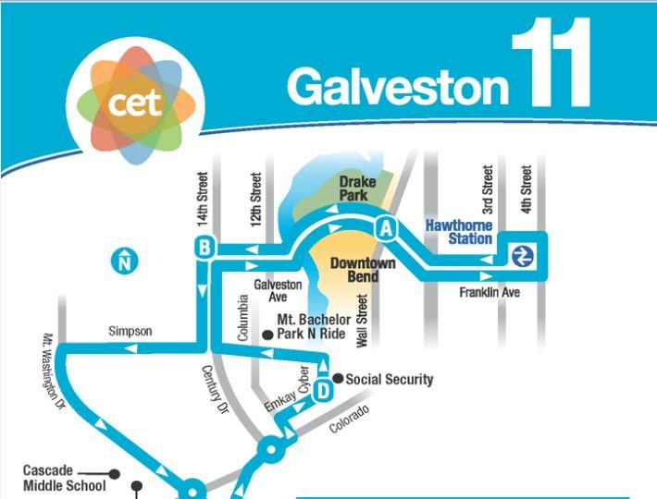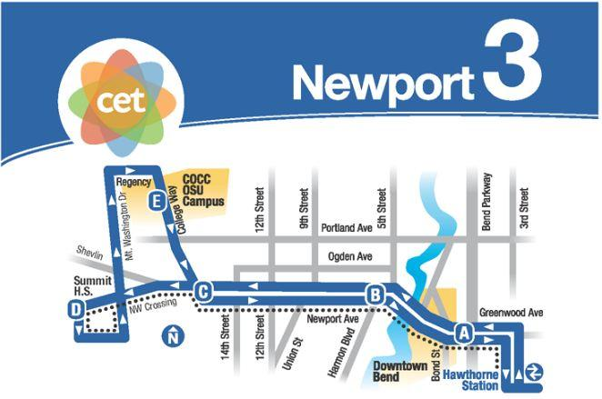

*Ridership Statistics* [22]*:*

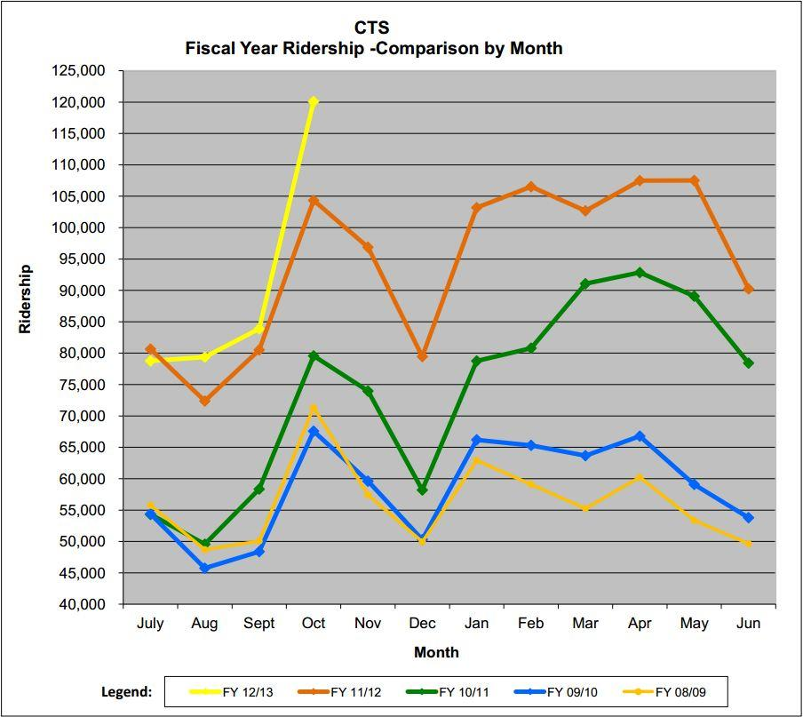

*D. Biofuels*

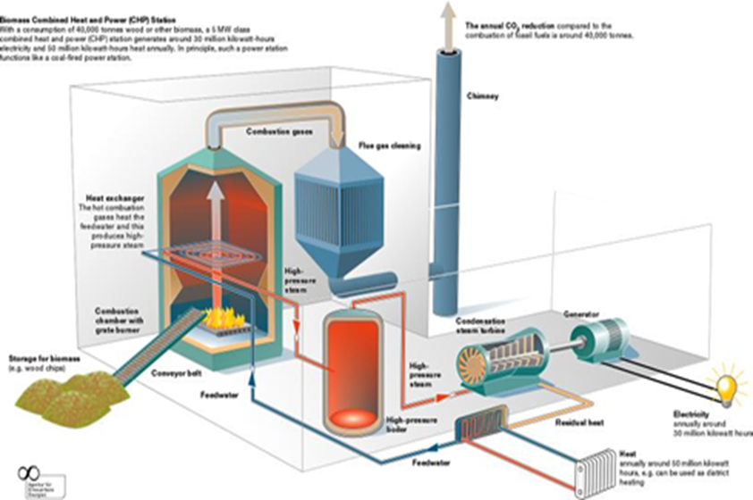

**Figure D.1:** General layout of a biomass generation plant. [26]

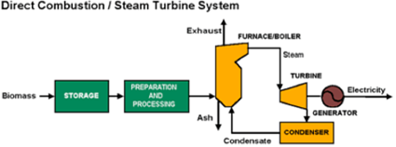

**Figure D.2:** Biomass to electricity flow chart. [24]

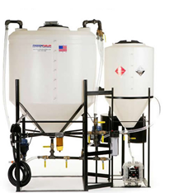

**Figure D.3:** Small scale prefabricated biodiesel production system. [25]

*E. Solar Power*

$$\frac{\$0.1527}{1 kWh}$$ $$×$$ $$\frac{1000kW}{1MW}$$ $$×$$ $$\frac{Avg. 7.6kWh Sun}{24 Hours}$$ $$×$$ $$\frac{24 Hours}{1 Day}$$ $$×$$ $$\frac{365 Days}{1 Year}$$ $$=\frac{\$393,492.62}{1 Year}$$

**Figure E.1**: Annual payback of 1 MW solar facility. [31]