Trevor Bramwell
Vicki de Tal
WR 327 – TR 16:00 - 17:20 PM
September 30th, 2012

Virtualization Definition

DEFINITION 1:
Virtualization is the abstraction of hardware from software. The word is commonly used to refer to physical computers that contain other, non-physical computers. It provides one or more computers, or operating systems, the illusion of full, independent hardware access.

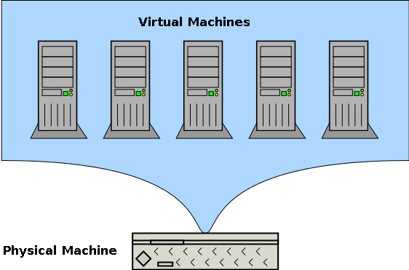

DEFINITION 2:
Virtualization is another name for what is generally referred to as 'The Cloud'. Virtualization is the existence of one or more non-physical computers that live on a physical computer.

For example the ACME corporation has three computers: one that handles their email, one that handles their website, and one that handles their database. If these computer were virtualized, it would mean that all three of them live on a single physical computer. If they were not virtualized, each computer would be its own physical machine.

