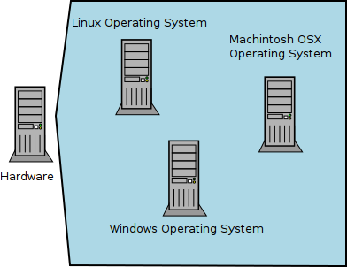
Trevor Bramwell
WR 327 (213)
September 30th, 2012

Virtualization Defined

Audience 1: ENG 211 Students
Virtualization is the emulation of computer hardware by computer software. It enables the separation of an operating system from hardware (see Figure 1). An operating system is software that enables programs or applications to run on a computer. Virtualization allows for programs designed for one operating system, such as Windows, to be run under another operating system, such as Linux.

It is generally used in reference to the term 'Virtualized Infrastructure', where 'Infrastructure' is a collection of servers, or computers designed for a specific purpose, and 'Virtualized' means that those servers contain other servers. This infrastructure may only consist of three servers, yet those servers contain hundred of other servers within them.

Virtualization is used through the computer industry for commercial hosting, creating large scale testing environments, distributing web traffic, and computing large sets of data.

Figure 1: Virtualized Hardware

Audience 2: Technical Writing Instructor
Virtualization, generally referred to as 'The Cloud', is a collection of computers connected to the internet.

For example the Acme Corporation has three computers: one that delivers their email, one that serves their website, and one that holds their database. If these computer were virtualized, it would mean that all three of them live on a single physical computer. If they were not virtualized, each computer would be its own physical machine.

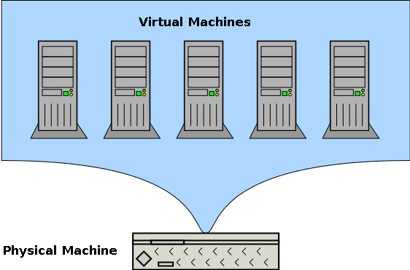
Figure 2: Virtualization – Virtual Machines on a Physical Server

